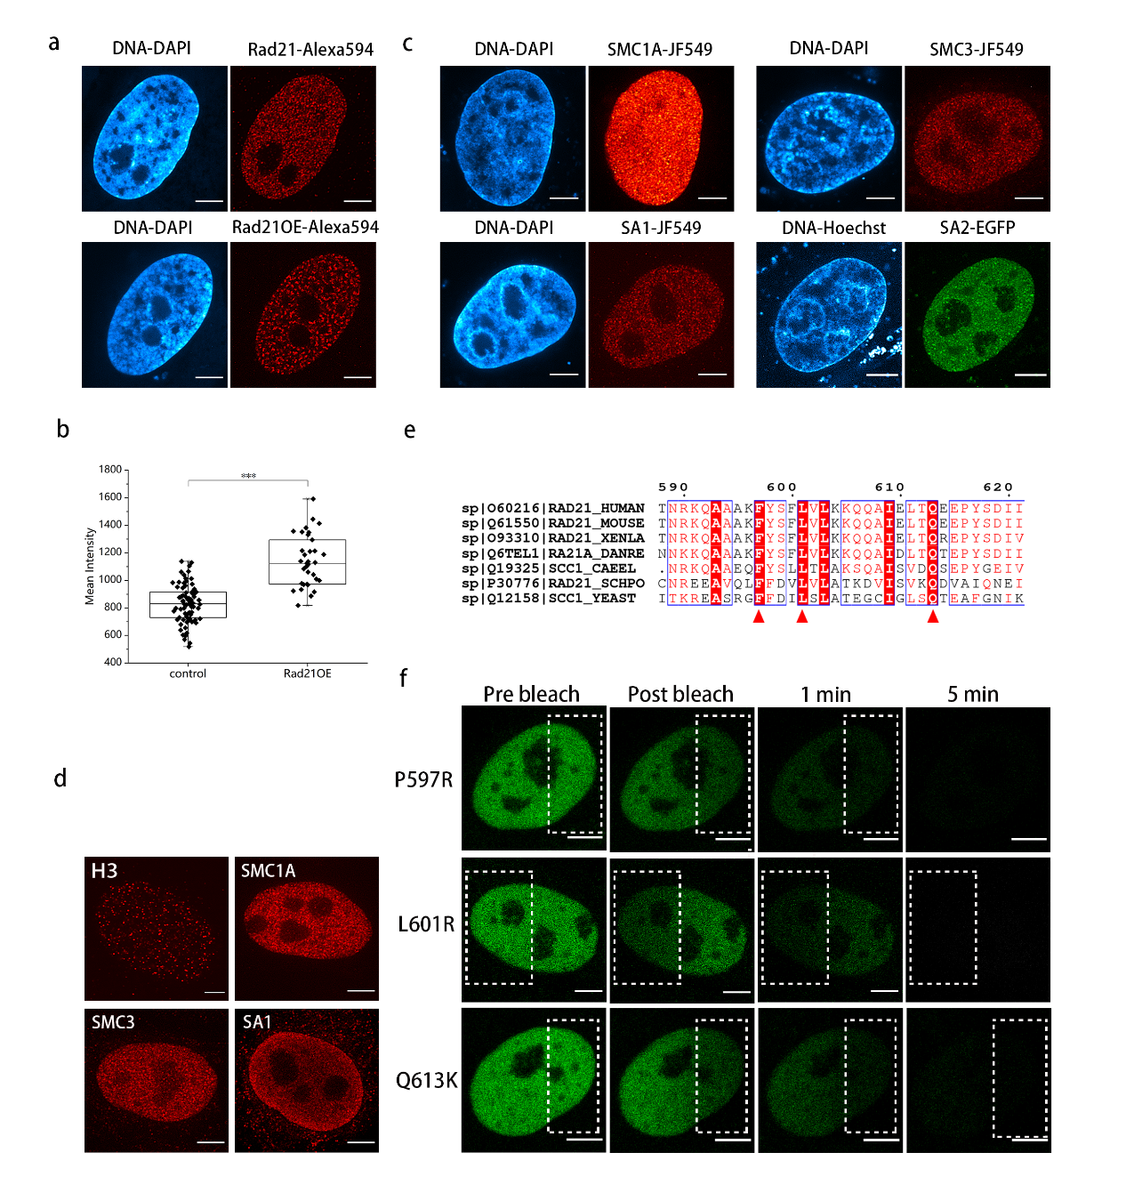
Fig. S1 The whole cohesion complex is required for the formation of the vermicelli in Rad21-OE cells.
- Super-resolution images of endogenous Rad21 and up-regulated Rad21 labeled with antibody. Scare bar, 5 μm.
- Measurement of Rad21 expression level by mean intensity quantification (n>35 per condition).
- Super-resolution images of HeLa cell transfected with human SMC1A, SMC3, SA1, SA2. Scare bar, 5 μm.
- Super-resolution images of endogenous H3 and cohesin subunits labeled with antibody. Scare bar, 5 μm.
- Multiple sequence alignment of partial Rad21 using ClutsterW. Red arrows represent conserved amino acids that are import for Rad21 association with SMC1A/SMC3 dimers.
- Still images of an iFRAP assay of three Rad21 mutants in Fig.1i over-expressed in HeLa cell. Scale bar, 5 μm.
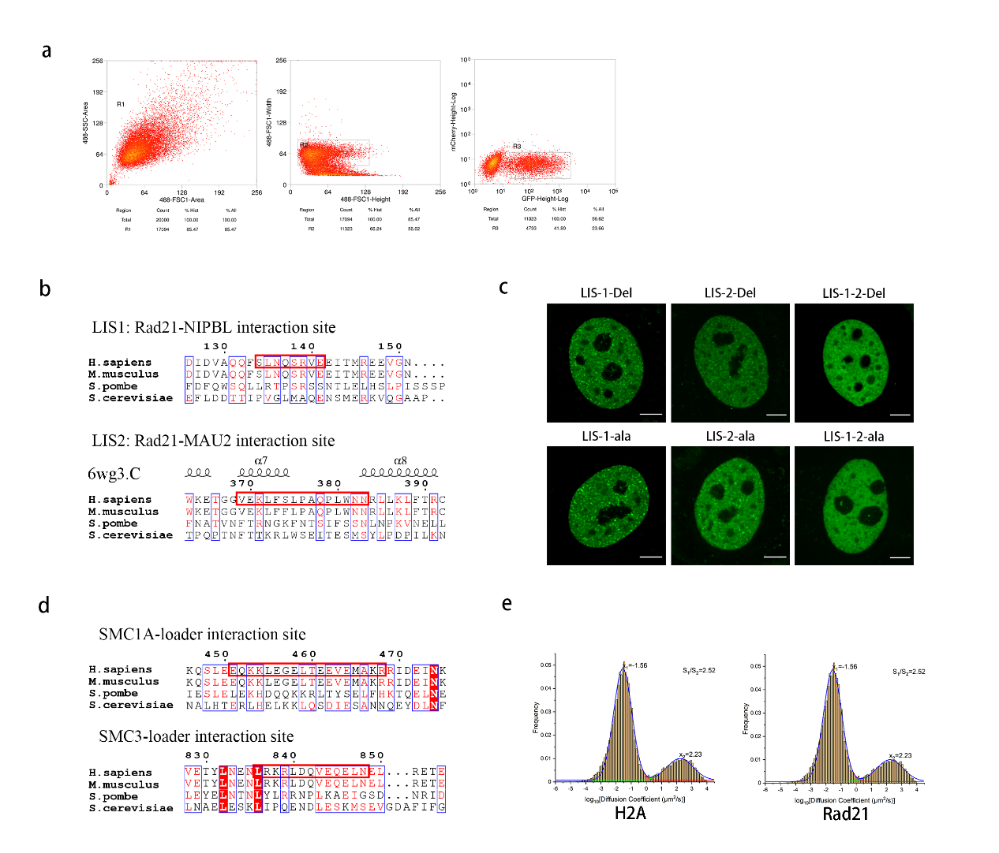
Fig. S2 Sorting of artificial Rad21 cells and identification of roles of cohesin subunits in cohesin loading process.
- The population of Rad21-GFP positive cells were sorted by FACS.
- Multiple sequence alignment of Rad21 Loader-Interaction-Site between human, mouse, fission yeast and budding yeast using ClutsterW. Red box represents conserved LIS1 and LIS2. Secondary structure elements are generated by structure data of human cohesin (6wg3.C).
- Example images of HeLa cells transfected with LIS-deletion or LIS-Ala-mutant Rad21 (scare bar is 5 μm).
- Multiple sequence alignment of SMC1A and SMC3 Loader-Interaction-Site between human, mouse, fission yeast and budding yeast using ClutsterW. Red box represents conserved LIS in SMC1A and SMC3.
- Example histogram showing distribution of log₁₀(diffusion coefficient) of single molecule motion and Gaussian fitting after tracking for 30000 frames (n>15 per condition).

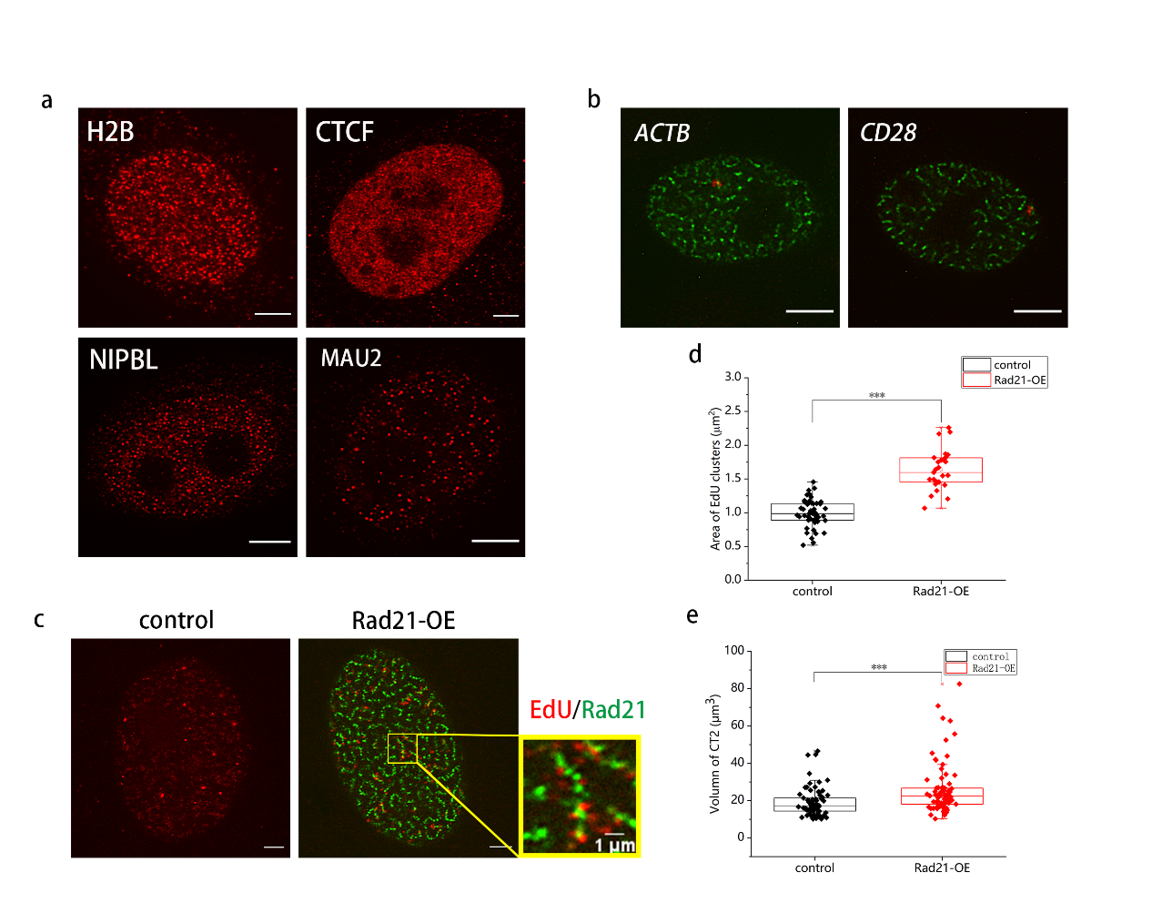
Fig. S3 Profile of vermicelli-like structures and chromatin domain after Rad21 up-regulation by super-resolution image.
- Still super-resolution image of endogenous H2B, CTCF, NIPBL and MAU2 labeled with antibody. Scare bar, 5 μm.
- Super-resolution images of ACTB and CD28 TADs after Rad21 over-expression labelled by in situ hybridization with DNA probes. Scare bar, 5 μm.
- Super-resolution images of HeLa in the absence or presence of Rad21-OE were labelled with Cy3-EdU. Scare bar, 5 µm. Boxed regions are shown as magnified inserts. Scare bar, 1 µm.
- Quantification of area change of EdU clusters after Rad21 over-expression. (n> 27 per condition). The lower quartile, median and upper quartile values were labelled in the box.
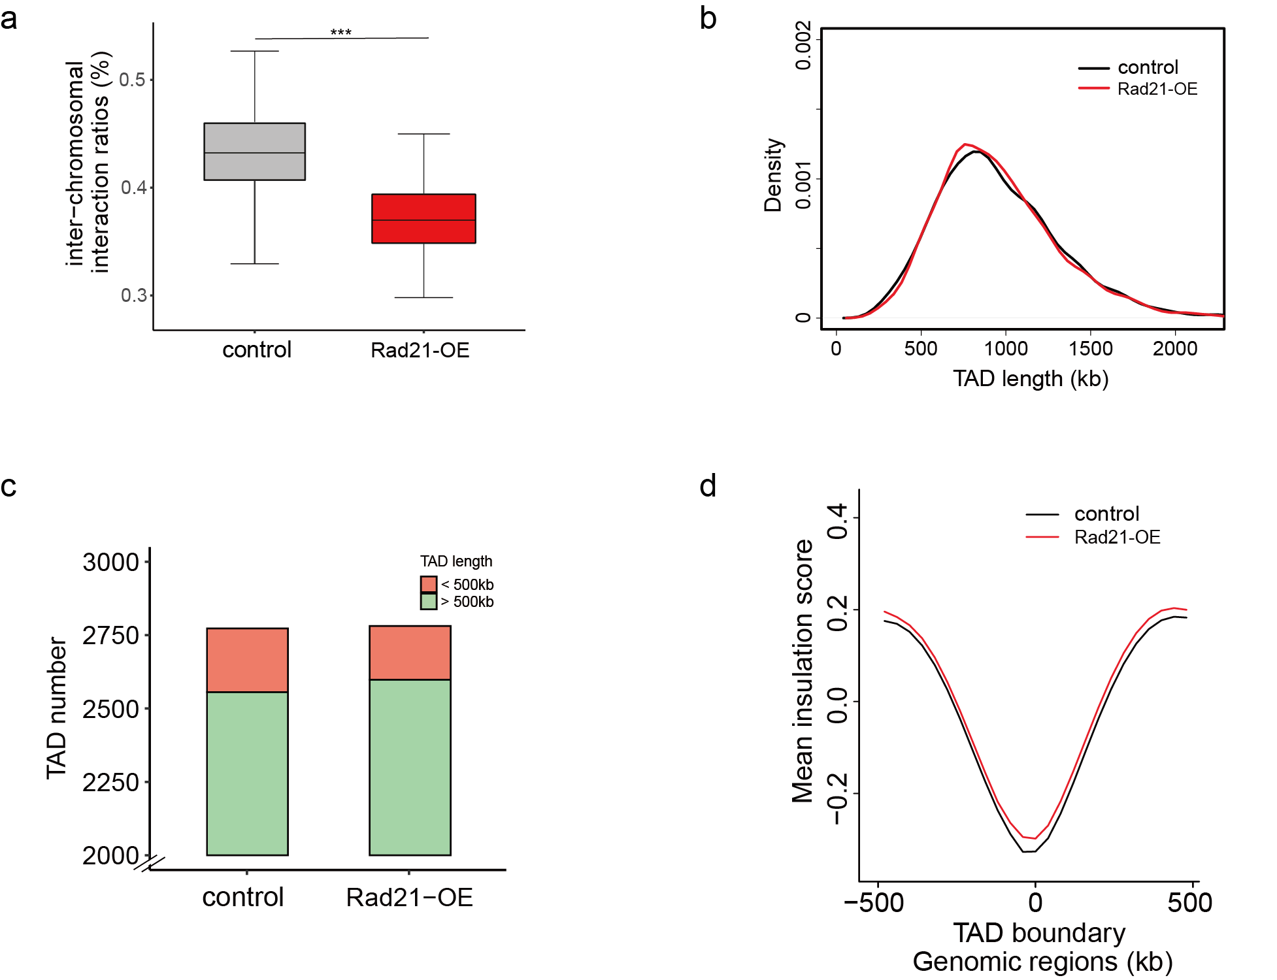
Fig. S4 Chromatin interaction reorganization and TAD changes upon Rad21 up-regulation.
- Trans-interaction ratios of each chromosome in control and Rad21-OE cells. For each chromosome, trans-interaction ratio is the percentage of trans-interaction in total interaction of this chromosome. (***P < 0.001, Wilcoxon test.)
- Distribution of TAD length in control and Rad21-OE cells.
- The number of short (< 500kb) and long (> 500 kb) TADs.
- Average insulation score distribution around TAD boundaries (±500 kb) in control and Rad21-OE cells.
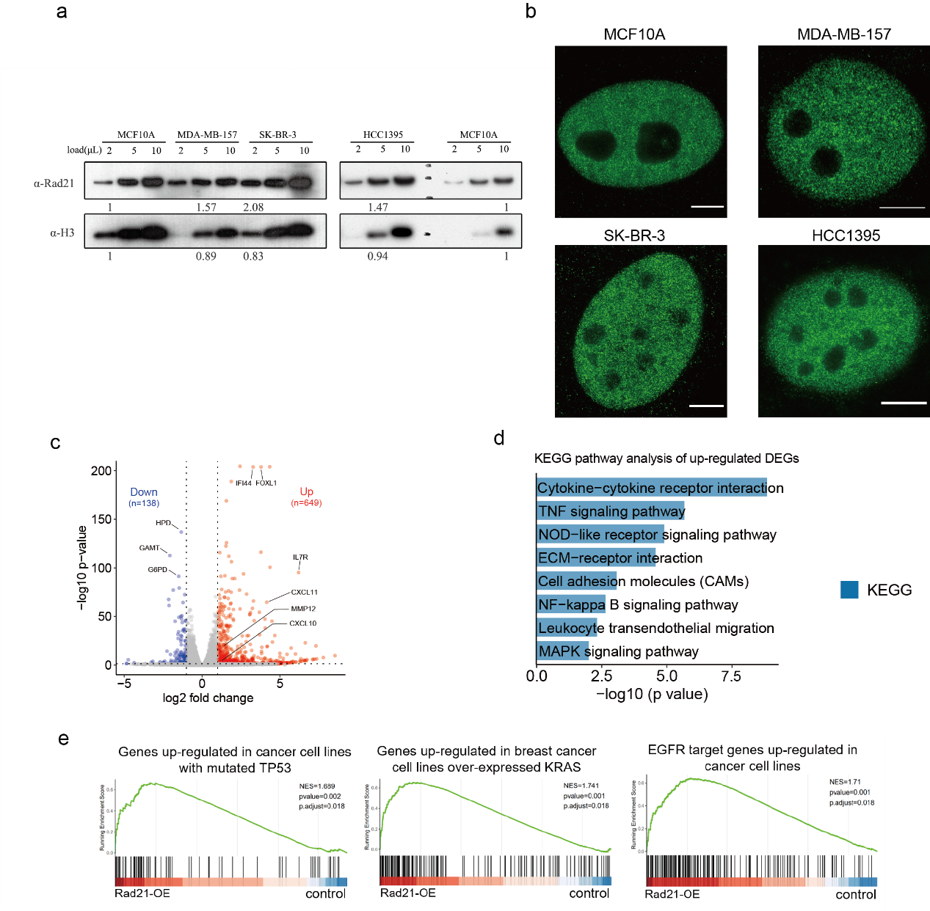
Fig. S5 Aggregated Rad21 in breast cancer cell lines and enrichment of cancer-related gene set upon Rad21 up-regulation.
- Immunoblot against endogenous Rad21 and H3 in MCF10A, MDA-MB-157, SK-BR-3 and HCC1395 cells.
- Example STED images of MCF10A, MDA-MB-157, SK-BR-3 and HCC1395 cells labelled with Rad21 antibodies. Scare bar, 5 μm.
- Volcano plot showing genes expression level change between control and Rad21-OE cells. The red and blue dots denote up- and down-regulated genes upon Rad21 up-regulation respectively.
- KEGG pathways enriched (false discovery rate (FDR) q < 0.05) in up-regulated genes of Rad21-OE cells. (DEGs, differentially expressed genes)
- GSEA showing the enrichment of several gene sets associated with basal-like breast cancer (Using oncogenic signature gene sets of the MSigDB).

