Supplementary material

Evidence of microbial and metabolic convergence during lactate-oriented acidogenic fermentation of heterogeneous household food waste
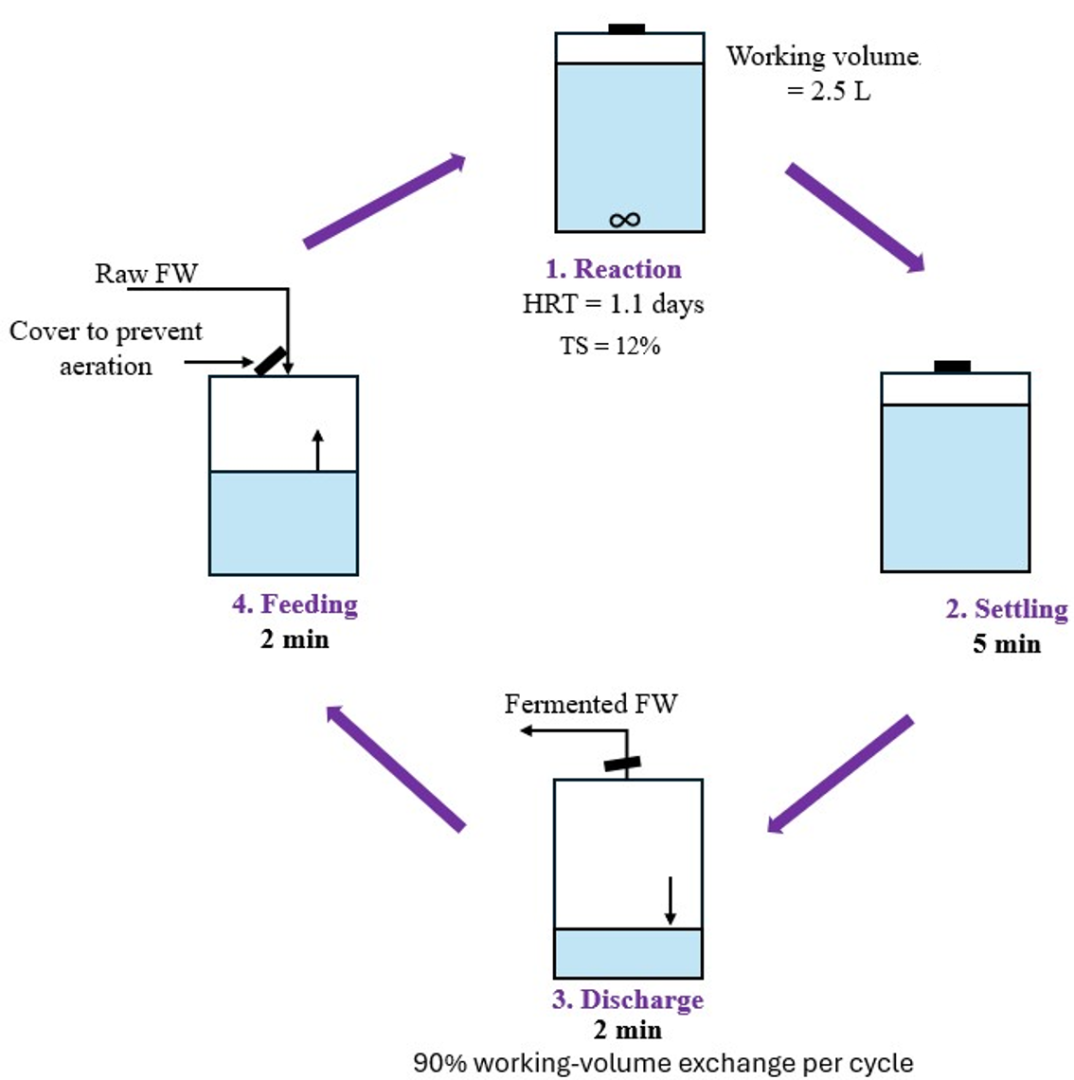

Figure S1. Schematic representation of one complete sequential operational cycle in the anaerobic reactor, including feeding, reaction, settling, and discharge. After discharge, the reactor was refilled with fresh substrate to restore the working volume and start the next cycle. A 90% working-volume exchange was performed in each cycle while maintaining the reactor closed to prevent aeration.

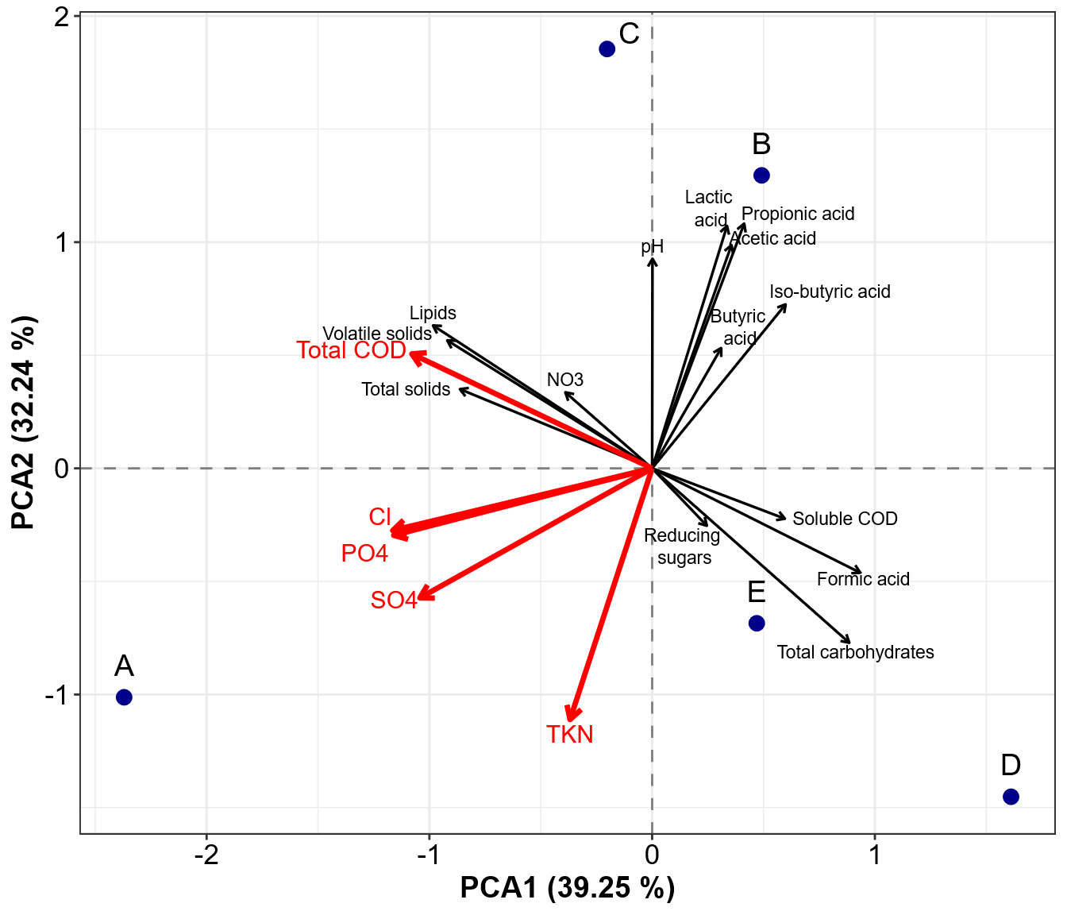
Figure S2. Principal component analysis (PCA) of the five household food waste (FW) batches based on their physicochemical composition. Blue points represent the individual FW batches (A-E), and red vectors highlight the variables with the strongest contribution to sample separation. PCA1 and PCA2 explained 39.25% and 32.24% of the total variance, respectively. Because the plot contains five batch centroids, it is used descriptively and no inferential PERMANOVA claim is made.
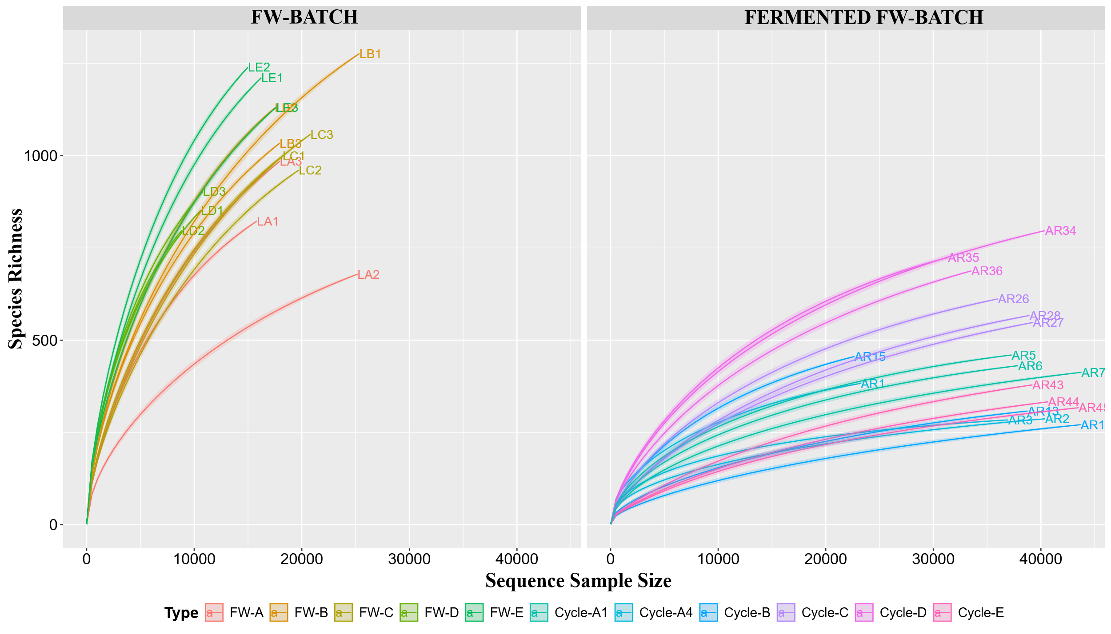
Figure S3. Rarefaction curves of amplicon sequence variants (ASVs) for raw household food waste samples (FW-BATCH, left panel) and fermented household food waste samples (FERMENTED FW-BATCH, right panel). Curves show the relationship between sequencing depth and observed species richness for each sample.

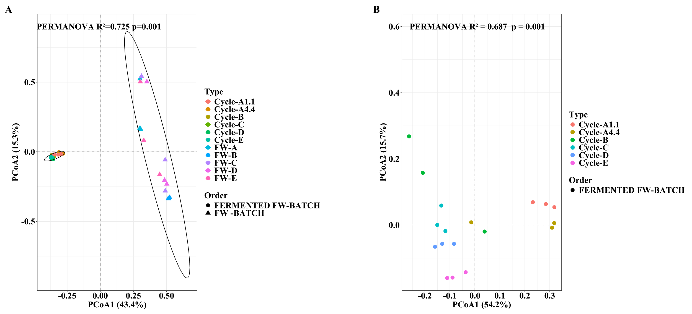
Figure S4. Principal coordinates analysis (PCoA) of microbial communities based on Bray-Curtis distances derived from ASV abundances. Panel (A) shows the ordination of raw FW batches and fermented FW batches together, highlighting the separation between incoming feedstocks and post-fermentation communities. Panel (B) shows only the fermented FW batches to visualize differences among operational conditions in greater detail. Colors indicate sample type, and symbols in panel (A) distinguish raw FW batches from fermented FW batches. PERMANOVA indicated significant differences in community structure in both ordinations; panel B retained condition-specific structure among fermented samples (R2 = 0.687, p = 0.001), thus, the result is interpreted as reduced diversity and partial compositional similarity rather than an identical taxonomic endpoint.
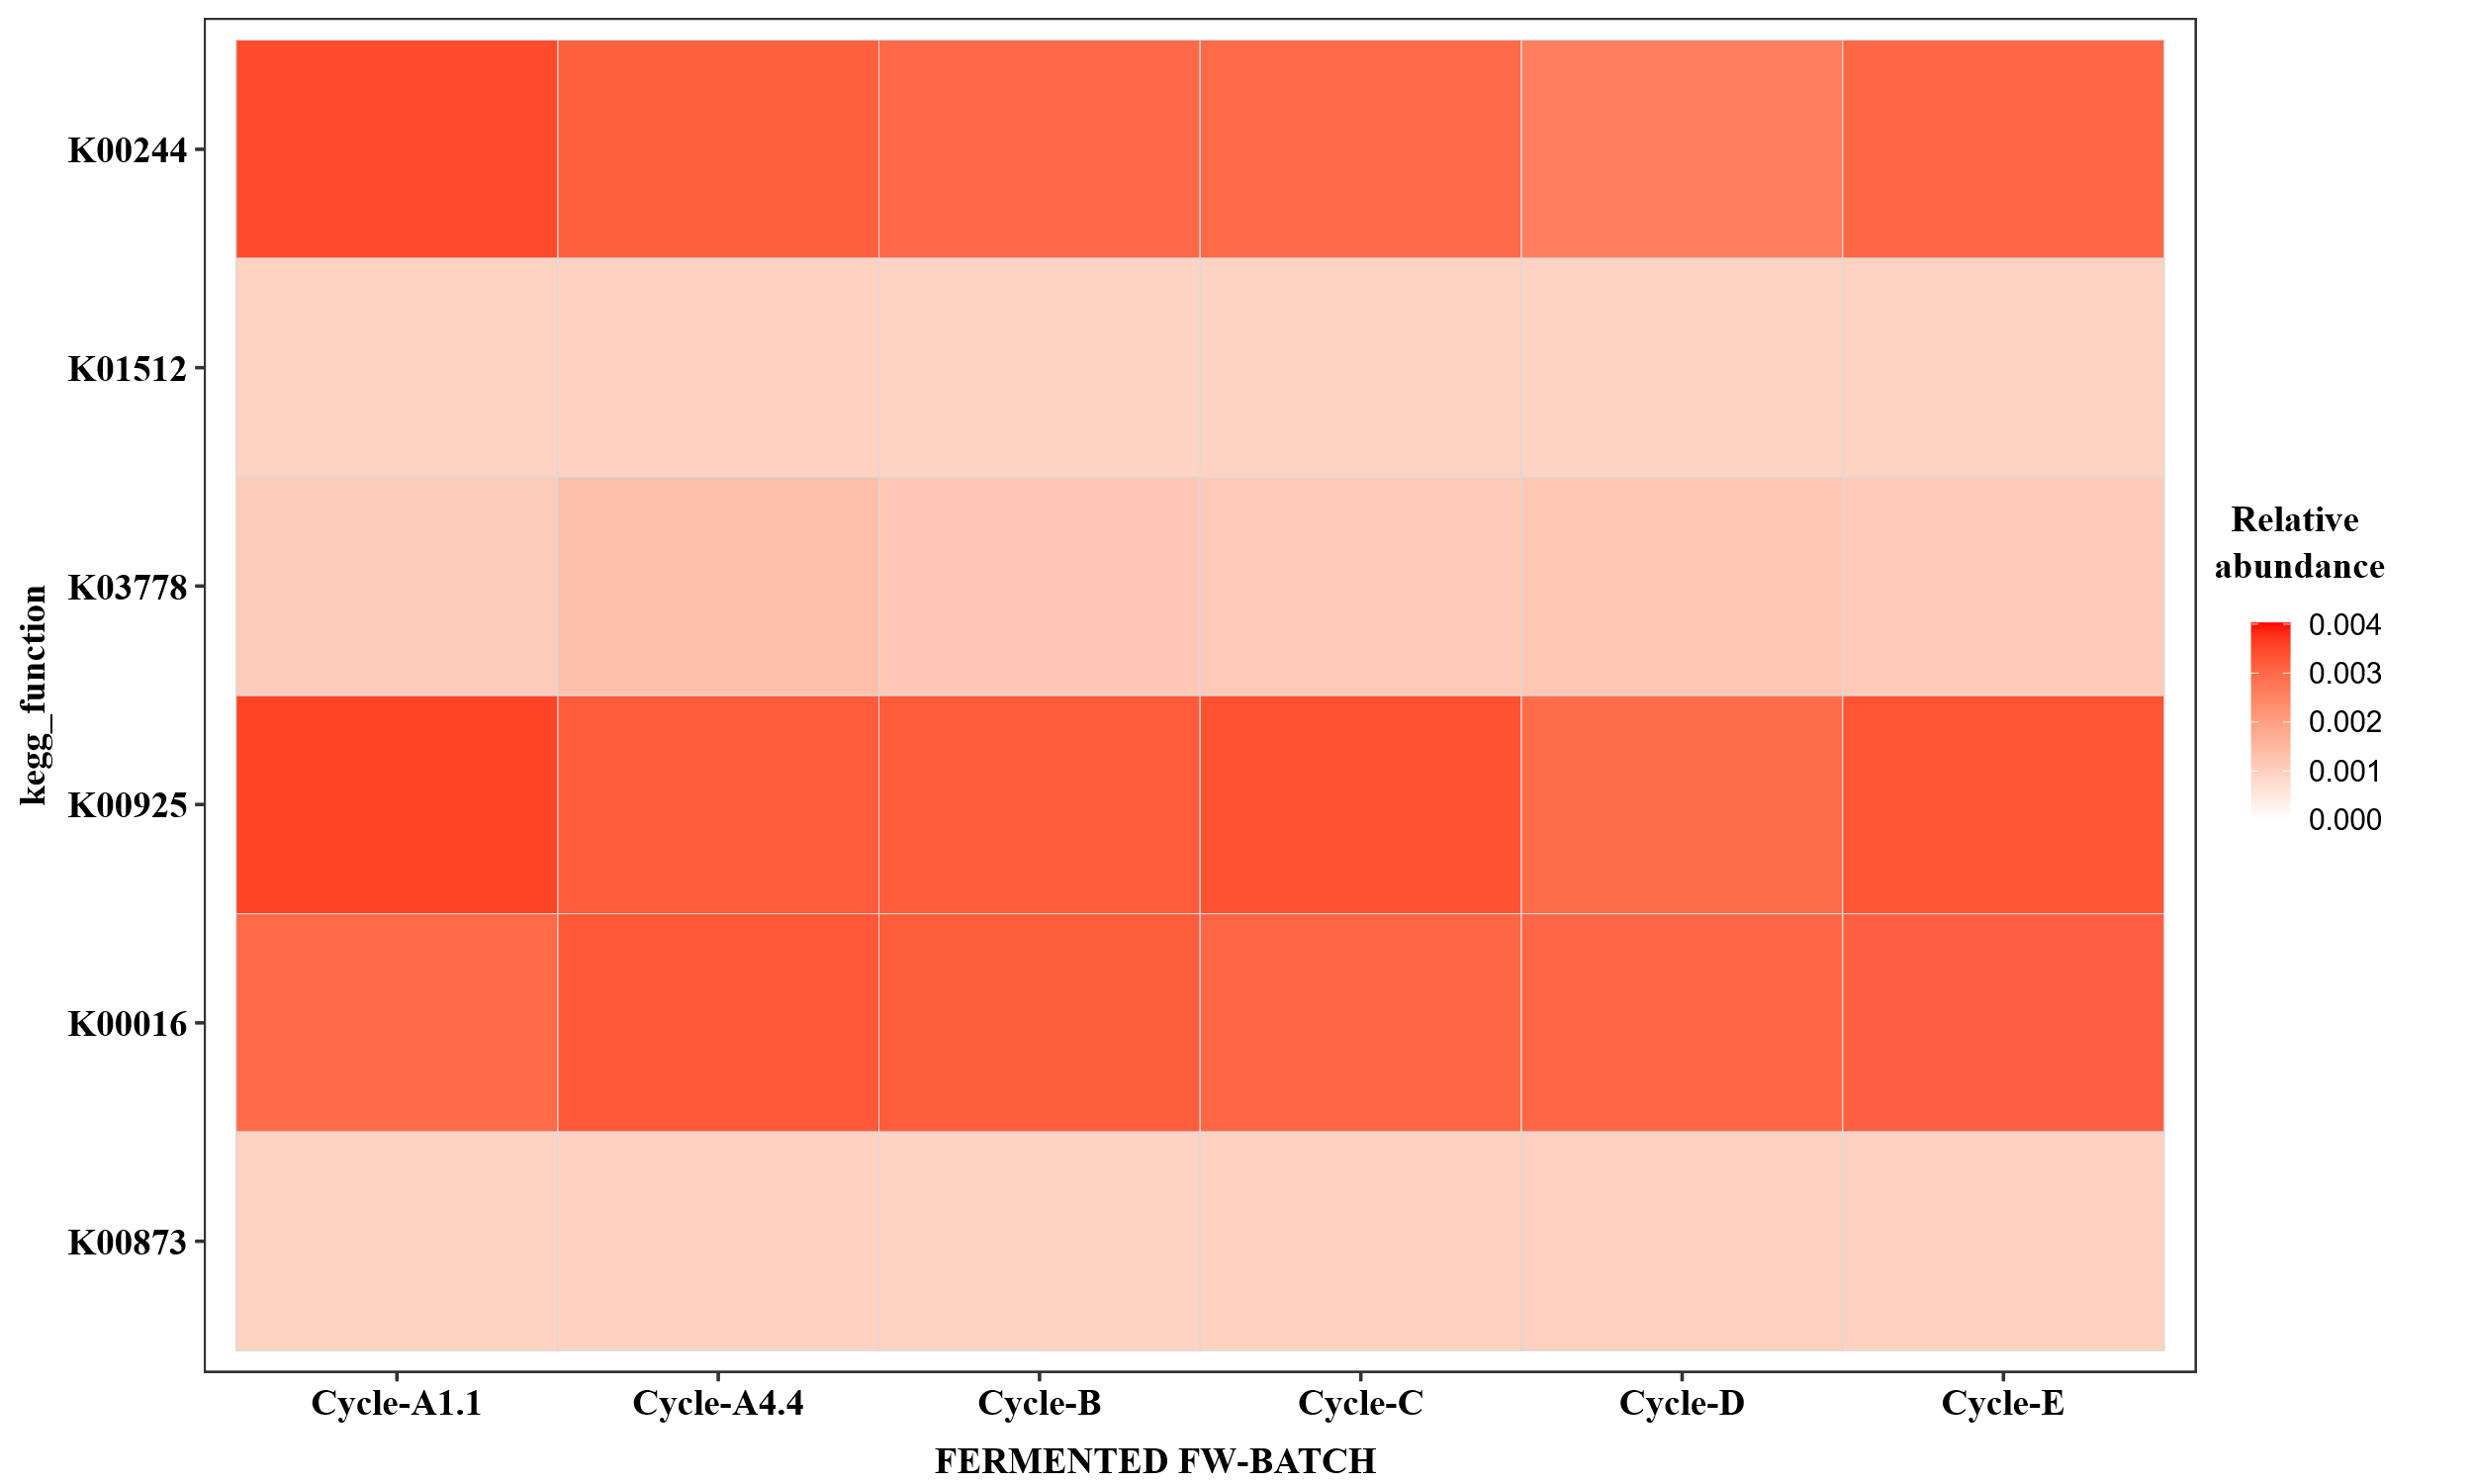
Figure S5. Relative abundance heatmap of selected KEGG orthologs predicted by PICRUSt2 across fermented FW samples under the different operational conditions (Cycle-A1.1, Cycle-A4.4, Cycle-B, Cycle-C, Cycle-D, and Cycle-E). Color intensity indicates the relative abundance of each predicted ortholog, including the core lactate-associated orthologs K00873 and K00016 discussed in Section 3.4. These 16S-based predictions describe functional potential and do not establish pathway activity, enzyme activity, flux, or lactate stereoisomer composition.

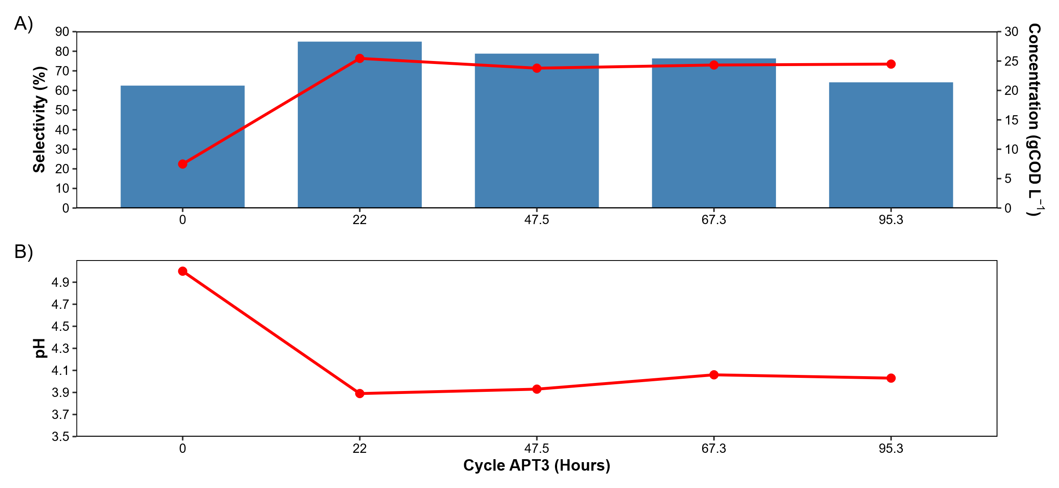
Figure S6. Time course of lactic acid selectivity, lactic acid concentration, and pH during the representative APT3 cycle operated with FW-A at an HRT of 4.4 d. (A) Lactic acid selectivity (blue bars; left y-axis) and lactic acid concentration expressed as COD equivalents (g COD/L; red line; right y-axis). (B) pH evolution during the same cycle. With 90% of the working volume exchanged per cycle, this operating regime corresponded to an HRT of approximately 4.4 d.

Table S1. Operational conditions and performance parameters of the sequential batch acidogenic reactor during each experimental period (I-V) using different FW batches.
 | Period
 | ¹I | II | III | IV | V
FW-batch | FW-A | FW-B | FW-C | FW-D | FW-E
Days of operation | 0-16; 16-21 | 21-29 | 29-42 | 42-50 | 50-59
Cycles | 4; 5 | 8 | 13 | 8 | 9
HRT (days) | 4.4; 1.1 | 1.1 | 1.1 | 1.1 | 1.1
OLR (g VS/L-d) | 23.32; 93.29 | 95.51 | 94.40 | 101.63 | 97.61
TS (%) | 12; 12 | 12 | 12 | 12 | 12
Initial pH | 5.17 ± 0.22; 5.05 ± 0.07 | 4.85 ± 0.2 | 4.61 ± 0.13 | 4.07 ± 0.10 | 4.38 ± 0.15
Final pH | 4.19 ± 0.11; 3.97 ± 0.08 | 3.82 ± 0.04 | 3.80 ± 0.07 | 3.44 ± 0.07 | 3.56 ± 0.11
¹Period I comprised two consecutive operational phases with FW-A: days 0-16 at HRT 4.4 d and days 16-21 at HRT 1.1 d.

Table S2. Identification of the raw and fermented household food waste (FW) samples included in the microbial community analysis and deposited in the NCBI Sequence Read Archive under BioProject accession number PRJNA1372389. The table indicates the sample ID, sample type, and corresponding FW-batch or representative operational cycle.
Sample ID | Sample type | FW-batch/Cycle | Biosample
LA1 | Raw FW-batch | A | SAMN53540071
LA2 | Raw FW-batch | A | SAMN53540072
LA3 | Raw FW-batch | A | SAMN53540073
LB1 | Raw FW-batch | B | SAMN53540074
LB2 | Raw FW-batch | B | SAMN53540075
LB3 | Raw FW-batch | B | SAMN53540076
LC1 | Raw FW-batch | C | SAMN53540077
LC2 | Raw FW-batch | C | SAMN53540078
LC3 | Raw FW-batch | C | SAMN53540079
LD1 | Raw FW-batch | D | SAMN53540080
LD2 | Raw FW-batch | D | SAMN53540081
LD3 | Raw FW-batch | D | SAMN53540082
LE1 | Raw FW-batch | E | SAMN53540083
LE2 | Raw FW-batch | E | SAMN53540084
LE3 | Raw FW-batch | E | SAMN53540085
AR1 | Fermented FW-batch | ¹A4.4-0 | SAMN53540086
AR2 | Fermented FW-batch | ¹A4.4-1 | SAMN53540087
AR3 | Fermented FW-batch | ¹A4.4-2 | SAMN53540088
AR5 | Fermented FW-batch | ²A1.1-6 | SAMN53540089
AR6 | Fermented FW-batch | ²A1.1-7 | SAMN53540090
AR7 | Fermented FW-batch | ²A1.1-8 | SAMN53540091
AR13 | Fermented FW-batch | B-14 | SAMN53540092
AR14 | Fermented FW-batch | B-15 | SAMN53540093
AR15 | Fermented FW-batch | B-16 | SAMN53540094
AR26 | Fermented FW-batch | C-27 | SAMN53540095
AR27 | Fermented FW-batch | C-28 | SAMN53540096
AR28 | Fermented FW-batch | C-29 | SAMN53540097
AR34 | Fermented FW-batch | D-35 | SAMN53540098
AR35 | Fermented FW-batch | D-36 | SAMN53540099
AR36 | Fermented FW-batch | D-37 | SAMN53540100
AR43 | Fermented FW-batch | E-44 | SAMN53540101
AR44 | Fermented FW-batch | E-45 | SAMN53540102
AR45 | Fermented FW-batch | E-46 | SAMN53540103
¹A4.4: refers to fermented cycles operated at a hydraulic retention time (HRT) of 4.4 days; ²A1.1: refers to fermented cycles operated at a HRT of 1.1 days.
Table S3. Organic acid profiles and process performance indicators at the beginning and end of the fermentation cycles for the different household food waste (FW) batches evaluated under the corresponding HRT conditions.
Parameters | FW - A |  |  |  | FW - B |  | FW - C |  | FW - D |  | FW - E
Parameters | HRT 4.4 days |  | HRT 1.1 days |  | HRT 1.1 days |  | HRT 1.1 days |  | HRT 1.1 days |  | HRT 1.1 days
Parameters | Initial | Final | Initial | Final | Initial | Final | Initial | Final | Initial | Final | Initial | Final
Lactic acid (g/L) | 8.17 ± 2.12 | 23.26 ± 1.83 | 7.93 ± 1.06 | 29.25 ± 2.04 | 6.18 ± 2.88 | 25.15 ± 2.88 | 7.51 ± 0.78 | 24.62 ± 2.68 | 4.36 ± 1.15 | 17.58 ± 0.93 | 5.82 ± 1.61 | 24.22 ± 4.57
Selectivity (%) | 60.11 ± 3.97 | 61.8 ± 5.08 | 56.10 ± 3.78 | 88.02 ± 1.39 | 49.99 ± 3.33 | 77.162 ± 5.37 | 52.36 ± 2.65 | 82.57 ± 3.34 | 57.27 ± 4.60 | 69.96 ± 1.57 | 58.94 ± 4.36 | 82.97 ± 3.59
Formic acid (g/L) | 0.31 ± 0.28 | 0.34 ± 0.49 | 0.44 ± 0.23 | 0.08 ± 0.02 | 0.50 ± 0.31 | 0.32 ± 0.78 | 0.40 ± 0.05 | 0.07 ± 0.01 | 0.40 ± 0.07 | 0.91 ± 0.09 | 0.32 ± 0.11 | 0.31 ± 0.27
Selectivity (%) | 0.75 ± 0.64 | 0.40 ± 0.33 | 1.056 ± 0.55 | 0.08 ± 0.014 | 1.13 ± 0.65 | 0.36 ± 0.47 | 0.92 ± 0.09 | 0.08 ± 0.01 | 1.79 ± 0.26 | 1.19 ± 0.18 | 1.092 ± 0.38 | 0.37 ± 0.33
Acetic acid (g/L) | 2.71± 0.91 | 5.64 ± 1.80 | 2.25 ± 0.65 | 2.77 ± 0.43 | 2.10 ± 0.75 | 4.78 ± 0.75 | 2.46 ± 0.32 | 3.86 ± 0.34 | 1.20 ± 0.44 | 4.85 ± 0.42 | 1.09 ± 0.25 | 3.44 ± 0.65
Selectivity (%) | 19.47 ± 1.07 | 17.41 ± 4.02 | 15.74 ± 3.82 | 8.32 ± 1.54 | 13.59 ± 1.54 | 15.14 ± 2.66 | 17.03 ± 1.72 | 12.93 ± 1.02 | 15.46 ± 1.69 | 19.20 ± 2.54 | 11.14 ± 1.27 | 11.76 ± 1.82
Propionic acid (g/L) | 1.18 ± 0.22 | 0.240 ± 0.10 | 2.00 ± 0.91 | 0.29 ± 0.03 | 2.49 ± 0.98 | 0.22 ± 0.98 | 2.25 ± 0.19 | 0.34 ± 0.56 | 0.81 ± 0.21 | 0.08 ± 0.19 | 1.48 ± 0.25 | 0.32 ± 0.25
Selectivity (%) | 14.31 ± 1.33 | 1.98 ± 1.47 | 20.22 ± 6.75 | 1.23 ± 0.173 | 29.12 ± 1.54 | 1.07 ± 0.58 | 22.34 ± 1.61 | 1.57 ± 2.59 | 15.62 ± 2.59 | 0.44 ± 0.97 | 21.66 ± 2.64 | 1.76 ± 1.72
Butyric acid (g/L) | 0.13 ± 0.21 | 1.09 ± 0.74 | 0.13 ± 0.16 | 0.07 ± 0.05 | 0.27 ± 0.22 | 0.21 ± 0.22 | 0.04 ± 0.08 | 0.04 ± 0.04 | 0.12 ± 0.00 | 0.15 ± 0.07 | 0.05 ± 0.05 | 0.05 ± 0.09
Iso-butyric acid (g/L) | 0.30 ± 0.39 | 0.87 ± 0.80 | 0.43 ± 0.30 | 0.38 ± 0.22 | 0.19 ± 0.15 | 0.48 ± 0.15 | 0.58 ± 0.11 | 0.19 ± 0.11 | 0.31 ± 0.10 | 0.26 ± 0.25 | 0.23 ± 0.14 | 0.07 ± 0.03
Isovaleric acid (g/L) | 0.00 | 0.00 | 0.00 | 0.00 | 0.00 | 0.06 ± 0.01 | 0.00 | 0.00 | 0.00 | 0.00 | 0.00 | 0.00
Valeric acid (g/L) | 0.01 ± 0.01 | 0.40 ± 0.27 | 0.00 | 0.00 | 0.00 | 0.39 ± 0.01 | 0.00 | 0.14 ± 0.16 | 0.00 | 0.82 ± 0.25 | 0.00 | 0.23 ± 0.39
Hexanoic acid (g/L) | 0.00 | 0.40 ± 0.24 | 0.00 | 0.00 | 0.00 | 0.01 | 0.00 | 0.00 | 0.00 | 0.00 | 0.00 | 0.17 ± 0.22
Total COD (g/L) | 139.18±18.60 | 103.01 ± 7.75 | 165.21 ± 11.30 | 135.62 ± 13.96 | 128.95 ± 15.51 | 108.85 ± 9.91 | 235.89 ± 22.63 | 160.82 ± 24.03 | 155.25 ± 20.83 | 133.69 ± 11.44 | 193.80 ± 26.46 | 160.00 ± 13.95
Apparent decrease in measured total COD (%) | 25.98 ± 18.6 |  | 17.91 ± 6.92 |  | 15.58 ± 2.86 |  | 31.82 ± 14.45 |  | 13.88 ± 5.57 |  | 17.44 ± 6.28
Soluble COD (g/L) | 60.50 ± 4.19 | 56.29 ± 12.06 | 66.93 ± 3.69 | 62.22 ± 1.58 | 65.86 ± 1.80 | 62.95 ± 1.80 | 61.50 ± 9.94 | 57.01 ± 2.44 | 76.10± 4.75 | 54.73 ± 11.53 | 66.17 ± 4.59 | 61.96 ± 7.65
Apparent decrease in measured soluble COD (%) | 6.94 ± 3.10 |  | 6.76 ± 6.91 |  | 4.43 ± 2.57 |  | 7.30 ± 2.87 |  | 28.08 ± 7.11 |  | 6.36 ± 2.90
Total carbohydrates (g/L) | 48.95 ± 1.16 | 33.37 ± 1.82 | 57.66 ± 5.28 | 37.77 ± 13.35 | 81.85 ± 8.50 | 38.74 ± 3.60 | 73.47 ± 1.62 | 41.08± 5.39 | 83.72 ± 5.40 | 38.34 ± 15.11 | 90.59 ± 9.71 | 56.02 ± 9.81
Removal of total carbohydrates (%) | 31.15 ± 3.54 |  | 35.65 ± 13.21 |  | 52.00 ± 8.38 |  | 44.77 ± 12.75 |  | 53.88 ± 11.66 |  | 38.21 ± 5.06
Reducing sugars (g/L) | 33.28 ± 2.49 | 12.69 ± 1.81 | 30.44 ± 7.27 | 11.62 ± 2.36 | 52.32 ± 5.06 | 14.22 ± 5.06 | 22.83 ± 3.74 | 6.54 ± 1.87 | 34.47 ± 8.54 | 18.90 ± 6.11 | 27.53 ± 6.93 | 11.54 ± 2.63
Removal of reducing sugars (%) | 61.77 ± 5.55 |  | 61.58 ± 2.35 |  | 72.59 ± 4.12 |  | 70.64 ± 9.91 |  | 45.89 ± 7.93 |  | 57.22 ± 8.59
Acidification degree (%) | 61.84 ± 3.39 |  | 55.76 ± 1.71 |  | 55.85 ± 3.21 |  | 55.85 ± 8.91 |  | 51.63 ± 13.48 |  | 52.60 ± 8.59
Hydrolysis rate (%) | 40.62 ±7.75 |  | 25.49 ± 7.75 |  | 27.22± 15.43 |  | 40.47 ± 11.00 |  | 0.23 ± 0.01 |  | 23.18 ± 6.76

Table S4. Variability of lactic acid fermentation performance across household food waste (FW) batches, expressed as mean values and coefficients of variation (CV).
FW batch | HRT (days) | Lactic acid (g/L) | CV (%) | Selectivity (%) | CV (%) | ¹Yield (g lactic acid/g VS) | CV (%) | ²Yield (g lactic acid/g VS) | CV (%) | Productivity (g lactic acid/L-h) | CV (%)
A | 4.4 | 23.26 ± 1.83 | 7.9 | 61.80 ± 5.08 | 8.2 | 0.25 ± 0.02 | 7.8 | 0.16 ± 0.01 | 5.6 | 0.143 ± 0.008 | 5.6
A | 1.1 | 29.25 ± 2.04 | 7.0 | 88.02 ± 1.39 | 1.6 | 0.31 ± 0.02 | 7.0 | 0.23 ± 0.02 | 9.6 | 0.808 ± 0.078 | 9.6
B | 1.1 | 24.64 ± 1.08 | 4.4 | 77.16 ± 5.37 | 7.0 | 0.26 ± 0.01 | 4.4 | 0.18 ± 0.03 | 15.6 | 0.670 ± 0.104 | 15.6
C | 1.1 | 24.62 ± 2.68 | 10.9 | 82.57 ± 3.34 | 4.0 | 0.26 ± 0.03 | 10.9 | 0.18 ± 0.03 | 15.0 | 0.648 ± 0.097 | 15.0
D | 1.1 | 17.58 ± 0.93 | 5.3 | 69.96 ± 1.56 | 2.2 | 0.16 ± 0.01 | 5.3 | 0.12 ± 0.01 | 7.1 | 0.501 ± 0.036 | 7.1
E | 1.1 | 25.68 ± 1.40 | 5.5 | 83.10 ± 3.55 | 4.3 | 0.24 ± 0.01 | 5.5 | 0.18 ± 0.02 | 12.0 | 0.748 ± 0.090 | 12.0
FW-A at HRT 4.4 d was included as a reference condition to illustrate the effect of HRT reduction on lactate-oriented fermentation performance. Sample sizes were: FW-A at HRT 4.4 d (n = 4), FW-A at HRT 1.1 d (n = 5), FW-B (n = 8; cycle 9 excluded), FW-C (n = 13), FW-D (n = 8), and FW-E (n = 8; cycle 38 excluded). Productivity was calculated using all available cycles for each substrate. ¹ Yields calculated from the final lactic acid concentration. ² Yields calculated from the net increase in lactic acid concentration.

Table S5. Kruskal-Wallis test statistics for selected physicochemical and fermentation parameters among fermented household food waste (FW) batches.
Parameter | H | df | P_value | ¹Significance
pH | 32.88 | 4 | 1.26×10-7 | ****
Reducingsugars | 30.73 | 4 | 3.53×10-4 | ****
Totalcarbohydrates | 12.05 | 4 | 0.02 | *
Lactic | 23.77 | 4 | 8.88×10-5 | ****
Formic | 25.79 | 4 | 3.48×10-6 | ****
Acetic | 28.01 | 4 | 1.24×10-6 | ****
Propionic | 10.64 | 4 | 0.03 | *
Selectivity_Lactic | 28.15 | 4 | 1.16×10-5 | ****
¹Significance levels are indicated as **** (p < 0.0001), *** (p < 0.001), ** (p < 0.01), and * (p < 0.05).

Table S6. Pairwise comparisons among fermented household food waste (FW) batches based on Dunn’s post hoc test for selected physicochemical and fermentation parameters.
Parameter | Reference Group | Comparison group | Z statistic | p-value | Adjusted p-value | Significance
pH | A1.1 | B | -1.52 | 0.13 | 1.00 | ns
pH | A1.1 | C | -1.73 | 0.08 | 0.84 | ns
pH | A1.1 | D | -4.68 | 0.00 | 0.00 | ****
pH | A1.1 | E | -3.82 | 0.00 | 0.00 | **
pH | B | C | -0.10 | 0.92 | 1.00 | ns
pH | B | D | -3.61 | 0.00 | 0.00 | **
pH | B | E | -2.60 | 0.01 | 0.09 | ns
pH | C | D | -3.91 | 0.00 | 0.00 | ***
pH | C | E | -2.82 | 0.00 | 0.05 | *
pH | D | E | 1.11 | 0.27 | 1.00 | ns
Reducingsugars | A1.1 | B | 0.24 | 0.81 | 1.00 | ns
Reducingsugars | A1.1 | C | -3.04 | 0.00 | 0.02 | *
Reducingsugars | A1.1 | D | 1.06 | 0.29 | 1.00 | ns
Reducingsugars | A1.1 | E | -1.41 | 0.16 | 1.00 | ns
Reducingsugars | B | C | -3.87 | 0.00 | 0.00 | **
Reducingsugars | B | D | 0.94 | 0.35 | 1.00 | ns
Reducingsugars | B | E | -1.90 | 0.06 | 0.58 | ns
Reducingsugars | C | D | 4.91 | 0.00 | 0.00 | ****
Reducingsugars | C | E | 1.88 | 0.06 | 0.60 | ns
Reducingsugars | D | E | -2.86 | 0.00 | 0.04 | *
Totalcarbohydrates | A1.1 | B | -0.07 | 0.94 | 1.00 | ns
Totalcarbohydrates | A1.1 | C | -0.11 | 0.91 | 1.00 | ns
Totalcarbohydrates | A1.1 | D | 1.28 | 0.20 | 1.00 | ns
Totalcarbohydrates | A1.1 | E | 2.20 | 0.03 | 0.28 | ns
Totalcarbohydrates | B | C | -0.04 | 0.97 | 1.00 | ns
Totalcarbohydrates | B | D | 1.54 | 0.12 | 1.00 | ns
Totalcarbohydrates | B | E | 2.61 | 0.01 | 0.09 | ns
Totalcarbohydrates | C | D | 1.76 | 0.08 | 0.79 | ns
Totalcarbohydrates | C | E | 2.96 | 0.00 | 0.03 | *
Totalcarbohydrates | D | E | 1.02 | 0.31 | 1.00 | ns
Lactic acid | A1.1 | B | -2.01 | 0.04 | 0.45 | ns
Lactic acid | A1.1 | C | -2.56 | 0.01 | 0.10 | ns
Lactic acid | A1.1 | D | -4.68 | 0.00 | 0.00 | ****
Lactic acid | A1.1 | E | -2.03 | 0.04 | 0.42 | ns
Lactic acid | B | C | -0.45 | 0.65 | 1.00 | ns
Lactic acid | B | D | -3.05 | 0.00 | 0.02 | *
Lactic acid | B | E | 0.03 | 0.98 | 1.00 | ns
Lactic acid | C | D | -2.94 | 0.00 | 0.03 | *
Lactic acid | C | E | 0.50 | 0.62 | 1.00 | ns
Lactic acid | D | E | 3.16 | 0.00 | 0.02 | *
Formic acid | A1.1 | B | -0.15 | 0.88 | 1.00 | ns
Formic acid | A1.1 | C | -0.79 | 0.43 | 1.00 | ns
Formic acid | A1.1 | D | 2.88 | 0.00 | 0.04 | *
Formic acid | A1.1 | E | 1.60 | 0.11 | 1.00 | ns
Formic acid | B | C | -0.73 | 0.47 | 1.00 | ns
Formic acid | B | D | 3.46 | 0.00 | 0.01 | **
Formic acid | B | E | 2.01 | 0.04 | 0.44 | ns
Formic acid | C | D | 4.58 | 0.00 | 0.00 | ****
Formic acid | C | E | 3.01 | 0.00 | 0.03 | *
Formic acid | D | E | -1.55 | 0.12 | 1.00 | ns
Acetic acid | A1.1 | B | 3.79 | 0.00 | 0.00 | **
Acetic acid | A1.1 | C | 2.44 | 0.01 | 0.14 | ns
Acetic acid | A1.1 | D | 4.16 | 0.00 | 0.00 | ***
Acetic acid | A1.1 | E | 1.05 | 0.30 | 1.00 | ns
Acetic acid | B | C | -1.94 | 0.05 | 0.52 | ns
Acetic acid | B | D | 0.42 | 0.68 | 1.00 | ns
Acetic acid | B | E | -3.24 | 0.00 | 0.01 | *
Acetic acid | C | D | 2.41 | 0.02 | 0.16 | ns
Acetic acid | C | E | -1.62 | 0.11 | 1.00 | ns
Acetic acid | D | E | -3.67 | 0.00 | 0.00 | **
Propionic acid | A1.1 | B | -0.46 | 0.64 | 1.00 | ns
Propionic acid | A1.1 | C | -1.49 | 0.14 | 1.00 | ns
Propionic acid | A1.1 | D | -2.38 | 0.02 | 0.17 | ns
Propionic acid | A1.1 | E | -0.03 | 0.97 | 1.00 | ns
Propionic acid | B | C | -1.15 | 0.25 | 1.00 | ns
Propionic acid | B | D | -2.19 | 0.03 | 0.28 | ns
Propionic acid | B | E | 0.50 | 0.62 | 1.00 | ns
Propionic acid | C | D | -1.29 | 0.20 | 1.00 | ns
Propionic acid | C | E | 1.76 | 0.08 | 0.79 | ns
Propionic acid | D | E | 2.76 | 0.01 | 0.06 | ns
Lactic acid selectivity | A1.1 | B | -3.30 | 0.00 | 0.01 | **
Lactic acid selectivity | A1.1 | C | -2.21 | 0.03 | 0.27 | ns
Lactic acid selectivity | A1.1 | D | -4.89 | 0.00 | 0.00 | ****
Lactic acid selectivity | A1.1 | E | -2.09 | 0.04 | 0.37 | ns
Lactic acid selectivity | B | C | 1.60 | 0.11 | 1.00 | ns
Lactic acid selectivity | B | D | -1.81 | 0.07 | 0.70 | ns
Lactic acid selectivity | B | E | 1.48 | 0.14 | 1.00 | ns
Lactic acid selectivity | C | D | -3.61 | 0.00 | 0.00 | **
Lactic acid selectivity | C | E | 0.00 | 1.00 | 1.00 | ns
Lactic acid selectivity | D | E | 3.34 | 0.00 | 0.01 | **
Sample sizes were: FW-A at HRT 4.4 d (n = 4), FW-A at HRT 1.1 d (n = 5), FW-B (n = 8; cycle 9 excluded), FW-C (n = 13), FW-D (n = 8), and FW-E (n = 8; cycle 38 excluded). Only batches operated at HRT 1.1 d were included in the pairwise comparisons to evaluate the effect of feedstock variability under a common operational condition. FW-A at HRT 4.4 days was therefore not included in this analysis. ¹Significance levels are indicated as **** (p < 0.0001), *** (p < 0.001), ** (p < 0.01), * (p < 0.05), and ns (not significant, p ≥ 0.05). Unequal sample sizes were considered when interpreting statistical power, and adjusted nonsignificant comparisons were not used to infer equivalence.

