Appendices
Appendix A. Lived Experience Commentary by the #StaffedWards Lived Experience Advisory Group
Katy Greenfield, Bavon, Dev D, Robyn Frances, Sophina M (The #StaffedWards Lived Experience Advisory Group)
This commentary has been written by people with lived experience of mental inpatient mental health wards, to reflect on the findings of the integrative review and highlight differences in understanding and focus between researchers and those with real-life exposure. It reflects the experiences of a small group and is not seeking to be the sole voice of all inpatients; recognising that others may have had different experiences on mental health inpatient wards.
‘Being safe isn’t just about avoiding violence.’: Safety as a concept.
The research in this review is primarily focused on safety in terms of incidents that are recordable, measurable and reportable, including aggression, violence, restrictive practices, medication errors, falls, absconding, self-harm and suicide. These measurable incidents are generally framed as occurring due to patient behaviours, be that aggression towards staff, or restrictive practices as a staff response. Few papers focus on incidents as experienced by patients.
We argue that there is a mismatch in our understanding of safety as a concept, and that which is being researched. While we acknowledge these types of incidents are harmful and important to understand, our experience of safety and harm is much broader and continuous rather than incident focussed and cannot be measured by numbers. A ward can feel unsafe and traumatic experiences can happen without any incident ever being recorded. Rather than safety being incident focussed, to us it is an everyday concern that ebbs and flows, with psychological and emotional safety often far more relevant than physical safety. This understanding of safety also misses the context in which the incident happens, thus misses the opportunity to really understand the way in which environments can be made safer in real terms.
Inpatient mental health wards are assumed to be a place of safety, and often this is described as the benefit of being there to someone in acute mental distress. Where this is the assumed starting position, the idea of safety will inevitably be around events that dismantle the ward as safe to start with. The assumption of an inpatient ward as a safe place is not one that is always shared by those with lived experience. Absconding was of particular interest in relation to this, as it is researched as an incident by researchers and policy makers. Our question was, what is it that patients are running from? Whilst we understand there are many reason’s people leave the ward, understanding those reasons are as important as the incident of absconding itself. This is something that has not been captured by the review.
How we view and understand safety impacts on subsequent research design and aim. Where safety is defined by incidents that are reportable and measurable, the scope of research is already framed within this context. Patients have little power to impact on what is reported as an incident or is harmful into a system where data might be drawn. How do we report feeling unsafe in an environment where those which we report to are those which impact on those feelings through illogical rule enforcement, lack of care or disinterest.
‘The most influential factor in feeling safe on a ward was how staff communicated with me.’: Characteristics of importance.
The review highlights the continued focus on the demographics of staff, including their experience or qualifications as demonstrated by volume of research, despite the mixed direction in findings. We recognise that enough regular, qualified and skilled staff has an impact on the way in which a shift will run, and there is empathy on a human level as to what it is like to work within an environment with limited resources, but the focus on staffing numbers appears to be borne from an assumption that more staff will equal better safety.
We know that staff are more than demographic characteristics. They are working in an environment and system that impacts on their work, as well as bringing their own human experiences on to the ward. We believe that how staff navigate their own identity and present themselves on the ward, impacts on their interactions with patients, influencing safety. The findings in this review consistently show that poor interactions with staff led to a greater number of incidents, although there are fewer research papers on these types of characteristics.
How we are treated by staff, either as a team or as individuals can alter our experience on wards. When we feel listened to, cared for and respected, it contributes to how safe we feel, our ability to trust staff and engage in care. Where communications are dismissive, inconsistent and disrespectful, it can result in people feeling anxious, becoming withdrawn and feeling unsafe.
This consistency in findings relating to interpersonal relationships therefore, resonate with our experience; communication and behaviour of staff is far more important than staff numbers.
Findings of note
The lack of research and consistent findings regarding ward round days was surprising and differed from our personal experience. Only one study included in the review looked at this and the research design could perhaps account for the unexpected result. We would be interested in further research which explored ward round days, which might explain or reflect lived experiences.
We also noted the small number of papers in relation to continuity of care, with six papers noting that temporary staffing had an impact on safety. In reality, familiar faces can make a big impact on how safe you feel, particularly during psychosis. The consistency in this small number of papers feels important and tangible for real change to safety on wards.
Strengths and limitations
Strengths
Although the majority of the research comes from the UK (followed by USA and Australia), there was a broad range of countries represented in the data, suggesting safety on mental health inpatient wards is a global concern, not confined to the NHS, but healthcare systems globally.
Whilst this review highlights the focus on safety as measured by the professionals (organisations and staff), it has allowed people with lived experience to join the conversation, through the PPIE work undertaken as part of the review and as well as this commentary.
Limitations
Safety is measured by reported incidents. People with lived experience would argue that this is a not a measure of safety, and that safety is a continuous and holistic issue. We would also argue that safety incidents are not a measure of harm. Harm is a separate issue which is not easy to measure but is a major concern to those with firsthand experience of mental health inpatient wards.
Research focuses on what can be measured such as staff numbers and personality questionnaires, but how does this impact the experience of those on inpatient wards. There is a lack of explanation for why these characteristics impact on safety, and how these findings can inform policy or practice. The lack of research on patient experience demonstrates this gap further.
For people with lived experience, some of the findings from descriptive studies also appear obvious. For example, burnout impacting on safety on wards and staff’s negative attitudes impacting patients. However, if they do not demonstrate why this is important, or a clear direction for change, it raises questions about research priorities.
The research is primarily UK focused and we have questioned whether this is because the NHS provide more opportunities for researchers to access this population. This bias sits uncomfortably with us as we know that inpatient settings are not homogenous, and we question why other countries are producing less research in this area. For example, is there a conflict of interest in doing this in in countries where healthcare is a business, and as such critical research may not be funded? We feel this misses potentially valuable data, where approaches in care may differ and offer other ideas and solutions to safety issues on wards. It also fails to capture any cultural differences within mental health care which may present different understanding of safety, incidents and ways of working.
What we would like to see next
We would be interested in further research which removes the assumption of mental health wards as inherently safe, shifting the concept of patient safety from measurable incidents to patient defined harm. We are particularly interested in psychological safety and what lasting trauma is caused by being in the ward environment. We believe that safety is a continuous concern which goes beyond reporting systems. We also believe concepts of safety need to include unmet need, particularly in relation to those with disabilities and physical illness which are not adequately addressed during an inpatient stay. There is an inherent imbalance of power within this system where the care provider defines what constitutes harm and chooses how it is measured.
As this review is part of a wider project, we hope that the findings, particularly those pertaining to under researched staff and team characteristics, will inform studies later in the project. We hope that the research team will be able to add to the currently small number of research papers which focus on characteristics beyond demographics. We are specifically interested in what happens before and after a traditionally recordable incident, to understand the timeline of a patients experience of a safety incident.
Finally, we would be interested to see further work which explores how different people experience safety. For example, looking at the experiences of people from different ethnic backgrounds, LGBTQI+ communities, people with disabilities, or those who experience repeat admissions, to ensure under-represented, diverse and unique experiences are not missed.

Appendix B. Online Supplementary Material
Table S1. PRISMA 2020 Checklist
Table S2. Mixed Methods Appraisal Tool (MMAT) Summary Table
Table S3. Study Characteristics Table
Table S4. Detailed Summary of Characteristics-Incident Relationship

Table S1. PRISMA 2020 Checklist
Section and Topic | Item # | Checklist item | Location where item is reported
TITLE
Title | 1 | Identify the report as a systematic review. | 1
ABSTRACT
Abstract | 2 | See the PRISMA 2020 for Abstracts checklist. | 2
INTRODUCTION
Rationale | 3 | Describe the rationale for the review in the context of existing knowledge. | 3
Objectives | 4 | Provide an explicit statement of the objective(s) or question(s) the review addresses. | 4
METHODS
Eligibility criteria | 5 | Specify the inclusion and exclusion criteria for the review and how studies were grouped for the syntheses. | 5
Information sources | 6 | Specify all databases, registers, websites, organisations, reference lists and other sources searched or consulted to identify studies. Specify the date when each source was last searched or consulted. | 5
Search strategy | 7 | Present the full search strategies for all databases, registers and websites, including any filters and limits used. | 5
Selection process | 8 | Specify the methods used to decide whether a study met the inclusion criteria of the review, including how many reviewers screened each record and each report retrieved, whether they worked independently, and if applicable, details of automation tools used in the process. | 5
Data collection process | 9 | Specify the methods used to collect data from reports, including how many reviewers collected data from each report, whether they worked independently, any processes for obtaining or confirming data from study investigators, and if applicable, details of automation tools used in the process. | 5
Data items | 10a | List and define all outcomes for which data were sought. Specify whether all results that were compatible with each outcome domain in each study were sought (e.g. for all measures, time points, analyses), and if not, the methods used to decide which results to collect. | 6
Data items | 10b | List and define all other variables for which data were sought (e.g. participant and intervention characteristics, funding sources). Describe any assumptions made about any missing or unclear information. | 6
Study risk of bias assessment | 11 | Specify the methods used to assess risk of bias in the included studies, including details of the tool(s) used, how many reviewers assessed each study and whether they worked independently, and if applicable, details of automation tools used in the process. | 6
Effect measures | 12 | Specify for each outcome the effect measure(s) (e.g. risk ratio, mean difference) used in the synthesis or presentation of results. | n/a
Synthesis methods | 13a | Describe the processes used to decide which studies were eligible for each synthesis (e.g. tabulating the study intervention characteristics and comparing against the planned groups for each synthesis (item #5)). | 6
Synthesis methods | 13b | Describe any methods required to prepare the data for presentation or synthesis, such as handling of missing summary statistics, or data conversions. | 6
Synthesis methods | 13c | Describe any methods used to tabulate or visually display results of individual studies and syntheses. | 6
Synthesis methods | 13d | Describe any methods used to synthesize results and provide a rationale for the choice(s). If meta-analysis was performed, describe the model(s), method(s) to identify the presence and extent of statistical heterogeneity, and software package(s) used. | 6
Synthesis methods | 13e | Describe any methods used to explore possible causes of heterogeneity among study results (e.g. subgroup analysis, meta-regression). | n/a
Synthesis methods | 13f | Describe any sensitivity analyses conducted to assess robustness of the synthesized results. | n/a
Reporting bias assessment | 14 | Describe any methods used to assess risk of bias due to missing results in a synthesis (arising from reporting biases). | n/a
Certainty assessment | 15 | Describe any methods used to assess certainty (or confidence) in the body of evidence for an outcome. | n/a
RESULTS
Study selection | 16a | Describe the results of the search and selection process, from the number of records identified in the search to the number of studies included in the review, ideally using a flow diagram. | 7
Study selection | 16b | Cite studies that might appear to meet the inclusion criteria, but which were excluded, and explain why they were excluded. | 7
Study characteristics | 17 | Cite each included study and present its characteristics. | 7
Risk of bias in studies | 18 | Present assessments of risk of bias for each included study. | 8
Results of individual studies | 19 | For all outcomes, present, for each study: (a) summary statistics for each group (where appropriate) and (b) an effect estimate and its precision (e.g. confidence/credible interval), ideally using structured tables or plots. | Table S2
Results of syntheses | 20a | For each synthesis, briefly summarise the characteristics and risk of bias among contributing studies. | 8
Results of syntheses | 20b | Present results of all statistical syntheses conducted. If meta-analysis was done, present for each the summary estimate and its precision (e.g. confidence/credible interval) and measures of statistical heterogeneity. If comparing groups, describe the direction of the effect. | 8-16
Results of syntheses | 20c | Present results of all investigations of possible causes of heterogeneity among study results. | n/a
Results of syntheses | 20d | Present results of all sensitivity analyses conducted to assess the robustness of the synthesized results. | n/a
Reporting biases | 21 | Present assessments of risk of bias due to missing results (arising from reporting biases) for each synthesis assessed. | n/a
Certainty of evidence | 22 | Present assessments of certainty (or confidence) in the body of evidence for each outcome assessed. | n/a
DISCUSSION
Discussion | 23a | Provide a general interpretation of the results in the context of other evidence. | 17
Discussion | 23b | Discuss any limitations of the evidence included in the review. | 18
Discussion | 23c | Discuss any limitations of the review processes used. | 18
Discussion | 23d | Discuss implications of the results for practice, policy, and future research. | 19
OTHER INFORMATION
Registration and protocol | 24a | Provide registration information for the review, including register name and registration number, or state that the review was not registered. | 4
Registration and protocol | 24b | Indicate where the review protocol can be accessed, or state that a protocol was not prepared. | 4
Registration and protocol | 24c | Describe and explain any amendments to information provided at registration or in the protocol. | n/a
Support | 25 | Describe sources of financial or non-financial support for the review, and the role of the funders or sponsors in the review. | 20
Competing interests | 26 | Declare any competing interests of review authors. | 20
Availability of data, code and other materials | 27 | Report which of the following are publicly available and where they can be found: template data collection forms; data extracted from included studies; data used for all analyses; analytic code; any other materials used in the review. | 4

Table S2. Mixed Methods Appraisal Tool (MMAT) Summary Table
Qualitative Studies
First Author | Year | Screening Questions |  | Qualitative Studies
 |  | S1. Are there clear research questions? | S2. Do the collected data allow to address the research questions? | 1.1. Is the qualitative approach appropriate to answer the research question? | 1.2. Are the qualitative data collection methods adequate to address the research question? | 1.3. Are the findings adequately derived from the data? | 1.4. Is the interpretation of results sufficiently substantiated by data? | 1.5. Is there coherence between qualitative data sources, collection, analysis and interpretation?
Aluh et al. | 2023 | Yes | Yes | Yes | Yes | Yes | Yes | Yes
Bigwood & Crowe | 2008 | Yes | Yes | Yes | Yes | Yes | Yes | Yes
Bimenyimana et al. | 2009 | Yes | Can't tell | Yes | Yes | Yes | Yes | Can't tell
Bowers et al.* | 2014 | No | Can't tell | Can't tell | Can't tell | Can't tell | Can't tell | Can't tell
Chien et al. | 2005 | Yes | Yes | Yes | Yes | Yes | Yes | Yes
Cutler et al. | 2020 | Yes | Yes | Yes | Yes | Yes | Yes | Yes
Cutler et al. | 2021 | Yes | Yes | Yes | Yes | Yes | Yes | Yes
Delaney & Johnson | 2006 | Yes | Yes | Yes | Yes | Yes | Yes | Yes
Duxbury* | 2002 | Yes | Yes | Yes | Can't tell | No | No | Can't tell
Duxbury et al.* | 2005 | Yes | Yes | Yes | Yes | Yes | Yes | Yes
Eweida & Ibrahim* | 2024 | Yes | Yes | Yes | Yes | Can’t tell | No | No
Gildberg et al. | 2021 | Yes | Yes | Yes | Yes | Yes | Yes | Yes
Goodman et al. | 2020 | Yes | Yes | Yes | Yes | Yes | Yes | Yes
Hueske | 2008 | Yes | Yes | Yes | Yes | Yes | Yes | Yes
Hylen et al. | 2019 | Yes | Yes | Yes | Yes | Yes | Yes | Yes
Ilkiw-Lavalle et al.* | 2003 | Yes | Yes | Yes | Yes | Yes | Yes | Yes
Ireland et al.* | 2019 | Yes | Yes | Yes | Can't tell | Yes | Yes | Yes
Jacob & Holmes | 2011 | Yes | Yes | Yes | Yes | Yes | Yes | Yes
Jacob et al. | 2019 | Yes | Yes | Yes | Yes | Yes | Yes | Yes
Jallow et al.* | 2024 | Yes | Yes | Yes | Yes | Yes | Yes | Yes
Johnston et al. | 2022 | Yes | Yes | Yes | Yes | Yes | Yes | Yes
Kaggwa et al. | 2021 | Yes | Yes | Yes | Yes | Yes | Yes | Yes
Lamanna et al. | 2016 | Yes | Yes | Yes | Yes | Yes | Yes | Yes
Lantta et al. | 2016 | Yes | Yes | Yes | Yes | Yes | Yes | Yes
Larsen & Terkelsen | 2014 | Yes | Yes | Yes | Yes | Yes | Yes | Yes
Lawrence et al. | 2025 | Yes | Yes | Yes | Yes | Yes | Yes | Yes
Meehan, McIntosh & Bergen | 2006 | Yes | Yes | Yes | Yes | Yes | Yes | Yes
Mistry, Levack & Johnson | 2015 | Yes | Yes | Yes | Yes | Yes | Yes | Yes
Moylan et al.* | 2011 | Yes | Yes | Can't tell | Can't tell | Can't tell | Can't tell | No
Muir-Cochrane et al. | 2013 | Yes | Yes | Yes | Yes | Yes | Yes | Yes
Olsson & Schon | 2016 | Yes | Yes | Yes | Yes | Yes | Yes | Yes
Olsson et al. | 2015 | Yes | Yes | Yes | Yes | Yes | Yes | Yes
Papadopoulos et al.* | 2012 | Yes | Yes | Yes | Yes | Can't tell | Can't tell | Can't tell
Pelto-Piri & Kjellin | 2021 | Yes | Yes | Yes | Yes | Yes | Can't tell | Yes
Pelto-Piri et al. | 2019 | Yes | Yes | Yes | Yes | Yes | Yes | Yes
Perron et al. | 2015 | Yes | Yes | Yes | Yes | Yes | Yes | Yes
Price et al. | 2024 | Yes | Yes | Yes | Yes | Yes | Yes | Yes
Quirk , Lelliott & Seale | 2004 | Yes | Yes | Yes | Yes | Yes | Yes | Yes
Secker et al. | 2004 | No | Can't tell | Can't tell | Can't tell | Yes | Yes | Yes
Snorrason & Biering | 2018 | Yes | Yes | Yes | Yes | Yes | Yes | Yes
Sollied et al. | 2023 | Yes | Yes | Yes | Yes | Yes | Yes | Yes
Spokes et al. | 2002 | Yes | Yes | Yes | Yes | Yes | Yes | Yes
Stenhouse | 2013 | Yes | Yes | Yes | Yes | Yes | Yes | Yes
Sun et al. | 2006 | No | Yes | Yes | Yes | Yes | Yes | Yes
Tingleff et al. | 2025 | Yes | Yes | Yes | Yes | Yes | Yes | Yes
Vahidi et al. | 2018 | Yes | Yes | Yes | Yes | Yes | Yes | Yes
van Wijk et al. | 2014 | Yes | Yes | Yes | Yes | Yes | Yes | Yes
Vandewalle et al. | 2021 | Yes | Yes | Yes | Yes | Yes | Yes | Yes
Vandewalle et al. | 2019 | Yes | Yes | Yes | Yes | Yes | Yes | Yes
Vogt et al. | 2024 | Yes | Yes | Yes | Yes | Yes | Yes | Yes
Ward | 2013 | Yes | No | Yes | No | Yes | No | Yes
Watson et al. | 2020 | Yes | Yes | Yes | Yes | Yes | Yes | Yes
Wilson et al. | 2018 | Yes | Yes | Yes | Yes | Yes | Yes | Yes
Wright et al. | 2014 | Yes | Yes | Yes | Yes | Yes | Yes | Yes
Yang et al. | 2016 | Yes | Yes | Yes | Yes | Yes | Yes | Yes
Mixed Methods Studies
First Author | Year | Screening Questions |  | 5. Mixed Methods Studies
 |  | S1. Are there clear research questions? | S2. Do the collected data allow to address the research questions? | 5.1. Is there an adequate rationale for using a mixed methods design to address the research question? | 5.2. Are the different components of the study effectively integrated to answer the research question? | 5.3. Are the outputs of the integration of qualitative and quantitative components adequately interpreted? | 5.4. Are divergences and inconsistencies between quantitative and qualitative results adequately addressed? | 5.5. Do the different components of the study adhere to the quality criteria of each tradition of the methods involved?
Bowers et al. | 2014 | No | Can't tell | Yes | Yes | Yes | Yes | Can't tell
Duxbury | 2002 | Yes | Yes | Yes | No | No | Can't tell | No
Duxbury et al. | 2005 | Yes | Yes | Yes | Yes | Yes | Yes | Yes
Eweida & Ibrahim | 2024 | Yes | Yes | Yes | Yes | No | No | No
Ilkiw-Lavalle et al. | 2003 | Yes | Yes | Yes | Yes | Yes | Can't tell | Yes
Ireland et al. | 2019 | Yes | Yes | Yes | Yes | Yes | Yes | Yes
Jallow et al. | 2024 | Yes | Yes | Yes | Yes | Yes | Can't tell | Yes
Moylan et al. | 2011 | Yes | Yes | Yes | Yes | Yes | Yes | No
Papadopoulos et al. | 2012 | Yes | Yes | Yes | Yes | Can't tell | Can't tell | No
Quantitative Studies – Non-Randomised
First Author | Year | Screening Questions |  | 3. Non-Randomised Studies
 |  | S1. Are there clear research questions? | S2. Do the collected data allow to address the research questions? | 3.1. Are the participants representative of the target population? | 3.2. Are measurements appropriate regarding both the outcome and intervention (or exposure)? | 3.3. Are there complete outcome data? | 3.4. Are the confounders accounted for in the design and analysis? | 3.5. During the study period, is the intervention administered (or exposure occurred) as intended?
Anderson et al. | 2021 | Yes | Yes | Can't tell | Yes | Can't tell | Yes | Yes
Chou, Lu & Chang | 2001 | Yes | Yes | Can't tell | Yes | Can't tell | Yes | Yes
Chou, Lu & Mao | 2002 | Yes | Yes | Can't tell | Yes | Can't tell | Yes | Yes
Doedens et al. | 2022 | Yes | Yes | Yes | Yes | No | Yes | Yes
Doedens et al. | 2017 | Yes | Yes | No | Yes | No | Yes | Yes
Donat | 2002 | Yes | Yes | Can't tell | Yes | Yes | No | Yes
Fukasawa et al. | 2018 | Yes | Yes | Yes | Yes | Can't tell | Yes | Yes
Ireland et al. | 2019 | Yes | Yes | Can't tell | Yes | Yes | Yes | Yes
Jalil et al. | 2020 | Yes | Yes | Can't tell | Yes | Can't tell | No | Yes
Lindsey | 2009 | Yes | Yes | Yes | Yes | Yes | Can't tell | Yes
Nienaber et al. | 2018 | Yes | Yes | Yes | Yes | No | Yes | Can't tell
Pekurinen et al. | 2017 | Yes | Yes | Yes | Yes | Yes | Yes | Yes
Seeherunwong et al. | 2022 | Yes | Yes | Yes | Yes | Yes | No | Yes
Stagg | 2015 | Yes | Yes | Can't tell | Yes | Can't tell | No | Yes
Weltens et al. | 2024 | Yes | Yes | Yes | Yes | Yes | No | Yes
Weltens et al. | 2023 | Yes | Yes | Can't tell | Yes | No | Can't tell | Yes
Quantitative Descriptive Studies
First Author | Year | Screening Questions |  | 4. Quantitative Descriptive Studies
 |  | S1. Are there clear research questions? | S2. Do the collected data allow to address the research questions? | 4.1. Is the sampling strategy relevant to address the research question? | 4.2. Is the sample representative of the target population? | 4.3. Are the measurements appropriate? | 4.4. Is the risk of nonresponse bias low? | 4.5. Is the statistical analysis appropriate to answer the research question?
Abdi et al. | 2018 | Yes | Yes | Yes | Yes | Yes | Yes | Yes
Aguglia et al. | 2020 | Yes | Yes | Yes | Can't tell | Yes | Can't tell | Yes
Al-Azzam et al. | 2017 | Yes | Yes | Yes | Can't tell | Yes | No | Yes
Al-Omari et al. | 2019 | Yes | Yes | Yes | No | Yes | Can't tell | Yes
Bak et al. | 2015 | Yes | Yes | Yes | Can't tell | Yes | No | Yes
Baker, Bowers & Owiti | 2009 | Yes | Yes | Yes | Yes | Yes | Yes | Yes
Barr et al. | 2022 | Yes | Yes | Yes | Can't tell | Yes | Can't tell | Yes
Bekelepi & Martin | 2023 | Yes | Yes | Yes | Yes | Yes | Can't tell | Yes
Bilici, Sercan & Izci | 2016 | Yes | Yes | Can't tell | No | Can't tell | No | Yes
Boumans et al. | 2012 | Yes | Yes | Yes | Yes | Yes | No | Yes
Bowers & Crowder | 2012 | Yes | Yes | Yes | Yes | Yes | Can't tell | Yes
Bowers et al. | 2012 | Yes | Yes | Yes | Can't tell | Yes | No | Yes
Bowers et al. | 2009 | Yes | Yes | Yes | Can't tell | Yes | Can't tell | Yes
Bowers et al. | 2007 | Yes | Yes | Yes | Can't tell | Yes | Can't tell | Yes
Bowers et al. | 2007 | Yes | Yes | Yes | Can't tell | Yes | Can't tell | Yes
Bowers et al. | 2013 | Yes | Yes | Yes | Yes | Yes | Can't tell | Yes
Bowers et al. | 2008 | Yes | Yes | Yes | Yes | Yes | No | Yes
Bowers et al. | 2011 | Yes | Yes | Yes | Yes | Yes | No | Yes
Bowers et al. | 2010 | Yes | Yes | Yes | Yes | Yes | Can't tell | Yes
Bowers L. | 2009 | Yes | Yes | Yes | Yes | Yes | Yes | Yes
Bowers, Wright & Stewart | 2014 | No | Can't tell | Yes | Can't tell | Can't tell | Can't tell | Can't tell
Camelot et al. | 2020 | Yes | Yes | Yes | Yes | Yes | Yes | Yes
Chaplin et al. | 2006 | Yes | Yes | Yes | Can't tell | Yes | Can't tell | Yes
Chen et al. | 2011 | Yes | Yes | Yes | Yes | Yes | Yes | Yes
Chen et al. | 2009 | Yes | Yes | Yes | Yes | Yes | Yes | Yes
Daffern, Mayer & Martin | 2006 | Yes | Yes | Yes | Can't tell | Yes | Can't tell | Yes
De Benedictis et al. | 2011 | Yes | Yes | Yes | Yes | Yes | Yes | Yes
Decaire et al. | 2006 | Yes | Yes | Yes | Can't tell | Yes | No | Yes
Di Lorenzo et al. | 2012 | Yes | Yes | Yes | Yes | Yes | Yes | Yes
Dickens et al. | 2013 | Yes | Yes | Yes | Can't tell | Yes | Can't tell | Yes
Doedens et al. | 2021 | Yes | Yes | Yes | Yes | Yes | Yes | Yes
Drori et al. | 2017 | Yes | Yes | Can't tell | Can't tell | Yes | Can't tell | Yes
Duxbury | 2002 | Yes | Yes | Yes | Can't tell | Yes | Can't tell | Yes
Duxbury | 2005 | Yes | Yes | Yes | Yes | Yes | Yes | Yes
Eweida & Ibrahim | 2024 | Yes | Yes | Yes | Can't tell | Yes | Can't tell | Yes
Ezeobele et al. | 2019 | Yes | Yes | Yes | Can't tell | Yes | No | Yes
Han et al. | 2022 | Yes | Yes | Yes | Yes | Yes | Yes | Yes
Haw & Cahill | 2011 | Yes | Yes | Yes | Yes | Yes | Yes | Yes
Ilkiw-Lavalle & Grenyer | 2003 | Yes | Yes | Yes | Yes | Yes | Yes | Yes
Ito & Yamazumi | 2003 | Yes | Yes | Yes | Can't tell | Yes | No | Yes
Jalil et al. | 2017 | Yes | Yes | Yes | No | Yes | Can't tell | Yes
Jallow, Punpeng & Boonshuyar | 2024 | Yes | Yes | Yes | Yes | Yes | Yes | Yes
James et al. | 2012 | Yes | Yes | Yes | Yes | Yes | Yes | Yes
James, Isa & Oud | 2011 | Yes | Can't tell | Yes | Yes | Yes | Can't tell | Yes
Keers et al. | 2015 | Yes | Yes | Yes | Yes | Yes | Yes | Yes
Keers et al. | 2014 | Yes | Yes | Yes | Yes | Yes | Yes | Yes
Kodal, Kjaer & Larsen | 2018 | Yes | Yes | Yes | No | Yes | Yes | Yes
Kurian et al. | 2023 | Yes | Yes | Yes | Yes | Yes | Yes | Yes
Laukkanen et al. | 2021 | Yes | Yes | Yes | No | Yes | Yes | Yes
Lewin et al. | 2012 | Yes | Yes | Yes | Yes | Yes | Yes | Yes
Mann-Poll et al. | 2011 | Yes | Yes | Can't tell | Can't tell | Yes | Can't tell | Yes
McGeorge, Lelliott & Stewart | 2000 | Yes | Yes | Yes | Can't tell | Can't tell | Can't tell | Can't tell
Miodownik et al. | 2024 | Yes | Yes | Yes | Yes | Yes | Yes | Yes
Miodownik et al. | 2019 | Yes | Yes | Yes | Yes | Yes | Yes | Yes
Moylan & Cullinan | 2011 | Yes | Yes | Yes | Can't tell | Yes | Can't tell | Yes
Newbill et al. | 2010 | Yes | Yes | Yes | Yes | Yes | Can't tell | Yes
Nolan et al. | 2009 | Yes | Yes | Yes | Yes | Yes | Can't tell | Yes
Olashore,Akanni & Ogundipe | 2018 | Yes | Yes | Yes | No | Yes | Yes | Yes
O'Malley et al. | 2007 | Yes | Yes | Can't tell | Can't tell | Yes | Can't tell | Yes
Papadopoulos et al. | 2012 | Yes | Yes | Yes | No | Yes | No | Yes
Pawlowsi & Baranowski | 2018 | Yes | Yes | Yes | Yes | Yes | Can't tell | Yes
Pulsford et al. | 2013 | Yes | Yes | Yes | No | Yes | No | Yes
Renwick et al. | 2019 | Yes | Yes | Yes | Can't tell | Yes | Can't tell | Yes
Ridenour et al. | 2015 | Yes | Yes | Yes | Can't tell | Yes | Can't tell | Yes
Staggs | 2013 | Yes | Yes | Yes | Yes | Yes | Can't tell | Yes
Stewart & Bowers | 2012 | Yes | Yes | Yes | Yes | Yes | Can't tell | Yes
Terpstra, Pettee & Hunter | 2001 | Yes | Yes | Yes | Can't tell | Yes | No | Yes
Tulloch, Walker & Ion | 2024 | Yes | No | Yes | Yes | No | Yes | Yes
Williams & Myers | 2001 | Yes | Yes | Yes | Yes | Yes | Yes | Yes
Wynn | 2003 | Yes | Yes | Yes | Can't tell | Yes | Yes | Yes
Wynn, Kvalvik & Hynnekleiv | 2011 | Yes | Yes | Yes | Can't tell | Yes | Can't tell | Yes
Yang et al. | 2018 | Yes | Yes | Yes | No | Yes | Yes | Yes
Zeng et al. | 2013 | Yes | Yes | Yes | Yes | Yes | Yes | Yes
*Mixed methods paper, where both qualitative and quantitative components have been appraised; Can’t tell: insufficient information in the paper to allow judgement of whether criterion is met.

Table S3. Study Characteristics Table
Author (Date) | Country of Data Collection | Aim | Design | Sample | Reported Outcome
Abdi et al. (2018) | Iran | This study was conducted to determine the role of associated factors in the incidence of medication errors in the psychiatric ward of Razi Hospital in Tabriz from the perspectives of nurses in 2017 | Quantitative, descriptive cross-sectional study | 150 nurses working in a psychiatric ward of a psychiatric hospital participated | Medication error
Aguglia et al. (2020) | Italy | The aim of this study was to explore the association between  workplace violence and burnout among mental health workers and to assess whether individual or workplace characteristics could influence that relationship | Quantitative, cross-sectional survey study | 183 participants; 39 psychiatrists, 58 residents, 56 nurses, 30 other professionals | Workplace violence
Al-Azzam et al. (2017) | Jordan | To assess (a) the incidence and frequency of workplace violence among mental health department’s staff in Jordan and (b) the responses of staff to such violence. To describe the policies and the supportive interventions that exist in the workplace to deal with violence. To identify (a) factors that may contribute to the workplace violence and (b) strategies to prevent them from the perspectives of staff working in mental health departments | Quantitative, cross-sectional correlational design using self-reported questionnaires | 262 members of staff who worked in acute and chronic inpatient mental health settings across Jordan between May 30th-August 31st 2016 | Workplace violence: physical assault, homicide, verbal abuse, bullying/mobbing, sexual and racial harassment and psychological distress
Al-Omari et al. (2019) | Jordan | (1) to examine the prevalence of physical and verbal workplace violence among nurses working in acute psychiatric settings, (2) to investigate the relationship between physical violence, verbal abuse, worries regarding the threat of violence, and selected demographic variables | Quantitative, cross-correlational design | Data collected from 57 nurses working in acute, inpatient psychiatric units at 3 different facilities | Physical (use of physical force, beating, kicking, slapping etc. against another person or group) and verbal (potentially harmful behaviour that includes bullying/mobbing, harassment, and threatening against another person or group) workplace violence
Aluh et al. (2023) | Portugal | To qualitatively explore the perspectives of Portuguese mental health care professionals on the contextual factors that influence the use of coercion in mental health services | Qualitative, focus groups used to collect data | 40 participants. 23 doctor and 17 nurses that had worked for at least 6 months | Coercion “the act or practice of using force or threat to persuade a person to do something”
Anderson et al. (2021) | USA | To examine whether organizational climate and clinician morale are associated with the use of seclusion and physical restraints in inpatient psychiatric units in a large integrated health care organization in the United States. | Quantitative, retrospective database analysis of data obtained through employee surveys, public records and administrative data | 6646 survey responses were analysed from clinicians practicing at 111 unique sites | Seclusion and physical restraint
Bak et al. (2015) | Denmark and Norway | To examine how presumed mechanical restraint preventive factors of non-medical origin may explain the differing number of mechanical restraint episodes between Denmark and Norway | Quantitative, cross-sectional comparative study using survey data | The study included psychiatric hospital units that treat adult inpatients and used mechanical restraint for 2 years before the study period. This included 43 units for Denmark and 47 units for Norway | Mechanical restraint
Baker et al. (2009) | England | To explore the relationship of medication-related conflict to other conflict behaviours, the use of containment methods, service environment, physical environment, patient routines, staff demographics and staff group variables | Quantitative, a multi-variate cross sectional study using shift report data | 136 acute mental health wards in 67 hospitals within 26 NHS Trusts in England | Medication related conflict
Barr et al. (2022) | Australia | The aim of the study was to determine if seclusion is influenced by nursing staff composition. The study also sought to determine if seclusion events were influenced by contextual factors including day of the week, month, the number of admissions to the unit, the number of patients requiring specials the unit (specifically, patients requiring one  nurse for continuous monitoring and care) and whether the presence of security officers on the wards influenced the use of seclusion | Not stated, appears to be a quantitative study using 6 months’ worth of data | Data were collected from 546 shifts across a six-month period (January to June 2016). Data were obtained from staff rosters, daily ward reports and the services' clinical incident management system. Seclusion event data were collected for all nursing shifts. There were 61 incidents of seclusion during the study period | Seclusion
Bekelepi et al. (2023) | South Africa | This study aimed to determine self-reported incidents of physical and verbal violence towards nurses working in acute psychiatric units in Western Cape, South Africa | Quantitative, cross-section survey design | 103 nurses working in 3 participating hospitals that had experienced violence while working in acute psychiatric wards | Physical and verbal violence
Bigwood et al. (2008) | New Zealand | The aim of the study was to answer the question ‘How do  mental health nurses perceive the experience of physical  restraint of patients in an acute mental health service?’ | Qualitative, descriptive phenomenological methodology and interviews | 7 nurses | Physical restraint
Bilici et al. (2016) | Turkey(?) | To determine the rates of exposure to violence among physicians, nurses, and other healthcare staff members working at the locked psychiatric clinics, to examine the quantity and types of violence exposed, and to compare occupational groups by the level of exposure to violence | Design not reported, appears to be quantitative, using survey data | 137 participants: 62 nurses (out of 84 actively working nurses), 50 physicians (out of 106 actively working physicians),  and 25 health officers (out of 82 actively working health officers) | Exposure to violence (verbal aggression, threats, physical contact, minor injuries, serious injuries, sexual assault)
Bimenyimana et al. (2009) | South Africa | To explore and describe the lived  experiences by psychiatric  nurses of aggression and violence from patients in a Gauteng psychiatric institution and to describe guidelines to assist the psychiatric nurses to manage the aggression and violence from patients in the psychiatric institution | Qualitative, descriptive  and contextual research design using interviews | 10 registered  psychiatric nurses who had been working in the institution at least for the last two years | Physical, verbal and emotional violence and aggression
Boumans et al. (2012) | Netherlands | To quantify the relative importance of several factors influencing nurse decision making on seclusion and explore the effect of reflexivity on the tendency to seclude patients | Quantitative, professional judgement questionnaire using vignettes | 60 Dutch psychiatric nurses in 4 teams: from 4 wards in a psychiatric hospital | Seclusion
Bowers (2009) | England | To test the hypothesis  that staff factors have a significant influence on conflict and containment  rates on wards | Quantitative, multi-variate, cross-sectional study | 136 acute psychiatric wards with their patients and staff in 67 hospitals within 26 NHS trusts | Conflict and containment
Bowers et al. (2007) | England | To explore the relationship between adverse incidents on acute psychiatric wards, admissions and nursing workforce variables | Quantitative, a retrospective analysis of officially collected data covering a period of 30 months | Data were drawn from official reporting systems of one NHS Trust in London, comprising 14 acute psychiatric wards on 3 hospital sites were included in the sample. The study period was from from 2002 (week 14) to 2004 (week 45). This data included 69 serious untoward incidents. | Adverse incidents (verbal abuse, property damage, physical assault, self-harm, and absconding)
Bowers et al. (2007) | England | (1) To examine the relationship between junior staffing changes (doctors and nursing students) and adverse incidents. (2) To explore the distribution of incidents over the working week, and their relationship to ward round days | Quantitative, a retrospective analysis of formally reported incident rates and staffing records over 30 months | The data covered 30 months on 17 psychiatric wards, and  were collected in 2002–2004. | Adverse incidents (absconds, physical aggression, property damage, self-harm, verbal aggression and all incidents)
Bowers et al. (2008) | England | To assess the relationship between special observation and self-harm rates, by ward, while controlling for potential confounding variables | Quantitative, multivariate cross-sectional study | The 136 wards of the sample were situated within 67 hospitals within 26 NHS trusts | Self-harm and special observation
Bowers et al. (2009) | England | To assess the relationship of patient aggression to other conflict behaviours, the use of containment methods, service environment, physical environment, patient routines, staff demographics, and staff group variables | Quantitative, multi-variate cross-sectional design | The sample comprised 136 acute psychiatric wards with their  patients and staff in 67 hospitals within 26 NHS Trusts in England, proximate to three regional centres, in 2004–2005 | Patient aggression (verbal abuse, aggression to objects, physical violence)
Bowers et al. (2010) | England | To assess the relationship of seclusion and time-out to conflict behaviours, the use of containment methods, service environment, physical environment, patient routines, staff characteristics, and staff group variables | Quantitative, multi-variate cross-sectional study | 136 acute mental health wards with their patients and staff in 67 hospitals in 26 NHS Trusts | Seclusion and conflict behaviours
Bowers et al. (2011) | England | To identify the mechanisms by which attempted inpatient suicides are prevented, so that their use can become more widespread. | Quantitative, retrospective analysis of nationally reported suicide attempts | 602 cases of suicide attempts were included in the analysis | Suicide attempts
Bowers et al. (2012) | England | This study aimed to assess the relationship of manual restraint and show of force to conflict behaviours, the use of containment methods, service environment, physical environment, patient routines, staff characteristics, and staff group variables. | Quantitative, multivariate, cross-sectional study | The sample comprised 136 acute mental health wards with their patients and staff in 67 hospitals in 26 NHS trusts in England, in 2004–2005 | Manual restraint and show of force
Bowers et al. (2012) | England | To assess whether rises in staffing numbers precede or follow levels of adverse  incidents on the wards of psychiatric hospitals | Quantitative, longitudinal data analysis | 6 months’ worth of data from 32 wards | Patient-staff conflict and containment
Bowers et al. (2013) | England | To determine the variables associated with high and low conflict and containment wards | Quantitative, secondary analysis of cross-sectional data from the ‘City-128 study’ | 136 acute psychiatric wards included in the ‘City-128 study’ | Conflict and containment
Bowers et al. (2014) | UK | To discover how best to manage those patients who pose the most serious and severe challenges to staff’s ability to cope | Mixed methods, cross section of case note data, staff interviews and questionnaires | Three categories of data: (1) case notes of 26 patients [adult acute (n = 3; 0.7%), PICU (n = 4; 4.6%), older adult (n = 5; 3.2%), child and adolescent (n = 6; 50%) and forensic (n = 8; 2%)] (2) interviews with 22 nurses and 16 psychiatrists. (3) questionnaires completed by staff, N not given | Containment
Camelot et al. (2020) | France | (1) to determine which factors - unrelated to the patient's symptoms - influence the length of stay in seclusion. (2) to compare the composition of the medical and nursing teams at two times, the beginning and the end of the seclusion time period | Quantitative, observational cohort study | 124 episodes of seclusion | Seclusion
Chaplin et al. (2006) | England | “We audited 184 psychiatric wards against clinical practice guidelines for the management of violence.” | Quantitative, descriptive audit using questionnaires and environmental inspections | The 184 wards comprised 120 acute wards, 25 psychiatric intensive care units.25 forensic wards and 14 rehabilitation wards. Questionnaires were received from 1386 service users,  2291 nurses, 463 other clinical staff and 320 non-clinical staff. Data from the environmental audit were returned for 139 wards | Violence
Chen et al. (2009) | Taiwan | To determine the incidence rate and risk factors of workplace violence encountered by nursing  staff caring for chronic psychiatric patients in Taiwan | Quantitative, one-year follow up study | 167 nursing staff caring for psychiatric patients | Violence: physical, verbal abuse, bullying /mobbing, sexual harassment, racial harassment
Chen et al. (2011) | Taiwan | To explore the incidence of various types of workplace violence towards female nurses in an acute psychiatric ward. Furthermore, we attempted to ascertain as to whether or not the anxiety level of female nurses can serve as a predictor of violence | Quantitative, prospective, follow-up study using an internet reporting system | 74 female nurses from a psychiatric hospital for long stay patients | Workplace  violence towards female nurses: physical, verbal, bullying/ mobbing, sexual harassment, racial harassment
Chien et al. (2005) | China | The purpose of this study, was to explore the perspectives of Chinese psychiatric inpatients with violent behaviours concerning the effects of the use of restraint on them | Qualitative, exploratory study using interviews | 30 participants were recruited from 2 acute admission wards located in Hong Kong that had experienced restraint | Restraint
Chou et al. (2001) | Taiwan | To better understand the factors related to assaultive behaviour of patients with psychiatric disorders in Taiwan, the following research questions will be examined: (1) What patterns and severity of assaults are most common with the psychiatric patients in Taiwan? (2) Are the assaults related to patient, environmental, or nursing staff factors? | Quantitative, design unclear | 4 acute psychiatric wards were included in this study, situated in one hospitals in Taiwan. This study was conducted over a 7-month period from January 1, 2000 to July 31, 2000. The data collected showed 595 episodes of assaults from 238 patients in four hospitals during a 7-month period. 41 nurses participated in this study. | Assaultive behaviours from patients (physical assault toward others, physical assault towards objects and threats)
Chou et al. (2002) | Taiwan | To better understand the factors related to assaultive behaviour of patients with psychiatric disorders in Taiwan: (1) What patterns and severity of assaults are most common with the psychiatric  patients in Taiwan? (2) Are the assaults related to patient, environmental, or nursing staff factors? | Design not stated, appears to be a quantitative survey study comparing assault vs non-assaulted staff | 79 nurses participated in this study recruited from 7 acute psychiatric wards situated in four hospitals in Taiwan | Assaultive behaviours from patients
Cutler et al. (2020) | Australia | To explore how nurses influence the perceptions and experience of safety among consumers who have been admitted to an acute mental health unit | Qualitative, descriptive study using semi-structured interviews | 15 participants who had five or more previous admission to an acute mental health unit | Experience of safety in acute units
Cutler et al. (2021) | Australia | This paper explores how consumers’ personhood influences their perception and experience of safety in acute mental health units | Qualitative, semi-structured interviews | 15 participants who had previously been admitted to an acute mental health unit | Feelings of safety
Daffern et al. (2006) | Australia | We hypothesized that the percentage of male staff working on a shift would be inversely correlated with the severity of aggressive incident | Design not reported, appears to be a quantitative, descriptive study | There were 316 incidents of aggression recorded during the 6 months under review. Argyle (male acute) recorded 135 incidents, Atherton (male acute) 93 and Barossa (female acute) 88. | Aggressive incident
De Benedictis et al. (2011) | Canada | To identify the most accurate predictors of the use of seclusion and restraint on psychiatric ward | Quantitative, psychometric and sociodemographic survey | 309 staff including nurses, rehab instructors and aides, recruited from one general psychiatric hospital (N=59 participants), one forensic hospital (N=67), three psychiatric departments of general teaching hospitals (N=114), and three suburban hospitals (N=69) | Seclusion and restraint
Decaire et al. (2006) | Canada | The purpose of this study was to examine the nature of the relationship between nursing staff and patients on a Canadian psychiatric forensic unit. | Quantitative, retrospective data collection of one year of data related to incidents and attendance at work and questionnaire data from staff | Of the 25 members of the forensic nursing staff who were approached to participate in the study, 13 (four men, five women, four unreported  gender) completed and returned the questionnaire package | Incidents (non-violent incidents, violent incidents and verbal incidents)
Delaney et al. (2006) | USA(?) | The aim of this study is to describe the de-escalation skills of psychiatric nurses | Qualitative, informed by grounded theory using observations and interviews | 3 nurse managers, 13 direct care staff (mix of mental health workers and registered nurses) and 12 patients were interviewed. The study sites were two inpatient psychiatric units. | De-escalation strategies and safe milieu
Di Lorenzo et al. (2012) | Italy | To describe the use of mechanical restraint in a determinate period of time and to examine various indicators in order to provide comparable data and to analyse the relationship between restraint use and selected variables related to patients, staff, and ward in order to evidence the influence of clinical situations or environmental factors on the use of physical restraint | Quantitative, correlational study using data from medical charts | The sample was composed of all restrained patients admitted to an acute psychiatric ward from January 2005-December 2008 (n = 268) | Physical restraint use
Dickens et al. (2013) | England | To compare the attitudes held by patients and staff in a forensic mental health service with the Management of Aggression and Violence Attitudes Scale, and to examine the factor validity of the tool | Quantitative, prospective comparative questionnaire study | 98 patients and 72 staff (38 qualified nurses and 24 health care assistants) | Aggression and violent incidents
Doedens et al. (2017) | Netherlands | To perform a prospective study  to determine whether nursing staff characteristics are associated with seclusion of adult inpatients admitted to a closed psychiatric ward. | Quantitative, naturalistic prospective cohort study | The total group of nurses (n = 47) consisted of subgroups of permanent staff of registered nurses (n = 20), registered nurses  with a temporary employment (n = 18) and student nurses (n = 9). The study was conducted for 6 months at a closed admission ward on the psychiatric department of an academic hospital in Amsterdam | Seclusion
Doedens et al. (2021) | Netherlands | To explore the influence of demographic, professional or psychological, nursing team-level, and shift characteristics on the frequency of use of seclusion | Quantitative, prospective 2-year follow-up study | 224 inpatients and 98 nurses recruited from a closed inpatient psychiatric admission ward | Seclusion
Doedens et al. (2022) | Netherlands | To estimate the effect of nursing, shift, and patient characteristics on patients' aggression. | Quantitative, prospective 2-year follow up study | 224 inpatients and 98 nurses recruited from a closed inpatient psychiatric admission ward | Aggressive behaviour by patient (verbal and physical)
Donat (2002) | USA | To examine the association between gradual improvements in direct staffing and seclusion/restraint reliance at a public psychiatric hospital | Design not stated, appears to be a retrospective study using 2 years’ worth of routinely collected data | These data were collected at a public psychiatric hospital in Virginia. This hospital  specifically embarked on a project to gradually reduce the hospital census  while increasing the number of staff. | Seclusion and restraint
Drori et al. (2017) | Israel | To assess this phenomenon [violence perpetrated by people diagnosed with mental  health problems toward health care workers] in Israel by outlining incident, assailant, and victim characteristics, as evident from mandatory objective staff reports | Quantitative, retrospective study using written mandatory standardised incident reports | During the 2-year period examined in this study, a total of 80  violent incidents were perpetrated by patients against staff | Patient violence towards psychiatric health care workers
Duxbury (2002) | England(?) | To identify and evaluate approaches used to manage patient aggression and  violence on three acute mental health wards | Mixed methods, pluralistic evaluation using questionnaire data, patient records and interviews | Convenience sample of patients (n = 80), nursing (n = 72) and medical staff (n = 10) in three acute mental health wards | Aggression and violence
Duxbury et al. (2005) | England(?) | To compare the views of patients and staff about the causes of aggression on three mental health wards, and second, to explore perspectives on existing management approaches | Mixed methods, data collected using surveys and interviews | 82 patients and 80 nurses from three mental health wards (a psychiatric intensive care unit, a high dependency ward and an acute ward) | Patient aggression and violence
Eweida et al. (2024) | Egypt | The aim of this study is to generate group consensus from nurse experts about the possible key factors contributing to the existence of aggressive behaviour at psychiatric inpatient units through Delphi method | Mixed methods, Delphi study using qualitative data collection and refined using quantitative methods | 21 nurses | Aggressive behaviours
Ezeobele et al. (2019) | USA | To explore staff attitudes toward patient aggression, its management, and exposure to aggressive events | Quantitative, exploratory study using staff surveys | 143 staff members returned surveys: 73 in nursing, 30 psychiatry technicians, 22 in support services and 18 physicians | Patient aggression
Fukasawa et al. (2018) | Japan | The aim of this study was to clarify the effect of the nurse-to-bed ratio on the use of seclusion and restraint in Japanese general psychiatric wards, controlling for patient characteristics and ward-level characteristics | Design not reported, appears to be quantitative, using data obtained through the Patient Electronic Clinical Observation system | Analysed data related to 3679 admissions involved in at least 1 seclusion episode and 1496 admissions with at least 1 mechanical restraint episode | Seclusion and mechanical restraint (5-point restraint to a bed or a chair used on arms, legs and torso)
Gildberg (2021) | Denmark | To explore how mental health nurses and nursing assistants perceive conflict and their use of restrictive practices with mental health inpatients in forensic mental health care | Qualitative, semi-structured interviews | 11 nurses and 13 nursing assistants working within one of two forensic mental health wards in a large mental health hospital | Conflict behaviours (challenging behaviours from patients in the form of physical or verbal assaults on staff or objects)
Goodman et al. (2020) | England | To explore the perceived barriers and facilitators to effective de-escalation from a high-secure patient, carer and staff viewpoint | Qualitative, using interviews and focus groups | 25 staff, 8 patients and 4 carers | Conflict behaviours: aggression, self-harm, medication refusal, rule-breaking, absconding and suspected or proven alcohol/drug use
Han et al. (2022) | China | This study examines workplace violence against psychiatrists and psychiatric nurses in China as well as its association with workforce stability and well-being | Quantitative, cross-sectional survey using data from a large-scale nationwide online survey | Of the 14,264 participants, 68% were nurses | Workplace violence: verbal and physical assault
Haw et al. (2011) | UK | To describe the first 2 years of operation of an electronic  system for reporting medication events in psychiatry | Quantitative, service evaluation | 446 incident forms | Medication events
Hueske (2008) | USA | 1) to explore perceptions of mental health care workers about factors that contribute to aggression; and  2) to describe mental healthcare workers perceptions of the influence of staff behaviours  and attitudes on aggression in hospitalized mentally ill clients | Qualitative, naturalistic inquiry using interviews and observations | 5 registered nurses, 2 licensed vocational nurses, 5 psychiatric technicians, 1 licensed master social worker, 1 professional counsellor and 1 licensed chemical dependency counsellor, all with a minimum of 5 years work experience, currently employed in direct care with hospitalised mentally ill patients | Aggressive behaviour
Hylen et al. (2019) | Sweden | To describe the nursing staff and ward managers’ experiences of safety and violence in (1) the everyday meeting with the patient and (2) meetings that are violent or present a risk of violence | Qualitative, focus groups using semi-structured interviews | This study was conducted in three different psychiatric  inpatient care wards in Sweden: general inpatient care, forensic care, and addictive care. The participants were nurses and assistant nurses working on the wards (n = 17) and their managers (n = 3) | Violence
Ilkiw-Lavalle et al. (2003) | Australia | This study examined the views of patients and staff involved in incidents of aggression to help understand emotions experienced, perceptions of causes, and recommendations for ways of reducing the frequency of aggression | Mixed methods, prospective, observational, comparative study using Likert scales and semi-structured interviews | 29 staff and 29 patients from four psychiatric inpatient units who were involved in 47 incidents of aggression over a four-month period were interviewed shortly after the incidents | Aggressive incidents (any act of verbal or physical aggression directed towards self or others) and assaultive incidents
Ireland et al. (2019) | England | The contribution of environmental and organisational factors in predicting security incidents within a high secure male psychiatric setting is considered using a series of connected studies | Mixed methods, systematic review (study 1) and quantitative* (study 2; cross-correlational, observational study and study 3; cross-correlational, observational study using mediational analysis) | Study 2: 157 staff working at a high secure forensic  psychiatric facility in the UK and 73 patients from the same facility.  Study 3: 151 staff and 62 patients were recruited from a  high secure forensic psychiatric facility | ‘Security incident’ is broadly defined to cover a range of behaviours  within secure forensic hospitals, such as harm to others, escape incidents and rule breaking
Ito et al. (2003) | Japan | This multi-center study identified the most frequent types of medication errors in long-term psychiatry | Limited design information, quantitative data analysis | Analysed 221 reports of a potential adverse drug event during the study period, from 85 units in 44 hospitals | Potential adverse drug event: any event that come be harmful to patients whether the incident was intercepted or not
Jacob et al. (2011) | Canada | To describe and comprehend how fear influences nurse–patient interactions in a forensic psychiatric setting | Qualitative, grounded theory using semi-structured interviews | 18 nurses in a forensic facility | Safety
Jacob et al. (2019) | Canada | (1) to gain access to the bodily phenomenon of being placed in mechanical restraints; (2) to  give voice to the intimate experiential understanding of this experience; and (3) through phenomenological  interpretation, to understand the subjective processes and meaning making of this experience | Qualitative, interpretative phenomenological analysis using semi-structured interviews | 21 nurses and 19 patients recruited from an inpatient psychiatric unit of a general hospital | Mechanical restraint
Jalil et al. (2017) | England | To identify relationships between mental health nurses’ exposure to patient aggression, their emotions, their attitudes towards coercive containment measures, and their involvement in incidents involving seclusion and restraint | Quantitative, cross-sectional questionnaire study | 68 qualified nurses were recruited into the study. Participants were all ward-based nurses, some with additional managerial responsibilities (Ward Manager, Deputy Ward Manager) | Seclusion and restraint
Jalil et al. (2020) | UK | To measure self-reported anger and reciprocally rated interpersonal styles to explore the relationship between complementary and anticomplementary nurse–patient interaction styles with aggression (in the case of patients) and with involvement in restraint and seclusion (nurses). | Quantitative, correlational, pseudoprospective cohort design | 150 participants were recruited from forensic wards: n = 85 patients and n = 65 nurses | Patient aggression and staff involvement in restraint and seclusion
Jallow et al. (2024) | Gambia | This study aimed to provide a comprehensive report of workplace violence (WPV) at a psychiatric hospital in Gambia | Mixed methods, cross-sectional study involving questionnaires and interviews | 54 staff at a psychiatric hospital and 6 senior managers of mental health treatment | Violence (physical violence, verbal abuse and sexual harassment)
James et al. (2011) | Nigeria | To determine mental health nurses’ attitudes towards, and perception of, the prevalence of  aggression within inpatient psychiatric settings | Quantitative, cross-sectional study using survey data | 73 nursing staff at two psychiatric facilities | Aggression from patients
James et al. (2012) | UK | To describe the demographic characteristics of those who self-harm, and the characteristics of self-harming behaviour within adult psychiatric wards across the UK | Quantitative, service evaluation using prospective documentary analysis of incident reports | Final sample included 448 case reports of self-harm occurring between January 2009 and December 2009 | Self-harm: defined through classification by reporting clinicians
Johnston et al. (2022) | UK | The primary objective of this study was to identify and describe individual professional, cultural and system-level barriers and enablers to the implementation of de-escalation in forensic mental health inpatient settings. The secondary objective was to identify the changes in capabilities, opportunities and motivations required to enhance de-escalation behaviours in these settings | Qualitative, data collected through 5 focus groups and 1 individual interview | A total of eleven in-patients were  interviewed across two focus groups from their respective wards (male and female forensic medium secure wards) one patient from the male low secure ward was interviewed alone. A total of eighteen members of staff (4 ward manager, 1 senior nurse manager, 2 senior clinical nurse, 1 social worker, 5 staff nurse, 5 nursing assistant) were interviewed across three focus groups | De-escalation
Kaggwa et al. (2021) | Uganda | To qualitatively explore patients’ perspectives and emotional experiences related to the phenomenon of absconding from a psychiatric hospital in Uganda, as well as to understand what it means for patients to experience life in a psychiatric ward. | Qualitative, descriptive study using semi-structured interviews | 10 participants were patients with mental illness in a remission phase who were attending an outpatient mental health clinic. Patients with prior history of absconding from the psychiatry unit were purposively selected | Absconding
Keers et al. (2014) | UK | To determine the  prevalence, nature and predictors of inpatient prescribing errors in UK mental health settings | Quantitative, descriptive study | Prescribing errors in routine clinical practice over 10 collection days of 29 pharmacists | Prescribing errors
Keers et al. (2015) | UK | To determine the prevalence, nature and predictors of inpatient prescribing errors, clerical errors and errors involving a lack of communication of medicines stopped during admission affecting discharge prescriptions from three UK mental  health NHS trusts | Quantitative, descriptive prospective review of discharge prescriptions | Three mental health NHS trusts based in the North-West of England took part in the study, with each providing both inpatient and community services across a total of 25 acute adult and later life inpatient wards. 274 discharge prescriptions were screened | Prescribing errors
Kodal et al. (2018) | Denmark | To analyse the associations between the incidence of mechanical restraint and staff level, staff demographics, patient characteristics and shift of staff | Quantitative, naturalistic descriptive study | Study took place on a mood disorder unit, consisted of 4 wards. During the 1-year study period, mechanical restraint took place 114 times in 20 patients. Staff demographics in the study period: 14 nurses, 15 HCAs, 3 nursing aid,1 unskilled | Mechanical restraint
Lamanna et al. (2016) | Canada | This study explored and compared inpatient and clinician perspectives on the factors affecting verbal and physical aggression by psychiatric inpatients | Qualitative, using an interpretive theoretical framework and interviews | 14 patients and 10 clinicians were recruited from the psychiatric department of a general hospital in Toronto | Aggression
Lantta et al. (2016) | Finland | To explore nurses’ descriptions of violent events that have taken place on psychiatric wards, the ward climate, and suggestions for preventive activities | Qualitative, descriptive exploratory design using focus groups | In total, 22 nurses participated in the focus groups. At the time, nine worked on the acute admissions ward, six on the acute forensics ward, and seven on the treatment and rehabilitation ward, which is specialized in treating patients with violent behaviour | Violent events
Larence et al. (2025) | UK | The aim of this study was to address the identified gaps in the  research by using grounded theory to develop a psychological  model of the whole seclusion decision-making process for staff  based in forensic mental health service | Qualitative, grounded theory study using semi-structured interviews | Thirteen participants were recruited for the study, all of whom were senior nurses, either Charge Nurses (6) or Ward Managers (7), from a UK-based forensic hospital | Seclusion
Larsen et al. (2014) | Norway | How do patients and staff in a Norwegian locked psychiatric ward experience coercion? | Qualitative, participants observations and interviews | 12 patients and 22 staff on a locked ward | Coercion
Laukkanen et al. (2021) | Finland | To describe the associations between the use of seclusion and psychiatric nursing managers' attitudes to containment methods | Quantitative, cross-sectional descriptive design using a combination of register data and survey data | 70 nursing managers provided survey responses | Seclusion
Lewin et al. (2012) | Australia | (1) To describe the methods used to assess shift climate and to report associated profiles; and  (2) To examine the contributions that unit, staff and patient  characteristics make to shift climate | Quantitative, service evaluation study | 12 months of nurse-completed logs and patient characteristics data from 11 adult psychiatric units | Shift climate
Lindsey (2009) | USA | To examine the association of nurses' work empowerment with nurses' decision to restrain and to examine the association between individual characteristics of the patient and of the nurses with nurse' decision to restrain, and the decision patterns used by psychiatric nurses in response to patient situations in which restraint might be considered | Quantitative, correlational descriptive design using surveys | 30 registered nurses working in a psychiatric unit | Decision to restrain
Mann-Poll et al. (2011) | Netherlands | To construct an explanatory model of factors that contribute to the decision of mental health professionals to use seclusion | Quantitative, Delphi study using vignettes | 82 professionals: nurses (n=72), physicians, psychiatrists, social workers | Seclusion
McGeorge et al. (2000) | England | To report the preliminary findings of a subsequent audit of the management of violence in in-patient settings assessed against the Royal College of Psychiatrists published guideline standards on the identification and prevention of violent incidents in mental health care settings | Quantitative, multi‑centre descriptive clinical audit | 42 NHS trusts in England agreed to participate, comprising of 96 adult in-patient wards and units | Perceptions of violence and safety
Meehan et al. (2006) | Australia(?) | The discussion focused on two areas: (1) patients’ perceptions  and experiences of aggressive behaviour in the ward; and  (2) potential strategies to minimize such behaviour | Qualitative, focus groups used for data collection | 27 patients participated across 5 focus groups | Aggressive behaviours
Miodownik et al. (2019) | Israel | Investigates characteristics of adult inpatients in a closed male psychiatric ward in Israel  who underwent restraint and/or seclusion in an upholstered room, and identifies correlations between demographic, clinical, and other factors with the length of the restriction periods | Quantitative, one-year retrospective evaluation study | During this period, 176 patients were  restricted and/or secluded. Since some patients underwent restraint or seclusion repeatedly, the total number of coercive interventions was 488: 311 were restrained, and 177 secluded | Restraint and seclusion
Miodownik et al. (2024) | Israel | The purpose of this study was to demonstrate the relationship between the length of coercion and a variety of factors, including the sociodemographic background of patients, their diagnoses and the characteristics of hospital staff | Quantitative, one-year retrospective study | During the study period there were 973 hospitalisations (voluntary and involuntary) in total in the study wards. As some patients underwent restraint or seclusion repeatedly, the total number of coercive interventions was 1216: 709 (58.3%) of them were restrained and 507 (41.7%) were secluded. | Coercion (restraint and seclusion)
Mistry et al. (2015) | England | The aim of the study was to examine patients’ views on factors that contribute to good or poor staff morale on inpatient wards and on the impact of staff morale on patient experiences. Linked to this, the study also aimed to examine patients’ views on the staff-related factors that contribute to good clinical relationships and healthy ward environments. | Qualitative, investigation using interviews | Purposive sampling was used to choose patients from three wards in bottom quartile and four wards in top quartile for average staff morale scores. 21 participants, 12 from high staff morale and 9 low staff morale wards | Patient perspectives on staff morale, clinical relationships and healthy ward environments
Moylan et al. (2011) | USA | To understand: 1. What is the frequency of nurse assault in acute care psychiatry? 2. What specific injuries have been sustained? | Mixed methods: quantitative, descriptive,  descriptive-comparative and correlational elements; qualitative data were gathered from written accounts of assault experiences and interviews with the study respondents | 110 staff members (80 Staff Nurses, 6 Assistant Unit Coordinators,  2 Unit Coordinators, 8 Supervisors, 14 nurses, 4 Charge Nurse, 2 Director, 2 Manager, 3 Utilization Review,  1 Nurse Practitioner and 2 missing). from 5 institutions | Assault and decision to restrain
Muir-Cochrane et al. (2013) | Australia | To explore why people abscond from psychiatric inpatient units | Qualitative, using semi-structured interviews | 12 participants who were patients of mental health services in Australia that had experience of absconding from an inpatient psychiatric unit | Absconding
Newbill et al. (2010) | USA | To investigate what triggers assaults on staff by patients using observational techniques | Quantitative, observations using the Staff–Resident Interaction Chronograph | 805 staff members were observed over 10 years at a forensic psychiatric hospital | Assault on staff by patients measured by reports on the Incident and Injury Form
Nienaber et al. (2018) | Germany(?) | The hypothesis underlying the study is that the size of the acute psychiatric ward and the number of nursing staff working there have an influence on the occurrence of conflicts. | Quantitative, multi-centre prospective study | A total of 2,026 evaluable shifts (early, late, and night shifts) were documented across the 12 wards during the study period. Data was collected over a 90 period from 12 acute psychiatric wards across 6 psychiatric hospital care facilities. | Conflict behaviour: self-harm and suicide attempts, the use of illegal or legal drugs, unauthorized absence from the ward (absence), verbal or physical violence against persons and/or objects, and refusal of prescribed medication
Nolan et al. (2009) | USA | To explore reasons for aggressive behaviour reported by patients and staff | Design not reported, appears to be quantitative using survey of reports of patient aggression | 42 patients caused 317 aggressive incidents | Patient aggression (self-directed aggression was excluded)
O’Malley et a. (2006) | New Zealand | The aim of this study was to examine the effect of a change in unit size and other variables, such as time of day and nursing workload, on the rates of use of seclusion in an intensive care inpatient psychiatric unit | Design not reported, uses quantitative data | Data were taken from three time periods: period one, 12 weeks immediately prior to the split; period two, 12 weeks immediately following the split; and period three, 6 months commencing 1 year after the split | Use of seclusion
Olashore et al. (2018) | Botswana | Not explicit: "We, therefore, decided to provide this, by investigating the prevalence of violence, related factors and the available sources of support for the victims of workplace  violence." | Quantitative, cross-sectional retrospective study | 201 healthcare staff agreed to participate and returned surveys: 4 psychiatrists, 6 medical officers, 31 psychiatric nurses, 108 nurses, 2 student nurses, 3 psychologists, 7 social workers, 1 occupational therapist, 5 pharmacists, 5 record officers, 4 auxillary staff, 2 lab technicians | Physical violence (included kicking,  pushing, shaking, biting, strangle-holding with attendant  injury or discomfort, blushing or hurting of the skin, rape or attempted rape with apparent damage to the apparel, excluding mere threats or verbal violence)
Olsson et al. (2015) | Sweden | To understand inpatients' experiences of decreased and increased risk of violence | Qualitative, using semi-structured interviews | 13 forensic psychiatric inpatients | Violence and aggression
Olsson et al. (2016) | Sweden | To determine what resources forensic staff use to avoid or prevent violent situations, and to explore how these practices resemble the domains of recovery-oriented care | Qualitative, using semi-structured interviews | 13 key workers working at a maximum-security forensic hospital | Violence
Papadopoulos et al. (2012) | England | The main objective of this study was to learn more about what increases or decreases the likelihood of patient conflict and containment events in acute  inpatient psychiatric wards | Mixed methods, combined matched longitudinal qualitative and quantitative data | A total of 463 score transitions were  identified. Of these, 128 were identified as upturns in total conflict scores and 112 were upturns in containment scores, 118 were downturns in conflict scores, and 105 were downturns in containment scores. | Conflict (such as verbal abuse, violence, and rule breaking) and containment (such as seclusion, manual restraint, and enforced medication)
Parakkal Kurian et al. (2023) | India | This study aimed to examine the level of aggression and its associated factors | Quantitative, descriptive observational study using direct structured  participant observation with the event sampling  method | 55 patients admitted to the emergency ward of a psychiatric hospital who had at least one incidence of aggressive behaviour and staff | Aggressive behaviour
Pawlowsi et al. (2018) | Poland | To identify the factors that determine the use of coercion by professional staff of psychiatric wards | Quantitative, descriptive, prospective, longitudinal design using one-year restraint/seclusion records and staff questionnaires | Questionnaire sample unclear, possibly 83(?) questionnaires returned | Coercion: seclusion and restraint
Pekurinen et al. (2017) | Finland | This study tested the hypothesis that poor organizational justice and collaboration among nurses are associated with increased stress among nurses, which, in turn, increases the likelihood of violent assaults by patients | Quantitative, cross-sectional surveys | 758 nurses across 90 psychiatric inpatient wards in five district hospitals | Violent assault on staff by patients
Pelto-Piri et al. (2019) | Sweden | To enhance understanding of feelings of being safe or unsafe in psychiatric inpatient care | Qualitative, interview study | 17 patients treated in four inpatient settings for adults in 3 Swedish regions: one general psychiatric, one psychiatric addiction and two forensic psychiatric clinics | Feelings of safety
Pelto-Piri et al. (2021) | Sweden | To explore opportunities and problems with regard to participation, reciprocity and social justice that different stakeholders experience when it comes to social inclusion for service users and minimizing violence in psychiatric inpatient care | Qualitative, interviews with patients and focus groups with staff | 12 service users with experience of being cared for in inpatient care, 3 nurses and 12 assistant nurses | Minimising coercion, violence and injuries
Perron et al. (2015) | Canada | To explore how nurses respond to the risk of violence, what strategies are used to identify and manage risks and manifestations of violence and how these aspects influence the provision of nursing care | Qualitative, semi-structured interviews | A total of ten patients  and thirteen nurses were recruited for this study from a psychiatric care unit and psychiatric emergency department of an urban hospital | Violence
Price et al. (2024) | UK | To identify, using the Theoretical Domains Framework, the relevant factors influencing successful de-escalation of aggression in adult acute inpatient mental health settings, from the perspective of clinical staff and patients | Qualitative, secondary data analysis of semi-structured interviews | 20 ward staff and 26 patients | De-escalation of patient aggression
Pulsford et al. (2013) | UK | To ascertain and compare the beliefs of staff and patients in a high secure hospital as to the causes of, and best means of responding to, aggressive and  violent incidents. | Quantitative, descriptive study using survey data | 109 staff surveys and 26 patient surveys. The study took place in one of three high secure hospitals servicing England and Wales | Aggressive and violent incidents
Quirk et al. (2004) | England | To explore service users’ strategies for managing risk in the volatile environment of an acute psychiatric ward | Qualitative, comprises two phases: ethnographic research and content analysis of qualitative survey data | Observations on 3 acute wards in different hospitals and 26 interviews with key informants including patients, advocacy workers and hospital staff. Two survey questions analysed, one had a response rate of 1566 and the other 3603 responses. The groups offering the largest amount of data were nurses (40% of the total database), service users (28%) and visitors (12%). | Managing risk
Renwick et al. (2019) | England | To evaluate and describe the physical and mental health of staff on acute psychiatric  wards and examine whether violence exposure is linked with health status. | Quantitative, cross-sectional survey | 384 staff provided questionnaires for analysis. Most of the sample were qualified nurses (64%) and healthcare assistants (unqualified support workers, 32%), the remaining being a mixture of occupational therapists and other professions | Exposure to violence
Ridenour et al. (2015) | USA | To investigate the association between demographics of the nurses prior to enrolment and verbal and physical aggression  (against persons and against property) within the last 30 days, and the association between training characteristics and verbal and physical aggression, and the association between risk factors and incident rates | Design not reported, uses quantitative data analysis | Two-hundred eighty-four nurses working in eight acute locked psychiatric units of the Veterans Health Administration throughout the United States between September 2007 and September 2010 | Patient aggression towards nursing staff
Secker et al. (2004) | England | To make a contribution to a more systemic understanding by treating violent or aggressive incidents as social interactions and seeking to understand the social contexts in which they took place. | Qualitative, semi-structured interviews | 15 staff accounts of 11 incidents. Roles included: senior house officer, ward manager, deputy ward manager, support workers and staff nurses | Violent/aggressive incidents (specific incidents within, physical aggression towards staff, verbal aggression and threats)
Seeherunwong et al. (2022) | Thailand | To investigate the staffing factors and patient-related factors that increase the likelihood of falls among psychiatric inpatients | Quantitative, 5-year prospective matched case-control study matching 1 patient who had fallen with 2 control patients who had not | Conducted at a psychiatric hospital, governed by Department of Mental Health, Ministry of Public Health. 80 cases of inpatients who fell and 160 patients who had never fell. | Falls - defined as an event resulting in  a person coming to rest inadvertently on the ground or floor or other lower level. Excludes those due to assault and self-harm
Snorrason et al. (2018) | Iceland | “It is of great importance to understand the factors that enhance de-escalation and restraint teams’ competence in managing patients with aggression in a successful and safe manner. The aim of this hermeneutic study was  to identify and understand those factors.” | Qualitative, hermeneutic methodology using interviews | Twelve members of the de-escalation and restraint team at The Icelandic State and  University Hospital | Safety
Sollied et al. (2023) | Norway | To explore healthcare professionals’ experiences with facilitating a safe and caring atmosphere in patients’ everyday lives in forensic mental health wards | Qualitative, a phenomenological hermeneutic design using interviews | 16 healthcare professionals recruited from two different high security forensic care wards in a university hospital in Norway from January 2013 to July 2013 | Safety
Spokes et al. (2002) | England | To obtain the views of a sample of mental health nurses in current clinical practice about staff-related factors, which they perceive to contribute to, or protect against, the occurrence of violent incident | Qualitative, semi-structured interviews | A total of 108 nurses working in psychiatric acute admission, intensive care and low secure units, in two NHS Trusts were  interviewed | Violent incidents
Staggs (2013) | USA | To explore: 1) is the overall association between nurse staffing and  patient assault rates on psychiatric unit positive? 2) the possibility of a nonlinear staffing–  assault rate association 3) the  relationship between nursing skill mix and assault rates | Quantitative, analysis of incident data | Monthly data on staffing and assaults were collected from 351 adult psychiatric units in 255 (11 psychiatric hospitals and 244 general hospitals) U.S. hospitals participating in the American Nurses Association’s National Database of Nursing Quality Indicators | Physical and  sexual assaults carried out by patients against other persons
Staggs et al. (2015) | USA | The study examined associations between staffing levels by registered nurses (RNs) and non-RNs on psychiatric units and the rate of injurious assaults against hospital personnel, the rate of injurious assaults against other patients, and the total rate of injurious assaults | Design not reported, appears to be a quantitative retrospective study using data from the National Database of Nursing Quality Indicators | The final sample comprised 461  units from 311 general and 16 psychiatric hospitals. Counts of hospitals by U.S. census division were as follows: New England, N=20 (6%); Middle Atlantic, N=80 (24%); South Atlantic, N=68 (21%); East North Central, N= 35 (11%); East South Central, N=61 (19%); West North Central, N=19 (6%), West South Central, N=22 (7%); Mountain, N=10 (3%); and Pacific, 12 (4%) | Injurious assaults on hospital personnel and patients
Stenhouse et al. (2013) | Scotland | To explore patient perspectives of safety through the question, “What is it like to be a patient on an acute psychiatric inpatient ward?” | Qualitative, interview study | 13 patients were recruited from an acute ward in a large psychiatric hospital serving an urban–rural area in Scotland. Interviews were carried out 2-6 weeks post discharge | Safety
Stewart et al. (2012) | England | This study explores the relationship of special observation to a range of patient, staff, and ward variables. | Quantitative, using end of shift reports | The sample comprised data from 136 acute psychiatric wards across 67 hospitals in England during 2004– 2005. This national sample represented 25% of the estimated total of 551 wards in England | Special observation
Sun et al. (2006) | Taiwan(?) | To explore nurses and patients’ views of the acute psychiatric ward (the context) and the type of care received (the intervening conditions) | Qualitative, grounded theory | 15 patients and 15 psychiatric nurses on an acute psychiatric ward | Supporting suicidal patients
Terpstra et al. (2001) | USA | What attitudes or opinions do nursing staff have toward seclusion and restraint use? What reasons do nursing staff have for choosing one intervention over the other? Do staff view the use of seclusion and restraint as an opportunity to provide more therapeutic intervention? | Quantitative, descriptive correlational design | Distributed to 144 staff of a neuropsychiatric hospital in midwestern USA | Seclusion and restraint
Tingleff et al. (2025) | Denmark | To investigate the perceptions of service users, relatives, and staff regarding the content and feasibility of seven  interventions to reduce mechanical restraint use in adult forensic mental health services | Qualitative, using semi-structured interviews | 7 service users, 3 relatives, 9 staff (including 5 psychiatric nurses) recruited from adult forensic mental health services | Mechanical restraint
Tulloch et al. (2024) | UK | The study aimed to examine forensic mental health nurses’ attitudes and views on seclusion, determine whether their characteristics influence its use | Quantitative, cross-section survey | 147 nurses (both registered and un-registered) working in a high secure forensic mental health hospital completed the survey | Seclusion use
Vahidi et al. (2018) | Iran | A study that explored the link between therapeutic relationships and safety in Iranian psychiatric inpatient units | Qualitative, exploratory, descriptive study using interviews | 7 patients and 19 staff (a psychiatrist, a psychologist, a nurse mentor, 2 nursing supervisors, 13 nurses and a support staff member) with experience in psychiatric inpatient units | Safety of care
van Wijk et al. (2014) | South Africa | The aim of the study was to describe patients’ perceptions of the possible environmental and staff factors that might contribute to their aggressive and violent behaviour after admission to a mental health facility; and to propose strategies to prevent and manage such behaviour | Qualitative, phenomenological study using interviews | 40 patients from two pre-discharge wards at two state mental health facilities in Cape Town that have been involved in or exposed to some form of aggression and physical violence on the ward | Aggression and physical violence
Vandewalle et al. (2019) | Belgium | To uncover and understand the core elements of how nurses in psychiatric hospitals make contact with patients experiencing suicidal ideation | Qualitative, based on grounded theory using semi-structured interviews | Nineteen nurses were recruited. They were employed on adult wards with a closed entrance or on wards with an open entrance divided according to age group | Suicidal ideation
Vandewalle et al. (2021) | Belgium | To understand how patients in suicidal crises perceive their engagement with nurses in mental hospitals | Qualitative, based on grounded theory using semi-structured interviews | 11 hospitalised adults | Engagement during suicidal crisis
Vogt et al. (2024) | UK | To understand what constitutes as psychological safety for service users of inpatient mental health settings | Qualitative, semi-structured interviews | 12 interviews with adults who had prior experience as inpatients in psychiatric wards (forensic settings excluded) | Psychological safety
Ward (2013) | Australia | The purpose of this study was to investigate nursing practices in acute inpatient mental health care environments and to  explore the nurse-patient relationship, violence, and aggression | Qualitative, individual interviews and focus groups | 13 female registered nurses | Violence and aggression
Watson et al. (2020) | Australia | To investigate and document experiences of gender-based violence in adult mental health inpatient units and perpetrated against those identifying  as women | Qualitative, using interviews and workshops for data collection | 11 patient interviews and 6 workshops with 63 service providers (21 nurses and allied health professionals) | Gender based violence
Weltens et al. (2023) | Netherlands | To study the dynamics of ward configurations (whereabouts of nurses and nurse–patient interactions) and behavioural and emotional variations of nurses associated with development of aggression | Quantitative, using the experience sampling method (ESM) to collect real-time data at different time points | 29 nurses working on a high intensive care unit within a mental health institution that treats patients with severe psychiatric disorders | Aggressive incidents (verbal, physical and towards objects)
Weltens et al. (2024) | Netherlands | To investigate the behavioural and emotional consequences of aggressive experiences on nurses working in psychiatric wards both at work and at home as well as the contribution of nurses’ behaviour to the development of  aggression. | Quantitative, using the experience sampling method (ESM) to collect real-time data at different time points | 29 nurses working on a high intensive care unit within a mental health institution that treats patients with severe psychiatric disorders | Aggressive incidents (verbal, physical and towards objects)
Williams et al. (2001) | USA | This descriptive/correlational study examined the relationship of least restrictive intervention with seclusion and/or restraint usage, average years of psychiatric experience of nursing staff, and staff mix | Quantitative, descriptive/correlational design | The sample consisted of all events in which a  patient required crisis intervention (across a 5-week period) which led to the initiation and completion of the crisis cycle intervention tool. Eighty-two crisis events were identified. For analysis of research question one, the subsample of 66 was  used, whereas the total sample (N = 82) was used to address research questions two and three. | Seclusion and/or restraint use
Wilson et al. (2018) | UK | To explore mental health patients’ and staff members’ suggestions for reducing physical restraint, whilst addressing barriers to implementation. | Qualitative, using semi-structured interviews | Participants comprised 13 patients (3 had been an eyewitness to other patients being restrained, and 10 had lived experience of being restrained) and 22 staff members (included nurses, ward managers, healthcare assistants and occupational therapists) from one NHS trust | Reducing physical restraint
Wright et al. (2014) | England and Wales | To identify nursing staff and patients’ attitudes to the management of violence and aggression within a high security hospital | Qualitative, using semi-structured interviews | Eight male patients and ten members of staff from a high security hospital were interviewed | Violence and aggression
Wynn (2003) | Norway | To explore, to what degree staff held the opinion that their own contribution was central to reducing patient violence  and the use of restraint and seclusion | Quantitative, descriptive study using questionnaires | 267 responses from 17 doctors, 61 nurses, 55 nurses aid, 18 psychologists, 50 qualified non-medical, 66 unqualified | Seclusion and restraint
Wynn et al. (2011) | Norway | To examine to what degree staff at psychiatric units located in different areas of Norway display similar attitudes to the use of coercion in psychiatric emergencies | Quantitative, survey study | 180 staff from psychiatric wards at two locations in Norway | Coercion
Yang et al. (2016) | Taiwan | To understand mental health nurses’ experiences of being assaulted, the influences on their patient care, and their perspectives of the effectiveness of in-service, violence-prevention education | Qualitative, descriptive study using semi-structured interviews | 10 participants that had experience of assault while working on psychiatric wards | Aggressive incidents perpetrated by patients (verbal and physical assault)
Yang et al. (2018) | China | To 1) investigate the incidence and type of WPV; 2) explore factors related to WPV; 3) investigate the level of job burnout among mental health nurses and its association with the incidence of WPV; and, 4) explore what types of coping strategies nurses used and their suggestions. | Design not reported, appears to be a quantitative survey study | A total of 245 valid questionnaires were returned from Chinese nurses out of a total of 355 registered nurses employed at a 950-bed mental health hospital in central China. | Workplace violence
Zeng et al. (2013) | China | To examine the frequency of violence on nurses in Chinese psychiatric hospitals and explore risk factors and the impact on nurses’ quality of life | Quantitative, survey study | 387 frontline psychiatric nurses working in two hospitals in different parts of China | Violence (including sexual violence) at work

Table S4. Detailed Summary of Characteristics-Incident Relationship
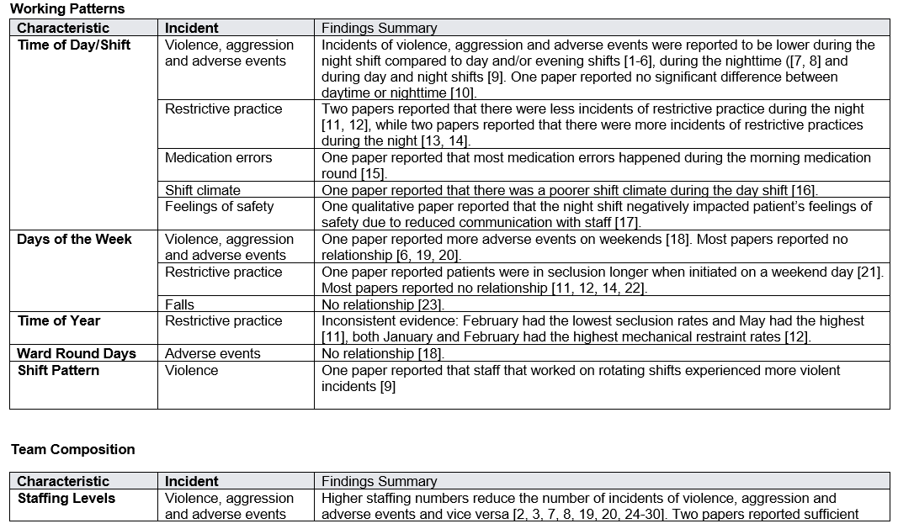
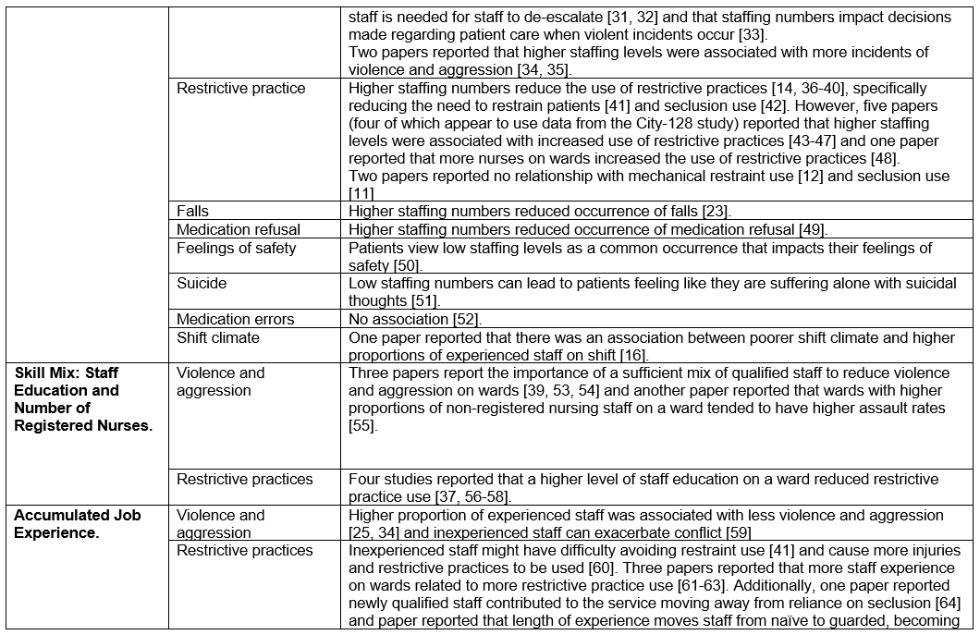
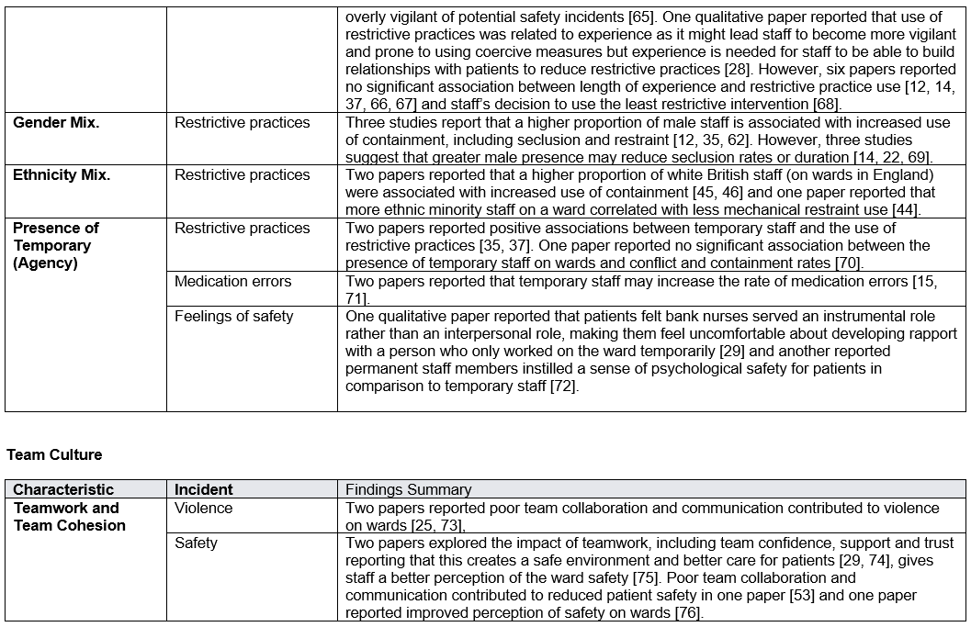
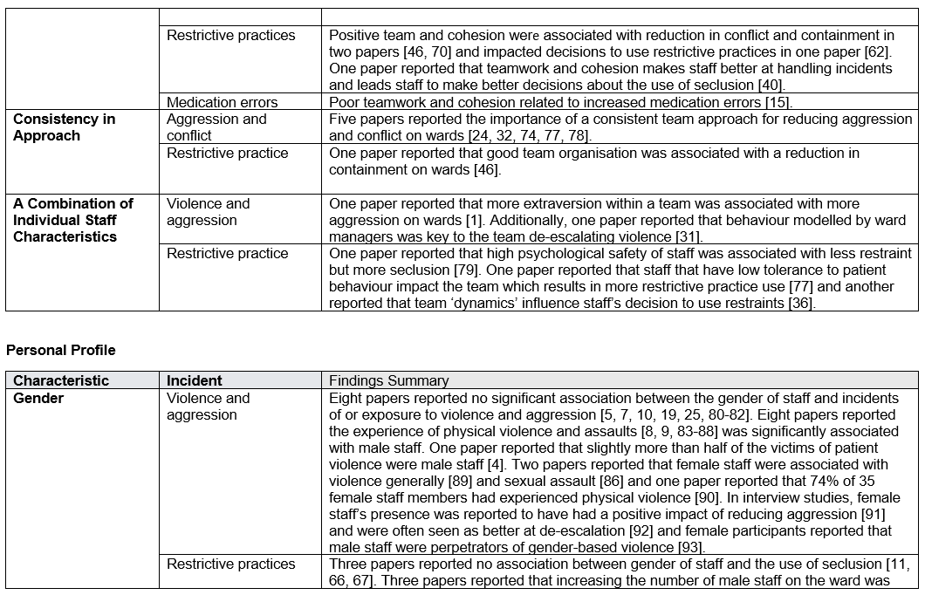
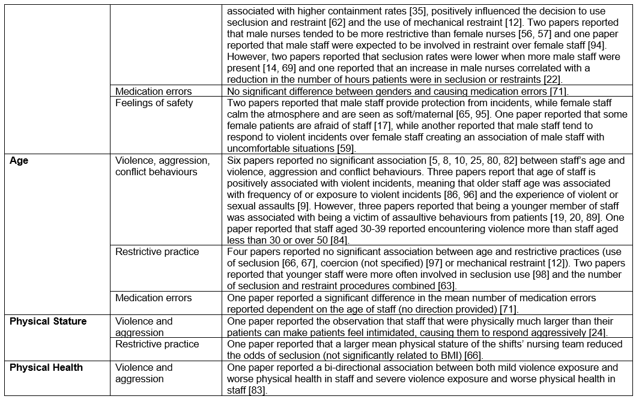
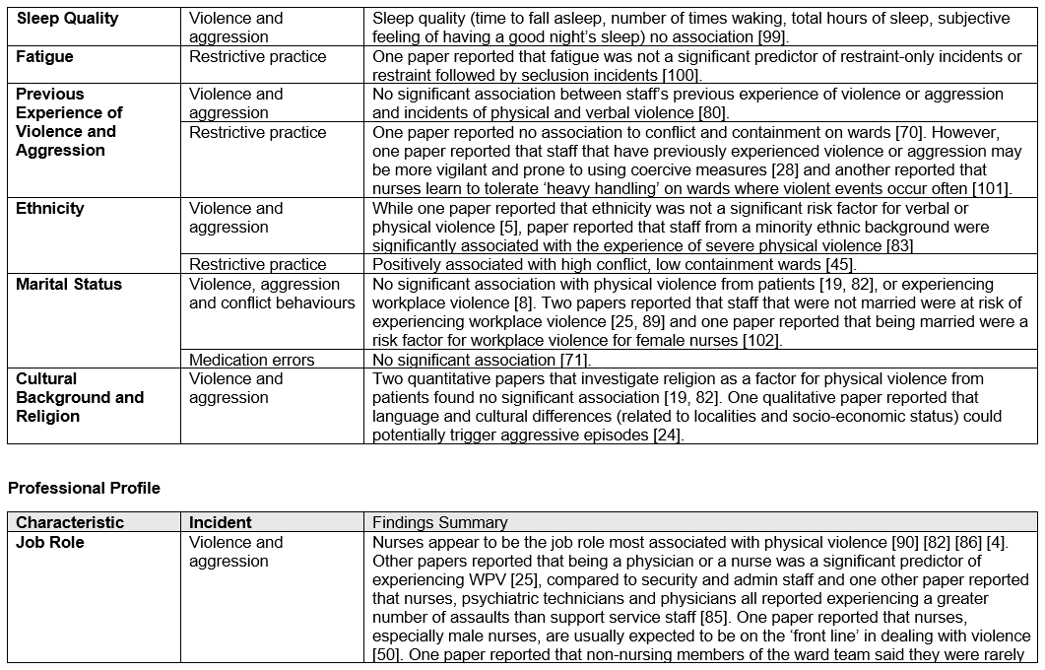
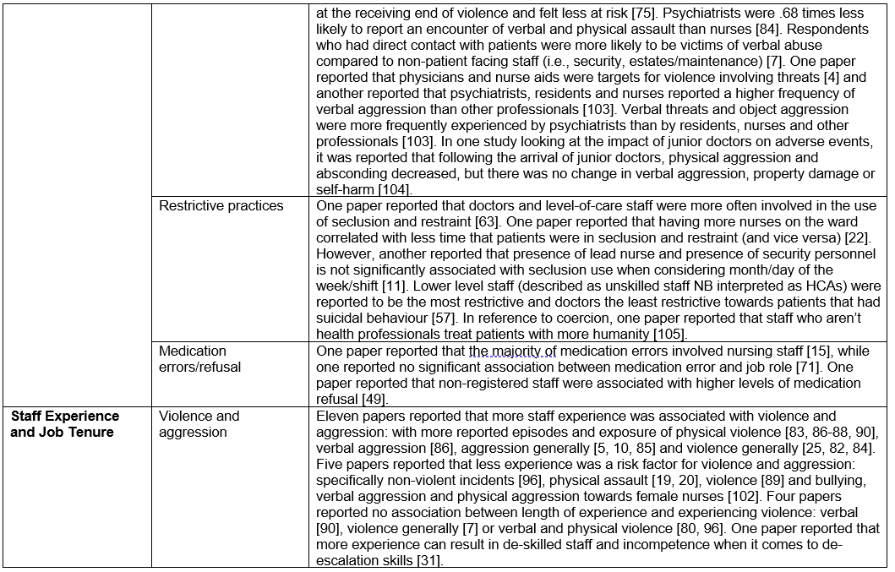
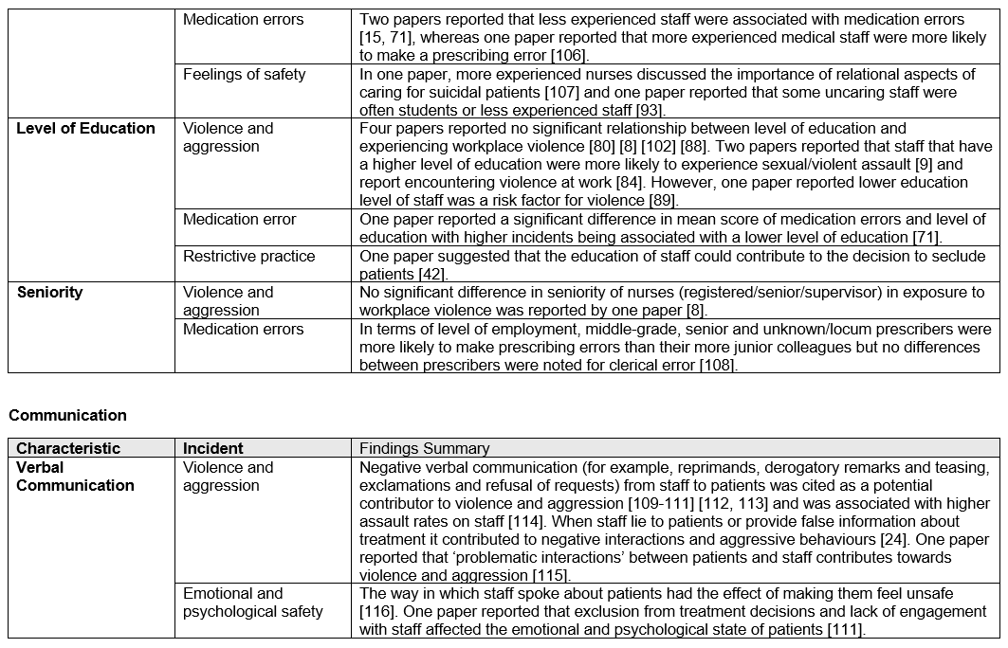
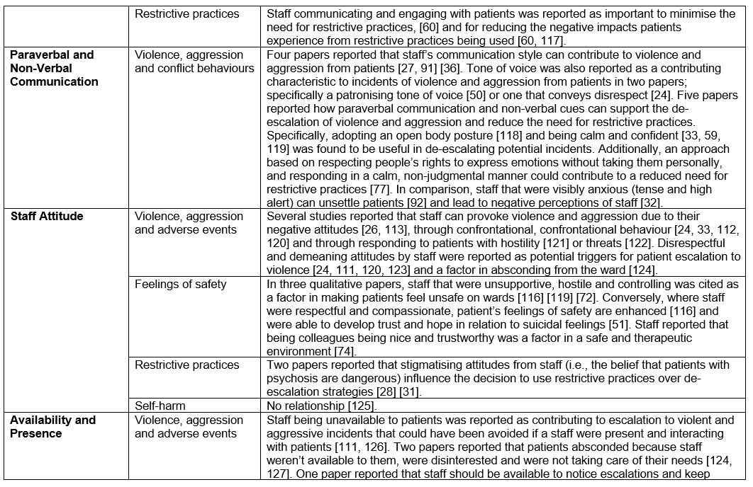
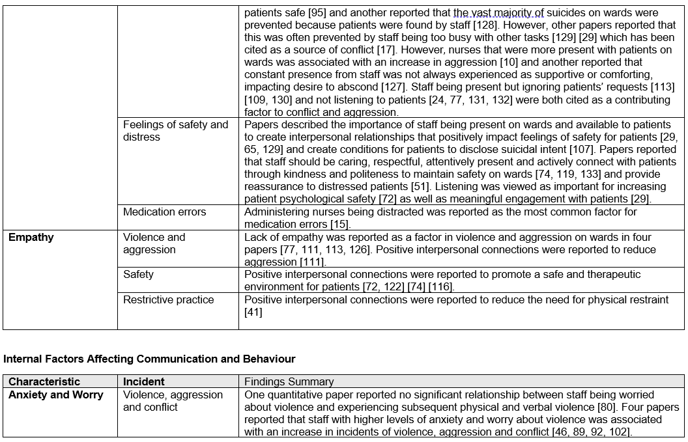
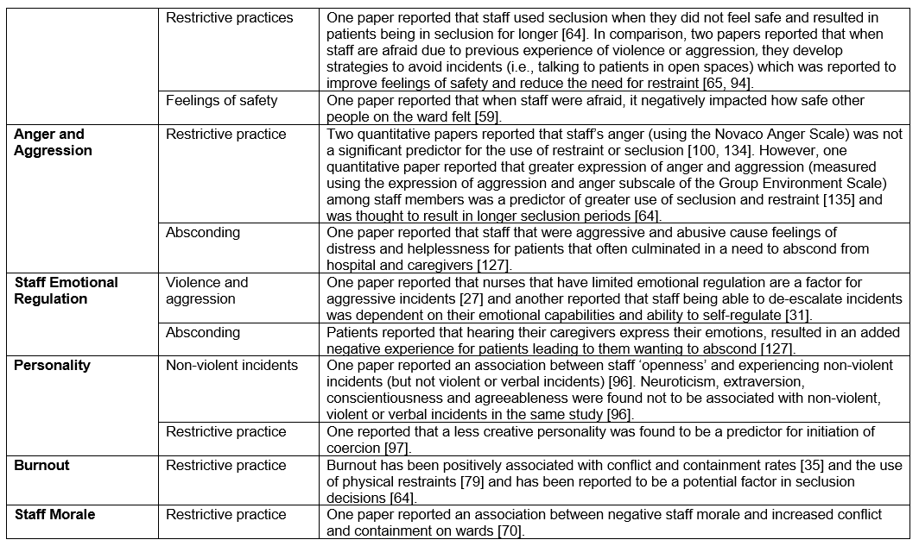

References
1. Doedens, P., et al., Association between characteristics of nursing teams and patients' aggressive behavior in closed psychiatric wards. Perspectives in Psychiatric Care, 2022. 58(4): p. 2592-2600.
2. Parakkal Kurian, L., et al., Aggressive behavior and its associated factors among persons with mental illness: An observational study. Journal of Education and Health Promotion, 2023. 12(1): p. 249.
3. Nienaber, A., et al., Influence of staffing levels on conflicts in inpatient psychiatric care. Der Nervenarzt, 2018. 89(7): p. 821-827.
4. Drori, T., et al., Patient violence toward psychiatric health care workers in Israel as viewed through incident reports: A retrospective study. Journal of the American Psychiatric Nurses Association, 2017. 23(2): p. 143-148.
5. Ridenour, M., et al., Incidence and risk factors of workplace violence on psychiatric staff. Work: Journal of Prevention, Assessment & Rehabilitation, 2015. 51(1): p. 19-28.
6. James, K., et al., Self harm in adult inpatient psychiatric care: A national study of incident reports in the UK. International Journal of Nursing Studies, 2012. 49(10): p. 1212-1219.
7. Jallow, A., T. Punpeng, and C. Boonshuyar, The Prevalence and Risk Factors of Workplace Violence at a Psychiatric Hospital in The Gambia. Psychiatry International, 2024. 6(1).
8. Yang, B.X., et al., Incidence, Type, Related Factors, and Effect of Workplace Violence on Mental Health Nurses: A Cross-sectional Survey. Archives of Psychiatric Nursing, 2018. 32(1): p. 31 EP - 38.
9. Zeng, J., et al., Frequency and risk factors of workplace violence on psychiatric nurses and its impact on their quality of life in China. Psychiatry Research, 2013. 210(2): p. 510 EP - 514.
10. Weltens, I., et al., Staff and ward factors associated with aggression development on an acute closed psychiatric ward: an experience sampling method study. BMJ Open, 2023. 13(2): p. e067943.
11. Barr, L., et al., Nursing staff composition and its influence on seclusion in an adult forensic mental health inpatient setting: The truth about numbers. Archives of Psychiatric Nursing, 2022. 41: p. 333 EP - 340.
12. Kodal, J.S., J.N. Kjaer, and E.R. Larsen, Mechanical restraint and characteristics of patient, staff and shifts in a psychiatric ward. Nordic Journal of Psychiatry, 2018. 72(2): p. 103 EP - 108.
13. Di Lorenzo, R., et al., Physical restraints in an Italian psychiatric ward: Clinical reasons and staff organization problems. Perspectives in Psychiatric Care, 2012. 48(2): p. 95-107.
14. O'Malley, J.E., et al., Factors influencing seclusion rates in an adult psychiatric intensive care unit. Journal of Psychiatric Intensive Care, 2007. 3(2): p. 93-100.
15. Haw, C. and C. Cahill, A computerized system for reporting medication events in psychiatry: The first two years of operation. Journal of Psychiatric and Mental Health Nursing, 2011. 18(4): p. 308 EP - 315.
16. Lewin, T.J., et al., Shift climate profiles and correlates in acute psychiatric inpatient units. Social Psychiatry and Psychiatric Epidemiology, 2012. 47(9): p. 1429 EP - 1440.
17. Pelto-Piri, V., et al., Feeling safe or unsafe in psychiatric inpatient care, a hospital-based qualitative interview study with inpatients in Sweden. International Journal of Mental Health Systems, 2019. 13.
18. Bowers, L., et al., Adverse incidents, patient flow and nursing workforce variables on acute psychiatric wards: The Tompkins Acute Ward study. International Journal of Social Psychiatry, 2007. 53(1): p. 75-84.
19. Chou, K.R., R.B. Lu, and M. Chang, Assaultive behavior by psychiatric in-patients and its related factors. The Journal of Nursing Research, 2001. 9(5): p. 139 EP - 151.
20. Chou, K.R., R.B. Lu, and W.C. Mao, Factors relevant to patient assaultive behavior and assault in acute inpatient psychiatric units in Taiwan. Archives of psychiatric nursing, 2002. 16(4): p. 187 EP - 195.
21. Camelot, G., A.-L. Boyer, and J.-M. Durand, Duration of seclusion and exit of the seclusion room, study of the impact of anamnestic and institutional factors. Encephale, 2020. 46(3): p. 184 EP - 189.
22. Miodownik, C., et al., Risk factors for coercion length at psychiatric hospitals in Israel: Relationship with staff. Indian Journal of Psychiatry, 2024. 66(1): p. 36 EP - 42.
23. Seeherunwong, A., et al., Staffing and patient-related factors affecting inpatient falls in a psychiatric hospital: A 5-year retrospective matched case-control study. International Journal of Mental Health Systems, 2022. 16.
24. Hueske, C., Perceptions of aggressive behaviors in mental health clients. 2008, University of Texas Medical Branch Graduate School of Biomedical Sciences. p. 247 p-247 p.
25. Al-Azzam, M., et al., Prevalence and risk factors of workplace violence toward mental health staff departments in Jordanian hospitals. Issues in Mental Health Nursing, 2017. 38(5): p. 435-442.
26. Chaplin, R., et al., The National Audit of Violence: In-patient care for adults of working age. Psychiatric Bulletin, 2006. 30(12): p. 444-446.
27. Eweida, R. and N. Ibrahim, Using Delphi method to address factors contributing to aggressive behaviour in mental health settings. Journal of Psychiatric and Mental Health Nursing, 2024. 31(6): p. 973 EP - 980.
28. Aluh, D.O., et al., Contextual factors influencing the use of coercive measures in Portuguese mental health care. International Journal of Law and Psychiatry, 2023. 90: p. 101918.
29. Mistry, H., W.M.M. Levack, and S. Johnson, Enabling people, not completing tasks: Patient perspectives on relationships and staff morale in mental health wards in England. BMC Psychiatry, 2015. 15(1): p. 307.
30. Bimenyimana, E., et al., The lived experience by psychiatric nurses of aggression and violence from patients in a Gauteng psychiatric institution. Curationis, 2009. 32(3): p. 4 EP - 13.
31. Johnston, I., et al., De-escalation of conflict in forensic mental health inpatient settings: a Theoretical Domains Framework-informed qualitative investigation of staff and patient perspectives. BMC Psychology, 2022. 10(1): p. 30.
32. Yang, C.-I., et al., Assault experiences: Lessons learned from mental health nurses in Taiwan. International Journal of Mental Health Nursing, 2016. 25(3): p. 225 EP - 233.
33. Perron, A., et al., Identification and management of violence in psychiatry : Nurse and patient perceptions of safety and dangerousness. Recherche En Soins Infirmiers, 2015(120): p. 47-60.
34. Staggs, V.S., Nurse staffing, RN mix, and assault rates on psychiatric units. Research in Nursing and Health, 2013. 36(1): p. 26 EP - 37.
35. Bowers, L., et al., Identifying key factors associated with aggression on acute inpatient psychiatric wards. Issues in Mental Health Nursing, 2009. 30(4): p. 260-271.
36. Jacob, J.D., et al., Convergence and divergence: An analysis of mechanical restraints. Nursing Ethics, 2019. 26(4): p. 1009-1026.
37. Bak, J., et al., Comparing the effect of non-medical mechanical restraint preventive factors between psychiatric units in Denmark and Norway. Nordic Journal of Psychiatry, 2015. 69(6): p. 433-443.
38. Donat, D.C., Impact of improved staffing on seclusion/restraint reliance in a public psychiatric hospital. Psychiatric Rehabilitation Journal, 2002. 25(4): p. 413 EP - 416.
39. Tingleff, E.B., et al., Content and Feasibility of Interventions to Reduce Mechanical Restraint Use in Adult Forensic Mental Health Inpatient Settings: A Qualitative Study of Service Users', Relatives', and Staff's Perceptions in Denmark. Journal of Forensic Nursing, 2025(101234500).
40. Boumans, C.E., et al., Nurses' decision on seclusion: patient characteristics, contextual factors and reflexivity in teams. Journal of Psychiatric and Mental Health Nursing, 2012. 19(3): p. 264-270.
41. Wilson, C., et al., Mental health inpatients' and staff members' suggestions for reducing physical restraint: A qualitative study. Journal of Psychiatric and Mental Health Nursing, 2018. 25(3): p. 188 EP - 200.
42. Mann-Poll, P.S., et al., Factors contributing to mental health professionals' decision to use seclusion. Psychiatric services, 2011. 62(5): p. 498-503.
43. Bowers, L., et al., The practice of seclusion and time-out on English acute psychiatric wards: the City-128 Study. Archives of Psychiatric Nursing, 2010. 24(4): p. 275-86.
44. Bowers, L., et al., Manual restraint and shows of force: The City-128 Study. International Journal of Mental Health Nursing, 2012. 21(1): p. 30-40.
45. Bowers, L., et al., Correlation between levels of conflict and containment on acute psychiatricwards: The city-128 study. Psychiatric Services, 2013. 64(5): p. 423 EP - 430.
46. Bowers, L., Association between staff factors and levels of conflict and containment on acute psychiatric wards in England. Psychiatric Services, 2009. 60(2): p. 231 EP - 239.
47. Bowers, L. and M. Crowder, Nursing staff numbers and their relationship to conflict and containment rates on psychiatric wards-A cross sectional time series Poisson regression study. International Journal of Nursing Studies, 2012. 49(1): p. 15 EP - 20.
48. Fukasawa, M., et al., Relationship between the use of seclusion and mechanical restraint and the nurse-bed ratio in psychiatric wards in Japan. International Journal of Law and Psychiatry, 2018. 60: p. 57 EP - 63.
49. Baker, J.A., L. Bowers, and J.A. Owiti, Wards features associated with high rates of medication refusal by patients: a large multi-centred survey. General Hospital Psychiatry, 2009. 31(1): p. 80 EP - 89.
50. Quirk, A., P. Lelliott, and C. Seale, Service users' strategies for managing risk in the volatile environment of an acute psychiatric ward. Social Science and Medicine, 2004. 59(12): p. 2573 EP - 2583.
51. Vandewalle, J., et al., Engagement between adults in suicidal crises and nurses in mental health wards: A qualitative study of patients' perspectives. Archives of Psychiatric Nursing, 2021. 35(5): p. 541-548.
52. Ito, H. and S. Yamazumi, Common types of medication errors on long-term psychiatric care units. International Journal for Quality in Health Care, 2003. 15(3): p. 207 EP - 212.
53. Snorrason, J. and P. Biering, The attributes of successful de-escalation and restraint teams. International Journal Of Mental Health Nursing, 2018. 27(6): p. 1842-1850.
54. Ward, L., Ready, aim Fire! mental health nurses under siege in acute inpatient facilities. Issues in Mental Health Nursing, 2013. 34(4): p. 281 EP - 287.
55. Staggs, V.S., Injurious assault rates on inpatient psychiatric units: Associations with staffing by registered nurses and other nursing personnel. Psychiatric Services, 2015. 66(11): p. 1162 EP - 1166.
56. Miodownik, C., et al., Clinical and demographic characteristics of secluded and mechanically restrained mentally ill patients: A retrospective study. Israel Journal of Health Policy Research, 2019. 8(1): p. 9.
57. Wynn, R., A.-M. Kvalvik, and T. Hynnekleiv, Attitudes to coercion at two Norwegian psychiatric units. Nordic Journal of Psychiatry, 2011. 65(2): p. 133 EP - 137.
58. Stewart, D. and L. Bowers, Under the Gaze of Staff: Special Observation as Surveillance. Perspectives in Psychiatric Care, 2012. 48(1): p. 2-9.
59. Hylen, U., et al., Providing good care in the shadow of violence - An interview study with nursing staff and ward managers in psychiatric inpatient care in Sweden. Issues in Mental Health Nursing, 2019. 40(2): p. 148-157.
60. Pelto-Piri, V. and L. Kjellin, Social inclusion and violence prevention in psychiatric inpatient care. A qualitative interview study with service users, staff members and ward managers. BMC Health Services Research, 2021. 21(1).
61. Lindsey, P., Psychiatric Nurses' Decision to Restrain The Association Between Empowerment and Individual Factors. Journal of Psychosocial Nursing and Mental Health Services, 2009. 47(9): p. 41-49.
62. Terpstra, T.L., E.J. Pettee, and M. Hunter, Nursing staff's attitudes toward seclusion & restraint. Journal of Psychosocial Nursing and Mental Health Services, 2001. 39(5): p. 20 EP - 28.
63. Wynn, R., Staff's attitudes to the use of restraint and seclusion in a Norwegian university psychiatric hospital. Nordic Journal of Psychiatry, 2003. 57(6): p. 453 EP - 459.
64. Lawrence, D., et al., To Seclude or Not to Seclude? Using Grounded Theory to Develop a Model of the Seclusion Decision-Making Process Used by Mental Health Nurses in Forensic Services. Issues in Mental Health Nursing, 2025. 46(3): p. 227 EP - 238.
65. Jacob, J.D. and D. Holmes, Working under threat: Fear and nurse-patient interactions in a forensic psychiatric setting. Journal of Forensic Nursing, 2011. 7(2): p. 68 EP - 77.
66. Doedens, P., et al., Nursing staff factors contributing to seclusion in acute mental health care-An explorative cohort study. Issues in Mental Health Nursing, 2017. 38(7): p. 584-589.
67. Tulloch, L., H. Walker, and R. Ion, What influences the use of seclusion? A cross-sectional study of forensic mental health nurses in a UK high secure hospital. Journal of Forensic Practice, 2024. 26(4): p. 201-218.
68. Williams, J. and R. Myers, Relationship of less restrictive interventions with seclusion/restraints usage, average years of psychiatric experience, and staff mix. Journal of the American Psychiatric Nurses Association, 2001. 7(5): p. 139-144.
69. Doedens, P., et al., Influence of nursing staff characteristics on seclusion in acute mental health care-A prospective two-year follow-up study. Archives of psychiatric nursing, 2021. 35(5): p. 491-498.
70. Papadopoulos, C., et al., Events preceding changes in conflict and containment rates on acute psychiatric wards. Psychiatric Services, 2012. 63(1): p. 40-47.
71. Abdi, M., et al., Factors associated with medication errors in the psychiatric ward of Razi Hospital in Tabriz: Perspectives of nurses. Preventive Care in Nursing & Midwifery Journal, 2018. 8(2): p. 1-8.
72. Vogt, K., et al., Safer, Not Safe': Service Users' Experiences of Psychological Safety in Inpatient Mental Health Wards in the United Kingdom. International Journal of Mental Health Nursing, 2024. 33(6): p. 2227-2238.
73. Pekurinen, V., et al., Organizational Justice and Collaboration Among Nurses as Correlates of Violent Assaults by Patients in Psychiatric Care. Psychiatric Services, 2017. 68(5): p. 490-496.
74. Sollied, S.A., et al., Facilitating a safe and caring atmosphere in everyday life in forensic mental health wards - a qualitative study. International journal of qualitative studies on health and well-being, 2023. 18(1): p. 2209966.
75. McGeorge, M., P. Lelliott, and J. Stewart, Managing violence in psychiatric wards: preliminary findings of a multi-centre audit. Mental Health & Learning Disabilities Care, 2000. 3(11): p. 366-369.
76. Olsson, H. and U.-K. Schon, Reducing violence in forensic care - how does it resemble the domains of a recovery-oriented care? Journal of Mental Health, 2016. 25(6): p. 506-511.
77. Gildberg, F., et al., Conflict management: A qualitative study of mental health staff's perceptions of factors that may influence conflicts with forensic mental health inpatients. Archives of Psychiatric Nursing, 2021. 35(5): p. 407-417.
78. Sun, F.-K., et al., Patients and nurses' perceptions of ward environmental factors and support systems in the care of suicidal patients. Journal of Clinical Nursing, 2006. 15(1): p. 83-92.
79. Anderson, E., et al., Influence of Organizational Climate and Clinician Morale on Seclusion and Physical Restraint Use in Inpatient Psychiatric Units. Journal of Patient Safety, 2021. 17(4): p. 316 EP - 322.
80. Al-Omari, H., et al., Workplace violence against nurses working in psychiatric hospitals in Jordan. Archives of Psychiatric Nursing, 2019. 33(5): p. 58-62.
81. Daffern, M., M. Mayer, and T. Martin, Staff gender ratio and aggression in a forensic psychiatric hospital. International Journal of Mental Health Nursing, 2006. 15(2): p. 93 EP - 99.
82. Olashore, A.A., O.O. Akanni, and R.M. Ogundipe, Physical violence against health staff by mentally ill patients at a psychiatric hospital in Botswana. BMC Health Services Research, 2018. 18(1): p. 362.
83. Renwick, L., et al., The physical and mental health of acute psychiatric ward staff, and its relationship to experience of physical violence. International Journal of Mental Health Nursing, 2019. 28(1): p. 268-277.
84. Han, X., et al., Workplace Violence, Workforce Stability, and Well-being in China's Psychiatric Hospitals. American Journal of Preventive Medicine, 2022. 62(4): p. e265 EP - e273.
85. Ezeobele, I.E., et al., Aggression in Acute Inpatient Psychiatric Care: A Survey of Staff Attitudes. The Canadian journal of nursing research = Revue canadienne de recherche en sciences infirmieres, 2019. 51(3): p. 145 EP - 153.
86. Bilici, R., M. Sercan, and F. Izci, Levels of the Staff's Exposure to Violence at Locked Psychiatric Clinics: A Comparison by Occupational Groups. Issues in Mental Health Nursing, 2016. 37(7): p. 501 EP - 506.
87. James, B.O., E.W. Isa, and N. Oud, Patient aggression in psychiatric services: The experience of a sample of nurses at two psychiatric facilities in Nigeria. African Journal of Psychiatry, 2011. 14(2): p. 130 EP - 133.
88. Moylan, L.B. and M. Cullinan, Frequency of assault and severity of injury of psychiatric nurses in relation to the nurses' decision to restrain. Journal of Psychiatric and Mental Health Nursing, 2011. 18(6): p. 526 EP - 534.
89. Chen, W.-C., et al., Incidence and risk factors of workplace violence on nursing staffs caring for chronic psychiatric patients in Taiwan. International Journal of Environmental Research and Public Health, 2009. 6(11): p. 2812 EP - 2821.
90. Bekelepi, N. and P. Martin, Self-reported incidents of violence towards nurses working in acute psychiatric units. Curationis, 2023. 46(1): p. 1-8.
91. Wright, K.M., et al., A qualitative study into the attitudes of patients and staff towards violence and aggression in a high security hospital. Journal of Psychiatric and Mental Health Nursing, 2014. 21(2): p. 184 EP - 188.
92. Goodman, H., et al., Barriers and facilitators to the effective de-escalation of conflict behaviours in forensic high-secure settings: a qualitative study. International Journal of Mental Health Systems, 2020. 14(1): p. 59.
93. Watson, J., et al., Preventing gender-based violence in mental health inpatient units. 2020, ANROWS.
94. Bigwood, S. and M. Crowe, 'It's part of the job, but it spoils the job': A phenomenological study of physical restraint: Feature Article. International Journal of Mental Health Nursing, 2008. 17(3): p. 215 EP - 222.
95. Stenhouse, R.C., 'Safe enough in here?': Patients' expectations and experiences of feeling safe in an acute psychiatric inpatient ward. Journal of Clinical Nursing, 2013. 22(21): p. 3109 EP - 3119.
96. Decaire, M.W., et al., Incidents in a Psychiatric Forensic Setting: Association with Patient and Staff Characteristics. CJNR: Canadian Journal of Nursing Research, 2006. 38(3): p. 69-80.
97. Pawlowski, T. and P. Baranowski, Personality traits of nurses and organizational climate in relation to the use of coercion in psychiatric wards. Perspectives in Psychiatric Care, 2018. 54(2): p. 287-292.
98. Laukkanen, E., et al., A Bayesian network model to identify the associations between the use of seclusion in psychiatric care and nursing managers' attitudes towards containment methods. Journal of Psychiatric and Mental Health Nursing, 2021. 28(5): p. 815-828.
99. Weltens, I., et al., Exploring the Consequences of Aggressive Experiences on Psychiatric Nurses: A Real-Time Assessment Study. Perspectives in Psychiatric Care, 2024. 2024.
100. Jalil, R., et al., Mental health nurses' emotions, exposure to patient aggression, attitudes to and use of coercive measures: Cross sectional questionnaire survey. International Journal of Nursing Studies, 2017. 75: p. 130 EP - 138.
101. Lantta, T., et al., Violent events, ward climate and ideas for violence prevention among nurses in psychiatric wards: A focus group study. International Journal of Mental Health Systems, 2016. 10(1): p. 27.
102. Chen, W.-C., et al., The incidence and risk factors of workplace violence towards female nurses reported via internet in an acute psychiatric hospital. Archives of Environmental and Occupational Health, 2011. 66(2): p. 100 EP - 106.
103. Aguglia, A., et al., Workplace violence and burnout among mental health workers. Psychiatric Services, 2020. 71(3): p. 284 EP - 288.
104. Bowers, L., et al., Junior staffing changes and the temporal ecology of adverse incidents in acute psychiatric wards. Journal of Advanced Nursing, 2007. 57(2): p. 153-160.
105. Larsen, I.B. and T.B. Terkelsen, Coercion in a locked psychiatric ward: Perspectives of patients and staff. Nursing Ethics, 2014. 21(4): p. 426 EP - 436.
106. Keers, R.N., et al., Prevalence, nature and predictors of prescribing errors in mental health hospitals: A prospective multicentre study. BMJ Open, 2014. 4(9): p. e006084.
107. Vandewalle, J., et al., Contact and communication with patients experiencing suicidal ideation: A qualitative study of nurses' perspectives. Journal of Advanced Nursing, 2019. 75(11): p. 2867 EP - 2877.
108. Keers, R.N., et al., Medication safety at the interface: evaluating risks associated with discharge prescriptions from mental health hospitals. Journal of Clinical Pharmacy & Therapeutics, 2015. 40(6): p. 645-654.
109. Bowers, L., S. Wright, and D. Stewart, Patients subject to high levels of coercion: staff's understanding. Issues in Mental Health Nursing, 2014. 35(5): p. 364 EP - 371.
110. Nolan, K.A., et al., Staff and patient views of the reasons for aggressive incidents: A prospective, incident-based study. Psychiatric Quarterly, 2009. 80(3): p. 167 EP - 172.
111. Lamanna, D., et al., Aggression in psychiatric hospitalizations: a qualitative study of patient and provider perspectives. Journal of Mental Health, 2016. 25(6): p. 536-542.
112. Spokes, K., et al., HOVIS-The Hertfordshire/Oxfordshire Violent Incident Study. Journal of Psychiatric and Mental Health Nursing, 2002. 9(2): p. 199-209.
113. Meehan, T., W. McIntosh, and H. Bergen, Aggressive behaviour in the high-secure forensic setting: the perceptions of patients. Journal of psychiatric and mental health nursing, 2006. 13(1): p. 19 EP - 25.
114. Newbill, W., et al., Direct Observational Coding of Staff Who Are the Victims of Assault. Psychological Services, 2010. 7(3): p. 177-189.
115. Duxbury, J., An evaluation of staff and patient views of and strategies employed to manage inpatient aggression and violence on one mental health unit: a pluralistic design. Journal of Psychiatric and Mental Health Nursing, 2002. 9(3): p. 325-37.
116. Cutler, N.A., et al., Understanding how personhood impacts consumers' feelings of safety in acute mental health units: a qualitative study. International Journal of Mental Health Nursing, 2021. 30(2): p. 479-486.
117. Chien, W.T., et al., Psychiatric inpatients' perceptions of positive and negative aspects of physical restraint. Patient Education and Counseling, 2005. 59(1): p. 80 EP - 86.
118. Price, O., et al., De-escalating aggression in acute inpatient mental health settings: a behaviour change theory-informed, secondary qualitative analysis of staff and patient perspectives. BMC Psychiatry, 2024. 24(1): p. 548.
119. Vahidi, M., et al., Therapeutic Relationships and Safety of Care in Iranian Psychiatric Inpatient Units. Issues in Mental Health Nursing, 2018. 39(11): p. 967-976.
120. van Wijk, E., A. Traut, and H. Julie, Environmental and nursing-staff factors contributing to aggressive and violent behaviour of patients in mental health facilities. Curationis, 2014. 37(1): p. 1-9.
121. Ireland, C.A., et al., Predicting security incidents in high secure male psychiatric care. International Journal of Law & Psychiatry, 2019. 64: p. 40-52.
122. Olsson, H., et al., Reducing or increasing violence in forensic care: a qualitative study of inpatient experiences. Archives of Psychiatric Nursing, 2015. 29(6): p. 393 EP - 400.
123. Duxbury, J. and R. Whittington, Causes and management of patient aggression and violence: staff and patient perspectives. Journal of Advanced Nursing, 2005. 50(5): p. 469-478.
124. Muir-Cochrane, E., et al., The inpatient psychiatric unit as both a safe and unsafe place: Implications for absconding. International Journal of Mental Health Nursing, 2013. 22(4): p. 304-312.
125. Bowers, L., et al., Relationship between service ecology, special observation and self-harm during acute in-patient care: City-128 study. British Journal of Psychiatry, 2008. 193(5): p. 395 EP - 401.
126. Secker, J., et al., Understanding the social context of violent and aggressive incidents on an inpatient unit. Journal of Psychiatric and Mental Health Nursing, 2004. 11(2): p. 172 EP - 178.
127. Kaggwa, M.M., et al., Patients' perspectives on the experience of absconding from a psychiatric hospital: a qualitative study. BMC Psychiatry, 2021. 21(1): p. 371.
128. Bowers, L., et al., Learning from prevented suicide in psychiatric inpatient care: an analysis of data from the National Patient Safety Agency. International Journal of Nursing Studies, 2011. 48(12): p. 1459-65.
129. Cutler, N.A., et al., Nurses' influence on consumers' experience of safety in acute mental health units: A qualitative study. Journal of Clinical Nursing (John Wiley & Sons, Inc.), 2020. 29(21): p. 4379-4386.
130. Pulsford, D., et al., Aggression in a high secure hospital: Staff and patient attitudes. Journal of Psychiatric and Mental Health Nursing, 2013. 20(4): p. 296-304.
131. Dickens, G., M. Piccirillo, and N. Alderman, Causes and management of aggression and violence in a forensic mental health service: Perspectives of nurses and patients. International Journal of Mental Health Nursing, 2013. 22(6): p. 532-544.
132. Ilkiw-Lavalle, O. and B. Grenyer, Differences between patient and staff perceptions of aggression in mental health units. Psychiatric Services, 2003. 54(3): p. 389-393.
133. Delaney, K. and M. Johnson, Keeping the unit safe: mapping psychiatric nursing skills. Journal of the American Psychiatric Nurses Association, 2006. 12(4): p. 198-207.
134. Jalil, R., et al., The role of interpersonal style in aggression and its containment in a forensic mental health setting: A correlational and pseudoprospective study of patients and nursing staff. International Journal of Mental Health Nursing, 2020. 29(3): p. 427 EP - 439.
135. De Benedictis, L., et al., Staff perceptions and organizational factors as predictors of seclusion and restraint on psychiatric wards. Psychiatric Services, 2011. 62(5): p. 484 EP - 491.

