Table 1 Clinicopathologic Features of Patients With Edema
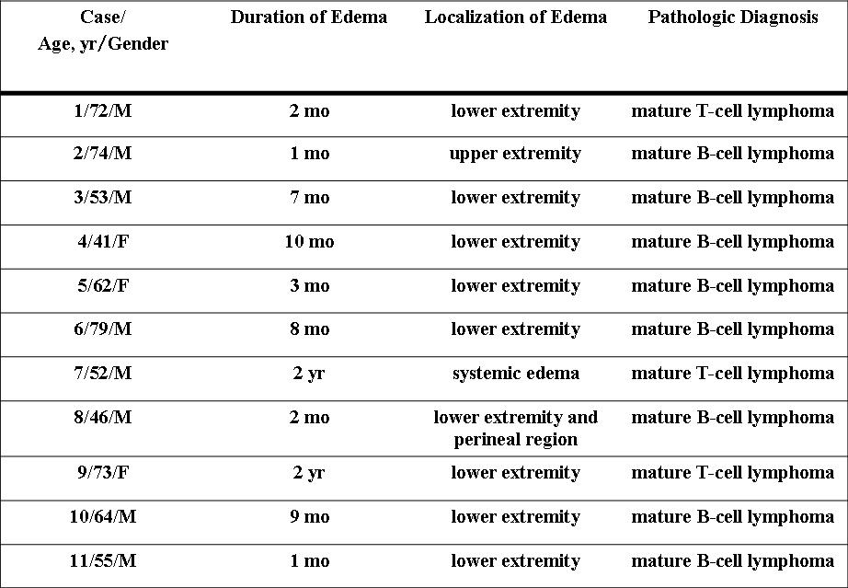

Table 2 Clinical Features of Patients With Edema
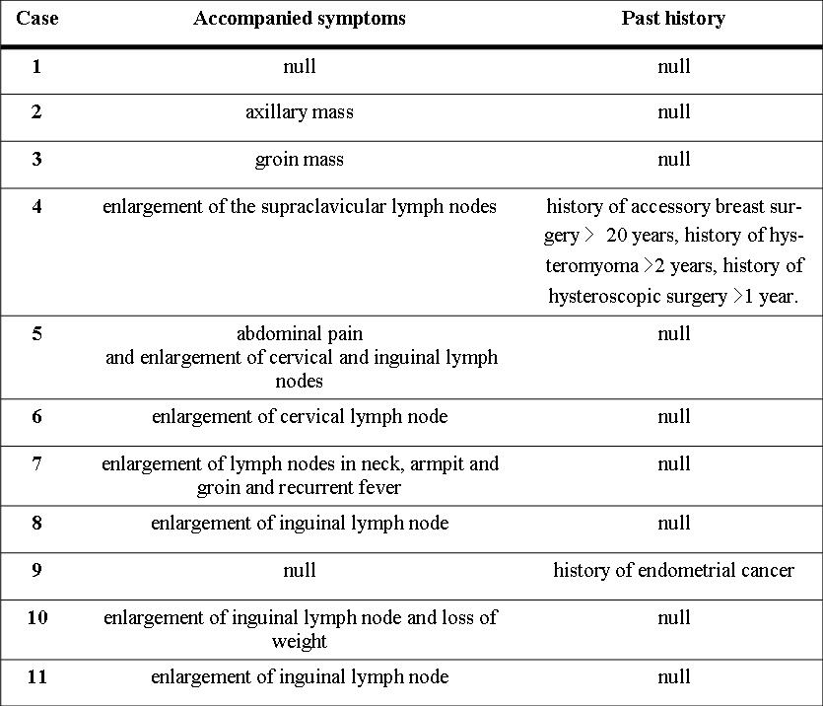

Table 3 Histological Types of Lymphoma
