Supplementary Material for:
Cooperative and trained dogs follow misleading human cues regardless of human beliefs

Lucrezia Lonardo, Jasmin Hasenöhrl, Jacco Spithout, Jannes Dommisse, Christoph J. Völter & Ludwig Huber
Article submitted to: Scientific Reports

This file includes:

Supplementary text, Tables S1 to S3 and Figure S1 to S4.

Other supplementary materials for this manuscript (R code, data files and statistical tools used for the analyses and plots) are available on Zenodo: https://doi.org/10.5281/zenodo.20555809

Supplementary text

Familiarisation phase 1
During the three familiarisation phases described from here on, the tunnel was covered with a black fleece blanket that did not allow the dogs to see the screen contained inside of it. The aim of the first familiarisation phase was to make dogs familiar with the hider and with the hiding and relocation of food. At the beginning of each trial, only the dog, the caregiver and the hider were present in the room. The dog was kept (through collar or harness) by the seated and blindfolded caregiver at the starting position (the green square marked on the floor in Fig. 1B), equidistant from both containers and with a full view of the experimenter’s actions. In the first trial of this phase, the “no displacement” trial, food was hidden only in one container (container A). In detail, the hider showed to the dog that he had food and hid it in container A, closing the paper lid on the container. He made eye contact with the dog and left the room. Once the door was about to be closed, the hider signaled to the caregiver to release the dog by saying “ok”. Dogs were then released by their caregivers and were free to approach one of the containers and retrieve its content (if any). If dogs chose the baited container, they moved on to the next trial, otherwise the no-displacement trial was repeated for a maximum of two times. In the next trial, dogs additionally witnessed a displacement of the food to container B (“displacement trial”). Immediately (i.e., approximately less than 2 seconds) after closing container A, the hider opened it again, retrieved the food from there, closed it and visibly transferred the food into container B. Then, after closing container B, he left again the room. Once more, caregivers released the dogs after the hider had left and closed the door behind him. If dogs did not move up to 10 seconds from the release, caregivers were allowed to give verbal encouragement (such as “ok” or “you can go”). After additional 10 s, caregivers could repeat the encouragement, if necessary. Caregivers were instructed to refrain from nudging their dog physically and to avoid the command “search” as this might have been confusing for the dogs during the test trial. If dogs still did not move, after 30 seconds from the moment of release, we would have scored the trial as “no choice” and repeated it for a maximum of 2 trials, but none of the dogs had no choice trials.
If dogs chose the empty container, the hider went back into the room and removed the food from the baited bucket. The incorrect trial was immediately repeated. If dogs made a second mistake they were excluded from the study. If, instead, they chose the baited container, the other type of trial (displacement or no displacement) was repeated again as well. Only dogs that made two correct choices in two consecutive trials (one with displacement, one without displacement) within four trials moved on to the next phase.

Familiarisation phase 2
In the second familiarisation phase, we controlled for dogs’ motivation to follow the communicator’s cue to find food even when they had not witnessed the hiding event. The order of displacement and no displacement trials in this condition was fully counterbalanced across dogs, so for half of the dogs food was hidden in container A and for the other half of the dogs food was hidden in container B in the first trial of this phase and vice versa in the second trial (if the dogs chose correctly in the first trial). Hider and communicator entered the room while dog and caregiver waited outside. The dog and caregiver stayed outside the room during the baiting of the containers, without visual access to the baiting (the door to the experimental room was closed after the two experimenters had entered). However, the dogs saw that hider and communicator went into the room together and that the hider was holding a piece of food. Having witnessed the hiding, the communicator knew the correct location of food, unlike the dogs. In this phase, the hider took care to hide food without making any noise. Then he left the room and invited the caregiver to enter and take the seat in the experimental room. When entering the room from the door partly visible on the right side of Fig. 1B, the caregiver held the dog so that s/he could not approach the containers yet. Upon entering, dogs found the communicator crouched down, in a position equidistant from the two containers (the same starting position the communicator would assume also for test trials, shown in Fig. 1A). Once the dog was in its starting position and the caregiver was seated and wearing the blindfold again, the communicator suggested to the dog where to look for food. She approached the baited container, crouched down close to it, picked it up, alternated gaze between it and the dog while saying: “look, this is good, this is very good”. The suggestion lasted approx. 10 s. Then she walked back to her starting position and signaled to the caregiver to release the dog by saying “ok” while looking to the floor. In this phase, dogs could rely solely on the communicator’s suggestion to find food above chance level, as they could not witness the hiding procedure. If dogs were correct on both trials, they moved on to the next phase. If not, we used the same procedure and inclusion criteria described above.

Familiarisation phase 3
The aim of the third familiarisation phase was twofold; a) to make the dog familiar with the complete hiding and suggesting procedure and b) to test whether dogs are attentive and motivated enough to approach the correct (baited) container. Dog and caregiver started each trial again inside the experimental room, as in familiarisation phase 1. Hider and communicator entered the room together. The hider approached the first bucket to be baited (container A) while the communicator crouched down facing the dog, in a position equidistant from the two containers, and (visibly) followed the hiding procedure with her head and gaze. In the “no displacement” trial, the hider showed to the dog that he had food and hid it in container A. Then, he closed the container before leaving the room. In the “displacement” trial, dogs additionally witnessed a displacement of the food. Immediately after closing container A, the hider opened it again, retrieved the food from there, closed container A and visibly transferred the food into container B. Then, after closing also container B, he left the room. In both trials, once the hider had left the room, the communicator suggested to the dog where to look for food (approach, manipulation of the container, voice and gaze alternation as described above). The communicator then went back to her neutral starting position and said “ok”, to signal to the blindfolded caregiver that it was time to release the dog. Dogs now had two converging pieces of information about the (final) location of food: their own visual experience of the hiding events, and the communicator’s suggestion. Only dogs that made two correct choices in two consecutive trials (one with displacement, one without displacement) within four trials were subsequently tested in the final test phase.
We asked caregivers to wear a blindfold at the beginning of each trial. Throughout the whole experiment, caregivers took care their dog’s body was centered between the containers (Fig. 1) at least at the beginning of each trial. During the hiding and suggesting procedure, caregivers were instructed to let the dog freely move their head and body within the reach of their arm. At the end of each trial, caregivers were allowed to remove the blindfold to recall and catch their dogs. Also, they removed the blindfold when necessary in order to leave and re-enter the room safely. Caregivers were made aware of the aim and hypothesis behind the study only after the test.

Experience phase
During the experience phase, the dogs could experience for the first time the visual properties of the screen inside the tunnel (see-through in the TB group, opaque in the FB group). Together with the caregiver, the dog moved to the opposite side of the transparent barrier dividing the room in two, relative to the side where they stayed during the previous familiarisation phases. They left the side with the containers by walking through a gate made of fully opaque chipboard placed between the wall and the tunnel (right of the tunnel in Fig. S2). Only after the dog and caregiver had reached the other side of the room did the communicator remove the blanket from the tunnel, potentially revealing the screen for the first time to the dogs. The hider brought the required materials (a bowl, cup, tennis ball, pieces of sausage, kibble, knife, and chopping board) into the room, on the side with the containers.
The dog was then released on the opposite side, and the communicator left the room. The hider presented a piece of sausage to the dog, once above the tunnel and once behind it. In the FB condition (in which the tunnel contained an opaque screen, Fig. S2), gentle tapping sounds were produced on the wooden screen to maintain the dog's attention despite the lack of visual access. In both conditions, the dog received the piece of sausage at the other end of the room relative to the tunnel, so away from the tunnel, so that the dogs to not be able to associate approaching the tunnel with receiving food. This procedure was repeated once more. Next, the hider showed and bounced the tennis ball above and behind the tunnel, and given good at the other end of the room. This procedure was repeated once more. Finally, dry food was scooped back and forth between the cup and the bowl, both above (Fig. S2A) and behind (Fig. S2A) the tunnel, and the dog received a piece of it at the other end of the room. This demonstration was also repeated once more.

Manipulation check
At the end of the experience phase, a manipulation check was conducted to verify whether the dogs had learned whether the tunnel contained a transparent or opaque screen. All fences dividing the room in two were covered with blankets to block visual access between the dog’s side of the room and the hider’s (Fig. S3). In this phase, the only point in the room from which dogs could have seen the hider was through the tunnel, but only in the TB group (Fig. S3B). In the FB group, dogs could not see the hider’s side of the room (Fig. S3A). The hider, holding a chopping board and pieces of sausage, approached the fence so his upper body was visible to the dog, showed and threw a piece of sausage to the dog. The owner held the dog in the centre of the wall furthest away from the fence while the hider moved to the predefined position on the opposite side of the room and produced chopping sounds with a knife on the chopping board for 30 seconds (Figure S3A). During this time, the dog was released and allowed to move freely. If the dogs in the TB condition remembered that the tunnel contained a transparent screen, they were expected to approach the tunnel to gain visual access to the hider faster and/or more often than dogs in the FB condition (Figure S3B), who should remember that no visual access could be gained from the tunnel to the other side of the room. Dogs were allowed to put their paws on the fence and look over it, and were only excluded in this phase if they barged through or jumped over the fence (which only happened with one dog).

Tables
Table S1. Demographic and counterbalancing information of the tested dogs.
 | Age range | Mean age | SD Age | Nr. females | Nr. males | Tot. dogs TB | Tot. dogs FB
TB dogs | 9-180 | 68.48 | 36.83 | 30 | 30 | 60 | -
FB dogs | 12-171 | 72.2 | 44.32 | 26 | 34 | - | 60
Dogs with training | 13-171 | 81.35 | 37.56 | 23 | 25 | 20 | 28
Dogs without training | 9-180 | 63 | 41.17 | 33 | 39 | 40 | 32
Cooperative breeds | 9-180 | 66.94 | 37.06 | 33 | 39 | 37 | 35
Independent breeds | 10-171 | 75.44 | 45.38 | 23 | 25 | 23 | 25
Age is reported in months. Individual information, including breed and performance, is contained in the dataset “Tunnel_FB_tested_dogs.csv” in the Zenodo repository.

Table S2. Results of binomial GLMM analyzing the effect of condition (FB vs TB) and breed type (cooperative vs independent) on dogs’ tendency to follow the misleading communication (first choice).
 | Estimate | Std. Error | CI min | Ci max | χ² | df | P | Min⁽⁷⁾ | Max⁽⁷⁾
Intercept | 0.62 | 0.68 | -3.96 | 9.68 | ⁽¹⁾ | ⁽¹⁾ | ⁽¹⁾ | 0.49 | 0.82
Condition ⁽²⁾ | 0.65 | 0.68 | -3.14 | 10.6 | 0.86 | 1 | .353 | 0.44 | 0.95
Breed type ⁽³⁾ | -1.75 | 0.73 | -15.21 | -0.2 | 6.08 | 1 | .014 | -2.01 | 1.64
Age ⁽⁴⁾ | 0.18 | 0.56 | -4.2 | 7.75 | 0.1 | 1 | .751 | 0 | 0.39
Sex ⁽⁵⁾ | 1.06 | 0.8 | -2.28 | 14.36 | 1.6 | 1 | .205 | 0.84 | 1.36
First baited bucket ⁽⁶⁾ | 1.52 | 0.69 | 0.21 | 15.09 | 6.48 | 1 | .011 | 1.33 | 1.63
⁽¹⁾ Not shown due to its very limited interpretability
⁽²⁾ FB was the reference category
⁽³⁾ Cooperative was the reference category
⁽⁴⁾ Z-transformed to a mean of 0 and a standard deviation of 1.
⁽⁵⁾ Female was the reference category.
⁽⁶⁾ The blue bucket (on dogs’ left side) was the reference category.
⁽⁷⁾ Min and Max report the range of the model estimates obtained when calculating model stability by removing each breed at a time using the leave-one-out method.

Table S3. Results of binomial GLMM analyzing the effect of condition (FB vs TB), breed type (cooperative vs independent) and professional training experience (yes vs no) on dogs’ tendency to follow the misleading communication (first choice).
 | Estimate | Std. Error | CI min | Ci max | χ² | df | P | Min⁽⁸⁾ | Max⁽⁸⁾
Intercept | 0.06 | 0.67 | -3.78 | 5.1 | ⁽¹⁾ | ⁽¹⁾ | ⁽¹⁾ | -0.31 | 0.31
Condition ⁽²⁾ | 0.59 | 0.6 | -1.28 | 6.82 | 0.96 | 1 | .326 | 0.2 | 0.97
Breed type ⁽³⁾ | -1.37 | 0.67 | -13.07 | -0.23 | 4.85 | 1 | .028 | -1.86 | -0.97
Age ⁽⁴⁾ | -0.12 | 0.33 | -2.9 | 0.95 | 0.13 | 1 | .72 | -0.27 | 0.13
Sex ⁽⁵⁾ | 0.76 | 0.57 | -0.53 | 7.38 | 1.7 | 1 | .192 | 0.4 | 1.05
First baited bucket ⁽⁶⁾ | 1.39 | 0.59 | 0.41 | 12.58 | 6.51 | 1 | .011 | 1.23 | 1.91
Training ⁽⁷⁾ | 1.75 | 0.89 | 0.43 | 16.37 | 5.42 | 1 | .02 | 1.18 | 2.39
⁽¹⁾ Not shown due to its very limited interpretability
⁽²⁾ FB was the reference category
⁽³⁾ Cooperative was the reference category
⁽⁴⁾ Z-transformed to a mean of 0 and a standard deviation of 1.
⁽⁵⁾ Female was the reference category.
⁽⁶⁾ The blue bucket (on dogs’ left side) was the reference category.
⁽⁷⁾ No training was the reference category.
⁽⁸⁾ Min and Max report the range of the model estimates obtained when calculating model stability by removing each breed at a time using the leave-one-out method.

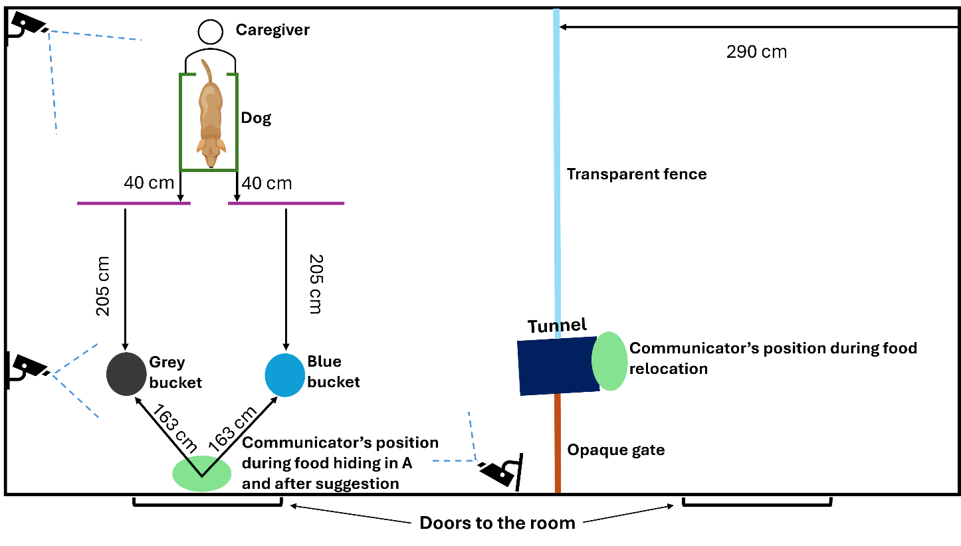
Figures
Figure S1 Sketch of the experimental room and set-up seen from above.

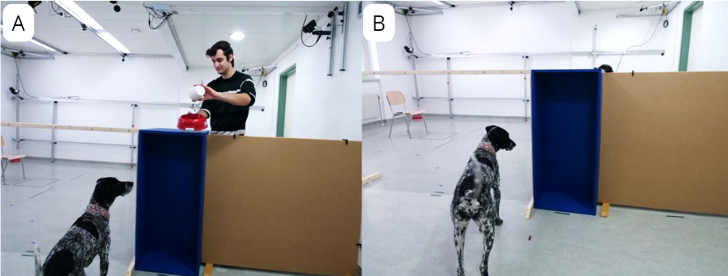
Figure S2 (A) The hider scoops the dry food back and forth above the barrier. (B) The hider scoops the food back and forth behind the barrier. The tunnel contains an opaque screen

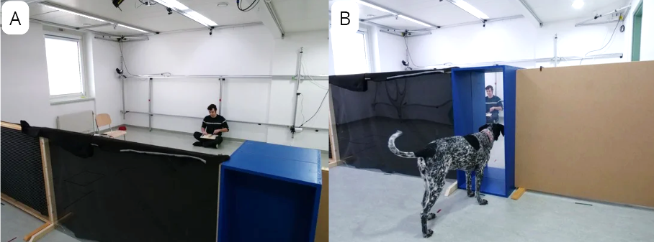
Figure S3. The manipulation check (A) The hider takes place in the predefined position in the middle of the wall and produces chopping sounds with a knife on a chopping board. For dogs in the FB group the tunnel contains an opaque screen so the hider is not visible from any point of the fence dividing the room in two sides. (B) The dog is free to roam on the other side of the fence relative to the hider and has visual access through the transparent screen in the tunnel to the hider in the TB condition.

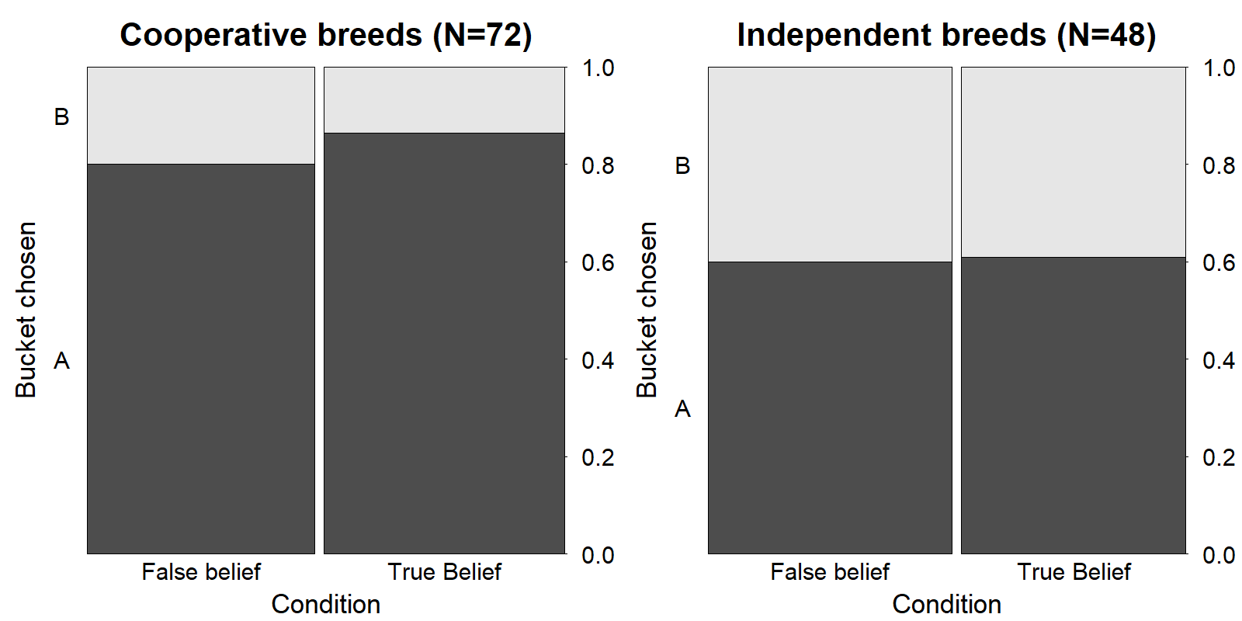
Figure S4. The interaction between breed type and condition.

