Fig. S1 Differential expression statistics for the GSE100179 and GSE117606 datasets. (A–C) Differential expression analysis of the GSE100179 dataset. (A) DEGs between adenoma and normal samples; (B) DEGs between tumor and adenoma samples; (C) DEGs between tumor and normal samples. (D–F) Differential expression analysis of the GSE117606 dataset. (D) DEGs between adenoma and normal samples; (E) DEGs between tumor and adenoma samples; (F) DEGs between tumor and normal samples. DEGs, differentially expressed genes.
Fig. S2 Stage‑specific GO and KEGG functional enrichment analyses of DEGs during CRC malignant progression. (A) Top enriched Gene Ontology (GO) terms covering biological process (BP), cellular component (CC), and molecular function (MF) for DEGs in the normal–tumor group. (B) Top enriched Kyoto Encyclopedia of Genes and Genomes (KEGG) pathways for DEGs in the normal–tumor group. (C) Representative enriched GO terms (BP, CC, MF) for DEGs in the adenoma–tumor group. (D) Representative enriched KEGG pathways for DEGs in the adenoma–tumor group. BP, biological process; CC, cellular component; MF, molecular function; CRC, colorectal cancer.
Fig. S3 Performance heatmaps of the two-layer machine learning classification models for colorectal cancer malignant transformation. Heatmaps display performance metrics of all combinatorial models from the two-layer ML framework across training, internal validation, and external test datasets. (A–D) First-layer models for classification of normal versus diseased samples: (A) Accuracy, (B) AUC-ROC, (C) F-score, (D) Recall. (E–H) Second-layer models for discrimination between adenoma and colorectal cancer tumor samples: (E) Accuracy, (F) AUC-ROC, (G) F-score, (H) Recall. Each row represents one independent combinatorial model. The color gradient reflects metric magnitude, where red corresponds to superior predictive performance and blue to inferior performance.

Fig. S4 Feature importance and average rank of lncRNA candidates identified by the two-layer machine learning model for stratifying colorectal cancer malignant transformation.(A) Importance ranking of lncRNA features in the first-layer model discriminating normal and diseased colonic tissues. Features are ordered by average rank across valid combinatorial models; bar color indicates the number of models in which each feature was included.(B) Importance ranking of lncRNA features in the second-layer model distinguishing adenoma from CRC tumor samples. Features are ordered by average rank across valid combinatorial models; bar color indicates the number of models in which each feature was included.

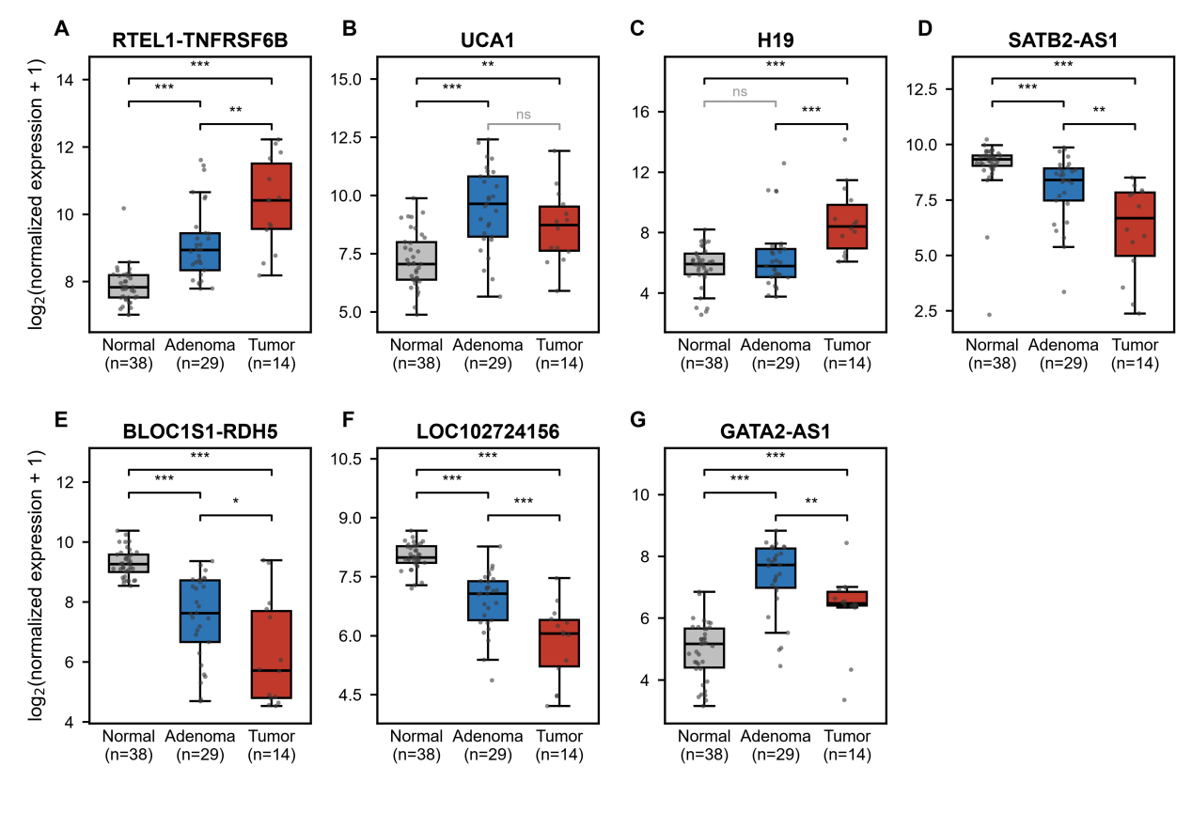

Fig. S5 Expression of seven lncRNAs across the normal mucosa–adenoma–carcinoma sequence in GSE37364. Box plots show the interquartile range (IQR) with the median as the horizontal line; whiskers extend to 1.5 × IQR; individual points represent single biopsy samples and are jittered horizontally. Expression values are presented as log2(normalized expression + 1). Groups: normal colonic mucosa (N, n = 38), adenoma (A, n = 29) and colorectal adenocarcinoma (T, n = 14, Dukes A/B). Panels: (A) RTEL1-TNFRSF6B, (B) UCA1, (C) H19, (D) SATB2-AS1, (E) BLOC1S1-RDH5, (F) LOC102724156, (G) GATA2-AS1. Comparisons were performed with two-sided Mann–Whitney U tests; *P < 0.05, **P < 0.01, ***P < 0.001, ns, not significant.

Fig. S6 Cellular composition across normal, adenoma (polyp), and CRC samples. Box plots showing the proportional distribution of 14 annotated cell types in normal, adenoma (polyp), and colorectal cancer (CRC) groups. P values indicate statistical differences in cell fraction among pathological groups. scRNA-seq data from GSE201349 (46,562 cells) were used to quantify cell proportions after cell-type annotation by SingleR.

