Supplementary Data

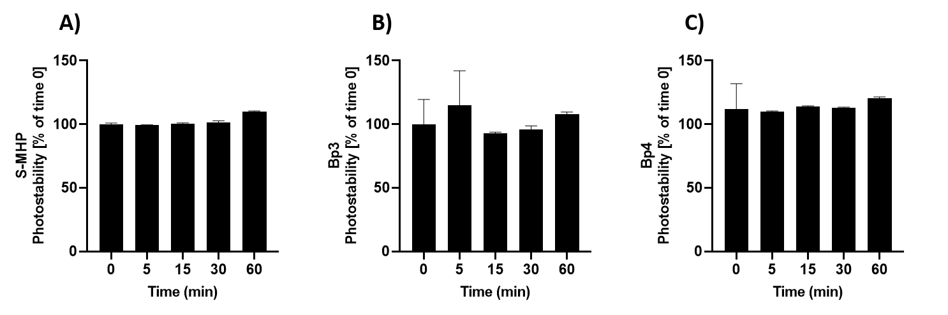
Figure S1. Photostability assessment of S-MHP (A) compared to Bp3 (B) and Bp4 (C). Absorbance values (270 nm for MHP , 290 nm for Bp3 and Bp4) were measured at different exposure times under UV irradiation (2.0 mW/cm2). S-MHP demonstrates high stability, with no significant decrease in absorbance after 60 min of irradiation. Data are presented as mean ± SD of at least three independent experiments.

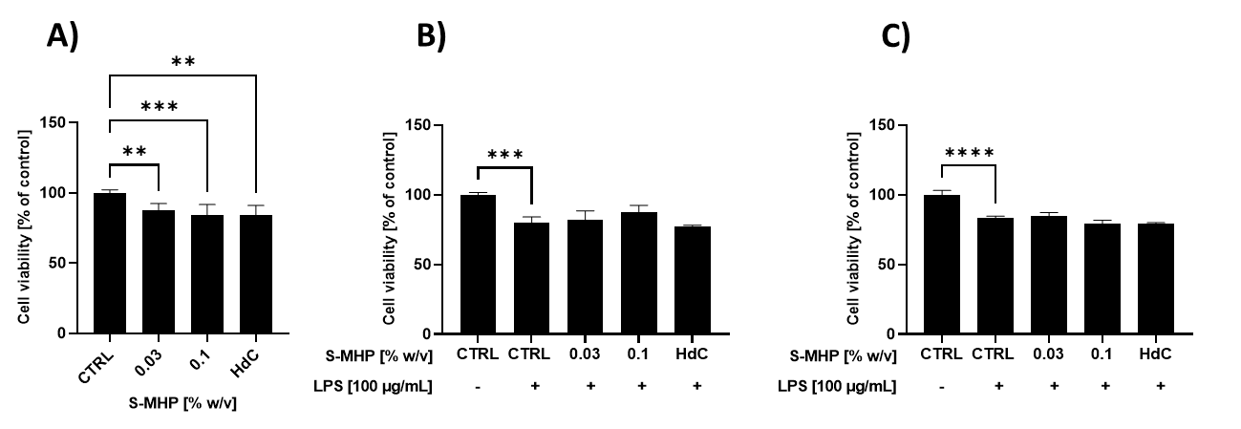
Figure S2. Evaluation of cell viability and cytoprotective effects of the S-MHP sample on RAW.264 cells.
(A) MTT assay of RAW.264 cells treated 24h with different concentrations of the extract (0.03–0.1% w/v). (B) Curative effect against inflammatory stress: cells were exposed for 24h to LPS, followed by 24 h of treatment with the extract (0.03% and 0.1% w/v). (C) Preventive effect against inflammatory stress: cells were pre-treated with the extract for 24 h before 24 h of LPS exposure. Cell viability was assessed by MTT assay and expressed as a percentage (%) relative to the negative control (CTRL). Data are presented as mean ± SD of at least three independent experiments. The significant differences are indicated by symbols on bars (**** p≤ 0.0001, (*** p≤ 0.001, ** p ≤ 0.01 vs CTRL). Other significant differences not indicated in the figure are reported below.
Fig. 2B: p≤ 0.001: CTRL- vs HdC; p ≤ 0.01: CTRL- vs 0.03%; p ≤ 0.05: CTRL- vs 0.1%; Fig. 2C: p≤ 0.0001: CTRL- vs 0.03%; CTRL- vs 0.1%; CTRL- vs HdC;

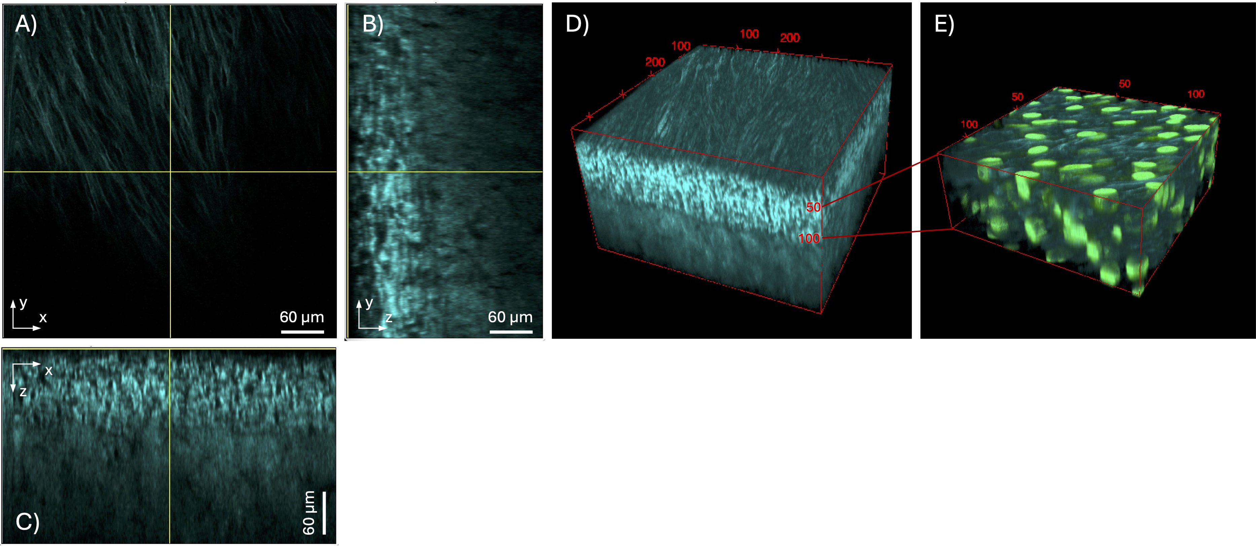
Video S1. Three-dimensional visualization of SHG and TPEF signals in the dermal compartment of the 3D skin model.
(A–C) Orthogonal views of the SHG z-stack acquired from a sample treated with 0.1% w/v F-MHP, displayed in the x–y, y–z, and x–z planes, respectively, as a dynamic reconstruction illustrating the three-dimensional organization of collagen fibers across increasing imaging depths. (D) Three-dimensional rendering of the same SHG z-stack shown in (A–C) covering a volume of 150 × 150 × 260 μm³. (E) Three-dimensional rendering of a 50 μm-deep dermal region from the same sample following Hoechst 33342 staining of fibroblast nuclei. The green channel corresponds to two-photon excited fluorescence (TPEF) of nuclei, while the cyan channel represents the SHG signal from collagen fibers.

