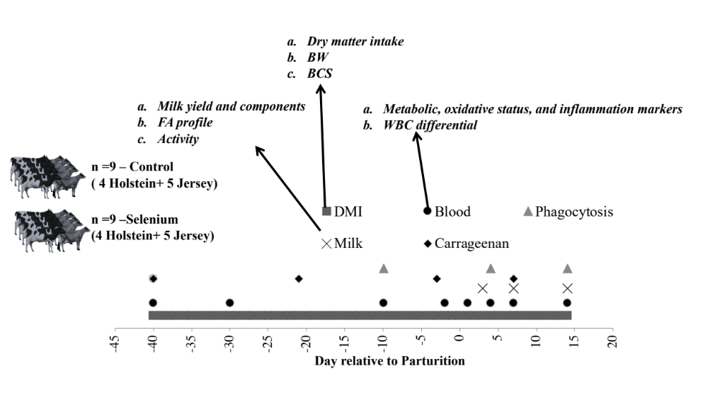
Figure S1. Experimental design and samplings. The Selenium group received 1% BW of Se-biofortified alfalfa (3.25 ppm of Se) from -40 to 14 day relative to parturition while the Control group received alfalfa without biofortification (0.43 ppm of Se). Indicated are the various samples taken and the analysis performed.

Figure S2. A) Weekly milk yield up to 120 days in milk, B) delta 9 activity toward C14:0, C) proportion (mg/100 mg fatty acid) of C23n3 and D) proportion (mg/100 mg fatty acid) of conjugated C18:3 in Jersey (Jer; n=5/group) and Holstein (Hol; n=4/group) pregnant heifers supplemented with 1% BW of Se-biofortified alfalfa hay (Sel) or no biofortified alfalfa hay (CTR) from 40 days prior expected parturition to 14 days after calving. Reported in the graph are the P-value of the overall effect of (TRT), Time, Br, and their interactions. Different letters denote statistical difference of P<0.05.

