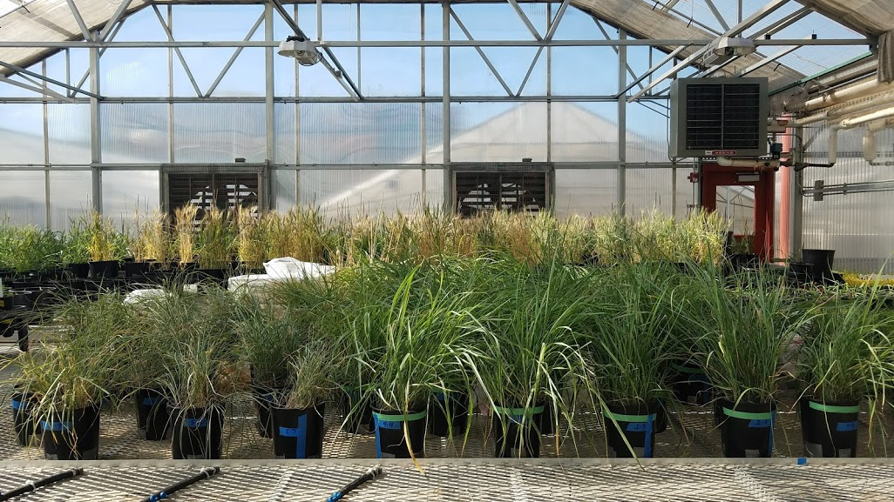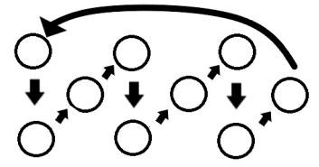
Fig. 1 (A) Illustrative photograph of treated communities. The pots on the left side show communities receiving the late-season drought treatment after 18 days, and the pots on the right show pots receiving the control treatment. These pots were mixed randomly prior to the 18th day following the initiation of the late-season drought treatment, but the relatively low canopy cover of the drought-treatment pots necessitated their grouping together to avoid shading from the control-treatment plants. After 18 days post-initiation of the late-season drought treatment, all pots were rotated according to (B) every 4 days.

Table S1 Wilcox tests for differences in RNE values between control and drought treatment. The two species, Andropogon gerardii and Sorghastrum nutans, and their three performance metrics were tested independently.
Species | Metric | Control RNE | Drought RNE | N | statistic | p-value
A. gerardii | ANPP | -0.22 | -0.228 | 5 | 11 | 0.841
A. gerardii | Reproduction | -0.129 | -0.147 | 5 | 17 | 0.421
A. gerardii | Survival | -0.096 | -0.109 | 5 | 15 | 0.69
S. nutans | ANPP | 0.136 | 0.115 | 5 | 14 | 0.841
S. nutans | Reproduction | -0.174 | -0.41 | 5 | 19 | 0.222
S. nutans | Survival | -0.096 | 0.001 | 5 | 16 | 0.293

