Electronic Supplementary Material
A recognition-enhanced colorimetric sensor based on molecularly imprinted CoFe LDH nanozymes for detection of enrofloxacin in real water samples
Chunyan Xiao^{1 *}, Zhihang Guo¹, Yunlong Jiu¹, Dongxue Lu¹, Yubo Yao², Baihan Li², Dongyang Wang^{2 *}
¹Institute of Resources and Environment, Henan Polytechnic University, Jiaozuo, 454000, China
²School of Environmental and Chemical Engineering, Jiangsu University of Science and Technology, Zhenjiang 212003, Jiangsu Province, PR China.

*Corresponding authors:
Chunyan Xiao
xiaochunyan@hpu.edu.cn (C. Xiao),
Dongyang Wang
wangdongyang@just.edu.cn (D. Wang)

Contents of Electronic Supplementary Material
Texts 3
Text S1 Chemicals and Instruments 3
Text S2 Optimization of Parameters Affecting the Specific Recognition of ENR 5
Text S3 Evaluation of the Peroxidase-Like Activity and Adsorption Behavior of CoFe LDH and MIPs@CoFe LDH 5
Text S4 Steady-State Kinetic Analysis of CoFe LDH toward H₂O₂ 6
Text S5 Reactive Oxygen Species Scavenging Experiments 7
Text S6 Electron Paramagnetic Resonance (EPR) Identification of Reactive Oxygen Species 8
FIGURES 9
Fig. S1 TEM images of (A) CoFe LDH, (B) magnified view of CoFe LDH, (C) NIPs-CoFe LDH, (D) magnified view of NIPs-CoFe LDH, (E) MIPs-CoFe LDH, and (F) magnified view of MIPs-CoFe LDH. 9
Fig. S2 Zeta potential profiles of CoFe LDH, NIPs@CoFe LDH, and MIPs@CoFe LDH 10
Fig. S3 Contribution ratios of various quenchers to the degradation efficiency of ENR 11
Fig. S4 UV–vis absorption spectra of the system introduced with MIPs@CoFe LDH before and after elution 12
Fig. S5 (A) Kinetic adsorption curves of MIPs@CoFe LDH and NIPs@CoFe LDH; (B) Pseudo-first-order kinetic fitting results; (C) Pseudo-second-order kinetic fitting results. 13
Fig. S6 (A) Effect of mass ratio between CoFe LDH and CS for the synthesis of MIPs@CoFe LDH; (B) Influence of mass ratio of CoFe LDH to ENR on catalytic optical response; (C) Optimization of MIPs@CoFe LDH concentration for nanozyme catalysis; (D), (E) and (F) display the effects of reaction time, pH and temperature on the MIPs@CoFe LDH + H2O2 + TMB system with and without ENR, respectively. 14
TABLES 15
Table S1 The chemical structures of ENR and its analogues. 15

Texts

Text S1 Chemicals and Instruments
Co(NO₃)₂·6H₂O, absolute ethanol, absolute methanol, and anhydrous sodium acetate (NaAc, 99%) were purchased from Xilong Scientific Co., Ltd. (Shantou, China). Fe(NO₃)₃·9H₂O, NH₄F (99.9%), urea (99%), glutaraldehyde (GA, 50%), CS; degree of deacetylation ≥95%; viscosity: 100–200 mPa·s), tert-butanol (TBA), furfuryl alcohol (FFA), p-benzoquinone (p-BQ), and tetracycline hydrochloride (TTC·HCl, 99%) were obtained from Shanghai Macklin Biochemical Co., Ltd. (Shanghai, China). 3,3′,5,5′-Tetramethylbenzidine (TMB, 98%) was purchased from Aladdin Reagent (Shanghai, China) Co., Ltd. H₂O₂ (30%) was supplied by Tianjin Xinbote Chemical Co., Ltd. (Tianjin, China). Hydrochloric acid (HCl) was purchased from Guangzhou Howei Pharma Tech Co., Ltd. (Guangzhou, China). Enrofloxacin (ENR, 98%) was obtained from Shanghai Yien Chemical Technology Co., Ltd. (Shanghai, China). Ciprofloxacin (CIP) was purchased from Beijing Huamaike Biotechnology Co., Ltd. (Beijing, China). difloxacin (DIF) from Shanghai Jianglai Biotechnology Co., Ltd. (Shanghai, China). and florfenicol (FLO) from Henan Shinong Biopharmaceutical Co., Ltd. (Jiaozuo, China). Sodium chloride, potassium chloride, barium chloride, zinc nitrate standard solution, Methanol (MeOH), calcium nitrate standard solution, magnesium nitrate standard solution, and aluminum nitrate standard solution were purchased from Sinopharm Chemical Reagent Co., Ltd. (Shanghai, China). Deionized water used throughout the experiments was produced using a Milli water purification system in our laboratory. All chemicals used in this study were of analytical grade and were used without further purification. The specifications of all chemicals are indicated throughout the manuscript where appropriate.
The morphology of the prepared materials was characterized using a scanning electron microscope (SEM, Hitachi SU8010, Japan). Transmission electron microscopy (TEM) was performed using a transmission electron microscope (JEM-2100F, JEOL, Japan). Fourier transform infrared (FT-IR) spectra were recorded using a Fourier transform infrared spectrometer (BRUKER TENSOR II, Germany). N2 adsorption desorption isotherms and pore size distributions were measured using a surface area and porosity analyzer (ASAP 2460, USA). The surface chemical composition was investigated by X-ray photoelectron spectroscopy (XPS, Thermo Scientific NEXSA, USA). Particle size and zeta potential were determined using a nanoparticle size and zeta potential analyzer (Nano ZS90, Malvern, England). Thermogravimetric analysis (TGA) was performed using a thermogravimetric analyzer (STA6000, USA). Ultraviolet-visible (UV–vis) absorption spectra were recorded using a UV-2600 spectrophotometer (Shimadzu, Japan). The crystalline phases and crystal structures of the prepared materials were characterized using an X-ray diffractometer (SmartLab SE, Rigaku, Japan).Electron paramagnetic resonance (EPR) spectra were acquired using an EPR spectrometer (Magnettech MS5000, Germany). 5,5-dimethyl-1-pyrroline N-oxide (DMPO), 2,2,6,6-tetramethylpiperidine (TEMP), and 5-tert-butoxycarbonyl-5-methyl-1-pyrroline N-oxide (BMPO) were utilized as spin-trapping agents to capture hydroxyl radicals (•OH), singlet oxygen (¹O₂), and superoxide anion radicals (•O₂–), respectively.

Text S2 Optimization of Parameters Affecting the Specific Recognition of ENR
To enhance the specific recognition capability and sensing performance of MIPs@CoFe LDH toward ENR, both the synthesis parameters and sensing conditions were systematically optimized ^{1, 2}. First, the thickness of the imprinted layer was regulated by varying the mass ratio of CS to CoFe LDH from 1:0 to 1:5. Subsequently, the mass ratio of the template molecule ENR to CoFe LDH was adjusted from 1:0.25 to 1:1 to optimize the density of the imprinted cavities. The effect of nanozyme concentration (0.05–0.2 mg·mL^{–1}) on the colorimetric response was also investigated. Finally, the catalytic reaction time (0–20 min) and the reaction pH (3.0–7.0) were optimized. In all experiments, the absorbance difference (ΔA = A₀ – A) between the presence and absence of ENR was used as the evaluation criterion to determine the optimal conditions for highly selective detection.

Text S3 Evaluation of the Peroxidase-Like Activity and Adsorption Behavior of CoFe LDH and MIPs@CoFe LDH
To evaluate the molecular recognition selectivity of MIPs@CoFe LDH toward ENR, several structural or functional analogues of ENR were selected as control compounds. The chemical structures of these compounds are listed in Table S1. Among them, CIP and DIF were selected as structural analogues belonging to the fluoroquinolone family, whereas TTC·HCl and FLO were chosen as representative antibiotics from the tetracycline and amphenicol classes, respectively, with structures similar to that of ENR ^{3, 4}. The selectivity experiments were conducted according to the colorimetric sensing procedure described in Section 2.6, except that the ENR solution (10 μM) was replaced with an equal concentration (10 μM) of each analogue. In addition, anti-interference experiments were performed to investigate the influence of common coexisting substances in environmental water samples. At a fixed ENR concentration of 10 μM, common inorganic ions in aquatic environments, including Na⁺, K⁺, Ca²⁺, Mg²⁺, Al³⁺, Zn²⁺, Ba²⁺, Cu²⁺, NH₄⁺ CO₃^{2–}, HCO₃–, SO₄^{2–}, and Br– ⁵, were individually introduced into the reaction system at a concentration of 100 μM, corresponding to ten times the ENR concentration.

Text S4 Steady-State Kinetic Analysis of CoFe LDH toward H₂O₂
The steady-state kinetic behavior of CoFe LDH toward H₂O₂ was investigated by monitoring the catalytic oxidation of 3,3′,5,5′-tetramethylbenzidine (TMB) ⁶. The experiments were conducted at pH 7.0 using a fixed CoFe LDH concentration of 100 mg L^{–1} and a constant TMB concentration, while the concentration of H₂O₂ was systematically varied. After all components were mixed, the absorbance of oxidized TMB at 652 nm was immediately recorded as a function of reaction time using a UV–vis spectrophotometer. The initial reaction velocity was calculated from the linear portion of the absorbance–time curve. The apparent Michaelis–Menten constant (K_{m}) and maximum reaction velocity (V_{max}) were obtained by fitting the initial reaction velocities to the Michaelis–Menten equation. The kinetic parameters were further determined using the Lineweaver–Burk equation:

$$\frac{1}{v_{0}}=\frac{K_{m}}{V_{max}}∙\frac{1}{{[H}_{2}O_{2}]}+\frac{1}{V_{max}}$$ | (1)

where v₀ is the initial reaction velocity and [H₂O₂] is the H₂O₂ concentration. The slope and intercept of the Lineweaver–Burk plot were used to calculate Kₘ and V_{max}, respectively.

Text S5 Reactive Oxygen Species Scavenging Experiments
The reactive oxygen species involved in the CoFe LDH-catalyzed oxidation process were investigated using different scavengers ⁷. Unless otherwise specified, the experiments were performed at pH 7.0 using 100 mg L^{–1} CoFe LDH and 100 μM ENR. MeOH and TBA were each added at a final concentration of 40 mM. MeOH was used as a scavenger for both ·OH and SO₄·–, whereas TBA was primarily used to quench ·OH. p-BQ and FFA were each added at a final concentration of 5 mM to scavenge O₂·–and ¹O₂, respectively.
For each experiment, the selected scavenger was added to the reaction system before initiation of the catalytic reaction. A control experiment without any scavenger was conducted under otherwise identical conditions. After the reaction was initiated by adding H₂O₂, the oxidation of TMB was monitored by measuring the absorbance at 652 nm. The oxidation efficiency in the presence of each scavenger was normalized against that of the scavenger-free control according to the following equation:

$$Relative oxidation efficiency \left(\%\right)=\frac{A_{scavenger}}{A_{control}}×100$$ | (2)

where A_{scavenger} and A_{control} represent the absorbance values obtained in the presence and absence of the corresponding scavenger, respectively. The apparent reaction rate constants were further obtained by fitting the time-dependent oxidation data using a pseudo-first-order kinetic model.

Text S6 Electron Paramagnetic Resonance (EPR) Identification of Reactive Oxygen Species
Electron paramagnetic resonance spectroscopy was used to further identify the reactive oxygen species generated in the CoFe LDH catalytic system. 5,5-Dimethyl-1-pyrroline N-oxide (DMPO) was employed as the spin-trapping agent for oxygen-centered radical species, including ·OH, SO₄·–, and O₂·–, while 2,2,6,6-tetramethylpiperidine (TEMP) was used as the spin-trapping agent for ¹O₂.
For ·OH and SO₄·– detection, DMPO was added to the freshly prepared CoFe LDH/H₂O₂ reaction system. For O₂·– detection, the corresponding DMPO trapping experiment was conducted under conditions suitable for stabilizing the DMPO–O₂·– adduct. For ¹O₂ detection, TEMP was added to the CoFe LDH/ H₂O₂ system immediately before EPR measurement. The reaction mixtures were rapidly transferred into quartz capillary tubes and analyzed using an EPR spectrometer. Control experiments lacking CoFe LDH or H₂O₂ were performed under identical conditions. The characteristic quartet signal with an intensity ratio of 1:2:2:1 was assigned to the DMPO–·OH adduct, whereas the characteristic triplet signal with an intensity ratio of 1:1:1 was attributed to the TEMP–¹O₂ adduct.

FIGURES
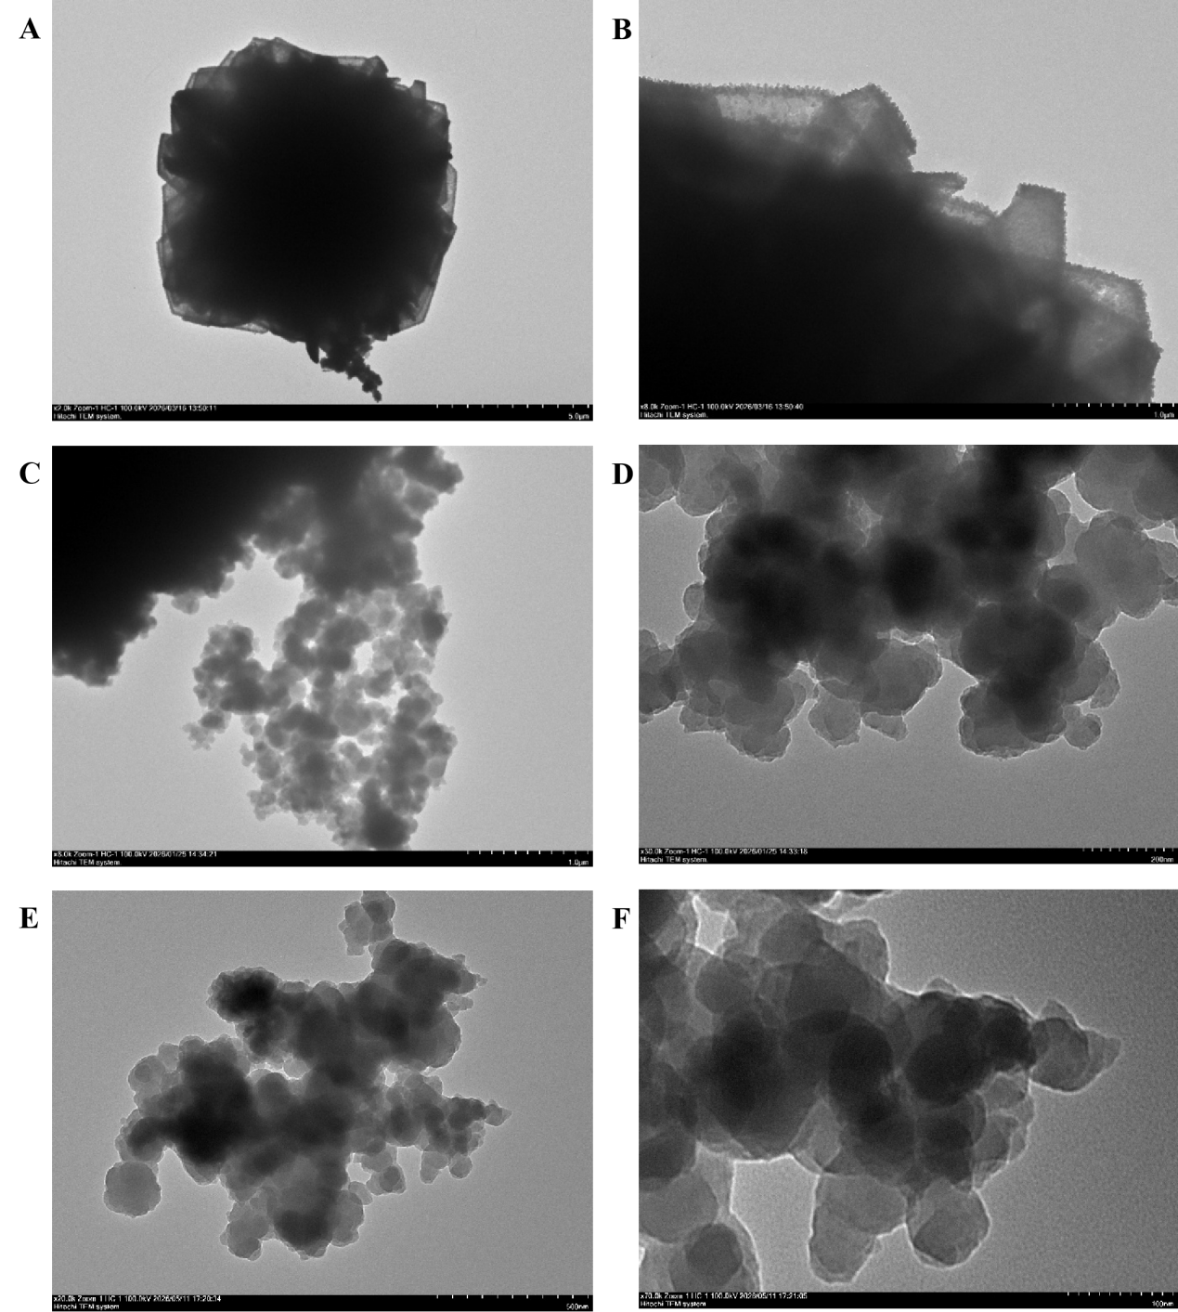

Fig. S1 TEM images of (A) CoFe LDH, (B) magnified view of CoFe LDH, (C) NIPs-CoFe LDH, (D) magnified view of NIPs-CoFe LDH, (E) MIPs-CoFe LDH, and (F) magnified view of MIPs-CoFe LDH.

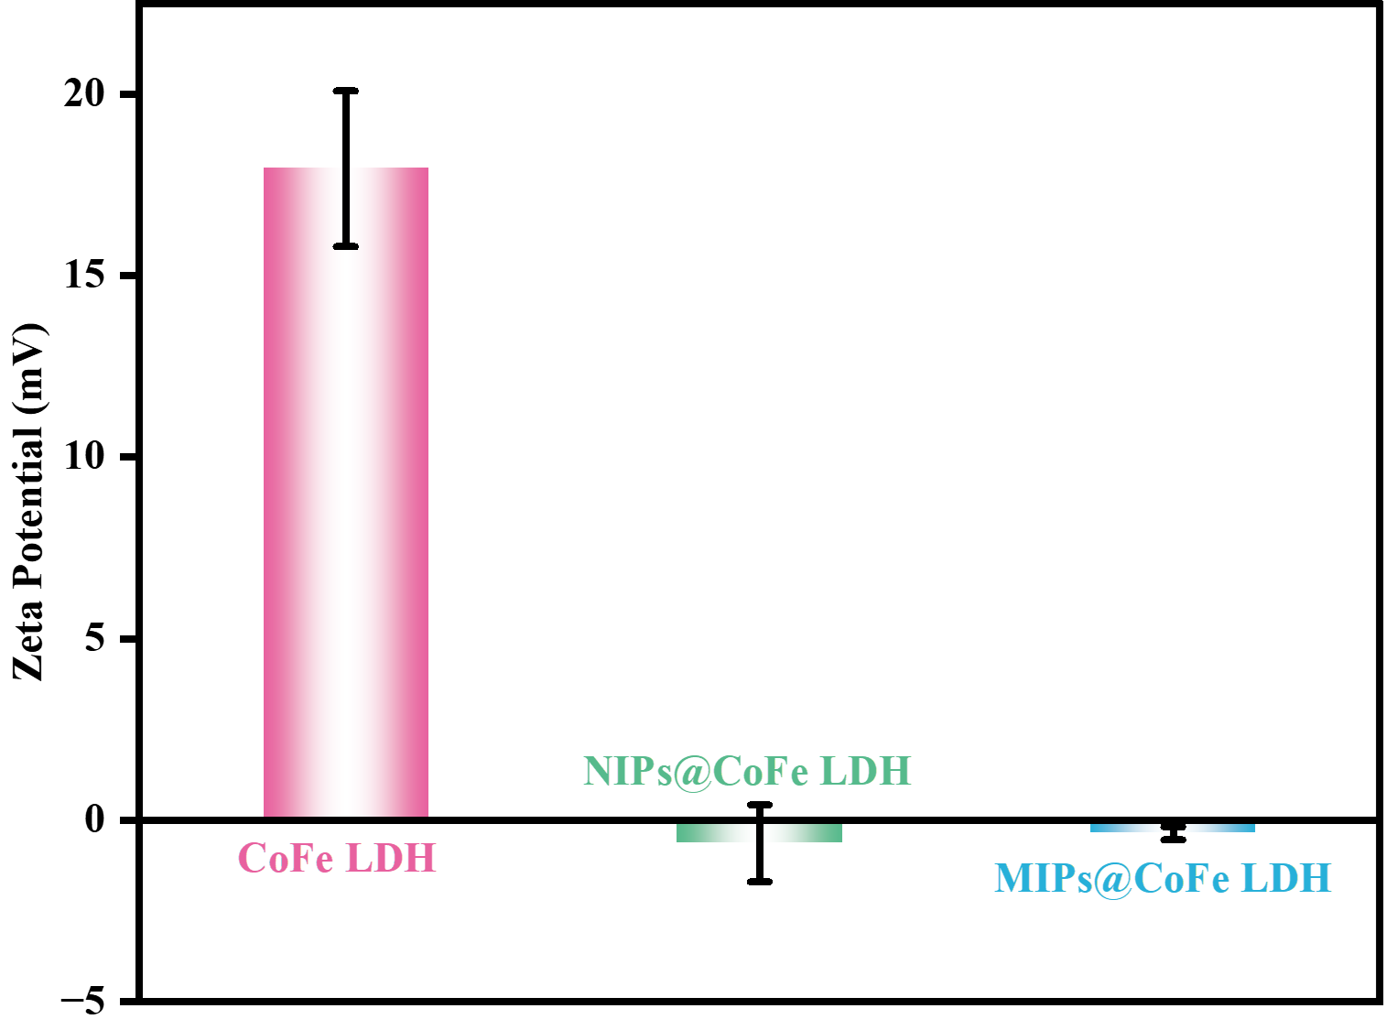

Fig. S2 Zeta potential profiles of CoFe LDH, NIPs@CoFe LDH, and MIPs@CoFe LDH

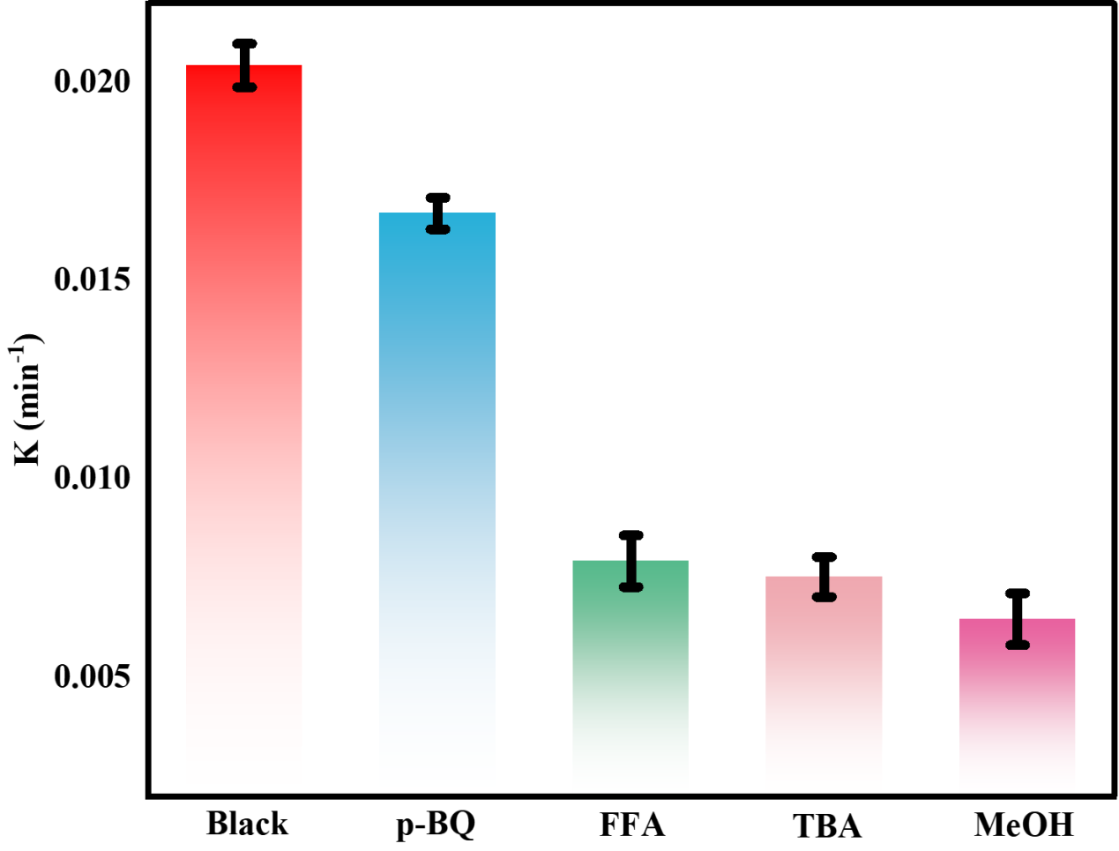

Fig. S3 Contribution ratios of various quenchers to the degradation efficiency of ENR

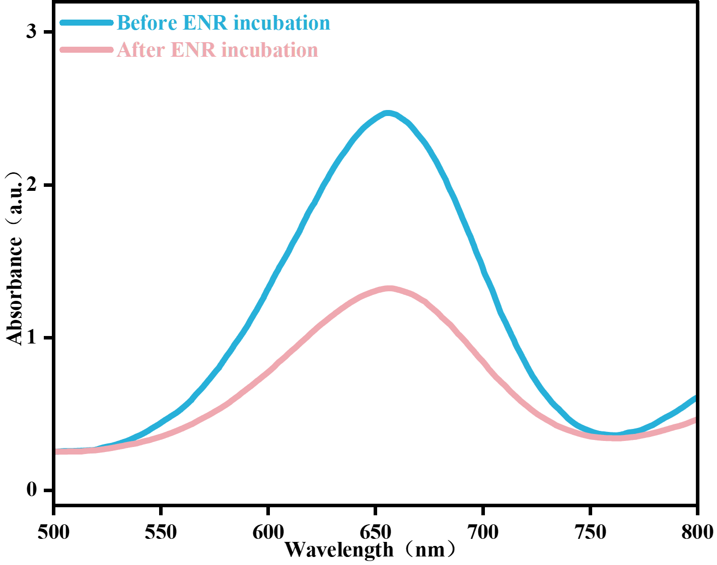

Fig. S4 UV–vis absorption spectra of the system introduced with MIPs@CoFe LDH before and after elution

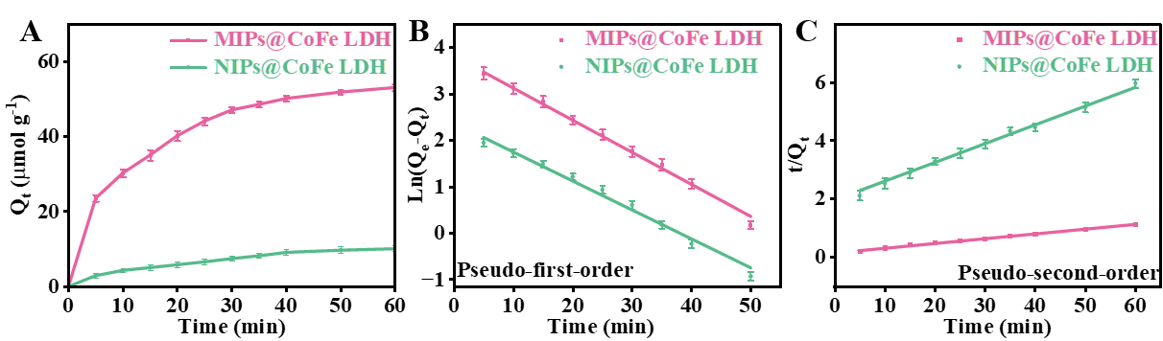

Fig. S5 (A) Kinetic adsorption curves of MIPs@CoFe LDH and NIPs@CoFe LDH; (B) Pseudo-first-order kinetic fitting results; (C) Pseudo-second-order kinetic fitting results.

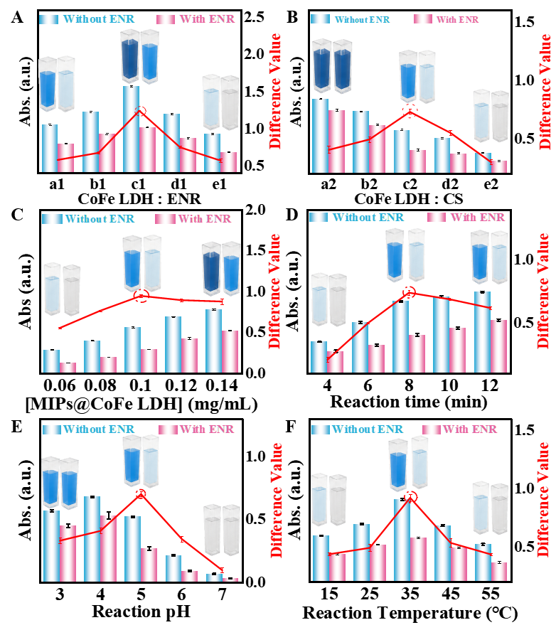

Fig. S6 (A) Effect of mass ratio between CoFe LDH and CS for the synthesis of MIPs@CoFe LDH; (B) Influence of mass ratio of CoFe LDH to ENR on catalytic optical response; (C) Optimization of MIPs@CoFe LDH concentration for nanozyme catalysis; (D), (E) and (F) display the effects of reaction time, pH and temperature on the MIPs@CoFe LDH + H2O2 + TMB system with and without ENR, respectively.

TABLES

Table S1 The chemical structures of ENR and its analogues.
Abbreviation | Chemical Name | Chemical Structure
ENR | 1-Cyclopropyl-7-(4-ethylpiperazin-1-yl)-6-fluoro-4-oxo-1,4-dihydroquinoline-3-carboxylic acid | 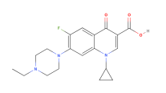
CIP | 1-Cyclopropyl-6-fluoro-4-oxo-7-(piperazin-1-yl)-1,4-dihydroquinoline-3-carboxylic acid | 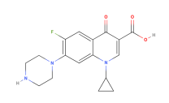
DIF | 6-Fluoro-1-(4-cyclopropylpiperazin-1-yl)-7-(4-methoxypiperazin-1-yl)-4-oxoquinoline-3-carboxylic acid | 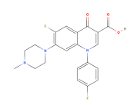
TTC | (4S,4aR,5S,5aR,6S,12aS)-4-(Dimethylamino)-1,4,4a,5,5a,6,11,12a-octahydro-3,6,10,12,12a-pentahydroxy-6-methyl-1,11-dioxonaphthacene-2-carboxamide | 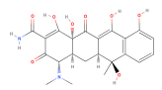
FLO | (2R,3R)-2-[(1R)-1-Fluoromethyl-2-hydroxy-2-(4-(methylsulfonyl)phenyl)ethyl]-5-(dichloromethyl)-4-methylthiazolidin-3-ol | 