Appendix

Table S1. Results of linear mixed-effects models examining the effects of mulberry stand age on soil physicochemical properties, enzyme activities and microbial characteristics. Linear Mixed-Effects Models (LMMs) were used to test the fixed effects of stand age on each measured variable, with plot included as a random effect. Here, AN, AP, and TC represent available nitrogen, available phosphorus and total carbon, respectively.
Category | Variables | NumDF | DenDF | F | P
Soil properties | Water content | 1 | 19 | 14.61 | 0.0011
 | pH | 1 | 19 | 0.55 | 0.4669
 | AN | 1 | 19 | 4.87 | 0.0397
 | AP | 1 | 19 | 3.03 | 0.0979
 | NH₄⁺-N | 1 | 19 | 15.81 | <0.001
 | NO₃⁻-N | 1 | 19 | 1.26 | 0.2758
 | TC | 1 | 19 | 7.56 | 0.0127
 | SOC | 1 | 19 | 5.71 | 0.0274
Microbial properties | Bacteria diversity | 1 | 19 | 2.10 | 0.1632
 | Fungi diversity | 1 | 19 | 0.00 | 0.9918
 | Bacteria community | 1 | 19 | 0.85 | 0.3694
 | Fungi community | 1 | 19 | 0.03 | 0.8632

Figure S1. Pictures of mulberry trees with different stand ages in the study area (a-f). (a) 5-year-old mulberry (T1); (b) 10-year-old mulberry (T2); (c) 15-year-old mulberry (T3); (d) 30-year-old mulberry (T4); (e) 70-year-old mulberry (T5); (f) 100-year-old mulberry (T6).
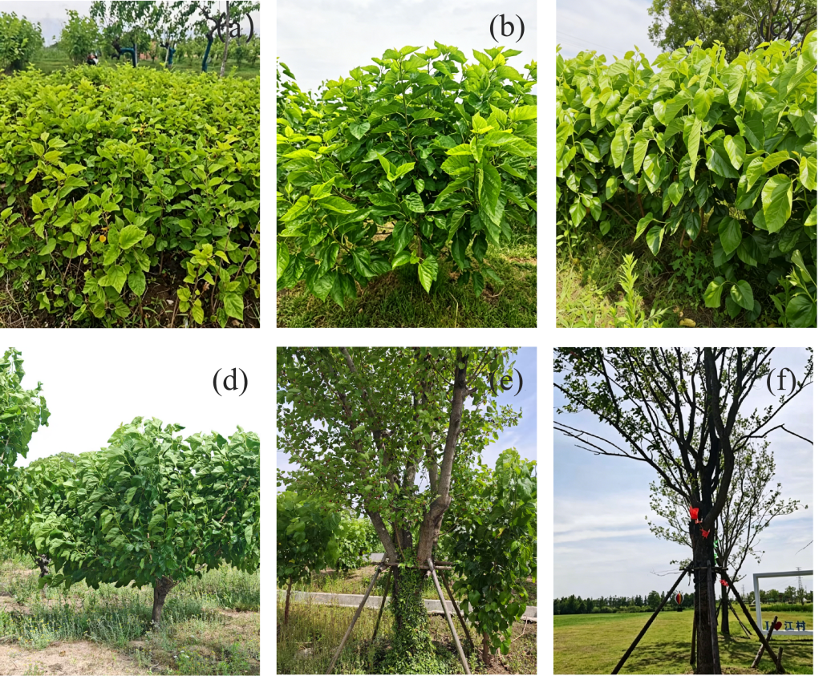

Figure S2. Linear regressions showing the relationship between soil physicochemical properties and stand age. Solid lines represent fitted regression lines for significant relationship (P<0.05), while dashed lines indicate non-significant trends. Here, AN, AP, and TC represent available nitrogen, available phosphorus and total carbon, respectively. The numbers 0, 5, 10, 15, 30, 70, and 100 represent CK (soil without mulberry cultivation), 5-year-old mulberry stands, 10-year-old mulberry stands, 15-year-old mulberry stands, 30-year-old mulberry stands, 70-year-old mulberry stands and 100-year-old mulberry stands.
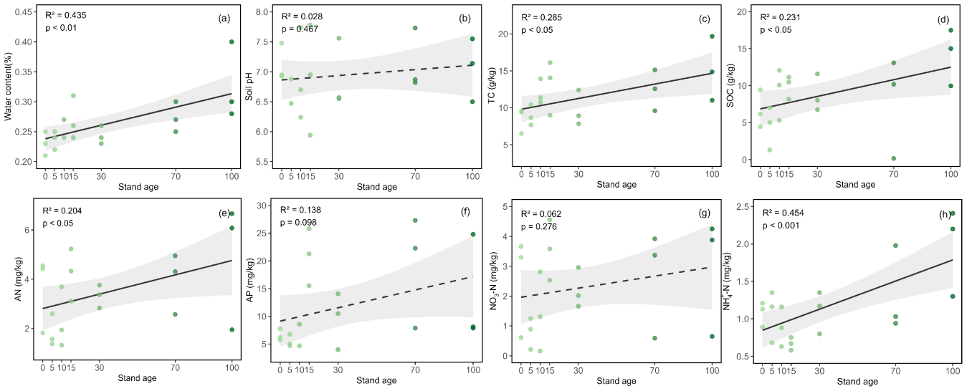
Figure S3. Alpha diversity indices of soil bacteria in mulberry stands of different ages, including the variations in Chao1 and Shannon indices. Here, 0, 5, 10, 15, 30, 70, and 100 represent CK (soil without mulberry cultivation), 5-year-old mulberry stands, 10-year-old mulberry stands, 15-year-old mulberry stands, 30-year-old mulberry stands, 70-year-old mulberry stands and 100-year-old mulberry stands.
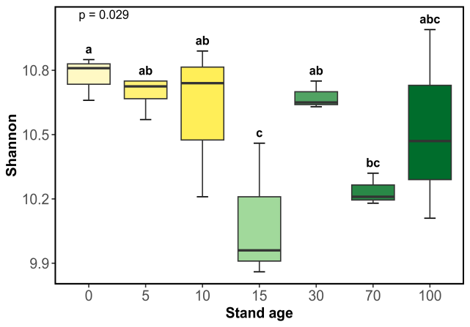
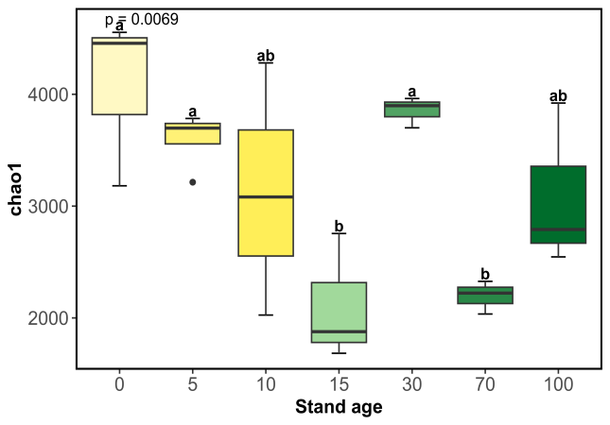
Figure S4. Alpha diversity indices of soil fungi in mulberry stands of different ages, including the variations in Chao1 and Shannon indices. Here, 0, 5, 10, 15, 30, 70, and 100 represent CK (soil without mulberry cultivation), 5-year-old mulberry stands, 10-year-old mulberry stands, 15-year-old mulberry stands, 30-year-old mulberry stands, 70-year-old mulberry stands and 100-year-old mulberry stands.
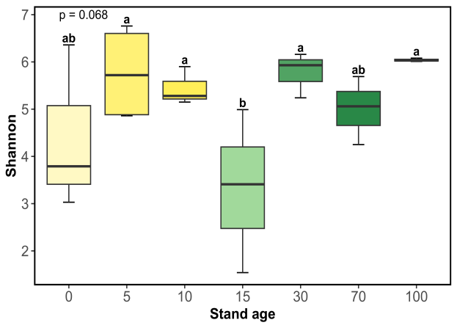
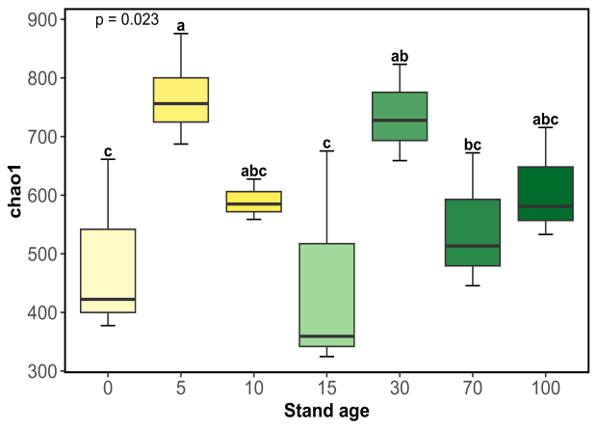
Figure S5. Community structure and composition of soil bacteria (a) and fungi (b) in mulberry stands with different stand ages. Non-metric multidimensional scaling (NMDS) was applied to distinguish the differences in bacterial and fungal community composition among mulberry stands of varying ages. Here, 0, 5, 10, 15, 30, 70, and 100 represent CK (soil without mulberry cultivation), 5-year-old mulberry stands, 10-year-old mulberry stands, 15-year-old mulberry stands, 30-year-old mulberry stands, 70-year-old mulberry stands and 100-year-old mulberry stands.
