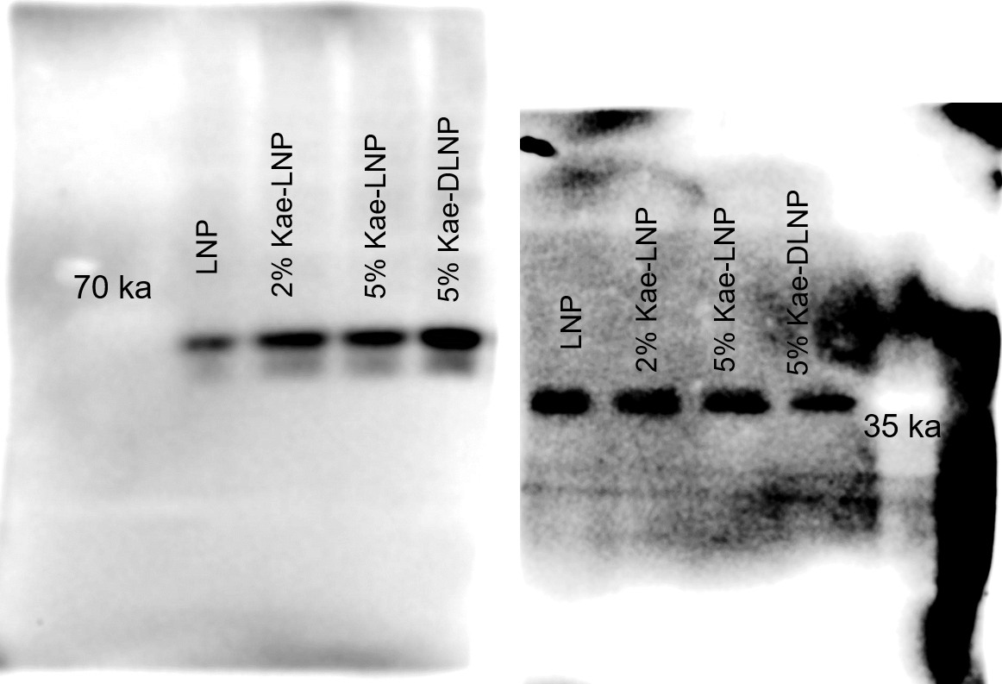
Figure6 d WB of p53 and GAPDH

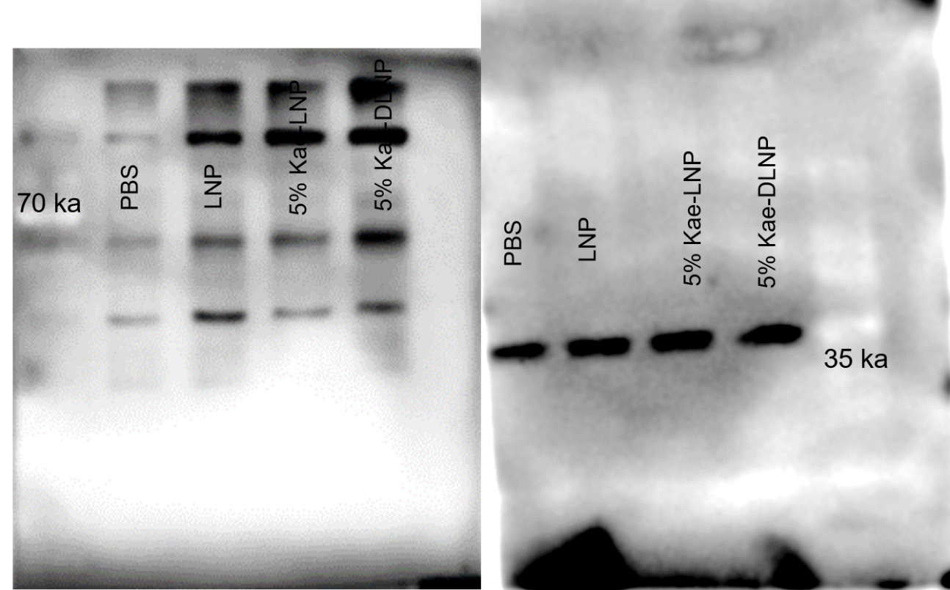
Figure7 d WB of p53 and GAPDH

