Supporting Information

Anti-Inflammatory Lipid Nanoparticles Derived from Kaempferol: A Dual-Functional mRNA Delivery Platform for Lung Cancer Therapy

Ruonan Li^{1,2,#}, Rui Chang^{3,#}, Zhaoxu Chen^{4,#}, Baozhong Li³, Kenan Chen³, Xianfu Liu⁵, Yiwen Liu^{1,2,**}, Shegan Gao^{1,2,*}

¹The First Affiliated Hospital, and College of Clinical Medicine of Henan University of Science and Technology, Luoyang, Henan, China, 471003
²Institute of Organoid‑on‑Chip and Drug Translation, Henan Academy of Sciences, Zhengzhou, Henan, China, 450046
³Department of Head and Neck Surgery, Anyang Tumor Hospital, Anyang, Henan, China, 455000
⁴School of Life Science and Technology, Xidian University, Xi’an, Shaanxi, China, 710126
⁵Linzhou Hospital of Traditional Chinese Medicine, Linzhou, Henan, China, 456550

#Ruonan Li, Rui Chang, and Zhaoxu Chen contributed equally to this work.
*Corresponding authors: yiwenliu810@163.com (Y. L.); gsg_112258@163.com (S. G.)

Keywords: Kaempferol; Lipid nanoparticles; Anti-inflammatory; mRNA delivery; Lung cancer

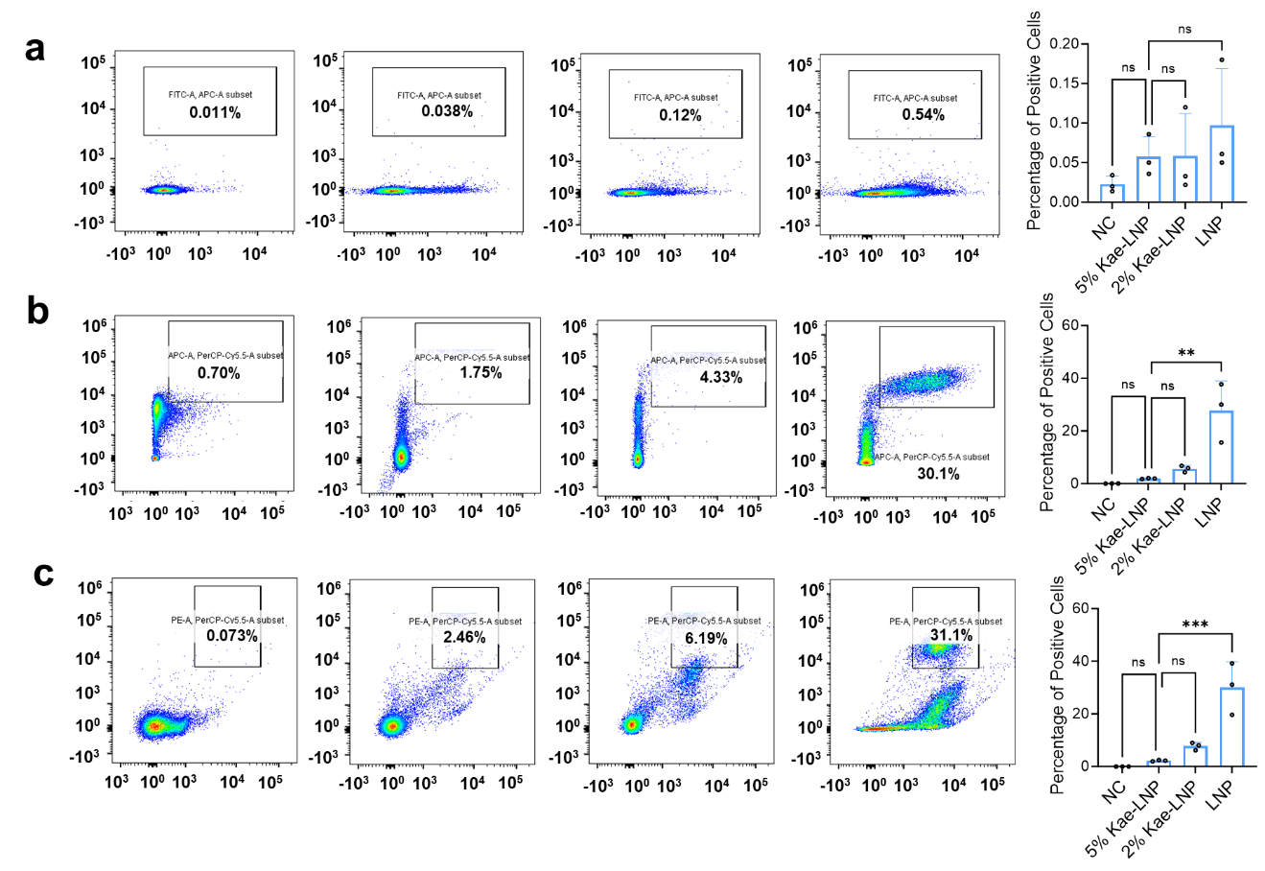
Figure S1. Mice were administered LNP, 5% Kae-LNP, or 2% Kae-LNP (10 mg/kg, 200 μL) via nebulization. Twelve hours later, immune cells were collected by bronchoalveolar lavage and analyzed by flow cytometry for positive rates. (a) Macrophages, (b) NK cells, (c) B cells, and the corresponding quantitative analysis of positive rates.

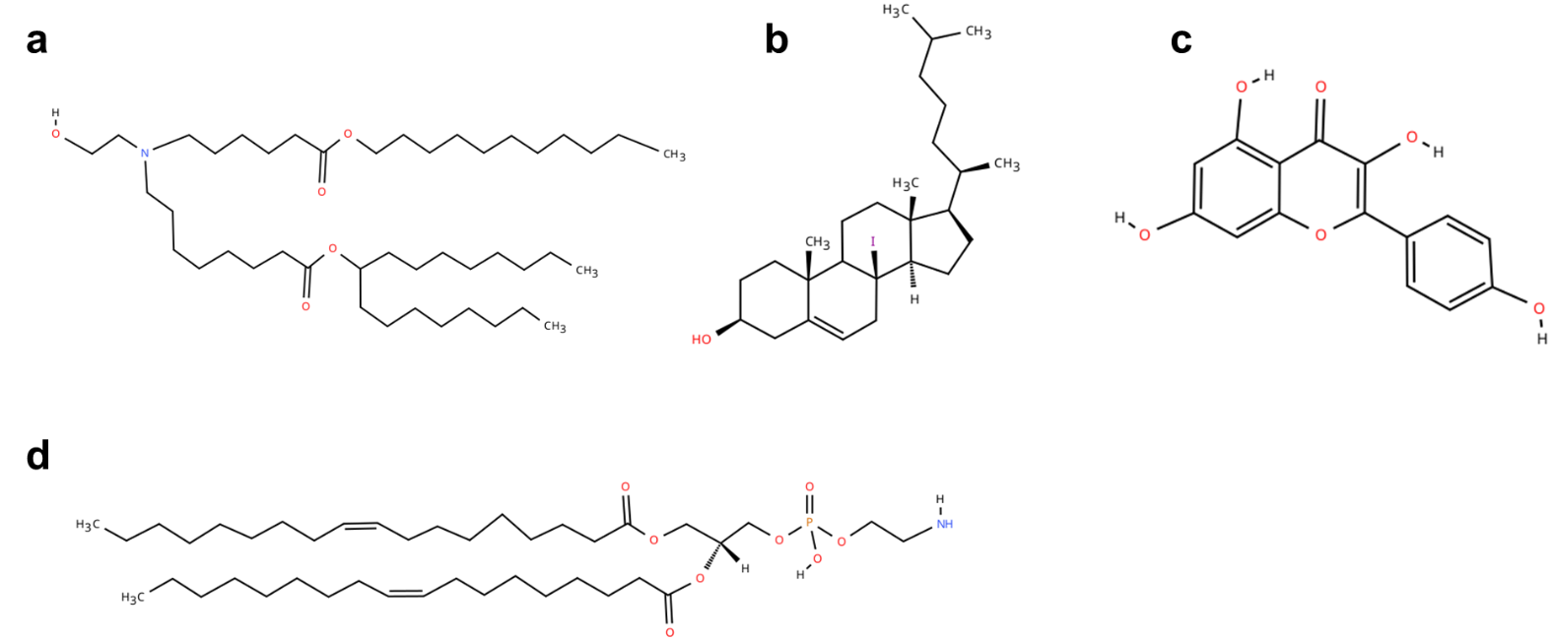
Figures S2. Chemical structures of the constituent lipids and functional components of the 5% Kae-DLNP formulation. (a) Ionizable lipid SM-102, (b) cholesterol, (c) kaempferol (Kae), (d) fusogenic helper lipid DOPE.

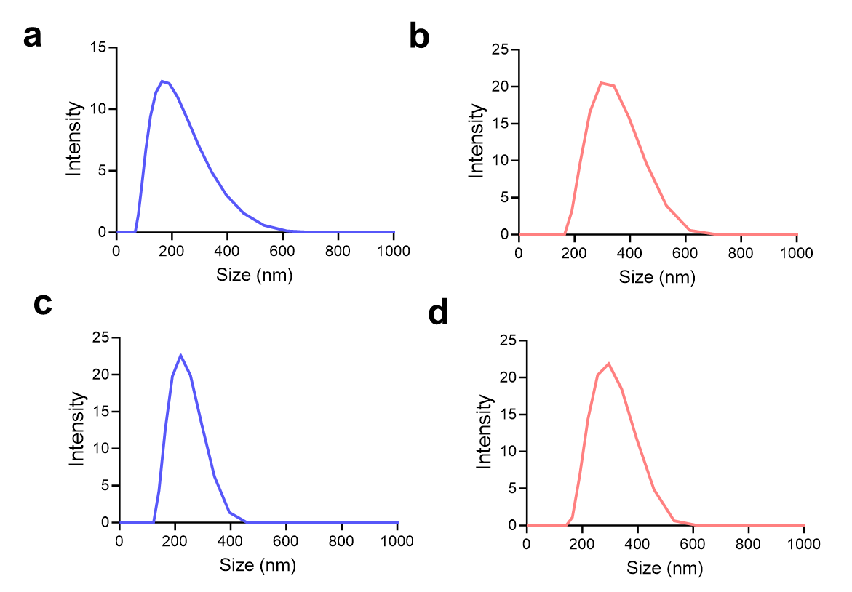
Figures S3. Particle size distribution of LNP and 5% Kae-DLNP measured by DLS before and after nebulization. (a) LNP pre-nebulization, (b) LNP post-nebulization, (c) 5% Kae-DLNP pre-nebulization, (d) 5% Kae-DLNP post-nebulization.

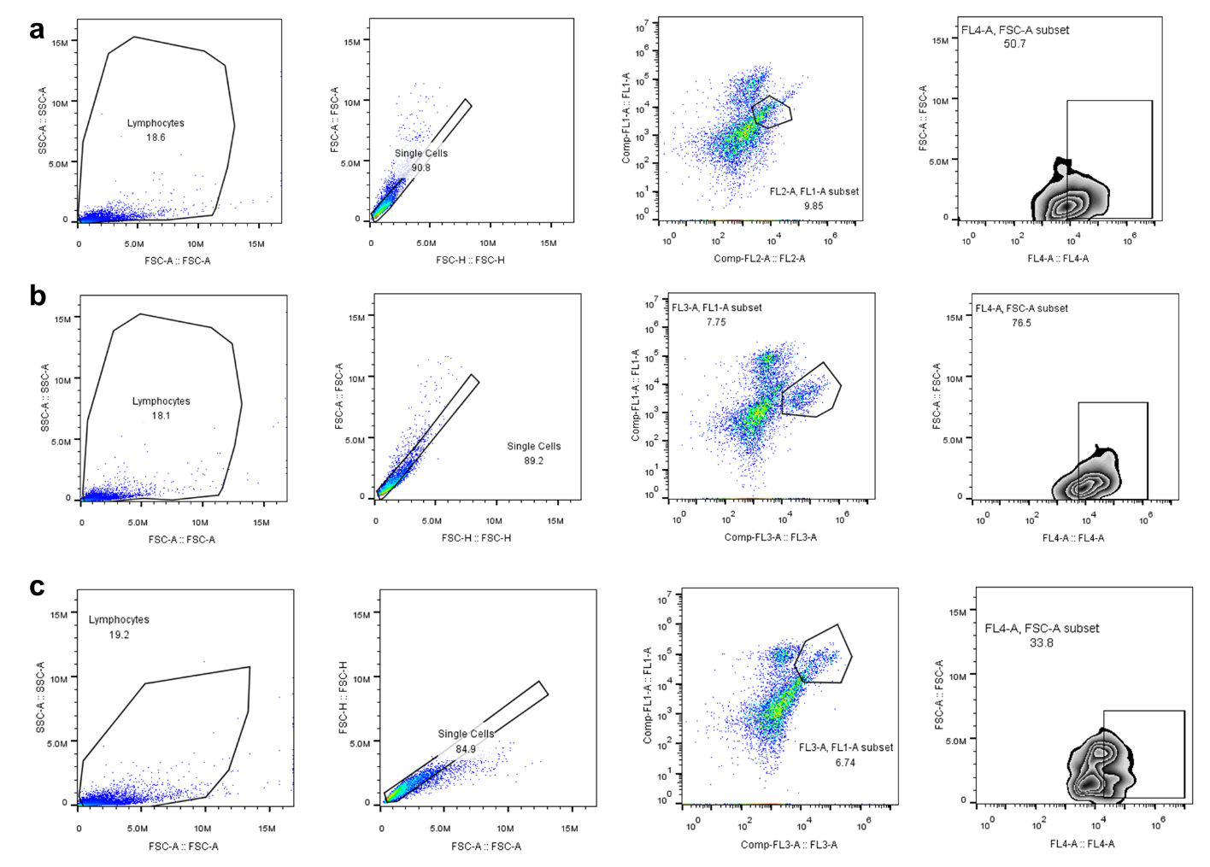
Figure S4. Representative flow cytometry gating plots showing the uptake of 5% Kae-DLNP by distinct pulmonary cell subsets. Mice were euthanized at 6 h after nebulization, and lung tissues were dissociated into single-cell suspensions for flow cytometric analysis. (a) Endothelial cells (CD45⁻/CD31⁺), (b) epithelial cells (CD45⁻/CD326⁺), (c) macrophages (CD45⁺/CD11b⁺).

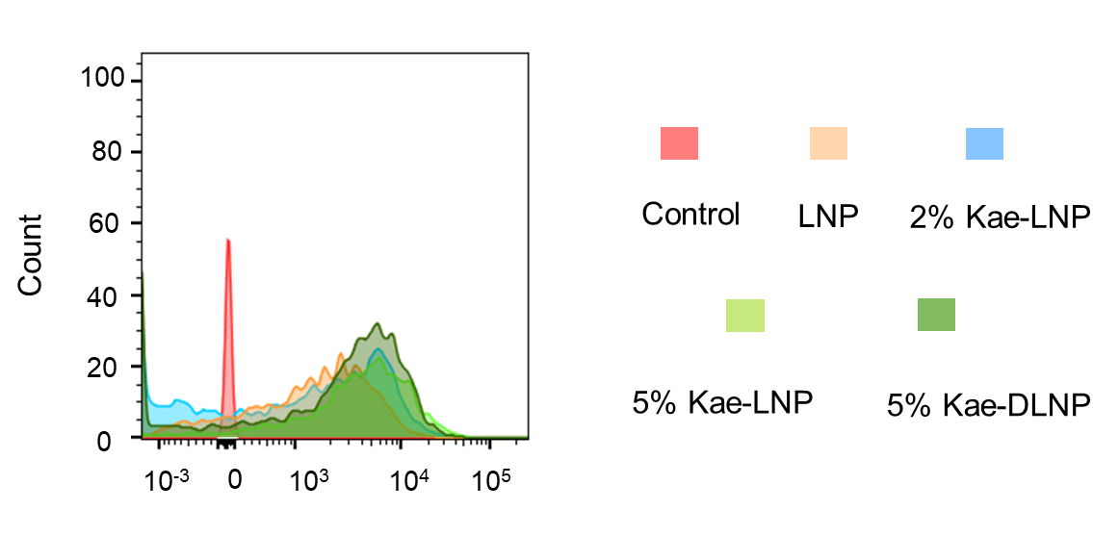

Figure S5. Cellular uptake of Cy5-labeled 5% Kae-DLNP, 5% Kae-LNP, 2% Kae-LNP, and LNP in A549 cells after 4 h of co-incubation, analyzed by flow cytometry.

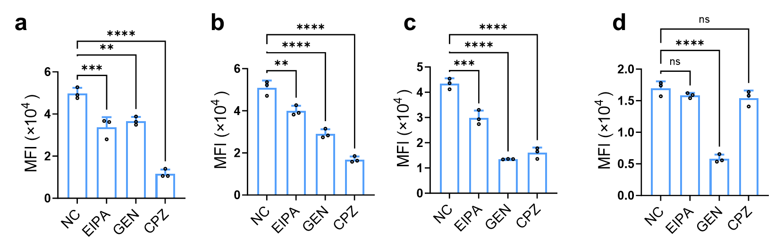
Figure S6. Flow cytometric analysis of the effects of endocytic inhibitors on cellular uptake of Cy5-labeled LNP formulations in A549 cells. A549 cells were treated with Cy5-labeled (a) LNP, (b) 2% Kae-LNP, (c) 5% Kae-LNP, or (d) 5% Kae-DLNP in the presence of the caveolae-mediated endocytosis inhibitor Genistein (GEN), the clathrin-mediated endocytosis inhibitor Chlorpromazine (CPZ), or the macropinocytosis inhibitor EIPA hydrochloride for 2 h. The mean fluorescence intensity (MFI) of Cy5 was then analyzed by flow cytometry to assess changes in cellular uptake. Data are presented as mean ± SD (n = 3).

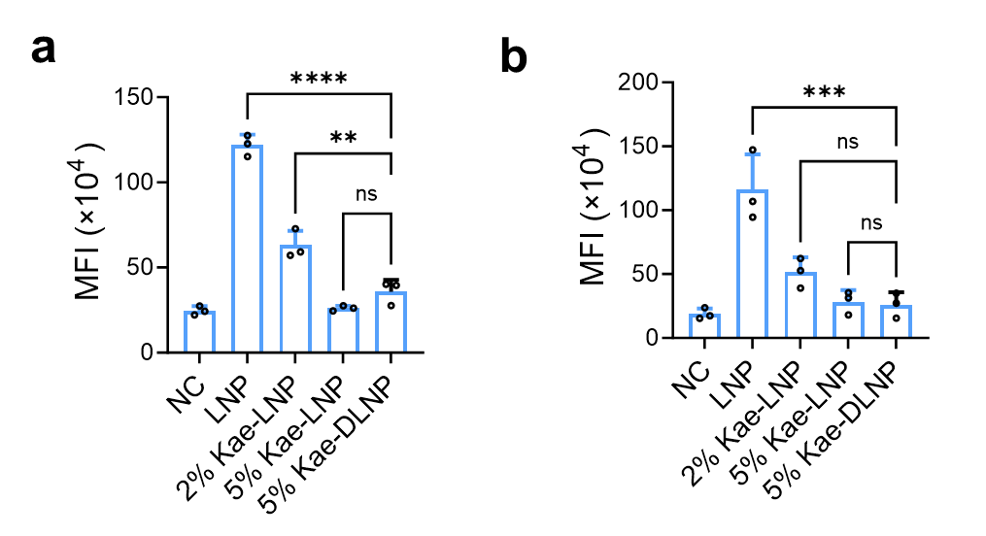
Figure S7. Quantitative analysis of immunofluorescence staining for (a) NLRP3 inflammasome and (b) the pro-inflammatory marker p65 in RAW 264.7 macrophages. Cells were treated with LNP, 2% Kae-LNP, 5% Kae-LNP, or 5% Kae-DLNP for 6 h. NC denotes the untreated negative control group. Data are presented as mean ± SD (n = 3).

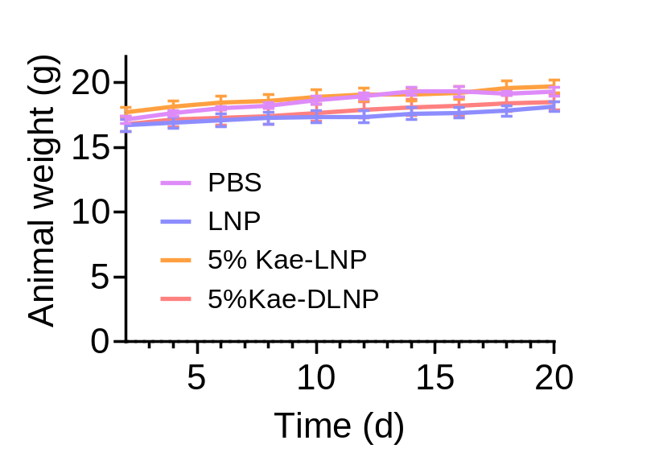
Figure S8. Monitoring of body weight in tumor-bearing mice throughout the treatment regimen. Mice were weighed every 2 days during the entire treatment period. Data are presented as mean ± SD (n = 5).

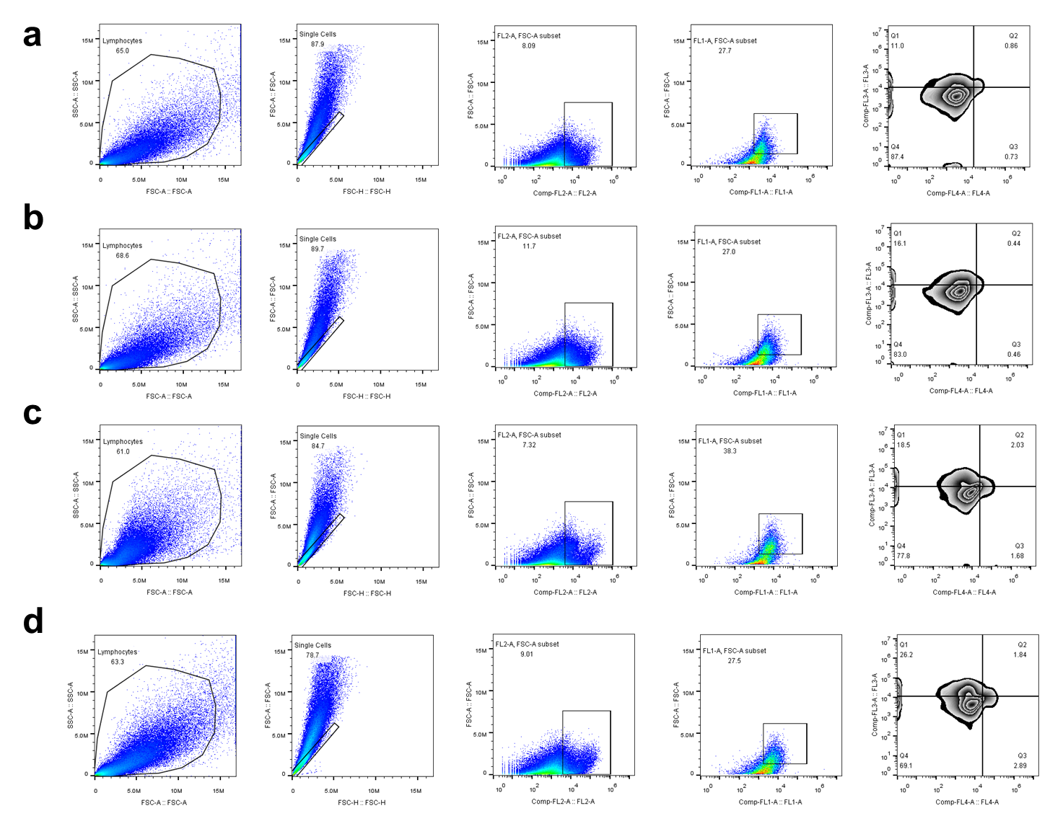
Figure S9. Representative flow cytometry gating strategy for tumor-infiltrating CD8⁺ T cells in the lung cancer model following treatment. Tumor tissues were harvested from mice treated with (a) PBS, (b) LNP, (c) 5% Kae-LNP, or (d) 5% Kae-DLNP, and CD8⁺ T cell populations were analyzed by flow cytometry.

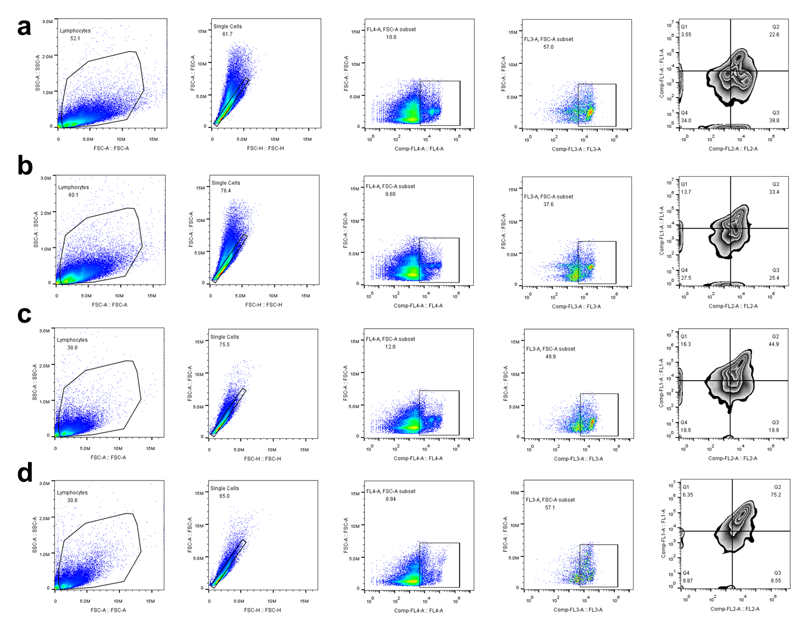
Figure S10. Representative flow cytometry gating strategy for memory T cell activation (CD44⁺/CD62L⁺) in splenocytes following treatment in the lung cancer model. Mice were treated with (a) PBS, (b) LNP, (c) 5% Kae-LNP, or (d) 5% Kae-DLNP. Splenocytes were harvested after treatment completion and analyzed by flow cytometry for the presence of activated memory T cells (CD44⁺/CD62L⁺ double-positive among CD3⁺CD4⁺ T cells).

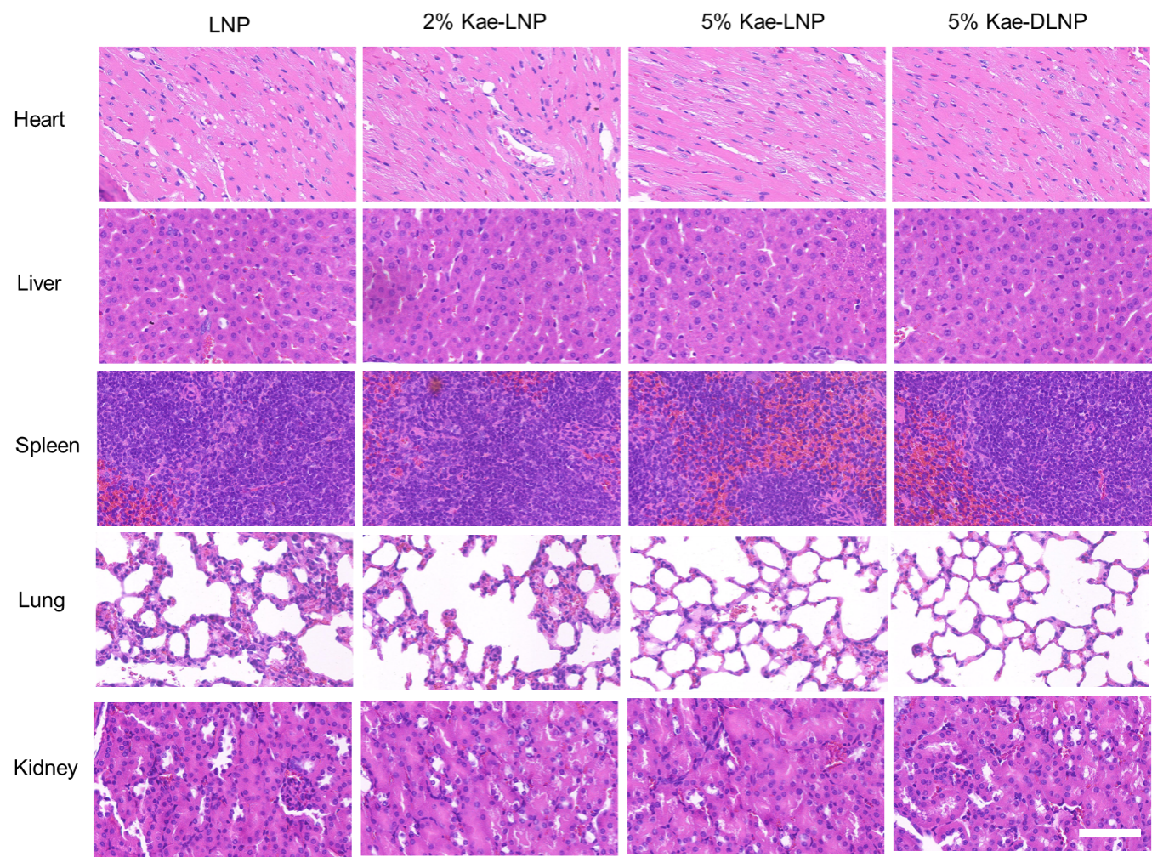
Figure S11. Figure S9. Histopathological analysis of major organs following pulmonary administration of LNP formulations. Mice were euthanized 24 h after nebulization with 5% Kae-DLNP, 5% Kae-LNP, 2% Kae-LNP, or LNP. Heart, liver, spleen, lungs, and kidneys were harvested and subjected to H&E staining for histological evaluation of potential organ damage or inflammatory responses. Scale bar: 100 µm.

