Supplementary Information for
Atomic-scale dynamics of water-triggered pathway-selective phase evolution in perovskite nanocrystals

Xu Xiang¹, Cheng Zheng¹, Yong Lu¹, Wenlong Wang¹, Bin Chen^{1,2,3*}

¹Center for Ultrafast Science and Technology, School of Chemistry and Chemical Engineering, Shanghai Jiao Tong University, Shanghai 200240, China
²State Key Laboratory of Synergistic Chem-Bio Synthesis, Shanghai Jiao Tong University, Shanghai 200240, China
³State Key Laboratory of Silicon and Advanced Semiconductor Materials, Zhejiang University, Hangzhou 310027, China

E-mail: cbcce@sjtu.edu.cn

This PDF file includes:
Supplementary Text
Supplementary Figs. 1 to 12
Supplementary Tables 1 to 7
Captions for Supplementary Movies 1 to 4
References

Supplementary Text
Supplementary Text 1. Estimation of electron-beam-induced temperature rise
The electron-beam-induced temperature rise was estimated using two steady-state heat-conduction models. The following e-beam characteristics were utilized for the estimation. The measured total e-beam current was 1.96 nA. At the electron fluence rate of 1.69 × 10⁴ e⁻ Å⁻² s⁻¹, the illuminated area of e-beam was about 7.24 × 10³ nm², corresponding to an equivalent beam diameter of approximately 96.0 nm.

Method 1. Egerton steady-state radial heat-flow model
Neglecting radiative heat loss, the steady-state temperature rise of a thin TEM specimen under electron irradiation is given by the radial heat-flow equation of Egerton-Li-Malac (1):
$${ΔT}_{Egerton} = \frac{I⟨E⟩}{4πκλ_{i}}[0.58 + 2ln(\frac{2R_{0}}{d})]$$
where I is the beam current, ⟨E⟩ is the mean energy loss per inelastic-scattering event, κ is the thermal conductivity, λᵢ is the inelastic mean free path, R₀ is the distance to an effective heat sink, and d is the equivalent illuminated beam diameter. Following the Malis–Cheng–Egerton dipole expression (2, 3), the effective atomic number Z_{eff} = 50.37 of CsPbBr₃ yields a characteristic energy loss E_{m} = 31.16 eV; meanwhile, with an incident electron energy of 200 keV and an assumed electron energy-loss spectroscopy (EELS) collection semi-angle β = 1 mrad, the inelastic mean free path is obtained as λᵢ = 164.6 nm. Approximating ⟨E⟩ by E_{m} and using I = 1.96 nA, κ = 0.42 W m⁻¹ K⁻¹ (4), R₀ = 30 μm, and d = 96.0 nm gives
$${ΔT}_{Egerton} = 0.95 K$$
Method 2. Fisher thin-foil heat-conduction model
The e-beam-induced temperature rise is also estimated using the Fisher model for a Gaussian electron beam in a thin foil (5, 6).
$${ΔT}_{Fisher} = \frac{I}{4πκe}(\frac{ΔE}{d})[1 + 2ln(\frac{b}{r_{0}})]$$
where e is the elementary charge, $\frac{ΔE}{d}$ is the electron stopping power, b is the radius of the effective heat sink, and $r_{0}$ is the beam radius. For a thin specimen, the stopping power is approximated from the inelastic-loss parameters as $\frac{ΔE}{d}$ ≈ $\frac{⟨E⟩}{λᵢ}$ = 0.189 eV nm⁻¹ = 3.03 × 10⁻¹¹ J m⁻¹. Taking b = 30 μm, $r_{0}$ = 48.0 nm, and the above parameters of I and κ into the Fisher equation, one gets
$${ΔT}_{Fisher} = 0.98 K$$
Both approaches yield a similar temperature rise of approximately 1 K under the stated assumptions. Our estimation is consistent with previous TEM studies showing negligible thermal heating of CsPbBr₃ under the e-beam irradiation (7). Such a small temperature increase is insufficient to account for the observed structural transformations.

Supplementary Text 2. Estimation of the critical size for the molten-like phase
As is well known, the temperature needed for the solid-liquid phase transformation is particle-size dependent. The Gibbs–Thomson relation provides a general estimate for the melting point $T_{m}\left(d\right)$ of a nanocrystal (NC) of diameter $d$, relative to the bulk melting temperature $T_{m,bulk}$ (8, 9):
$$ΔTₘ = T_{m,bulk} - Tₘ\left(d\right)=\frac{4T_{m,bulk} γ_{sl}}{{d ρ}_{s} L_{f} }$$
$$T_{m}(d) = T_{m,bulk}(1 - \frac{K}{d})$$
For the Gibbs–Thomson coefficient, K is given as
$$K = \frac{4γ_{sl}}{ρ_{s}L_{f}} = \frac{4γ_{sl}M}{ρ_{s}ΔH_{fus}}$$
where $γ_{sl}$ is the interfacial energy, $M$ is the molar mass, $ρ_{s}$ is the density, and $ΔH_{fus}$ is the molar enthalpy of fusion. The parameters of intermediate PbBr₂ used in the calculation are summarized in the following table. Note that in the estimation, $γ_{sl}$ is approximated using the available reported surface energy of PbBr₂ for the (002) facet, $γ_{eff}$ = 0.159 J m⁻² (12).
$$L_{f} = \frac{ΔH_{fus}}{M} = 44.69 kJ kg⁻¹$$
$$K ≈ \frac{4γ_{eff}}{ρ_{s}L_{f}} = 2.12 nm$$
In our work, the in-situ experiments were conducted at room temperature and the molten phase (MP) was present under this condition. Therefore, when substituting T₀ = 298 K and other parameters shown in the table, the critical diameter is obtained
$$d_{c} = \frac{K}{1 - \frac{T_{0}}{T_{m,bulk}}} = 3.95 nm ≈ 4.0 nm$$
This estimated value, though approximate, is in good agreement with the experimental observations, which provides a useful pictorial understanding of the size-dependent melting behavior in nanoscale particles.

Parameter | Symbol | Value | Source / Note
Bulk melting temperature | T_{m,bulk} | 644 ± 4 K | NIST recommended value (10)
Molar enthalpy of fusion | ΔH_{fus} | 16.4 ± 0.3 kJ mol⁻¹ | NIST recommended value (10)
Molar mass | M | 367.01 g mol⁻¹ | PbBr₂ molar mass
Solid density | ρ_{s} | 6.714 × 10³ kg m⁻³ | Reference-data (11)
Effective surface-energy | $$γ_{eff}$$ | 0.159 J m⁻² | PbBr₂ (002) surface energy (12)
Temperature | T₀ | 298 K | Room-temperature

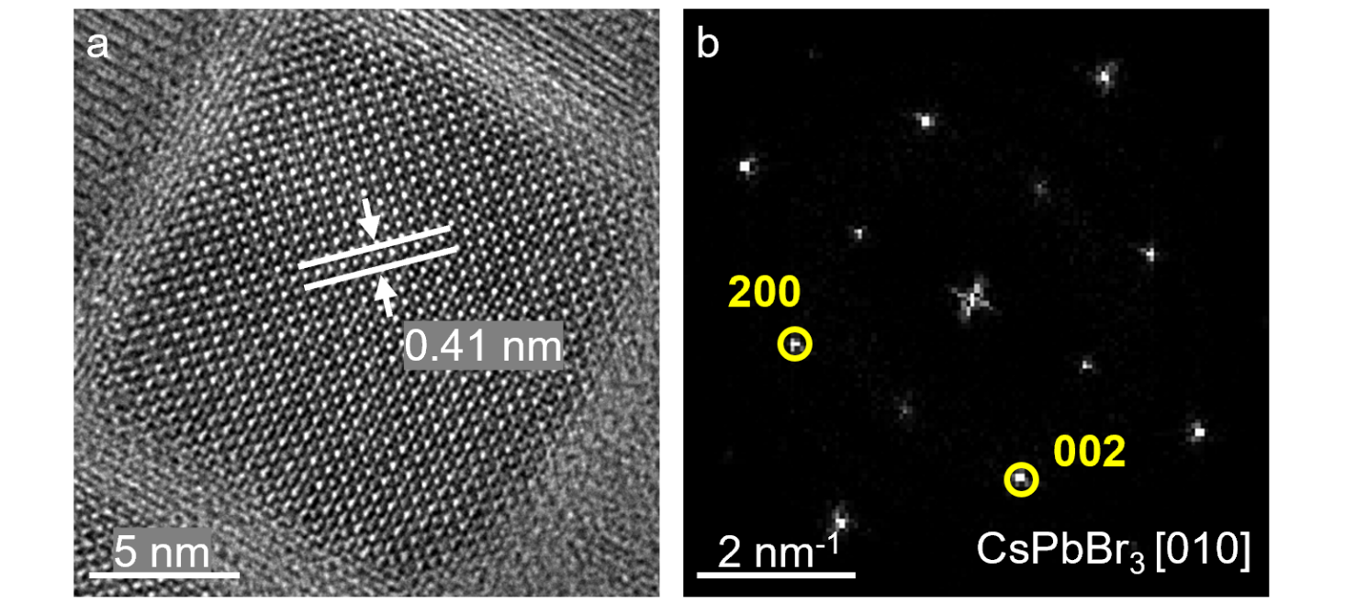
Supplementary Fig. 1 | a Typical HRTEM image, and b corresponding FFT pattern of the as-synthesized CsPbBr₃ NC. The measured lattice spacing of 0.41 nm corresponded to the {002} crystal plane of orthorhombic CsPbBr₃ perovskite.

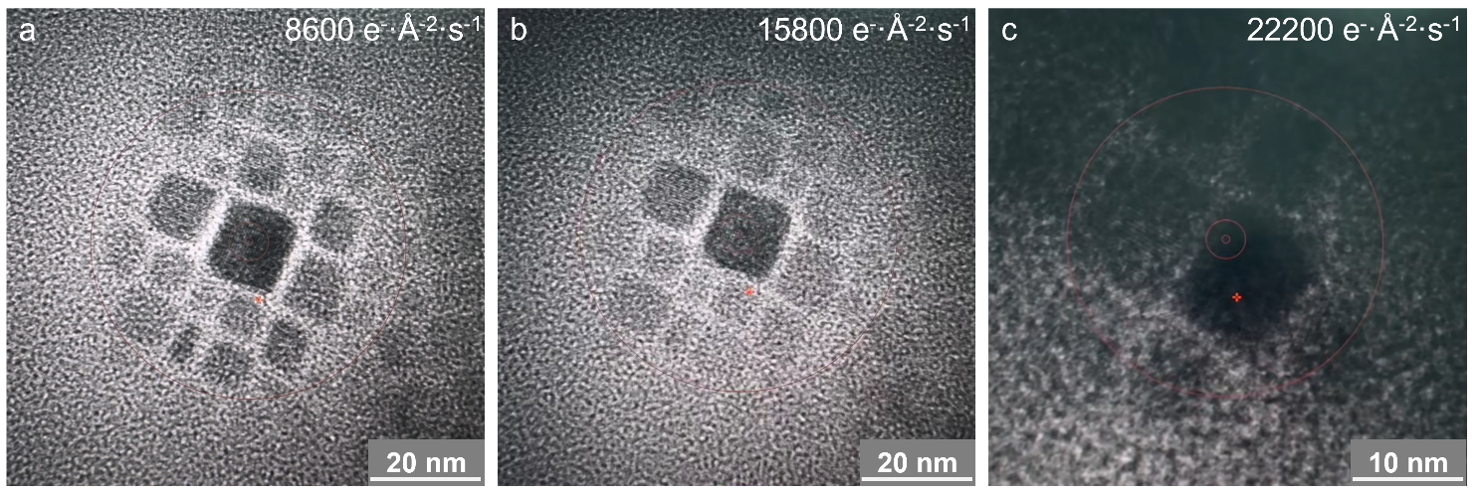
Supplementary Fig. 2 | Stability of the water-free CsPbBr₃ NCs under e-beam illumination. Representative TEM images acquired at the electron fluence rates of 8.6 × 10³ (a), 1.58 × 10⁴ (b), and 2.22 × 10⁴ e⁻ Å⁻² s⁻¹ (c), respectively. No obvious degradation was observed for the water-free NCs.

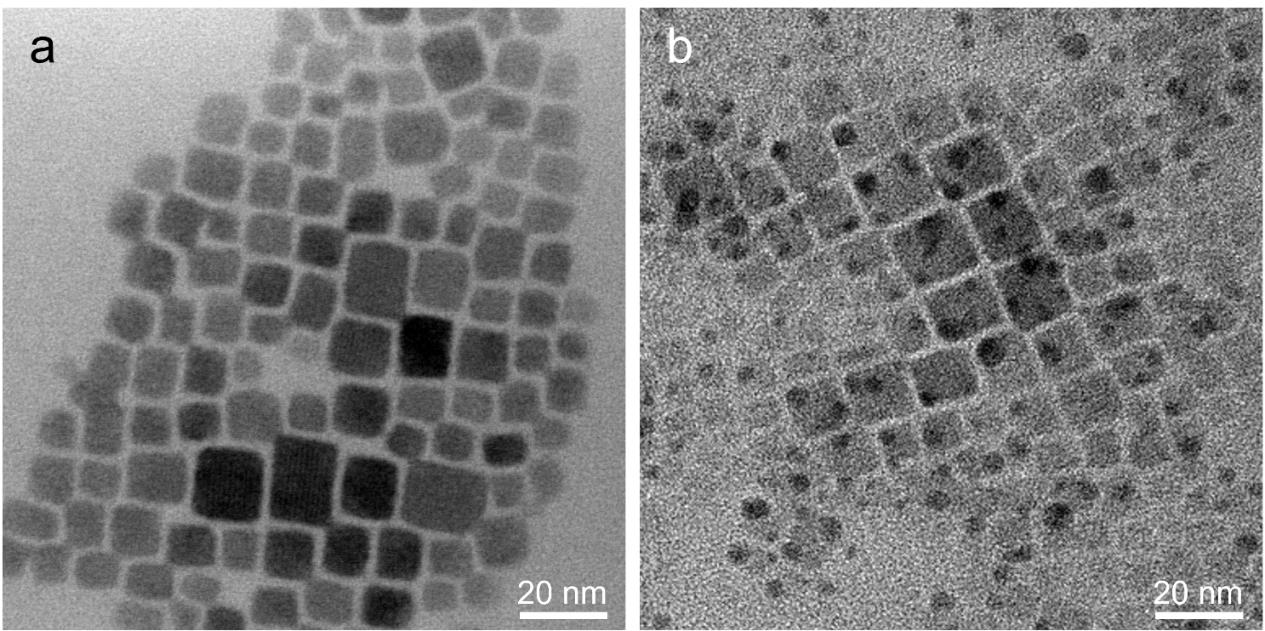
Supplementary Fig. 3 | Degradation of CsPbBr₃ NCs upon exposure to ambient humidity. a Initial morphology of the NCs before the water exposure. b Pronounced structural degradation of the NCs after ambient moisture exposure with a relative humidity of ~60%. The electron fluence rate for the observation was ~40 e⁻ Å⁻² s⁻¹.

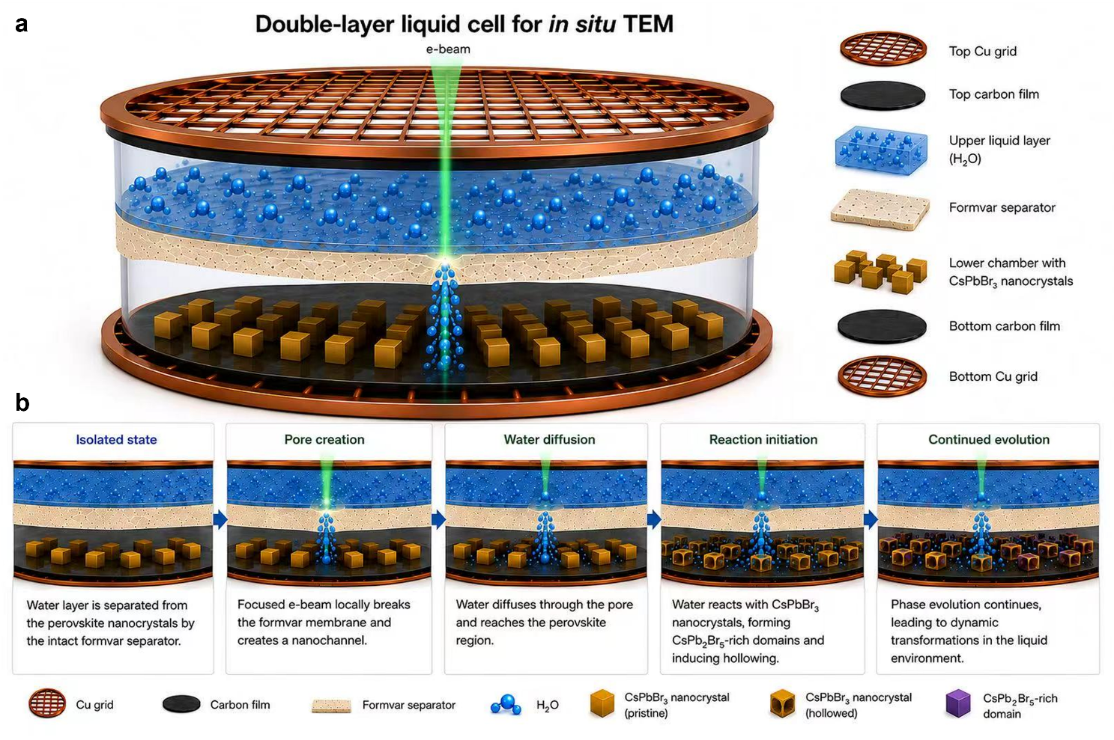
Supplementary Fig. 4 | Schematic of double-layer liquid cell used for in-situ observation of perovskite–water interaction. a Layered architecture showing the upper water layer is separated from the lower CsPbBr₃ NCs by an intermediate formvar separator. b Evolution sequence of the NCs from the initially isolated state, through local formvar-pore creation and water diffusion, to water–nanocrystal contact and subsequent structural evolution.

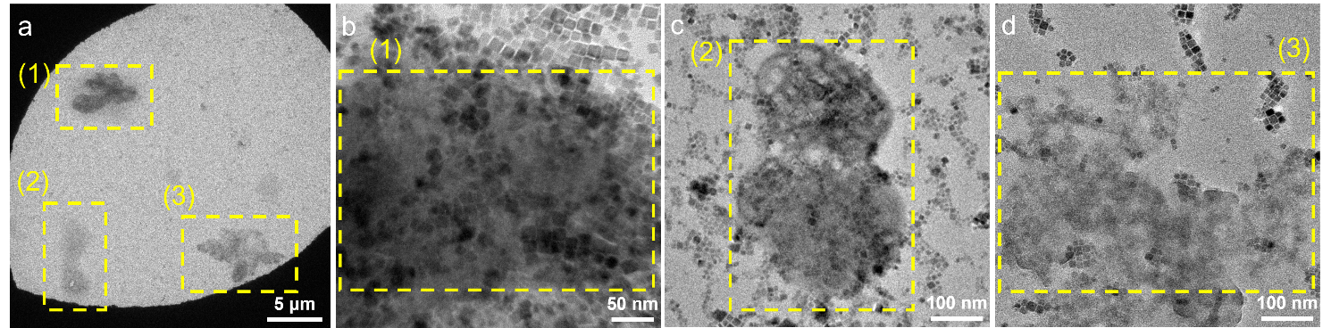
Supplementary Fig. 5 | Initial morphology of CsPbBr₃ NCs in the assembled double-layer liquid cell before the rupture of the intermediate formvar layer (no contact with water). a TEM image showing the overall distribution of CsPbBr₃ NCs in the liquid-cell specimen. The dashed boxes labeled (1)–(3) indicate three representative regions selected for higher-magnification observation. b–d Enlarged TEM images corresponding to the regions (1), (2), and (3), respectively. These shaded regions were the liquid pockets inside the double-layer liquid cell.

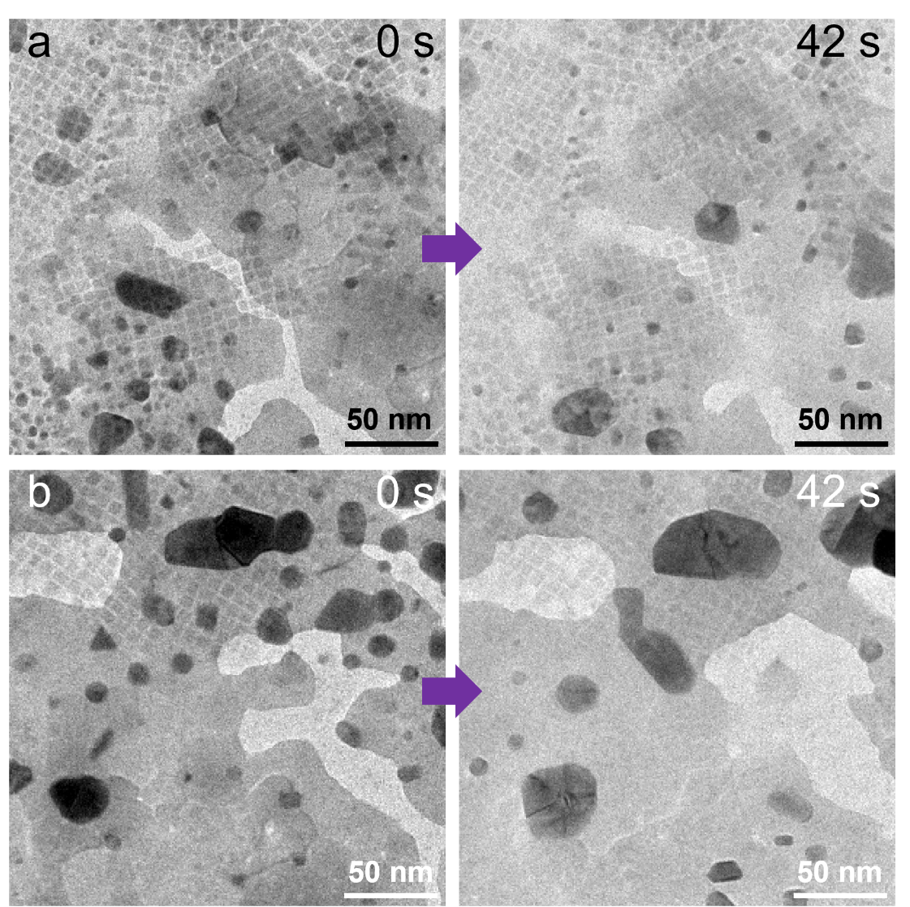
Supplementary Fig. 6 | CsPbBr₃ NCs in the double-layer liquid cell without the rupture of the intermediate formvar layer. a, b Two examples from different regions were illustrated, showing the morphology of the NCs during the period from 0 s to 42 s. At the low electron fluence rate of ~40 e⁻ Å⁻² s⁻¹, the intermediate formvar layer remained intact and the NCs were spatially separated from the top liquid layer. No obvious degradation was observed even though the liquid water flowed inside the top layer.

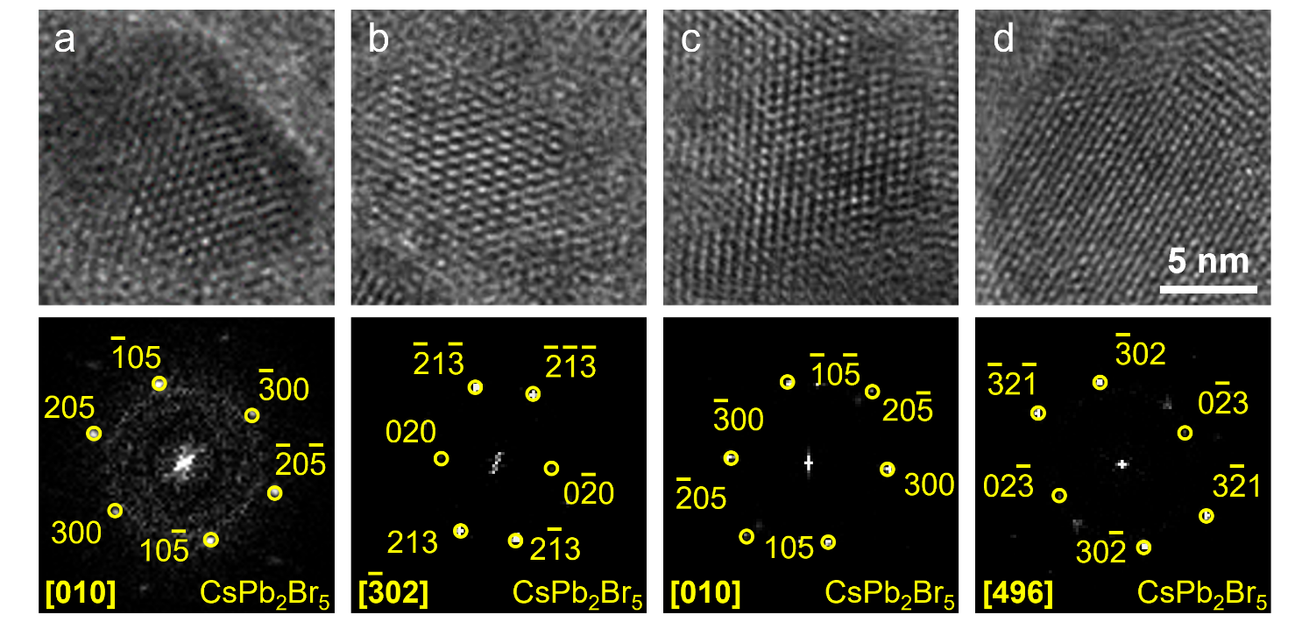
Supplementary Fig. 7 | Structural identification of water-induced CsPb₂Br₅ nanoparticles. a–d Representative HRTEM images and corresponding FFT patterns of the newly formed CsPb₂Br₅ nanoparticles viewed along different zone axes. Detailed analyses are listed in Supplementary Tables S1 to S4.

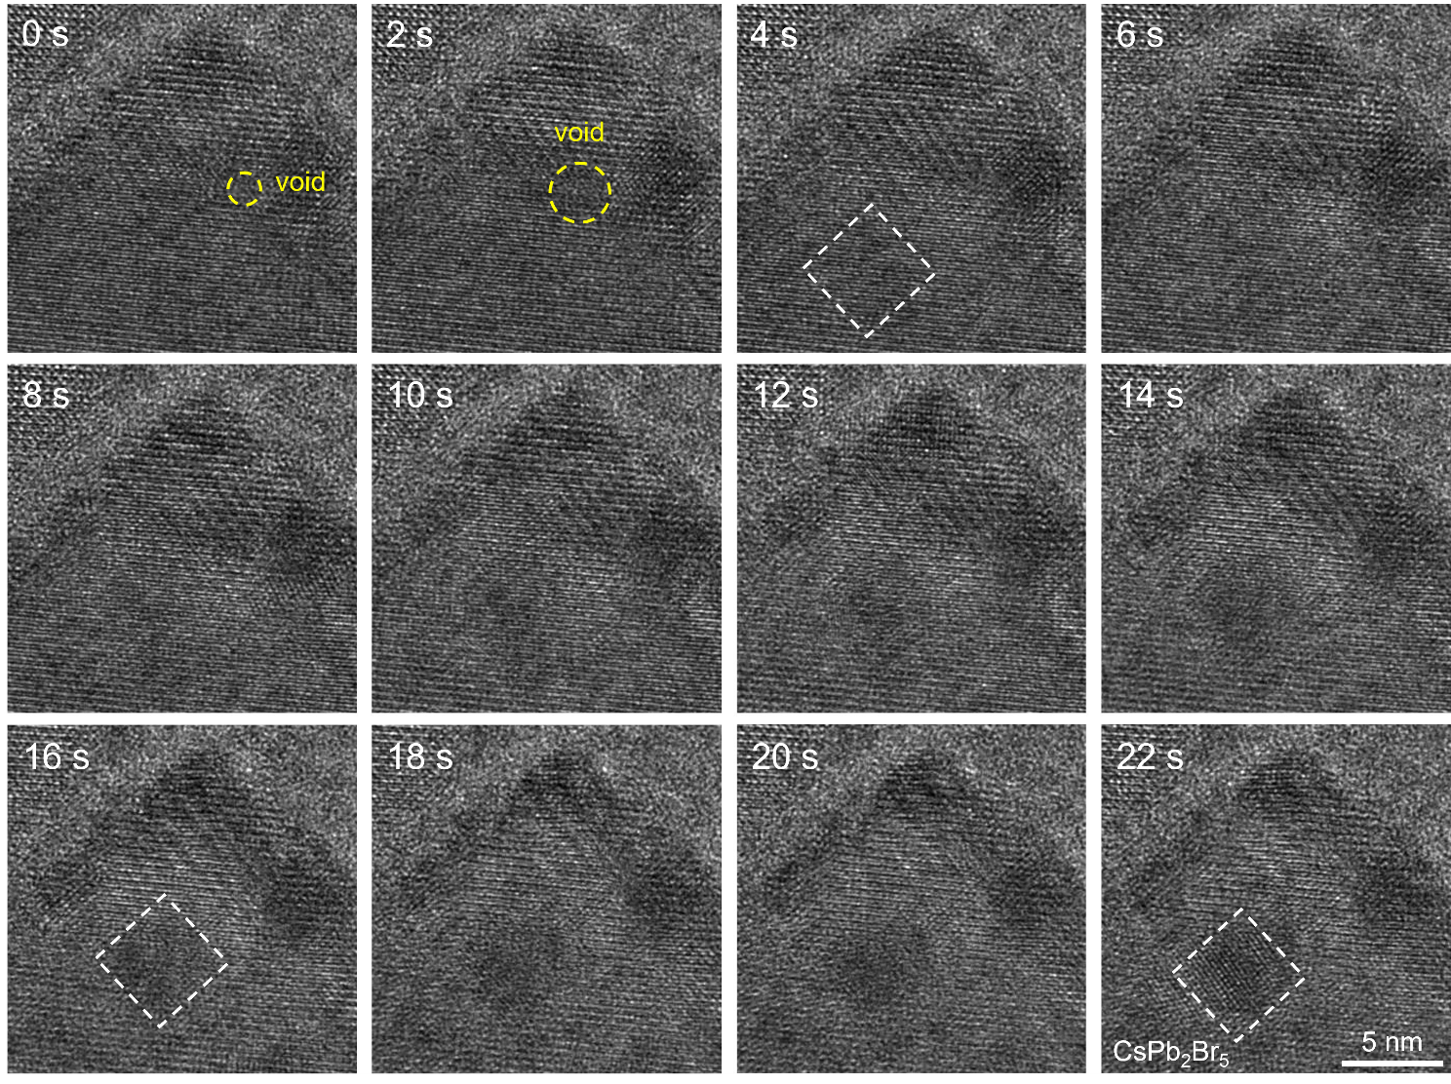
Supplementary Fig. 8 | Time-resolved HRTEM images showing the formation of crystalline CsPb₂Br₅ from a water-degraded CsPbBr₃ region. Voids were formed at the early stage (marked by dashed circle). The water-induced nanoparticle (dark contrast, indicated by dashed box) was gradually evolved into the crystalline CsPb₂Br₅ NC.

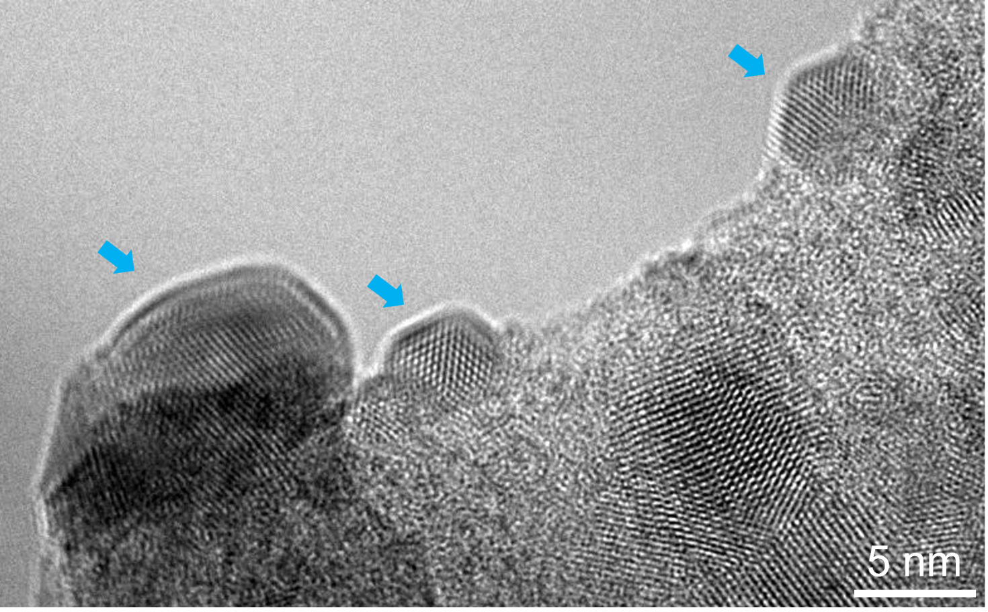
Supplementary Fig. 9 | TEM image showing the example of small NCs with different sizes locating at the carbon-film edge (marked by the arrows) after the rupture of the carbon supporting film.

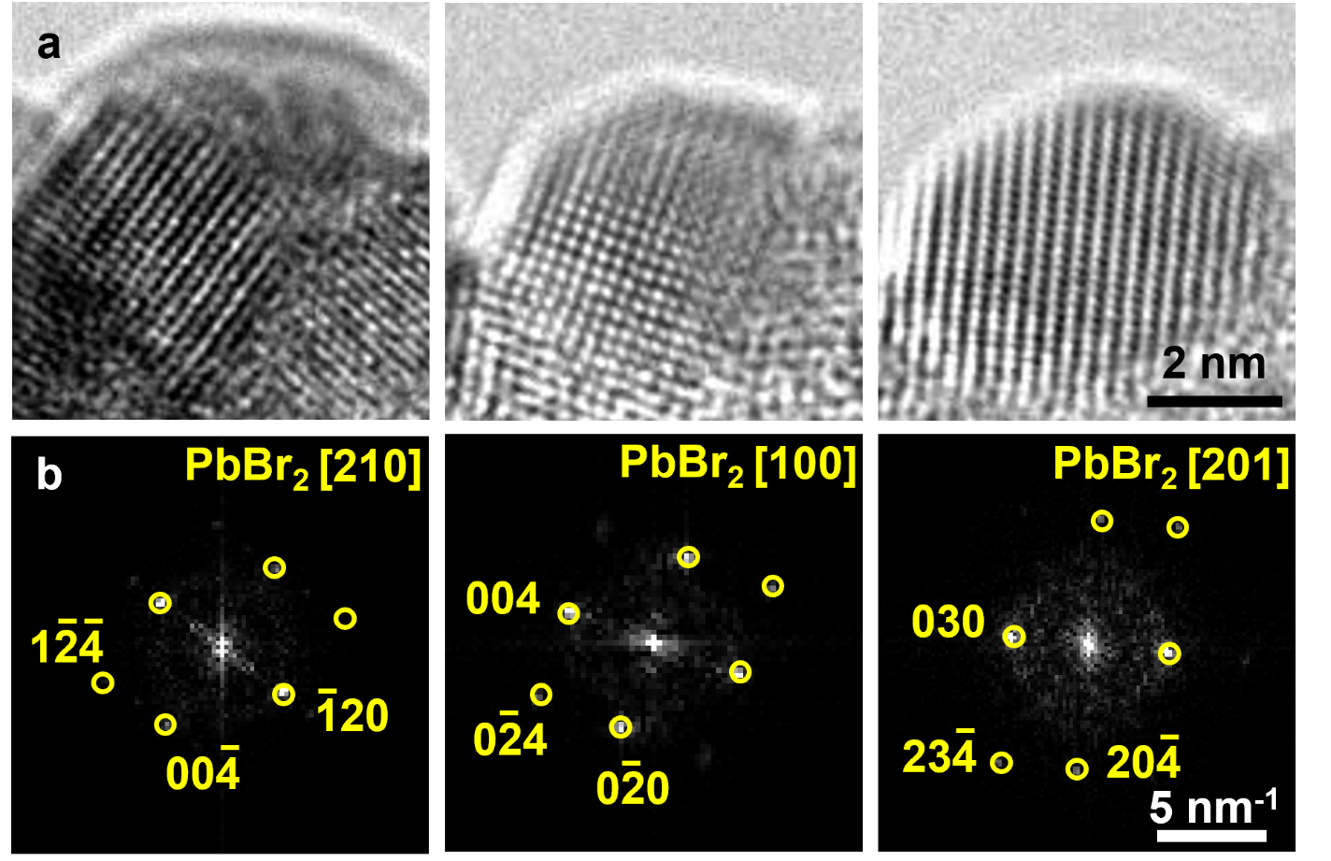
Supplementary Fig. 10 | Identification of PbBr₂ intermediate during cyclic transformation. a Typical HRTEM images of the crystalline intermediate. b Corresponding FFT patterns indexed to orthorhombic PbBr₂ viewed along the [210], [100], and [201] zone axes. The parameters of various spacings and angles are detailed in Supplementary Tables S5 to S7.

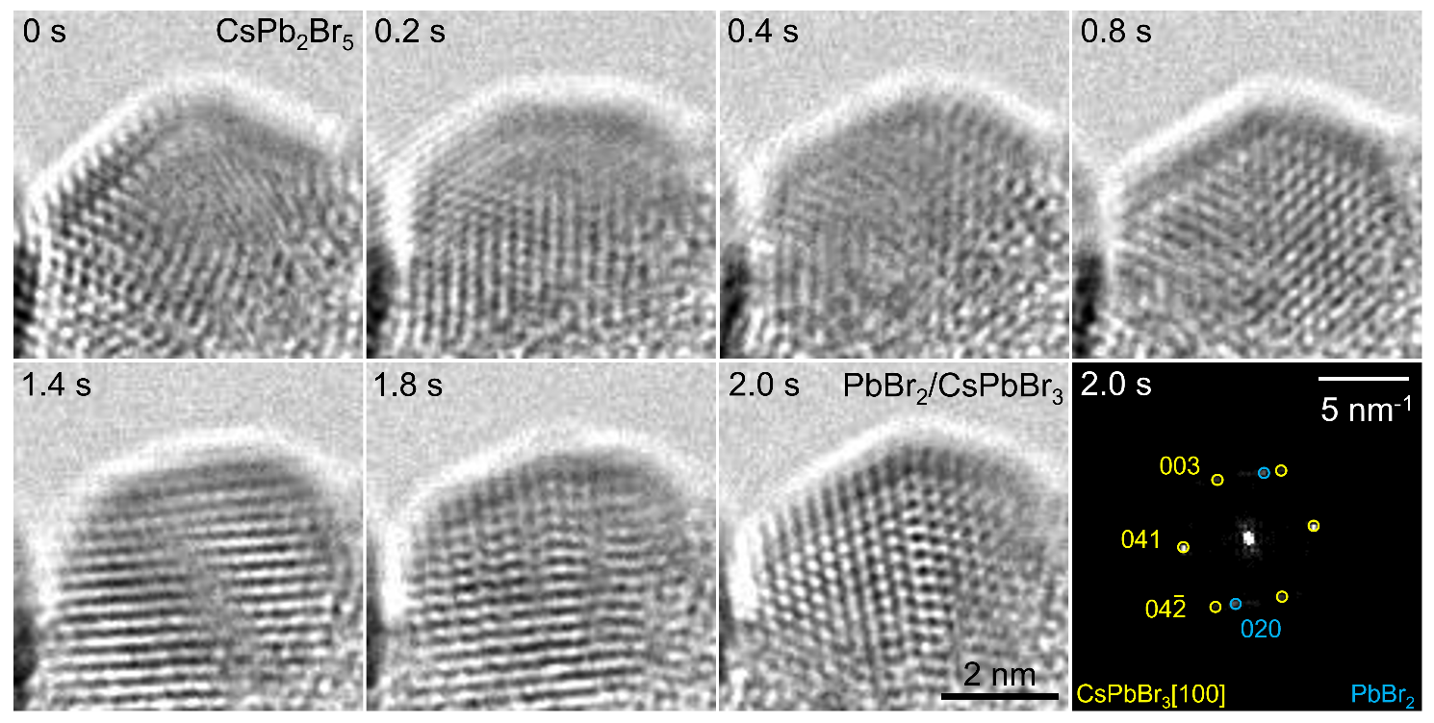
Supplementary Fig. 11 | Time-resolved HRTEM images showing structural conversion from CsPb₂Br₅ to CsPbBr₃. The initial CsPb₂Br₅ underwent progressive lattice reconstruction toward CsPbBr₃. The FFT pattern corresponded to the HRTEM image at 2.0 s, identifying the feature of the mixed state of CsPbBr₃ and PbBr₂.

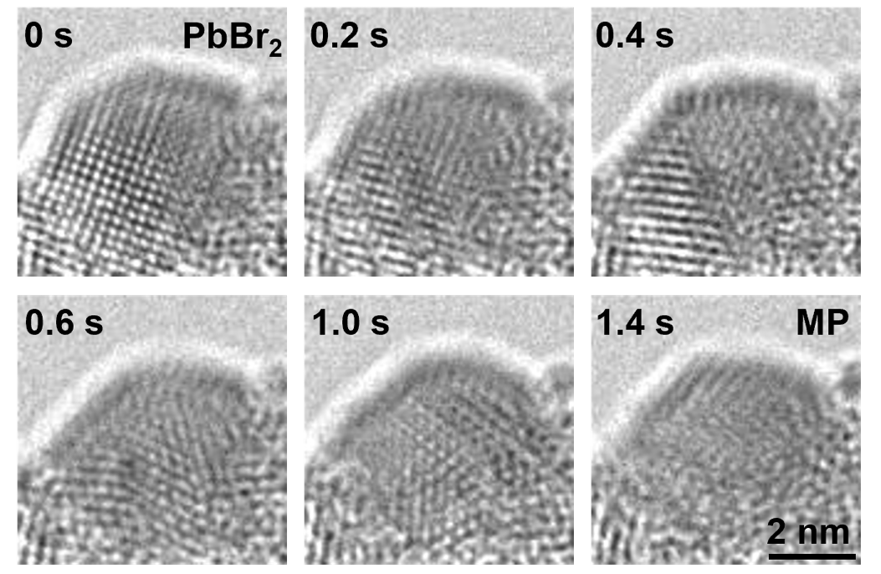
Supplementary Fig. 12 | Additional example of the formation of the intermediate MP. Starting from crystalline PbBr₂, the long-range lattice periodicity progressively weakened and was replaced by a highly disordered MP configuration at 1.4 s.

Supplementary Table
Supplementary Table 1 | Identification of CsPb₂Br₅ based on the reference and measured interplanar spacings/angles (see Supplementary Fig. 7a). The reference values were obtained from the crystallographic parameters of tetragonal CsPb₂Br₅ (ICSD #13939).

Plane | Reference/Å | Measurement/Å | |Δ|/%
$$(300)$$ | 2.831 | 2.79 | 1.45
$$(40\overline{5})$$ | 1.740 | 1.70 | 2.32
$$(10\overline{5})$$ | 2.860 | 2.80 | 2.11
$$(\overline{2}0\overline{5})$$ | 2.471 | 2.44 | 1.24

Angle | Reference/° | Measurement/° | |Δ|
$$(300)/(40\overline{5})$$ | 34.953 | 35.532 | 0.579
$$(40\overline{5})/(10\overline{5})$$ | 35.367 | 36.103 | 0.736
$$(10\overline{5})/(\overline{2}0\overline{5})$$ | 55.258 | 53.348 | 1.910
$$(\overline{2}0\overline{5})/(300)$$ | 125.577 | 124.982 | 0.595
Supplementary Table 2 | Comparison between the reference and measured interplanar spacings and angles of CsPb₂Br₅ (refer to Supplementary Fig. 7b). The reference values were acquired from the crystallographic parameters of tetragonal CsPb₂Br₅ (ICSD #13939).

Plane | Reference/Å | Measurement/Å | |Δ|/%
$$(213)$$ | 3.038 | 3.03 | 0.27
$$(233)$$ | 2.136 | 2.11 | 1.20
$$(020)$$ | 4.247 | 4.16 | 2.04
$$(\overline{2}1\overline{3})$$ | 3.038 | 3.03 | 0.27

Angle | Reference/° | Measurement/° | |Δ|
$$(213)/(233)$$ | 28.011 | 28.019 | 0.008
$$(233)/(020)$$ | 41.028 | 40.127 | 0.900
$$(020)/(\overline{2}1\overline{3})$$ | 69.039 | 68.620 | 0.419
$$(\overline{2}1\overline{3})/(213)$$ | 138.078 | 136.766 | 1.312
Supplementary Table 3 | Identification of CsPb₂Br₅ according to the reference and measured interplanar spacings and angles (see Supplementary Fig. 7c). The reference values were from the crystallographic parameters of tetragonal CsPb₂Br₅ in the ICSD database (ID #13939).

Plane | Reference/Å | Measurement/Å | |Δ|/%
$$(300)$$ | 2.831 | 2.88 | 1.73
$$(20\overline{5})$$ | 2.471 | 2.45 | 0.84
$$(\overline{1}0\overline{5})$$ | 2.860 | 2.89 | 1.04
$$(\overline{4}0\overline{5})$$ | 1.740 | 1.79 | 2.86

Angle | Reference/° | Measurement/° | |Δ|
$$(300)/(20\overline{5})$$ | 54.423 | 52.881 | 1.542
$$(20\overline{5})/(\overline{1}0\overline{5})$$ | 55.258 | 55.099 | 0.159
$$(\overline{1}0\overline{5})/(\overline{4}0\overline{5})$$ | 35.367 | 35.851 | 0.484
$$(\overline{4}0\overline{5})/(300)$$ | 145.047 | 143.831 | 1.216
Supplementary Table 4 | The reference and measured interplanar spacings and angles of CsPb₂Br₅ (see Supplementary Fig. 7d). The reference values were obtained from the crystallographic parameters of tetragonal CsPb₂Br₅ (ICSD #13939).

Plane | Reference/Å | Measurement/Å | |Δ|/%
$$(30\overline{2})$$ | 2.653 | 2.72 | 2.54
$$(3\overline{2}1)$$ | 2.328 | 2.37 | 1.82
$$(0\overline{2}3)$$ | 3.254 | 3.32 | 2.04
$$(\overline{3}\overline{2}5)$$ | 1.861 | 1.91 | 2.61

Angle | Reference/° | Measurement/° | |Δ|
$$(30\overline{2})/(3\overline{2}1)$$ | 44.201 | 44.214 | 0.013
$$(3\overline{2}1)/(0\overline{2}3)$$ | 58.771 | 58.285 | 0.486
$$(0\overline{2}3)/(\overline{3}\overline{2}5)$$ | 43.143 | 43.296 | 0.153
$$(\overline{3}\overline{2}5)/(30\overline{2})$$ | 146.115 | 145.795 | 0.320

Supplementary Table 5 | Identification of PbBr₂ based on the reference and measured interplanar spacings and angles from the [210]-zone-axis FFT pattern in Supplementary Fig. 10b. The reference values were from the crystallographic parameters of orthorhombic PbBr₂ in the ICSD database (ID #36170).

Plane | Reference/Å | Measurement/Å | |Δ|/%
$$(00\overline{4})$$ | 2.375 | 2.31 | 2.74
$$(\overline{1}2\overline{4})$$ | 1.876 | 1.81 | 3.53
$$(\overline{1}20)$$ | 3.060 | 2.96 | 3.28
$$(\overline{1}24)$$ | 1.876 | 1.83 | 2.47

Angle | Reference/° | Measurement/° | |Δ|
$$(00\overline{4})/(\overline{1}2\overline{4})$$ | 37.813 | 38.805 | 0.992
$$(\overline{1}2\overline{4})/(\overline{1}20)$$ | 52.187 | 52.171 | 0.016
$$(\overline{1}20)/(\overline{1}24)$$ | 52.187 | 50.973 | 1.214
$$(\overline{1}24)/(00\overline{4})$$ | 142.187 | 141.949 | 0.238

Supplementary Table 6 | The reference and measured interplanar spacings and angles of PbBr₂ from the [100]-zone-axis FFT pattern in Supplementary Fig. 10b. The reference values were acquired from the crystallographic parameters of orthorhombic PbBr₂ (ICSD #36170).

Plane | Reference/Å | Measurement/Å | |Δ|/%
$$(020)$$ | 2.360 | 2.37 | 0.42
$$(024)$$ | 1.674 | 1.70 | 1.55
$$(004)$$ | 2.375 | 2.45 | 3.16
$$(0\overline{2}4)$$ | 1.674 | 1.71 | 2.15

Angle | Reference/° | Measurement/° | |Δ|
$$(020)/(024)$$ | 44.818 | 44.379 | 0.439
$$(024)/(004)$$ | 45.182 | 45.621 | 0.439
$$(004)/(0\overline{2}4)$$ | 45.182 | 43.326 | 1.856
$$(0\overline{2}4)/(020)$$ | 135.182 | 133.326 | 1.856

Supplementary Table 7 | Identification of PbBr₂ according to the reference and measured interplanar spacings and angles from the [201]-zone-axis FFT pattern in Supplementary Fig. 10b. The reference values were obtained from the crystallographic parameters of orthorhombic PbBr₂ (ICSD #36170).

Plane | Reference/Å | Measurement/Å | |Δ|/%
$$(030)$$ | 2.680 | 2.786 | 3.96
$$(23\overline{4})$$ | 1.420 | 1.482 | 4.38
$$(20\overline{4})$$ | 1.674 | 1.725 | 3.04
$$(\overline{2}\overline{3}4)$$ | 1.420 | 1.482 | 4.38

Angle | Reference/° | Measurement/° | |Δ|
$$(030)/(23\overline{4})$$ | 58.009 | 57.976 | 0.033
$$(23\overline{4})/(20\overline{4})$$ | 31.991 | 32.115 | 0.124
$$(20\overline{4})/(\overline{2}\overline{3}4)$$ | 148.009 | 147.885 | 0.124
$$(\overline{2}\overline{3}4)/(030)$$ | 121.991 | 122.024 | 0.033

Captions for Supplementary Movies
Supplementary Movie 1 | Water-triggered degradation of the CsPbBr₃ NCs in region I of the double-layer liquid cell. Movie at 4.5 × speed.
Supplementary Movie 2 | Degradation of the CsPbBr₃ NCs in region II during the exposure to water. Movie at 4.5 × speed.
Supplementary Movie 3 | Repeatable crystalline–amorphous transition of the water-induced CsPb₂Br₅ nanoparticle. Movie at 10 × speed.
Supplementary Movie 4 | Cyclic transformation of a small NC at the carbon-film edge with a trace amount of water. Movie at 4 × speed.

References
1. R. F. Egerton, P. Li, M. Malac, Radiation damage in the TEM and SEM. Micron 35, 399–409 (2004).
2. T. Malis, S. C. Cheng, R. F. Egerton, EELS log-ratio technique for specimen-thickness measurement in the TEM. J. Electron Microsc. Tech. 8, 193–200 (1988).
3. J. F. Orri et al., Unveiling the interaction mechanisms of electron and X-ray radiation with halide perovskite semiconductors using scanning nanoprobe diffraction. Adv. Mater. 34, 2200383 (2022).
4. W. Lee et al., Ultralow thermal conductivity in all-inorganic halide perovskites. Proc. Natl. Acad. Sci. U.S.A. 114, 8693–8697 (2017).
5. S. B. Fisher, On the temperature rise in electron irradiated foils. Radiat. Eff. 5, 239–243 (1970).
6. Y. Bu et al., Unconventional deformation behaviours of nanoscaled high-entropy alloys. Entropy 20, 778 (2018).
7. Z. Dang et al., In situ transmission electron microscopy study of electron beam-induced transformations in colloidal cesium lead halide perovskite nanocrystals. ACS Nano 11, 2124–2132 (2017).
8. J. Martín et al., On the effect of confinement on the structure and properties of small-molecular organic semiconductors. Adv. Electron. Mater. 4, 1700308 (2018).
9. J. W. Gibbs, The collected works of J. Willard Gibbs, vol. 1, Thermodynamics (Longmans, Green & Co., New York, 1928).
10. D. R. Burgess Jr., Melting points, binary eutectic points, and heats of melting for the metal halides, NIST Technical Note 2358 (National Institute of Standards and Technology, 2026).
11. M. C. Morris et al., Standard X-ray diffraction powder patterns: Section 17—data for 54 substances. NBS Monograph 25-17 (National Bureau of Standards, 1980).
12. J.-Y. Zheng et al., Synthesis of centimeter-size free-standing perovskite nanosheets from single-crystal lead bromide for optoelectronic devices. Sci. Rep. 9, 11738 (2019).

