Supplementary Information
PALR-DNA: A Probability-Aware Latent Recovery Framework for Error-Resilient Image Storage in DNA
Siqiang Chen¹, Ruijing Zhao¹, Tianyu Wu¹, Ting Huang¹, Xiaozhi Huang¹, and Qingjiang Sun^{1*}
¹State Key Laboratory of Digital Medical Engineering, School of Biological Science & Medical Engineering, Southeast University, Nanjing 211102, China.
*Fax: (86)25-83792349; E-mail: sunqj@seu.edu.cn

Contents
Table S1. Comparison among PALR-DNA variants at 1–4% error rates. S2
Figure S1. Illustration of BMPE completion for an unresolved DNA sequence. S3
Figure S2. The encoding flowchart of PALR-DNA. S4
Figure S3. Visual comparison among PALR-DNA variants at 5% error rate. S4
Figure S4. Latent vector recovery accuracy under different TCBS search parameters. S5
Figure S5. Decoding time under different TCBS search parameters. S5

Table S1. Comparison among PALR-DNA variants at 1–4% error rates. “w/o” denotes “without”. “↓” and “↑” arrows indicate that lower and higher values are better.
Error Rate | Variant | MSE ↓ | PSNR (dB) ↑ | SSIM ↑ | MS-SSIM ↑
1% | w/o DLRT | 367.43 ± 6.24 | 22.78 ± 0.07 | 0.8079 ± 0.0022 | 0.8050 ± 0.0028
1% | w/o TCBS | 66.18 ± 2.54 | 30.72 ± 0.10 | 0.9031 ± 0.0025 | 0.9631 ± 0.0008
1% | w/o BMPE | 43.50 ± 2.24 | 32.98 ± 0.13 | 0.9128 ± 0.0025 | 0.9789 ± 0.0006
1% | PALR-DNA | 33.69 ± 2.08 | 34.63 ± 0.16 | 0.9159 ± 0.0025 | 0.9857 ± 0.0006
2% | w/o DLRT | 1337.98 ± 21.01 | 17.15 ± 0.07 | 0.5766 ± 0.0017 | 0.5495 ± 0.0046
2% | w/o TCBS | 145.20 ± 3.81 | 27.01 ± 0.09 | 0.8725 ± 0.0025 | 0.9114 ± 0.0014
2% | w/o BMPE | 97.52 ± 3.49 | 28.99 ± 0.10 | 0.8964 ± 0.0025 | 0.9454 ± 0.0012
2% | PALR-DNA | 40.44 ± 2.23 | 33.44 ± 0.14 | 0.9135 ± 0.0025 | 0.9810 ± 0.0006
3% | w/o DLRT | 2770.47 ± 42.02 | 13.99 ± 0.07 | 0.3606 ± 0.0016 | 0.3756 ± 0.0045
3% | w/o TCBS | 263.18 ± 5.67 | 24.33 ± 0.08 | 0.8281 ± 0.0024 | 0.8453 ± 0.0021
3% | w/o BMPE | 226.35 ± 6.63 | 25.23 ± 0.10 | 0.8591 ± 0.0025 | 0.8774 ± 0.0023
3% | PALR-DNA | 54.79 ± 2.47 | 31.74 ± 0.12 | 0.9074 ± 0.0025 | 0.9709 ± 0.0006
4% | w/o DLRT | 4261.88 ± 64.96 | 12.12 ± 0.07 | 0.2169 ± 0.0015 | 0.2679 ± 0.0038
4% | w/o TCBS | 418.70 ± 8.31 | 22.28 ± 0.08 | 0.7727 ± 0.0024 | 0.7715 ± 0.0029
4% | w/o BMPE | 475.63 ± 12.94 | 22.01 ± 0.10 | 0.7936 ± 0.0026 | 0.7773 ± 0.0038
4% | PALR-DNA | 83.60 ± 3.15 | 29.68 ± 0.10 | 0.8945 ± 0.0025 | 0.9515 ± 0.0009

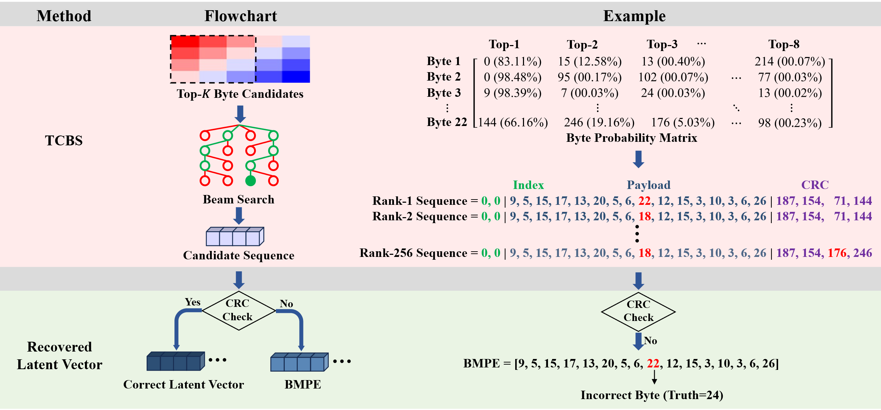
Figure S1. Illustration of BMPE completion for an unresolved DNA sequence. BMPE estimates each payload byte from its predicted probability distribution. All payload bytes are correctly estimated except one, for which the ground-truth value of 24 is estimated as 22. The example highlights the approximate nature of BMPE completion when CRC-verified recovery is unavailable.

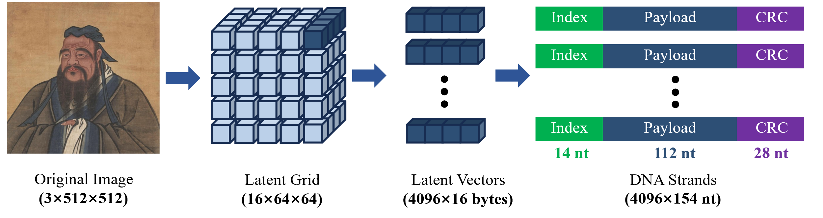
Figure S2. The encoding flowchart of PALR-DNA. A 3×512×512 image is transformed into a 16×64×64 quantized latent representation, corresponding to 4,096 local latent vectors and 65,536 payload bytes. Each 16-byte payload is combined with a two-byte spatial index and a four-byte CRC-32 checksum. The resulting 22-byte sequence is mapped to a 154-nt DNA strand, producing 4,096 strands and 630,784 bases per image.

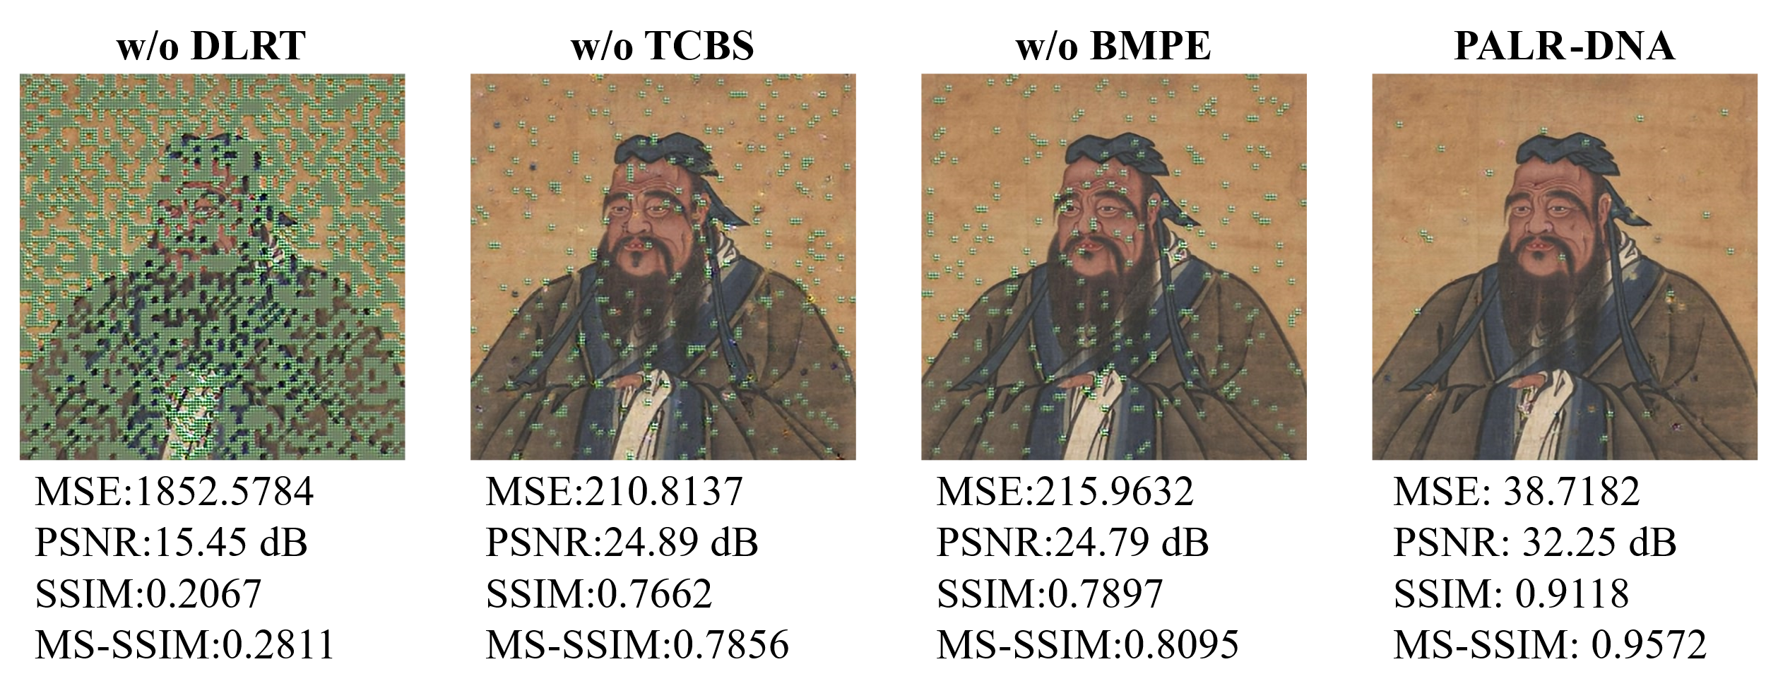
Figure S3. Visual comparison among PALR-DNA variants at 5% error rate.

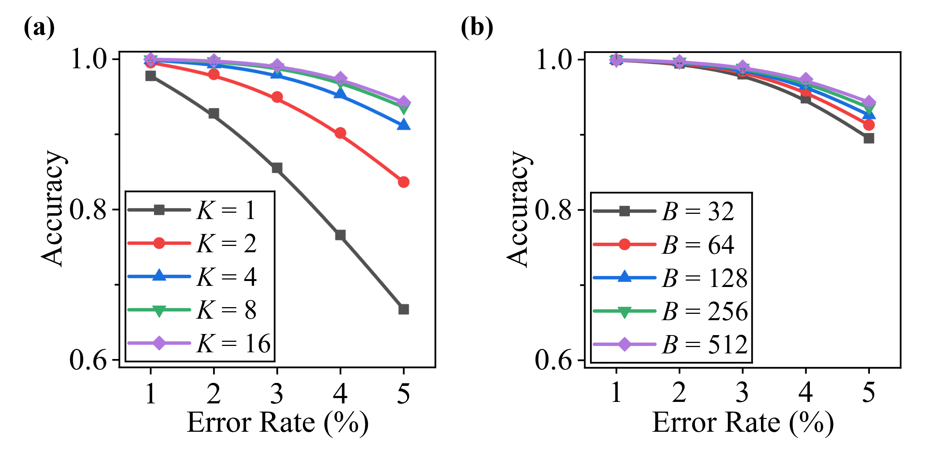
Figure S4. Latent vector recovery accuracy under different TCBS search parameters. (a) Mean latent vector recovery accuracy per image for $K$ values of 1, 2, 4, 8, and 16 at $B=256$; (b) Mean latent vector recovery accuracy per image for $B$ values of 32, 64, 128, 256, and 512 at $K=8$.

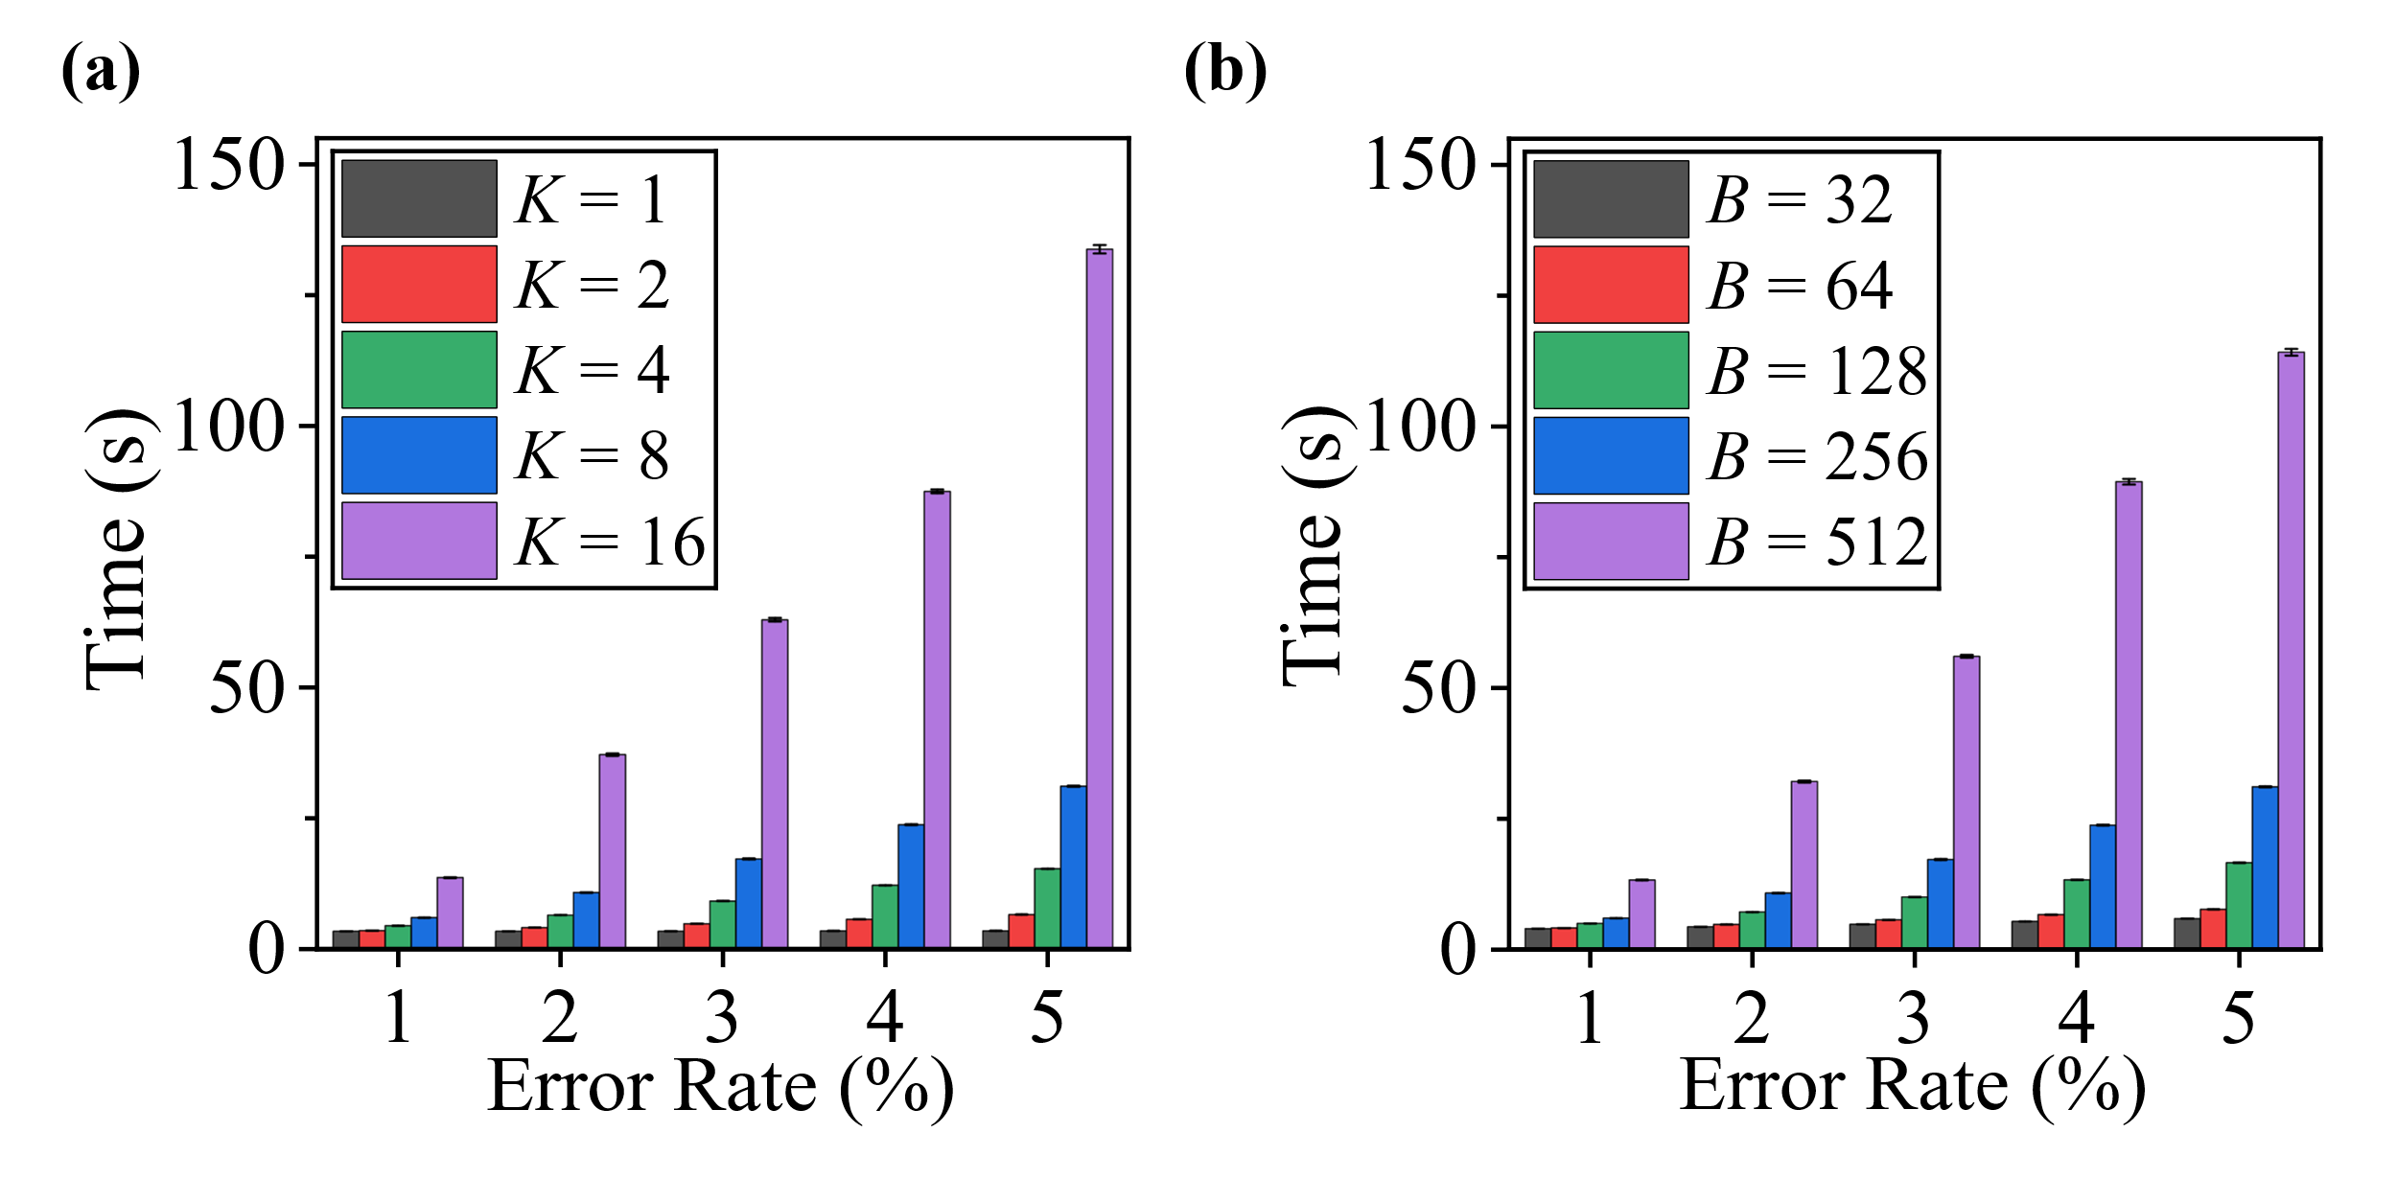
Figure S5. Decoding time under different TCBS search parameters. (a) Mean decoding time per image for $K$ values of 1, 2, 4, 8, and 16 at $B=256$; (b) Mean decoding time per image for $B$ values of 32, 64, 128, 256, and 512 at $K=8$.

