Supporting information for
Termination controlled Phase-Pure Ti₃C₂T_{x} MXenes Towards Efficient Electrocatalysis Gyanprakash Mishra,^{1,2,3} Saswati Mishra,^{1,2} Brijesh K. Patel,⁴ Satyabrata Sahoo,^{1,3} Ashutosh Rath,*^{2,3} Simantini Nayak*^{1,2}
¹Department of Materials Chemistry and Interfacial Engineering, CSIR-Institute of Minerals and Materials Technology, Bhubaneswar 751013, India
²Department of Mineralogy and Materials Characterisation, CSIR-Institute of Minerals and Materials Technology, Bhubaneswar 751013, India
³Academy of Scientific and Innovative Research (AcSIR), Gaziabad 201002, India
⁴Tata Institute of Fundamental Research, 36/P, Gopanpally Village, Hyderabad 500046, India

*Corresponding authors
Email: ashutosh.immt@csir.res.in
Email: simantini.immt@csir.res.in

Contents:
Experimental Section
Supplementary Figures
XRD patterns of Ti₃AlC₂ MAX phase
- Supplementary Fig. 1. | Sintered at different temperatures (1200, 1250, 1300 and 1350 °C) for 4 h
- Supplementary Fig. 2. | Sintered using different precursor ratios at 1300 °C for 4 h
- Supplementary Fig. 3. | Sintered at 1300 °C for different times: 2 h and 4 h
XRD patterns of Ti₃C₂-F and Ti₃C₂-O MXenes
- Supplementary Fig. 4. | Ti₃C₂-F MXene formed via in situ HF etching at RT and with heating (55 °C) for 24 h
- Supplementary Fig. 5. | Ti₃C₂-F MXene formed via in situ HF etching at 55 °C for different durations (12, 18, 24 and 30 h)
- Supplementary Fig. 6. | Ti₃C₂-O MXene formed at different molten salt etching durations (6, 12 and 24 h) at 700 °C
Surface area, pore size distribution and thermal analysis
- Supplementary Fig. 7. | N₂ adsorption–desorption isotherm with pore size distribution
- Supplementary Fig. 8. | Thermogravimetric Differential Scanning Calorimetry (TG-DSC) analysis of Ti₃AlC₂ MAX phase, Ti₃C₂-F and Ti₃C₂-O MXenes
XPS analysis
- Supplementary Fig. 9. | XPS characterisations of Ti₃AlC₂ MAX phase
- Supplementary Fig. 10. | XPS characterisations of Ti₃C₂-F MXene
- Supplementary Fig. 11. | XPS characterisations of Ti₃C₂-O MXene
- Supplementary Fig. 12. | Comparison of XPS survey spectra of Ti₃AlC₂ MAX phase, Ti₃C₂-F and Ti₃C₂-O MXenes
Electrochemical analysis
- Supplementary Fig. 13. | Electrochemically active surface area (ECSA) characterisation of MXenes for universal pH hydrogen evolution reaction (HER)
- Supplementary Fig. 14. | ECSA characterisation of MXenes for oxygen evolution reaction (OER)
- Supplementary Fig. 15. | C_{dl} measurements of Ti₃C₂-F and Ti₃C₂-O MXenes for HER and OER
- Supplementary Fig. 16. | Electrochemical impedance spectroscopy (EIS; Nyquist plots) of Ti₃C₂-F and Ti₃C₂-O MXenes in 0.5 M H₂SO₄ and 1 M KOH
- Supplementary Fig. 17. | Faradaic efficiencies of Ti₃C₂-F MXene in 0.5 M H₂SO₄
- Supplementary Fig. 18. | Post-electrochemical (FESEM and XPS) analysis of Ti₃C₂-F MXene after HER stability test
- Supplementary Fig. 19. | Post-electrochemical (FESEM and XPS) analysis of Ti₃C₂-O MXene after HER stability test
- Supplementary Fig. 20. | Post-electrochemical (FESEM and XPS) analysis of Ti₃C₂-O MXene after OER stability test
Supplementary Tables
- Supplementary Table 1. | Assignment of XPS peaks observed for Ti 2p, C 1s, O 1s and Al 2p spectra of Ti₃AlC₂ MAX phase
- Supplementary Table 2. | Assignment of XPS peaks observed for Ti 2p, C 1s, O 1s, Al 2p and F 1s spectra of Ti₃C₂-F MXene
- Supplementary Table 3. | Assignment of XPS peaks observed for Ti 2p, C 1s, O 1s, Al 2p, Cl 2p and S 2p spectra of Ti₃C₂-O MXene
- Supplementary Table 4. | Atomic percentage of elements of Ti₃AlC₂, Ti₃C₂-F and Ti₃C₂-O MXenes derived from XPS spectra
- Supplementary Table 5. | Comparison of the synthesis parameters and phase purities of the synthesised Ti₃AlC₂ MAX phase
- Supplementary Table 6. | Comparison of the synthesis parameters and phase purities of the Ti₃C₂-F and Ti₃C₂-O MXenes
- Supplementary Table 7. | Double-layer capacitance (C_{dl}) and ECSA values of Ti₃C₂-F and Ti₃C₂-O MXenes in 0.5 M H₂SO₄ and 1 M KOH
- Supplementary Table 8. | Comparison of the HER performance of the Ti₃C₂-F and Ti₃C₂-O MXenes in universal pH with reported MXene-based electrocatalysts
- Supplementary Table 9. | Comparison of the overall water-splitting performance of the Ti₃C₂-F and Ti₃C₂-O MXenes in 1 M KOH with reported MXene-based electrocatalysts
References

XRD patterns of Ti₃AlC₂ MAX phase:
- Effect of sintering temperatures:
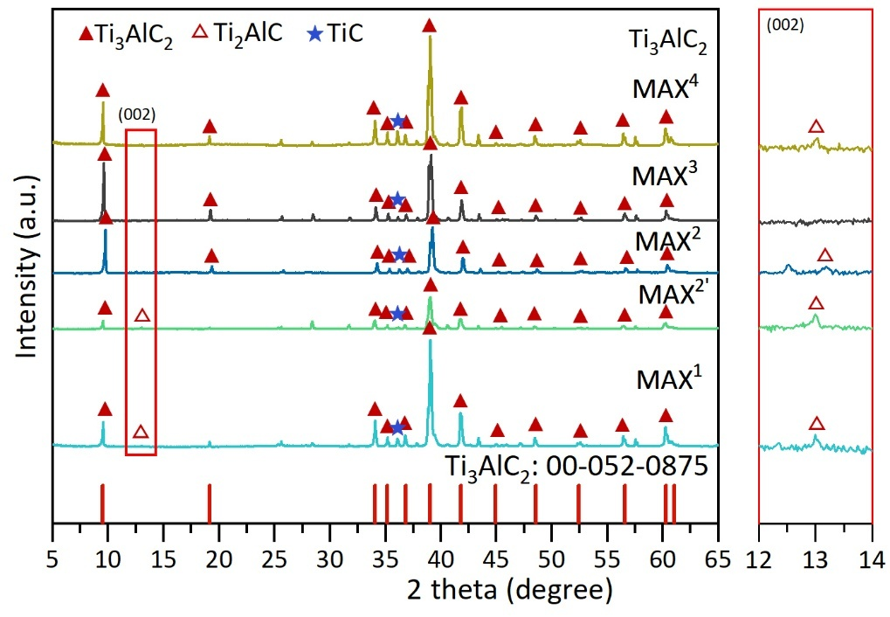
Supplementary Fig. 1. XRD pattern of Ti₃AlC₂ MAX phase sintered at 1200 °C, 1250 °C, 1300 °C and 1350 °C for 4 h.

We investigated the effect of sintering temperature on the phase purity of the Ti₃AlC₂ MAX phase, produced at 1200 °C (MAX¹), 1250 °C (MAX^{2’}), 1250 °C (MAX²), 1300 °C (MAX³), and 1350 °C (MAX⁴) for 1-4 h in air. XRD patterns of Ti₃AlC₂ MAX phase synthesised at 1200 and 1250 °C show a peak at 2θ ~13° corresponding to Ti₂AlC impurities, whereas this peak is absent in the sample formed at 1300 °C.

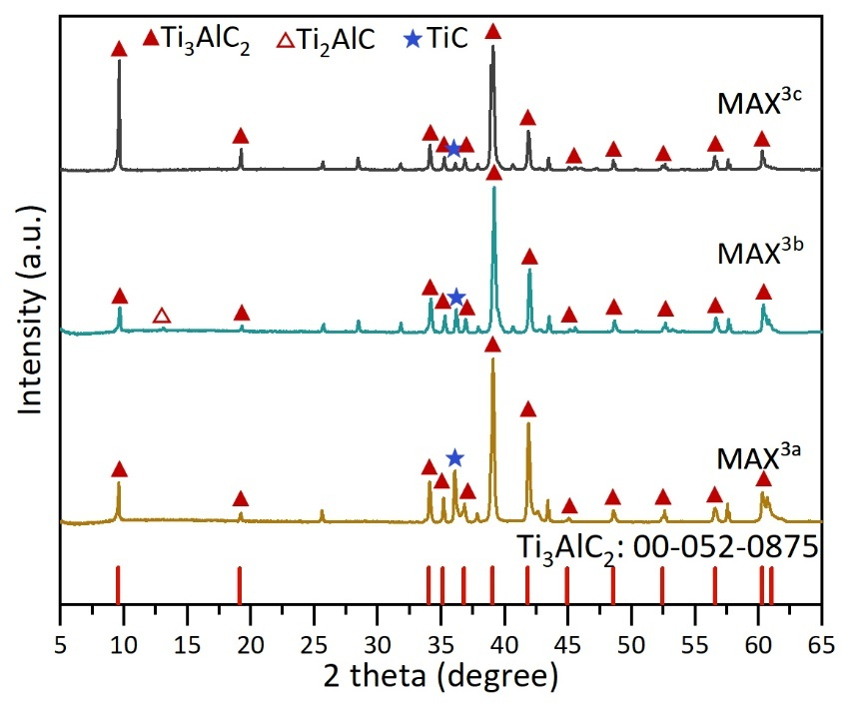
- Effect of precursor ratios:
Supplementary Fig. 2. XRD pattern of Ti₃AlC₂ MAX phase sintered using different precursor ratios at 1300 °C for 4 h.

We studied how precursor molar ratios affect Ti₃AlC₂ MAX phase formation at 1300 °C over 4 h. Using Ti, TiC, and Al at molar ratios of 1.1:2:1.4, 1.2:2:1.8, and 1.25:2:2.2, XRD showed that the 1.1 ratio yielded an 89.22% phase-pure Ti₃AlC₂ MAX phase, with minimal Ti₂AlC and TiC phases. Increasing the Ti and Al ratios increased MAX phase purity to 99.48% with lower Ti₂AlC and TiC phases, indicating that higher Al promotes conversion to the Ti₃AlC₂ MAX phase.

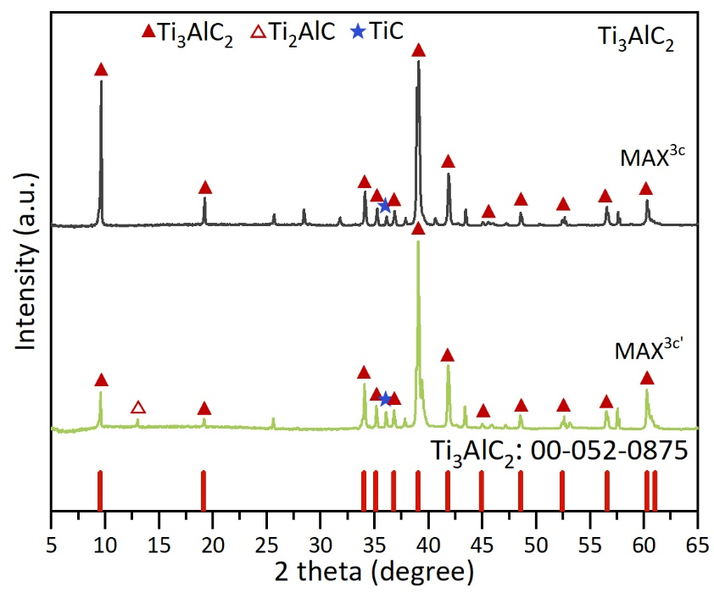
- Effect of sintering time:
Supplementary Fig. 3. XRD pattern of Ti₃AlC₂ MAX phase sintered at 1300 °C for 2 h and 4 h.

We investigated the effect of sintering time on the phase purity of the Ti₃AlC₂ MAX phase. We sintered the Ti₃AlC₂ MAX phase at 1300 °C for 4 h and 2 h. Different sintering times for the formation of the Ti₃AlC₂ MAX phase show that the peak at 2θ=13° for the (002) plane of the Ti₂AlC phase was present at 2 hours but absent at 4 hours. Hence, this result indicates that a minimum sintering duration of 4 hours at 1300 °C is required to form a highly phase-pure Ti₃AlC₂ MAX phase.
XRD patterns of Ti₃C₂-F and Ti₃C₂-O MXenes
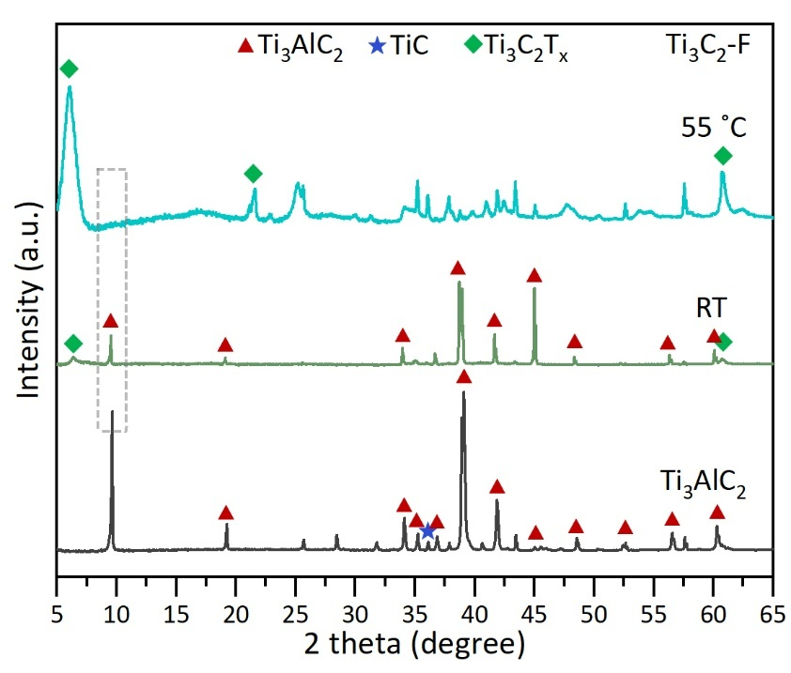
- Effect of temperature on the formation of Ti₃C₂-F MXene via in situ HF etching
Supplementary Fig. 4. XRD pattern of Ti₃C₂-F MXene formation at different in situ HF etching temperature for 24 h.

To evaluate the effect of temperature during in situ HF etching of the Ti₃AlC₂ MAX phase to obtain Ti₃C₂-F MXene, we performed etching at room temperature (RT) and at 55 °C for 24 h. XRD pattern of the Ti₃C₂-F MXene formed by RT etching shows a peak at ~9.6° for the (002) plane of Ti₃AlC₂, whereas this peak was absent in the 55 °C etching, indicating the complete conversion of the MAX phase to the Ti₃C₂-F MXene.

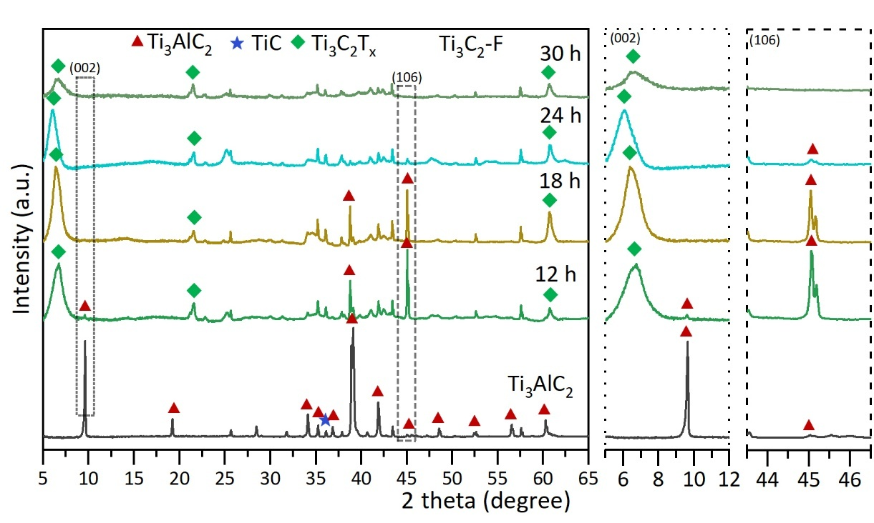
- Effect of etching duration on the formation of Ti₃C₂-F MXene via in situ HF etching:
Supplementary Fig. 5. XRD pattern of Ti₃C₂-F MXene formation at different in situ HF etching times at 55 °C.
We have performed in situ HF etching of the Ti₃AlC₂ MAX phase at 55 °C for 12, 18, 24, and 30 h. XRD pattern shows that, by varying the etching time to 12, 18, 24, and 30 h at 55 °C, the peak at ~9.6° of the (002) plane for the Ti₃AlC₂ MAX phase was still present after 12 h and 18 h of etching, while it was absent after 24 h and 30 h of etching. Hence, it shows that for effective and complete etching of the Ti₃AlC₂ MAX phase, a minimum etching time of 24 hours is required.

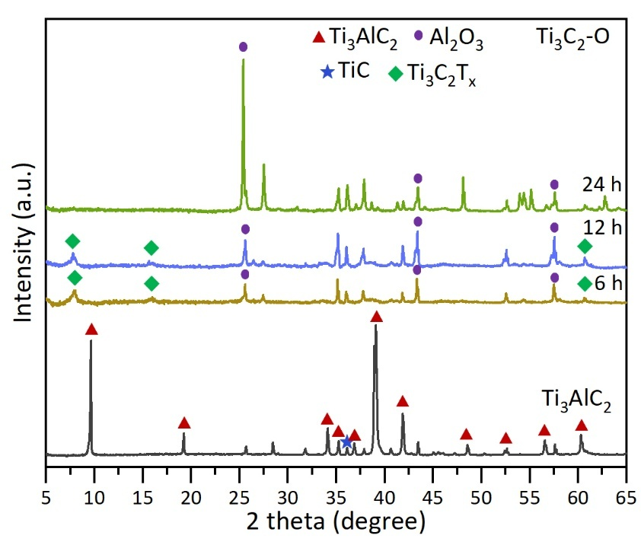
- Effect of etching duration on the formation of Ti₃C₂-O MXene via molten salt etching:
Supplementary Fig. 6. XRD pattern of Ti₃C₂-O MXene formation at different molten salt etching times: 6, 12, and 24 h at 700 °C.

We have investigated the molten salt etching time for the formation of Ti₃C₂-O MXene at 700 °C for 6 h, 12 h and 24 h. XRD patterns of the Ti₃C₂-O MXene formed at 700 ⁰C with different etching durations show that the peak at 2θ ~ 39⁰ for the (104) plane of the MAX phase completely vanishes for 6, 12 and 24 h of etching. However, for 6 h and 12 h etching times, the peak at ~9.5° for the (002) plane of MXene was found to be present, while it completely vanished with 24 h etching time and instead a peak at ~25.5° was visible for the (102) plane due to the formation of oxides. Hence, for effective and complete etching of the Ti₃AlC₂ MAX phase, a molten salt etching time of at least 6 h is required at 700 °C.

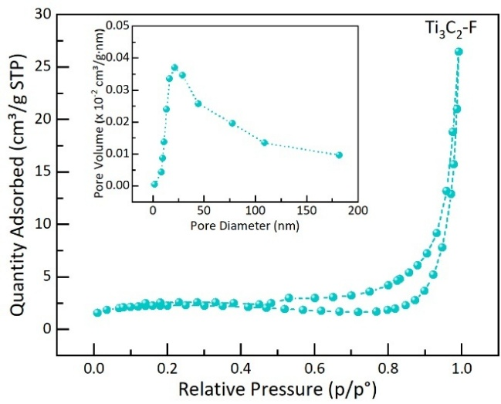
Surface area, pore size distribution:
a
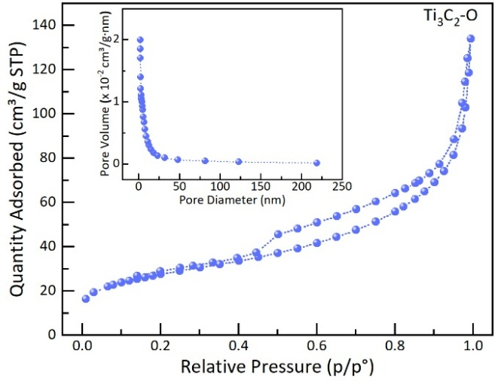
Supplementary Fig. 7. N₂ adsorption–desorption isotherm with the associated BJH pore size distribution (inset). a, Ti₃C₂-F MXene. b, Ti₃C₂-O MXene.
b

We have investigated the surface area and pore size of the Ti₃C₂-F and Ti₃C₂-O MXenes. The specific surface area of Ti₃C₂-F MXene was found to be ~8.18 ± 0.11 m²/g, and the associated Barrett-Joyner-Halenda (BJH) pore size distribution spanned 3-180 nm, with most pore diameters between ~5 and 30 nm and a total pore volume of 0.019 cm³g⁻¹. The specific surface area of Ti₃C₂-O MXene was found to be ~98.96 ± 0.40 m²/g, and the associated BJH pore size distribution spanned 1.5-221 nm, with most pore diameters between ~2 and 50 nm and a total pore volume of 0.1445 cm³g⁻¹.

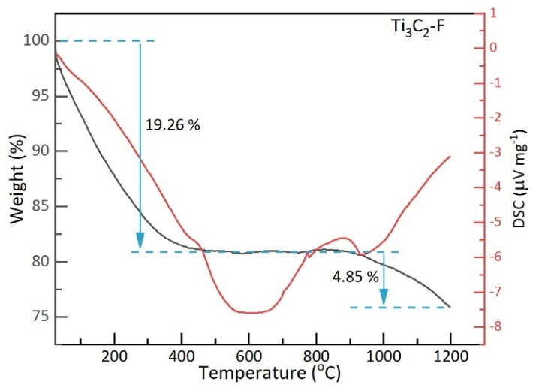
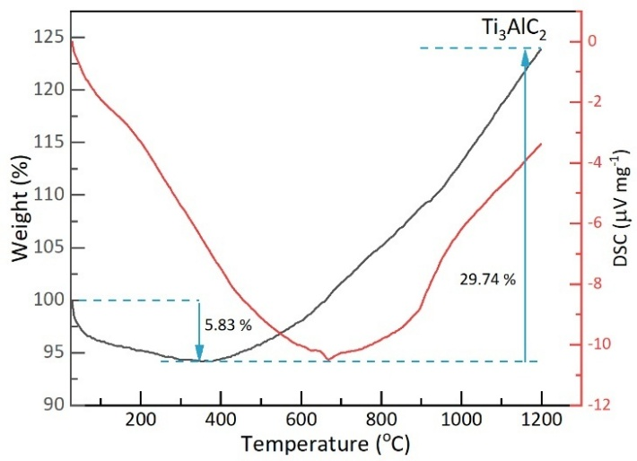
Thermal Analysis:
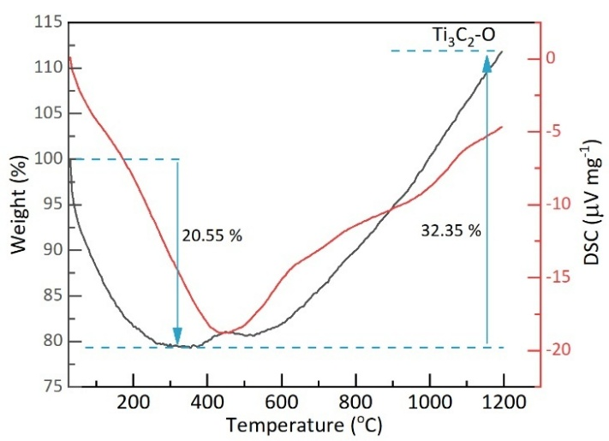
c
b
a
Supplementary Fig. 8. TG-DSC curves of synthesised MAX phase and MXenes. a, Ti₃AlC₂ MAX phase. b, Ti₃C₂-F MXene. c, Ti₃C₂-O MXene.
XPS analysis of Ti₃AlC₂ MAX phase and Ti₃C₂T_{x} MXene:
XPS analysis of the Ti₃AlC₂ MAX phase and Ti₃C₂T_{x} MXene are presented in Supplementary Figs. 9-12. The XPS survey spectra (Supplementary Fig. 12) show that the Ti₃AlC₂ MAX phase contains Ti 2p, Al 2p, and C 1s signals along with a strong O 1s signal, indicating partial surface oxidation of the MAX phase. The XPS survey spectra of both Ti₃C₂-F and Ti₃C₂-O MXenes formed after the etching process show that the Ti 2p peak intensity is enhanced, whereas the Al 2p peak intensity is weaker than in the Ti₃AlC₂ MAX phase, confirming the removal of Al. Moreover, no significant amounts of Cu were detected in Ti₃C₂-O MXene. The high-resolution Al 2p survey spectrum of the Ti₃AlC₂ MAX phase shows Al–Ti (71.49 eV) and Al-C (73.85 eV) bonds, confirming Al is bonded in a Ti-Al-C framework, and the presence of Al₂O₃(74.7 eV) confirms the formation of the Ti₃AlC₂ MAX phase with minor impurities (Supplementary Fig. 9e).¹ Ti₃C₂-F MXene contains trace amounts of Al₂O₃ and AlF₃ impurities, indicating efficient Al extraction from the Ti₃AlC₂ MAX phase (Supplementary Fig. 10e).² In contrast, the Ti₃C₂-O MXene has a higher Al₂O₃ content than Ti₃C₂-F, suggesting more residual or newly formed oxide species, likely due to differences in etching conditions: molten salt etching promotes oxidation relative to in situ HF etching. The high-resolution C 1s spectrum of the Ti₃AlC₂ MAX phase shows a dominant C-C+CH_{x} (284.8 eV) along with a Ti-C (281.22 eV) bond, confirming the carbide nature of the MAX phase. Additionally, C-OH (286.86 eV) and COO (288.75 eV) components indicate slight surface oxidation and the presence of surface carbonaceous environments (Supplementary Fig. 9d).^{1,3,4} After etching, both Ti₃C₂-F and Ti₃C₂-O (Supplementary Fig. 10d and 11d) MXenes show a dominant C-C+CH_{x} contribution, indicating that the carbon framework remains structurally stable during MXene formation. The retained Ti–C contribution, together with the presence of C=O components in Ti₃C₂-F, suggests partial surface oxidation and a stable carbide framework after HF etching. In contrast, the absence of Ti–C bonding, along with pronounced C-O and COO functionalities in Ti₃C₂-O MXene, indicates extensive oxygen-rich surface functionalization induced by the molten salt etching route, as illustrated in Supplementary Fig. 11b. Supplementary Fig. 10f shows F 1s peaks of Ti₃C₂-F MXene at 684.56 and 686.37 eV corresponding to C-Ti-F and Al-(OF)ₓ, arising from in situ HF etching using LIF in HCl solution. For Ti₃C₂-O MXene, the Cl 2p peaks at 198.44 and 200.06 eV (Supplementary Fig. 11f) indicate Ti-Cl bonding from molten-salt etching with a mixture of NaCl and KCl. Additionally, S 2p peaks at 169 eV and 170.28 eV (Supplementary Fig. 11g) correspond to S–O species introduced during ammonium persulfate treatment, while no Cu signal is observed (Supplementary Fig. 11h), confirming complete removal of Cu²⁺.⁵
XPS analysis of Ti₃AlC₂ MAX phase:
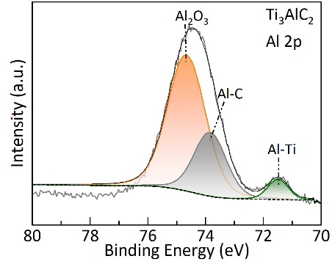
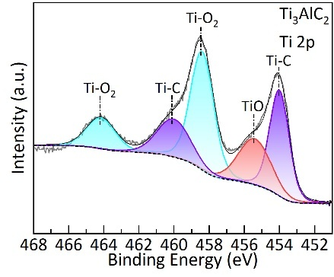
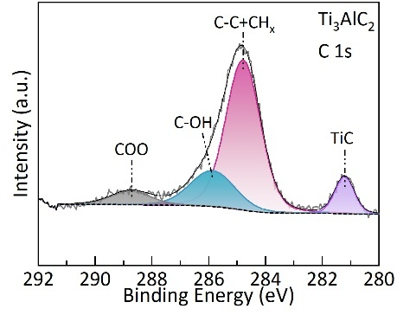
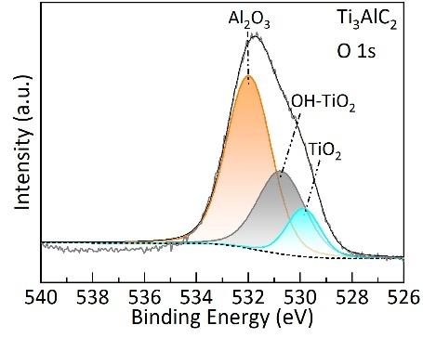
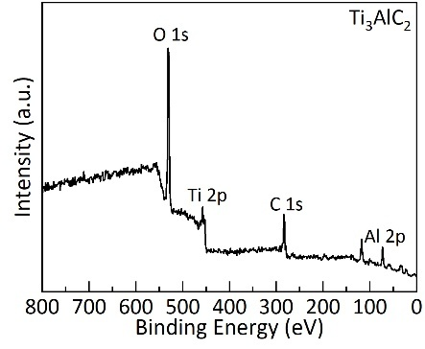
Supplementary Fig. 9. XPS characterizations of Ti₃AlC₂ MAX phase. a, survey spectrum b, Ti 2p c, O 1s d, C 1s e, Al 2p.
c
e
b
d
a

 | B. E. (eV) | Assigned to
Ti 2p_{3/2} (2p_{1/2}) | 454.01 (460.05) | Ti-C
 | 458.43 (464.18) | TiO₂
 | 455.33 | TiO
C 1s | 281.22 | Ti-C
C 1s | 284.8 | C-C + CH_{x}
C 1s | 286.86 | C-OH
C 1s | 288.75 | COO
O 1s | 529.86 | TiO₂
 | 530.93 | OH-TiO₂
 | 532.04 | Al₂O₃
Al 2p | 71.49 | Al-Ti
 | 73.85 | Al-C
 | 74.70 | Al₂O₃

Supplementary Table 1. Assignment of XPS peaks observed for Ti 2p, C 1s, O 1s and Al 2p spectra of the Ti₃AlC₂ MAX phase.
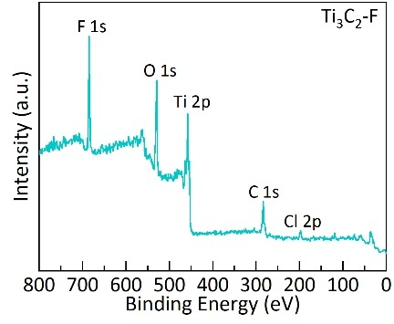
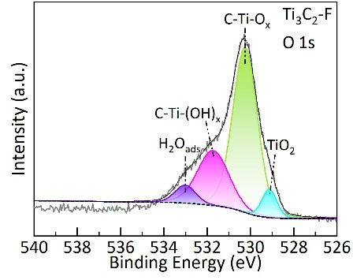
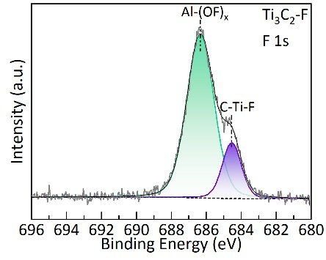
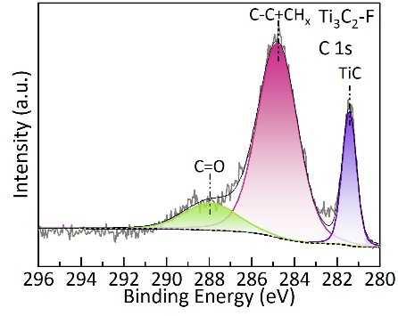
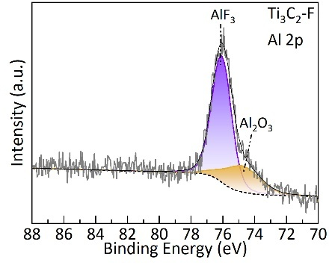
XPS analysis of Ti₃C₂-F MXene:
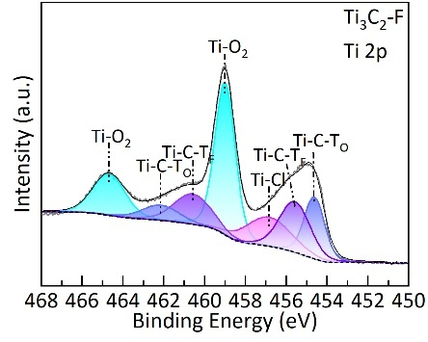
Supplementary Fig. 10. XPS characterizations of Ti₃C₂-F MXene. a, XPS survey spectrum. b, Ti 2p c, O 1s d, C 1s e, Al 2p f, F 1s.
f
e
d
a
c
b

 | B. E. (eV) | Assigned to
Ti 2p_{3/2} (2p_{1/2}) | 454.53 (460.51) | Ti-C-T_{O}
 | 459.01 (464.89) | TiO₂
 | 457.01 | Ti-Cl
 | 455.44 (461.81) | Ti-C-T_{F}
C 1s | 281.44 | Ti-C
 | 284.8 | C-C + CH_{x}
 | 287.95 | C=O
O 1s | 529.15 | TiO₂
 | 530.25 | C-Ti-O_{x}
 | 531.35 | C-Ti-(OH)_{x}
 | 533.60 | H₂O_{ads}
Al 2p | 74.79 | Al₂O₃
 | 76.08 | AlF₃
F 1s | 684.56 | C-Ti-F
 | 686.37 | Al-(OF)_{x}

Supplementary Table 2. Assignment of XPS peaks observed for Ti 2p, C 1s, O 1s, Al 2p and F 1s spectra of Ti₃C₂- F MXene.
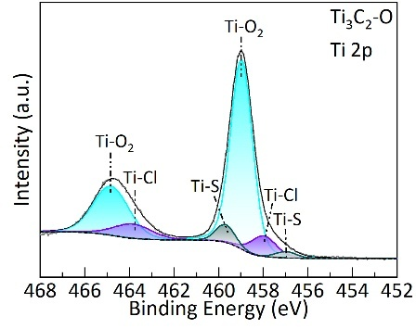
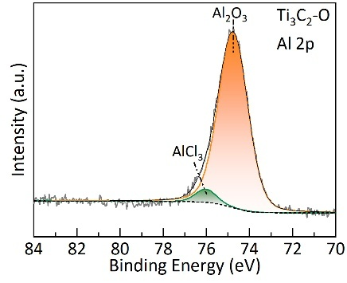
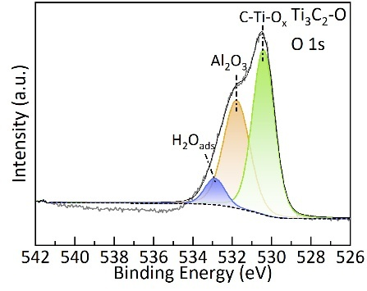
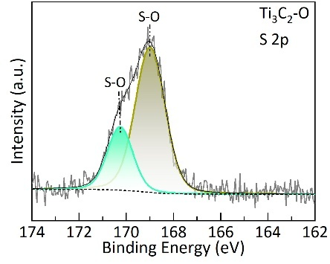
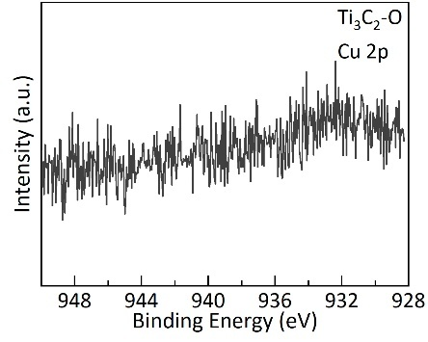
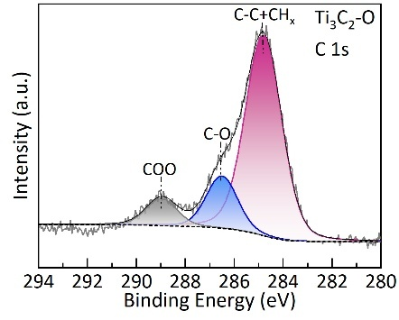
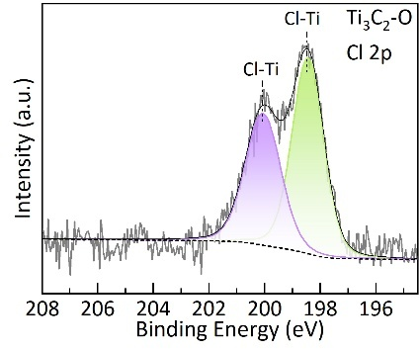
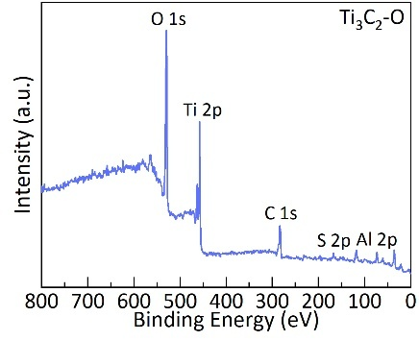
XPS analysis of Ti₃C₂-O MXene:
g
h
Supplementary Fig. 11. XPS characterisations of Ti₃C₂-O MXene. a, survey spectrum. b, Ti 2p c, O 1s d, C 1s e, Al 2p f, Cl 2p g, S 2p h, Cu 2p.
f
e
d
c
b
a
 | B. E. (eV) | Assigned to
Ti 2p_{3/2} (2p_{1/2}) | 457.61 (460.1) | Ti-S
 | 459.93 (465.53) | Ti-Cl
 | 460.01 (465.53) | Ti-O
C 1s | 284.8 | C-C+ CH_{x}
 | 286.51 | C-O
 | 288.87 | COO
O 1s | 530.39 | C-Ti-O_{x}
 | 531.65 | Al₂O₃
 | 532.93 | H₂O_{ads}
Al 2p | 74.70 | Al₂O₃
 | 76.02 | AlCl₃
Cl 2p_{3/2} (2p_{1/2}) | 198.44 (200.06) | Cl-Ti
S 2p_{3/2} (2p_{1/2}) | 169 (170.28) | S-O

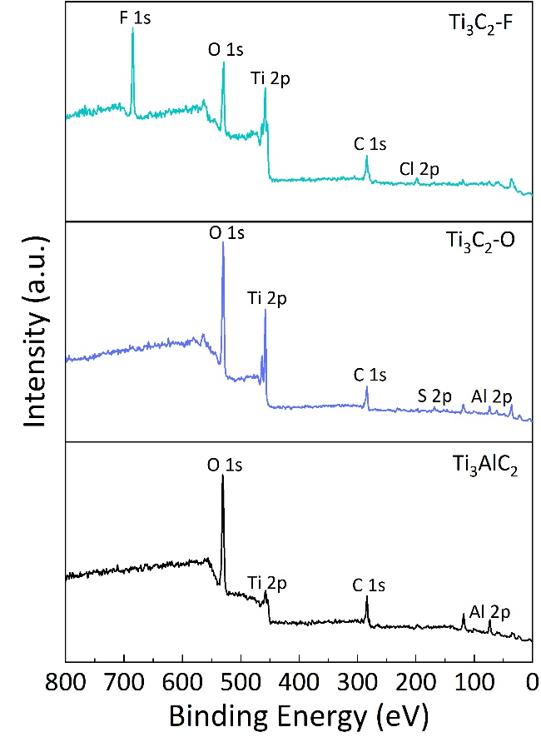
XPS Survey spectra:
Supplementary Table 3. Assignment of XPS peaks observed for Ti 2p, C 1s, O 1s, Al 2p, Cl 2p and S 2p spectra of Ti₃C₂-O MXene.
Supplementary Fig. 12. XPS Survey spectra of the Ti₃AlC₂ MAX phase, Ti₃C₂-F, and Ti₃C₂-O MXenes.

Sample | Name | Position | FWHM | Area | Atomic %
Ti₃AlC₂ | Ti 2p | 457.26 | 7.21 | 303.36 | 21.11
Ti₃AlC₂ | C 1s | 283.78 | 2.98 | 224.57 | 15.63
Ti₃AlC₂ | Al 2p | 73.28 | 2.74 | 87.95 | 6.12
Ti₃AlC₂ | O 1s | 530.57 | 3.61 | 821.30 | 57.15
Ti₃C₂-F | Ti 2p | 458.07 | 2.47 | 365.69 | 32.78
Ti₃C₂-F | C 1s | 284.00 | 3.14 | 165.89 | 14.87
Ti₃C₂-F | Al 2p | 74.08 | 1.30 | 6.27 | 0.56
Ti₃C₂-F | O 1s | 529.33 | 3.15 | 258.05 | 23.13
Ti₃C₂-F | F 1s | 684.99 | 2.55 | 286.11 | 25.65
Ti₃C₂-F | Cl 2p | 198.07 | 3.78 | 33.65 | 3.02
Ti₃C₂-O | Ti 2p | 457.79 | 2.25 | 569.35 | 34.28
Ti₃C₂-O | C 1s | 283.82 | 3.16 | 164.11 | 9.88
Ti₃C₂-O | Al 2p | 73.59 | 2.33 | 27.50 | 1.66
Ti₃C₂-O | O 1s | 529.83 | 3.50 | 874.06 | 52.63
Ti₃C₂-O | S 2p | 168.09 | 2.11 | 15.07 | 0.91
Ti₃C₂-O | Cl 2p | 196.79 | 1.73 | 10.67 | 0.64

Supplementary Table 4. Atomic percentages of elements in Ti₃AlC₂, Ti₃C₂-F, and Ti₃C₂-O MXenes derived from XPS spectra.
 | Ti₃AlC₂ MAX phase
Sample | Precursor  (molar ratio) |  |  | Synthesis parameters |  | Phase  (wt %)
 | Ti | TiC | Al | Temp (°C) | Time (h) | Ti₂AlC | TiC | Ti₃AlC₂
MAX¹ | 1.25 | 2 | 2.2 | 1200 | 4 | 1.45 | 2.6 | 95.94
MAX^{2’} | 1.25 | 2 | 2.2 | 1250 | 1 | 3.79 | 1.50 | 94.71
MAX² | 1.25 | 2 | 2.2 | 1250 | 4 | 0.19 | 0.71 | 99.0
MAX^{3a} | 1.1 | 2 | 1.4 | 1300 | 4 | 1.12 | 9.66 | 89.22
MAX^{3b} | 1.2 | 2 | 1.8 | 1300 | 4 | 3.48 | 6.88 | 89.64
MAX^{3ć} | 1.25 | 2 | 2.2 | 1300 | 2 | 4.77 | 3.41 | 91.82
MAX³ /MAX^{3c} | 1.25 | 2 | 2.2 | 1300 | 4 | 0.04 | 0.50 | 99.48
MAX⁴ | 1.25 | 2 | 2.2 | 1350 | 4 | 0.34 | 2.68 | 96.98
Comparison of the synthesis parameters and phase purity of MAX phase and MXenes:
Supplementary Table 5. Comparison of the synthesis parameters and phase purity of the synthesised Ti₃AlC₂ MAX phase.

Ti₃C₂T_{x} MXene | Etching parameters |  |  | Phase  (wt %)
 | Etchants | Temp (°C) | Time (h)
Ti₃C₂-F | LiF+ HCl | RT | 24 | 30.70
Ti₃C₂-F | LiF+ HCl | 55 | 12 | 96.40
Ti₃C₂-F | LiF+ HCl | 55 | 18 | 99.36
Ti₃C₂-F | LiF+ HCl | 55 | 24 | 99.71
Ti₃C₂-F | LiF+ HCl | 55 | 30 | 97.89
Ti₃C₂-O | CuCl₂ | 700 | 6 | 97.81
Ti₃C₂-O | CuCl₂ | 700 | 12 | 99.66
Ti₃C₂-O | CuCl₂ | 700 | 24 | --

Supplementary Table 6. Comparison of the synthesis parameters and phase purity of the Ti₃C₂-F and Ti₃C₂-O MXenes.

After sintering at 1200 °C for 4 h, the wt% of Ti₃AlC₂ was 95.94%, Ti₂AlC was 1.45%, and TiC was 2.6%. Increasing temperature to 1250 °C for 1 h decreased Ti₃AlC₂ to 94.71%, increased Ti₂AlC to 3.79%, and lowered TiC to 1.5%. Longer sintering at 1250 °C for 4 h improved Ti₃AlC₂ to 99.0%, with Ti₂AlC at 0.19% and TiC at 0.71%. At 1300 °C, Ti₃AlC₂ increased to 99.48%, while Ti₂AlC and TiC decreased. At 1350 °C, the Ti₃AlC₂ content dropped to 96.98%, while the Ti₂AlC and TiC contents increased. For high-purity Ti₃AlC₂, 1300 °C for 4 h is optimal; temperatures above 1300 °C cause conversion to Ti₂AlC and TiC. Varying precursor ratios, a molar ratio of 1.25:2:2.2 (MAX_{3c}) yielded 99.48% Ti₃AlC₂, while lower ratios resulted in less pure phases. Reducing sintering time to 2 h lowered Ti₃AlC₂ to 91.82%, increasing Ti₂AlC and TiC.
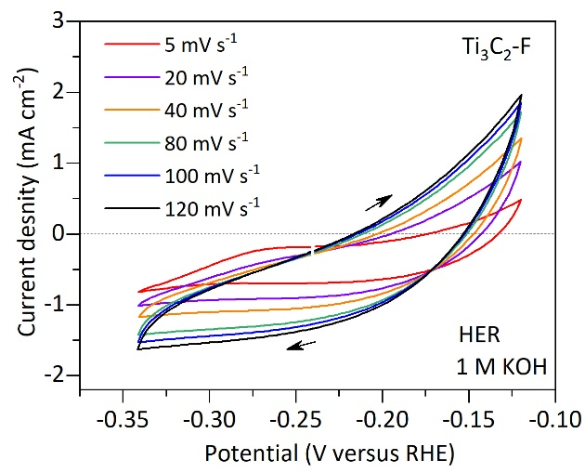
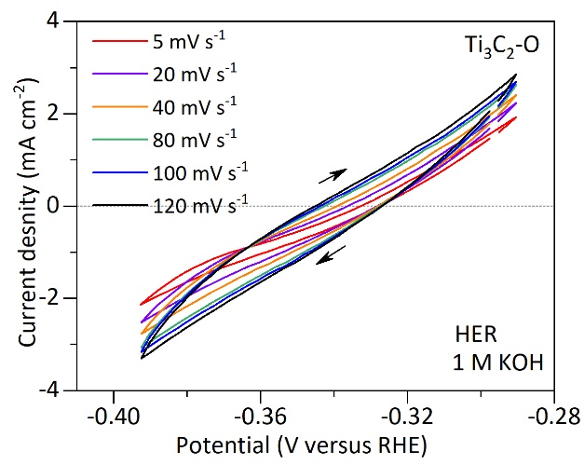
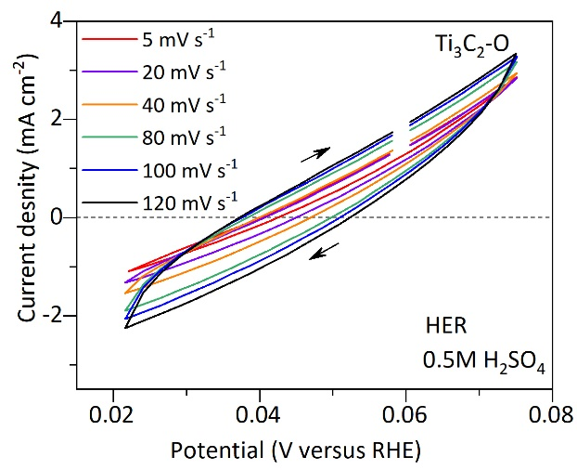
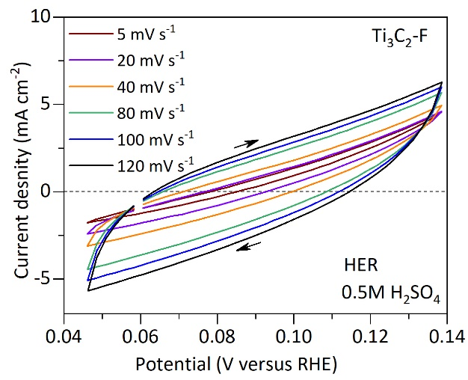
Electrochemical analysis:
a
b
c
d
Supplementary Fig. 13. Electrochemically active surface area characterization for universal pH HER. CV curves of Ti₃C₂-F and Ti₃C₂-O MXenes during HER: a, b in 0.5 M H₂SO₄; c, d in 1 M KOH, from which double-layer capacitance (C_{dl}) values are derived from the linear slope, which is equivalent to twice of C_{dl.}
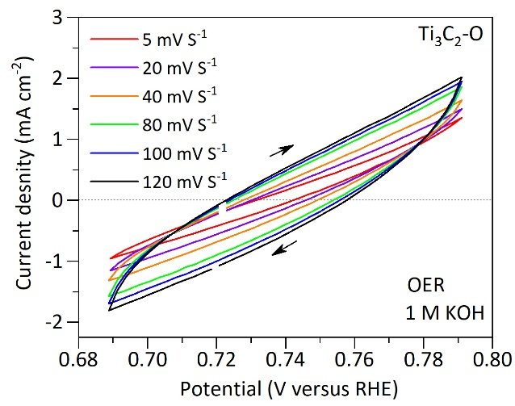
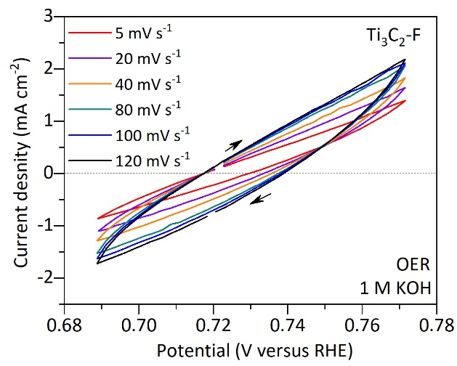
f
a
b
Supplementary Fig. 14. Electrochemically active surface area characterization for OER. a, b, CV curves of Ti₃C₂-F and Ti₃C₂-O MXenes during OER in 1 M KOH, from which C_{dl} values are derived from the linear slope, which is equivalent to twice C_{dl.}

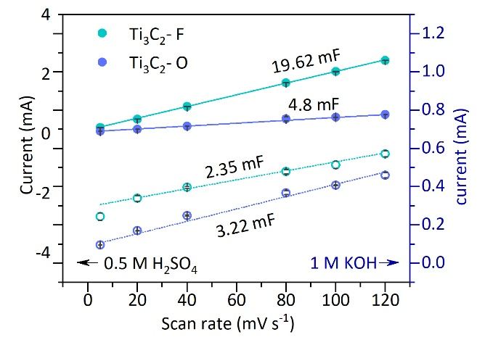
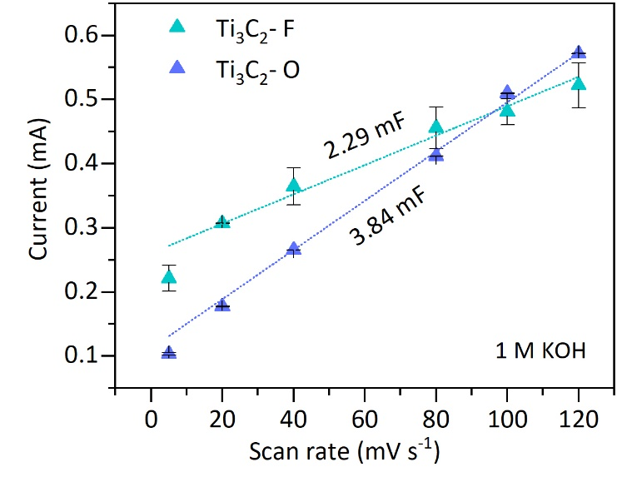
a
b
Supplementary Fig. 15. C_{dl} measurements of Ti₃C₂-F and Ti₃C₂-O MXenes. a, for HER in 0.5 M H₂SO₄ and 1 M KOH. b, for OER in 1 M KOH.

Media | Sample | HER |  |  | OER
Media | Sample | C_{dl}  (mF cm⁻²) | ECSA (cm²) | RF | C_{dl}  (mF cm⁻²) | ECSA (cm²) | RF
0.5 M H₂SO₄ | Ti₃C₂-F | 19.71 | 563.14 | 2252.56
0.5 M H₂SO₄ | Ti₃C₂-O | 4.87 | 121.79 | 487.16
1 M KOH | Ti₃C₂-F | 2.68 | 67 | 268 | 2.29 | 57.25 | 114.5
1 M KOH | Ti₃C₂-O | 3.03 | 75.75 | 300 | 3.84 | 96 | 192
Supplementary Table 7. C_{dl} and ECSA values of Ti₃C₂-F and Ti₃C₂-O MXenes in 0.5 M H₂SO₄ and 1 M KOH.

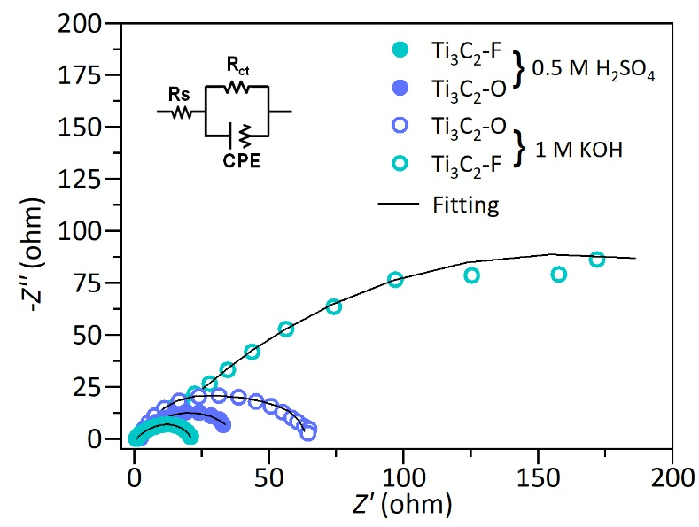
Supplementary Fig. 16. Electrochemical impedance spectroscopy (EIS; Nyquist plots) with fitting data of Ti₃C₂-F and Ti₃C₂-O MXenes in 0.5 M H₂SO₄ and 1 M KOH electrolytes.

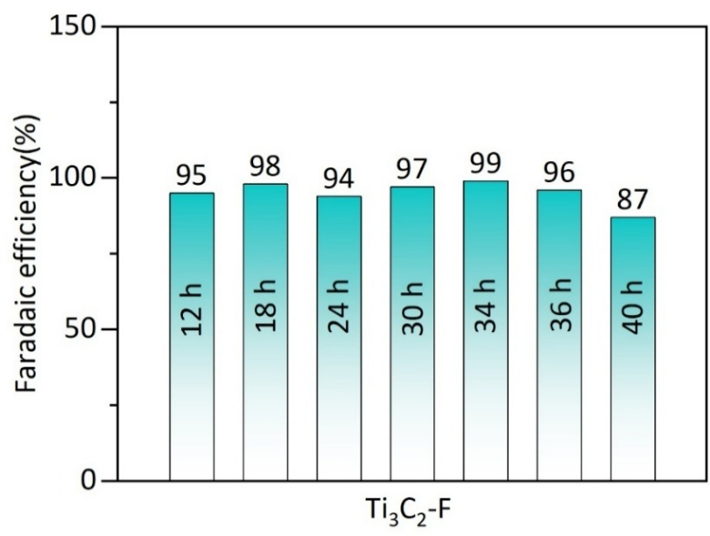
The impedance spectra were fitted to equivalent circuit models that included solution resistance (R_{s}), charge-transfer resistance (R_{ct}), and a constant phase element (CPE) to describe the non-ideal interfacial capacitance. The Nyquist spectra of both catalysts show a semicircle in the high-frequency region and an inclined line at lower frequencies, indicating the coexistence of charge transfer and diffusion-controlled processes. In 0.5 M H₂SO₄, Ti₃C₂-F shows a lower R_{s} of 0.76 Ω and an R_{ct} of 20.12 Ω compared to Ti₃C₂-O (R_{s} = 0.86 Ω, R_{ct} = 39.5 Ω). In contrast, in 1 M KOH, Ti₃C₂-O exhibits lower R_{s} (2.06 Ω) and R_{ct} (61.8 Ω) values than Ti₃C₂-F (R_{s} = 1.33 Ω, R_{ct} = 308.5 Ω).
Supplementary Fig. 17. Faradaic efficiencies of Ti₃C₂-F MXene at acidic pH at different time intervals.

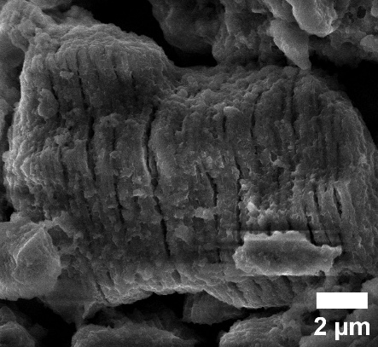
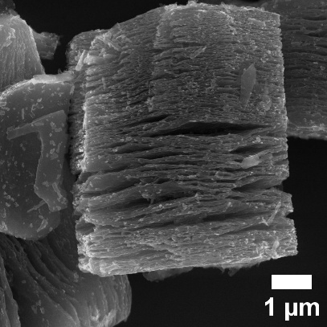
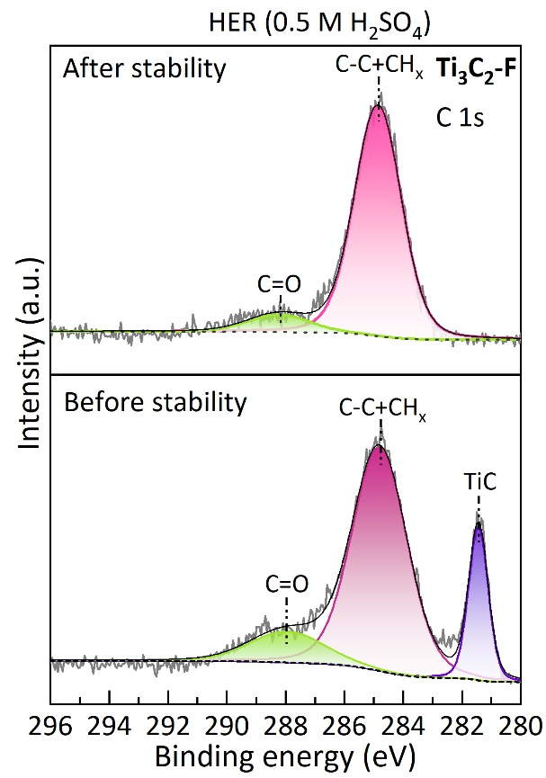
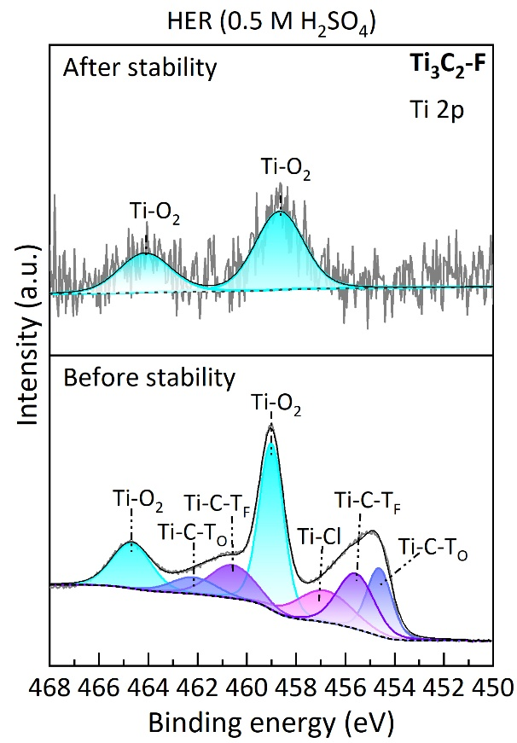
Post-electrochemical stability analysis:
Supplementary Fig. 18. Post-electrochemical analysis of Ti₃C₂-F MXene during the HER stability test (39.05 h, E = -0.34 V vs RHE) in 0.5 M H₂SO₄: a) morphological analysis i) before and ii) after the HER stability test. b) XPS spectra of i) Ti 2p and ii) C 1s before and after the stability test.
a
b
i
ii
ii
i

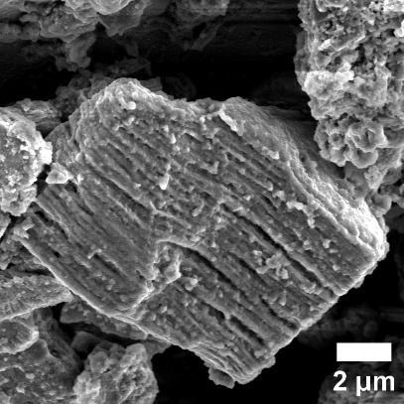
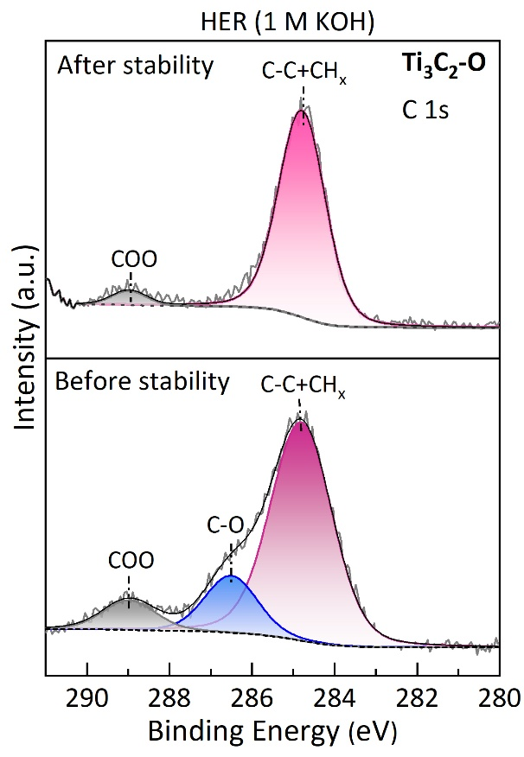
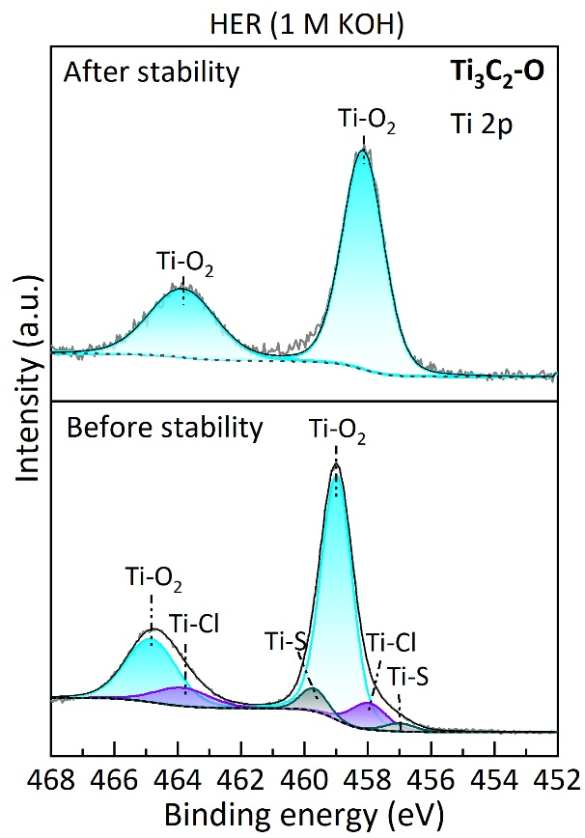
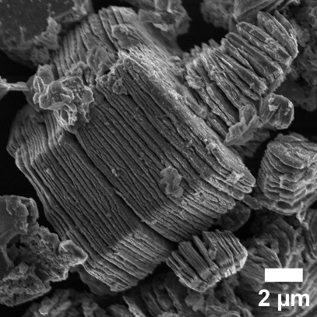
b
i
ii
a
i
ii
Supplementary Fig. 19. Post-electrochemical analysis of Ti₃C₂-O MXene during the HER stability test (19.2 h, E = -0.36 V vs RHE) in 1 M KOH: a) morphological analysis i) before and ii) after the HER stability test. b) XPS spectra of i) Ti 2p and ii) C 1s before and after the HER stability test.

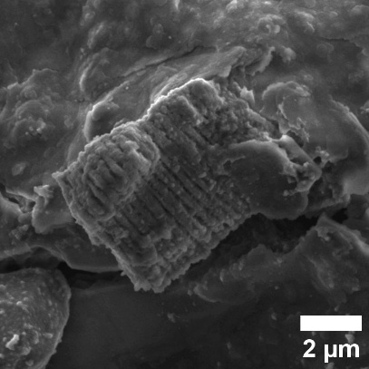
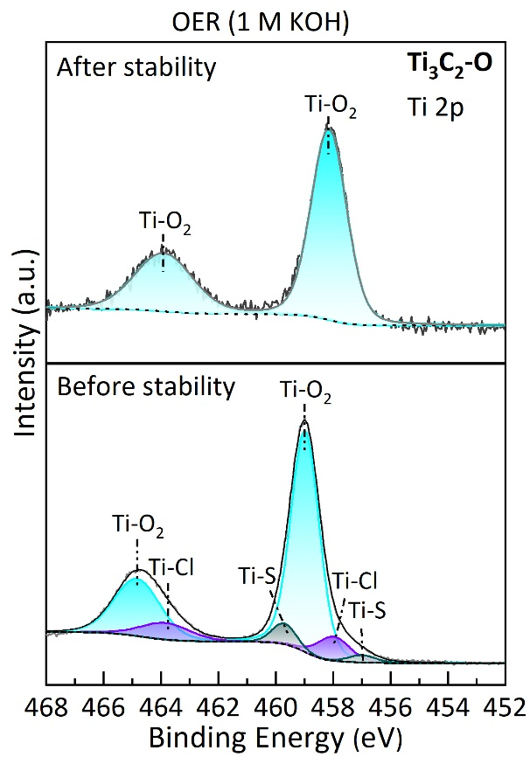
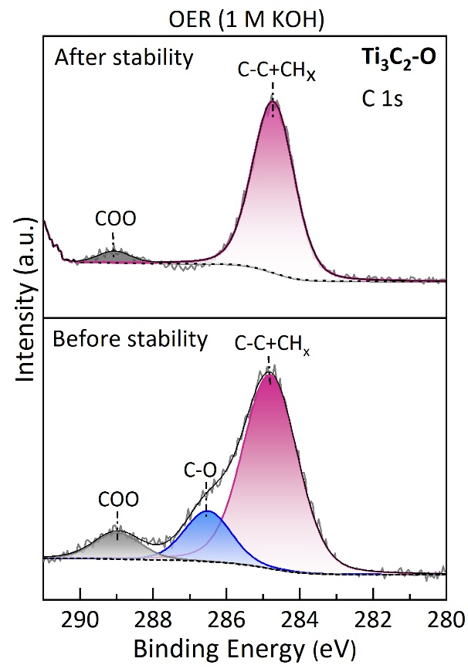
Supplementary Fig. 20. Post-electrochemical analysis of Ti₃C₂-O MXene during the OER stability test (17.8 h, E = +1.87 V vs RHE) in 1 M KOH: a) morphological analysis i) before and ii) after the OER stability test. b) XPS spectra of i) Ti 2p and ii) C 1s before and after the OER stability test.
b
ii
a
i
i
ii
Post-electrochemical XPS analysis reveals that both Ti₃C₂-F and Ti₃C₂-O exhibit notable changes in their surface chemical states after electrolysis, consistent with morphological alterations observed in FESEM images. The preserved layered structure, combined with increased surface roughness and partial agglomeration, suggests surface modification of the MXene during electrochemical stability. For Ti₃C₂-F, the Ti 2p spectrum is primarily characterised by Ti–O/TiO₂ after HER, with the Ti–C signal in the C 1s spectrum disappearing. This points to substantial surface oxidation and modification during acidic HER. Similarly, after HER and OER, Ti₃C₂-O's Ti 2p spectra are dominated by broad Ti–O or TiO₂ peaks, with another Ti feature no longer clearly visible. In the C 1s spectra, the C=O peak intensity decreased, and the C–O peak vanished after electrolysis. These findings indicate that both cathodic and anodic alkaline operations induced significant surface oxidation.
Materials | Catalyst mass loading  (mg cm⁻²) | 0.5 M H₂SO₄ |  |  | 1 M KOH |  |  | Ref.
Materials | Catalyst mass loading  (mg cm⁻²) | ⴄ₁₀  (mV) | Tafel slope  (mV dec⁻¹) | Stability | ⴄ₁₀  (mV) | Tafel slope  (mV dec⁻¹) | Stability | Ref.
Ti₃C₂T_{x} MXene
Ti₃C₂T_{x} | 1 | 70 | 150 |  |  |  |  | 6
Ti₃C₂O_{x} | 0.19 | 190 | 60.7 | 2000 cycles |  |  |  | 7
TiVCT_{x} | 0.025 | 151 | 116 | 12 h |  |  |  | 8
Ti₃C₂ | 2 |  |  |  | 188 | 110 | 2000 cycles | 3
Ti₂CT_{x} | 0.1 |  |  |  | 570 | 157 | 1000 cycles | 9
Doped/ Heterostructured Ti₃C₂T_{x} MXene
Re@Ti₃C₂T_{x} | 0.708 | 298 | 110 | 30 h |  |  |  | 10
Ti₃C₂T_{x} | 0.708 | 584 | 186.8 |  |  |  |  | 10
Ru-NS-Ti₃C₂T_{x} |  | 76 | 90 | 16 h |  |  |  | 11
Ti₃C₂T_{x} |  | 673 | 271 |  |  |  |  | 11
Ru_{SA}@Ti₃C₂T_{x} | 1 |  |  |  | 40.3 | 90 | 24 h,  5000 cycles | 12
Ti₃C₂T_{x} | 1 |  |  |  | 516 | 660 |  | 12
Ti₃C₂-F | 0.625 | 87 | 55 | 39.05 h,  9000 cycles | 143 | 103 |  | This work
Ti₃C₂-O | 0.625 | 105 | 76 |  | 76 | 86 | 19.2 h,  2100 cycles | This work
Supplementary Table 8. Comparison of the HER performance of the Ti₃C₂-F and Ti₃C₂-O MXenes in universal pH with reported MXene-based electrocatalysts.
Supplementary Table 9. Comparison of the overall water-splitting performance of the Ti₃C₂-F and Ti₃C₂-O MXenes in 1 M KOH with reported MXene-based electrocatalysts.
Materials | Catalyst mass loading  (mg cm⁻²) | HER |  |  | OER
Materials | Catalyst mass loading  (mg cm⁻²) | ⴄ₁₀  (mV) | Tafel slope (mV dec⁻¹) | Stability | ⴄ₁₀  (mV) | Tafel slope (mV dec⁻¹) | Stability | Ref.
Ti₃C₂T_{x} MXene
Ti₃C₂T_{x} | 0.7 | 245 | 107 | 24 h,  3000 cycles | 267 | 81 | 24 h,  3100 cycles | 13
Ti₃C₂T_{x} MXene Heterostructures
Co/N-CNTs@Ti₃C₂T_{x} | 0.408 |  |  |  | 411 | 79.1 | 5.5 h,  2000 cycles | 14
Ti₃C₂T_{x} | 0.408 |  |  |  | 484 | 227 |  | 14
Ru_{SA}@Ti₃C₂T_{x} | 1 | 40.3 | 90 | 24 h,  5000 cycles |  |  |  | 12
Ti₃C₂T_{x} | 1 | 516 | 660 |  |  |  |  | 12
CoNi-Ti₃C₂T_{x} | 1 | 31 | 33 | 10 h | 241 | 79.8 | 10 h | 15
Ti₃C₂T_{x} | 1 | 145 | 176 |  | 375 | 112.6 |  | 15
d-Ti₃C₂/V₂O₅ | 2 | 90 | 49 | 24 h | 450 | 52 | 24 h | 16
d-Ti₃C₂ | 2 | 192 | 68 |  | 240 | 63
Ti₃C₂-F | 0.625 | 143 | 103 |  | 176 | 110 |  | This work
Ti₃C₂-O | 0.625 | 76 | 86 | 19.2 h,  2100 cycles | 165 | 102 | 17.8 h,  2100 cycles | This work
References
1. Naslund, L. Å., Persson, P. O. Å. & Rosen, J. X-ray photoelectron spectroscopy of Ti₃AlC₂, Ti₃C₂T_{z}, and TiC provides evidence for the electrostatic interaction between laminated layers in max-phase materials. Journal of Physical Chemistry C 124, 27732–27742 (2020).
2. Yang, H. et al. Catalytic Performance for the Conversion of Potent Fluorinated Greenhouse Gases by Aluminium Fluorides with Different Morphology. Catal. Letters 151, 2065–2074 (2021).
3. Sharma, P., Kainth, S., Pandey, O. P. & Mahajan, R. Customized Synthesis of 2D Ti₃C₂ MXene for Improved Overall Water Splitting. ACS Appl. Nano Mater. 6, 21788–21802 (2023).
4. Li, Y. et al. A general Lewis acidic etching route for preparing MXenes with enhanced electrochemical performance in non-aqueous electrolyte. Nat. Mater. 19, 894–899 (2020).
5. Yuan, K., Hao, P., Hu, X., Zhang, J. & Zhou, Y. Experimental and computational studies on S-decorated Ti₃C₂ MXene as anode material in Li-ion batteries. J. Mater. Sci. 57, 7001–7011 (2022).
6. Navjyoti, N. et al. Modulation of Surface Ti-O Species in 2D-Ti₃C₂T_{x} MXene for Developing a Highly Efficient Electrocatalyst for Hydrogen Evolution and Methanol Oxidation Reactions. Langmuir 39, 2995–3005 (2023).
7. Jiang, Y. et al. Oxygen-Functionalized Ultrathin Ti₃C₂T_{x} MXene for Enhanced Electrocatalytic Hydrogen Evolution. ChemSusChem 12, 1368–1373 (2019).
8. Wen, Y. et al. 2D TiVCT_{x} layered nanosheets grown on nickel foam as highly efficient electrocatalysts for the hydrogen evolution reaction. RSC Adv. 12, 23584–23594 (2022).
9. Pang, S. Y. et al. Universal Strategy for HF-Free Facile and Rapid Synthesis of Two-dimensional MXenes as Multifunctional Energy Materials. J. Am. Chem. Soc. 141, 9610–9616 (2019).
10. Suragtkhuu, S. et al. Rhenium anchored Ti₃C₂T_{x} (MXene) nanosheets for electrocatalytic hydrogen production. Nanoscale Adv. 5, 349–355 (2022).
11. Ramalingam, V. et al. Heteroatom-Mediated Interactions between Ruthenium Single Atoms and an MXene Support for Efficient Hydrogen Evolution. Advanced Materials 31, (2019).
12. Zou, Y. et al. Ruthenium single-atom modulated Ti₃C₂T_{x} MXene for efficient alkaline electrocatalytic hydrogen production. EcoMat 5, (2023).
13. Lv, Z. et al. Induction of Co2P Growth on a MXene (Ti₃C₂T_{x})-Modified Self-Supporting Electrode for Efficient Overall Water Splitting. Journal of Physical Chemistry Letters 12, 4841–4848 (2021).
14. Zhang, Y. et al. In Situ Growth of Cobalt Nanoparticles Encapsulated Nitrogen-Doped Carbon Nanotubes among Ti₃C₂T_{x} (MXene) Matrix for Oxygen Reduction and Evolution. Adv. Mater. Interfaces 5, (2018).
15. Zhao, X. et al. Dual-Atom Co/Ni Electrocatalyst Anchored at the Surface-Modified Ti₃C₂T_{x} MXene Enables Efficient Hydrogen and Oxygen Evolution Reactions. ACS Nano 18, 4256–4268 (2024).
16. Ashraf, I. et al. Hydrothermal synthesis and water splitting application of d-Ti₃C₂ MXene/V₂O₅ hybrid nanostructures as an efficient bifunctional catalyst. Int. J. Hydrogen Energy 47, 27383–27396 (2022).

