Supplementary Materials
Title: Development of a Short Form of the Life Functioning Scale for Older Adults in the Korea National Health and Nutrition Examination Survey
Authors:
Eunsaem Kim, Jinhee Kim, Yunhwan Lee, Jihye Yun, Jaewon Choi, Miji Kim, Kyungwon Oh, & Yangha Kim

Supplementary Table 1. 10-item Life Functioning (LF-10) scale questionnaire
How much difficulty do you have in carrying out the following activity without the help of someone else or the use of assistive devices?
Items | None | A little | Some | A lot | Cannot do
Standing up from an armless chair | 4 | 3 | 2 | 1 | 0
Standing on tiptoes | 4 | 3 | 2 | 1 | 0
Bending, squatting, or kneeling | 4 | 3 | 2 | 1 | 0
Walking 400m | 4 | 3 | 2 | 1 | 0
Climbing 1 floor (10-12 stairs) without resting | 4 | 3 | 2 | 1 | 0
Grasping and using small objects (e.g. writing with a pen, cutting paper with scissors, peeling fruit, tightening screws with a screwdriver) | 4 | 3 | 2 | 1 | 0
Lifting 5kg objects | 4 | 3 | 2 | 1 | 0
Bathing or showering | 4 | 3 | 2 | 1 | 0
Using public transportation | 4 | 3 | 2 | 1 | 0
Participating in social activities (e.g., clubs, religious activity, volunteering) | 4 | 3 | 2 | 1 | 0
Note. Item wording is presented in English; the scale was developed and validated in Korean. The English translation is provided to facilitate international use and has not been separately validated; The original Korean instrument is provided in Supplementary Table 8; Total scores are computed by summing item scores and multiplying by 2.5, yielding a 0–100 metric on which higher scores indicate better physical functioning.

Supplementary Table 2. 25-item Life Functioning (LF-25) scale questionnaire
How much difficulty do you have in carrying out the following activity without the help of someone else or the use of assistive devices?
Items | None | A little | Some | A lot | Cannot do
Q1 Sitting 2 hours | 4 | 3 | 2 | 1 | 0
Q2 Standing up from an armless chair | 4 | 3 | 2 | 1 | 0
Q3 Standing for 30 minutes | 4 | 3 | 2 | 1 | 0
Q4 Standing for 2 hours | 4 | 3 | 2 | 1 | 0
Q5 Standing on tiptoes | 4 | 3 | 2 | 1 | 0
Q6 Bending, squatting, or kneeling | 4 | 3 | 2 | 1 | 0
Q7 Walking 400m | 4 | 3 | 2 | 1 | 0
Q8 Walking 1 km | 4 | 3 | 2 | 1 | 0
Q9 Climbing 1 floor (10-12 stairs) without resting | 4 | 3 | 2 | 1 | 0
Q10 Getting in and out of the car | 4 | 3 | 2 | 1 | 0
Q11 Grasping and using small objects (e.g. writing with a pen, cutting paper with scissors, peeling fruit, tightening screws with a screwdriver) | 4 | 3 | 2 | 1 | 0
Q12 Opening Containers or bottle caps | 4 | 3 | 2 | 1 | 0
Q13 Pushing or pulling large objects | 4 | 3 | 2 | 1 | 0
Q14 Reaching behind back | 4 | 3 | 2 | 1 | 0
Q15 Reach up overhead | 4 | 3 | 2 | 1 | 0
Q16 Lifting 5kg objects | 4 | 3 | 2 | 1 | 0
Q17 Bathing or showering | 4 | 3 | 2 | 1 | 0
Q18 Getting in and out of bed | 4 | 3 | 2 | 1 | 0
Q19 Preparing meals | 4 | 3 | 2 | 1 | 0
Q20 Managing money | 4 | 3 | 2 | 1 | 0
Q21 Using public transportation | 4 | 3 | 2 | 1 | 0
Q22 Doing light housework | 4 | 3 | 2 | 1 | 0
Q23 Engaging indoor leisure activities (e.g., reading, watching TV, listening to the radio) | 4 | 3 | 2 | 1 | 0
Q24 Participating in social activities (e.g., clubs, religious activity, volunteering) | 4 | 3 | 2 | 1 | 0
Q25 Going outside (e.g., shopping, movies, sports events) | 4 | 3 | 2 | 1 | 0

Supplementary Table 3 Results of expert content evaluation for 25 items of LF Scale (n = 9)
Item | Content Validity Index (CVI) |  |  |  | Content Validity Ratio (CVR)
Item | Clarity | Relevance | Representativeness | Objectivity | Clarity | Relevance | Representativeness | Objectivity
Q1 Sitting 2 hours | 0.78 | 0.56 | 0.33 | 0.44 | 0.56 | 0.11 | -0.33 | -0.11
Q2 Standing up from an armless chair | 1.00 | 0.89 | 1.00 | 1.00 | 1.00 | 0.78 | 1.00 | 1.00
Q3 Standing for 30 minutes | 1.00 | 0.67 | 0.67 | 0.67 | 1.00 | 0.33 | 0.33 | 0.33
Q4 Standing for 2 hours | 0.78 | 0.44 | 0.44 | 0.55 | 0.56 | -0.11 | -0.11 | 0.11
Q5 Standing on tiptoes | 0.89 | 1.00 | 0.89 | 0.89 | 0.78 | 1.00 | 0.78 | 0.78
Q6 Bending, squatting, or kneeling | 0.89 | 0.78 | 0.78 | 0.78 | 0.78 | 0.56 | 0.56 | 0.56
Q7 Walking 400m | 1.00 | 0.89 | 0.89 | 1.00 | 1.00 | 0.78 | 0.78 | 1.00
Q8 Walking 1 km | 1.00 | 1.00 | 1.00 | 1.00 | 1.00 | 1.00 | 1.00 | 1.00
Q9 Climbing 1 floor without resting | 1.00 | 0.89 | 0.78 | 1.00 | 1.00 | 0.78 | 0.56 | 1.00
Q10 Getting in and out of the car | 0.89 | 0.78 | 0.67 | 1.00 | 0.78 | 0.56 | 0.33 | 1.00
Q11 Grasping and using small objects | 0.89 | 1.00 | 1.00 | 1.00 | 0.78 | 1.00 | 1.00 | 1.00
Q12 Opening Containers or bottle caps | 1.00 | 1.00 | 1.00 | 0.89 | 1.00 | 1.00 | 1.00 | 0.78
Q13 Pushing or pulling large objects | 0.78 | 0.67 | 0.56 | 0.56 | 0.56 | 0.33 | 0.11 | 0.11
Q14 Reaching behind back | 0.89 | 0.89 | 0.89 | 0.78 | 0.78 | 0.78 | 0.78 | 0.56
Q15 Reach up overhead | 0.78 | 0.78 | 0.78 | 0.78 | 0.56 | 0.56 | 0.56 | 0.56
Q16 Lifting 5kg objects | 1.00 | 1.00 | 1.00 | 1.00 | 1.00 | 1.00 | 1.00 | 1.00
Q17 Bathing or showering | 1.00 | 1.00 | 1.00 | 1.00 | 1.00 | 1.00 | 1.00 | 1.00
Q18 Getting in and out of bed | 1.00 | 0.78 | 0.78 | 0.78 | 1.00 | 0.56 | 0.56 | 0.56
Q19 Preparing meals | 1.00 | 0.89 | 0.89 | 0.89 | 1.00 | 0.78 | 0.78 | 0.78
Q20 Managing money | 1.00 | 1.00 | 0.89 | 0.78 | 1.00 | 1.00 | 0.78 | 0.56
Q21 Using public transportation | 1.00 | 1.00 | 1.00 | 1.00 | 1.00 | 1.00 | 1.00 | 1.00
Q22 Doing light housework | 1.00 | 1.00 | 0.89 | 0.89 | 1.00 | 1.00 | 0.78 | 0.78
Q23 Engaging indoor leisure activities | 1.00 | 1.00 | 1.00 | 1.00 | 1.00 | 1.00 | 1.00 | 1.00
Q24 Participating in social activities | 1.00 | 1.00 | 1.00 | 1.00 | 1.00 | 1.00 | 1.00 | 1.00
Q25 Going outside | 1.00 | 0.78 | 0.79 | 0.78 | 1.00 | 0.56 | 0.56 | 0.56
Note. Utilized 4-point Likert scales (e.g., 1 = not relevant to 4 = highly relevant) for each item; Calculated the proportion of experts rating 3 and 4; For a nine-member expert panel, the minimum acceptable thresholds were 0.78 for CVI and 0.62 for CVR [3].
Supplementary Table 4. Summary of results of cognitive interviewing (n = 8)

Issue | Item | Core finding
Comprehension problems | Sitting for 2 hours | Interpreted variously as watching TV on a sofa, reading in a library, or watching a film. Respondents who pictured sitting on the floor rated it harder than sitting on a chair. Neither the seating surface nor the amount of movement permitted was specified.
Comprehension problems | Standing for 30 minutes | Some pictured standing in a moving bus or subway while maintaining balance; others pictured a stationary posture. The permitted degree of movement was undefined.
Comprehension problems | Getting in and out of a car | "Car" evoked buses and subways rather than private vehicles. The two differ substantially: buses require stepping up, private cars require bending and lowering the body.
Comprehension problems | Pushing and pulling large objects | The example given (a dining chair) was not regarded as a large object. Pushing was considered easier than pulling. Some respondents interpreted the item as lifting and carrying.
Comprehension problems | Opening container/bottle caps | Respondents pictured glass or beer bottles rather than plastic bottles. Twist-off lids and lids requiring an opener were seen as distinct tasks, as were lids of differing size.
Comprehension problems | Managing money | The phrase "without help from another person or assistive devices" was unclear: respondents asked whether help from adult children with banking apps, or from bank staff, counted, and whether a calculator constituted an assistive device.
Comprehension problems | Using public transportation | Understood as going out using transportation rather than boarding and alighting. Driving one's own car was seen as categorically different from taking a taxi, bus, or subway.
Comprehension problems | Climbing one floor (10-12 stairs) without resting | The clarification "10–12 steps" was misread by some as 10–12 floors. Respondents distinguished sharply between climbing with and without a handrail, and found "without holding the handrail" clearer than "without assistive devices or help from another person."
Comprehension problems | Reaching behind the back | The bathing example redirected attention to soaping the entire back rather than to the reaching motion itself. A simpler referent (reaching back to touch the opposite shoulder) was suggested.
Comprehension problems | Going outside (e.g., shopping, movies, sports events) | Examples (shopping, films, sporting events) were interpreted differently by region, age, and sex. Men treated any purposeful trip outside the home as going out; women distinguished routine errands from leisure shopping.
Retrieval and estimation problems | Standing for 2 hours | Almost no respondent had sustained this posture, and most could not estimate their capacity. Several answered "don't know." Boredom was confounded with physical difficulty. Respondents could estimate one hour but not two.
Retrieval and estimation problems | Walking 400 m | Distance was difficult to gauge without a concrete referent. "One lap of a running track" helped, but track sizes vary. Time-based framing was rejected because walking pace differs between individuals; a step-count equivalent was suggested.
Retrieval and estimation problems | Walking 1 km | Poorly differentiated from 400 m — respondents who could walk 400 m could generally walk 1 km. People monitor walking by duration or pedometer rather than distance.
Retrieval and estimation problems | Lifting a 5 kg object | Despite worked examples, women could not gauge 5 kg, whereas men estimated it accurately. Many interpreted the item as lifting and carrying. Difficulty also depended on whether the object was on the floor or on a table.
Multi-barreled items | Bending, squatting, or kneeling | Many respondents could bend and squat but not kneel, making a single response ambiguous. Respondents answered on the most difficult of the three; separating the actions, or instructing respondents explicitly to answer on the hardest, was recommended.
Multi-barreled items | Grasping and using small objects (e.g. writing with a pen, cutting paper with scissors, peeling fruit, tightening screws with a screwdriver) | The examples differed in both difficulty and familiarity: women rarely tightened screws, men rarely peeled fruit, so reported difficulty reflected unfamiliarity rather than functional decline. Writing with a pen was too easy. Chopsticks, nail scissors, and tweezers were suggested instead.
Multi-barreled items | Bathing or showering | Bathing (entering a tub and scrubbing) and showering were regarded as different activities, with bathing considered harder, particularly by women. Focusing the item on washing the body unaided was recommended.
Multi-barreled items | Reaching up overhead | Clearly understood. However, a respondent with a shoulder problem could raise one arm but not both; reaching with both arms was judged more informative about functional status.
Multi-barreled items | Participating in social activities (e.g., clubs, religious activity, volunteering) | The examples varied widely in difficulty. Meeting friends or relatives was regarded as socializing rather than social participation, which respondents defined as purposeful group activity and considered more demanding.
Multi-barreled items | Standing on tiptoes | Interpreted as a calf-raise exercise or as reaching a high shelf. Older respondents reported using a chair to reach high objects, so did not use that referent. Difficulty depended on whether the posture was brief or sustained.
Items where difficulty reflected experience rather than function | Preparing meals | Men reported difficulty owing to limited cooking experience and skill; women reported difficulty owing to physical decline. Interpretations of whether meal preparation resembles housework also differed by sex.
 | Doing light housework | Women rated the listed tasks as equally demanding; men differentiated among them, with responses driven by age and prior experience rather than physical capacity.
 | Engaging indoor leisure activities (e.g., reading, watching TV, listening to the radio) | Watching television or YouTube was not regarded as a hobby but as passive leisure. Board games such as Baduk (Go) and janggi (Korean chess) are typically played with friends outside the home, so were not seen as indoor solitary activities.

Supplementary Table 5. Two candidate shortened Life Functioning (LF) scales: the 12-item LF (LF-12) and the 10-item LF (LF-10) scales

Types | Items
Type A: 12-item LF scale (LF-12) | Standing up from an armless chair
Type A: 12-item LF scale (LF-12) | Standing on tiptoes
Type A: 12-item LF scale (LF-12) | Bending/squatting/kneeling
Type A: 12-item LF scale (LF-12) | Walking 400 meters
Type A: 12-item LF scale (LF-12) | Climbing one floor
Type A: 12-item LF scale (LF-12) | Grasping small objects
Type A: 12-item LF scale (LF-12) | Reaching behind back
Type A: 12-item LF scale (LF-12) | Lifting 5kg
Type A: 12-item LF scale (LF-12) | Bathing or showering
Type A: 12-item LF scale (LF-12) | Using public transportation
Type A: 12-item LF scale (LF-12) | Engaging in indoor leisure activities
Type A: 12-item LF scale (LF-12) | Participating in social activities
Type B: 10-item LF scale (LF-10) | Standing up from an armless chair
Type B: 10-item LF scale (LF-10) | Standing on tiptoes
Type B: 10-item LF scale (LF-10) | Bending/squatting/kneeling
Type B: 10-item LF scale (LF-10) | Walking 400m
Type B: 10-item LF scale (LF-10) | Climbing one floor
Type B: 10-item LF scale (LF-10) | Grasping small objects
Type B: 10-item LF scale (LF-10) | Lifting 5kg
Type B: 10-item LF scale (LF-10) | Bathing or showering
Type B: 10-item LF scale (LF-10) | Using public transportation
Type B: 10-item LF scale (LF-10) | Participating in social activities
Note. LF = Life Functioning.

Supplementary Table 6. Descriptive statistics for the 10-item Life Functioning scale (n = 260)

Items | Cannot do [0] | A lot [1] | Some [2] | A little [3] | None [4] | Do not do | Mean ± SD
Q1. Standing up from an armless chair | 1 (0.4%) | 2 (0.8%) | 3 (1.2%) | 20 (7.7%) | 234 (90.0%) | - | 3.86 ± 0.49
Q2. Standing on tiptoes | 4 (1.5%) | 4 (1.5%) | 8 (3.1%) | 23 (8.8%) | 212 (81.5%) | 9 (3.5%) | 3.73 ± 0.74
Q3. Bending/squatting/kneeling | 1 (0.4%) | 6 (2.3%) | 17 (6.5%) | 41 (15.8%) | 195 (75.0%) | - | 3.63 ± 0.74
Q4. Walking 400m | 4 (1.5%) | 5 (1.9%) | 4 (1.5%) | 23 (8.8%) | 223 (85.8%) | 1 (0.4%) | 3.76 ± 0.72
Q5. Climbing 1 floor | 4 (1.5%) | 5 (1.9%) | 20 (7.7%) | 43 (16.5%) | 183 (70.4%) | 5 (1.9%) | 3.55 ± 0.84
Q6. Grasping small objects | - | 1 (0.4%) | 1 (0.4%) | 9 (3.5%) | 249 (95.8%) | - | 3.95 ± 0.29
Q7. Lifting 5kg | 1 (0.4%) | 5 (1.9%) | 7 (2.7%) | 38 (14.6%) | 208 (80.0%) | 1 (0.4%) | 3.73 ± 0.65
Q8. Bathing/showering | 1 (0.4%) | - | 1 (0.4%) | 8 (3.1%) | 250 (96.2%) | - | 3.95 ± 0.32
Q9. Using public transportation | 1 (0.4%) | 1 (0.4%) | 3 (1.2%) | 20 (7.7%) | 234 (90.0%) | 1 (0.4%) | 3.87 ± 0.45
Q10. Participating in social activities | 1 (0.4%) | - | 1 (0.4%) | 17 (6.5%) | 239 (91.9%) | 2 (0.8%) | 3.91 ± 0.37
Note. [ ]: response score, SD = standard deviation.

Supplementary Table 7. Results of an exploratory factor analysis using a WLSMV estimator (n = 260)

Items | Factor  loadings | Explained  variance | Residual variance
Q1. Standing up from a chair | 0.969 | 0.939 | 0.061
Q2. Standing on tiptoes | 0.946 | 0.895 | 0.105
Q3. Bending/squatting/kneeling | 0.91 | 0.828 | 0.172
Q4. Walking 400m | 0.955 | 0.912 | 0.088
Q5. Climbing 1 floor | 0.944 | 0.891 | 0.109
Q6. Grasping small objects | 0.831 | 0.691 | 0.309
Q7. Lifting 5kg | 0.821 | 0.674 | 0.326
Q8. Bathing or showering | 0.953 | 0.908 | 0.092
Q9. Using public transportation | 0.945 | 0.893 | 0.107
Q10. Participating in social activities | 0.677 | 0.458 | 0.542
Note. WLSMV = Weighted Least Squares Mean and Variance-adjusted.

Supplementary Table 8. Differences in LF-10 scores by known groups

Characteristic | Categories | n (%) | Mean ±SD | Test Statistic
Gender | Men | 125 (48.1) | 95.66 ±10.91 | t = 1.90*
Gender | Women | 135 (51.9) | 92.78 ±13.28 | t = 1.90*
Age (y) | 50-59 | 102 (39.2) | 98.14 ±5.95 | F = 23.30***
Age (y) | 60-69 | 90 (34.6) | 95.58 ±9.61 | F = 23.30***
Age (y) | ≥ 70 | 68 (26.2) | 86.32 ±17.76 | F = 23.30***
Educational level | Middle school or lower | 83 (31.9) | 87.35 ±17.67 | F = 17.39***
Educational level | High school | 129 (49.6) | 97.36 ±6.54 | F = 17.39***
Educational level | College or higher | 48 (18.5) | 97.34 ±6.79 | F = 17.39***
Marital status | Married | 220 (86.3) | 95.09 ±11.67 | F = 7.56***
Marital status | Widowed | 23 (9.0) | 84.89 ±14.31 | F = 7.56***
Marital status | Divorced | 12 (4.7) | 95.21±13.55 | F = 7.56***
Monthly household income  (in thousand KRW) | < 2,000 | 47 (18.1) | 84.41 ±18.67 | F = 23.78***
Monthly household income  (in thousand KRW) | 2,000 – 3,999 | 90 (34.6) | 95.52 ±11.25 | F = 23.78***
Monthly household income  (in thousand KRW) | ≥ 4,000 | 101 (40.8) | 97.88 ±5.70 | F = 23.78***
Self-rated health | Very good or good | 158 (60.8) | 98.78 ±3.88 | F = 113.03***
Self-rated health | Fair | 85 (32.7) | 91.35 ±9.48 | F = 113.03***
Self-rated health | Poor | 17 (6.5) | 65.29 ±25.96 | F = 113.03***
Subjective cognitive decline | Yes | 30 (11.5) | 85.67 ±15.31 | t = 3.32**
Subjective cognitive decline | No | 230 (88.5) | 95.27 ±11.38 | t = 3.32**
Depressive symptoms | Minimal or no depression^{a)} | 247 (95) | 96.47 ±9.24 | t = 3.33**
Depressive symptoms | Mild to moderate^{b)} | 13 (5) | 69.42 ±28.16 | t = 3.33**
Multimorbidity | 0 | 119 (45.8) | 97.92 ±5.54 | F = 16.19***
Multimorbidity | 1 | 70 (26.9) | 94.00 ±11.99 | F = 16.19***
Multimorbidity | ≥ 2 | 71 (27.3) | 88.03 ±17.33 | F = 16.19***
Note. ^{a)}PHQ-9 ≤ 4; ^{b)}PHQ-9 ≥ 5; LF-10 = 10-item Life Functioning scale; PHQ-9 = nine-item Patent Health Questionnaire.
* p < 0.05, ** p < 0.01, *** p < 0.001

Items | Weighted kappa | Kappa | Spearman's ρ | Agreement | Cronbach’s α if item is deleted | McDonald’s ω if item is deleted
Standing up from a chair | 0.81*** | 0.72*** | 0.85** | 93.9% | 0.893 | 0.921
Standing on tiptoes | 0.59*** | 0.61*** | 0.58** | 85.1% | 0.886 | 0.911
Bending/squatting/kneeling | 0.66*** | 0.58*** | 0.70** | 80.7% | 0.895 | 0.920
Walking 400m | 0.53*** | 0.38*** | 0.40** | 82.5% | 0.890 | 0.915
Climbing one floor | 0.61*** | 0.59*** | 0.58** | 79.8% | 0.895 | 0.918
Grasping small objects | 0.52*** | 0.44*** | 0.37** | 94.7% | 0.910 | 0.929
Lifting 5kg | 0.42*** | 0.47*** | 0.39** | 79.8% | 0.900 | 0.928
Bathing or showering | 0.79*** | 0.72*** | 0.91** | 97.4% | 0.905 | 0.927
Using public transportation | 0.50*** | 0.57*** | 0.37** | 90.4% | 0.892 | 0.919
Participating in social activities | 0.67*** | 0.71*** | 0.54** | 94.7% | 0.914 | 0.932
Total score of LF-10 Intraclass coefficient = 0.94*** (95% CI: 0.92, 0.96)
Supplementary Table 9. Reliability of the 10-item Life Functioning (LF-10) scale
Note. * p < 0.05, ** p < 0.01, *** p < 0.001

Supplementary Table 10. 10-item Life Functioning (LF-10) questionnaire (in Korean)
귀하께서는 현재 다른 사람의 도움이나 보조기 없이 혼자서 다음의 동작을 하는 것이 얼마나 어려우십니까?
문항 | 전혀 어렵지 않다 | 약간 어렵다 | 중간 정도 어렵다 | 매우 어렵다 | 전혀 할 수 없다
1. 팔걸이 없는 의자에서 일어나기 | 4 | 3 | 2 | 1 | 0
2. 까치발로 서 있기 | 4 | 3 | 2 | 1 | 0
3. 몸을 구부리거나, 쭈그리고 않거나, 무릎을 꿇기 | 4 | 3 | 2 | 1 | 0
4. 400 m (운동장 한 바퀴) 걷기 | 4 | 3 | 2 | 1 | 0
5. 쉬지 않고 건물 1 층(10–12 계단)을 오르기 | 4 | 3 | 2 | 1 | 0
6. 작은 물건을 집고 사용하기(펜을 쥐고 글씨 쓰기, 가위를 사용하여 종이 자르기, 과일껍질 벗기기, 드라이버로 나사 조이기) | 4 | 3 | 2 | 1 | 0
7. 5 kg의 물건 들기(과일 한 상자 정도) | 4 | 3 | 2 | 1 | 0
8. 목욕이나 샤워하기 | 4 | 3 | 2 | 1 | 0
9. 교통수단 이용하기(자가용, 택시, 버스, 지하철 등) | 4 | 3 | 2 | 1 | 0
10. 사회활동에 참여하기(친구나 친척 만나기 또는 동호회, 계모임, 종교활동, 자원봉사, 정치사회단체 등) | 4 | 3 | 2 | 1 | 0

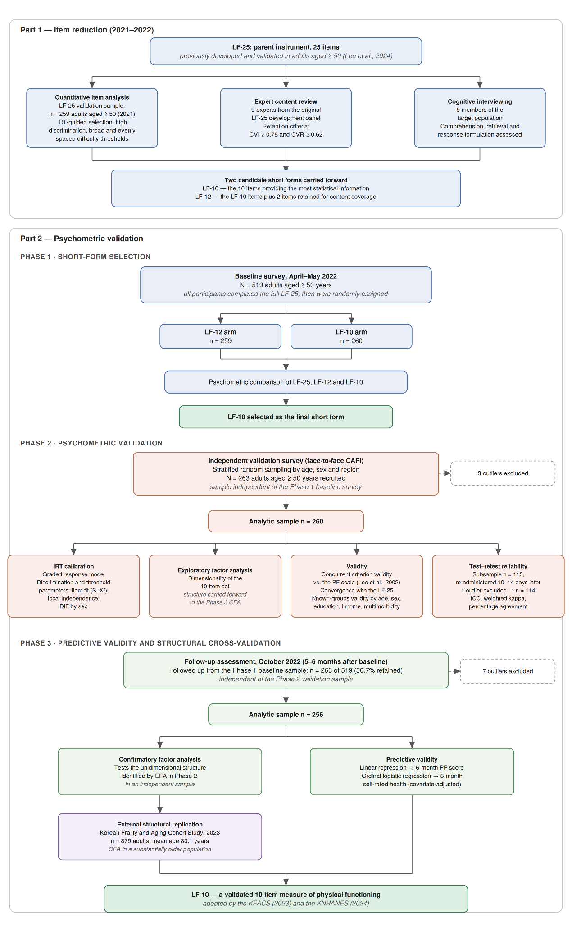
Supplementary Figure 1. Flow chart for development and validation of shortened Life-functioning scale
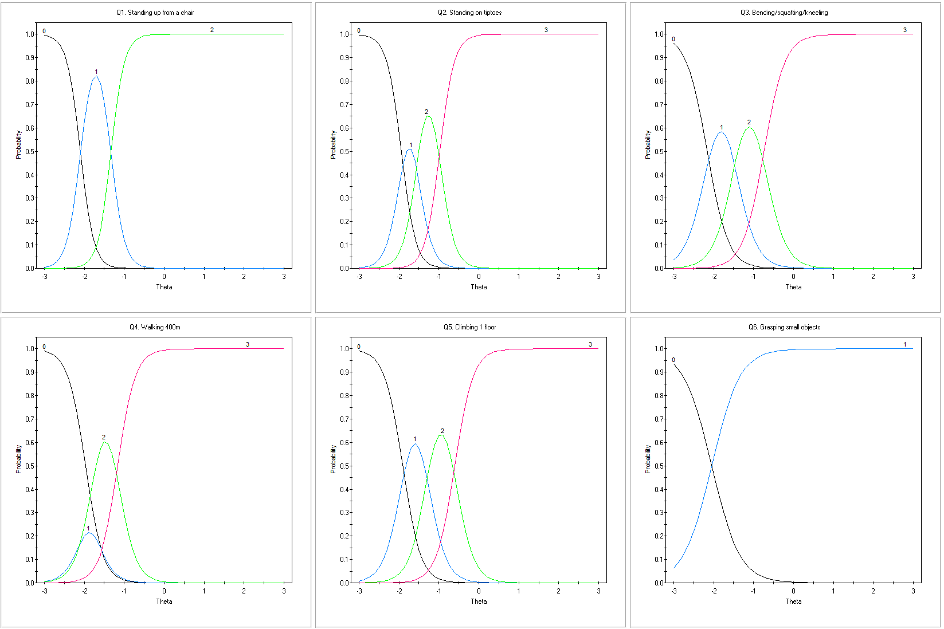
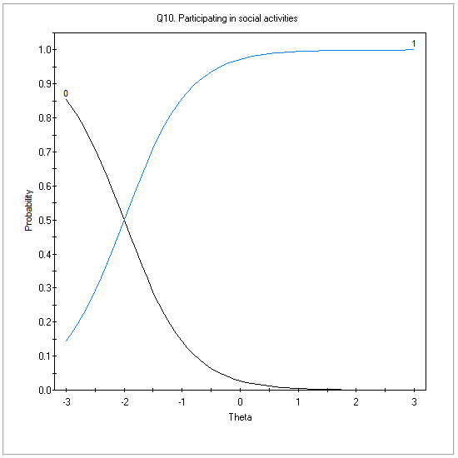
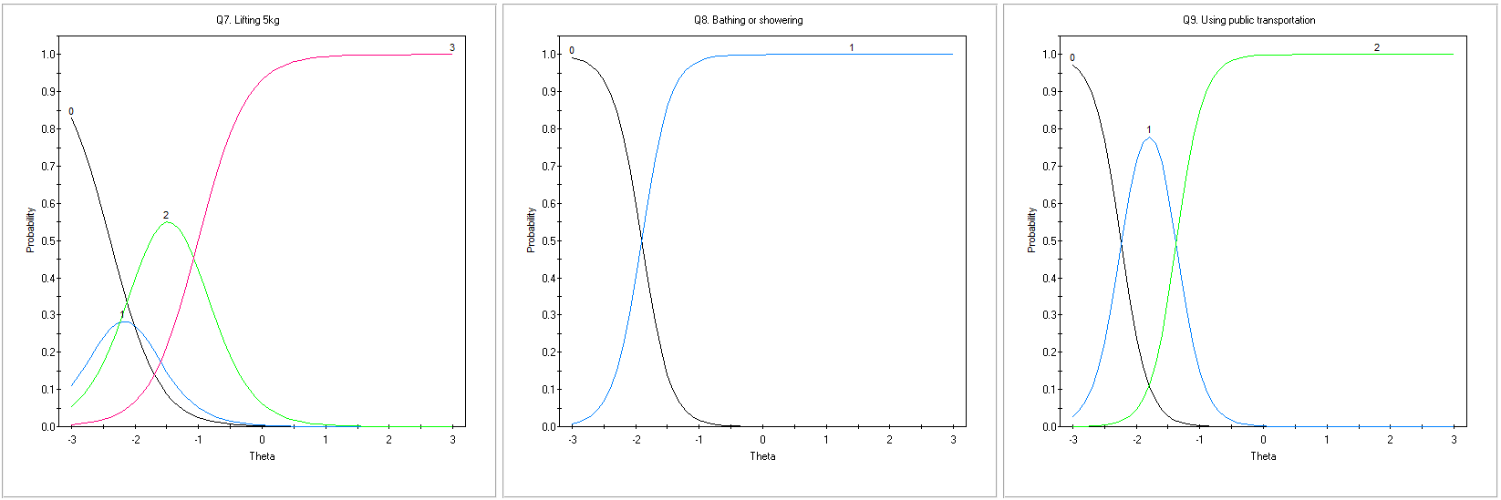

Supplementary Figure 2. Item characteristic curves (ICC)

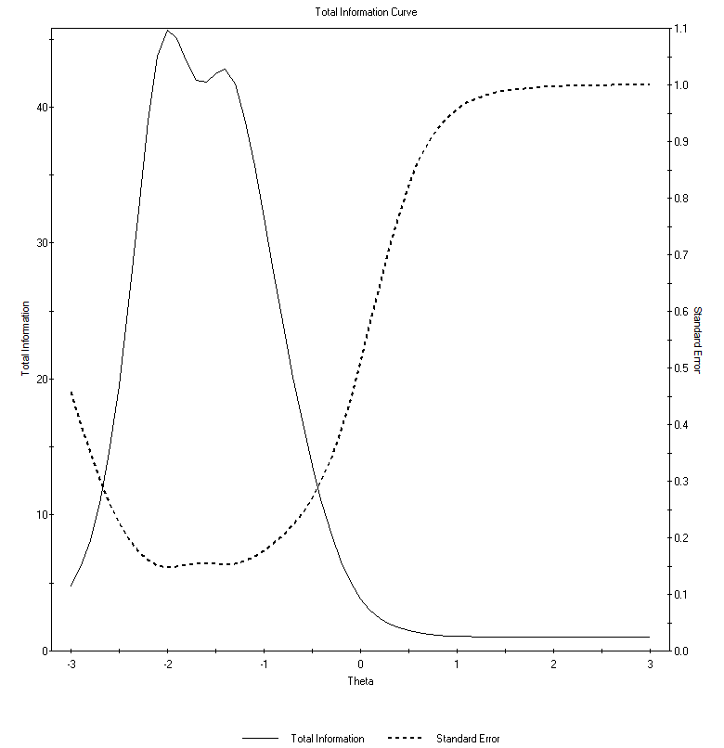

Supplementary Figure 3. Total information curve (TIC) and standard errors of the 10-item Life Functioning (LF-10) scale

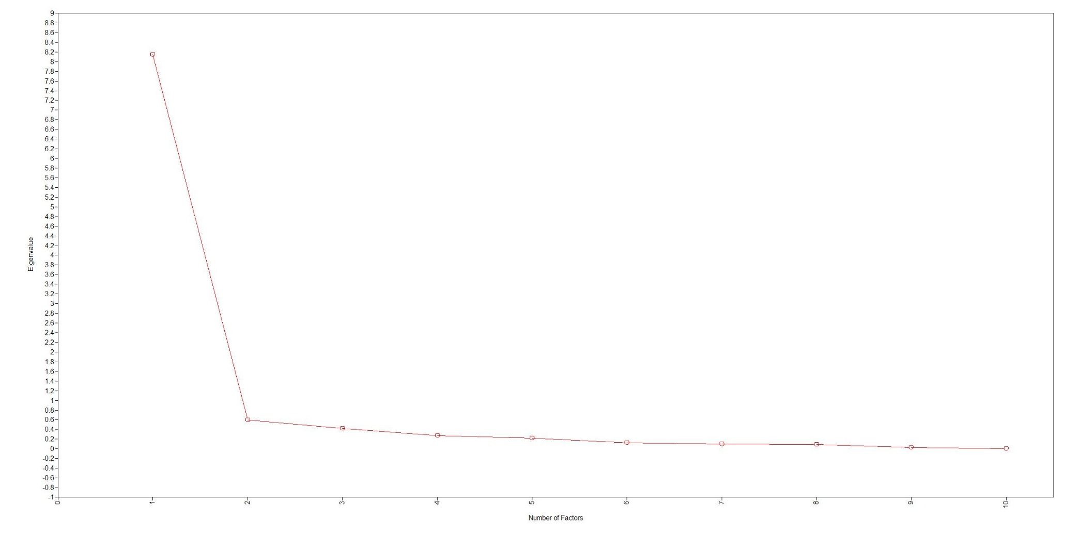
Supplementary Figure 4. Scree Plot
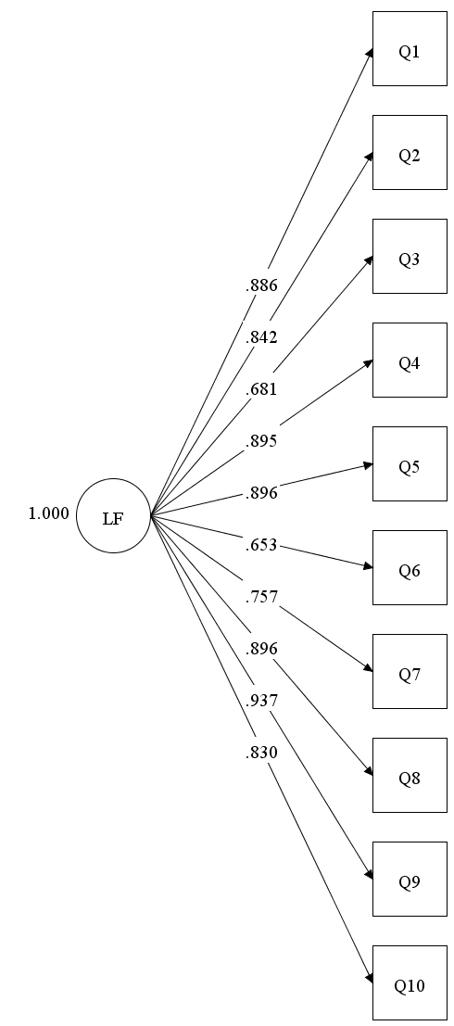

Supplementary Figure 5. Results of Confirmatory Factor Analysis (CFA) using 2023 data from the KFACS (n =879)
Note. LF = life functioning; KFACS = Korean Frailty and Aging Cohort Study.

Supplementary Methods
1. Approaches to Item Reduction
To develop a short-form measure with high validity, we reviewed psychometric theories and short-form development guidelines to establish four key guiding principles: (1) psychometric equivalence, ensuring the maintenance of psychometric properties comparable to the original scale; (2) preservation of content validity, ensuring core constructs and latent traits are not compromised; (3) independent validation using separate samples; and (4) justification for shortening, demonstrating the practical benefits gained through item reduction [1, 2]. Based on these principles, we employed a mixed-methods approach—combining qualitative evaluations (expert reviews and cognitive interviews) with quantitative psychometric analysis—to select items suitable for a national-level health survey.
2. Item Screening and Scale Reduction
The reduction of the original 25-item Life Functioning (LF-25) scale proceeded through three sequential phases: expert content validation, cognitive interviewing, and psychometric item analysis.
Phase 1: Expert Content Validation
Nine experts from the original development panel rated each item on a 4-point scale for clarity, relevance, representativeness, and objectivity. We calculated the Item-Level Content Validity Index (I-CVI) and Content Validity Ratio (CVR) based on the proportion of experts rating an item as 3 (relevant) or 4 (highly relevant). The minimum acceptable thresholds for nine experts were 0.78 for I-CVI and 0.62 for CVR [3]. Seven items ("walking 1 km," " grasping and using small objects," "opening containers or bottle caps," "lifting 5 kg objects," "bathing or showering," "using public transportation," and "participating in social activities") achieved nearly perfect scores (1.00) across metrics, confirming them as core indicators. Conversely, items such as "sitting for 2 hours," "standing for 2 hours," "standing for 30 minutes," "getting in and out of a car," and "pushing or pulling large objects" fell significantly below the thresholds. Additionally, while items such as "bending/squatting/kneeling," "reaching overhead," "lying down or getting up from bedding," and "going out" approached the I-CVI threshold (0.78–0.79), their average CVR was 0.56, failing the final criterion.
Phase 2: Cognitive Interviews
Following the expert review, we conducted semi-structured cognitive interviews with eight community-dwelling middle-aged and older adults. These interviews assessed how respondents interpreted items, retrieved relevant information, and formulated answers. This process identified five additional items as conceptually confusing, biased, or lacking real-world relevance, leading to their exclusion. Specifically, postural and mobility items (e.g., sitting/standing for extended periods, getting in and out of a vehicle, going out) demonstrated high situational dependency, with perceived difficulty varying based on surfaces, transport types, or the purpose of the outing. "Standing for two hours" proved particularly problematic; because it is a situation older adults rarely encounter, respondents were forced to guess their capabilities. Furthermore, "preparing meals" and " doing light housework " exhibited distinct gender bias: men frequently cited a lack of experience as the source of difficulty, whereas women cited actual physical functional decline. Finally, "walking 1 km" and "opening containers or bottle caps" lacked discriminative power; for instance, adults comfortable walking 400 meters reported no difficulty walking 1 km, rendering the latter item redundant.
Phase 3: Psychometric Analysis and Final Selection
In the final reduction phase, a graded response model (GRM)-based item analysis was conducted using the original validation survey data. Three additional items were removed due to poor psychometric fit, which was characterized by low internal consistency (Cronbach’s alpha < 0.80), low item-total or inter-item correlations (< 0.40), low factor loadings (< 0.50), or insufficient response variance. This sequential elimination process yielded a 12-item candidate short form (LF-12). To finalize a highly efficient 10-item alternative (LF-10), lower-extremity function items were further reduced by prioritizing those with the most robust psychometric properties related to essential activities of daily living.
3. Baseline Psychometric Evaluation
Although the psychometric properties of the original 25-item Life Functioning scale (LF-25) were established in previous studies [4], we re-verified its baseline properties in the Phase one (baseline) sample to serve as a benchmark for the shortened scales. Exploratory factor analysis (EFA) and item response theory (IRT)-based graded response model (GRM) analyses were conducted to evaluate structural validity, unidimensionality, and local independence across the LF-25, LF-12, and LF-10.
- LF-25 Analysis: After excluding 11 outliers, the analytic sample consisted of 508 participants. EFA supported the IRT assumption of unidimensionality: the primary factor explained 54.19% of the total variance, and the ratio of the first to the second factor (54.19 / 7.66 = 7.07) easily exceeded the minimum requirement of 4. Local independence was satisfied (all local dependence [LD] values < 10). Item discrimination parameters were robust across all items, and item difficulty parameters ranged from -4.07 to -0.50. The test information curve (TIC) peaked at the lower end of the latent trait (-2 < θ < -1). Internal consistency was excellent (alpha = 0.95).
- LF-12 Analysis: After outlier exclusion, 255 participants were analyzed. The unidimensionality assumption was met (variance ratio: 52.97 / 11.32 = 4.68). Item discrimination parameters were robust across the 12 items, ranging from 1.82 to 5.89. Difficulty parameters ranged from -3.89 to -0.71. The LF-12 demonstrated strong alternate-form reliability with the original scale (r = 0.96, p < 0.001) and good internal consistency (alpha = 0.88).
- LF-10 Analysis: After outlier exclusion, 253 participants were analyzed. Unidimensionality was strongly supported (variance ratio: 63.31 / 12.26 = 5.16), with the primary factor explaining 63.31% of the total variance. Item discrimination parameters were highly robust across all 10 items, ranging from 2.66 to 6.98. Difficulty parameters ranged from -3.58 to -0.60. Like the original scale, the LF-10 provided substantial measurement information for lower levels of the latent trait (-2 < θ < -1). Alternate-form reliability was excellent (r = 0.97, p < 0.001), and internal consistency was high (alpha = 0.91).
4. Comparative Analysis: LF-12 vs. LF-10
To finalize the short-form selection, a comparative analysis was conducted between the two candidate scales.
- Sample Homogeneity: A baseline comparison of self-rated health between the randomly assigned LF-12 and LF-10 groups revealed no statistically significant differences in population variance or means. The effect size for the mean difference was negligible (Cohen’s d = 0.10), confirming sample equivalence.
- Reliability: The LF-10 demonstrated superior internal consistency (alpha = 0.91) compared to the LF-12 (alpha = 0.88). Notably, removing the item "grasping small objects" from the LF-10 would only marginally raise the reliability to alpha = 0.92, suggesting strong item retention value.
- Model Fit Indices: While the LF-12 displayed slightly superior absolute fit indices, the LF-10 yielded lower Akaike Information Criterion (AIC) and Bayesian Information Criterion (BIC) values (Table 1). However, direct comparison of these information criteria is inherently limited due to the differing number of items.
- Item Fit and Diagnostic Issues: Several items across both forms exhibited sparse response categories (e.g., a lack of "cannot do" responses) due to ceiling effects within this relatively healthy sample. Consequently, the Orlando and Thissen S-X² fit statistic could not be computed for certain items (Table 2). Additionally, the item "standing on tiptoes" in the LF-10 yielded an LD value > 10, which was likely driven by these restricted response variances.
- Final Selection Conclusion: Despite the LF-12 exhibiting slightly better structural fit indices, the LF-10 was selected as the final scale. The LF-10 demonstrated superior internal consistency, a stronger unidimensional structure (explaining 63.31% of the variance compared to the LF-12's 52.97%), and a higher alternate-form correlation with the original LF-25. Most importantly, it achieved these robust psychometric properties while providing the greatest reduction in administrative burden for respondents. See Table 3.
Table 1. Comparison of information criteria
Type | p (> 0.05) | RMSEA  (< 0.06) | SRMSR  (< 0.08) | TLI  (> 0.95) | CFI  (> 0.95) | AIC | BIC
LF-12 | 0.746 | 0.00 | 0.086 | 1.02 | 1.00 | 1919 | 2071
LF-10 | 0.036 | 0.059 | 0.088 | 0.94 | 0.96 | 1755 | 1907

Table 2. Item fit and diagnostic issues
Scale | Item(s) | Diagnostic Issue
LF-12 | Grasping small objects; Bathing or showering; Engaging in indoor leisure activities | $S-X^{2}$ not computable due to sparse data
LF-10 | Lifting 5 kg | $S-X^{2}$ misfit ($p<0.01$)
LF-10 | Grasping small objects; Using public transportation | $S-X^{2}$ not computable due to sparse data
LF-25 | Sitting for 2 hours; Grasping small objects; Engaging in indoor leisure activities; Participating in social activities | $S-X^{2}$ misfit ($p<0.01$)
5. Tests of IRT Assumptions for the LF-10
Several of the analyses reported below were conducted using the 2023 KFACS sample rather than the Phase 2 validation sample. Because the Phase 2 responses were highly concentrated at the upper end of the scale, the dataset lacked the response variation required for these specific procedures. In contrast, the greater functional heterogeneity of the KFACS sample provided a more comprehensive range of item responses.
- Unidimensionality: Parallel analysis based on the polychoric correlation matrix (500 iterations, weighted least squares extraction) supported a unidimensional solution in the Phase 2 validation sample. The first eigenvalue (7.90) was more than 20 times the corresponding value from randomly generated data (0.34). In contrast, the second observed eigenvalue (0.19) did not exceed its simulated counterpart (0.19) and was negligible in absolute magnitude. The ratio of the first to the second eigenvalue was 41.1, well above the conventional criterion of 4 used to support essential unidimensionality. Parallel analysis in the KFACS sample yielded identical conclusions.
- Local Independence: Local independence was evaluated using the standardized local dependence (LD) $χ^{2}$ statistic. All item pairs demonstrated values well below the predefined violation threshold of 10. This indicates that the assumption of local independence was fully supported and that no items exhibited problematic redundant variance.
- Monotonicity: Monotonicity was evaluated using Mokken scale analysis in the KFACS sample (complete cases, $n=789$). Manifest monotonicity is assessed by comparing item step response functions across rest-score groups; the Phase 2 validation sample contained too few respondents in the lower rest-score groups for this comparison to be informative. No violations of manifest monotonicity were observed for any item (minvi = 0.03), and none reached statistical significance. Item scalability coefficients ranged from 0.41 to 0.65, and the overall scale scalability coefficient was 0.58 (SE = 0.02), indicating a highly robust scale.

Table 3. Summary of item analyses

 | LF-25 | LF-12 | LF-10
IRT  analysis | - Satisfying unidimentionaliy and local independence  - Model fit: M₂ = 259.36 (p = 0.02), RMSEA = 0.02  - Item mis fit (p ≤ 0.01): Eight items  - Discrimination parameter range: 2.42~ 6.43  - Difficulty parameter range: -4.07 ~ -0.50 | - Satisfying unidimentionaliy and local independence  - Model fit: M₂ = 29.12 (p = 0.746), RMSEA = 0.026  - Item mis fit (p ≤ 0.01): One item  - Discrimination parameter range: 1.80~ 7.42  - Difficulty parameter range: -3.91 ~ -0.63 | - Satisfying unidimentionaliy and local independence  - Model fit: M₂ = 22.13 (p = 0.035), RMSEA = 0.059  - Item mis fit (p ≤ 0.01): One item  - Discrimination parameter range: 2.81 ~ 11.08  - Difficulty parameter range: -2.91 ~ -0.56
Test information curve | 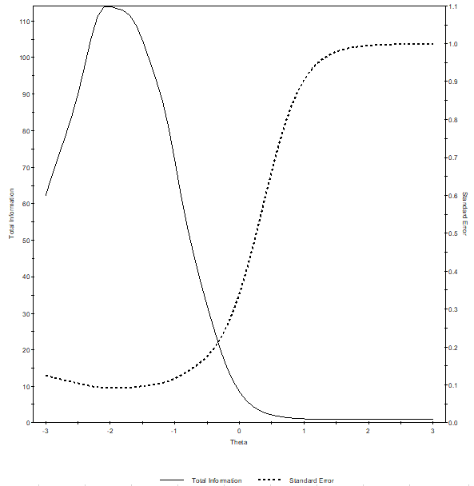 | 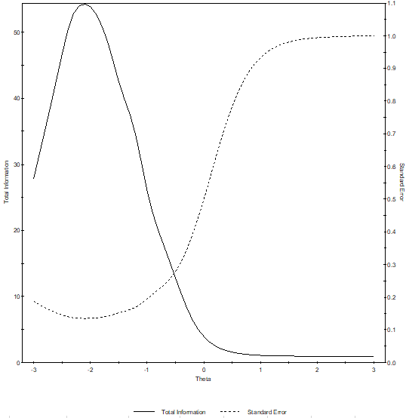 | 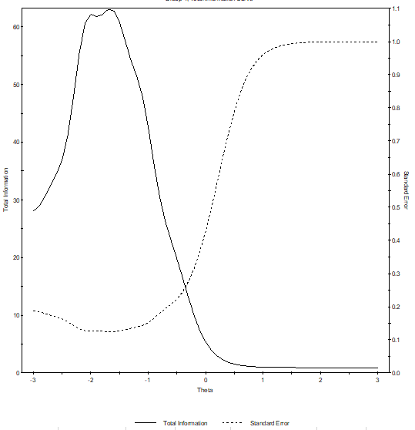
Validity | - 1 or 4 factor extraction (eigenvalue ≥ 1)  - Factor 1 explains 54.19% of the total variance.  - Communality 0.54 - 0.87  - Factor loading (Factor 1): 0.61 - 0.85 | - 2 factor extraction (eigenvalue ≥ 1)  - Factor 1 explains 52.92% of the total variance.  - Communality 0.26 ~ 0.79  - Factor loading (Factor 1): 0.46 ~ 0.83 | - 2 factor extraction (eigenvalue ≥ 1)  - Factor 1 explains 64.31% of the total variance.  - Communality 0.61 ~ 0.81  - Factor loading (Factor 1): 0.67 ~0.90
Reliability | Cronbach's alpha coefficient = 0.95 | Cronbach's alpha coefficient = 0.88 | Cronbach's alpha coefficient = 0.91
Alternative form reliability | — | Pearson’s correlation coefficient (LF-25 and LF-12) 0.96 (p < 0.001) | Pearson’s correlation coefficient (LF-25 and LF-10) 0.97 (p < 0.001)

Supplementary References
1. Ziegler, M., Kemper, C. J., & Kruyen, P. (2014). Short scales–Five misunderstandings and ways to overcome them. Journal of Individual Differences. 35(4), 185-189. https://doi.org/10.1027/1614-0001/a000148
2. Koğar, H. (2020). Development of a short form: Methods, examinations and recommendations. Journal of Measurement and Evaluation in Education and Psychology, 11(3). 301-310. http://doi.org/10.21031/epod.739548
3. Zamanzadeh, V., Rassouli, M., Abbaszadeh, A., Majd, H. A., Nikanfar, A., & Ghahramanian, A. (2014). Details of content validity and objectifying it in instrument development. Nursing Practice Today, 1(3), 163-171.
4. Lee, Y., Kim, E., Yun, J., Choi, J., Kim, J., Won, C. W., ... & Kim, J. (2024). The Life Functioning Scale: A measurement tool developed to assess the physical functioning abilities of community-dwelling adults aged 50 years or older. Annals of Geriatric Medicine and Research, 28(4), 410-418. https://doi.org/10.4235/agmr.24.0087

