Graphical abstract
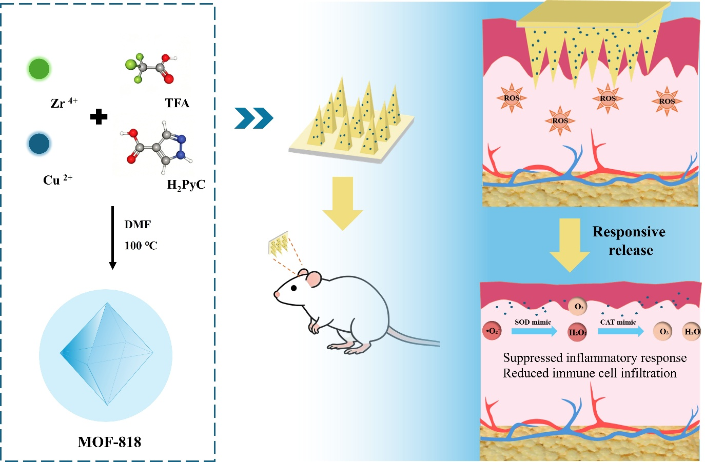
Disease-adaptive ROS-responsive MOF-818 nanozyme microneedles for localized catalytic antioxidant therapy of psoriasis. Elevated ROS in psoriatic skin triggers cleavage of dynamic boronate ester bonds within the HP/EGCG hydrogel, accelerating the release of MOF-818 nanozymes and EGCG. MOF-818 provides SOD- and CAT-like catalytic activities for ROS scavenging, while the microneedle architecture enables localized transdermal delivery beyond the skin barrier. The resulting antioxidant response attenuates oxidative and inflammatory signals, reduces epidermal hyperproliferation and CD3+/CD68+ immune cell infiltration, and alleviates psoriatic lesions.

