Figure 1F

NC group-1#
NC group-2#
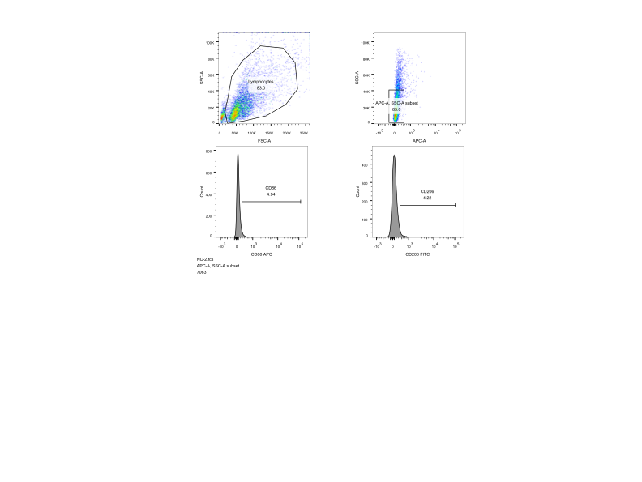
NC group-3#
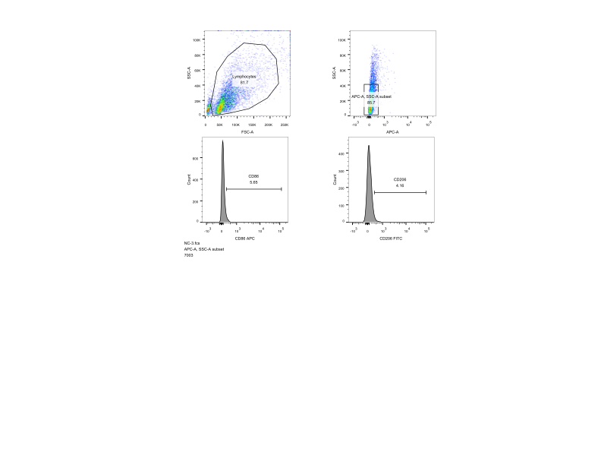
UVB group-1#
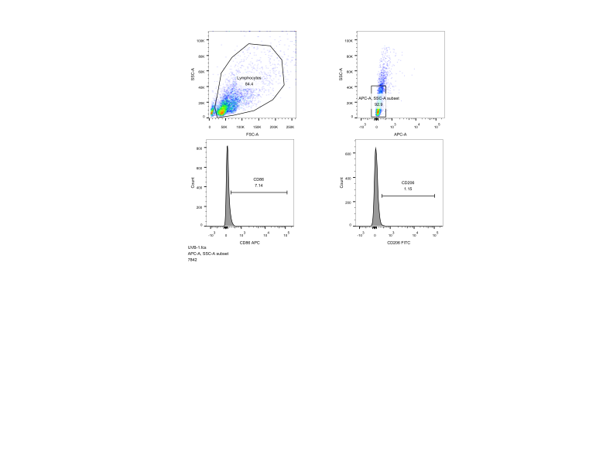

UVB group-2#
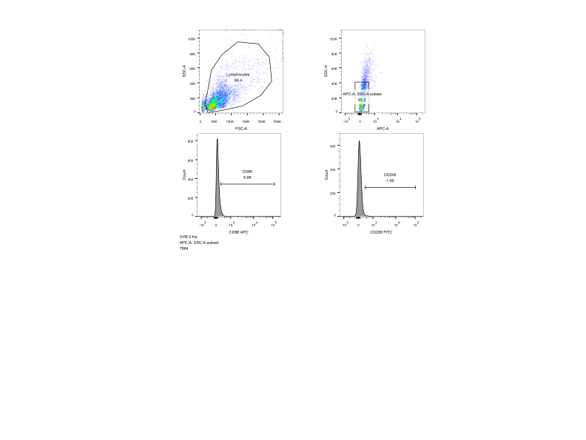

UVB group-3#
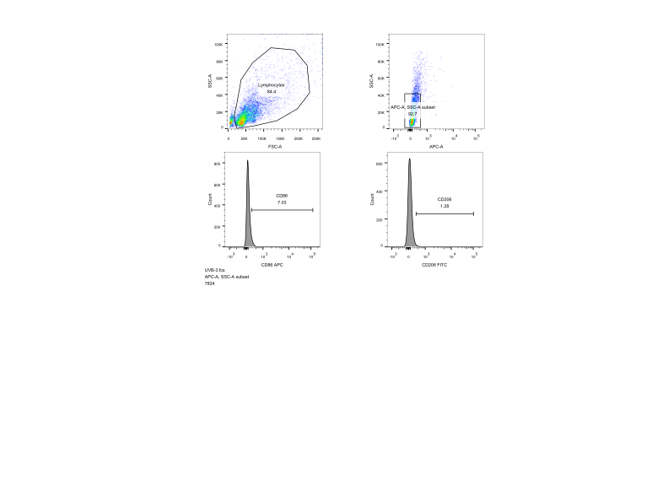

UVB+Fer-1 group-1#
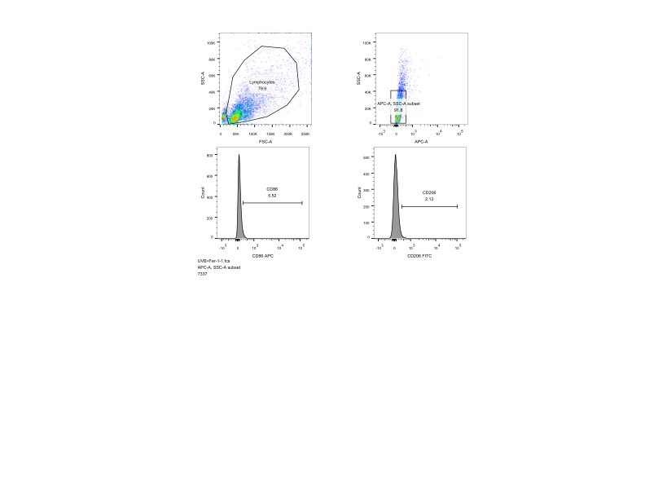
UVB+Fer-1 group-2#
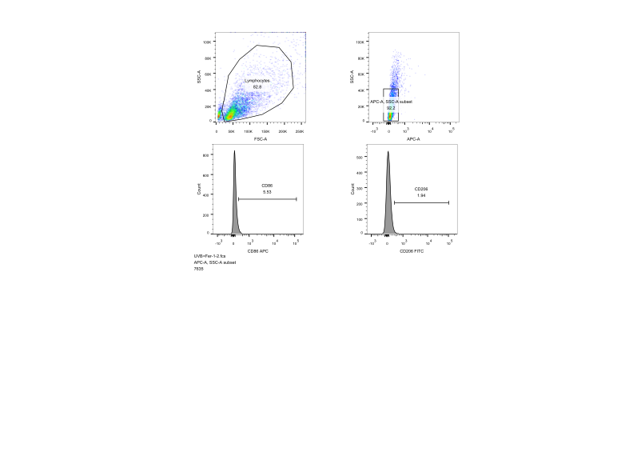

UVB+Fer-1 group-3#
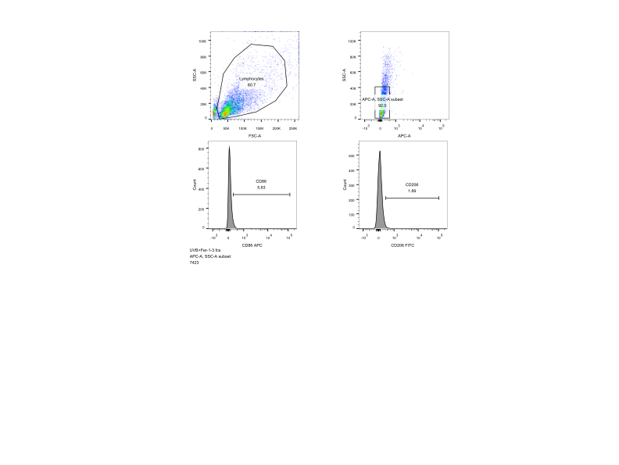

Figure 2F
NC group-1#
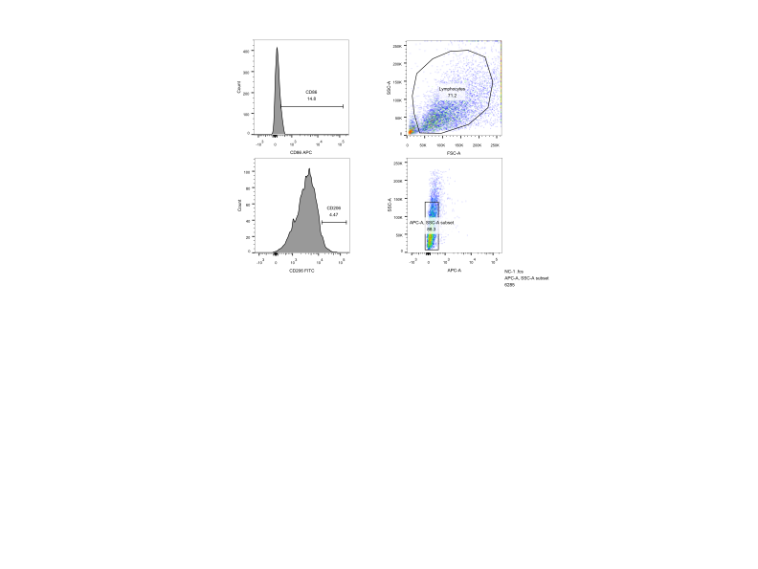
NC group-2#
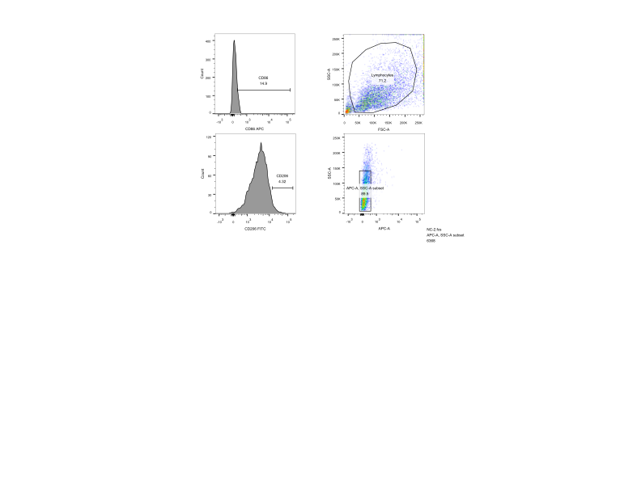
NC group-3#
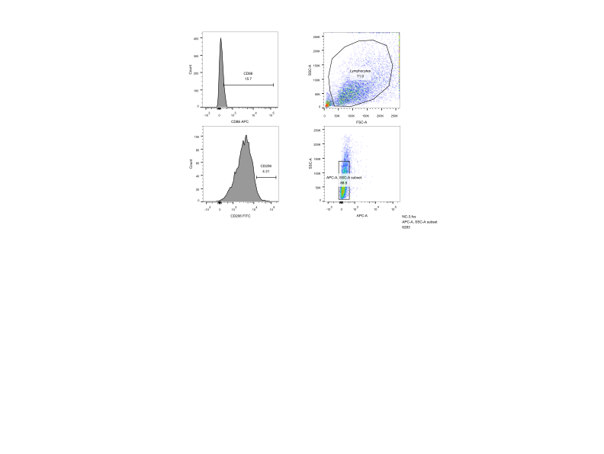

NDUFS4-OE group-1#
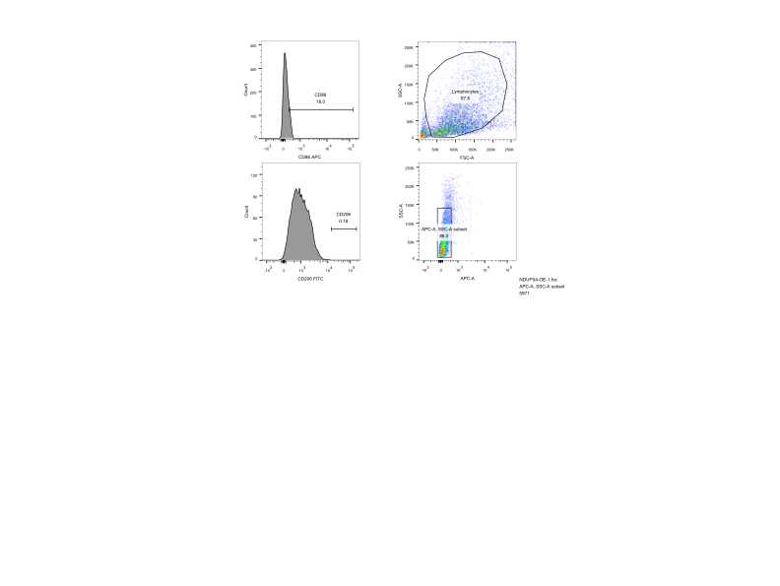
NDUFS4-OE group-2#
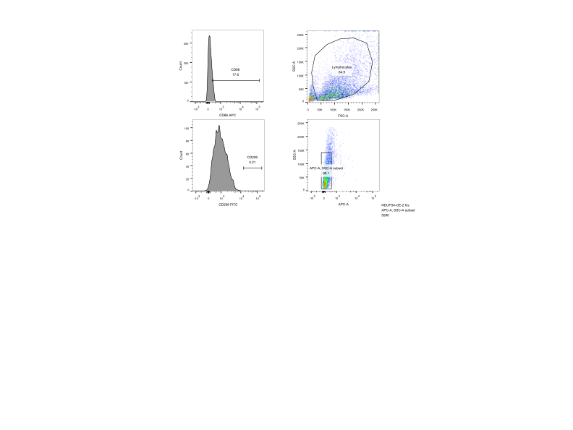
NDUFS4-OE group-3#
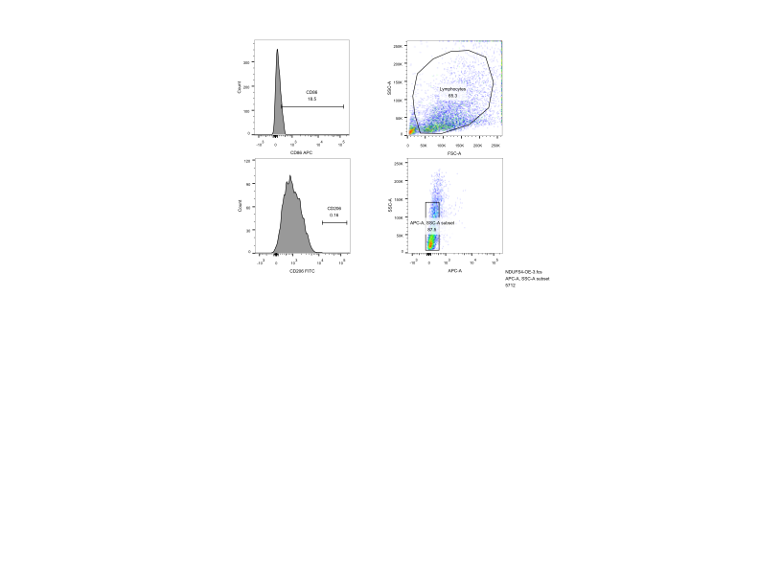
NDUFS4-OE + Fer-1 group-1#
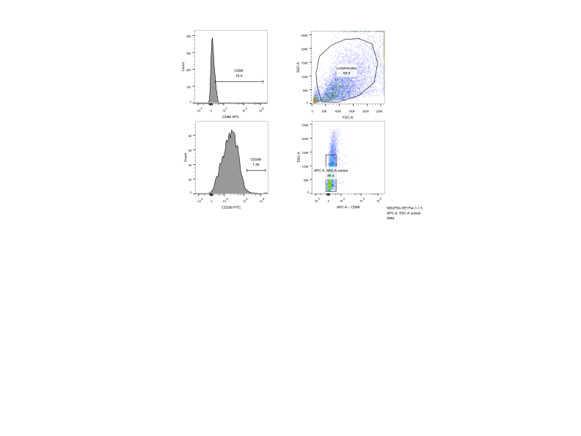
NDUFS4-OE + Fer-1 group-2#
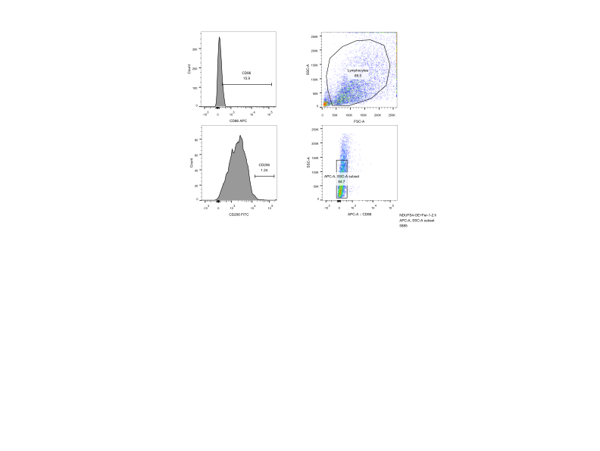
NDUFS4-OE + Fer-1 group-3#
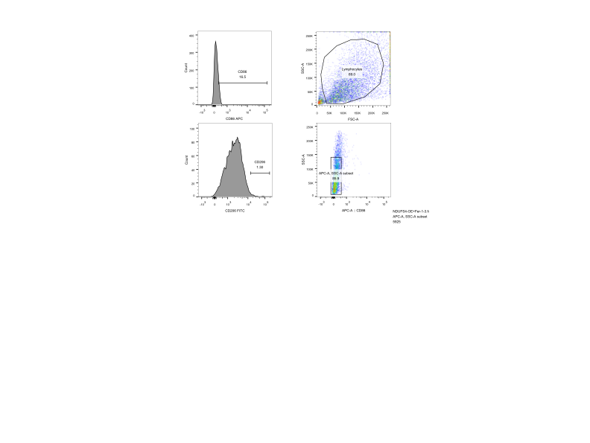

Figure 3C-CD86

NC group-1#
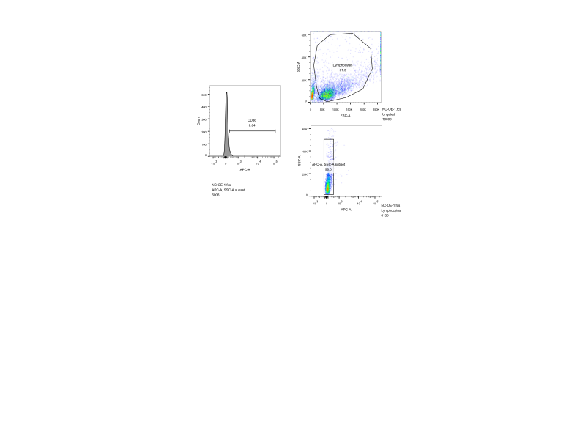
NC group-2#
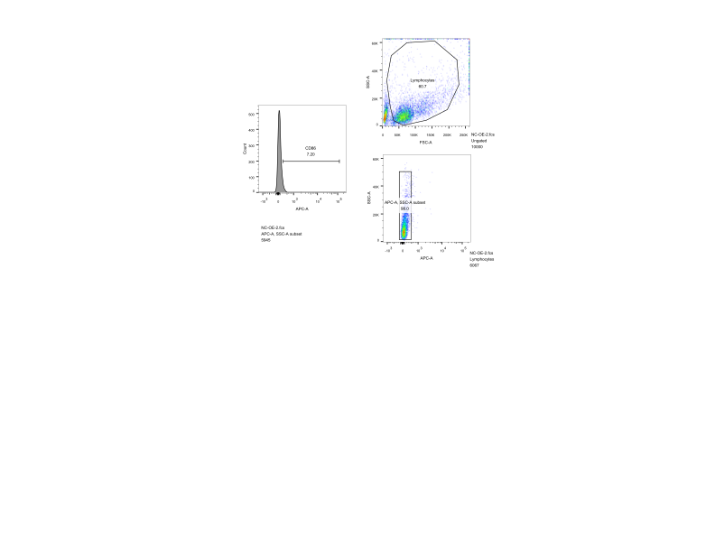
NC group-3#
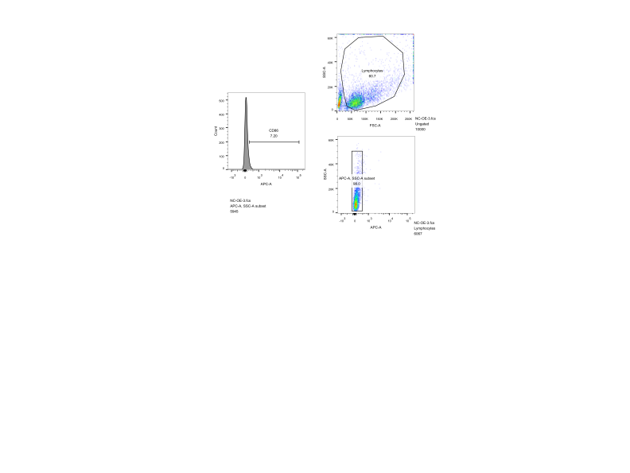
NDUFS4-OE group-1#
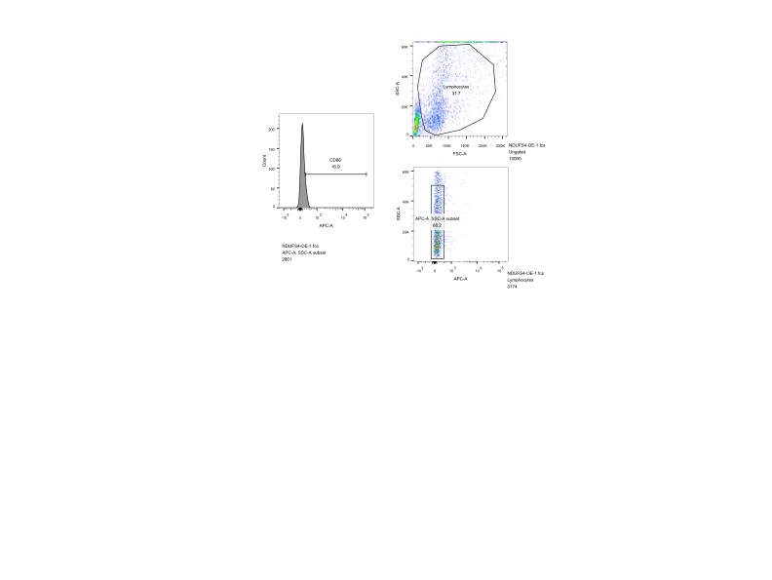

NDUFS4-OE group-2#
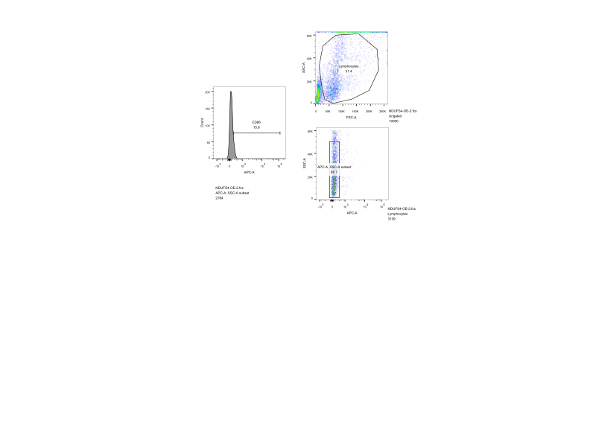
NDUFS4-OE group-3#
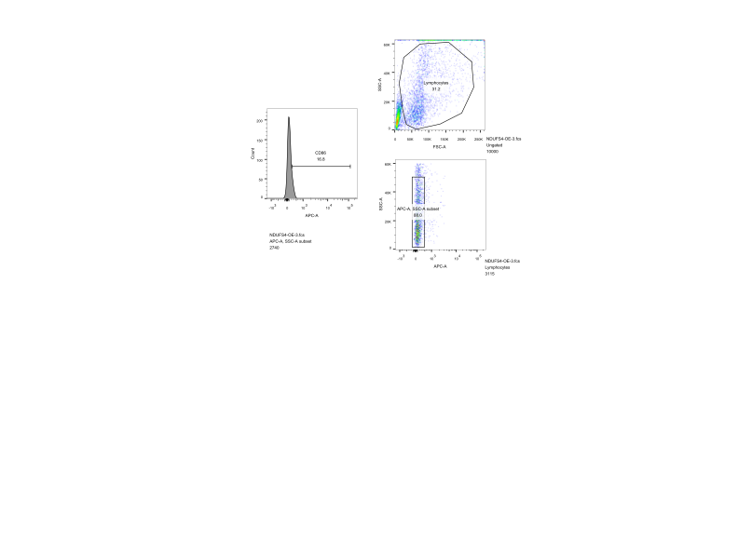
NDUFS4-OE + Fer-1 group-1#
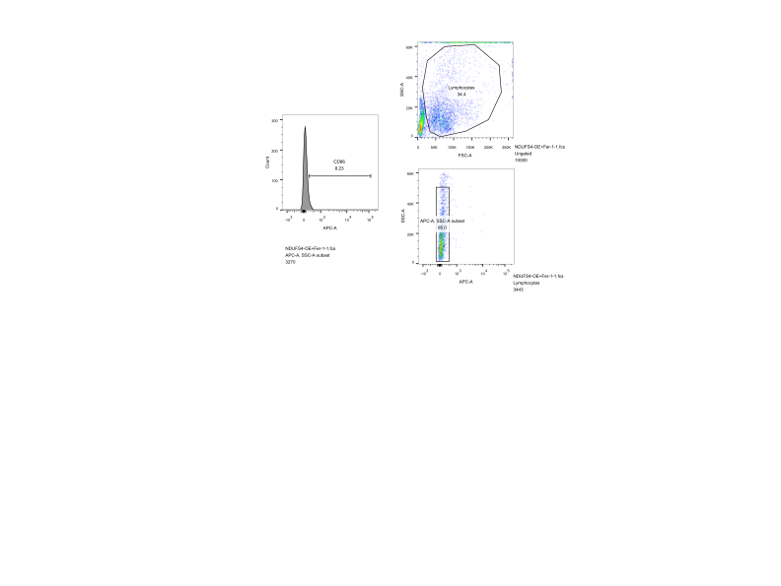
NDUFS4-OE + Fer-1 group-2#

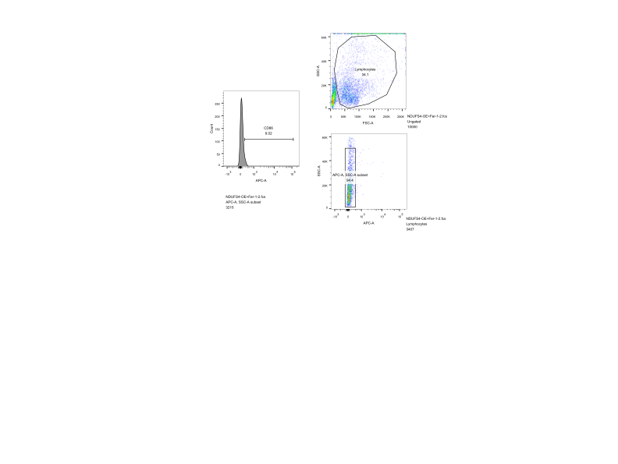

NDUFS4-OE + Fer-1 group-3#
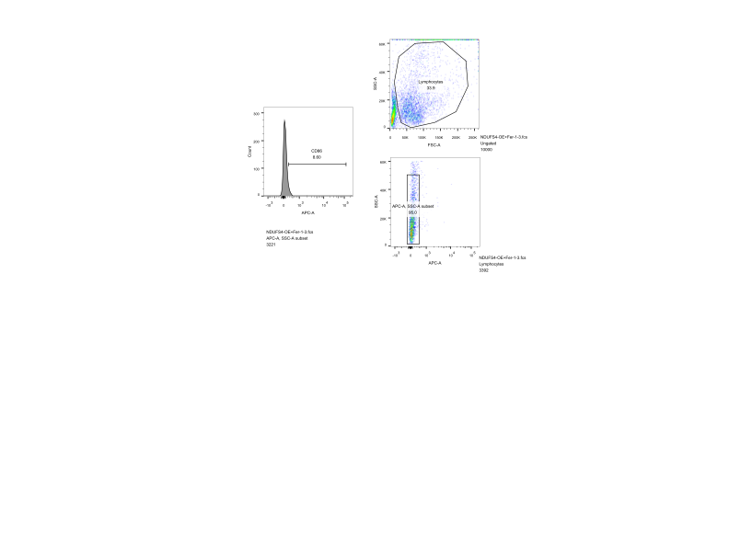

Figure 3C-CD206
NC group-1#
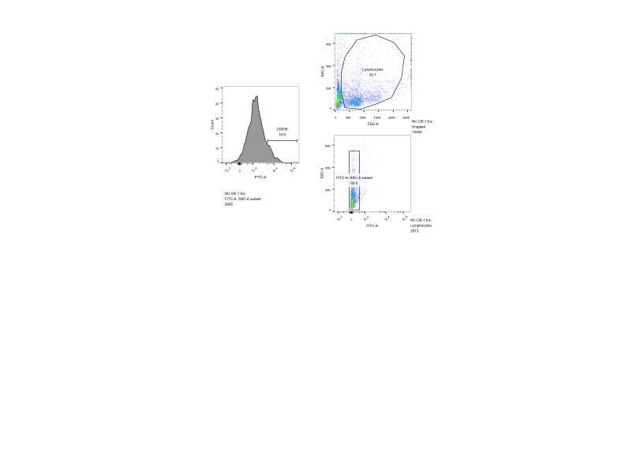
NC group-2#
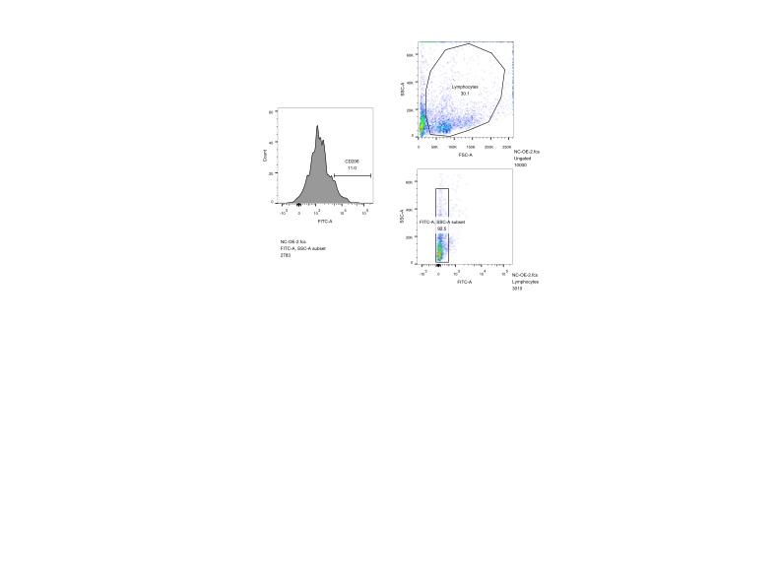
NC group-3#
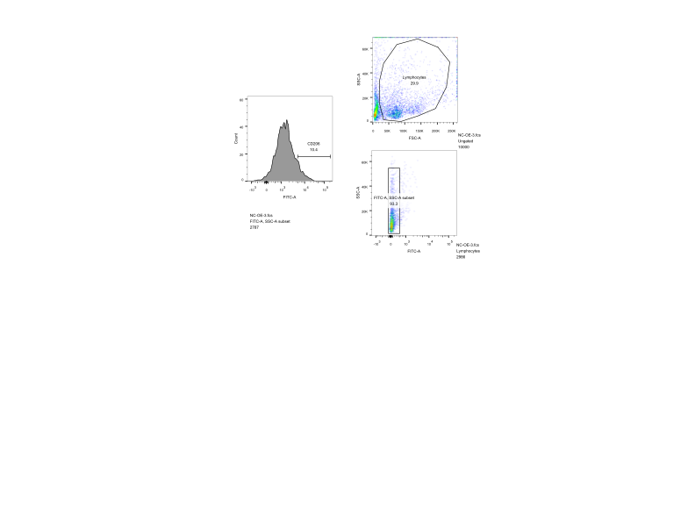

NDUFS4-OE group-1#
NDUFS4-OE group-2#
NDUFS4-OE group-3#

NDUFS4-OE + Fer-1 group-1#
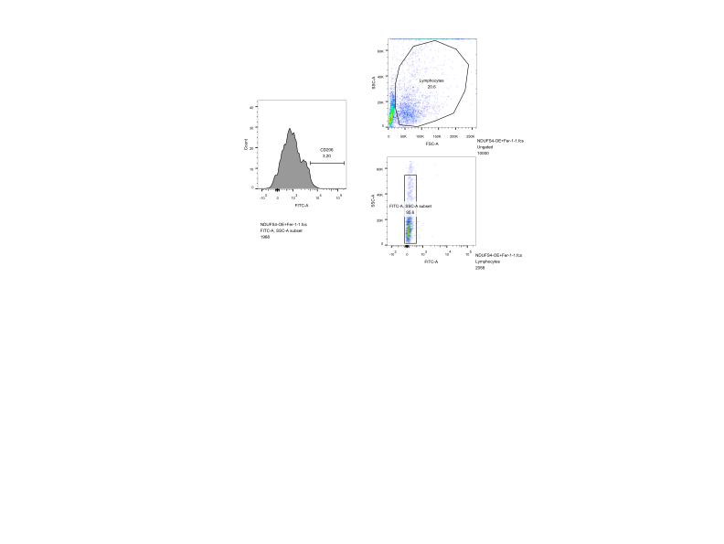

NDUFS4-OE + Fer-1 group-2#
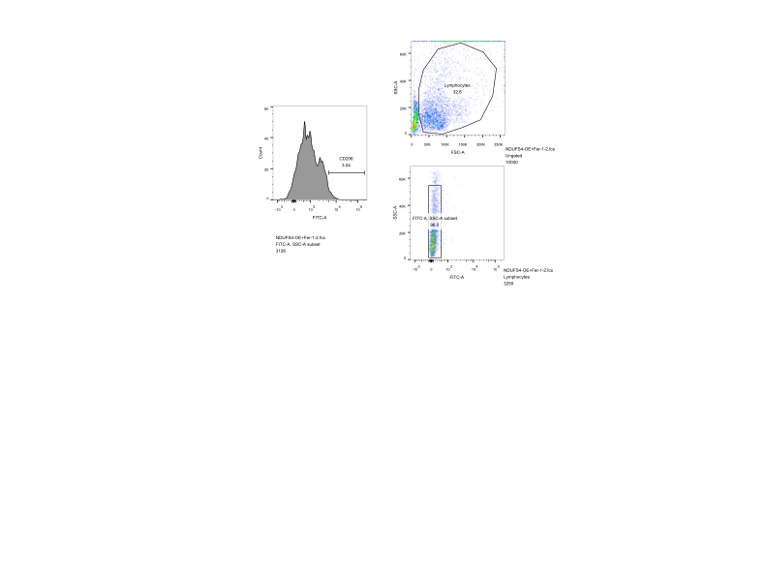

NDUFS4-OE + Fer-1 group-3#
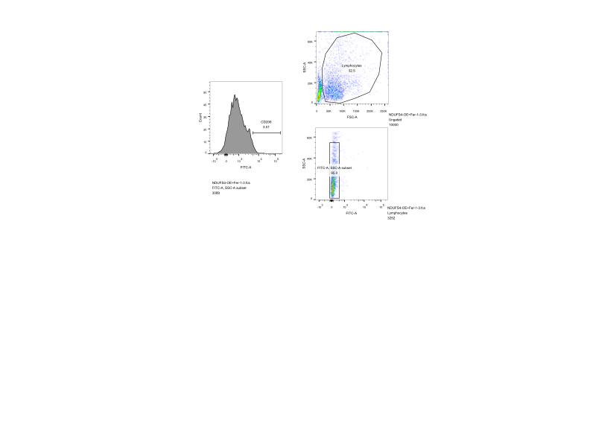

Figure 5C-CD86

NC group-1#
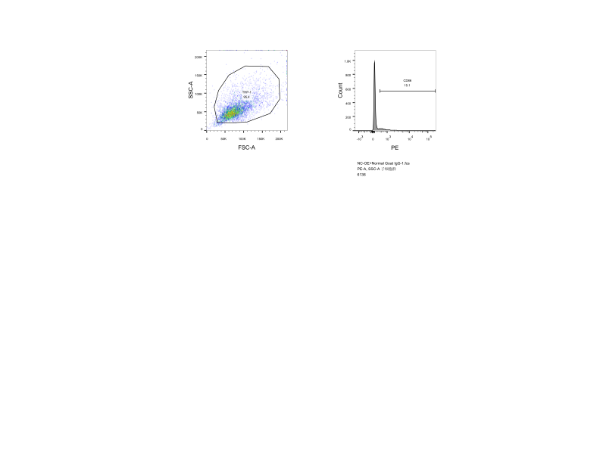

NC group-2#
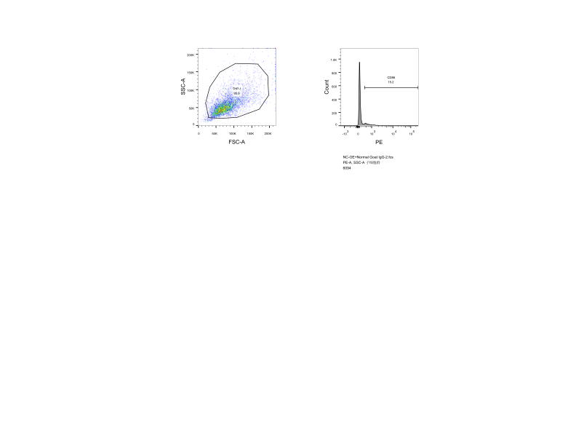

NC group-3#
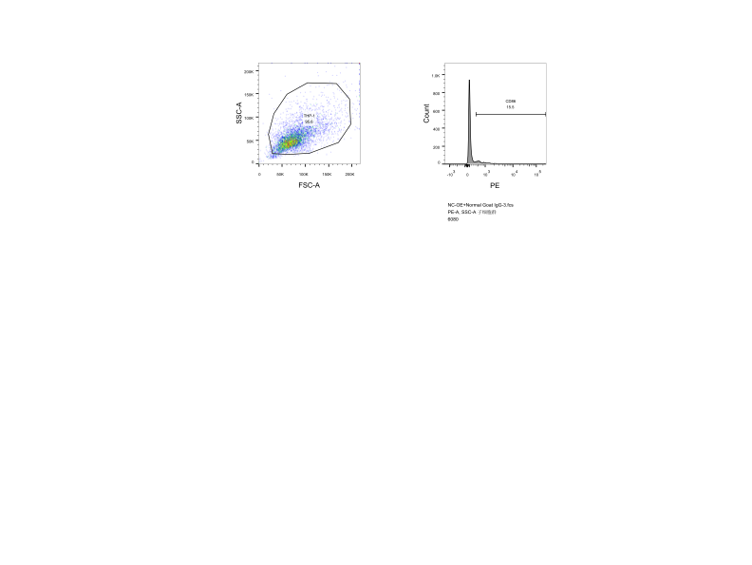

NC-OE+anti-CCL5 group-1#
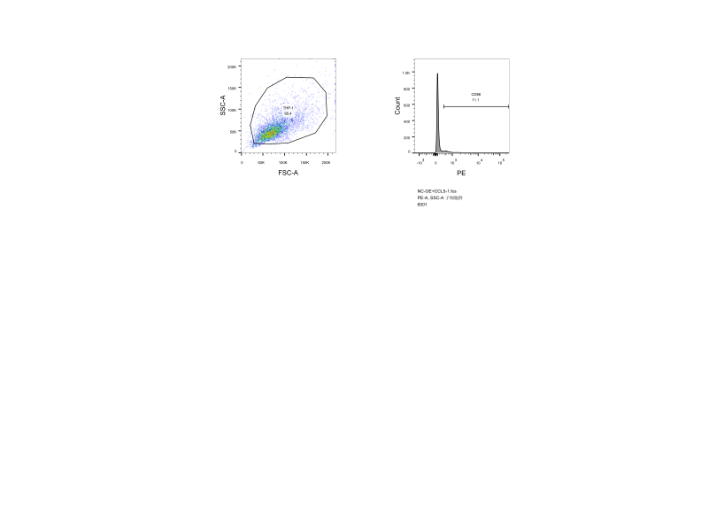
NC-OE+anti-CCL5 group-2#
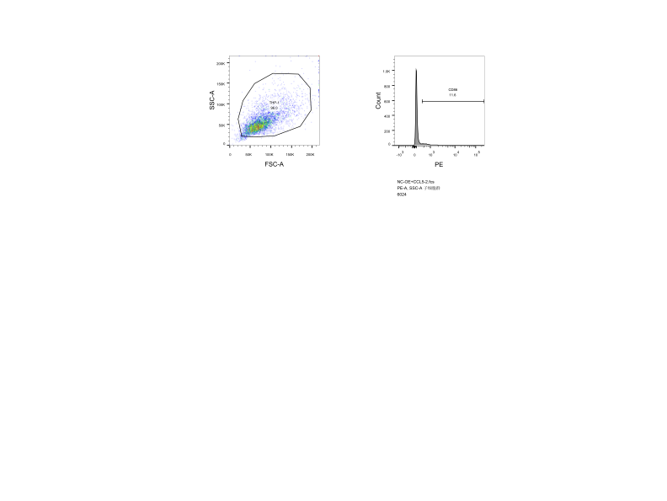
NC-OE+anti-CCL5 group-3#
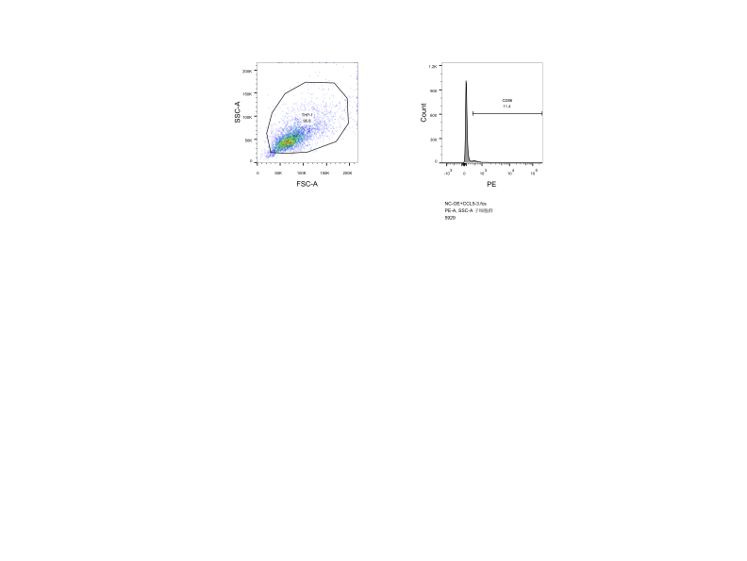
NDUFS4-OE group-1#
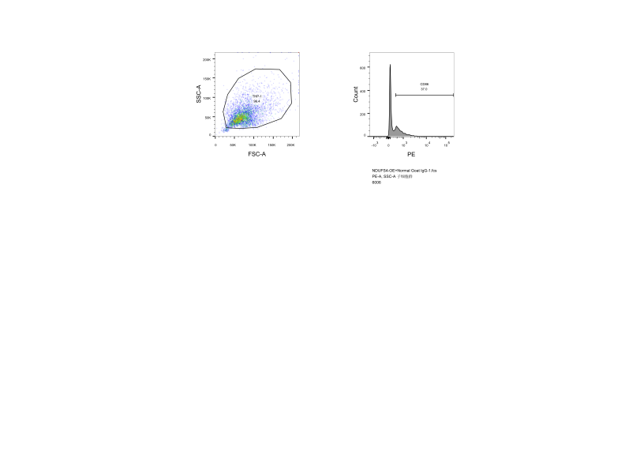
NDUFS4-OE group-2#
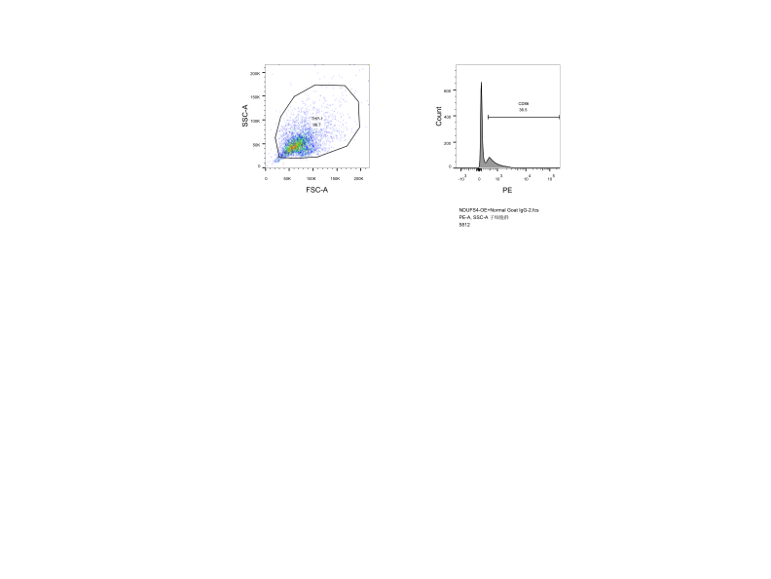
NDUFS4-OE group-3#
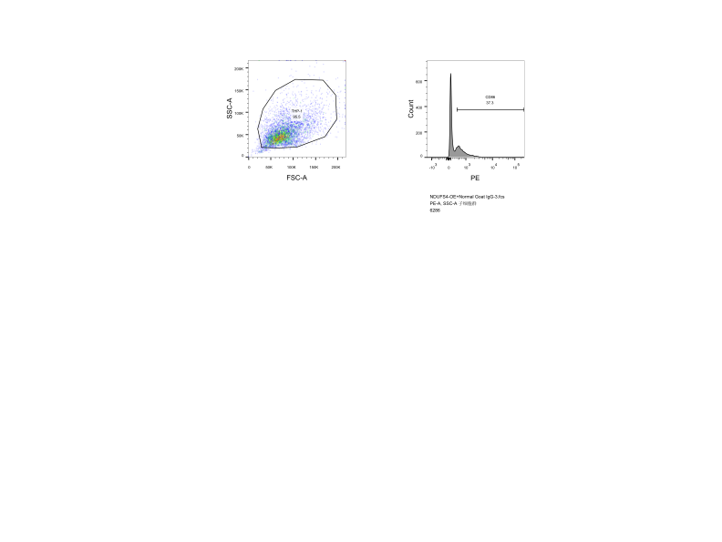
NDUFS4-OE + anti-CCL5 group-1#
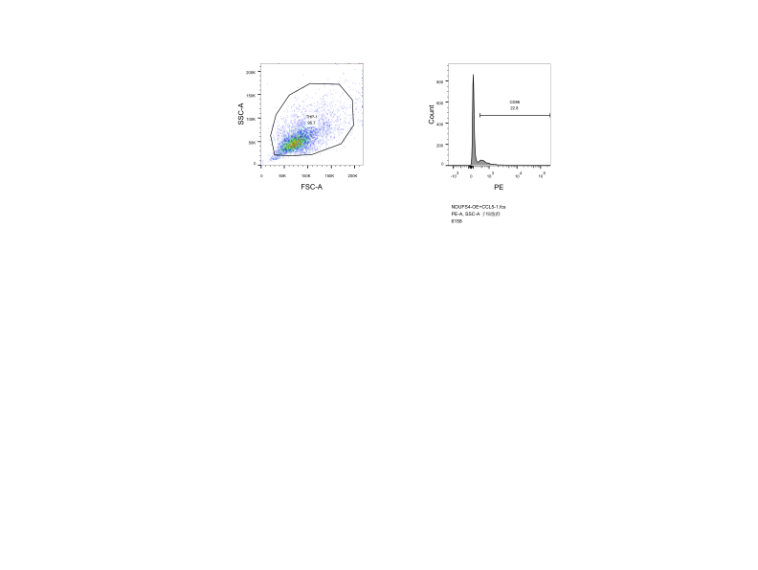
NDUFS4-OE + anti-CCL5 group-2#
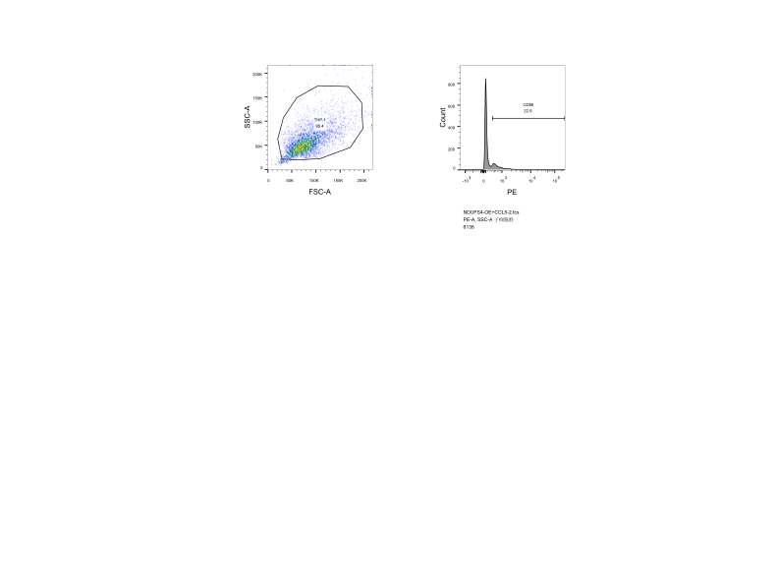

NDUFS4-OE + anti-CCL5 group-3#
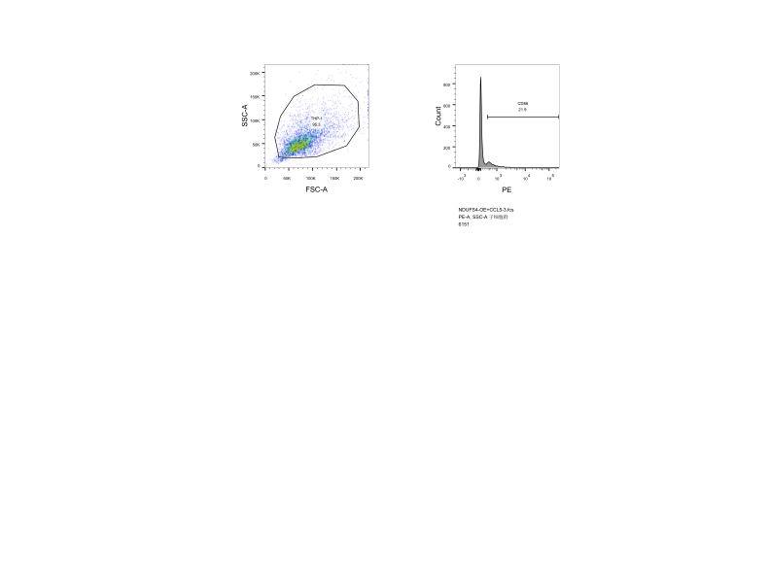

Figure 5C-CD206

NC group-1#
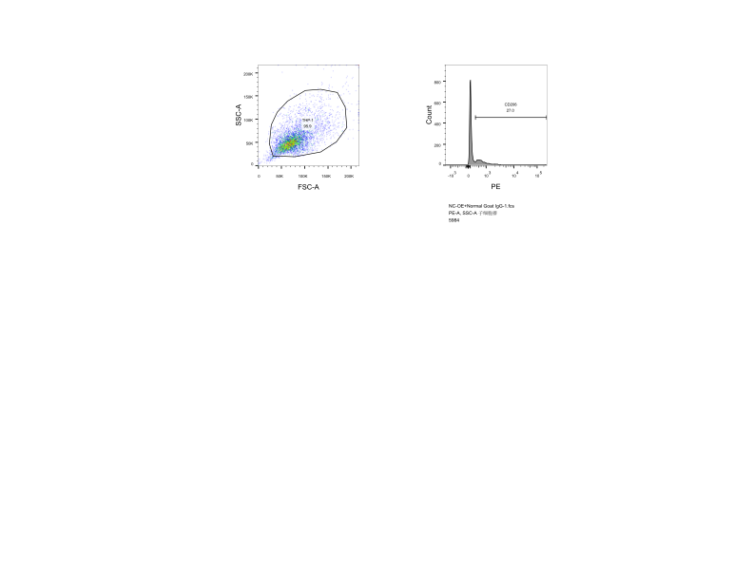

NC group-2#
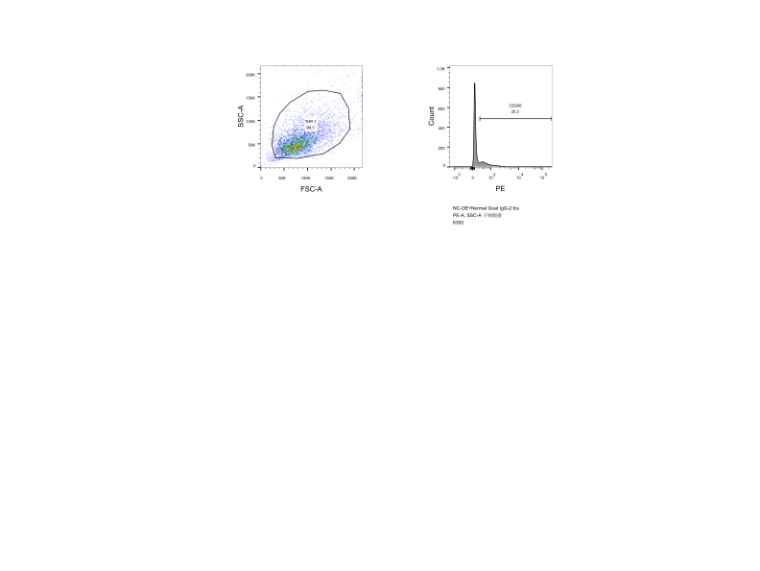

NC group-3#
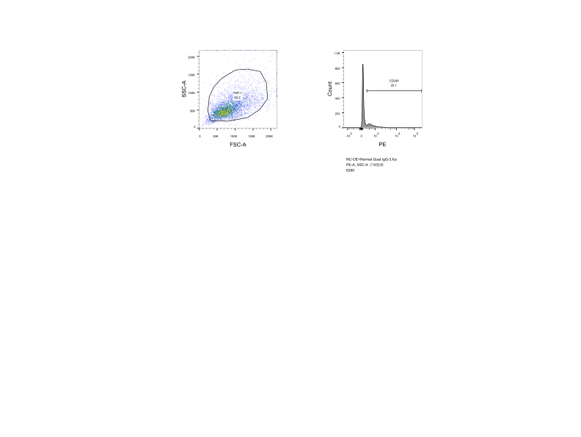

NC-OE+anti-CCL5 group-1#
NC-OE+anti-CCL5 group-2#
NC-OE+anti-CCL5 group-3#
NDUFS4-OE group-1#
NDUFS4-OE group-2#
NDUFS4-OE group-3#
NDUFS4-OE + anti-CCL5 group-1#
NDUFS4-OE + anti-CCL5 group-2#

NDUFS4-OE + anti-CCL5 group-3#
