Supplementary
Fig. S1 The Maud refinement performed NHoW sample.
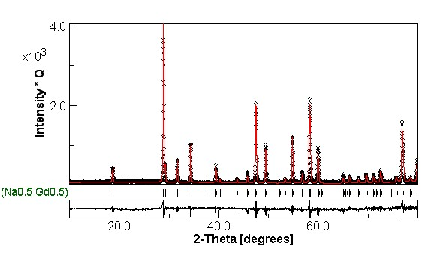

Fig. S2 The EDS mapping of NHoW sample
