Supplementary materials
File 1. Consensus-based Checklist for Reporting of Survey Studies (CROSS)

Section/topic | Item | Item description | Reported on page #
Title and abstract
Title and abstract | 1a | State the word “survey” along with a commonly used term in title or abstract to introduce the study’s design. | 1
Title and abstract | 1b | Provide an informative summary in the abstract, covering background, objectives, methods, findings/results, interpretation/discussion, and conclusions. | 2
Introduction
Background | 2 | Provide a background about the rationale of study, what has been previously done, and why this survey is needed. | 4-5
Purpose/aim | 3 | Identify specific purposes, aims, goals, or objectives of the study. | 5
Methods
Study design | 4 | Specify the study design in the methods section with a commonly used term (e.g., cross-sectional or longitudinal). | 6
 | 5a | Describe the questionnaire (e.g., number of sections, number of questions, number and names of instruments used). | 7
dData collection methods | 5b | Describe all questionnaire instruments that were used in the survey to measure particular concepts. Report target population, reported validity and reliability information, scoring/classification procedure, and reference links (if any). | 7
dData collection methods | 5c | Provide information on pretesting of the questionnaire, if performed (in the article or in an online supplement). Report the method of pretesting, number of times questionnaire was pre-tested, number and demographics of participants used for pretesting, and the level of similarity of demographics between pre-testing participants and sample population.
dData collection methods | 5d | Questionnaire if possible, should be fully provided (in the article, or as appendices or as an online supplement). | Table S2
Sample characteristics | 6a | Describe the study population (i.e., background, locations, eligibility criteria for participant inclusion in survey, exclusion criteria). | 6-7
Sample characteristics | 6b | Describe the sampling techniques used (e.g., single stage or multistage sampling, simple random sampling, stratified sampling, cluster sampling, convenience sampling). Specify the locations of sample participants whenever clustered sampling was applied. | 6
Sample characteristics | 6c | Provide information on sample size, along with details of sample size calculation. | 7
Sample characteristics | 6d | Describe how representative the sample is of the study population (or target population if possible), particularly for population-based surveys. | NA
Survey  administration | 7a | Provide information on modes of questionnaire administration, including the type and number of contacts, the location where the survey was conducted (e.g., outpatient room or by use of online tools, such as SurveyMonkey). | 7
Survey  administration | 7b | Provide information of survey’s time frame, such as periods of recruitment, exposure, and follow-up days. | 6-7
Survey  administration | 7c | Provide information on the entry process:  –>For non-web-based surveys, provide approaches to minimize human error in data entry.  –>For web-based surveys, provide approaches to prevent “multiple participation” of participants. | 7
Study preparation | 8 | Describe any preparation process before conducting the survey (e.g., interviewers’ training process, advertising the survey). | 6
Ethical considerations | 9a | Provide information on ethical approval for the survey if obtained, including informed consent, institutional review board [IRB] approval, Helsinki declaration, and good clinical practice [GCP] declaration (as appropriate). | 8
Ethical considerations | 9b | Provide information about survey anonymity and confidentiality and describe what mechanisms were used to protect unauthorized access. | 8
Statistical  analysis | 10a | Describe statistical methods and analytical approach. Report the statistical software that was used for data analysis. | 8
Statistical  analysis | 10b | Report any modification of variables used in the analysis, along with reference (if available). | NA
Statistical  analysis | 10c | Report details about how missing data was handled. Include rate of missing items, missing data mechanism (i.e., missing completely at random [MCAR], missing at random [MAR] or missing not at random [MNAR]) and methods used to deal with missing data (e.g., multiple imputation). | NA
Statistical  analysis | 10d | State how non-response error was addressed. | 7
Statistical  analysis | 10e | For longitudinal surveys, state how loss to follow-up was addressed. | NA
Statistical  analysis | 10f | Indicate whether any methods such as weighting of items or propensity scores have been used to adjust for non-representativeness of the sample. | NA
Statistical  analysis | 10g | Describe any sensitivity analysis conducted. | NA
Results
Respondent characteristics | 11a | Report numbers of individuals at each stage of the study. Consider using a flow diagram, if possible. | 9
Respondent characteristics | 11b | Provide reasons for non-participation at each stage, if possible. | 9
Respondent characteristics | 11c | Report response rate, present the definition of response rate or the formula used to calculate response rate. | 9
Respondent characteristics | 11d | Provide information to define how unique visitors are determined. Report number of unique visitors along with relevant proportions (e.g., view proportion, participation proportion, completion proportion). | 7
Descriptive  results | 12 | Provide characteristics of study participants, as well as information on potential confounders and assessed outcomes. | 9
Main findings | 13a | Give unadjusted estimates and, if applicable, confounder-adjusted estimates along with 95% confidence intervals and p-values. | 9
Main findings | 13b | For multivariable analysis, provide information on the model building process, model fit statistics, and model assumptions (as appropriate). | NA
Main findings | 13c | Provide details about any sensitivity analysis performed. If there are considerable amount of missing data, report sensitivity analyses comparing the results of complete cases with that of the imputed dataset (if possible). | Na
Discussion
Limitations | 14 | Discuss the limitations of the study, considering sources of potential biases and imprecisions, such as non-representativeness of sample, study design, important uncontrolled confounders. | 15
Interpretations | 15 | Give a cautious overall interpretation of results, based on potential biases and imprecisions and suggest areas for future research. | 15
Generalizability | 16 | Discuss the external validity of the results. | 16
Other sections
Role of funding source | 17 | State whether any funding organization has had any roles in the survey’s design, implementation, and analysis. | 17
Conflict of interest | 18 | Declare any potential conflict of interest. | 18
Acknowledgements | 19 | Provide names of organizations/persons that are acknowledged along with their contribution to the research. | 17

File 2. SURVEY QUESTIONNAIRE FOR PRIMARY HEALTHCARE PRACTITIONERS OPERATING IN THE PRIVATE SECTOR

A. Demographic Information
1. What is your biological sex?
o Female
o Male
o I prefer not to answer
2. Which of the following age groups do you belong to?
o 20 to 29 years old
o 30 to 39 years old
o 40 to 49 years old
o 50 years old or older
o I prefer not to answer
3. What is your highest level of education?
o MD/MBBS degree
o Clinical specialty diploma
o Doctoral degree
o I prefer not to answer
B. General information regarding medical practice
4. How long have you been a licensed healthcare practitioner in Nigeria?
o Less than 1 year
o 1 - 3 years
o 4 - 5 years
o More than 5 years
5. How long have you been practicing as a primary healthcare practitioner in the private sector?
o Less than 1 year
o 1 - 3 years
o 4 - 5 years
o More than 5 years
6. Which of the following types of care you are primarily involved in? If more than one apply, please select the option that reflects your predominant activity:
o Outpatient care (e.g. dispensary, ambulatory, day-time clinic including emergency room)
o Inpatient care (e.g. hospital ward)
o Home visits
o Other (please specify)
7. In which geographic area do you currently practice?
o South-West
o South – South
o South – East
o North – West
o North – Central
o North – East
8. What type of private healthcare facility do you currently practice in?
o My own private clinic or hospital.
o Private clinic or hospital owned/run by a faith-based non-governmental organization.
o Private clinic or hospital owned/run by a non-governmental organization other than faith-based ones.
o Private clinic or hospital owned/run by a for-profit organization.
o Other (Please specify)
C. Knowledge and Perceptions about Antimicrobial Resistance
9. Do you know what Antimicrobial Resistance is?
o Yes
o No
10. Please select the best option. Antimicrobial resistance…
o Occurs only when antimicrobials are prescribed indiscriminately by primary healthcare providers or dispensed without a prescription by pharmacists and patent medicine vendors.
o Occurs when bacteria, viruses, fungi, and parasites no longer respond to antimicrobial medicines.
o Occurs when germs like bacteria and fungi require the addition of antiviral and antifungal agents to work.
11. What do you consider to be the main drivers of the emergence and spread of antimicrobial resistance? Check all that apply:
o Poor hygiene and/or lack of sanitation
o Use of counterfeit or substandard medicines
o Misuse of antimicrobials in humans
o Overuse of antimicrobials in humans
o Misuse of antimicrobials in farming/agriculture
o Overuse of antimicrobials in farming/agriculture
o Environmental contamination
o Diseases that compromise immune responses
o Inadequate disposal of waste of health facilities or pharmaceutical manufacturing plants
o None of the above
o Other (please specify)
12. Please rate your level of agreement with the following statements on a scale from 1 (strongly disagree) to 5 (strongly agree)
a) Antimicrobial resistance is a problem in Nigeria.
b) Antimicrobial resistance is rising in Nigeria.
c) Antimicrobial resistance is rising globally, enough to be a threat to health and healthcare across the world.
d) Antimicrobial resistance is a relevant issue in my routine clinical practice.
e) Antimicrobial resistance may complicate the treatment of bacterial illnesses in Nigeria.
D. Practices and Experience regarding Antimicrobial Prescribing
13. How often do you prescribe antimicrobials?
o Daily
o A few times a week
o A few times a month
o Less than once per month
o Never
14. Please rate your level of agreement with the following statements, on a scale from 1 (strongly disagree) to 5 (strongly agree).
a) Antimicrobials are life-saving medicines, so I prescribe them without concern in any situation.
b) I prescribe antimicrobials only after performing clinical and/or laboratory tests.
c) Sometimes I prescribe antimicrobials if unsure about the diagnosis, to minimize potential risks.
d) I prescribe antimicrobials before conducting any additional diagnostic tests to save time and minimize costs for the patient.
e) I prescribe antimicrobials if patients ask for them, even if I disagree.
f) I prescribe antimicrobials when there is a compelling clinical and symptomatic pattern/indication to do so without the additional burden of conducting diagnostic tests.
15. Do you ever dispense antimicrobials directly to the patient instead of giving them a prescription to get the medicine from the pharmacy?
o Very often
o Often
o Sometimes
o Never
16. When you prescribe or dispense an antimicrobial, which of the following reasons primarily influence your decision on the best type of antimicrobial to use? Please select up to three options:
o Availability at my clinic and/or at local pharmacy
o Severity of clinical condition
o Cost for the patient
o Location and type of infection
o Patient’s request
o Other (please specify)
E. Experiences and Attitudes regarding Antimicrobial Stewardship
17. Are you familiar with the concept of Antimicrobial Stewardship?
o Yes
o No
18. Can you explain, in your own words, what Antimicrobial Stewardship is about?
[TEXT]
19. Have you attended any training, short course, or workshop on antimicrobial prescribing and use within the past 10 years?
o Yes
o No
Add a branching logic so that those who answered ‘No’ to Q19 would be directed to Q19.a
19.a. Which best describes the reason for not attending any training, short course, or workshop on these topics?
o Not relevant to my clinical practice
o Unaware of opportunities
o Training course not available
o Training course not accessible
o Not interested
o Did not have time
o Too expensive
o Other (please specify)
20. Would you like to participate in an Antimicrobial Stewardship program that is tailored for healthcare practitioners operating at the primary level of care?
o Yes
o No
Add a branching logic so that those who answered ‘No’ to Q20 would be directed to Q20.a
20.a. What are the main reasons why you would not? Please select the three most important reasons:
o I don’t believe it would be beneficial to my clinical practice and my patients
o It would limit my practice and profit
o It will add to my workload
o I am too busy
o I need to ask my supervisor/employer for permission
o Other (please specify)
21. How confident would you be in the effectiveness of an antimicrobial stewardship program designed for primary practitioners on the indiscriminate use of antimicrobials?
o Very confident
o Somewhat confident
o Neutral
o Not at all confident
o I don’t know
22. In your opinion, what might hinder an antimicrobial stewardship program designed for practitioners in the private sector to stop prescribing antimicrobials indiscriminately? Please check all that apply:
o Getting regulatory bodies to inspect facilities for enforcement
o Getting the cooperation of Primary Healthcare Practitioners to join such a program
o Limited coverage of implementation across the country
o Profits and sales for primary healthcare practitioners
o Patients demanding to be given antimicrobials
o Infrastructure deficiency and lack of adequate diagnostic capacity in private healthcare
o Other (please specify)
23. In your opinion, what types of measures should be in place to make it easier for practitioners to minimize unnecessary prescription and dispensing of antimicrobial?
o Improved training and education on antimicrobial stewardship for healthcare providers.
o Continuing education credits or professional development opportunities for healthcare providers who demonstrate proficiency in antimicrobial stewardship.
o Flexibility in workload or scheduling for healthcare providers who actively participate in antimicrobial stewardship activities.
o Encouraging collaboration between healthcare facilities to share best practices in antimicrobial stewardship.
o Other (please specify)
24. In your opinion, for an intervention program on antimicrobial stewardship to be successful, which regulatory bodies need be involved? Please check all that apply:
o Nigerian Medical Association (NMA)
o Pharmacy Council of Nigeria (PCN)
o National Agency for Food and Drug Administration and Control (NAFDAC)
o National Primary Health Care Development Agency (NPHCDA)
o Nigerian Association of Patent and Proprietary Medicine Vendors
o Police
o None of the above
o Other (please specify)
**Pop-up will appear after the survey for participants to enter their information for compensation**
First and Last Name: ____________________________
Email Address: ________________________

Table S1. Reasons for not attending antimicrobial stewardship training among survey participants (N=78).
Reasons for not attending AMS training | Overall (N=153)
Reasons for not attending AMS training | n | %
Unaware of opportunities | 64 |  | 37.9
Training course not accessible | 6 |  | 3.9
Did not have time | 4 |  | 2.6
Not relevant to my clinical practice | 1 |  | 0.7
Training course not available | 0 |  | -
Not interested | 0 |  | -
Too expensive | 0 |  | -
Other (please specify) | 1 |  | 0.7

Table S2. Antimicrobial prescribing practices and experience
Characteristics | Overall (N=153)
Characteristics | n | %
Antimicrobial prescription
Daily | 94 | 61.4
A few times a week | 44 | 28.8
A few times a month | 11 | 7.2
Less than once per month | 3 | 2.6
Direct dispensation of antimicrobials to patients
Never | 89 | 58.2
Sometimes | 49 | 32
Very often | 8 | 5.2
Often | 7 | 4.6

Figure S1. Perceived effectiveness Antimicrobial Stewardship Programs (N=153).

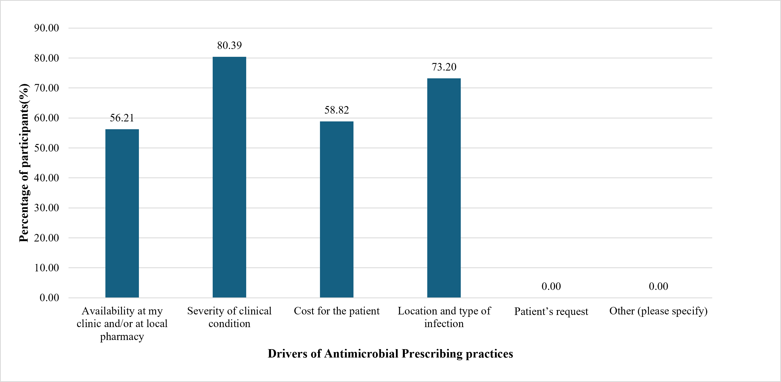

Figure S2. Drivers of AM Prescribing practices (N=153).

