Supplementary Materials
Heavy metal exposure alters the gut microbiota of the water hyacinth biocontrol agent Megamelus scutellaris (Hemiptera: Delphacidae): implications for biological control of Pontederia crassipes (Pontederiaceae)

Tafara F. Bute ^{1, 2}, Ryan J. Wasserman ^{3, 2}, Gwynneth Matcher ^{2, 4} Julie A. Coetzee ^{2, 1}
¹ Centre for Biological Control, Department of Zoology and Entomology, Rhodes University, Makhanda, 6140, South Africa
² South African Institute for Aquatic Biodiversity, Makhanda, South Africa
³ Department of Zoology and Entomology, Rhodes University, Makhanda, 6140, South Africa
⁴ Department of Biochemistry, Microbiology and Bioinformatics, Rhodes University, Makhanda, 6140, South Africa

Supplementary Table 1. One-way ANOVA results for Al, Mn, and Zn across different sites, with corresponding Tukey multiple comparison adjusted P-values. Significant P-values are highlighted in bold.
Metal(loid) | Df | F-value | P-value | Tukey’s multiple comparison | P-adj
Al | 2 | 16.77 | 0.003 | Civic Dam – Middle Lake | 0.025
 |  |  |  | Civic Dam – Waainek | 0.003
 |  |  |  | Middle Lake – Waainek | 0.177
Mn | 2 | 9.80 | 0.012 | Civic Dam – Middle Lake | 0.921
 |  |  |  | Civic Dam – Waainek | 0.026
 |  |  |  | Middle Lake – Waainek | 0.017
Zn | 2 | 16 | 0.004 | Civic Dam – Middle Lake | 0.029
 |  |  |  | Civic Dam – Waainek | 0.003
 |  |  |  | Middle Lake – Waainek | 0.179

Supplementary Table 2. Kruskal–Wallis results of selected metal(loid)s across sites, with Dunn’s post-hoc pairwise comparisons (Bonferroni-adjusted P-values). Significant P-values are highlighted in bold.
Metal(loid) | χ² | Df | P-value | Dunn’s post hoc test | Z | P-adjusted
Fe | 6.49 | 2 | 0.039 | Civic Dam – Middle Lake | 1.491 | 0.408
 |  |  |  | Civic Dam – Waainek | 2.534 | 0.034
 |  |  |  | Middle Lake – Waainek | 1.043 | 0.890
As | 5.60 | 2 | 0.060 | – | – | –
Cr | 4.63 | 2 | 0.099 | – | – | –
Cu | 1.17 | 2 | 0.558 | – | – | –
Ni | 4.36 | 2 | 0.113 | – | – | –
B | 2.85 | 2 | 0.240 | – | – | –

Supplementary Table 3. Comparison of alpha diversity indices across Middle Lake, Civic Dam, and Waainek mass rearing facility using the Kruskal–Wallis test. Asterisks (*) indicate statistically significant differences at P < 0.05.
Metric | Kruskal-Wallis χ² | df | p-value | pairwise comparisons (BH) | adjusted p-values
Chao1 | 6.9 | 2 | 0.032* | Middle Lake – Civic Dam | 0.086
 |  |  |  | Middle Lake – Waainek | 0.086
 |  |  |  | Civic Dam – Waainek | 0.559
ACE | 6.5 | 2 | 0.039* | Middle Lake – Civic Dam | 0.086
 |  |  |  | Middle Lake – Waainek | 0.086
 |  |  |  | Civic Dam – Waainek | 1.000
Shannon | 1.5 | 2 | 0.472 | Not significant
Simpson | 2.0 | 2 | 0.368 | Not significant

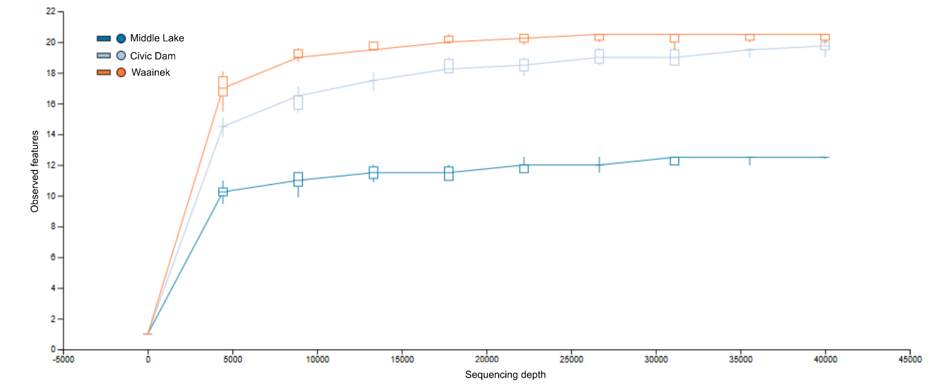
Supplementary Fig. 1. Rarefaction curves showing observed features as a function of sequencing depth at 40 000 reads for three M. scuterallis population; 10 iterations
Supplementary Table 4. Principal component analysis (PCA) loadings of individual heavy metals on HM_PC1 and HM_PC2.
Heavy metal | PC1 | PC2
Al | -0.36 | 0.08
As | -0.33 | -0.28
Cr | -0.36 | -0.09
Cu | -0.02 | 0.63
Fe | -0.36 | 0.09
Hg | -0.29 | 0.38
Mn | -0.33 | -0.26
Ni | -0.29 | -0.37
Pb | -0.29 | 0.38
Zn | -0.36 | 0.07
Variance explained (%) | 74.5 | 25.5

Supplementary Table 5. Eigenvalues and proportion of total variation captured by each axis in the redundancy analysis (RDA) of M. scutellaris gut microbiome composition constrained by HM_PC1. RDA1 is the constrained axis; PC1–PC10 are unconstrained axes representing residual variation.
Axis | Eigenvalue | % of total
RDA1 (constrained) | 0.04351 | 36.00
PC1 | 0.04381 | 36.20
PC2 | 0.02228 | 18.40
PC3 | 0.008 | 6.60
PC4 | 0.00179 | 1.50
PC5 | 0.00078 | 0.60
PC6 | 0.00024 | 0.20
PC7 | 0.00022 | 0.20
PC8 | 0.00011 | 0.10
PC9 | 0.00008 | 0.10
PC10 | 0.00006 | 0.00
Total | 0.12086 | ~100%

Supplementary Material 1
Sample digestion of plant leaves was performed using microwave-assisted acid digestion following the US EPA Method 3052 protocol. Approximately 0.5 g of dried and homogenized leaf material was digested using a mixture of HNO₃ (65%) and H₂O₂ in a microwave digestion system operated at 200 °C for 15 minutes (Step 1), followed by an additional 15 minutes (Step 2) at the same temperature. After cooling, the digested samples were made up to a final volume of 50 mL with distilled water prior to analysis. The following detection limits were employed for the studied HMs: 0.001 mg L⁻¹ for all elements and 0.025 mg L⁻¹ for Cr and Cd. Elemental concentrations in water samples were reported in mg L⁻¹, while concentrations in plant leaves were expressed in mg kg⁻¹ dry weight (DW).

Supplementary Material 2
Plant hoppers were placed in a sterile petri dish and immobilised by brief exposure (5–10 minutes) at −20 °C, following Msango et al. (2024). Dissections were performed aseptically under a stereo microscope in a laminar-flow hood (Vividair 6003, South Africa), using sterilised tools and following protocols adapted from Mattison et al. (2017) with modifications. Specimens were dissected in phosphate-buffered saline (PBS; pH 7.2) using insect pins (Ento Sphinx®; Pardubice, Czech Republic; size 0) and fine-tipped straight monofilament forceps (Moria, Antony, France; REF 13167). The hindgut was grasped with forceps at the base of the anus, then pulled to remove the entire gut. The forceps were flame-sterilized between successive uses on insects from different sites. Twenty guts per replicate were transferred to a 1.5 mL tube containing 0.5 mL sterile phosphate-buffered saline (PBS, pH 7.4) and stored at −80 °C until DNA extraction.

Supplementary Material 3
Multiplexed raw paired-end Illumina amplicon reads were processed using QIIME 2 v2024.10 (Bolyen et al. 2019).Sequences were imported as a manifest file, demultiplexed, and primer sequences were removed using the Cutadapt plugin. Denoising, quality filtering, paired-end merging, and chimera removal were performed using DADA2 (Callahan et al. 2016) to generate Amplicon Sequence Variants (ASVs). Taxonomic classification at a 99 % similarity index was performed using the Naïve Bayes classifier with the SILVA database v138 (Quast et al. 2013) to produce an Amplicon Sequence Variant (ASV) feature table. Mitochondria, chloroplasts, eukaryotes, and unclassified sequences were removed via taxa-based filtering from the feature table. The QIIME 2 outputs, including the ASV table, were integrated into R as a phyloseq object (McMurdie and Holmes 2013). Alpha and beta diversity metrics were calculated on a rarefied feature table at a maximum sampling depth of 40,000 reads per replicate. Functional prediction of the microbiome was performed by running PICRUSt2 (Douglas et al. 2020). The PICRUSt2 outputs used here consisted of predicted enzyme commission (EC) pathway abundances inferred from the MetaCyc pathway database (Caspi et al. 2016), while KEGG pathways were mapped from KEGG Orthology (KO) numbers based on the KEGG database. Metabolic and functional pathways visualisations were generated using ggpicrust2 (Chen et al. 2023).

References
Callahan, B.J., McMurdie, P.J., Rosen, M.J., Han, A.W., Johnson, A.J.A., & Holmes, S.P. (2016). DADA2: high–resolution sample inference from Illumina amplicon data. Nature Methods, 13 (7), 581–583. https://doi.org/10.1038/nmeth.3869
Caspi, R., Billington, R., Ferrer, L., Foerster, H., Fulcher, C.A., Keseler, I.M., Kothari, A., Krummenacker, M., & Latendresse, M. (2016). The MetaCyc database of metabolic pathways, 600 enzymes, and the Biocyc collection of pathway/genome databases. Nucleic Acids Research. 44 (601), 471–480. https://doi.org/10.1093/nar/gkv1164
Chen, Y., Jiahao, M., Xuan, C., Aaron, B., Fabio C., & Liangliang Z. (2023) ggpicrust2: an R package for PICRUSt2 predicted functional profile analysis and visualization, Bioinformatics, 39(8). https://doi.org/10.1093/bioinformatics/btad470
Douglas, G.M., Maffei, V.J., Zaneveld, J.R., Yurgel, S.N., James, R., Taylor, C.M., Huttenhower, C., & Langille, M.G.I. (2020). PICRUSt2 for prediction of metagenome functions. Nature Biotechnology, 38 (6), 685–688. https://doi.org/10.1038/s41587-020-0548-6
McMurdie, P.J., & Holmes, S. (2013). Phyloseq: an R package for reproducible interactive analysis and graphics of microbiome census data. PLoS One, 8 (4), e61217. https:// doi.org/10.1371/journal.pone.0061217
Msango, K., Gouda, M. R., Ramakrishnan, B., et al. (2024). Variation and functional profile of gut bacteria in the scarab beetle, Anomala dimidiata, under a cellulose-enriched microenvironment. Scientific Reports, 14(1), 22400. https://doi.org/10.1007/s00248-025-02579-0
Quast, C., Pruesse, E., Yilmaz, P., Gerken, J., Schweer, T., Yarza, P., Peplies, J., & Gl¨ockner, F.O. (2013). The SILVA ribosomal RNA gene database project: improved data processing and web–based tools. Nucleic Acids Research. 41 (D1), 590–596. https:// doi.org/10.1093/nar/gks1219

