Supplementary materials
Supplementary Table S1
MNI and BA Coordinates of DMN and CCN
Region | Abbreviation | BA | MNI (x) | MNI (y) | MNI (z) | Hemisphere
CCN
Dorsolateral prefrontal cortex | DLPFC | 9, 8 | -36 | 30 | 39 | Left
Dorsolateral prefrontal cortex | DLPFC | 9, 8 | 37 | 31 | 39 | Right
Rostrolateral prefrontal cortex | RLPFC | 10 | -31 | 54 | 35 | Left
Rostrolateral prefrontal cortex | RLPFC | 10 | 32 | 55 | 30 | Right
Inferior frontal junction | IFJ | 9, 6 | -50 | 4 | 35 | Left
Inferior frontal junction | IFJ | 9, 6 | 50 | 4 | 35 | Right
Posterior parietal cortex | PPC | 40, 7 | -41 | -53 | 52 | Left
Posterior parietal cortex | PPC | 40, 7 | 42 | -54 | 52 | Right
Dorsal-caudal anterior cingulate cortex | dACC | 32, 8 | 0 | 25 | 49 | Left-Right
Anterior insula cortex/ frontal operculum | AI | 47, 45, 13 | -39 | 20 | 6 | Left
Anterior insula cortex/ frontal operculum | AI | 47, 45, 13 | 40 | 20 | 5 | Right
DMN
Medial prefrontal cortex | MPFC | 10 | 1 | 55 | -3 | Left-Right
Posterior cingulate cortex | PCC | 23 | -10 | -45 | 25 | Left
Posterior cingulate cortex | PCC | 23 | 10 | -45 | 25 | Right
Prefrontal cortex | PFC | 46 | -45 | 25 | 25 | Left
Prefrontal cortex | PFC | 46 | 45 | 25 | 25 | Right
Parahippocampal gyrus | PHG | 36 | -25 | -30 | -20 | Left
Parahippocampal gyrus | PHG | 36 | 25 | -30 | -20 | Right
Note. Coordinates are reported in Montreal Neurological Institute (MNI) space. BA = Brodmann area; CCN = cognitive control network; DMN = default mode network.
Supplementary Table S2. Correlations Between Significant CCN Connectivity Measures and BPAQ Scores
Functional  connectivity | BPAQ  measure | r | 95% CI lower | 95% CI upper | raw p | FDR-adjusted q
Left DLPFC–  Right IFJ | Physical  Aggression | -0.648 | -0.807 | -0.402 | < .001 | 0.001
Left AI–Right  RLPFC | Physical  Aggression | -0.370 | -0.626 | -0.042 | 0.029 | 0.278
Left IFJ–Right IFJ | Physical  Aggression | -0.361 | -0.619 | -0.031 | 0.033 | 0.278
Left AI–Right  DLPFC | Physical  Aggression | -0.273 | -0.556 | 0.066 | 0.113 | 0.487
Left AI–Right  RLPFC | BPAQ Total | -0.270 | -0.554 | 0.069 | 0.117 | 0.487
Left DLPFC–  Right IFJ | BPAQ Total | -0.270 | -0.553 | 0.070 | 0.117 | 0.487
Left AI–Right AI | Physical  Aggression | -0.224 | -0.519 | 0.118 | 0.195 | 0.697
Left AI–Right  DLPFC | Hostility | 0.211 | -0.132 | 0.508 | 0.224 | 0.700
Left IFJ–Right IFJ | Verbal  Aggression | 0.178 | -0.165 | 0.482 | 0.307 | 0.852
Left IFJ–Right IFJ | BPAQ Total | -0.152 | -0.462 | 0.191 | 0.383 | 0.876
Left DLPFC–  Right IFJ | Hostility | 0.151 | -0.192 | 0.461 | 0.385 | 0.876
Left AI–Right AI | Hostility | 0.124 | -0.218 | 0.439 | 0.478 | 0.944
Left AI–Right  RLPFC | Hostility | 0.113 | -0.229 | 0.430 | 0.517 | 0.944
Left AI–Right  DLPFC | Verbal  Aggression | 0.105 | -0.236 | 0.424 | 0.547 | 0.944
Left AI–Right  RLPFC | Anger | -0.094 | -0.415 | 0.247 | 0.590 | 0.944
Left AI–Right AI | BPAQ Total | -0.091 | -0.412 | 0.250 | 0.604 | 0.944
Left IFJ–Right IFJ | Hostility | 0.074 | -0.265 | 0.398 | 0.671 | 0.987
Left AI–Right  DLPFC | BPAQ Total | -0.056 | -0.382 | 0.283 | 0.751 | 0.997
Left AI–Right  DLPFC | Anger | -0.029 | -0.359 | 0.307 | 0.869 | 0.997
Left DLPFC–  Right IFJ | Verbal  Aggression | 0.024 | -0.312 | 0.355 | 0.891 | 0.997
Left DLPFC–  Right IFJ | Anger | -0.023 | -0.354 | 0.312 | 0.894 | 0.997
Left AI–Right AI | Verbal  Aggression | 0.022 | -0.313 | 0.353 | 0.899 | 0.997
Left AI–Right AI | Anger | -0.016 | -0.347 | 0.319 | 0.928 | 0.997
Left IFJ–Right IFJ | Anger | -0.002 | -0.335 | 0.331 | 0.990 | 0.997
Left AI–Right  RLPFC | Verbal  Aggression | -0.001 | -0.334 | 0.333 | 0.997 | 0.997
Note. Values are Pearson correlation coefficients (r) between the five CCN connectivity measures that survived the primary max-statistic FWER correction and Buss–Perry Aggression Questionnaire (BPAQ) scores. Raw p values and Benjamini–Hochberg false discovery rate (FDR)-adjusted q values are reported for all 25 tests. FDR correction was applied across the complete set of 25 connectivity–BPAQ correlations. The association between left dorsolateral prefrontal cortex–right inferior frontal junction (DLPFC–IFJ) beta1 connectivity and BPAQ Physical Aggression remained significant after FDR correction. CCN = cognitive control network; BPAQ = Buss–Perry Aggression Questionnaire; DLPFC = dorsolateral prefrontal cortex; IFJ = inferior frontal junction; AI = anterior insula; RLPFC = rostrolateral prefrontal cortex; FWER = family-wise error rate; FDR = false discovery rate.

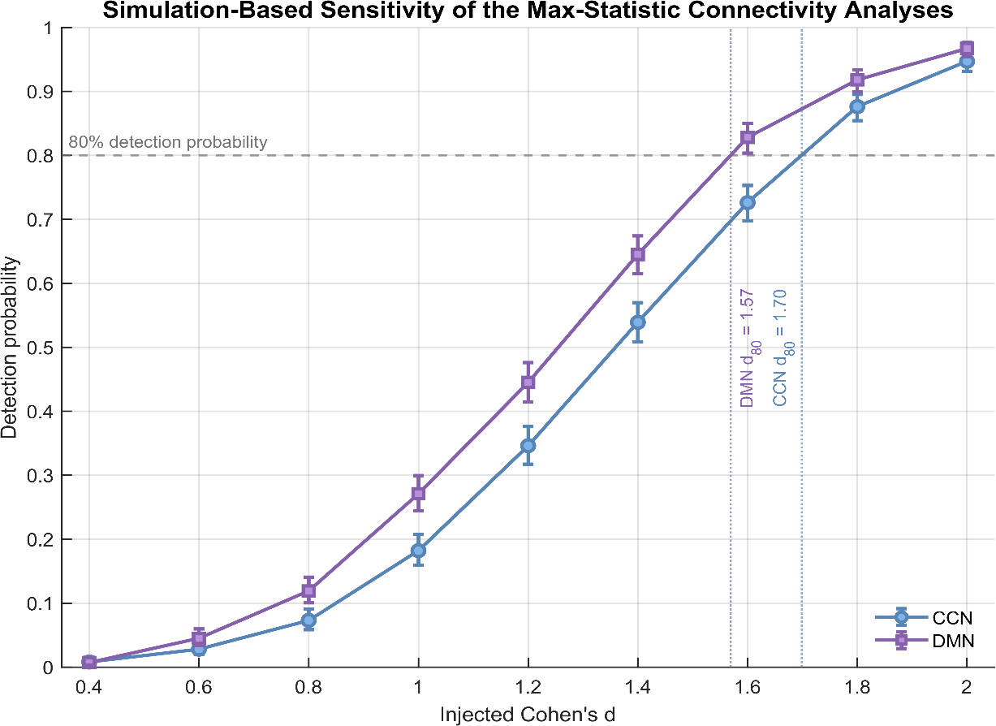

Figure S1. Simulation-based sensitivity curves for the CCN and DMN max-statistic connectivity analyses. Detection probabilities were estimated separately for the cognitive control network (CCN) and default mode network (DMN) using the observed group sizes (Low-EXT, n = 18; High-EXT, n = 17) and the same maximum-|t| FWER procedure used in the primary analyses. For each injected standardized effect size (Cohen's d = .40–2.00), 1,000 Monte Carlo datasets were generated, and each dataset was evaluated using 5,000 group-label permutations. Points represent estimated detection probabilities and error bars represent 95% Wilson confidence intervals. The horizontal dashed line denotes 80% detection probability. Linear interpolation indicated that approximately 80% detection probability was reached at Cohen's d = 1.70 for the CCN and d = 1.57 for the DMN. The difference in sensitivity partly reflects the larger multiplicity burden in the CCN analysis (385 connection × frequency tests) than in the DMN analysis (147 tests).

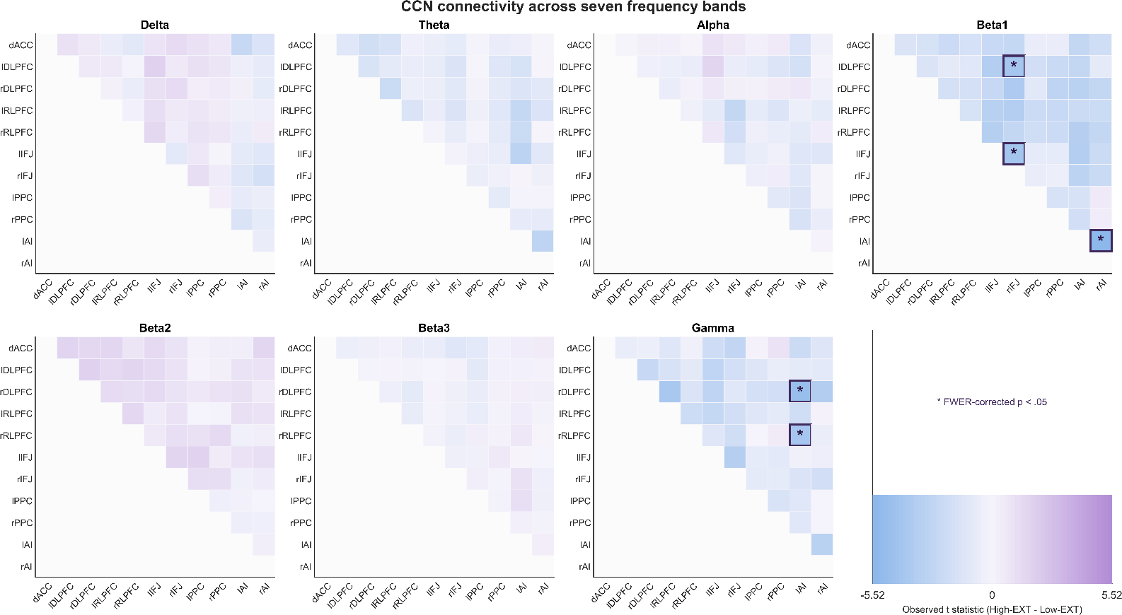

Figure S2. Frequency-specific between-group connectivity patterns across the cognitive control network (CCN). Heatmaps display the observed independent-samples t statistic for each unique ROI-to-ROI connection across the seven predefined frequency bands (delta, theta, alpha, beta1, beta2, beta3, and gamma). Values are defined as High-EXT minus Low-EXT; therefore, negative t values indicate lower lagged phase synchronization (LPS) in the High-EXT group. Only the upper triangular portion of each symmetric connectivity matrix is displayed. Statistical significance was evaluated using a maximum-|t| permutation procedure with 5,000 permutations, controlling the family-wise error rate (FWER) jointly across all CCN connections and frequency bands. Asterisks and outlined cells indicate connections surviving FWER correction at p < .05. Significant effects were confined to the beta1 band and gamma band.

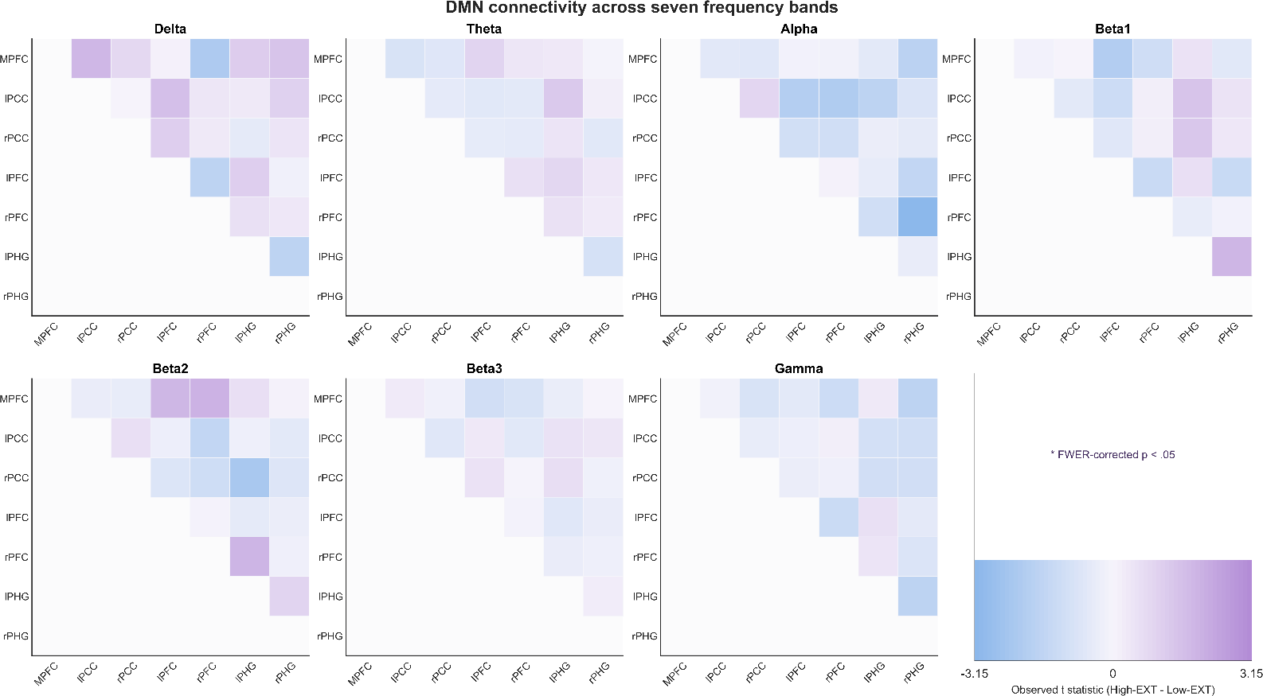

Figure S3. Frequency-specific between-group connectivity patterns across the default mode network (DMN). Heatmaps display the observed independent-samples t statistic for each unique ROI-to-ROI connection across the seven predefined frequency bands (delta, theta, alpha, beta1, beta2, beta3, and gamma). Values are defined as High-EXT minus Low-EXT, such that negative values indicate lower LPS in the High-EXT group and positive values indicate higher LPS. Only the upper triangular portion of each symmetric connectivity matrix is displayed. Statistical significance was evaluated using a maximum-|t| permutation procedure with 5,000 permutations, controlling FWER jointly across all DMN connections and frequency bands. No DMN connection survived FWER correction at p < .05.

