Supplementary material for:

Jet lag-like state affects cognitive performance of great tits

Utku Urhan^{1,2}, Barbara Mizumo Tomotani^{1,3} , Szymon M. Drobniak^{4,5} & Kees van Oers^{1,6}
¹Netherlands Institute of Ecology (NIOO-KNAW), Wageningen, The Netherlands
²Department of Biology, Lund University, Lund, Sweden
³Department of Arctic and Marine Biology, The Arctic University of Norway (UiT), Tromsø, Norway
⁴Institute of Environmental Sciences, Faculty of Biology, Jagiellonian University, Krakow, Poland
⁵Ecology & Evolution Research Centre (EERC), School of Biological, Environmental and Earth Sciences (BEES), University of New South Wales, Sydney, Australia
⁶Behavioural Ecology Group, Wageningen University & Research, Wageningen, the Netherlands
Keywords; circadian rhythm, biological clock, jet lag, cognition, motor inhibition, problem-solving, great tits

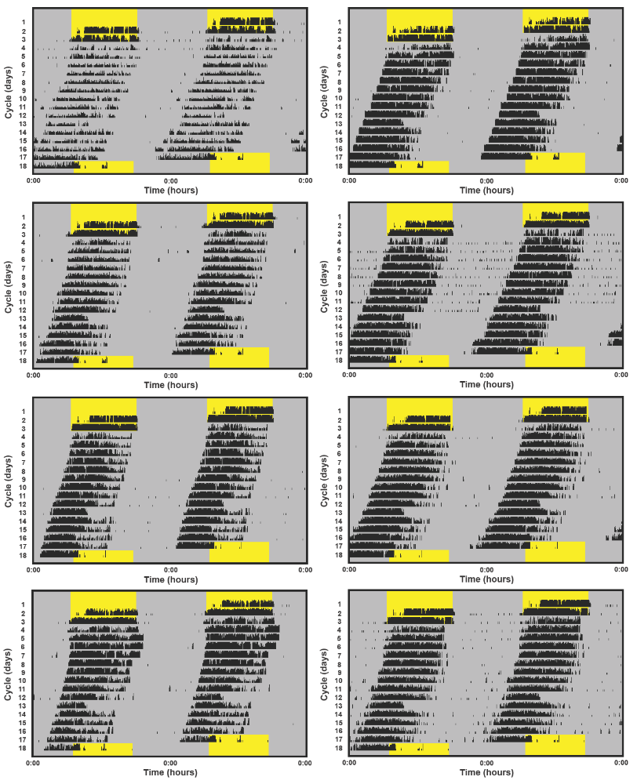
Figure S1. Double-plotted actograms of the birds in the jet lagged group. Yellow background = natural light phase; Dark background = dim white light 0.5 lux.

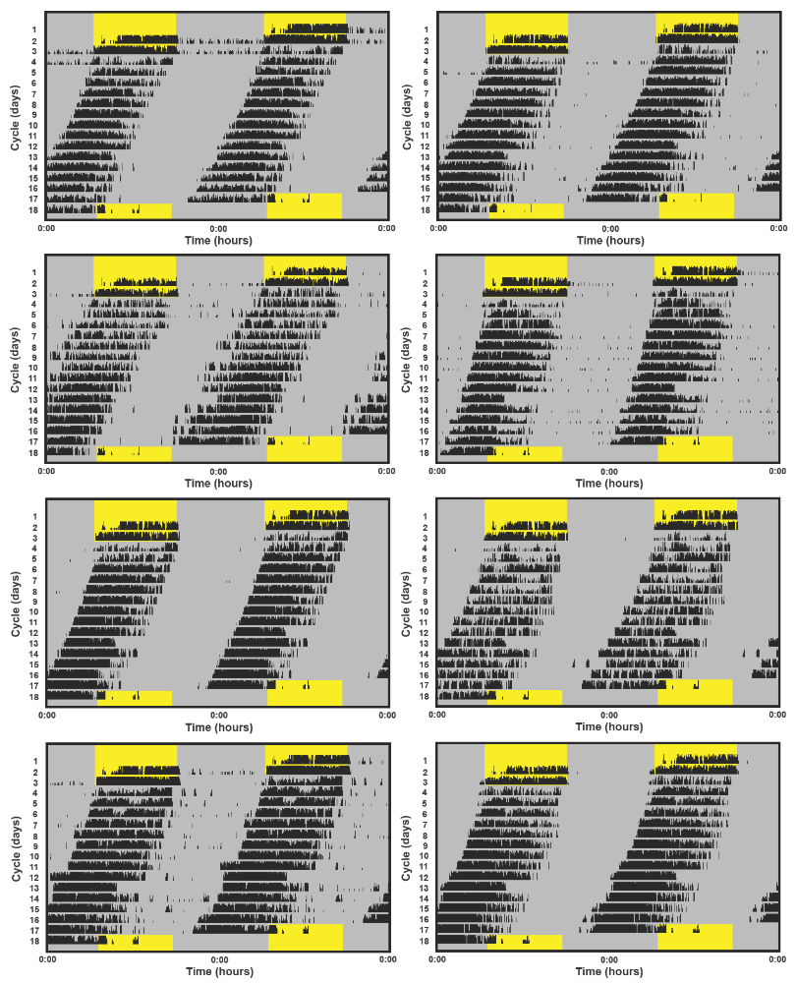
Figure S1 (cont.). Double-plotted actograms of the birds in the jet lagged group. Yellow background = natural light phase; Dark background = dim white light 0.5 lux.

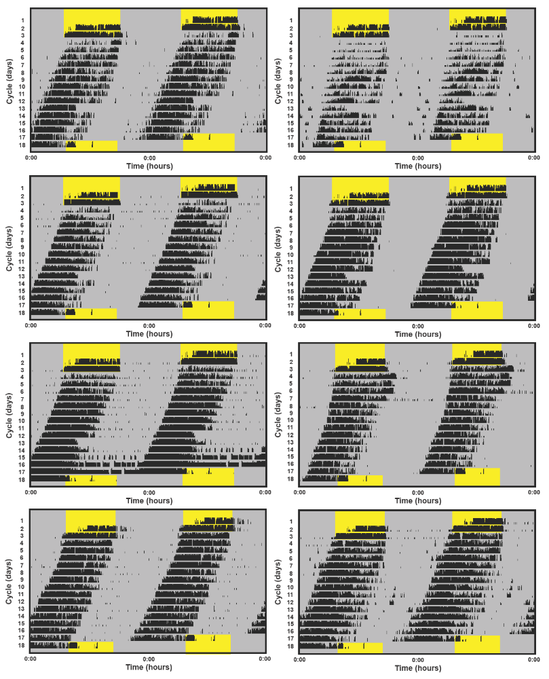
Figure S1 (cont.). Double-plotted actograms of the birds in the jet lagged group. Yellow background = natural light phase; Dark background = dim white light 0.5 lux.

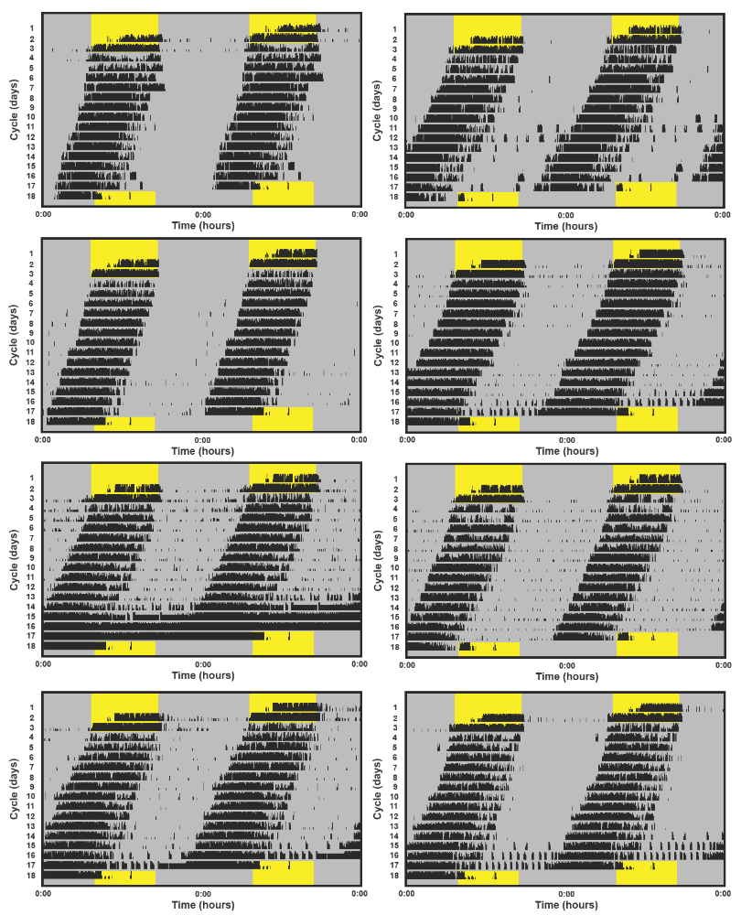
Figure S1 (cont.). Double-plotted actograms of the birds in the jet lagged group. Yellow background = natural light phase; Dark background = dim white light 0.5 lux.

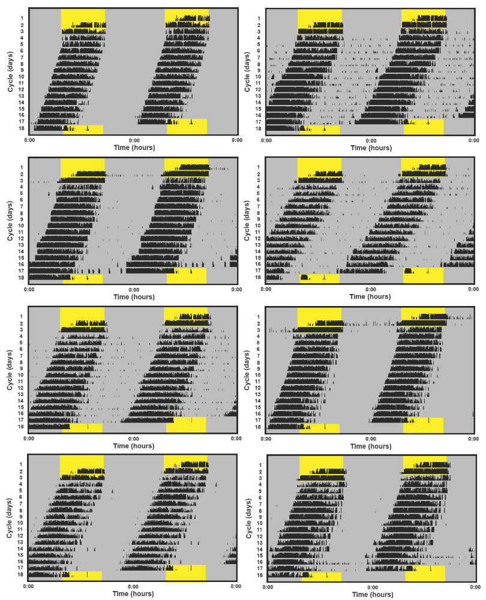
Figure S1 (cont.). Double-plotted actograms of the birds in the jet lagged group. Yellow background = natural light phase; Dark background = dim white light 0.5 lux.

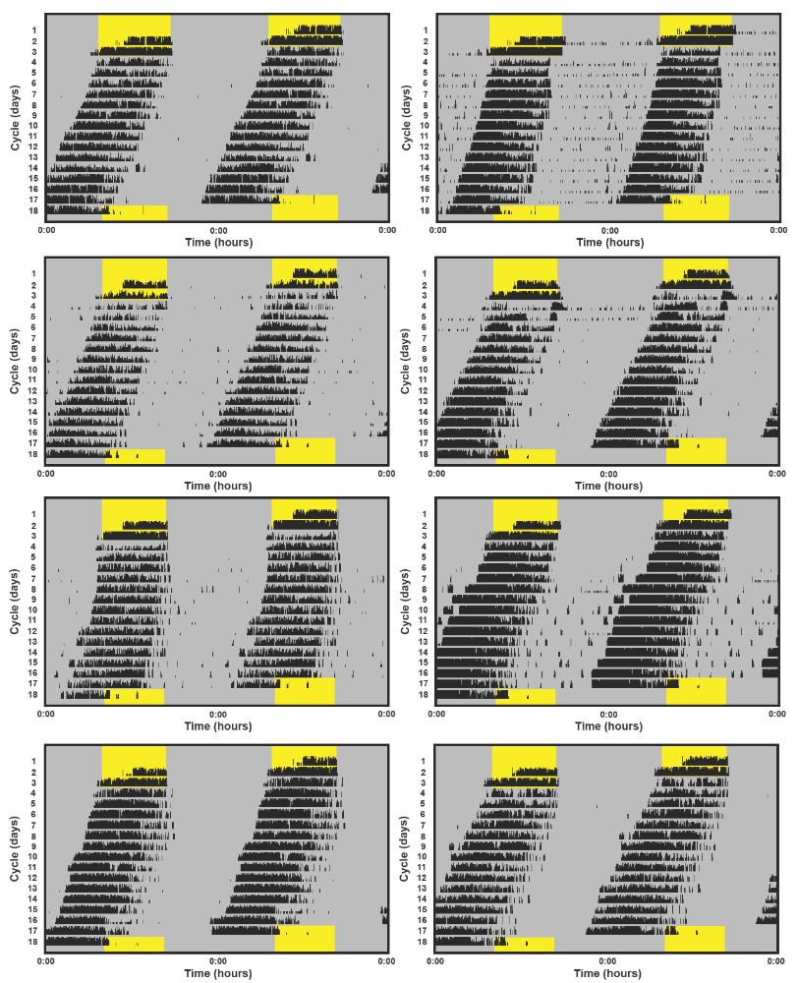
Figure S1 (cont.). Double-plotted actograms of the birds in the jet lagged group. Yellow background = natural light phase; Dark background = dim white light 0.5 lux.

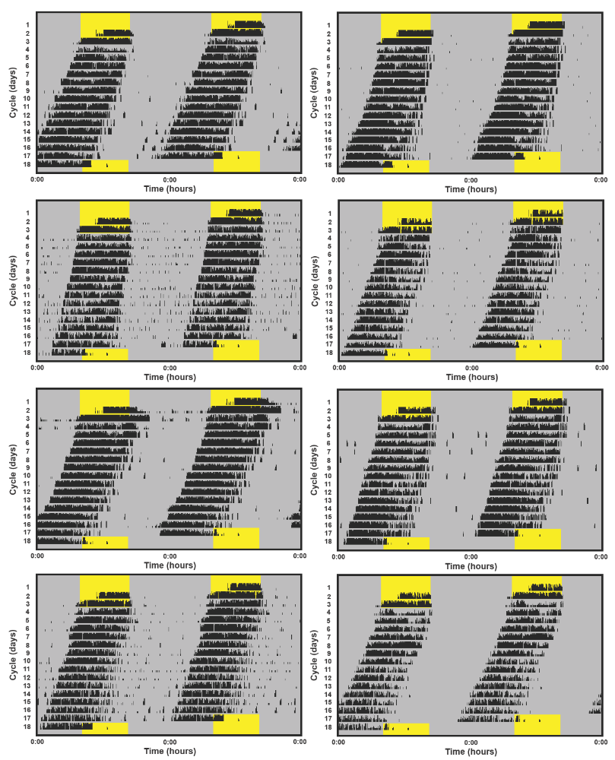
Figure S1 (cont.). Double-plotted actograms of the birds in the jet lagged group. Yellow background = natural light phase; Dark background = dim white light 0.5 lux.

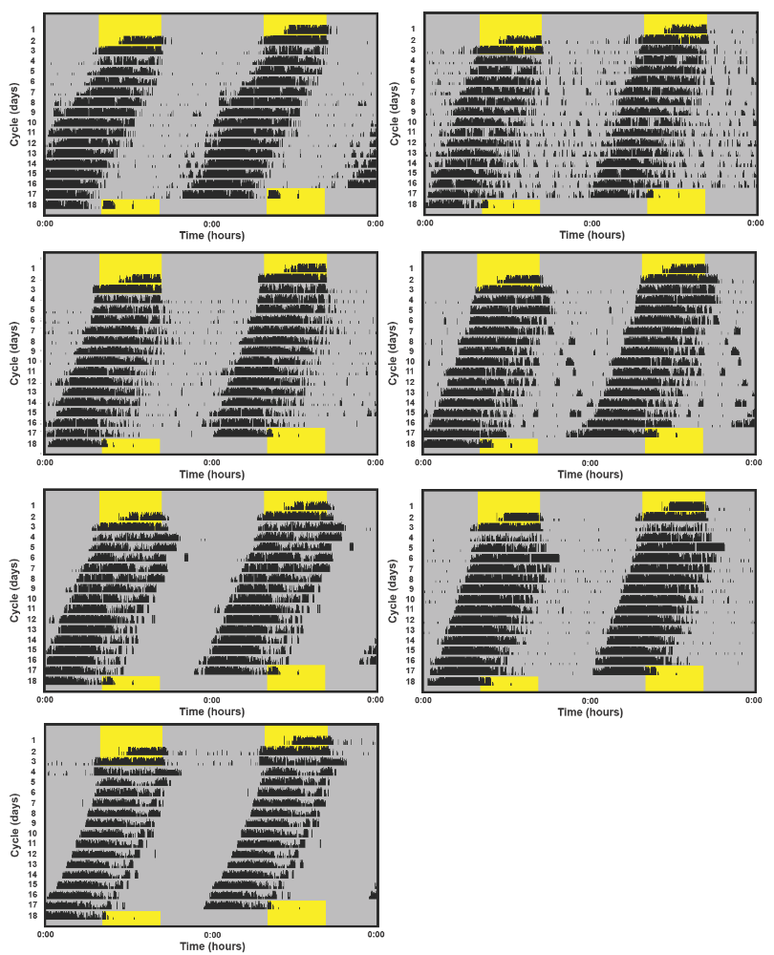
Figure S1 (cont.). Double-plotted actograms of the birds in the jet lagged group. Yellow background = natural light phase; Dark background = dim white light 0.5 lux.

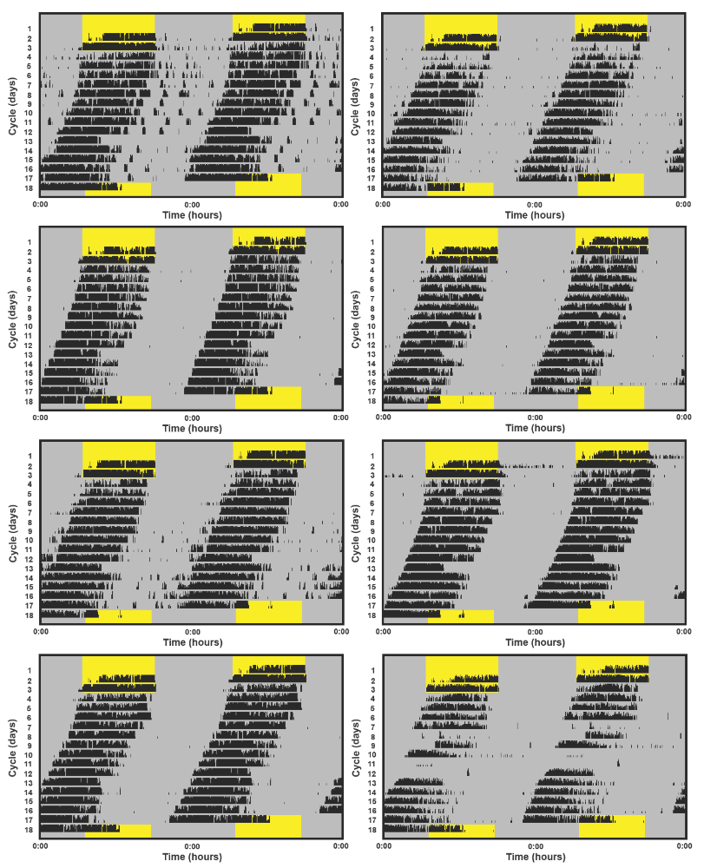
Figure S2. Double-plotted actograms of the birds in the recovered group. Yellow background = natural light phase; Dark background = dim white light 0.5 lux.

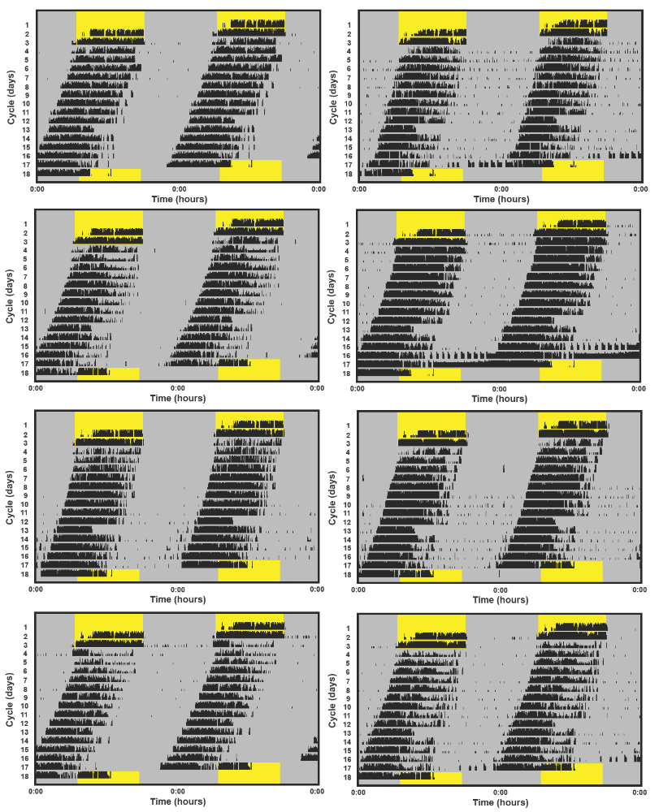
Figure S2 (cont.). Double-plotted actograms of the birds in the recovered group. Yellow background = natural light phase; Dark background = dim white light 0.5 lux.

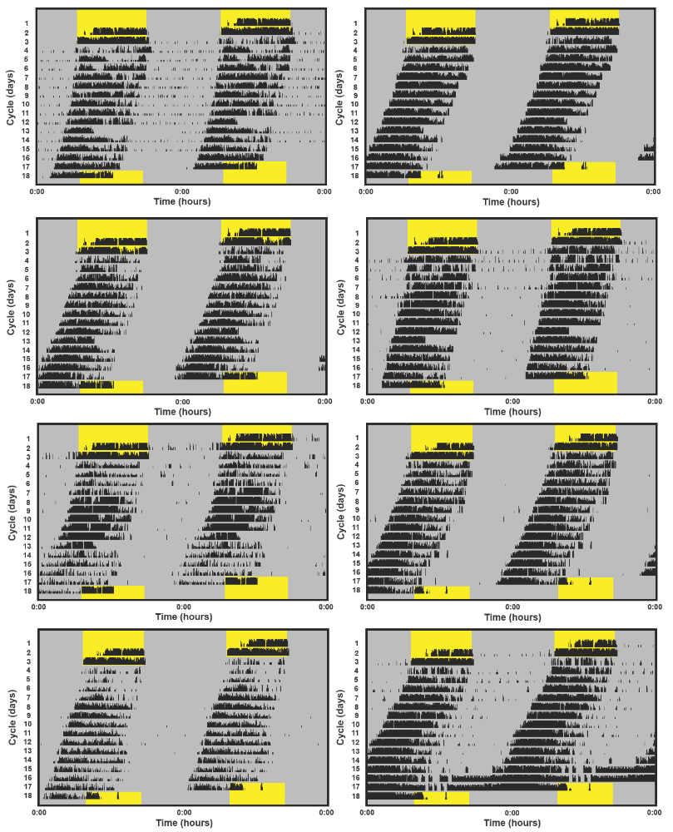
Figure S2 (cont.). Double-plotted actograms of the birds in the recovered group. Yellow background = natural light phase; Dark background = dim white light 0.5 lux.

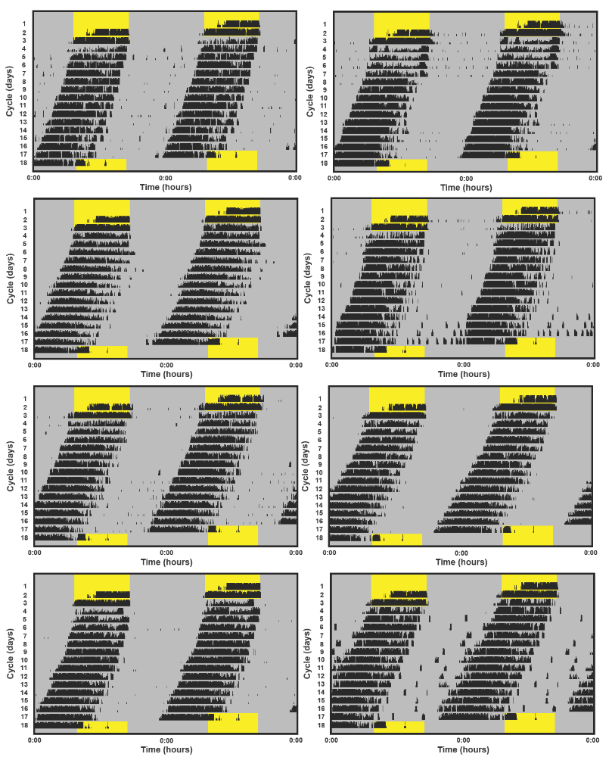
Figure S2 (cont.). Double-plotted actograms of the birds in the recovered group. Yellow background = natural light phase; Dark background = dim white light 0.5 lux.

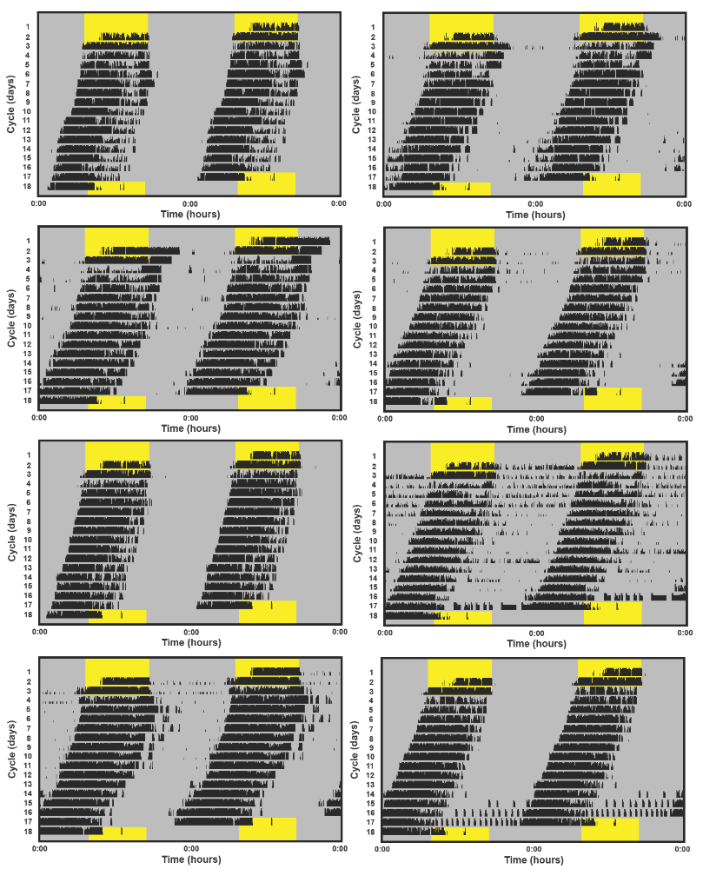
Figure S2 (cont.). Double-plotted actograms of the birds in the recovered group. Yellow background = natural light phase; Dark background = dim white light 0.5 lux.

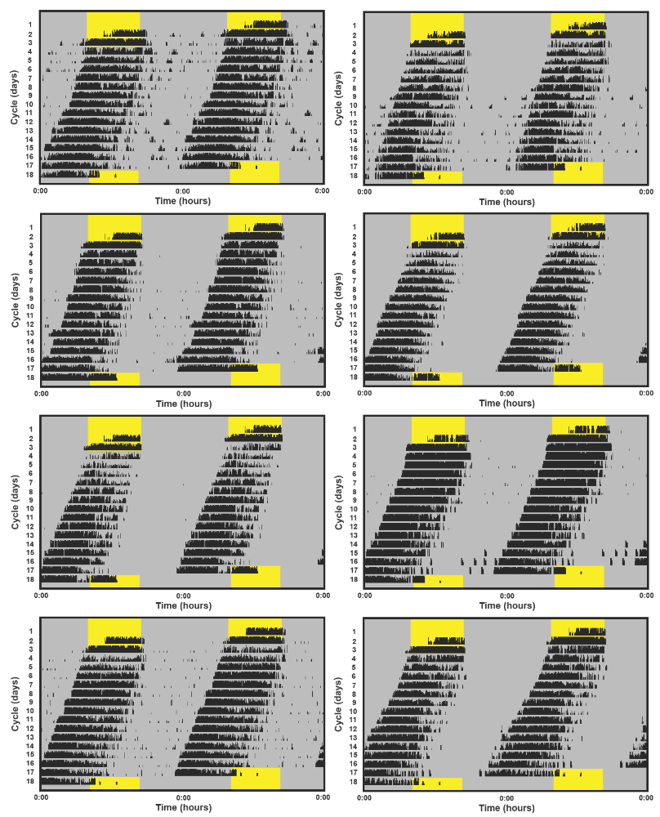
Figure S2 (cont.). Double-plotted actograms of the birds in the recovered group. Yellow background = natural light phase; Dark background = dim white light 0.5 lux.

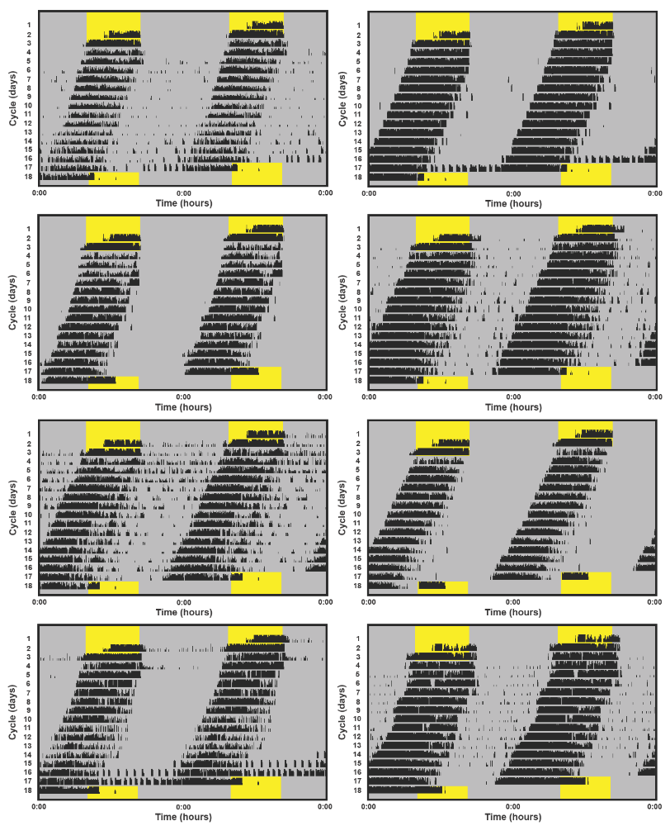
Figure S2 (cont.). Double-plotted actograms of the birds in the recovered group. Yellow background = natural light phase; Dark background = dim white light 0.5 lux.

Figure S2 (cont.). Double-plotted actograms of the birds in the recovered group. Part of these actograms are also reported in Tomotani and Visser (in prep). Yellow background = natural light phase; Dark background = dim white light 0.5 lux.

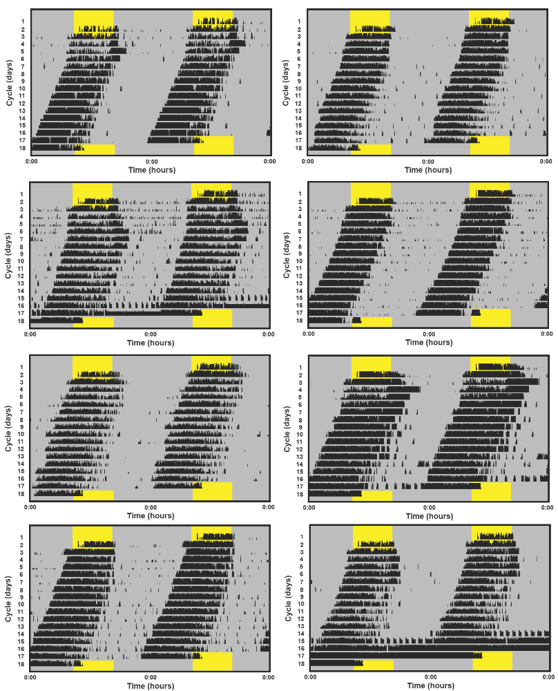
Figure S2 (cont.). Double-plotted actograms of the birds in the recovered group. Part of these actograms are also reported in Tomotani and Visser (in prep). Yellow background = natural light phase; Dark background = dim white light 0.5 lux.

