Online Resource 1
World Journal of Urology
Cardiovascular Mortality as a Negative Control Outcome for the Apparent Survival Benefit of Cytoreductive Nephrectomy in De Novo Metastatic Renal Cell Carcinoma
Xin Huang, Jin Kuang, Yi Huang, Hailin Luo, Xianxin Zhu, Jianqiang Zhang, Xiaolin Deng, Chuance Du, Cong Lai*, Mayao Luo*, Qiang Wei*
*Corresponding authors: Cong Lai (Department of Urology, Sun Yat-sen Memorial Hospital, Sun Yat-sen University, Guangzhou, China; laic3@mail.sysu.edu.cn); Mayao Luo (Department of Urology, Guangdong Provincial People's Hospital, Southern Medical University, Guangzhou, China; Romanyaogr@163.com); Qiang Wei (Department of Urology, Nanfang Hospital, Southern Medical University, Guangzhou, China; qwei@smu.edu.cn)
Contents: Supplementary methods; Tables S1–S8; Figs. S1–S6. Reference numbers in square brackets refer to the reference list of the main article.
Supplementary methods
Data source
Data were obtained from the Surveillance, Epidemiology, and End Results (SEER) Program of the US National Cancer Institute, using the SEER*Stat database Incidence – SEER Research Data, 17 Registries, Nov 2025 Sub (2000–2023) – Linked To County Attributes – Time Dependent (1990–2024) Income/Rurality, 1969–2024 Counties (National Cancer Institute, DCCPS, Surveillance Research Program; released April 2026, based on the November 2025 submission). Case listings were extracted with SEER*Stat software version 9.0.43.0. The SEER 17 registries cover approximately 26.5% of the US population.
Study population
We included cases with a primary site code of C64.9 (kidney). At extraction, we further required malignant behaviour, microscopic confirmation, a first or only primary tumour, a reporting source other than autopsy or death certificate only, and known age at diagnosis. Histology was restricted to renal cell carcinoma, defined by ICD-O-3 morphology codes 8310 (clear cell), 8260 (papillary), 8317 (chromophobe), 8318 (sarcomatoid), 8319 (collecting duct), 8312 (renal cell carcinoma, not otherwise specified), 8316, 8320, 8323, 8510 and 8311.
Patients aged 18 years or older and diagnosed between 2010 and 2022 were eligible. Cases diagnosed in 2023 were excluded because SEER introduced a new surgery of primary site field (RX Summ—Surg Prim Site 2023) from that year, which is not comparable with earlier coding. Distant metastasis at diagnosis (M1) was ascertained with three staging fields according to year of diagnosis: the American Joint Committee on Cancer (AJCC) 7th edition M category for 2010–2015, the SEER Combined M category for 2016–2017, and the EOD 2018 M category for 2018–2022.
We then sequentially excluded patients with missing survival time; patients with surgery of primary site codes 10–15 (local tumour destruction), 90 (surgery, not otherwise specified), 99 (unknown) or missing; patients for whom all four metastatic sites (bone, brain, liver and lung) were unknown; and patients who died with an uninterpretable cause-of-death code. Because the last exclusion depends on outcome information, it is reported separately (Fig. S1).
Exposure
The exposure was cytoreductive nephrectomy, defined from the field RX Summ—Surg Prim Site (1998–2022). Under the primary definition, codes 30 (partial or subtotal nephrectomy), 40 (complete or total nephrectomy), 50 (radical nephrectomy), 70 (nephrectomy in continuity with resection of other organs) and 80 (nephrectomy, not otherwise specified) were classified as nephrectomy, and code 00 as no surgery. Codes 20–27 (local tumour excision or excisional biopsy) may represent either a therapeutic or a diagnostic procedure; they were classified as no nephrectomy under the primary definition and as nephrectomy under an alternative definition used as a sensitivity analysis (SA1).
Outcomes
The outcome of interest was all-cause death, the end point most often reported in observational studies of cytoreductive nephrectomy.
At the design stage, cerebrovascular death alone was considered as the negative control outcome. A preliminary analysis showed only 71 events under this definition, and the resulting confidence interval was too wide to constrain the bias meaningfully. The primary analysis therefore used death from heart disease or cerebrovascular disease as the negative control outcome, and cerebrovascular death alone is reported as a sensitivity analysis (SA3). This change was made after the preliminary cerebrovascular results had been seen.
Follow-up started in the month of diagnosis and ended at death or last follow-up, with a study cut-off date of 31 December 2023; median follow-up was estimated with the reverse Kaplan–Meier method.
Covariates
Covariates comprised demographic characteristics (age at diagnosis, sex, race and ethnicity, marital status, quartile of county median household income, and residence: metropolitan area of ≥1 million, metropolitan area of <1 million, or non-metropolitan, based on the Rural–Urban Continuum Codes); year of diagnosis; tumour characteristics (histological type: clear cell, papillary, chromophobe, sarcomatoid, or other/not otherwise specified; grade: Fuhrman or WHO/ISUP grade 1, 2, 3 or 4, from 2018 pathological grade when available and clinical grade otherwise; T category; and N category, with TX and NX retained as separate levels); metastatic burden (the number of involved sites among bone, brain, liver and lung: 0–1, 2 or ≥3, with unknown status for an individual site treated as not involved); and coding era (2010–2015, 2016–2017 and 2018–2022), to absorb the two revisions of the staging and grading schemes.
Age was modelled with a restricted cubic spline with four knots at the 5th, 35th, 65th and 95th percentiles, and year of diagnosis with three knots at the 10th, 50th and 90th percentiles; knot locations were fixed in the full cohort and held constant across bootstrap resamples. Categorical levels with fewer than 50 patients were merged into the most frequent (reference) level before estimation (Table S1). First-course chemotherapy and radiotherapy occur after the exposure; they are reported descriptively and were not adjusted for.
Missing data
Missing grade occurred predominantly among patients without surgery, because grade is usually assigned from a surgical specimen. It was handled by multiple imputation by chained equations (MICE) using classification and regression trees (CART), with 10 imputed datasets and 5 iterations each. Imputation was performed separately within the no-surgery, local-excision and nephrectomy groups to preserve the association between exposure and grade. The imputation model included all covariates, the event indicators for both outcomes and the Nelson–Aalen estimates of the cumulative hazard for both outcomes.
Statistical analysis
Three successive Cox proportional hazards models were fitted: M0, unadjusted; M1, adjusted for all covariates; and M2, overlap-weighted (primary analysis). In M2, the propensity score e(X) was estimated by logistic regression including all covariates, and the overlap weight was w = 1 − e(X) for patients who underwent nephrectomy and w = e(X) for those who did not. Overlap weighting emphasises patients for whom either treatment would be clinically plausible, is robust to extreme propensity scores and, with a logistic propensity model, yields exact balance of weighted covariate means [16, 17].
Covariate balance was assessed with standardised mean differences (SMDs), with an absolute SMD below 0.10 considered adequate [17]. The effective sample size of each group was ESS = (Σw)² / Σw². We also report the c-statistic of the propensity model and the proportion of patients outside the region of common support, and assessed the proportional hazards assumption with a test based on Schoenfeld residuals.
The between-group difference in restricted mean survival time (RMST) at 60 months was obtained by integrating the overlap-weighted Kaplan–Meier curves: RMST(τ) = ∫ Ŝ(t) dt from 0 to τ, with τ = 60 months.
Point estimates were the mean log hazard ratio across the 10 imputed datasets. The 95% confidence intervals (CIs) were percentile intervals from 500 non-parametric bootstrap resamples; in each resample, patients were drawn with replacement and the multiple imputation, propensity score estimation and all model fits were repeated in full [18]. Both outcomes were estimated in the same resamples, so that CIs could be obtained directly for any function of the two estimates, including the calibrated estimates.
Bias calibration with the negative control outcome
Under the negative control assumption, the association with the negative control outcome arises entirely from bias [13, 14]. Transferring this bias proportionally to all-cause death gives the calibrated hazard ratio, log HR(cal) = log HR(all) − λ × log HR(NCO), and the proportion of the observed all-cause association attributable to bias, P(bias) = λ × log HR(NCO) / log HR(all) × 100%, where λ is a bias-transportability parameter: λ = 1 assumes equal bias for the two outcomes (the reference assumption), λ < 1 less bias for all-cause death, and λ > 1 the reverse. Results are reported for λ = 0.50, 0.75, 1.00, 1.50 and 2.00.
Sensitivity analyses
Exclusion restriction. Nephrectomy could affect cardiovascular death directly through loss of nephron mass and reduced renal function, which may increase cardiovascular death [15], or through removal of the primary tumour and tumour thrombus, which may reduce deaths such as pulmonary embolism that are classified under diseases of the heart. Denoting the true causal effect of nephrectomy on the negative control outcome by γ (hazard ratio scale), the part of the observed association that reflects bias is log HR(bias) = log HR(NCO) − log γ. We repeated the calibration at λ = 1 for γ between 0.6 and 1.3 and computed two tipping points: the value at which the all-cause association is fully explained by bias, γ = HR(NCO) / HR(all), and the value at which the negative control association is entirely caused by nephrectomy, γ = HR(NCO) (Table S4, Fig. S5).
Administrative truncation. The primary analysis was repeated with follow-up truncated at 12, 24, 36 and 60 months, to examine whether the associations with the two outcomes changed in parallel and whether the proportion attributable to bias was stable across time windows (Table S2).
Landmark analysis. To reduce immortal time bias, which has been raised specifically for registry analyses of cytoreductive nephrectomy [19], we excluded patients who died or were lost to follow-up within 3 months of diagnosis, reset the time origin to the landmark and repeated all analyses [20] (Table S7).
Pre-specified analytical variants. SA1, alternative exposure definition (including codes 20–27); SA2, death from any non-neoplastic cause as the negative control outcome; SA3, cerebrovascular death alone as the negative control outcome; SA4, exclusion of patients with brain metastasis at diagnosis; SA5, exclusion of patients diagnosed in 2016–2017; SA6, restriction to 2010–2017 (before publication of the CARMENA trial); SA7, restriction to 2018–2022 (after publication of the CARMENA trial); SA8a, inverse probability of treatment weighting targeting the average treatment effect; SA8b, 1:1 nearest-neighbour propensity score matching with a caliper of 0.2 standard deviations of the logit of the propensity score and robust standard errors clustered on matched pairs (Table S3).
Definition of partial nephrectomy (SA9). Because it is debated whether partial nephrectomy constitutes cytoreductive surgery, we additionally excluded patients who underwent partial nephrectomy (code 30), classified only codes 40, 50, 70 and 80 as exposure, and repeated the primary analysis and calibration.
Handling of missing grade (SA10, SA11). Missing grade arose mainly from the absence of a surgical specimen, so the missing-at-random assumption underlying multiple imputation may not hold. All analyses were therefore repeated in two further ways: in SA10, unknown grade was entered in the models as a separate category without imputation (missing-indicator approach [21]); in SA11, grade was omitted from the models (Table S8).
Bootstrap. SA1, SA2, SA3, SA8a and SA9 used the same bootstrap resamples as the primary analysis and are reported with CIs; the other variants are reported as point estimates pooled over the imputed datasets. SA10 and SA11 each used their own 500 bootstrap resamples.
Functional form of age and age strata. Age was alternatively modelled with 5-year categories and with single-year indicators. The propensity score and the negative control association were also re-estimated within age strata (<50, 50–69 and ≥70 years), with a linear age term within each stratum (Table S5, Fig. S6).
E-values. Because neither outcome was rare in this cohort, each hazard ratio was converted approximately to a risk ratio before the E-value was calculated [22]: RR ≈ (1 − 0.5^√HR) / (1 − 0.5^√(1/HR)), and E = RR* + √(RR* × (RR* − 1)), where RR* is the reciprocal of RR when RR < 1 (Table S6).
Decisions made after the preliminary analysis. The rule for merging sparse covariate levels (changed from a threshold based on negative control events to one based on the number of patients), the 3-month landmark analysis, SA9, SA10 and SA11, and the separation of grade 3 from grade 4 were specified after the preliminary analysis.
Software
Data were extracted with SEER*Stat 9.0.43.0. Analyses were performed in R 4.6.1 (R Foundation for Statistical Computing, Vienna, Austria) with survival 3.8.6 (Cox models and Kaplan–Meier estimation), rms 8.1.1 (restricted cubic splines), mice 3.19.0 (multiple imputation), MatchIt 4.7.2 (propensity score matching), data.table 1.18.6.1 (data management), ggplot2 4.0.3 and patchwork 1.3.2 (figures), and flextable 0.10.0 (tables). The random seed was fixed at 20260101. Results are reported as estimates with 95% CIs, without a P value threshold for statistical significance.
Supplementary Table S1. Covariate levels with fewer than 50 patients merged into the reference level
Variable | Level | n | Negative control deaths | Merged into
race | Unknown | 44 | 1 | NH White
rural | Unknown | 32 | 0 | Metro >=1M

Supplementary Table S2. Administrative truncation of follow-up
Follow-up truncated at | Cardiovascular deaths | All-cause death  HR (95% CI) | Cardiovascular death  HR (95% CI) | Proportion explained  at λ = 1, %
12 months | 231 | 0.363 (0.340–0.390) | 0.456 (0.285–0.661) | 77.5 (41.7 to 123.4)
24 months | 285 | 0.387 (0.366–0.411) | 0.485 (0.341–0.688) | 76.3 (38.6 to 111.6)
36 months | 312 | 0.403 (0.382–0.425) | 0.509 (0.374–0.684) | 74.2 (41.8 to 108.3)
60 months | 353 | 0.416 (0.396–0.437) | 0.519 (0.381–0.701) | 74.9 (40.6 to 110.6)
Full follow-up | 394 | 0.424 (0.403–0.447) | 0.528 (0.391–0.701) | 74.6 (42.0 to 108.9)
Spearman rank correlation of the two outcomes' HRs across the five windows: 1.000. Range of the proportion explained across windows: 3.3 percentage points (bootstrap median 16.0; 95% interval 5.8 to 40.3).

Supplementary Table S3. Negative control association across pre-specified analytical variants
Analysis | HR for cardiovascular death (95% CI)
Main analysis | 0.528 (0.391–0.701)
SA1 local excision (codes 20-27) included | 0.541 (0.404–0.723)
SA2 NCO = non-cancer death | 0.584 (0.480–0.689)
SA3 NCO = cerebrovascular death only | 0.608 (0.316–1.243)
SA4 brain metastasis at diagnosis excluded | 0.573
SA5 2016-2017 excluded | 0.538
SA6 pre-CARMENA only (2010-2017) | 0.538
SA7 post-CARMENA only (2018-2022) | 0.490
SA8a IPTW (ATE) | 0.361 (0.254–0.523)
SA8b 1:1 matching | 0.517
SA9 partial nephrectomy (code 30) excluded | 0.524 (0.391–0.700)
Age: restricted cubic spline | 0.528
Age: 5-year bands | 0.530
Age: single years | 0.525
Intervals are shown only where the bootstrap was run; other rows are point estimates pooled over imputations. IPTW-calibrated HR for all-cause death at λ = 1: 1.124 (0.798–1.631). SA9 excluded 250 patients who underwent partial nephrectomy (code 30), restricting the exposure to total, radical or unspecified nephrectomy; HR for all-cause death 0.429 (0.407–0.452); calibrated HR at λ = 1 0.819 (0.620–1.103).

Supplementary Table S4. Sensitivity to violation of the exclusion restriction
Assumed direct  effect, HR (γ) | Implied bias,  HR (95% CI) | Calibrated all-cause  HR (95% CI) | Proportion  explained, %
0.6 | 0.880 (0.651–1.168) | 0.483 (0.366–0.649) | 15.0 (−18.2 to 49.6)
0.7 | 0.754 (0.558–1.001) | 0.563 (0.427–0.758) | 33.0 (−0.1 to 67.3)
0.8 | 0.660 (0.489–0.876) | 0.643 (0.488–0.866) | 48.5 (15.6 to 83.1)
0.9 | 0.586 (0.434–0.779) | 0.724 (0.549–0.974) | 62.3 (29.6 to 97.0)
1.0 | 0.528 (0.391–0.701) | 0.804 (0.610–1.082) | 74.6 (42.0 to 108.9)
1.1 | 0.480 (0.355–0.637) | 0.885 (0.670–1.191) | 85.7 (53.2 to 119.9)
1.2 | 0.440 (0.326–0.584) | 0.965 (0.731–1.299) | 95.9 (63.6 to 130.2)
1.3 | 0.406 (0.301–0.539) | 1.046 (0.792–1.407) | 105.2 (73.2 to 139.9)
γ is the assumed causal effect of nephrectomy on the negative control outcome. γ = 1 (bold) corresponds to the exclusion restriction; γ > 1 represents harm (for example, reduced renal function) and γ < 1 benefit (for example, removal of tumour thrombus). Implied bias = observed negative control HR / γ; calibration at λ = 1. The all-cause association is fully explained by bias when γ = 1.24; the negative control association is entirely causal only when γ = 0.53.

Supplementary Table S5. Negative control association within age strata
Age stratum | Cardiovascular deaths | HR (point estimate)
<50 years | 10 | 0.039
50-69 years | 214 | 0.487
≥70 years | 170 | 0.712

Supplementary Table S6. Model diagnostics
Diagnostic | Value
Propensity score c-statistic | 0.888
Patients outside common support, % | 1.59
Effective sample size, nephrectomy | 3,862
Effective sample size, no nephrectomy | 4,865
Proportional hazards test P, all-cause death | <0.001
Proportional hazards test P, cardiovascular death | 0.54
E-value, all-cause death | 3.00
E-value, cardiovascular death | 2.48
Bootstrap resamples completed | 499

Supplementary Table S7. Primary analysis and 3-month landmark analysis compared
Measure | Primary analysis  (from diagnosis) | 3-month landmark  analysis
Cohort
Patients, n | 16,736 | 13,172
Nephrectomy, n (%) | 5,988 (35.8) | 5,609 (42.6)
Median follow-up (IQR), months | 69 (38–109) | 66 (35–106)
All-cause deaths, nephrectomy / no nephrectomy | 4,203 / 9,418 | 3,834 / 6,294
Cardiovascular deaths, nephrectomy / no nephrectomy | 133 / 261 | 120 / 161
All-cause death, HR (95% CI)
M0, unadjusted | 0.384 (0.371–0.397) | 0.446 (0.427–0.463)
M1, multivariable-adjusted | 0.406 (0.386–0.434) | 0.443 (0.419–0.472)
M2, overlap-weighted | 0.424 (0.403–0.447) | 0.463 (0.439–0.489)
RMST difference at 60 months, months | +16.49 (+15.55 to +17.34) | +15.06 (+14.13 to +15.95)
Cardiovascular death (negative control), HR (95% CI)
M0, unadjusted | 0.393 (0.313–0.482) | 0.453 (0.342–0.583)
M1, multivariable-adjusted | 0.519 (0.384–0.708) | 0.598 (0.411–0.833)
M2, overlap-weighted | 0.528 (0.391–0.701) | 0.594 (0.406–0.836)
Calibrated HR for all-cause death (95% CI)
λ = 0.50 | 0.584 (0.505–0.680) | 0.600 (0.499–0.724)
λ = 0.75 | 0.686 (0.556–0.856) | 0.684 (0.524–0.904)
λ = 1.00 | 0.804 (0.610–1.082) | 0.779 (0.546–1.127)
λ = 1.50 | 1.107 (0.732–1.721) | 1.011 (0.597–1.774)
λ = 2.00 | 1.524 (0.872–2.758) | 1.311 (0.656–2.791)
Proportion explained at λ = 1, % | 74.6 (42.0 to 108.9) | 67.6 (23.6 to 115.7)
Selected sensitivity analyses
γ at which the all-cause association is fully explained | 1.24 | 1.28
Non-cancer death as negative control (SA2), HR | 0.584 (0.480–0.689) | 0.605 (0.493–0.725)
IPTW, calibrated HR at λ = 1 (SA8a) | 1.124 (0.798–1.631) | 0.968 (0.668–1.526)
Partial nephrectomy excluded, calibrated HR at λ = 1 (SA9) | 0.819 (0.620–1.103) | 0.786 (0.561–1.126)
Diagnostics
Propensity score c-statistic | 0.888 | 0.880
Effective sample size, nephrectomy / no nephrectomy | 3,862 / 4,865 | 3,478 / 3,874
E-value, all-cause death / cardiovascular death | 3.00 / 2.48 | 2.79 / 2.22
Bootstrap resamples completed | 499 | 494
The landmark analysis excluded patients who died or were lost to follow-up within 3 months of diagnosis (3,564 patients: 3,185 without surgery and 379 with nephrectomy) and reset the time origin to the landmark. Cardiovascular death denotes death from diseases of the heart or cerebrovascular disease. Calibrated log HR = log HR(all-cause) − λ × log HR(negative control). γ, assumed direct effect of nephrectomy on the negative control outcome. HR, hazard ratio; IPTW, inverse probability of treatment weighting; IQR, interquartile range; RMST, restricted mean survival time.

Supplementary Table S8. Sensitivity of the results to the handling of missing grade
Measure | Multiple imputation  (primary) | Unknown grade as  a category (SA10) | Grade not in  the model (SA11)
Cohort
Patients, n | 16,736 | 16,736 | 16,736
Nephrectomy, n (%) | 5,988 (35.8) | 5,988 (35.8) | 5,988 (35.8)
Median follow-up (IQR), months | 69 (38–109) | 69 (38–109) | 69 (38–109)
All-cause deaths, nephrectomy / no nephrectomy | 4,203 / 9,418 | 4,203 / 9,418 | 4,203 / 9,418
Cardiovascular deaths, nephrectomy / no nephrectomy | 133 / 261 | 133 / 261 | 133 / 261
All-cause death, HR (95% CI)
M0, unadjusted | 0.384 (0.371–0.397) | 0.384 (0.371–0.397) | 0.384 (0.371–0.397)
M1, multivariable-adjusted | 0.406 (0.386–0.434) | 0.421 (0.398–0.442) | 0.462 (0.442–0.481)
M2, overlap-weighted | 0.424 (0.403–0.447) | 0.437 (0.413–0.458) | 0.473 (0.451–0.493)
RMST difference at 60 months, months | +16.49 (+15.55 to +17.34) | +16.01 (+15.17 to +16.97) | +14.44 (+13.61 to +15.26)
Cardiovascular death (negative control), HR (95% CI)
M0, unadjusted | 0.393 (0.313–0.482) | 0.393 (0.313–0.482) | 0.393 (0.313–0.482)
M1, multivariable-adjusted | 0.519 (0.384–0.708) | 0.522 (0.377–0.733) | 0.538 (0.405–0.692)
M2, overlap-weighted | 0.528 (0.391–0.701) | 0.491 (0.348–0.690) | 0.542 (0.406–0.704)
Calibrated HR for all-cause death (95% CI)
λ = 0.50 | 0.584 (0.505–0.680) | 0.624 (0.528–0.742) | 0.642 (0.558–0.735)
λ = 0.75 | 0.686 (0.556–0.856) | 0.746 (0.581–0.960) | 0.748 (0.612–0.920)
λ = 1.00 | 0.804 (0.610–1.082) | 0.892 (0.640–1.243) | 0.871 (0.671–1.149)
λ = 1.50 | 1.107 (0.732–1.721) | 1.273 (0.770–2.070) | 1.183 (0.806–1.802)
λ = 2.00 | 1.524 (0.872–2.758) | 1.817 (0.927–3.512) | 1.606 (0.961–2.829)
Proportion explained at λ = 1, % | 74.6 (42.0 to 108.9) | 86.1 (45.4 to 126.8) | 81.6 (47.3 to 118.5)
Selected sensitivity analyses
γ at which the all-cause association is fully explained | 1.24 | 1.12 | 1.15
Non-cancer death as negative control (SA2), HR | 0.584 (0.480–0.689) | 0.599 (0.494–0.717) | 0.601 (0.507–0.704)
IPTW, calibrated HR at λ = 1 (SA8a) | 1.124 (0.798–1.631) | 1.568 (0.931–2.676) | 1.053 (0.770–1.453)
Partial nephrectomy excluded, calibrated HR at λ = 1 (SA9) | 0.819 (0.620–1.103) | 0.895 (0.636–1.255) | 0.889 (0.687–1.177)
Diagnostics
Propensity score c-statistic | 0.888 | 0.927 | 0.867
Effective sample size, nephrectomy / no nephrectomy | 3,862 / 4,865 | 3,024 / 3,756 | 4,283 / 5,277
E-value, all-cause death / cardiovascular death | 3.00 / 2.48 | 2.93 / 2.65 | 2.74 / 2.42
Bootstrap resamples completed | 499 | 500 | 500
Grade (G1, G2, G3, G4) was missing mainly because no surgical specimen was available. Under multiple imputation, missing grade was imputed 10 times with classification and regression trees within exposure groups; in SA10, unknown grade was entered in the models as a separate category without imputation; in SA11, grade was omitted from the models. Confidence intervals are percentiles of the bootstrap resamples. Abbreviations as in Supplementary Table S7.
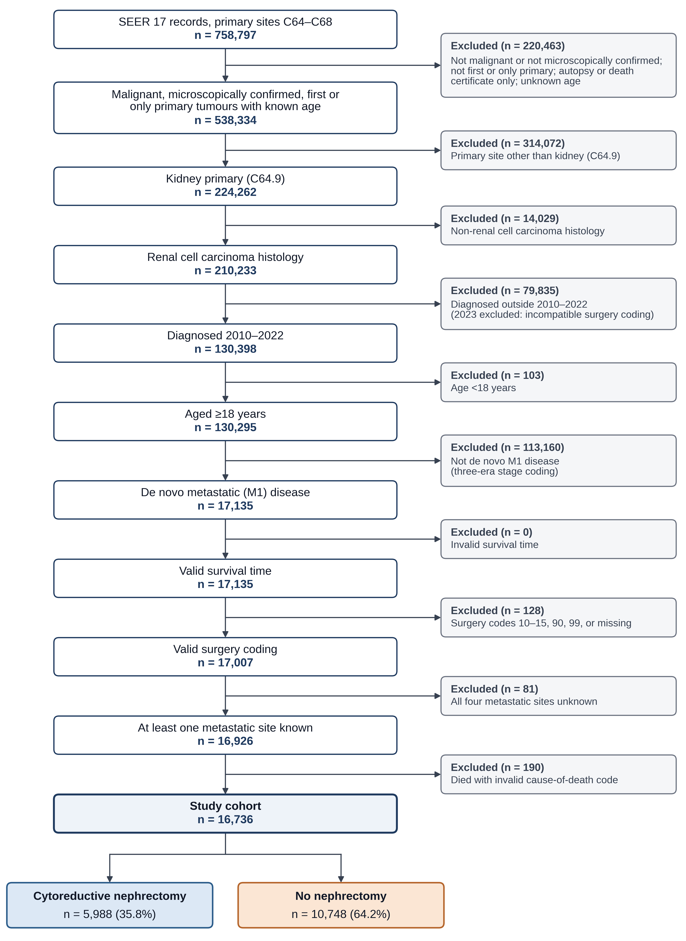
Fig. S1 Assembly of the study cohort. Selection of patients with de novo metastatic renal cell carcinoma from the SEER 17 registries, 2010–2022, with the number excluded at each step. The final exclusion (death with an uninterpretable cause-of-death code) depends on outcome information
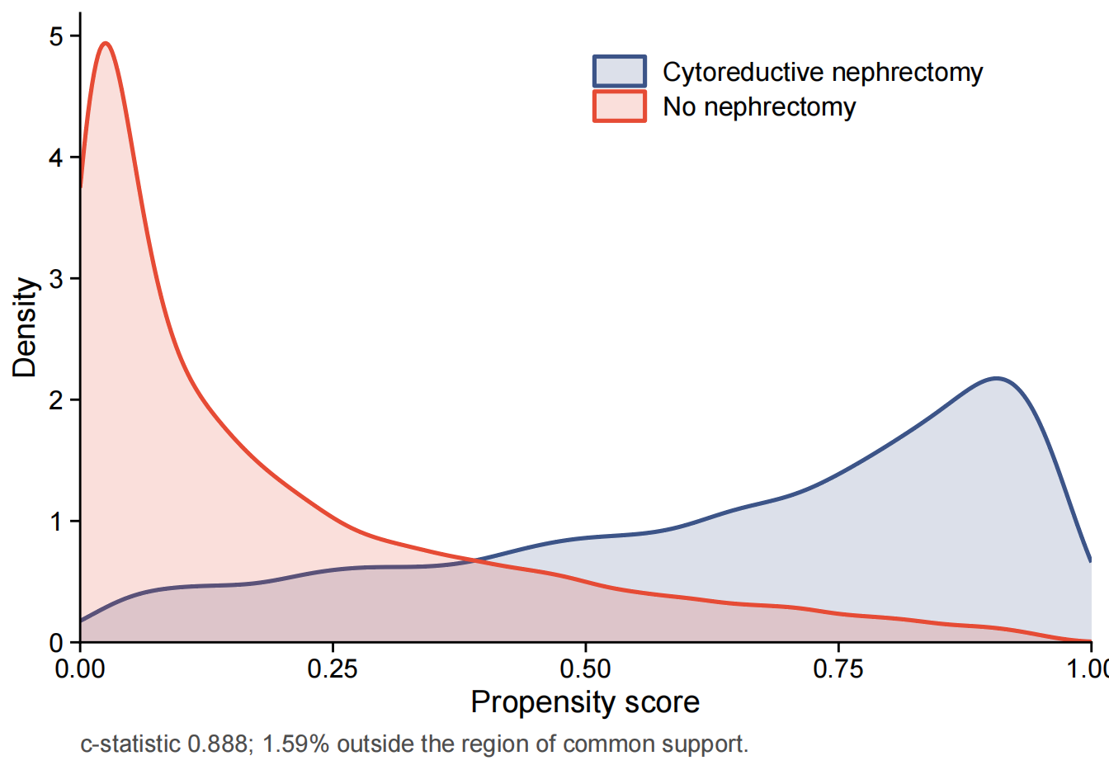
Fig. S2 Distribution of the propensity score by exposure group

Fig. S3 Covariate balance before and after overlap weighting. Absolute standardised mean differences for each covariate at the level with the largest unweighted difference; grade after imputation. The dashed line marks 0.10
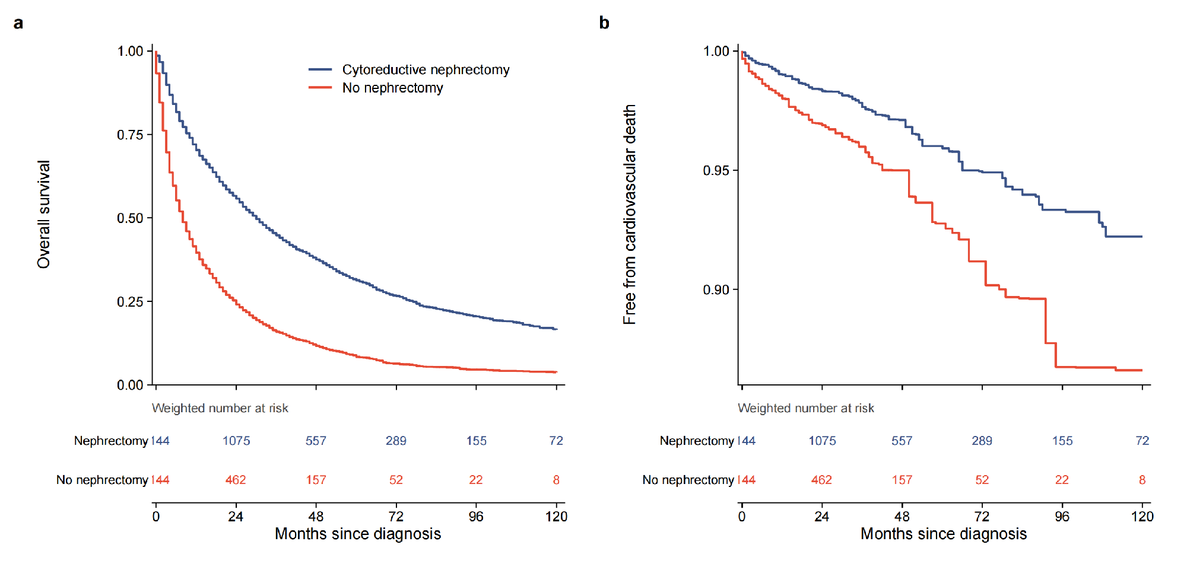
Fig. S4 Overlap-weighted survival by receipt of cytoreductive nephrectomy. (a) Overall survival. (b) Survival free of cardiovascular death, analysed as cause-specific with other deaths censored. Kaplan–Meier estimates weighted by overlap weights from the first imputed dataset; weighted numbers at risk are shown below each panel
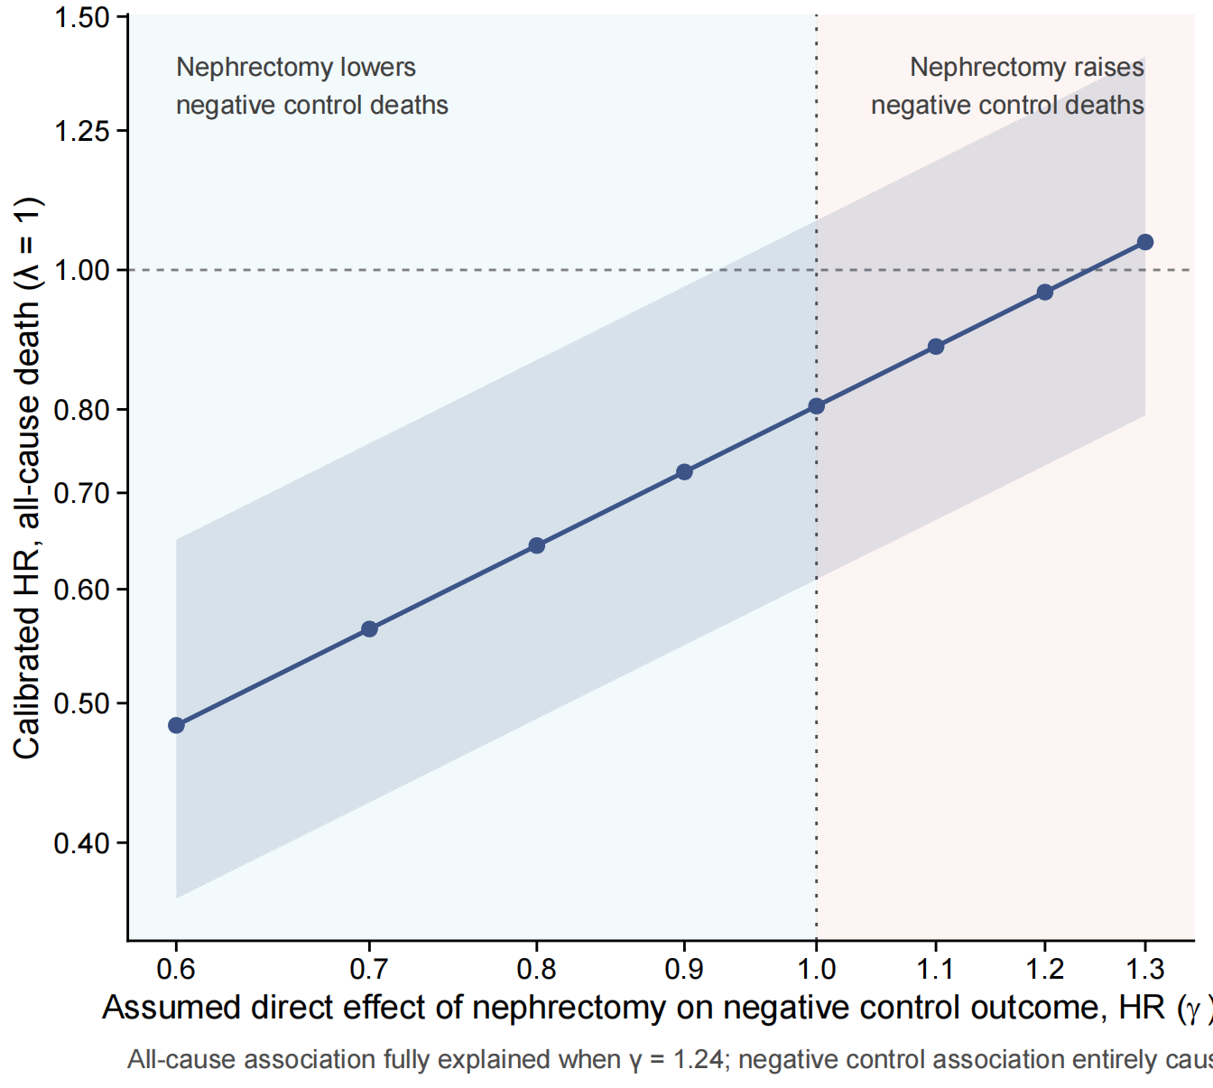
Fig. S5 Sensitivity to violation of the exclusion restriction. Calibrated hazard ratio for all-cause death at λ = 1 as a function of the assumed direct effect of nephrectomy on the negative control outcome (γ). γ < 1 represents a true reduction in cardiovascular death from nephrectomy and γ > 1 a true increase; the shaded band is the 95% bootstrap
confidence interval

Fig. S6 Negative control association within age strata. Point estimates; the dotted line marks the full-cohort estimate. The estimate for patients younger than 50 years rests on 10 events and is not interpreted

