Supplementary Information

An Ultra-Long-Acting Buprenorphine Prodrug Ion-Pair for Opioid Use Disorder

Ashrafi Sultana^{1,2}, Nam Thai Hoang Le², Mohammad Ullah Nayan², Brady Sillman², Sunday Ogundepo², Chen Zheng², Brandon W. Hanson², Suyash Deodhar², Xiaoqing Du³, Samuel M. Cohen⁴, Brian P. Kearney⁵, Alborz Yazdi⁵, Howard E. Gendelman^{2,3}, and Benson Edagwa² *
¹Department of Medical Sciences Interdepartmental Area Program, University of Nebraska Medical Center, Omaha, NE, 68198, USA
²Department of Pharmacology and Experimental Neuroscience, University of Nebraska Medical Center, Omaha, NE 68198, USA.
³Department of Pharmaceutical Sciences, University of Nebraska Medical Center, Omaha, NE 68198, USA.

⁴Department of Pathology, Microbiology, and Immunology, University of Nebraska Medical Center, Omaha, NE 68198, USA.
⁵Exavir Therapeutics Inc., San Francisco, CA, 94111, USA.
*Corresponding author: Benson Edagwa, Ph.D., Department of Pharmacology and Experimental Neuroscience, University of Nebraska Medical Center, Omaha, NE 68198-5880; phone 402 559 0856; fax 402 559 7495; email benson.edagwa@unmc.edu

This file contains the following information

- Supplementary Figures
- Supplementary Tables
Supplementary Figures

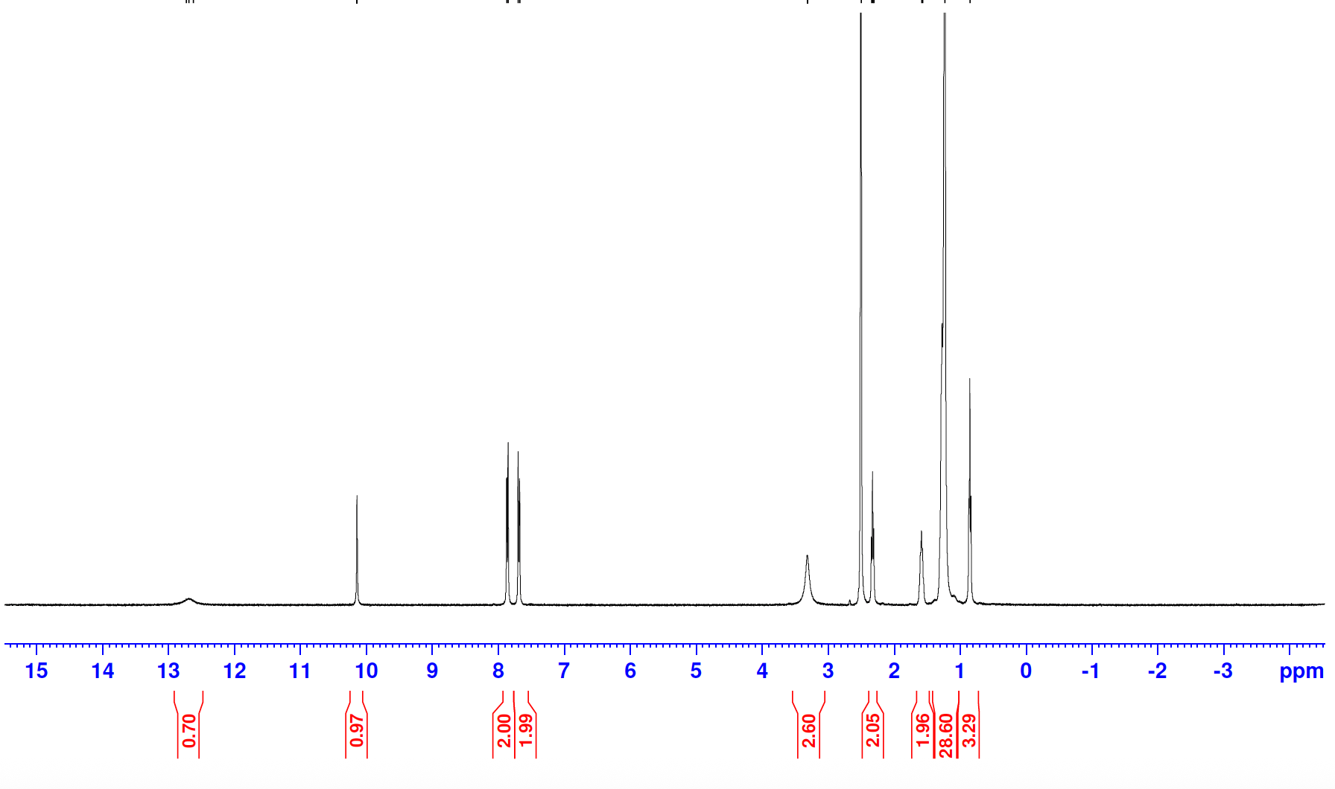

Supplementary Figure 1. Structural characterization and purity of 4-stearoylamidobenzoic acid. ¹H NMR spectra of 4-stearoylamidobenzoic acid. Experiments were repeated at least five independent times with equivalent results.
A)
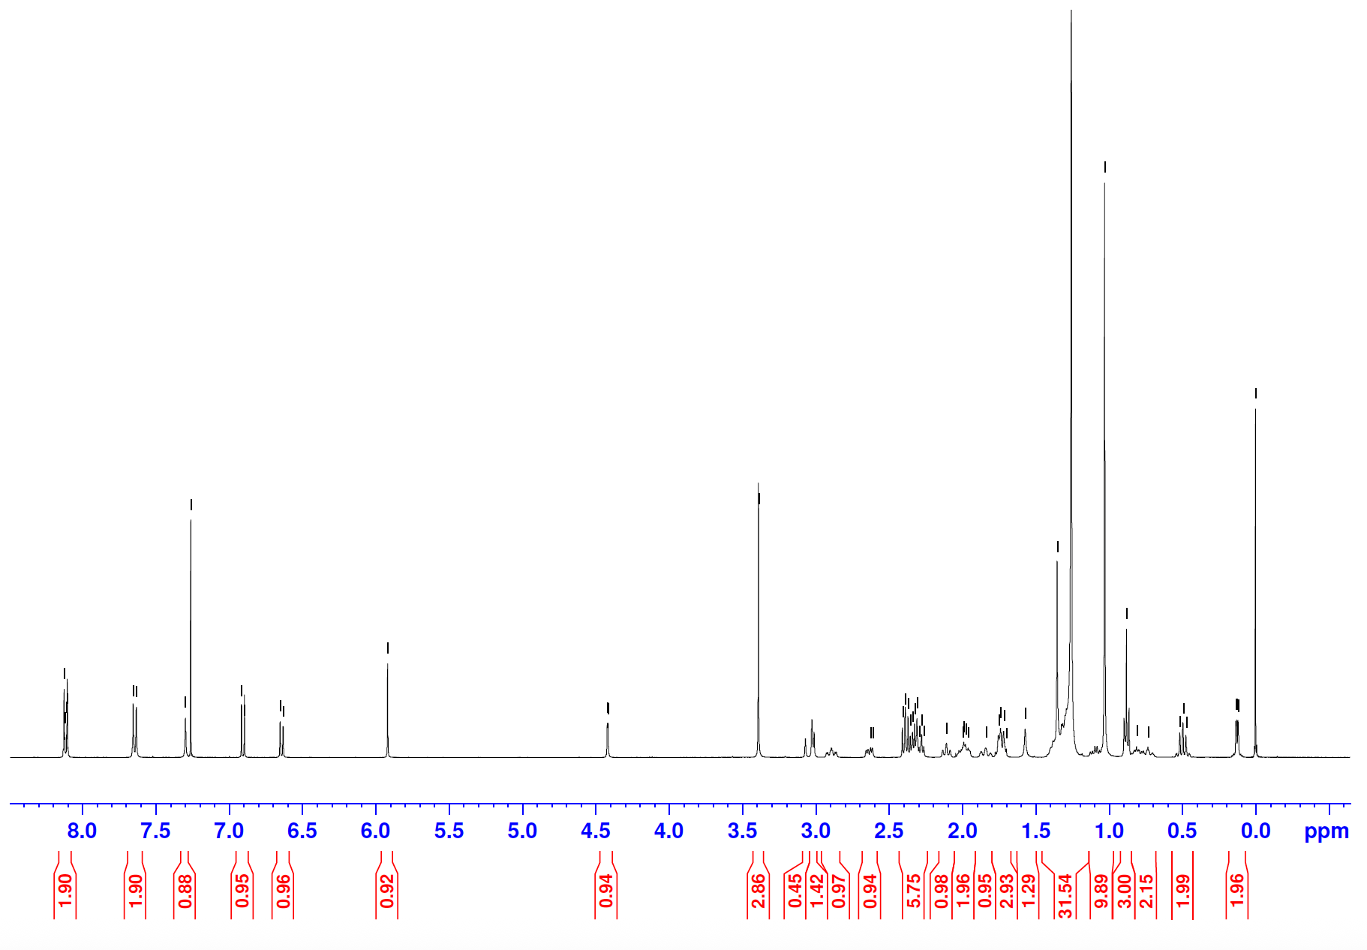
B)
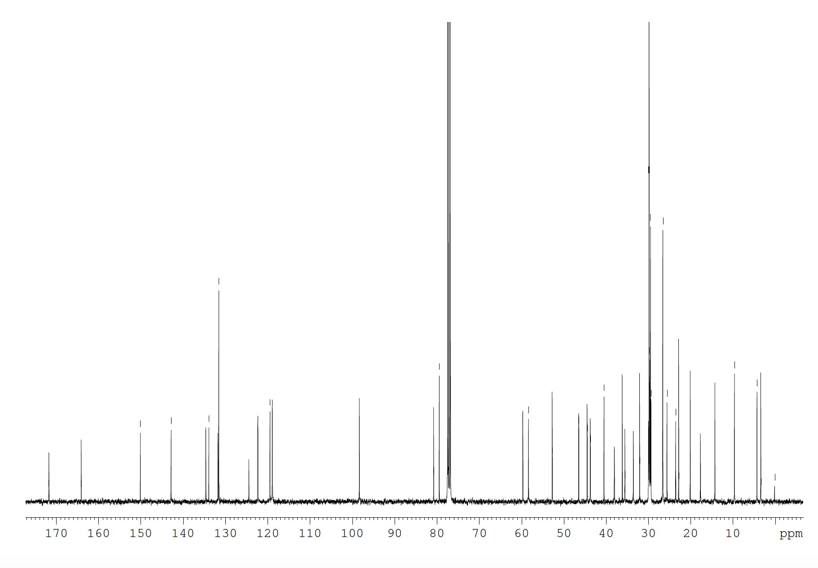
Supplementary Figure 2. Structural characterization and purity of M6BUP. (A) ¹H and (B) ¹³C NMR spectra of M6BUP. Experiments were repeated at least five independent times with equivalent results.
A)
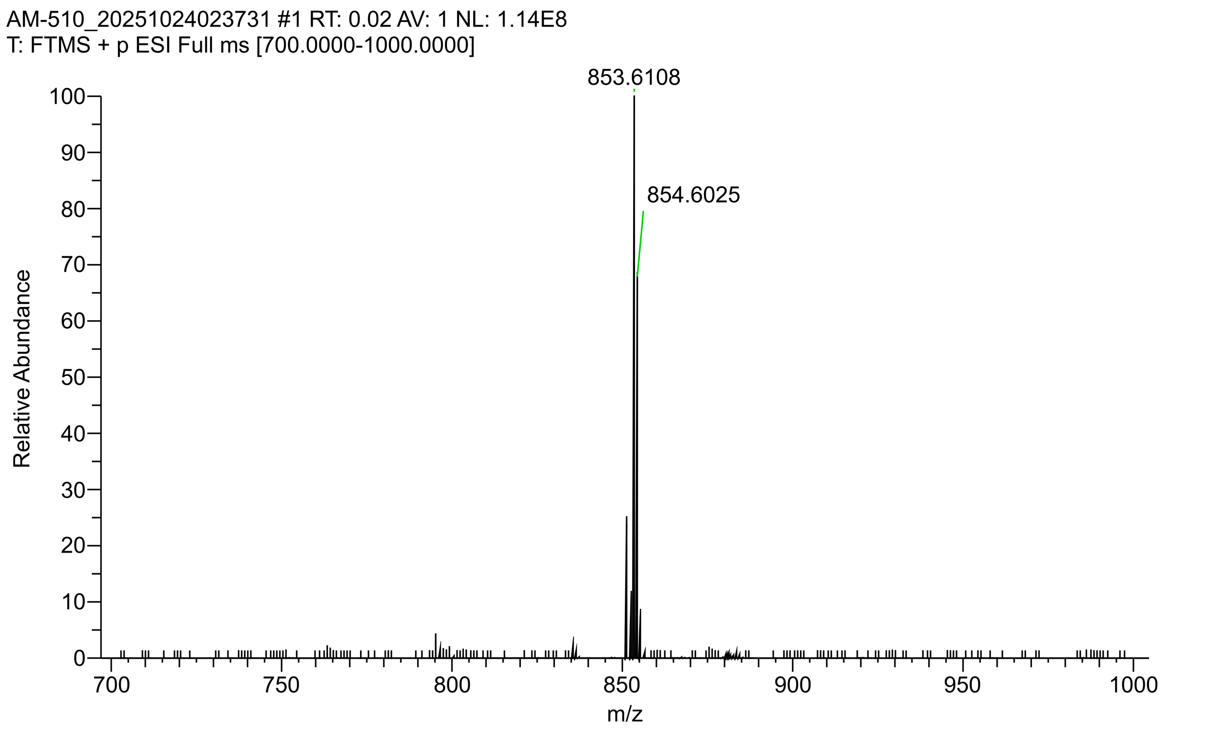
B)
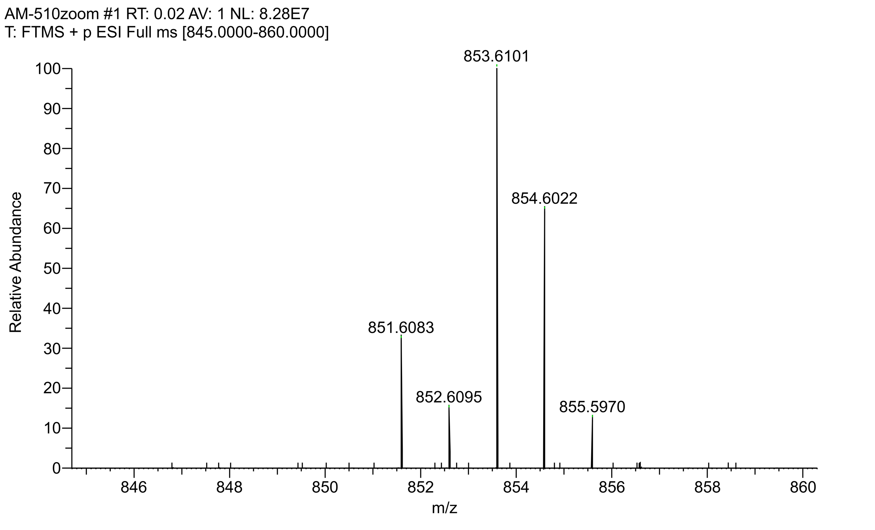

Supplementary Figure 3. ESI infusion of M6BUP. ESI infusion of M6BUP generated a strong signal at 853.6101 m/z; (A) infusion spectrum of M6BUP from m/z of 700-865; (B) enlarged spectrum for monoisotopic m/z determination. Experiments were repeated at least five times with equivalent results.

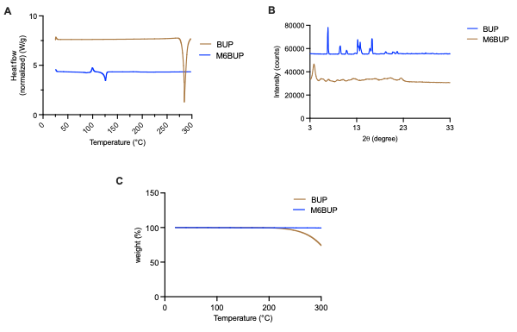

Supplementary Figure 4. Differential scanning calorimetry (DSC), X-ray diffraction (XRD) and thermal gravimetric analysis of BUP and M6BUP. (A) Differential scanning calorimetry (DSC) thermogram overlays of BUP and M6BUP determined changes in physical state with the temperature increase and (B) Overlay of X-ray diffraction (XRD) patterns of BUP and M6BUP powder at 2𝜃 = 2-70 at 1º/min.
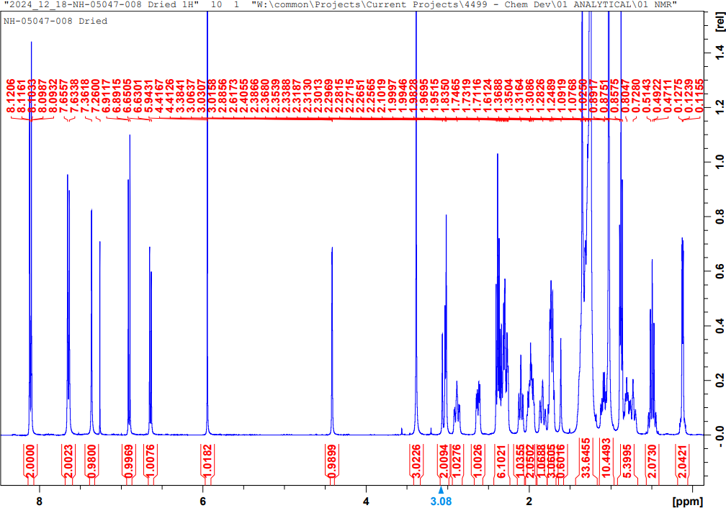
Supplementary Figure 5: ¹H NMR spectrum of M6BUP in CDCl₃

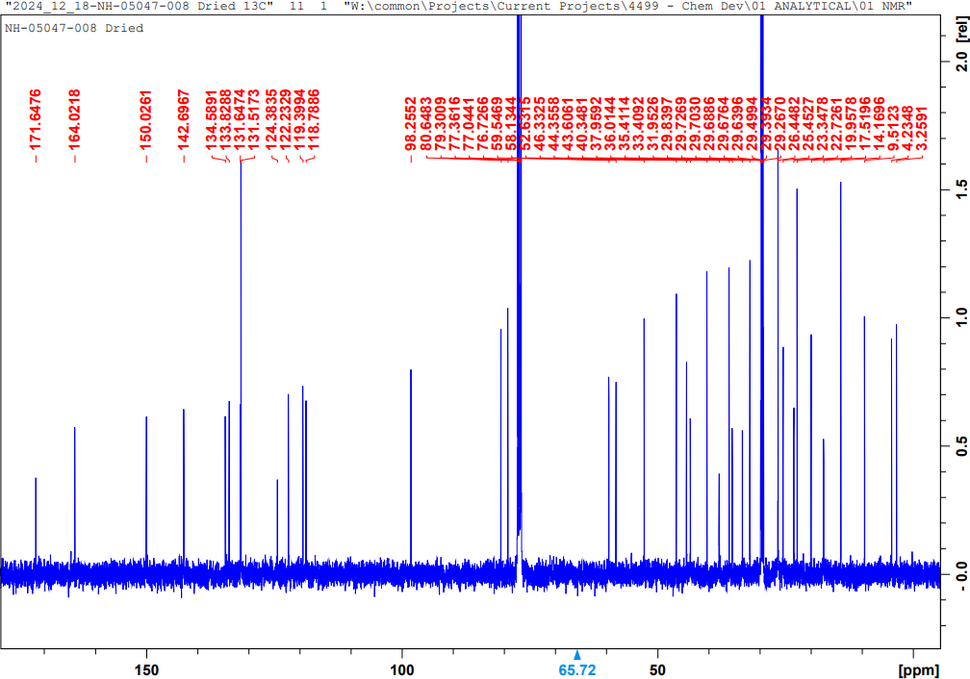

Supplementary Figure 6 : ¹³C NMR of M6BUP in CDCl₃
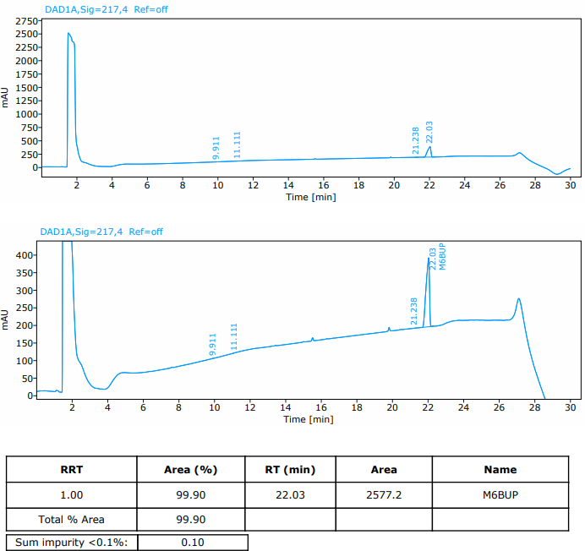

Supplementary Figure 7: M6BUP purity assessment by diode array detection

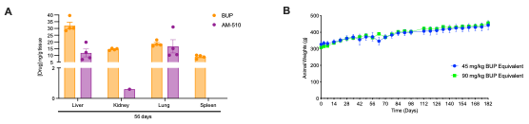

Supplementary Figure 8. Tolerability of NM6BUP in Sprague Dawley rats. A) Tissue BUP and M6BUP levels at day 56 after a single IM injection of either 45 or 90 mg/kg BUP equivalent dose of NM6BUP nanosuspension. Drug levels were quantified by UPLC-MS/MS and results are expressed as mean ± SEM with n=4. B) Body weights of male SD rats treated with either 45 or 90 mg/kg BUP equivalent single IM dose over 182 days. Results are expressed as mean ± SEM with n=4.

A)
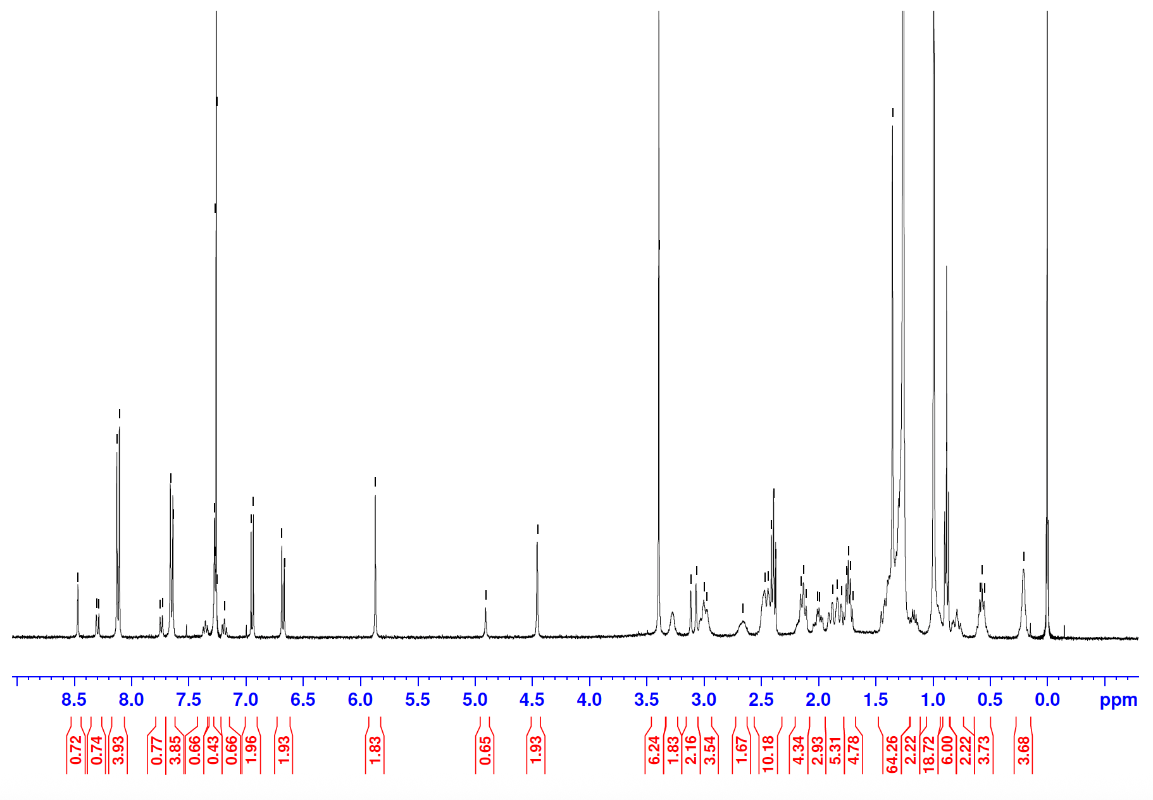
B)
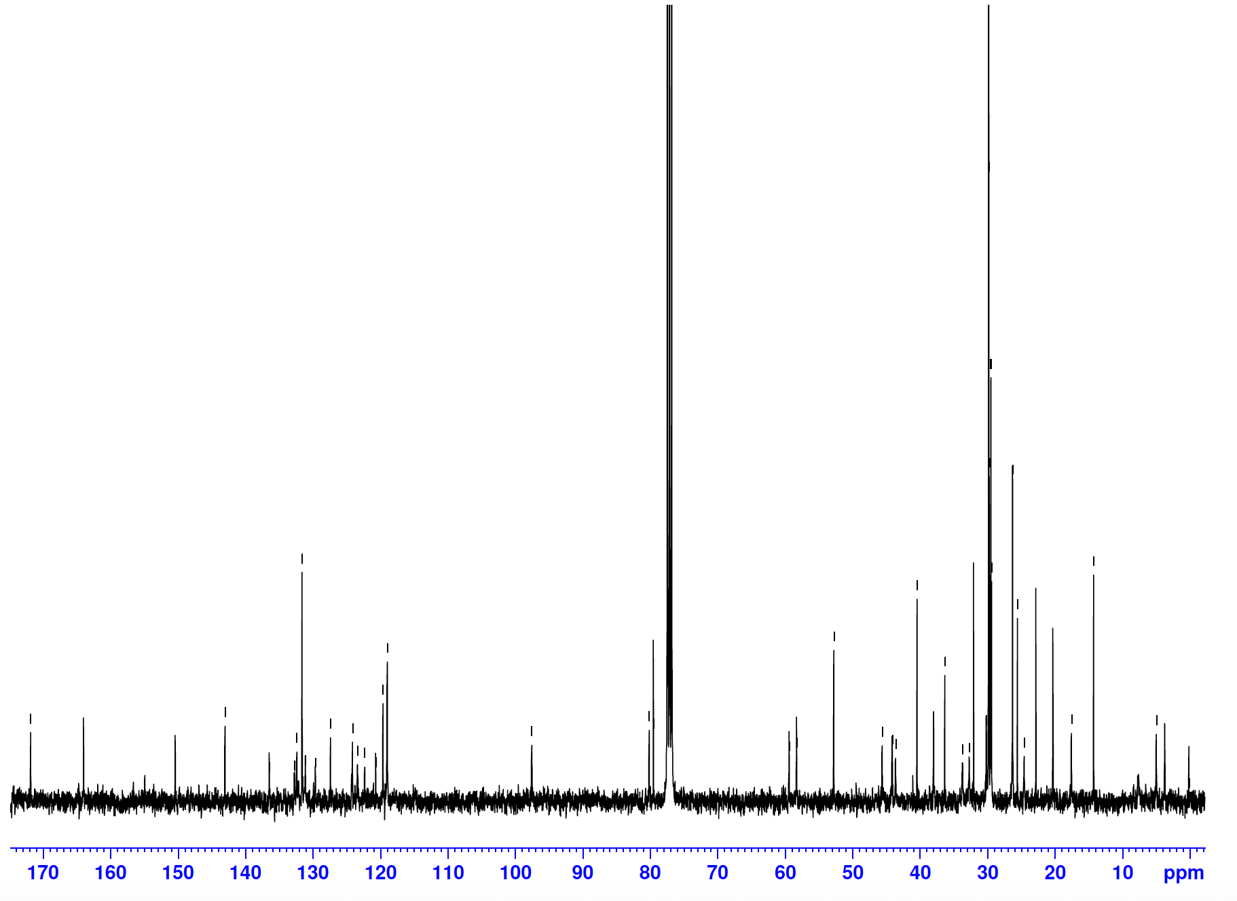
Supplementary Figure 9. Structural characterization and purity of M6BUP-Pamoate ion pair. (A) ¹H and (B) ¹³C NMR spectra of the salt in deuterated DMSO. Experiments were repeated at least five independent times with equivalent results.

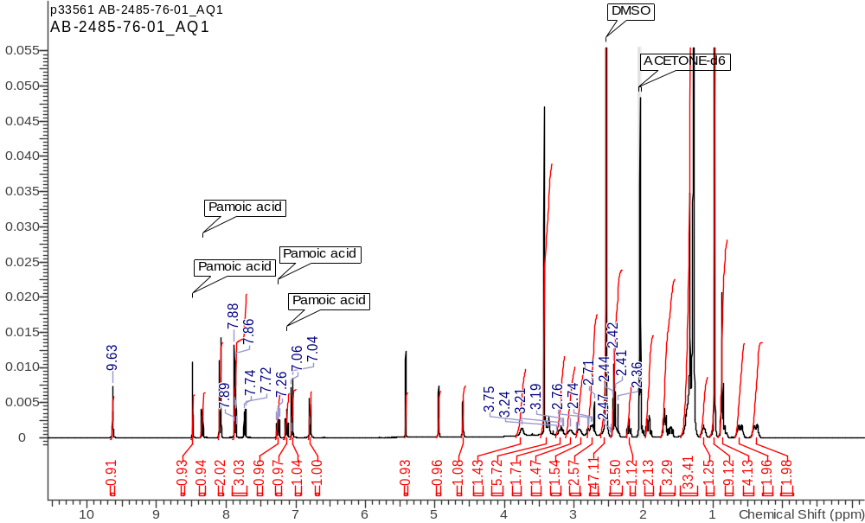

Supplementary Figure 10: ¹H NMR spectrum of scaled up M6BUP-Pamonte salt

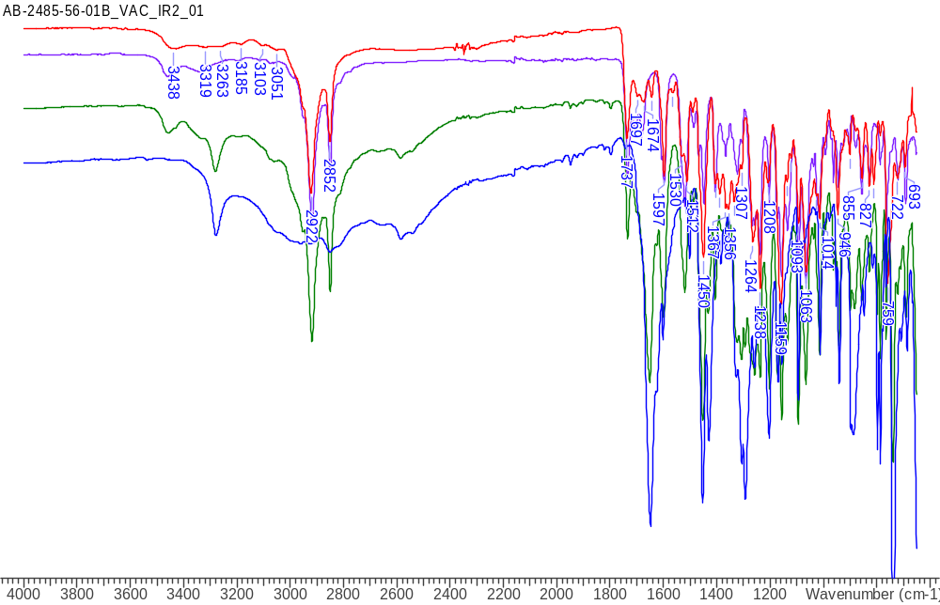

Supplementary Figure 11: Overlay of FT-IR Spectra of M6BUP-Pamoate: Peaks at 3280 cm⁻¹
(–OH stretching of pamoic acid) and 1652 cm⁻¹(-C=O of pamoic acid) are absent in the red trace suggesting salt formation.

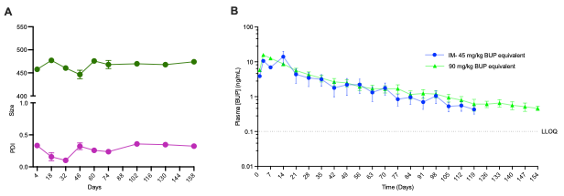
C

Dose (mg/kg  BUP Eq) | C_{max} | T_{max} | T_{1/2} | AUC _{0–∞} | MRT_{0–∞} | R²_{adjusted}
45 | 16.3 ± 4.9 | 8.5  (3-14) | 41.2  (288-54.0) | 377.4 ± 114.8 | 41.7  (38.6- 51.0) | 0.85  (0.7- 0.94)
90 | 15.8 ± 0.83 | 3  (3-3) | 46.6  (40.0- 49.8) | 453.5 ± 63.3 | 47.5  (43.4- 54.1) | 0.95  (0.8- 0.97)

Supplementary Figure 12. NM6BUP-Pamoate_{high concentration} formulation stability and plasma pharmacokinetics in Sprague Dawley rats. A) Particle sizes and polydispersity indices (PDIs) of the formulation were measured by dynamic light scattering (DLS) during formulation storage at room temperature for 158 days. The formulations were prepared using tween 20 and PEG3350 stabilizing surfactants at a drug concentration of 302 mg/ml. B) Plasma concentration of BUP following a single IM injection of NM6BUP-Pamoate_{high concentraiton} at 45 or 90 mg/kg BUP-equivalent dose. Drug levels were quantified by UPLC-MS/MS and results are expressed as mean ± SEM with n=4. C) Non-compartmental PK parameters after a single IM injection of NM6BUP-Pamoate_{high concentraiton} at 45 or 90 mg/kg BUP-equivalent dose. C_{max}, peak plasma concentration; T_{max}, time to C_{max}; T_{½}, elimination half-life; AUC_{₀–∞}, area under the concentration–time curve; MRT_{₀–∞}, mean residence time. Data are expressed as mean ± SEM for C_{max} and AUC_{₀–∞} and, as median (minimum–maximum) for for T_{max}, T_{½}, MRT_{₀–∞}, and R²_{adjusted}.

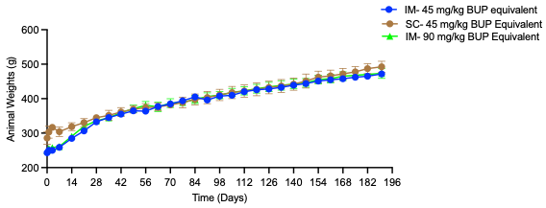
Supplementary Figure 13. Tolerability of NM6BUP-Pamoate in Sprague Dawley rats. Body weights of SD rats following a single IM (45 or 90 mg/kg BUP-equivalent) or SC (45 mg/kg BUP-equivalent) injection of NM6BUP-Pamoate into Sprague-Dawley rats (n = 4 animals/group). Results are expressed as mean ± SEM.

Supplementary Table 1: M6BUP off-target toxicity assessment using a cell-based functional panel that comprised 78 human-relevant targets. M6BUP was profiled in a cell-based, functional panel (SAFETYscan E/IC50 ELECT – 78) that comprised 78 human-relevant targets (GPCRs, ion channels, kinases, nuclear hormone receptors, other enzymes, and transporters) to assess off-target activity and the risk of clinical adverse drug reactions (ADRs). M6BUP did not exhibit agonism, antagonism, inhibition or activation of any target.

Target Class | Assay Name | Assay Target | Mode | Reference Compound | Result Type | RC50 (µM)
 |  |  |  |  |  | BUP | M6BUP | Reference Compound
GPCR | Calcium Flux | ADORA2A | Agonist | NECA | EC50 | >10 | >10 | 0.01418
GPCR | Calcium Flux | ADRA1A | Agonist | A 61603 Hydrobromide | EC50 | >10 | >10 | 0.00005
GPCR | Calcium Flux | AVPR1A | Agonist | [Arg8]-Vasopressin | EC50 | >10 | >10 | 0.00022
GPCR | Calcium Flux | CCKAR | Agonist | Sincalide | EC50 | >10 | >10 | 0.00007
GPCR | Calcium Flux | CHRM1 | Agonist | Acetylcholine chloride | EC50 | >10 | >10 | 0.02216
GPCR | Calcium Flux | CHRM3 | Agonist | Acetylcholine chloride | EC50 | >10 | >10 | 0.02216
GPCR | Calcium Flux | EDNRA | Agonist | Endothelin 1 | EC50 | >10 | >10 | 0.00189
GPCR | Calcium Flux | HRH1 | Agonist | Histamine | EC50 | >10 | >10 | 0.01231
GPCR | Calcium Flux | HTR2A | Agonist | Serotonin Hydrochloride | EC50 | >10 | >10 | 0.00731
GPCR | Calcium Flux | HTR2B | Agonist | Serotonin Hydrochloride | EC50 | >10 | >10 | 0.00731
GPCR | Calcium Flux | ADORA2A | Antagonist | NECA | IC50 | >10 | >10 | 0.01418
GPCR | Calcium Flux | ADRA1A | Antagonist | A 61603 Hydrobromide | IC50 | >10 | >10 | 0.00005
GPCR | Calcium Flux | AVPR1A | Antagonist | [Arg8]-Vasopressin | IC50 | >10 | >10 | 0.00022
GPCR | Calcium Flux | CCKAR | Antagonist | Sincalide | IC50 | >10 | >10 | 0.00007
GPCR | Calcium Flux | CHRM1 | Antagonist | Acetylcholine chloride | IC50 | >10 | >10 | 0.02216
GPCR | Calcium Flux | CHRM3 | Antagonist | Acetylcholine chloride | IC50 | >10 | >10 | 0.02216
GPCR | Calcium Flux | EDNRA | Antagonist | Endothelin 1 | IC50 | >10 | >10 | 0.00189
GPCR | Calcium Flux | HRH1 | Antagonist | Histamine | IC50 | >10 | >10 | 0.01231
GPCR | Calcium Flux | HTR2A | Antagonist | Serotonin Hydrochloride | IC50 | >10 | >10 | 0.00731
GPCR | Calcium Flux | HTR2B | Antagonist | Serotonin Hydrochloride | IC50 | >10 | >10 | 0.00731
GPCR | cAMP | ADRA2A | Agonist | UK 14304 | EC50 | >10 | >10 | 0.00006
GPCR | cAMP | ADRB1 | Agonist | (-)-Isoproterenol | EC50 | >10 | >10 | 0.00077
GPCR | cAMP | ADRB2 | Agonist | (-)-Isoproterenol | EC50 | >10 | >10 | 0.00077
GPCR | cAMP | CHRM2 | Agonist | Acetylcholine chloride | EC50 | >10 | >10 | 0.02216
GPCR | cAMP | CNR1 | Agonist | CP 55940 | EC50 | >10 | >10 | 0.00002
GPCR | cAMP | CNR2 | Agonist | CP 55940 | EC50 | >10 | >10 | 0.00002
GPCR | cAMP | DRD1 | Agonist | Dopamine | EC50 | >10 | >10 | 0.06478
GPCR | cAMP | DRD2S | Agonist | Dopamine | EC50 | >10 | >10 | 0.06478
GPCR | cAMP | HRH2 | Agonist | Histamine | EC50 | >10 | >10 | 0.01231
GPCR | cAMP | HTR1A | Agonist | Serotonin Hydrochloride | EC50 | >10 | >10 | 0.00731
GPCR | cAMP | HTR1B | Agonist | Serotonin Hydrochloride | EC50 | >10 | >10 | 0.00731
GPCR | cAMP | OPRD1 | Agonist | DADLE | EC50 | >10 | 0.26776 | 0.00009
GPCR | cAMP | OPRK1 | Agonist | Dynorphin A (1-17) | EC50 | >10 | >10 | 0.01802
GPCR | cAMP | OPRM1 | Agonist | DAMGO | EC50 | >10 | 0.25558 | 0.0037
GPCR | cAMP | ADRA2A | Antagonist | UK 14304 | IC50 | >10 | >10 | 0.00006
GPCR | cAMP | ADRB1 | Antagonist | (-)-Isoproterenol | IC50 | >10 | >10 | 0.00077
GPCR | cAMP | ADRB2 | Antagonist | (-)-Isoproterenol | IC50 | >10 | >10 | 0.00077
GPCR | cAMP | CHRM2 | Antagonist | Acetylcholine chloride | IC50 | >10 | >10 | 0.02216
GPCR | cAMP | CNR1 | Antagonist | CP 55940 | IC50 | >10 | >10 | 0.00002
GPCR | cAMP | CNR2 | Antagonist | CP 55940 | IC50 | >10 | >10 | 0.00002
GPCR | cAMP | DRD1 | Antagonist | Dopamine | IC50 | >10 | >10 | 0.06478
GPCR | cAMP | DRD2S | Antagonist | Dopamine | IC50 | >10 | >10 | 0.06478
GPCR | cAMP | HRH2 | Antagonist | Histamine | IC50 | >10 | >10 | 0.01231
GPCR | cAMP | HTR1A | Antagonist | Serotonin Hydrochloride | IC50 | >10 | >10 | 0.00731
GPCR | cAMP | HTR1B | Antagonist | Serotonin Hydrochloride | IC50 | >10 | >10 | 0.00731
GPCR | cAMP | OPRD1 | Antagonist | DADLE | IC50 | >10 | >10 | 0.00009
GPCR | cAMP | OPRK1 | Antagonist | Dynorphin A (1-17) | IC50 | >0.06481 | 9.24251 | 0.01802
GPCR | cAMP | OPRM1 | Antagonist | DAMGO | IC50 | >10 | >10 | 0.0037
Ion Channel | Ion Channel | CAV1.2 | Blocker | Isradipine | IC50 | >10 | >10 | 0.01234
Ion Channel | Ion Channel | GABAA | Blocker | Picrotoxin | IC50 | >10 | >10 | 2.54719
Ion Channel | Ion Channel | hERG | Blocker | Astemizole | IC50 | >10 | >10 | 0.29148
Ion Channel | Ion Channel | HTR3A | Blocker | Bemesetron | IC50 | >10 | >10 | 0.00202
Ion Channel | Ion Channel | KvLQT1/minK | Blocker | XE 991 | IC50 | >10 | >10 | 0.44511
Ion Channel | Ion Channel | nAChR(a4/b2) | Blocker | Dihydro-ß-erythroidine | IC50 | >10 | >10 | 0.70097
Ion Channel | Ion Channel | NAV1.5 | Blocker | Lidocaine Hydrochloride | IC50 | >10 | >10 | 35.64748
Ion Channel | Ion Channel | NMDAR (1A/2B) | Blocker | (+)-MK 801 | IC50 | >10 | >10 | 0.0242
Ion Channel | Ion Channel | GABAA | Opener | Picrotoxin | EC50 | >10 | >10 | 2.54719
Ion Channel | Ion Channel | HTR3A | Opener | Bemesetron | EC50 | >10 | >10 | 0.00202
Ion Channel | Ion Channel | KvLQT1/minK | Opener | XE 991 | EC50 | >10 | >10 | 0.44511
Ion Channel | Ion Channel | nAChR(a4/b2) | Opener | Dihydro-ß-erythroidine | EC50 | >10 | >10 | 0.70097
Ion Channel | Ion Channel | NMDAR (1A/2B) | Opener | (+)-MK 801 | EC50 | >10 | >10 | 0.0242
Kinases | Binding | INSR | Inhibitor | BMS-754807 | IC50 | >10 | >10 | 0.00041
Kinases | Binding | LCK | Inhibitor | Gleevec | IC50 | >10 | >10 | 0.01653
Kinases | Binding | ROCK1 | Inhibitor | Staurosporine | IC50 | >10 | >10 | 0.00052
Kinases | Binding | VEGFR2 | Inhibitor | SU-11248 | IC50 | >10 | >10 | 0.00019
NHR | NHR Nuclear Translocation | AR | Agonist | BMS-564929 | EC50 | >10 | >10 | 0.00205
NHR | NHR Nuclear Translocation | AR | Antagonist | BMS-564929 | IC50 | >10 | >10 | 0.00205
NHR | NHR Protein Interaction | GR | Agonist | Dexamethasone | EC50 | >10 | >10 | 0.02999
NHR | NHR Protein Interaction | GR | Antagonist | Dexamethasone | IC50 | >10 | >10 | 0.02999
Non-Kinase Enzymes | Enzymatic | AChE | Inhibitor | Physostigmine | IC50 | >10 | >10 | 0.03212
Non-Kinase Enzymes | Enzymatic | COX1 | Inhibitor | Indomethacin | IC50 | >0.53338 | >10 | 0.04047
Non-Kinase Enzymes | Enzymatic | COX2 | Inhibitor | NS-398 | IC50 | >0.21235 | >10 | 0.16833
Non-Kinase Enzymes | Enzymatic | MAOA | Inhibitor | Clorgyline | IC50 | >10 | >10 | 0.00204
Non-Kinase Enzymes | Enzymatic | PDE3A | Inhibitor | Cilostamide | IC50 | >10 | >10 | 0.11331
Non-Kinase Enzymes | Enzymatic | PDE4D2 | Inhibitor | Cilomilast | IC50 | >10 | >10 | 0.03623
Transporter | Transporter | DAT | Blocker | GBR 12909 | IC50 | >10 | >10 | 0.00102
Transporter | Transporter | NET | Blocker | Desipramine | IC50 | >10 | >10 | 0.03048
Transporter | Transporter | SERT | Blocker | Clomipramine | IC50 | >10 | >10 | 0.00342

Supplementary Table 2: Serum Chemistry of NM6BUP-treated Sprague Dawley rats. Serum chemistry profiles were evaluated on days 3, 56, and 182 following a single IM injection of NM6BUP at 45 or 90 mg/kg BUP-equivalent dose and compared with age-matched, untreated control SD rats. Results are reported as Mean ± SEM with n=4.

Treatment | NM6BUP |  |  |  |  |  |  |  |  |  |  |  | Control
Dose | 45 mg/kg BUP equivalent |  |  |  |  |  | 90 mg/kg BUP equivalent
Day | 3 |  | 56 |  | 182 |  | 3 |  | 63 |  | 182 |  | 3
n | Mean | SEM | Mean | SEM | Mean | SEM | Mean | SEM | Mean | SEM | Mean | SEM | Mean | SEM
ALB (g/dL) | 4.5 | 0.1 | 4.4 | 0.2 | 4.5 | 0.1 | 4.2 | 0.1 | 5.1 | 0.2 | 4.9 | 0.1 | 5.0 | 0.1
ALP (U/L) | 268.3 | 50.2 | 165.3 | 21.3 | 223.0 | 9.0 | 424.7 | 69.2 | 316.7 | 10.9 | 259.3 | 14.1 | 571.7 | 74.3
ALT (U/L) | 65.0 | 0.6 | 50.0 | 2.6 | 72.0 | 9.5 | 90.3 | 13.0 | 62.0 | 5.6 | 52.4 | 2.0 | 71.7 | 11.8
AMY (U/L) | 738.0 | 42.0 | 766.7 | 22.1 | 785.0 | 27.9 | 610.0 | 29.7 | 768.7 | 35.9 | 793.8 | 43.8 | 848.3 | 45.2
TBIL (mg/dL) | 0.2 | 0.0 | 0.2 | 0.0 | 0.3 | 0.0 | 0.3 | 0.0 | 0.2 | 0.0 | 0.2 | 0.0 | 0.3 | 0.0
BUN (mg/dL) | 13.7 | 0.9 | 14.0 | 1.2 | 15.0 | 0.6 | 20.3 | 3.8 | 17.7 | 1.8 | 18.3 | 2.7 | 17.0 | 2.1
Ca (mg/dL) | 11.1 | 0.1 | 10.6 | 0.2 | 10.8 | 0.1 | 12.7 | 0.2 | 10.7 | 0.2 | 10.8 | 0.2 | 11.5 | 0.1
PHOS (mg/dL) | 8.5 | 0.2 | 6.3 | 0.3 | 5.9 | 0.1 | 11.4 | 0.6 | 7.6 | 0.2 | 7.5 | 0.3 | 10.6 | 0.3
CRE (mg/dL) | 0.3 | 0.1 | 0.4 | 0.1 | 0.4 | 0.0 | 0.4 | 0.1 | 0.6 | 0.1 | 0.7 | 0.2 | 0.3 | 0.0
GLU (mg/dL) | 171.0 | 6.4 | 180.3 | 8.8 | 184.7 | 3.5 | 173.3 | 7.7 | 168.3 | 6.8 | 164.0 | 5.3 | 199.3 | 11.2
Na+ (mmol/L) | 142.3 | 0.3 | 141.0 | 0.6 | 141.0 | 1.0 | 148.7 | 1.5 | 137.3 | 3.0 | 135.0 | 0.5 | 144.3 | 0.9
K+ (mmol/L) | 6.5 | 0.2 | 6.5 | 0.2 | 6.1 | 0.2 | 7.0 | 0.4 | 7.5 | 0.3 | 7.7 | 0.4 | 7.7
TP (g/dL) | 6.0 | 0.1 | 6.0 | 0.2 | 6.3 | 0.1 | 6.2 | 0.1 | 6.5 | 0.1 | 6.6 | 0.1 | 6.3 | 0.0
GLOB (g/dL) | 1.4 | 0.1 | 1.6 | 0.1 | 1.8 | 0.1 | 2.0 | 0.1 | 1.3 | 0.1 | 1.8 | 0.2 | 1.3 | 0.1
* ALB, albumin (g/dL); ALP, alkaline phosphatase (U/L); ALT, alanine aminotransferase (U/L); AMY, amylase (U/L); TBIL, total bilirubin (mg/dL); BUN, blood urea nitrogen (mg/dL); Ca, calcium (mg/dL); PHOS, phosphorus (mg/dL); CRE, creatinine (mg/dL); GLU, glucose (mg/dL); Na⁺, sodium (mmol/L); K⁺, potassium (mmol/L); TP, total protein (g/dL); GLOB, globulin (g/dL)

Supplementary Table 3: Serum Chemistry of NM6BUP-Pamoate-treated Sprague Dawley rats. Serum chemistry profiles were evaluated on days 3, 56, and 182 following a single IM (45 or 90 mg/kg BUP-equivalent) or SC (45 mg/kg BUP-equivalent) injection of the formulation into Sprague-Dawley rats (n = 4 animals/group) and compared with age-matched, untreated control SD rats.

Treatment | NM6BUP-Pamoate |  |  |  |  |  |  |  |  |  |  |  | Control
Dose | 45 mg/kg BUP equivalent |  |  |  |  |  | 90 mg/kg BUP equivalent
Day | 3 |  | 63 |  | 182 |  | 3 |  | 63 |  | 182 |  | 3
 | Mean | SEM | Mean | SEM | Mean | SEM | Mean | SEM | Mean | SEM | Mean | SEM | Mean | SEM
ALB (g/dL) | 4.4 | 0.1 | 4.3 | 0.2 | 4.4 | 0.1 | 4.2 | 0.1 | 5.0 | 0.2 | 4.8 | 0.1 | 4.9 | 0.1
ALP (U/L) | 260.9 | 49.6 | 160.8 | 20.7 | 220.6 | 8.8 | 415.2 | 67.7 | 309.4 | 10.6 | 252.2 | 13.9 | 565.2 | 73.0
ALT (U/L) | 63.3 | 0.6 | 48.5 | 2.6 | 70.5 | 9.3 | 88.1 | 12.6 | 60.3 | 5.5 | 51.3 | 2.0 | 69.7 | 11.5
AMY (U/L) | 719.2 | 40.7 | 747.4 | 21.4 | 770.0 | 27.1 | 592.0 | 29.3 | 746.8 | 34.9 | 782.5 | 42.9 | 831.8 | 43.9
TBIL (mg/dL) | 0.2 | 0.0 | 0.2 | 0.0 | 0.3 | 0.0 | 0.3 | 0.0 | 0.2 | 0.0 | 0.2 | 0.0 | 0.3 | 0.0
BUN (mg/dL) | 13.3 | 0.9 | 13.8 | 1.2 | 14.7 | 0.6 | 20.0 | 3.7 | 17.3 | 1.8 | 18.0 | 2.7 | 16.8 | 2.1
Ca (mg/dL) | 10.8 | 0.1 | 10.4 | 0.2 | 10.7 | 0.1 | 12.5 | 0.2 | 10.5 | 0.2 | 10.6 | 0.2 | 11.2 | 0.1
PHOS (mg/dL) | 8.4 | 0.2 | 6.1 | 0.3 | 5.7 | 0.1 | 11.3 | 0.6 | 7.4 | 0.2 | 7.4 | 0.3 | 10.3 | 0.3
CRE (mg/dL) | 0.3 | 0.1 | 0.4 | 0.1 | 0.4 | 0.0 | 0.4 | 0.1 | 0.6 | 0.1 | 0.7 | 0.2 | 0.3 | 0.0
GLU (mg/dL) | 167.6 | 6.3 | 177.0 | 8.6 | 179.3 | 3.4 | 168.4 | 7.6 | 165.2 | 6.6 | 162.0 | 5.2 | 196.0 | 11.0
Na+ (mmol/L) | 140.6 | 0.3 | 138.9 | 0.6 | 138.9 | 1.0 | 146.7 | 1.5 | 133.5 | 2.9 | 133.0 | 0.5 | 142.1 | 0.9
K+ (mmol/L) | 6.3 | 0.2 | 6.3 | 0.2 | 5.9 | 0.2 | 6.9 | 0.4 | 7.3 | 0.3 | 7.5 | 0.4 | 7.5 | 0.0
TP (g/dL) | 5.8 | 0.1 | 5.9 | 0.2 | 6.2 | 0.1 | 6.1 | 0.1 | 6.4 | 0.1 | 6.4 | 0.1 | 6.1 | 0.0
GLOB (g/dL) | 1.4 | 0.1 | 1.6 | 0.1 | 1.8 | 0.1 | 2.0 | 0.1 | 1.3 | 0.1 | 1.8 | 0.2 | 1.3 | 0.1

* ALB, albumin (g/dL); ALP, alkaline phosphatase (U/L); ALT, alanine aminotransferase (U/L); AMY, amylase (U/L); TBIL, total bilirubin (mg/dL); BUN, blood urea nitrogen (mg/dL); Ca, calcium (mg/dL); PHOS, phosphorus (mg/dL); CRE, creatinine (mg/dL); GLU, glucose (mg/dL); Na⁺, sodium (mmol/L); K⁺, potassium (mmol/L); TP, total protein (g/dL); GLOB, globulin (g/dL)

Supplementary Table 4: Statistical significance correlation of non-compartmental pharmacokinetic parameters for NM6BUP. Non-compartmental pharmacokinetic parameters were derived from plasma BUP concentrations after a single IM injection of NM6BUP at 45 or 90 mg/kg BUP-equivalent dose. Group comparisons were performed using unpaired two-tailed t-test with welch’s correction (α= 0.05, **p<0.01. C_{max} and AUC_{0–∞} were log-transformed prior to statistical analysis. Statistical significance is denoted as p < 0.05 (*), < 0.01 (**), < 0.001 (***), and < 0.0001 (****); ns, not significant.

PK Parameter | IM-45- vs IM-90- mg/kg BUP equivalent
 | P value | P value summary
Cmax (ng/mL) | 0.0016 | **
Tmax (Day) | 0.2768 | ns
T1/2 (Day) | 0.0765 | ns
AUC _{0–∞} (ng) | 0.0012 | **
MRT_{0–∞} (Day) | 0.0405 | *

Supplementary Table 5. Statistical comparison of non-compartmental pharmacokinetic parameters of NM6BUP-Pamoate. Non-compartmental PK parameters were derived from plasma BUP concentrations following a single IM (45 or 90 mg/kg BUP-equivalent) or SC injection (45 mg/kg BUP-equivalent) into Sprague–Dawley rats (n = 4 animals per group). Group comparisons were performed using ordinary one-way ANOVA with Tukey’s multiple-comparisons correction (α = 0.05). C_{max} and AUC_{0–∞} were log-transformed prior to statistical analysis. Statistical significance is denoted as p < 0.05 (*), < 0.01 (**), < 0.001 (***), and < 0.0001 (****); ns, not significant.

PK Parameter | IM-45 vs SC-45 mg/kg BUP equivalent |  | IM-90 vs SC-45 mg/kg BUP equivalent |  | IM-45 vs IM-90 mg/kg BUP equivalent
PK Parameter | P value | P value summary | P value | P value summary | P value | P value summary
Cmax (ng/mL) | 0.0418 | * | 0.0021 | ** | 0.1659 | ns
Tmax (Day) | 0.7113 | ns | 0.2931 | ns | 0.7113 | ns
T1/2 (Day) | 0.0001 | *** | <0.0001 | **** | 0.6343 | ns
AUC _{0–∞} (ng) | 0.1718 | ns | 0.0005 | *** | 0.0075 | ns
MRT_{0–∞} (Day) | <0.0001 | **** | <0.0001 | **** | 0.9753 | ns

