Figure S1. Museum specimens and collection records of the two Hoolock samples analyzed in this study. (A) KIZ000166, including the preserved skin specimen, original collection tags, and museum registration card. The Chinese handwritten information on the tags and card is translated as follows: specimen no. 35 (original no. 000166), locality Lengshuihe, Tengchong, Yunnan, collection date 26 May 1960, sex male. (B) KIZ011338, including the skeletal specimen, handwritten specimen label, and museum registration card. The Chinese handwritten information on the label and card is translated as follows: specimen no. 34 (original no. 011338), locality Lengshuihe, Tengchong, Yunnan, collection date 26 May 1960, elevation 1,900 m, sex male.

Figure S2. Nucleotide deamination patterns of two museum hoolock gibbons. Plots show the frequency of C>T (red) and G>A (blue) substitutions. Both specimens exhibited elevated terminal C→T substitutions at the 5′ ends, with the first nucleotide position showing frequencies of 2.59% (KIZ000166) and 1.54% (KIZ011338), respectively. Terminal G→A misincorporation frequencies at the 3′ ends were lower, reaching 0.54% and 0.45% at the first nucleotide position for KIZ000166 and KIZ011338, respectively. These low-frequency terminal misincorporation patterns indicate mild DNA degradation signatures consistent with historical museum-derived genomic data.
Figure S3. Comparison of Grad-CAM heatmaps generated by four convolutional neural networks for the M1, M2, and M3 molars of KIZ014034. The four rows display heatmaps from ConvNeXt-Base (224 × 224 pixels), EfficientNet-X-B5 (448 ×448 pixels), EfficientNet-B5 (448 ×448 pixels), and EfficientNetV2-S (300 × 300 pixels). The three columns represent M1, M2, and M3 teeth, respectively. Warm colors (red/orange) indicate regions of higher importance contributing to the model’s classification decisions, while cool colors (blue) indicate areas with negligible impact.

Figure S4. Additional tooth images and Grad-CAM maps complementing Fig. 2. Representative tooth images (upper rows) and corresponding ConvNeXt-Base Grad-CAM activation maps (lower rows) for upper second (M2) and third (M3) molars of H. hoolock, H. leuconedys and H. tianxing. Columns indicate taxa and specimen vouchers: AMNH112688 (H. hoolock), AMNH112721 (H. leuconedys) and MCZ26474 (H. tianxing). This figure provides additional examples supporting the activation patterns illustrated in Fig. 2. Warmer colours indicate regions with greater contributions to the predicted class.

Figure S5. Maximum-likelihood phylogenetic tree inferred from mitogenomes of Hoolock species. Bootstrap support values are indicated at nodes (black circles: >90; grey circles: 70–90). The scale bar represents substitutions per site.

Figure S6. Pairwise genetic relatedness among western hoolock individuals estimated using KING. Pairwise kinship coefficients were calculated based on LD-pruned genome-wide SNPs and visualized as a hierarchical clustering heatmap. Darker colors indicate higher kinship coefficients and greater genetic relatedness among individuals

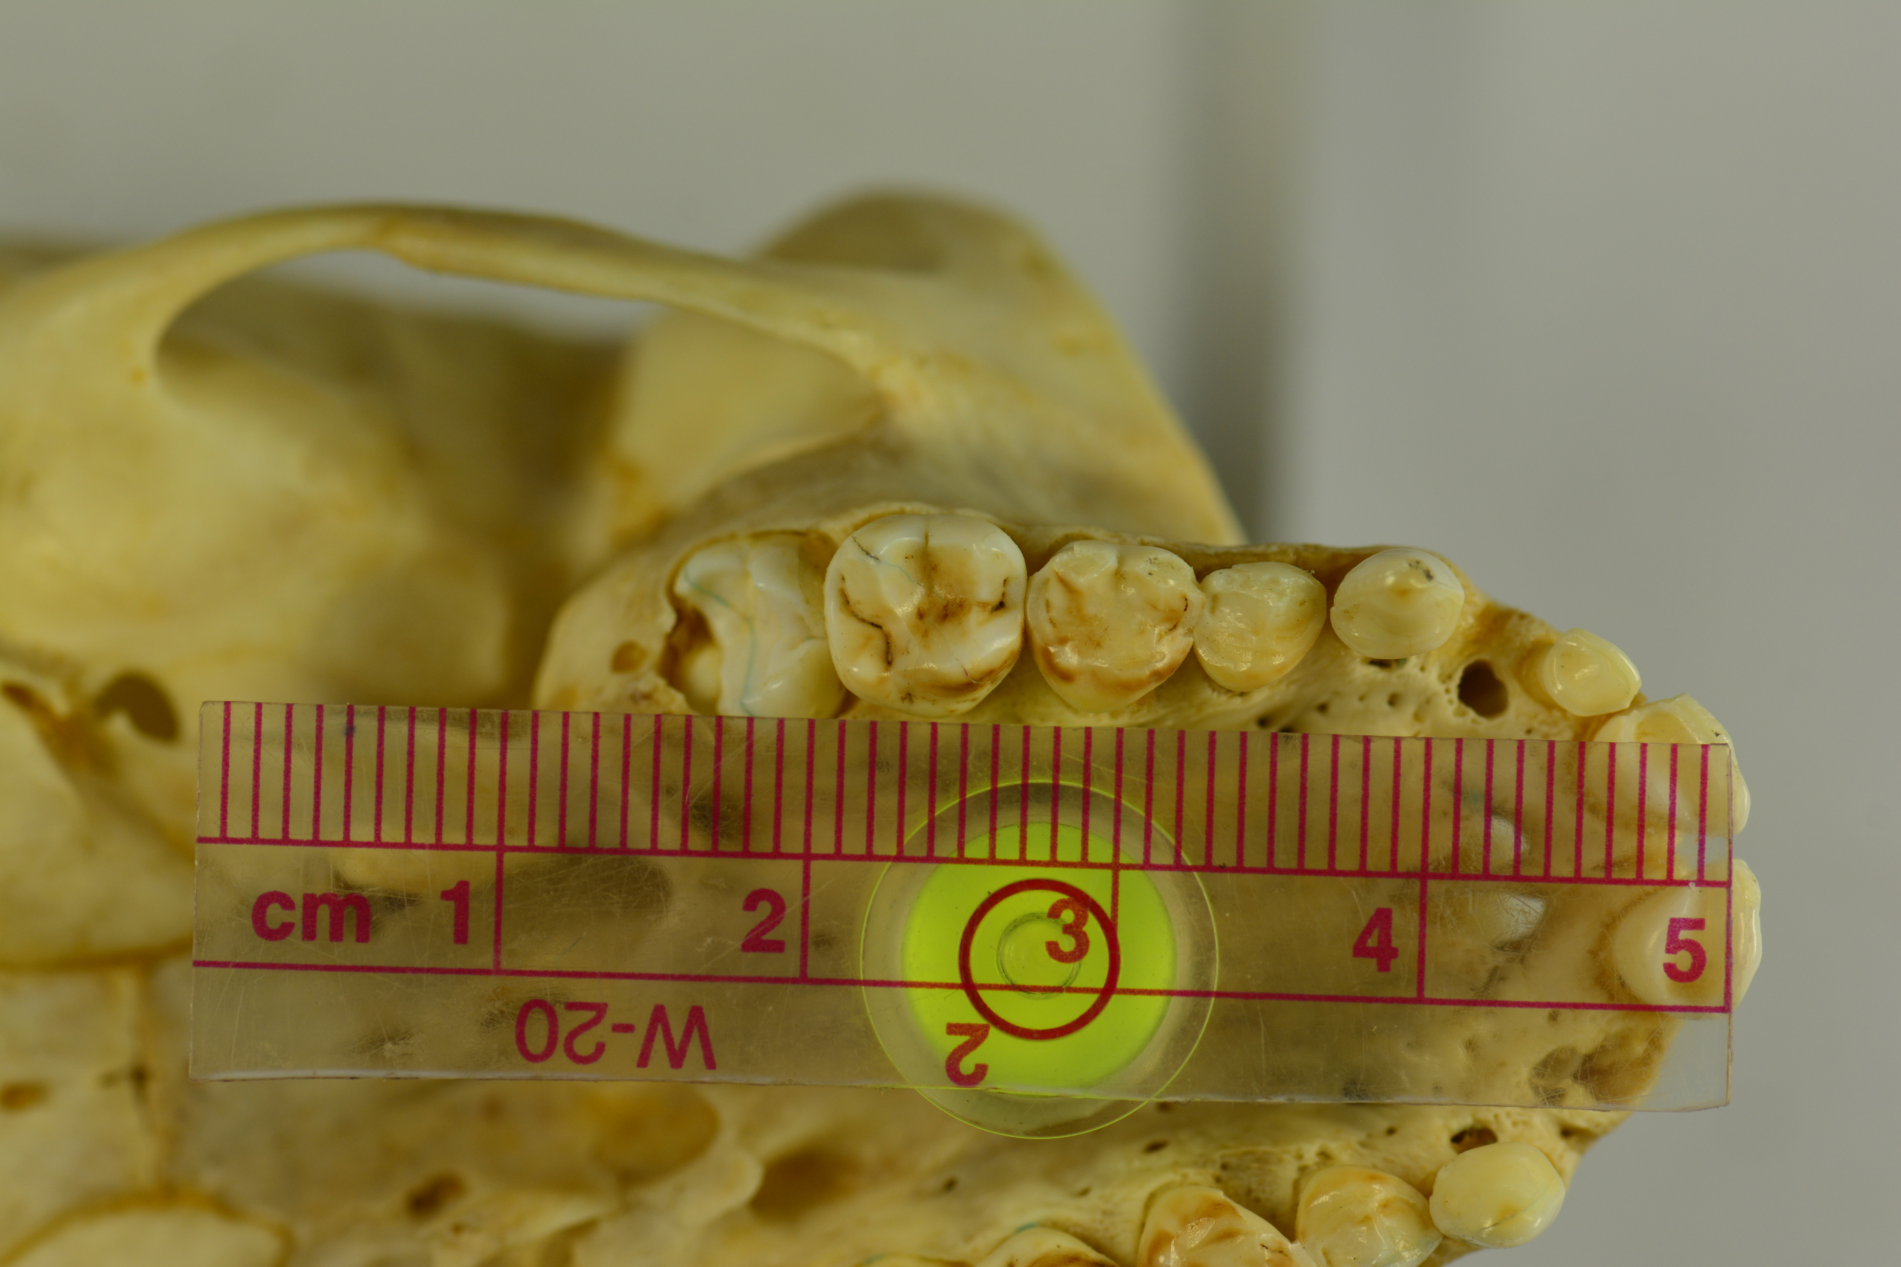 Figure S7. Upper tooth row of the historical Hoolock museum specimen KIZ011338. The dentition shows an incomplete molar eruption sequence: M1 is fully erupted, M2 is partially erupted, and M3 is not yet visible. Minimal occlusal wear on the erupted teeth is consistent with a juvenile or subadult developmental stage.

