Supplementary Information

Net carbon benefit of CO₂ curing of cement from coupled machine learning and process carbon accounting
Liyuan Chen and Jiaying Pan*
Department of Engineering Science, University of Oxford, Oxford, UK
*Correspondence: Jiaying Pan (jiaying.pan@wadham.ox.ac.uk)

Supplementary Note Data scope and reproducibility
The authors manually extracted material characteristics, curing conditions and CO₂ uptake from the source publications and curated the records into data_0519.xlsx. Uptake is expressed on a common original-material mass basis, including sand and aggregates where present. Supplementary Data 1 supplies all 465 curated records and row-level inclusion flags; temperature filtering leaves 461 observations. The Ref field preserves compilation source identifiers, which are distinct from the numerical citations in the article. Table S1 summarises these source groups. The 35 publications underlying the broader compilation are cited in the main reference list.
The broader compilation contains 548 records and 35 source identifiers. The curated workbook includes a thickness column and numerical modelling inputs. Supplementary Note “Retrospective comparison of the working tables” records differences between the supplied file versions. Such differences describe the development of the dataset and do not, by themselves, demonstrate extraction errors. Because the Number column changes between versions, the comparison uses source identifiers and recorded values to identify candidate correspondences. All analyses use the curated workbook without further imputation or deduplication. Material and measurement heterogeneity remains relevant to interpretation.
Each model is evaluated using fold-specific preprocessing. Stored prediction files contain the observed target, source identifier and out-of-fold prediction. The accompanying fold_assignments.csv ties both five-fold schemes to workbook rows. Leave-one-group-out files retain the held-out group in each row. No grouped scores were used to select new hyperparameters. The dataset is not a prospectively reserved external test cohort.

Supplementary Table S1 Source group sizes and targets
Group | Records | Mean uptake (%) | Minimum (%) | Maximum (%)
[1] | 15 | 4.313 | 0.500 | 10.200
[2] | 1 | 9.430 | 9.430 | 9.430
[3] | 20 | 22.266 | 3.700 | 39.480
[4] | 29 | 10.894 | 3.800 | 16.200
[5] | 1 | 14.030 | 14.030 | 14.030
[6] | 10 | 7.750 | 5.400 | 10.200
[7] | 6 | 7.333 | 4.700 | 8.900
[8] | 9 | 14.033 | 10.620 | 20.100
[9] | 26 | 5.688 | 0.500 | 9.600
[10] | 4 | 19.098 | 18.450 | 19.820
[11] | 12 | 11.533 | 5.100 | 15.800
[12] | 15 | 12.045 | 1.160 | 35.000
[13] | 10 | 6.690 | 4.100 | 8.500
[14] | 6 | 18.057 | 7.800 | 23.800
[15] | 8 | 20.087 | 14.900 | 28.300
[16] | 12 | 12.242 | 4.500 | 20.200
[17] | 24 | 18.688 | 5.400 | 26.700
[18] | 49 | 16.143 | 5.000 | 37.000
[19] | 11 | 16.020 | 10.500 | 22.500
[20] | 22 | 11.606 | 0.010 | 22.400
[21] | 6 | 10.883 | 7.700 | 13.000
[22] | 13 | 7.545 | 2.150 | 15.130
[23] | 8 | 7.332 | 3.360 | 15.600
[24] | 12 | 17.325 | 11.300 | 20.700
[25] | 2 | 15.450 | 15.100 | 15.800
[27] | 1 | 12.300 | 12.300 | 12.300
[28] | 3 | 31.533 | 17.170 | 51.110
[29] | 2 | 1.700 | 1.400 | 2.000
[30] | 4 | 7.900 | 3.400 | 10.800
[32] | 54 | 11.698 | 2.900 | 18.500
[33] | 8 | 8.273 | 4.680 | 13.670
[34] | 56 | 21.407 | 7.604 | 28.877
[35] | 2 | 5.865 | 5.590 | 6.140

Supplementary Table S2 Fixed model configurations
Model | Configuration
Ridge | α = 1
SVR | RBF kernel; C = 100; γ = scale; ε = 0.1
Random forest | 300 trees; maximum depth 12; random_state = 42
Gradient boosting | 300 estimators; maximum depth 3; learning rate 0.05; random_state = 42
Histogram boosting | 400 iterations; maximum depth 6; learning rate 0.05; L2 = 1; random_state = 42
MLP | Hidden layers (64, 32); α = 0.01; maximum iterations 2,000; random_state = 42
Ensemble | Voting average of histogram boosting, random forest and SVR above, weights (0.5, 0.3, 0.2)
Constrained model | Histogram boosting; 600 iterations; maximum depth 6; learning rate 0.1; L2 = 2; random_state = 42; monotonic vector (−1, +1, +1, 0, 0, +1, 0, −1)
All remaining estimator options retain the defaults of scikit-learn 1.7.2. Standardisation follows log(1 + x) transformation of pre-curing time, pressure, exposure and subsequent hydration. The pipeline is fitted separately for each training fold. No claim of exhaustive model search is made.

Supplementary Table S3 Validation metrics
Model | Random R² | Random RMSE | Grouped R² | Grouped RMSE
Ridge | 0.107 | 7.578 | -0.410 | 9.522
SVR-rbf | 0.592 | 5.122 | -0.448 | 9.649
RandomForest | 0.747 | 4.031 | -0.137 | 8.551
GradBoost | 0.744 | 4.055 | -0.252 | 8.973
HistGB | 0.713 | 4.299 | -0.129 | 8.523
MLP | 0.624 | 4.919 | -0.828 | 10.843
Ensemble | 0.737 | 4.114 | -0.086 | 8.359
Monotonic | 0.632 | 4.862 | -1.540 | 12.781
RMSE is in uptake percentage points. Metrics use pooled out-of-fold predictions from all 461 observations. Results are descriptive estimates for the specified partitions; no model-comparison significance test is reported.
For comparison with the original random 80:20 analysis, correcting the preprocessing to fit within each training fold gives training-subset five-fold R² = 0.765 for the ensemble and 0.604 for the constrained model. Their separate random held-out test R² values are 0.665 and 0.582. The training and test subsets contain 368 and 93 records. These are different sample partitions from the full-data comparisons and cannot be treated as independent study-level validation.

Supplementary Note Numerical inventory assumptions
The carbon scenarios are arithmetic illustrations of the coupled balance, not measured or fully validated plant inventories. Cases A–E retain electricity inputs from the original calculation, but commercial technology labels have been removed because the exact numerical inputs and heat allocations have not been substantiated as complete inventories of named facilities. The literature cited in the main text motivates accounting for supply burdens; it does not validate every coefficient below.

Supplementary Table S4 Upstream scenario coefficients
Case | Base electricity kWh/t CO₂ | Heat GJ/t CO₂ | Heat treatment | Total a kWh/kg CO₂
A | 152.9 | 5.25 | No additional heat burden | 0.247300
B | 450 | 6.0 | No additional heat burden | 0.544400
C | 630 | 0 | Electricity only | 0.724400
D | 450 | 6.0 | Heat converted at 1000/3.6 kWh/GJ | 2.211067
E | 2005.6 | 0 | Electricity only | 2.100000
All cases add liquefaction electricity of 89 kWh/t CO₂ and vaporisation electricity of 5.4 kWh/t CO₂. Diesel transport uses an assumed 100 km one-way distance, tare allocation 0.4212 t per tonne of delivered CO₂, and factor 0.112 kg CO₂/(t·km), giving b = (2 × 0.4212 + 1) × 100 × 0.112/1000 = 0.02063488 kg CO₂ per kg supplied. These are retained scenario inputs. No extra heat emissions are charged to A or B. Assigning such emissions would increase b; Eq. (2) permits recalculation. Where fossil combustion supplies heat, carbon origin and the fate of captured combustion CO₂ would additionally be needed for an atmospheric-removal claim, which is not made here.

Supplementary Table S5 Curing electricity at the example point
Operation | Assumption | kWh/m³
Pre-curing | 38.6 kWh/(m³·h) × 2 h | 77.2
Heating | Temperature equals assumed ambient 25 °C | 0
Humidity control | RH = 55%, below code threshold 80% | 0
Fan circulation | 0.05 m³/s per m³ × 500 Pa / 0.6 × 24 h / 1000 | 1.0
Pressurisation | Pressure ratio equals 1 | 0
Subsequent hydration | 0.05 kW/m³ × 48 h | 2.4
Total | Divide by assumed original-material mass 2400 kg/m³ | 80.6
The pre-curing coefficient of 38.6 kWh/(m³·h) is traced to El-Hassan and Shao (main reference 55), Section III.E and Table V. Their apparatus operated at 25 °C and 50% relative humidity with a reported 2.25 kW chamber and about 0.058 m³ specimen load. Transfer to the present scenario is not a scale-up calibration. Fan flow is normalised per unit processed volume. The executable code and accompanying notes specify different fan and subsequent-curing defaults; Table S7 evaluates both sets instead of treating either as measured plant data.
The updated surfaces use m = MU/η kg supplied CO₂/m³, where M = 2400 kg original material/m³ in the illustrative inventory and specific compression electricity c(P) = RT max[ln(P/1 bar), 0]/(3.6 × 10⁶ηc), with R = 188.9 J/(kg·K), T = 298 K and ηc = 0.7. All supplied pure CO₂ is compressed once from 1 bar after vaporisation. Below 1 bar the calculation excludes vacuum work and provides only an incomplete-energy scenario. updated_surface_grid.csv includes the controlled comparison with the legacy fixed mass of 30 kg/m³. Sensible heating and humidification are zero on the stated 25 °C and 55% relative-humidity grid; historical formulas for other conditions remain in code/original and are not validated by this reanalysis.

Supplementary Note Cross study validation and interpretation of prediction errors
The random and grouped five-fold evaluations use the same observations and the same model configurations. The ensemble achieves a pooled out-of-fold R² of 0.737 and an RMSE of 4.114 percentage points under random validation. The constrained model gives R² = 0.632 and RMSE = 4.862 percentage points. With source groups kept intact, the ensemble gives R² = −0.086 and RMSE = 8.359 percentage points, while the constrained model gives R² = −1.540 and RMSE = 12.781 percentage points (Supplementary Fig. S1). All eight models have negative pooled R² under this grouped partition. Full metrics are reported in Supplementary Table S3.
Leaving each of the 33 source groups out in turn gives pooled R² values of −0.089 for the ensemble and −0.793 for the constrained model. The training-mean baseline gives −0.061. Corresponding RMSE values are 8.370, 10.739 and 8.261 percentage points. The transferability failure therefore persists under a partition that differs from the grouped five-fold comparison.
Supplementary Figure S2 reports absolute error separately for each held-out group. Giving each group equal weight yields mean absolute errors of 6.565 percentage points for the ensemble, 8.126 for the constrained model and 6.304 for the baseline. Both models therefore have larger study-balanced absolute errors than the baseline. Record-weighted absolute errors are 6.474, 8.277 and 6.677 percentage points, respectively: the ensemble performs slightly better than the baseline under this particular metric. The difference between these summaries illustrates why the weighting and loss function must be specified. The evidence supports poor transfer under squared-error and study-balanced criteria, rather than a claim that every metric or every held-out study favours the baseline.
A negative pooled R² means that squared prediction error exceeds the error from assigning the pooled evaluation-set mean to every record. This is the reference used in the score definition, not a training-only baseline. The separately fitted training-mean baseline provides the operational comparison under leave-one-group-out validation. Record weighting and equal source-group weighting are reported separately because source-group sizes range from 1 to 56 observations.
The derivative ∂N/∂U is 0.841, 0.682, 0.586, −0.207 and −0.148 in A–E at 1 bar, I = 0.40 and η = 0.75. Multiplying an uptake perturbation by this coefficient gives the deterministic change in N when the other quantities remain fixed. It is not a statistical uncertainty propagation unless a defensible joint distribution of uptake and inventory errors is supplied. Changing operating conditions can also change E, η, a or b, which this partial derivative holds constant. At higher pressure with supplied-mass compression, subtract Ic(P)/η from these coefficients.
Mass basis and sensitivity. The accounting reference is 1 kg original material before carbonation, including sand and aggregates where present. The compilation already expresses uptake on this basis; the numerical target is unchanged. Volumetric curing energy is divided by M and supplied CO₂ equals MU/η per cubic metre. The original inventory value of 2400 kg/m³ is used only as an illustrative M. At M = 1000, 1800 and 2400 kg/m³, the 1 bar example uses 0.080600, 0.044778 and 0.033583 kWh/kg original material, respectively. Scenario A gives N = 0.161929, 0.176258 and 0.180736 kg CO₂/kg original material at I = 0.40. Across these alternatives A–C are positive and D–E negative; full results are in material_mass_sensitivity.csv. Holding uptake and volumetric energy fixed isolates the conversion assumption and does not describe how actual material changes affect uptake or energy demand.
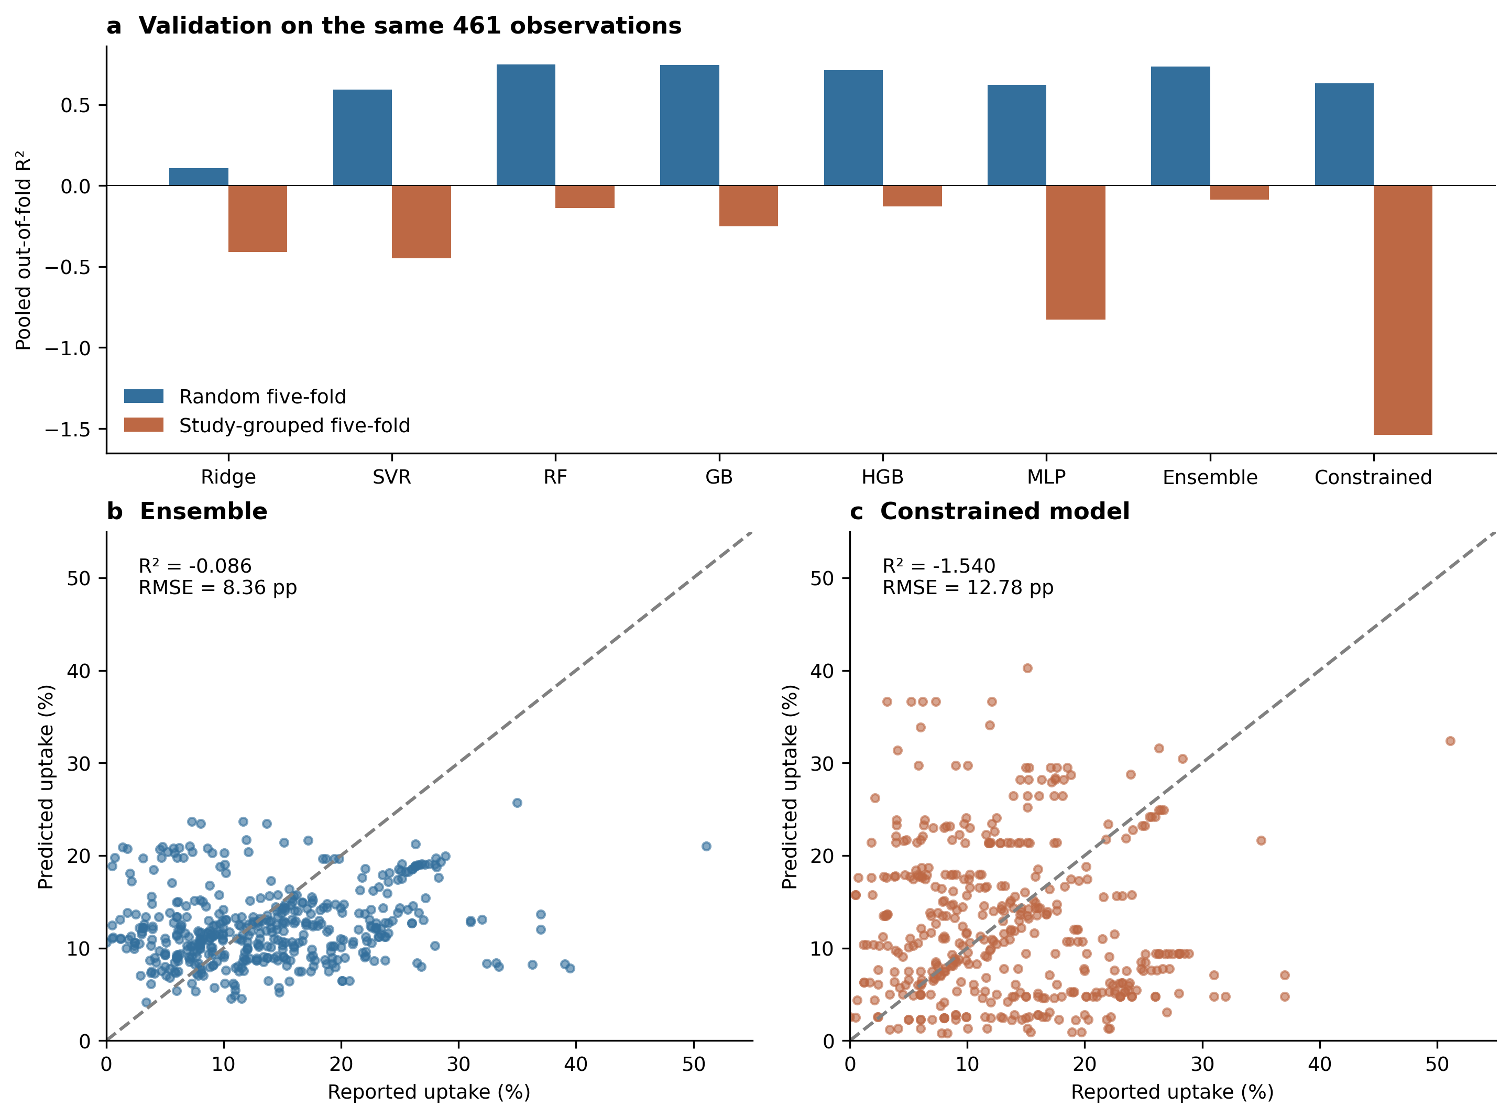
Supplementary Figure S1. Random and study-grouped five-fold validation. (a) Pooled out-of-fold R² for eight fixed model configurations, evaluated on the same 461 records with preprocessing fitted within each training fold. RF, random forest; GB, gradient boosting; HGB, histogram-based gradient boosting; MLP, multilayer perceptron. (b,c) Study-grouped predictions for the ensemble and constrained model. Dashed lines indicate equality; RMSE is in percentage points (pp). Bars are point estimates for the specified partitions, without confidence intervals.
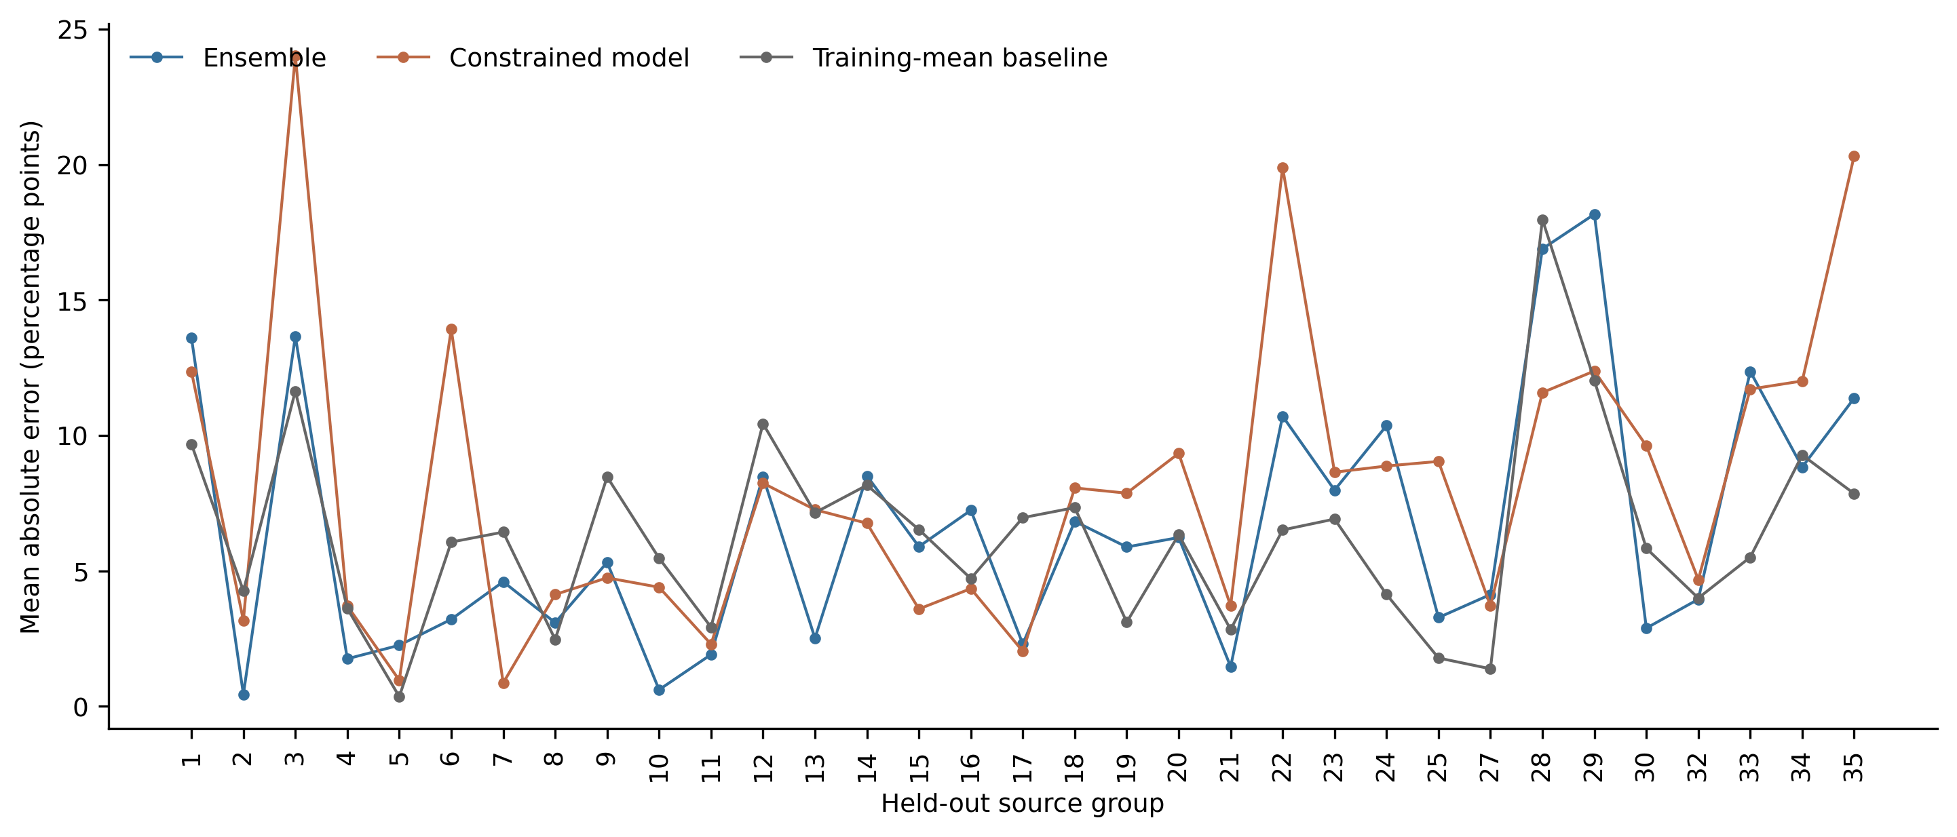
Supplementary Figure S2. Mean absolute error for each held-out source group under leave-one-group-out validation. The baseline predicts the training-record mean. Connecting lines aid comparison across group identifiers and do not imply an ordered physical trend. Each point is an average over the records in that group; no sampling interval is assigned to it. Group sizes range from 1 to 56.

Supplementary Note Retrospective comparison of the working tables
The broader-table snapshot contains 548 records and the working table contains 465. Their source-group counts differ by 83 records in total: group 2 decreases by 3, group 5 by 1, group 15 by 6, group 17 by 36, group 26 by 9, group 27 by 4, group 29 by 4 and group 31 by 20. Groups 26 and 31 are absent from the working table. These counts describe the change from the broader compilation to the curated modelling dataset. The subsequent four-record temperature filter is a separate operation.
Candidate correspondence was restricted to equal trimmed Ref labels and numerically equal uptake values (numpy.isclose with relative and absolute tolerances of 10⁻⁷). Within those candidates, pairs were ranked first by the number of disagreements in observed scalar fields and then by the number of matching scalar fields. Compared fields were water-to-cement ratio, pre-curing time, CO₂ partial pressure, temperature, relative humidity, exposure, subsequent hydration and uptake. Original blank and non-scalar entries were recorded separately and did not count as scalar disagreements. No match used Number as a cross-version identifier. Thickness was not compared because it is absent from the broader table.
Every working record has at least one candidate with the same source identifier and uptake. There are 459 unique best candidates and six ambiguous records; the unique candidates map to 459 distinct original records. Of the unique candidates, 418 have no observed scalar disagreements and 41 have one. Ambiguous working Excel rows are 87, 93, 107, 109, 190 and 193. These matches document correspondence between file versions; ambiguous matches are retained as such rather than assigned an artificial one-to-one lineage. No alternative values are substituted and no models are refitted on the basis of this comparison.

Supplementary Table S6 Differences among unique candidate pairs
Source group | Field | Broader table | Working table | Records
3 | Subsequent hydration (days) | 1 | 0 | 1
13 | Subsequent hydration (days) | 28 | 0 | 2
20 | Relative humidity (%) | 0 | 55 | 26
32 | Water-to-cement ratio | 0.19 | 0.187 | 6
32 | Water-to-cement ratio | 0.30 | 0.25 | 6
Counts are before the temperature filter. Four of the 26 humidity-change records in group 20 are subsequently excluded for temperature above 150 °C. Among unique candidate pairs, 371 original blank subsequent-hydration fields correspond to zero, 54 blank relative-humidity fields correspond to 55%, and 56 non-scalar water-to-cement entries of 0.4–0.6 correspond to 0.5. These field-level counts can overlap within a record. Whether a blank signifies no treatment, unavailable reporting or another condition cannot be established from the comparison alone.
The complete candidate correspondences, observed field differences and group counts are supplied in the data directory of Supplementary Code and Data, alongside the broader-table snapshot and comparison script. These results do not alter the validation scores reported in the main article. Uptake was converted during compilation to a common original-material mass basis, including aggregates. The retrospective comparison preserves both supplied versions; it does not repeat the original extraction and mass-normalisation procedure.

Supplementary Note Energy source reconciliation and sensitivity
The pre-curing source supports the rounded laboratory coefficient, whereas fan and subsequent-curing defaults are scenario inputs. At the example point, raising that coefficient from 38.6 to 38.8 changes scenario A from 0.180736 to 0.180669 kg CO₂/kg original material. Table S7 evaluates the conflicting documented defaults at fixed uptake and 1 bar. These are deterministic alternatives, not a probability distribution or uncertainty interval. All twenty A–E combinations are included in energy_parameter_sensitivity.csv.
Keith et al. (main reference 31) report 5.25 GJ natural gas plus 366 kWh electricity per tonne of atmospheric CO₂ captured, delivered at 15 MPa; the 8.81 GJ configuration is an alternative. Those figures do not directly establish the retained scenario-A capture-electricity value of 152.9 kWh/t. Substituting 366 while retaining separate conditioning and compression would require reconciliation of delivery boundaries and mass denominators. Cases A–E are therefore retained as controlled numerical scenarios. Scenario D uses the exact conversion 1 GJ = 1000/3.6 kWh, giving a = 2.211066667 kWh/kg; the small rounding change does not alter reported conclusions.
Supplementary Table S7 Alternative fan and subsequent-curing inputs for scenario A. Uptake is 0.230990 kg/kg, electricity intensity is 0.40 kg CO₂/kWh, and utilisation is 0.75. Flow is per cubic metre of processed material; E is total curing electricity. Full results for A–E accompany the code.
Flow  (m³/s per m³) | Subsequent power  (kW/m³) | E  (kWh/m³) | Net balance  (kg/kg) | Break-even I  (kg/kWh)
0.01 | 0.05 | 79.8 | 0.1809 | 2.053
0.01 | 0.50 | 101.4 | 0.1773 | 1.897
0.05 | 0.05 | 80.6 | 0.1807 | 2.047
0.05 | 0.50 | 102.2 | 0.1771 | 1.892
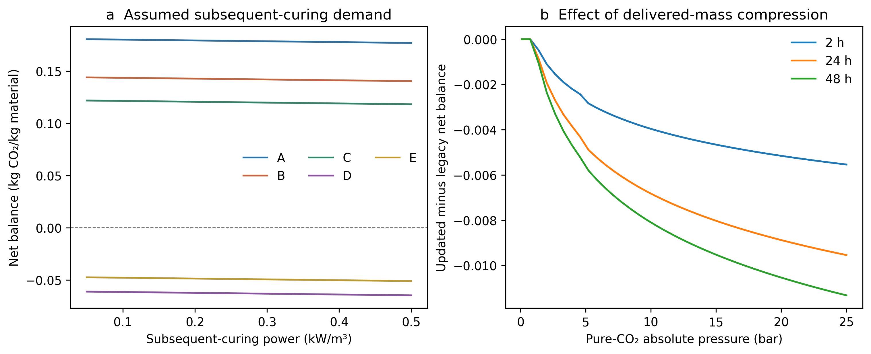
Supplementary Figure S3. Inventory sensitivity at fixed utilisation 0.75 and electricity intensity 0.40 kg CO₂/kWh. (a) Subsequent-curing power varies at the 1 bar example point, retaining baseline fan flow and uptake. (b) Difference between supplied-mass and fixed-30-kg/m³ compression at w/c = 0.4 for three exposure times. Each curve uses the same predicted uptake in the two compared inventories; differences arise only from compressed mass. Vertical values in both panels are kg CO₂/kg original material.

