Supporting Information
Interpretable Machine Learning Reveals Atom-Resolved VOCs Adsorption and Reactivity on Metal Oxides
Biluan Zhang^{1,2}, Pan Yan³, Lu Yan^{1,2}, Dongbo Zhou^{4*}, Jinlong Wang^{1,2,3*}, Yanbing Guo^{1,2,3*}

¹Institute of Environmental and Applied Chemistry, College of Chemistry, Central China Normal University, Wuhan 430079, P. R. China
²Engineering Research Center of Photoenergy Utilization for Pollution Control and Carbon Reduction, Ministry of Education, Central China Normal University, Wuhan 430079, P. R. China
³Wuhan Institute of Photochemistry and Technology, Wuhan 430083, P. R. China
⁴Laboratory for Artificial Intelligence and New Forms of Education, Central China Normal University, Wuhan 430079, China
*Correspondence: zhoudongbo@mail.ccnu.edu.cn; wjl2022@ccnu.edu.cn; guoyanbing@mail.ccnu.edu.cn

Supplementary Notes
N1 Dataset description.
N2 Theoretical derivation of dual-tower network.
N3 Hyperparameters for AdsDT models.
N4 Sensitivity of the AdsDT model to surface geometric fluctuations.
N5 Calibration curve and miscalibration area.
N6 Error curve at various uncertainty cutoffs.
N7 Dimensionality reduction of datasets.
N8 Computational methods.
N9 Similarity between OC20-Dense and metal oxides-VOCs datasets.
N10 Computational cost comparison.
N11 Identify different types of adsorption sites from cross-attention scores.
N12 Correlation between atomic contribution and chemical structural units.
N13 GCN-Ads (Graph Convolutional Network) model for VOCs adsorption energy prediction.
N14 SHAP based atomic weight analysis for VOCs adsorption.
N15 The Construction of Bond Activation Score S_{bond,ij}
N16 Experimental methods.

Supplementary Figures
S1 The architecture of AdsDT encoder.
S2 Independent aggregator and late interaction aggregator.
S3 (a) Loss function (b) Mean absolute error (c) Root mean squard error (d) R-square of the test set and train set versus training size for the AdsDT approach trained on OC20 dataset.
S4 Robustness evaluation under different types and intensities of noise for the AdsDT approach trained on OC20 dataset.
S5 Prediction performance of transfer learning models with unfrozen backbone under three different dataset combinations.
S6 Ablation performance of transfer learning fine-tuning path.
S7 The periodic table outlining elements included in the the Open Catalyst 2020 datasets.
S8 The periodic table outlining elements included in the Alloys-VOCs datasets.
S9 The periodic table outlining elements included in the metal oxides-VOCs datasets.
S10 The uniform manifold approximation and projection (UMAP) plot of surface/adsorbate combinations in three datasets.
S11 Comparison of the process of building a database using traditional DFT and deep learning model methods.
S12 Error distribution of predicted adsorption energies against DFT-calculated adsorption energies.
S13 Distribution range of adsorption energy and boxplot statistical significance on TiO₂ (Anatase, 101) surface.
S14 Comparison of SHAP analysis performance for analyzing the influence of functional groups on adsorption energy using on TiO₂ (Anatase, 101) surface.
S15 Cross-attention-based reasoning for adsorption site prediction. Multi-head attention scores between the adsorbate and surface atoms are averaged and visualized as an attention-colored surface, highlighting the most favorable adsorption sites.
S16 Visualization of singly bonded carbon (C1) atomic attention weights.
S17 Visualization of double bonded carbon (C2) atomic attention weights.
S18 Visualization of singly bonded nitrogen (N1) atomic attention weights.
S19 Visualization of double bonded nitrogen (N2) atomic attention weights.
S20 Visualization of singly bonded oxygen (O1) atomic attention weights.
S21 Visualization of double bonded oxygen (O2) atomic attention weights
S22 Visualization of halogen atom (F, Cl, Br) attention weights.
S23 Visualization of attention weights for multifunctional VOCs molecules.
S24 Correlation of oxygen attention values with (a) adsorption energy and (b) oxygen charge loss across different functional groups on TiO₂ (Anatase, 101) surface.
S25 Atomic attention weights for ethyl acetate molecules adsorbed on TiO₂(Anatase, 101) surface.
S26 The projected density of states (PDOS) analysis of ethyl acetate adsorption on TiO₂ (Anatase, 101) surface.
S27 Theoretical reaction pathways for ethyl acetate activation on TiO₂ (Anatase, 101) surface.
S28 The XRD patterns of TiO₂_Anatase catalyst.
S29 TEM images of TiO₂_Anatase catalyst.
S30 In situ DRIFTS of ethyl acetate adsorption over TiO₂_Anatase catalyst.
S31 Side and top views of the surface structures of eight metal oxides.
S32 GCN model performance for adsorption energy prediction on eight metal oxides

Supplementary Tables
S1 The hyperparameter specification table for AdsDT model.
S2 Comparison of input requirements for adsorption energy prediction models.
S3 Overall Test MAE results (eV) of AdsDT framework with different graph encoders on OC20-Dense datasets without transfer learning.
S4 Statistics of the DFT-constructed Alloys-VOCs dataset.
S5 Statistics of the DFT-constructed metal oxides-VOCs dataset.
S6 Performance table of progressive transfer learning fine-tuning path ablation.
S7 Dataset size and adsorption energy distribution of three datasets.
S8 Adsorbate information for OC20-Dense dataset.
S9 Adsorbate information for Alloys-VOCs and metal oxides-VOCs datasets.
S10 Chemical family distribution of adsorbates in the OC20-Dense dataset.
S11 Chemical family distribution of adsorbates in the Alloys-VOCs and metal oxides-VOCs datasets.
S12 Verify the selected data information, predictions, and DFT adsorption energy.
S13 Adsorption energy predictions for 816 VOC molecules on TiO₂(anatase, 101) surface by the transferable AdsDT model.
S14 Atom-level attention weights extracted from the transferable AdsDT model for 816 VOC molecules adsorbed on the TiO₂_Anatase (101) surface.
S15 In situ DRIFTS peak assignments for ethyl acetate on TiO₂.
S16 Structural details of eight metal oxide surfaces.
S17 Complete performance metrics of the GCN model on training and test sets for eight metal oxide surfaces.
S18 Average atomic attention weights of different atomic environments for VOCs molecules on eight metal oxides surfaces.
S19 Calculated bond activation scores for all chemical bonds in ethanol on TiO₂(anatase, 101) surface.

Supplementary Data
Data1 Atomic attention weights of all atoms across 816 VOCs molecules adsorbed on the eight metal oxide surfaces.
Data2 Bond activation scores of individual chemical bonds for 36 representative VOCs molecules adsorbed on the eight metal oxides surface.

Supplementary Notes
N1 Dataset description
The Open Catalyst 2020 (OC20) dataset is the most extensive and diverse dataset for heterogeneous catalysis. It contains over 1.2 million DFT relaxations computed using the revised Perdew-Burke-Ernzerhof (RPBE) functional. This dataset covers multiple tasks, including Initial Structure to Energy (IS2RE), Initial Structure to Relaxed Structure (IS2RS), and Structure to Energy and Force (S2EF). In our study, we focus on data from the IS2RE/IS2RS tasks, which consist of 460328 DFT relaxation trajectories. The core goal of the IS2RE task is to predict the relaxed adsorption energy from the unrelaxed initial atomic structure of each adsorbate-catalyst configuration. Accordingly, we extracted the final frame of these relaxation trajectories as our target energy labels. To systematically probe the global minimum adsorption energy of adsorbate-catalyst pairs, the OC20-Dense dataset was developed. While the original OC20 dataset covers broad types of adsorbates and catalytic surfaces, it lacks sufficient diversity in adsorption geometries. OC20-Dense addresses this gap by densely enumerating distinct adsorption configurations. Initial adsorbate-surface configurations were generated via both heuristic and random strategies, followed by structural relaxations using machine-learning and DFT methods. The OC20-Dense dataset contains 995 distinct adsorbate-catalyst pairs, evenly selected from the in-domain and three out-of-domain splits within the OC20 validation set. Therefore, the raw OC20-Dense dataset shares no overlap with the original OC20 training set. The official OC20-Dense provides an optional training subset containing 15450 data entries. Its validation set was randomly sampled with 9 001 entries from the three out-of-domain splits of the OC20 validation set. For its test set, ML-relaxed structures sourced from the same three out-of-domain splits of the OC20 validation set are provided by the Open Catalyst Challenge 2023. All noise-perturbation robustness tests reported in the main text were performed on this curated OC20-Dense dataset.
N2 Theoretical derivation of dual-tower network
The dual-tower network is a canonical two-branch encoding architecture with independently parameterized branches. Its core concept is to project heterogeneous input features originating from two distinct domains into a shared low-dimensional embedding space, enabling high-level semantic matching and similarity quantification. Owing to this decoupled encoding design, two-tower architectures deliver stable feature representations and strong noise robustness for matching-oriented tasks.
From a robustness perspective, this decoupled two-branch structure endows the model with intrinsic anti-interference properties. Input-level noise or perturbations only distort the embedding within one single branch, and cross-branch similarity computation mitigates biases introduced by local noise. Unlike single-branch architectures, the two-tower design prevents gradient aliasing of heterogeneous features during back-propagation. Since each branch updates its own parameters independently, stable training and consistent feature distributions can be maintained even under noisy conditions.

N3 Hyperparameters for AdsDT models
We optimized key hyperparameters of the AdsDT model via small-scale grid-search on a held-out subset of the OC20 dataset. The hyperparameters under tuning cover hidden-channel dimension, number of message-passing layers for graph encoders, layer count of vector encoders, batch size, initial learning rate, learning-rate decay factor (gamma), and maximum training epoch. Major hyperparameter settings for AdsDT are summarized in Table S1. Full hyperparameter configurations for all AdsDT variants are available at our GitHub repository: https://github.com/iojsea/metal-oxide-vocs-adsorption.

N4 Sensitivity of the AdsDT model to surface geometric fluctuations
To investigate the sensitivity of the AdsDT model to the surface’s geometry (e.g., atom distances and lattice constants), we introduced noise to input surface structures while preserving atomic connectivity via two strategies:
(1) Random perturbation of atomic coordinates along the x, y, and z directions (displacements < 0.2 Å);
(2) Random perturbation of the in-plane lattice vectors a and b (deviations < 2%). The c vector, which corresponds to the vacuum layer direction, was unchanged.
We assessed prediction fluctuations and mean energy offsets arising from geometric variations by comparing AdsDT predictions computed on pristine and noise-perturbed surface geometries. As shown in Figure S14, AdsDT models with different graph encoders exhibit low energy prediction fluctuation after adding geometric noise to the input surfaces. These observations demonstrate that our model exhibits low sensitivity to surface geometric distortions, provided that atomic connectivity is maintained. Such robustness is beneficial when processing surface structures retrieved from diverse crystallographic databases for interfacial interaction analysis.

N5 Calibration curve and miscalibration area
Calibration serves as a critical and rigorous metric for evaluating uncertainty estimation. It quantifies whether predicted uncertainty magnitudes yield statistically meaningful confidence intervals that match empirical observation. Although ensemble-based uncertainty quantification is widely adopted for deep neural networks, such predicted uncertainties can suffer from poor calibration, leading to either over-confident or under-confident model outputs. For instance, treating each model prediction and its associated uncertainty as the mean µ and standard deviation σ of a Gaussian distribution N(µ, σ²): at a nominal 95% confidence level, an over-confident model will enclose fewer than 95% of ground-truth data points within its predicted interval. By contrast, a well-calibrated model will capture approximately 95% of true observations inside this interval, whereas an under-confident model will enclose more than 95% of ground-truth points.
We followed standard protocols from prior literature to assess the calibration quality of our model-predicted uncertainties. For each sample x_{i}, we treated the predicted adsorption-energy value µ(x_{i}) and its uncertainty σ(x_{i}) as the mean and standard deviation of a Gaussian distribution N. For a given nominal confidence level α, we computed the α-level confidence-interval bounds L_{i}(α) and R_{i}(α) via the inverse cumulative-distribution function (inverse-CDF) of the corresponding Gaussian distribution. For an ideally calibrated model, the empirical fraction of ground-truth points falling within this interval should equal the nominal confidence level α. We calculated the observed empirical coverage fraction as:
$f(α)=\frac{\left|\left\{y_{i} | Li(α)≤y_{i}≤Ri(α)\right\}\right|}{N_{D}}$ (S1)
where N_{D} denotes the total number of data points. Plotting the empirical coverage fraction f(α) against the nominal confidence level α over the range 0≤α≤1 yields the calibration curve. A perfectly calibrated model produces a diagonal identity line. To numerically quantify miscalibration, we computed the integrated absolute area between the obtained calibration curve and this ideal diagonal reference line, known as the miscalibration area. All calibration-curve computation and miscalibration-area evaluation were performed using the Uncertainty Toolbox v0.1.1 software package

N6 Error curve at various uncertainty cutoffs
One common strategy for validating uncertainty estimates is to examine their correlation with actual prediction errors. A well-behaved uncertainty estimator is expected to deliver lower prediction error among its high-confidence predictions. We adopted a standard evaluation workflow to verify whether our predicted uncertainties correlate with real-world prediction errors. Test-set predictions are sorted in descending order of predicted uncertainty, indexed by r_{i}. Under this ordering, ŷ_{r1} corresponds to the prediction with the largest estimated uncertainty, whereas ŷ_{rn} represents the most confident prediction, with n being the total number of test samples. For each index i, we compute the cumulative mean absolute error (MAE_{i}) over the subset of samples satisfying j ≥ i:
${MAE}_{i}=\frac{1}{n−i+1}∑{}_{j ≥ i}^{n}{\left|ŷ_{rj}−y_{ri}\right|}$ (S2)
where y_{rj} denotes the ground-truth reference value for the prediction ŷ_{rj}. This metric quantifies model prediction performance under different confidence cutoffs. For instance, setting i=0.5n yields the MAE evaluated at the 50 % confidence cutoff. We construct the error curve by plotting cumulative MAE_{i} against varying confidence-cutoff thresholds.

N7 Dimensionality reduction of datasets
The imensionality reduction was carried out via the uniform manifold approximation and projection (UMAP) algorithm as implemented in umap-learn v0.5.5. UMAP constructs a weighted graph of three datasets in the high-dimensional space and then projects this graph to a two-dimensional space. Each node of the graph represents a surface/adsorbate combination, and each combination is depicted by the smooth overlap of atomic positions (SOAP) descriptors of surfaces concatenated with RDKit descriptors of adsorbates. The number of neighbors was set to 50, and the minimum distance between points was set to 0.4 Å. All other parameters were set to the default values (for reproducibility, a random seed of 16 was used). SOAP is a descriptor that encodes regions of atomic geometries by using a local expansion of a Gaussian smeared atomic density with orthonormal functions based on spherical harmonics and radial basis functions. In this work, average SOAP descriptors of catalyst surface were generated by DScribe v2.1.0 package. One way of turning a local SOAP descriptor matrix into a global descriptor vector is simply by taking the average over all sites. The inner averaging mode in DScribe was used, which is taken over the sites before summing up the magnetic quantum number based on:
$P_{nn'l}^{Z_{1},Z_{2}}\sim ∑\sum_{m}{\left(\frac{1}{n}\sum_{i}{c_{nlm}^{i,Z_{1}}}\right)}\left(\frac{1}{n}\sum_{i}{c_{n'lm}^{i,Z_{2}}}\right)$ (S3)
$c_{nlm}^{Z}\iiint_{R^{3}}^{n}{dVg_{n}(r)Y_{lm}(θ,ϕ)ρ^{Z}(r)}$ (S4)
where n and n’ are indices for the different radial basis functions up to nm is the angular degree of the spherical harmonics up to Ylm are atomic species, and ρZ(r) is the Gaussian smoothed atomic density for atoms. In general, the inner averaging will preserve the configurational information better. Additionally, the cutoff for the local region is set to 4.0 Å, the number of radial basis functions is set to 8, the maximum degree of spherical harmonics is set to 6, and the feature compression method is set to 2.

N8 Computational methods
Calculations performed in this work were carried out by using density functional theory (DFT) as performed by Vienna ab initio simulation package (VASP). Exchange-correlation functions are taken as the generalized gradient approximation (GGA) in the form of Perdew-Burke-Ernzerhof (PBE). The projector augmented wave (PAW) method was used to replace the pseudopotential of inner core electrons and nucleus with the valence electrons. The long-range van der Waals interaction was incorporated by adopting the zero damping DFT-D3 method of Grimme The Kohn-Sham electron wave functions were expanded using the plane-wave functions with an energy cutoff of 450 eV. The 2×2×1 k-point meshes in Brillouin zone was sampled for structure optimization and electronic property according to the Monk Horst-Pack scheme. The optimization was considered convergence and each atom would be fully relaxed until the spring force between adjacent images was less than 0.02 eV Å-1, the total energy change upon two steps for the electronic self-consistent field iteration was less than 1E-5 eV. The vacuum layer was set to 15 Å in the z-direction to avoide the interaction among mirror images. As for the adsorption case, the adsorption energy (E_{ads}) was defined as:
E_{ads} = E_{substrate+adsorbate} - E_{substrate} - E_{adsorbate} (S5)
where E_{substrate+adsorbate}, E_{substrate}, and E_{adsorbate} are the energies of the optimized adsorbate/substrate model, the clean substrate slab, and the adsorbate, respectively. Crystal structure diagrams were drawn with Visualization for Electronical and Structural Analysis (VESTA).

N9 Similarity between OC20-Dense and Metal oxides-VOCs datasets
Domain similarity between source and target domains constitutes a critical prerequisite for effective transfer-learning performance. The OC20-Dense dataset is derived from the Open Catalyst Project, where surfaces and adsorbates follow the unified DFT calculation protocols of the original OC20 dataset. All surface structures are built from crystal entries retrieved from the Materials Project database, covering 54 chemical elements, diverse crystal systems and space groups, with surface facets limited to a maximum Miller index below 2.
Our target metal oxides-VOCs dataset also adopts crystal-structure inputs originating from the Materials Project database and follows consistent DFT calculation conventions for adsorption systems. Both datasets contain diverse solid surfaces and molecular adsorbates, and share common physical descriptors for characterizing surface-adsorbate interfacial interactions. Benefiting from these shared foundations, the source-domain OC20-Dense and target metal-oxides-VOCs datasets exhibit reasonable domain similarity, which supports effective knowledge transfer in our progressive transfer-learning workflow.

N10 Computational cost comparison
For the AdsDT model, predicting adsorption energies for 1000 surface-adsorbate pairs takes approximately 12 s on an RTX 3090 GPU, corresponding to a prediction latency of 0.012 s per pair. We benchmark AdsDT against the AdsorbML workflow, which combines machine-learning interatomic potentials (MLIPs) with heuristic structure searching for adsorption-energy evaluation. For one individual surface-adsorbate pair, AdsorbML generates 100 candidate initial adsorption geometries via heuristic and random sampling (num_{site} = 100). Each initial geometry is subsequently relaxed using an MLIP. With the GemNet-OC model (39 M parameters, pretrained on the OC20 dataset), each 80-step structural relaxation costs ~4 s on an RTX 3090 GPU. Consequently, AdsorbML requires roughly 400 s to evaluate the adsorption energy for a single surface-adsorbate pair. Under this benchmark, AdsDT achieves a speedup of ~3.3×10⁴ relative to the AdsorbML pipeline.
Consider a target reaction with two key intermediate adsorbates and a catalyst library containing 200000 unique catalysts. Assuming 20 surface terminations are generated per catalyst, this yields a total of 4000000 candidate surfaces. Using AdsDT, computing adsorption energies for these two adsorbates across all candidate surfaces requires approximately 1 GPU day. In contrast, the AdsorbML pipeline based on the pretrained GemNet-OC (39 M) MLIP would demand ~37037 GPU days. Even with parallel computation across 100 GPUs, the full calculation would still take 370 days. Therefore, AdsDT exhibits superior computational efficiency and shows great promise for large-scale catalyst pre-screening, particularly for catalyst databases containing ≧1 M entries.

N11 Identify different types of adsorption sites from cross-attention scores
Furthermore, we explored extending our method to identify different types of adsorption sites rather than simply assessing the importance of individual surface atoms. Given a set of surface atoms A and their attention scores S, higher attention scores indicate that the atom is more important for strong adsorption. The maximum attention score is defined as s_{max}, and the set of atoms with scores above 0.8s_{max} is defined as the potential site atoms P. For the atom i in P, if no atom j in P satisfies Equation S6, then atom i is considered to constitute a top site. For the atom i in P, if there is only one atom j in P that satisfies Equation S6, then atoms i and j are considered to constitute a bridge site. If there are three atoms i, j and k in P, where d_{ij}, d_{ik} and d_{jk} all satisfy Equation S6 and form a triangle, then atoms i, j and k are considered to constitute a hollow site.
${\text{d}}_{\text{ij}} \text{<} {\text{r}}_{\text{i}}+{\text{r}}_{\text{j}}\text{+}\text{δ}\left(\text{i}\text{≠}\text{j}\right)$ (S6)
In Equation S6, dij represents the distance between atoms i and j, ri and rj are the covalent radii of atoms i and j, respectively, and δ can either be a fixed value or the geometric diameter of the adsorbate. We evaluated this extended method using our AdsDT models, without considering more complex site types. Based on the improved method described above, it is possible to identify adsorption site types (top, bridge, hollow) using attention scores and the distances between high-scoring atoms. Isolated high-scoring atoms without surrounding high-scoring atoms tend to form top sites, while high-scoring atoms close to each other are more likely to form bridge or hollow sites. The results show that the cross-attention scores have the potential to identify the adsorption site type through the improved method, which will be further studied in future work.

N12 Correlation between atomic contribution and chemical structural units
To further connect model-level interpretability with chemically meaningful structural units, we systematically analyzed the correlation between atom-wise attention contributions and the local chemical environments of adsorbate molecules. For each adsorbate-surface configuration, we extracted the cross-attention score assigned to every atom in the adsorbate molecule. These atom-level contributions were then grouped and aggregated according to predefined chemical structural units, including functional groups (e.g., -OH, -COOH, -NH₂, -NO₂, -SH, -Cl), heteroatom types (O, N, S, halogen), and bond types (C-C, C-H, C-O, C-N, C-S, C-halogen).
For a given structural unit u, we define its aggregated contribution C_{u} as the sum of attention scores of all atoms belonging to that unit:
${\text{C}}_{\text{u}}=\sum_{\text{a}\text{∈}\text{u}}{{\text{s}}_{\text{a}}}$ (S7)
where s_{a} denotes the cross-attention score of atom a. By comparing C_{u} across different structural units within the same molecule and across the entire dataset, we identified which chemical moieties dominate the adsorption interaction and which remain relatively inert.
The heteroatom-containing functional groups consistently exhibit higher aggregated contributions than hydrocarbon backbones. In particular, oxygen-containing groups (-OH, -COOH, -C=O) and nitrogen-containing groups (-NH₂, -NO₂) serve as the dominant adsorption anchors on most metal-oxide surfaces, owing to their strong lone-pair-metal coordination interactions. Sulfur- and halogen-containing groups show material-dependent behavior. They dominate adsorption on reducible metal oxides but contribute less on inert oxide surfaces.
Notably, the structural unit with the highest aggregated contribution does not always correspond to the bond that undergoes preferential cleavage during subsequent surface reactions. Instead, high-contribution anchoring groups induce significant interfacial electronic redistribution, which remotely activates neighboring C-H or C-C bonds within the hydrocarbon backbone. This observation is consistent with our earlier finding that the primary adsorption anchor is not necessarily the direct bond-cleavage site.
We further quantified the correlation between aggregated structural-unit contributions and experimentally/DFT-derived adsorption strengths using Pearson correlation coefficients. Across eight metal oxides and diverse heteroatom-containing VOCs, the aggregated contribution of the top-ranked structural unit shows a strong positive correlation with adsorption energy (R²>0.8), confirming that AdsDT-derived atom-wise contributions capture chemically meaningful structure-adsorption relationships. These results demonstrate that atom-level interpretability can be systematically mapped onto chemically intuitive structural units, providing a quantitative bridge between model attention weights and molecular-level adsorption chemistry.

N13 GCN-Ads (Graph Convolutional Network) Model for VOCs Adsorption Energy Prediction
Molecular Graph Representation and Node Feature Engineering. Each VOC molecule was represented as an undirected graph (G=V, E), the graph convolutional network (GCN)‑based model, where atoms correspond to node set V and covalent bonds form edge set E. Molecular graphs were constructed from SMILES strings via RDKit with explicit hydrogen atoms added. Bond‑type information was not adopted as input feature; edges only stored atom‑pair indices to define molecular topology. Each atomic node was encoded into a 29‑dimensional feature vector including element‑type one‑hot encoding, atomic degree, hybridization state, implicit valence, aromaticity flag, 3‑8‑membered ring membership, hydrogen‑bond donor‑acceptor tags, formal charge, shortest‑path distance to candidate adsorption‑relevant atoms, and binary marker for adsorption‑active sites. Candidate adsorption‑reactive atoms of VOCs were detected by RDKit‑based SMARTS sub‑structure matching for hydroxyl, carbonyl, amine, aromatic rings and halogen‑containing groups, and duplicate matches were removed by post‑processing.
The GCN‑Ads architecture contains five graph‑convolution layers followed by three fully‑connected layers. The hourglass‑shaped graph convolution block expands 29‑dim input features to 1024, compresses to 256, then expands back to 1024; batch normalization and ReLU activation follow each convolution layer. A global attention layer aggregates node embeddings into molecule‑level representation, and fully‑connected layers (1024 → 128 →16) output scalar adsorption‑energy prediction. The model was trained with batch size 128, Adam optimizer, initial learning rate 0.0001, decay factor 0.7 (triggered if validation‑set MSE plateaus for 10 epochs, learning‑rate decay factor = 0.00001), MSE loss function, maximum 1000 epochs. The checkpoint with optimal validation MSE was saved for prediction and interpretability. The curated dataset of VOCs adsorption‑energy samples was filtered by removing missing labels, physically unreasonable values, molecules >500 Da and non‑common elements, then split into training/validation/test sets.

N14 SHAP Based Atomic Weight Analysis for VOCs Adsorption
GraphSHAP was applied to quantify atomic‑level marginal contributions toward VOCs adsorption energy prediction. The Shapley value for atom i:
$ϕ_{i}=\sum_{S∈N}{\frac{\left|S\left|!(N−\left|S\right|−1\right|)!\right|}{N!}}\left[f_{x}(S∪\left\{i\right\})−f_{x}(S)\right]$ (S8)
where N is full atom set, S denotes atom subsets excluding atom i, and fx is trained GCN‑Ads prediction function. Monte‑Carlo sampling approximated exact Shapley values under chemical connectivity constraints for valid subgraphs; atomic masking was performed by zeroing node‑feature vectors. Two‑step standardization (Z‑score transformation followed by sigmoid mapping onto [-1,1] enabled cross‑molecule comparison. Positive SHAP values mean the atom increases predicted adsorption‑energy (promote adsorption); negative values mean the atom decreases adsorption‑energy (suppress adsorption). Standardized SHAP values were projected onto molecular diagrams for heatmap visualization. Structured SHAP further aggregated atomic contributions into functional‑group‑level scores, incorporating pairwise atomic interaction SHAP terms. The global attention weights from model internal layers were also extracted via forward‑pass hooks, min‑max normalized to [0,1] and mapped onto molecular structures as auxiliary heatmaps, which reveal which atomic regions the GCN model focuses on during adsorption energy regression task.

N15 The Construction of Bond Activation Score S_{bond,ij}
For each chemical bond (i-j) in VOCs molecules, three physically meaningful normalized sub-terms are defined to quantify atomic interaction, bond energetics and bond polarization, namely A_{ij} (normalized attention contribution), E_{ij} (normalized energetic contribution), and P_{ij} (normalized polarization contribution).
A_{ij} originates from atom-level weight parameters w_{i} and w_{j} of the two bonded atoms i and j. This term reflects synergistic or counteracting interactions between bonded atomic sites. Positive values occur when w_{i} and w_{j} share the same sign for cooperative sites, whereas negative values appear under opposite sign weights indicating mutual offset of atomic effects. Hydrogen atoms are assigned with fixed weight w_{H}=0. Consequently, the weight-interaction component of A_{ij} automatically equals zero for any bond involving hydrogen. An adsorption reward term R_{ij} is embedded within A_{ij}. R_{ij} is calculated from the minimum weight of the two bonded atoms, based on the hypothesis that the atom with the lowest weight in bond (i-j) serves as the dominant adsorption active site and brings positive reward for bond activation. A tunable and interpretable hyperparameter λ_{ads} ∈ [0,1] controls the relative magnitude of this adsorption reward effect.
E_{ij} denotes the energetic contribution derived from the bond energy (homolytic bond dissociation energy) BDE_{ij} of bond (i-j), calculated as the ratio of the average bond dissociation energy within the same VOC molecule to the bond energy of the target bond It describes the intrinsic difficulty for homolytic cleavage of the target bond. Larger E_{ij} corresponds to weaker intrinsic bond strength.
P_{ij} is the polarization contribution calculated from absolute Pauling electronegativity difference $\left|χ_{i}−χ_{j}\right|$ between atom i and j: P_{ij}=$1+\frac{\left|χ_{i}−χ_{j}\right|}{Δ\overline{χ}}$, where $Δ\overline{χ}$ is the average electronegativity difference of all bonds within the same VOC molecule. It quantifies charge separation and polar character of covalent bonds. The constant baseline value of unity represents the inherent activation contribution of nonpolar bonds, and increasingly polarized bonds receive an enhanced contribution from the electronegativity difference term.
The final bond activation score S_{bond,ij} is obtained by multiplying the three sub-terms to capture their coupled effects: S_{bond,ij}=A_{ij} · E_{ij}· P_{ij}. S_{bond,ij} provides an integrated measure of the susceptibility of bond (i-j) to activation. It jointly incorporates atomic weight adsorption effect, intrinsic bond energy and covalent bond polarizability. Higher S_{bond,ij} indicates that the corresponding covalent bond is more vulnerable to perturbation, polarization or activation under adsorption and catalytic conditions during VOCs oxidation. It should be noted that the physically driven S_{bond,ij} obeys physical monotonicity: bonds with lower bond energy and stronger polarity tend to acquire higher scores. Minor discrepancies are expected compared with legacy empirical bond score tables, since those empirical values contain implicit correction terms not implemented in current formulation. S_{bond,ij} is used for intra-molecular bond ranking rather than as a direct proxy for activation energies or kinetic barriers.

N16 Experimental methods
Catalyst Preparation. Pure TiO₂ Anatase powder was prepared by the sol-gel method as a support. First, 1 g of surfactant was dissolved in a 1-butanol solvent. Next, 0.01 mol of Ti precursor (CH₃CH₃CHO)₄Ti (titanium tetraisopropanolate) was added into the above solution. HNO₃ (1 g) was then added dropwise at room temperature (RT). The mixing solution was kept at 70 °C for 4 h to get clear light-yellow gel. Finally, the resulting pale-yellow transparent gel was annealed in air at 450 °C for 4 h.
In situ DRIFTS testing. To reveal the reaction mechanism of ethyl acetate adsorption on the catalyst surface, we employed diffuse reflectance Fourier transform infrared spectra (DRIFTS) to characterize the chemical species during the process. DRIFTS were conducted on a Thermo-Nicolet iS10 FTIR spectrometer equipped a mercury cadmium telluride (MCT-A) detector. About 50 mg of powdered catalyst was placed inside the in situ diffuse-reflectance cell (Harrick) cover with a ZnSe window. Prior to the introduction of the reactive ethyl acetate gas, the catalysts were pretreated at 300 °C for 1 h. Corresponding background spectra were collected prior to the introduction of N2 component.
PTR-TOF-MS testing. A proton-transfer-reaction time-of-flight mass spectrometer (PTR-TOF-4000, IONICON Analytik GmbH, Austria) was employed for the qualitative and quantitative analysis of gaseous intermediates generated during ethyl acetate catalytic oxidation. The outlet gas was directly introduced into the PTR-TOF-MS system through a heated transfer line. H₃O⁺ was used as the reagent ion to achieve soft ionization of volatile organic compounds through proton-transfer reactions. The intermediates were identified based on their accurate mass-to-charge ratios (m/z), together with reference standards and reported mass spectral data.

Supplementary Figures
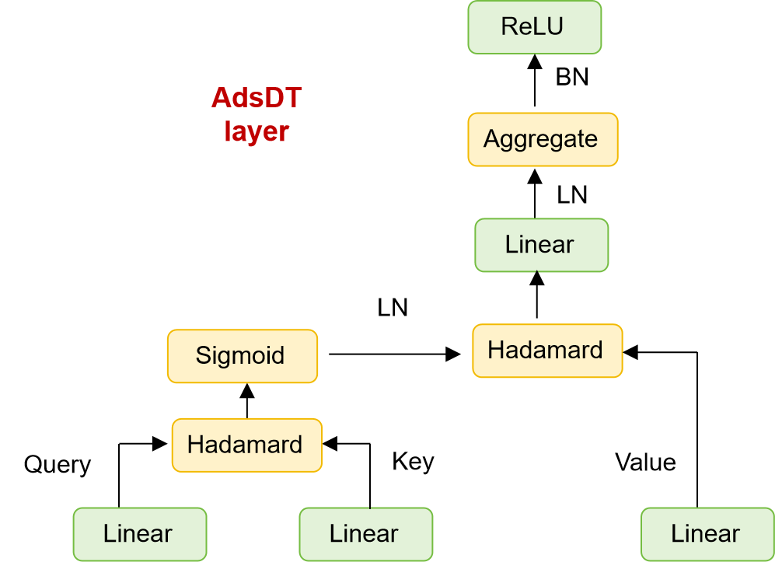
Figure S1. The architecture of AdsDT encoder.

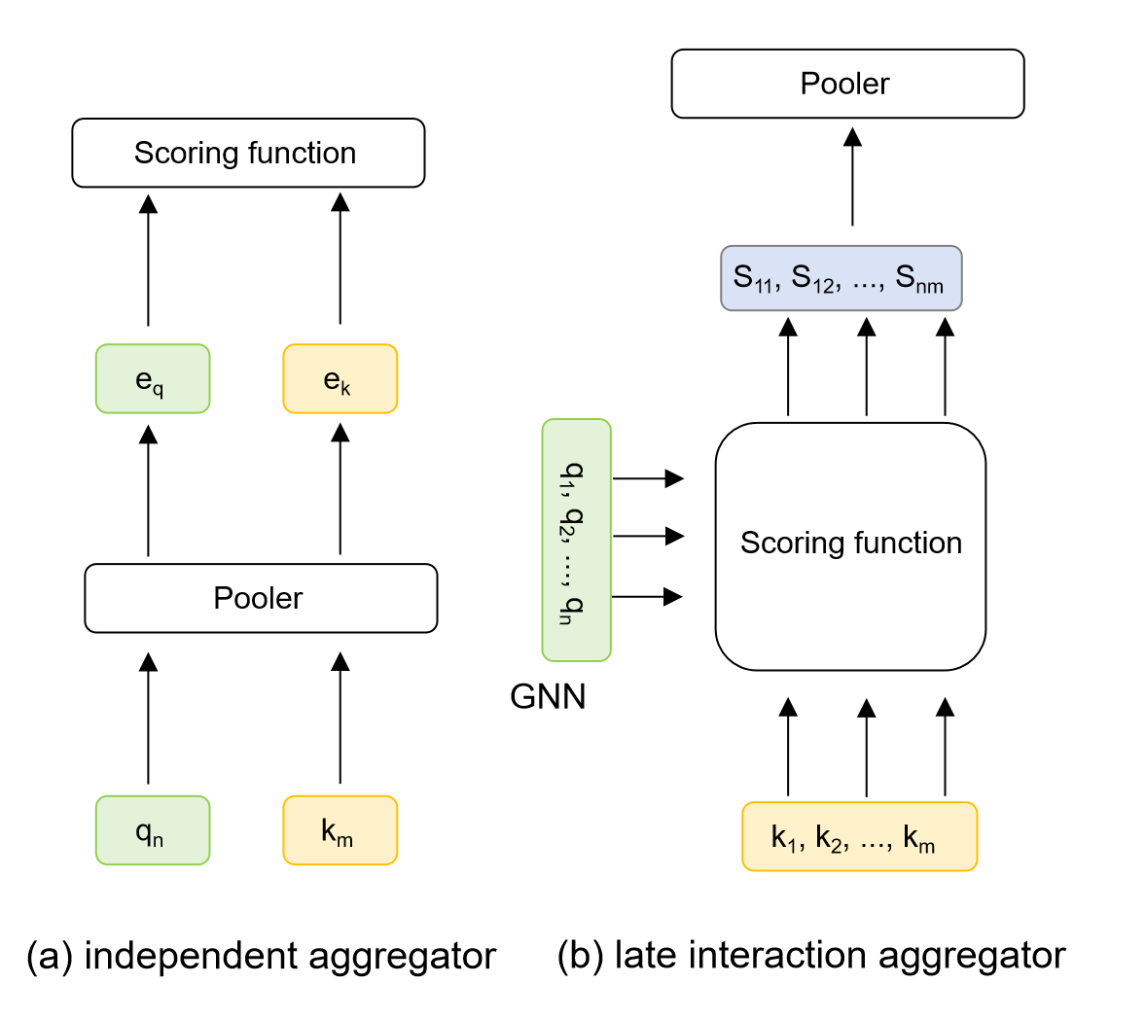
Figure S2. (a) Independent aggregator. (b) Late interaction aggregator.

The core methodological challenge then lies in how to integrate these decoupled features without re-introducing geometric constraints. traditional alternative coupling schemes typically fall into two extremes: the independent aggregator (Figure S2a), which prematurely condenses tokens into global vectors (e_{q}, e_{k}) via individual poolers before executing the scoring function, completely sacrificing localized, site-specific details. And the late interaction aggregator (Figure S2b), which forces exhaustive token-to-token scoring to construct a dense interaction matrix (S_{nm}) prior to pooling, incurring heavy computational overhead and risking overfitting.

Figure S3. (a) Loss function (b) Mean absolute error (c) Root mean squard error (d) R-square of the test set and train set versus training size for the AdsDT approach trained on OC20 dataset.

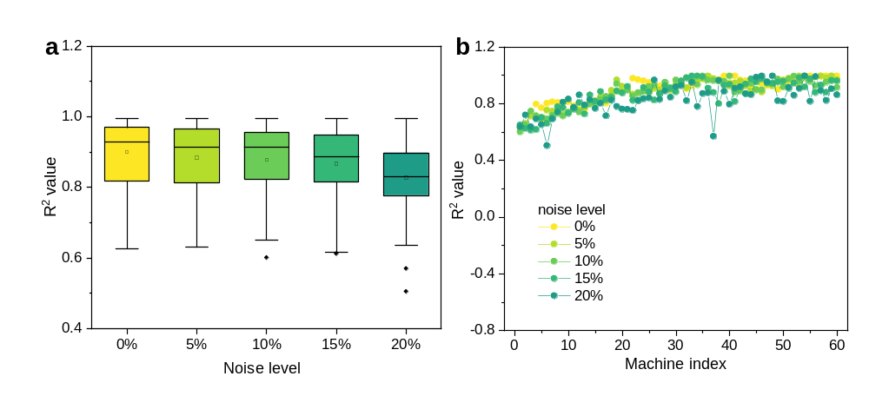
Figure S4. Robustness evaluation under different types and intensities of noise for the AdsDT approach trained on OC20 dataset.

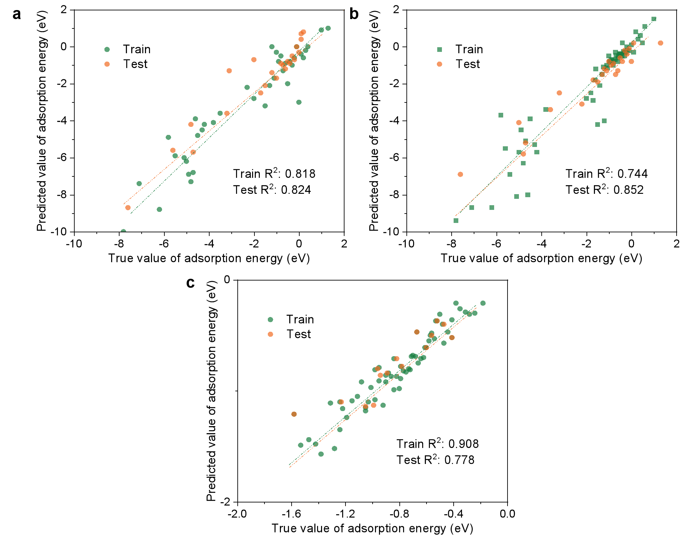
Figure S5. Prediction performance (predicted vs. true adsorption energy) of transfer learning models with unfrozen backbone (no layer freezing, direct one-step transfer learning) under three different dataset combinations. (a) Model trained on the Alloy+VOCs combined datase. (b) Model trained on the MO_{x}+VOCs combined dataset. (c) Model trained on the fully mixed dataset (Alloy+VOCs MO_{x}+VOCs)

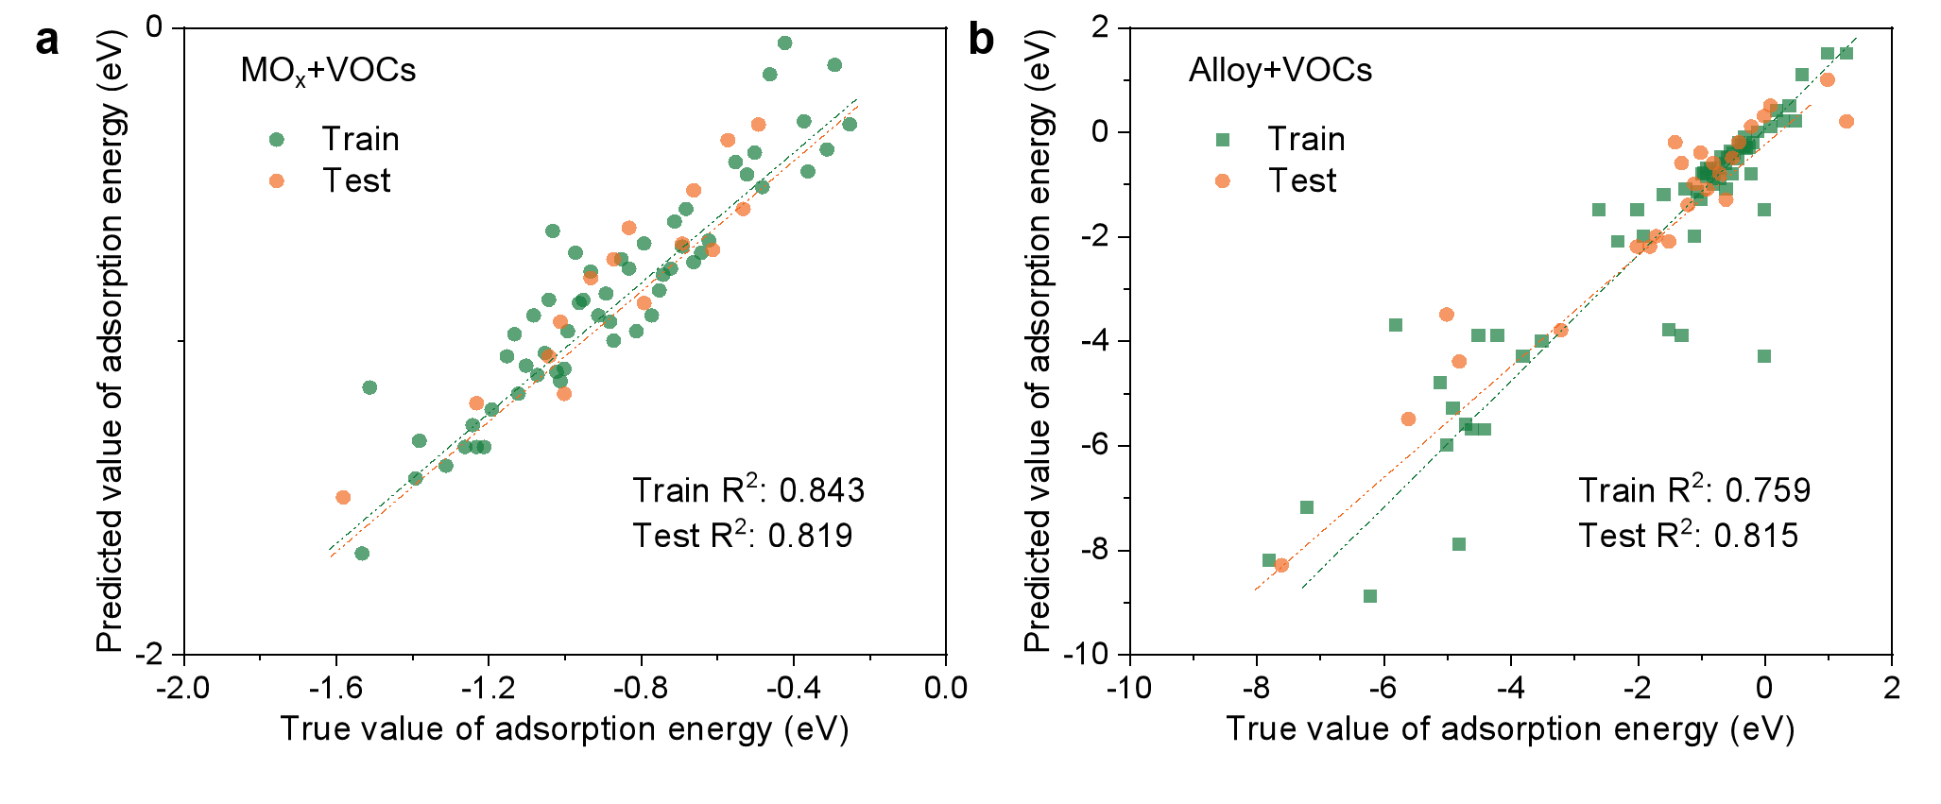
Figure S6. Ablation performance of transfer learning fine-tuning path. Parity plots comparing the AdsDT-predicted adsorption energies against the ground-truth DFT values (eV) for the downstream (a) MOx-VOCs and (b) Alloy+VOCs target datasets.

Comprehensive ablation studies were performed to evaluate the influence of transfer strategy on model performance, including direct fine-tuning, single-stage transfer learning, and reversed-sequence transfer learning (Figures S5-S6). When all network parameters were directly fine-tuned without freezing the alloy encoder, the model achieved a high training performance (R² ≈ 0.90), whereas the testing R² decreased to approximately 0.70 (Figure S5c), indicating substantial overfitting. This result demonstrates that unrestricted parameter updating may destroy transferable adsorption representations learned from the source domain and lead to over-adaptation to dataset-specific features.
In comparison, freezing the alloy encoder during the second-stage transfer effectively retained the adsorption knowledge learned from the large-scale alloy dataset while allowing the VOCs-related molecular representations to be optimized for metal oxide systems. This strategy resulted in improved prediction accuracy and generalization capability. Furthermore, reversing the transfer sequence (MO_{x}-VOCs→Alloy-VOCs) resulted in inferior performance and slower convergence compared with the proposed Alloy+VOCs→MO_{x}-VOCs strategy.

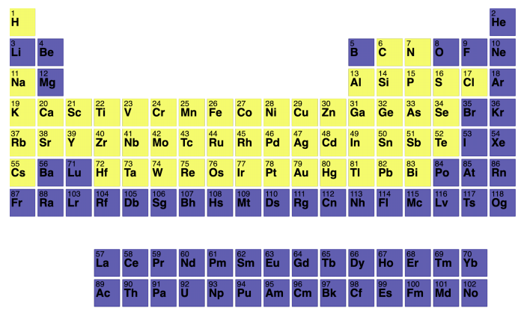
Figure S7. The periodic table outlining elements included in the OC20-Dense datasets.

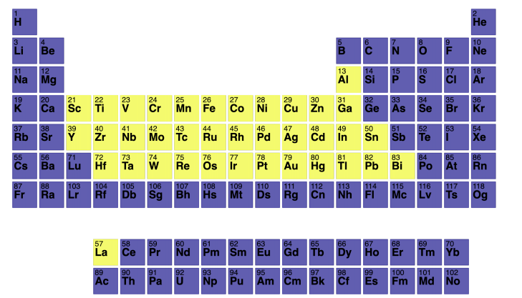
Figure S8. The periodic table outlining elements included in the Alloys-VOCs datasets.

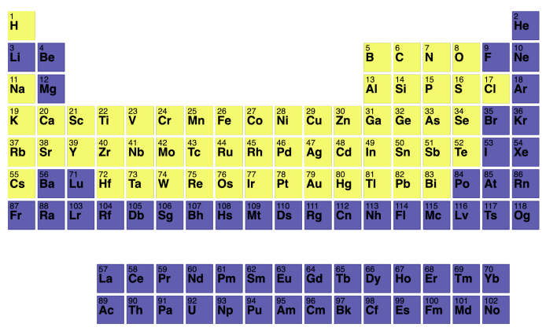
Figure S9. The periodic table outlining elements included in the metal oxides-VOCs datasets.

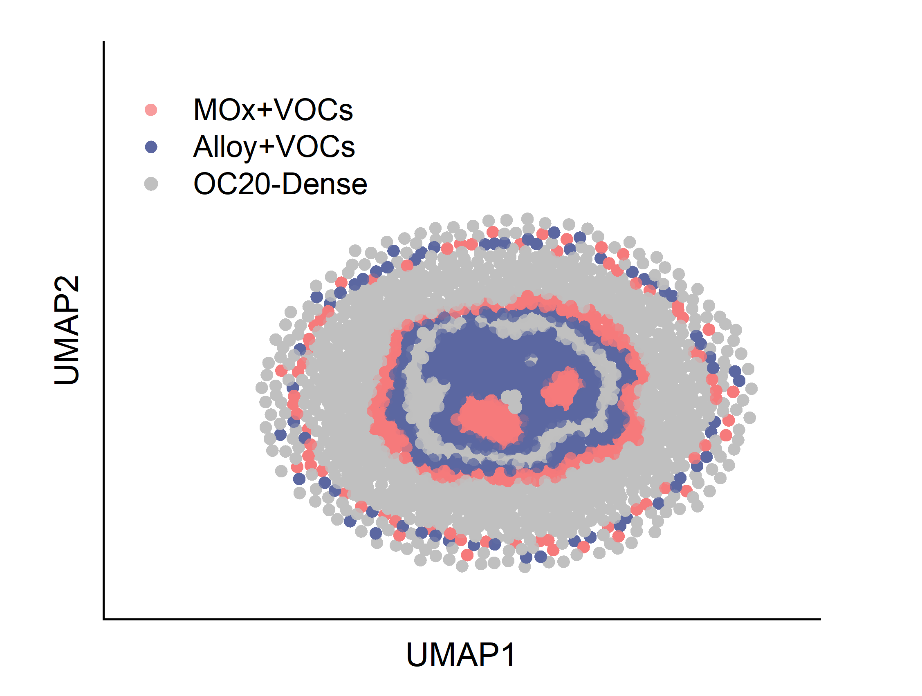
Figure S10. The uniform manifold approximation and projection (UMAP) plot of surface/adsorbate combinations in three datasets, where each combination is depicted by the smooth overlap of atomic positions (SOAP) descriptors of surfaces and RDKit descriptors of adsorbates. This panel illustrates that three datasets represent distinct chemical spaces, with some areas of overlap.

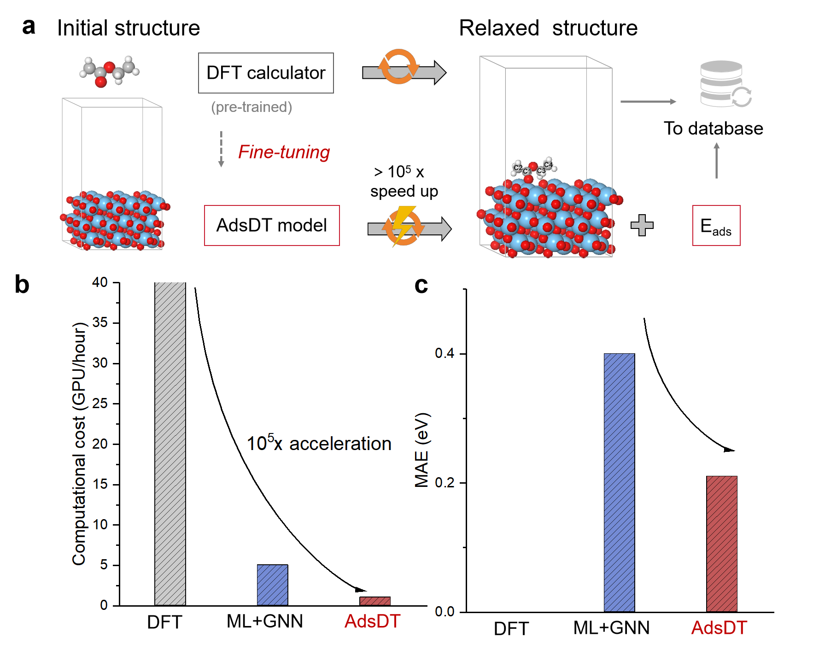
Figure S11. Comparison of the process of building a database using traditional DFT and deep learning model methods. (a) Schematic of the AdsDT framework for accelerated adsorption property prediction. (b) Computational cost comparison (GPU hours) among DFT, baseline ML+GNN, and AdsDT, demonstrating massive speedup. (c) Mean absolute error (MAE) of predicted adsorption energies relative to DFT reference values.

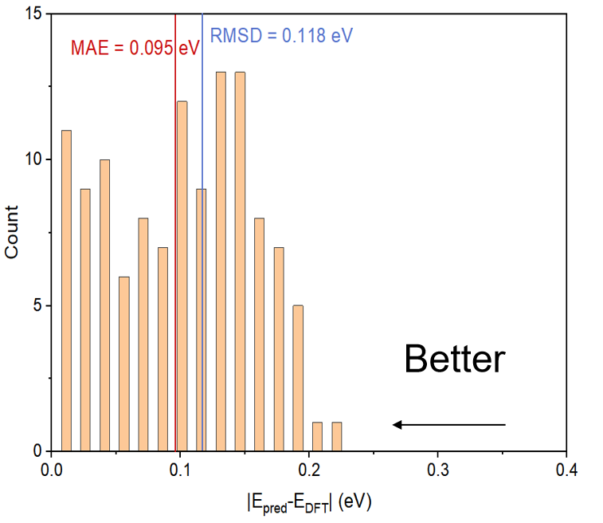
Figure S12. Error distribution of predicted adsorption energies against DFT-calculated adsorption energies.

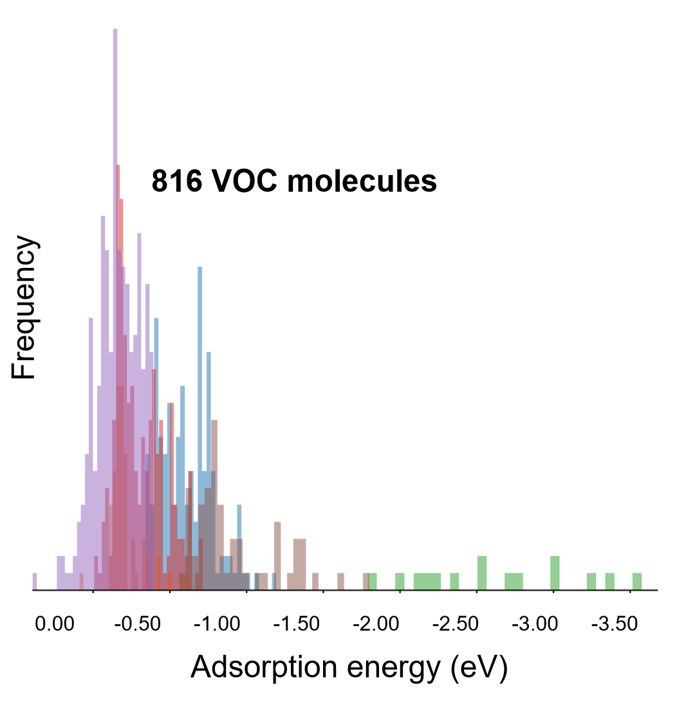
Figure S13. Distribution range of adsorption energy and boxplot statistical significance on TiO₂(Anatase, 101) surface.

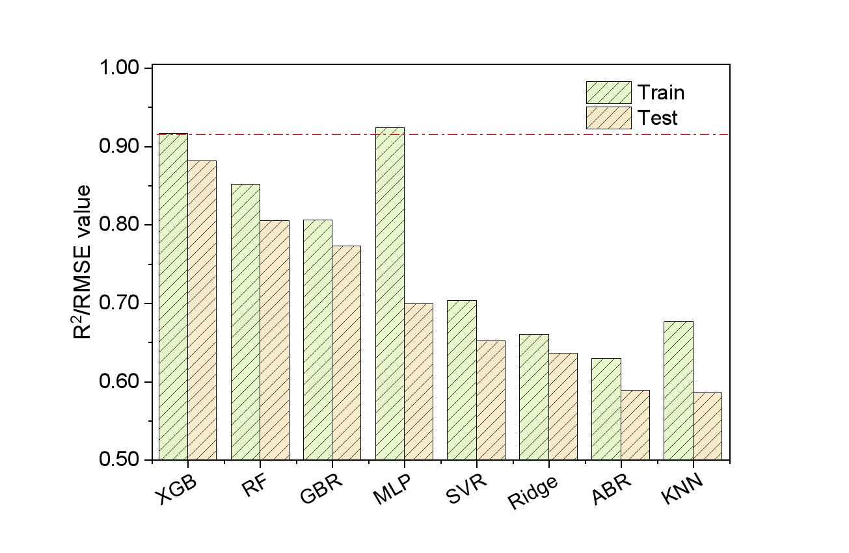
Figure S14. Comparison of SHAP analysis performance for analyzing the influence of functional groups on adsorption energy using on TiO₂(Anatase, 101) surface.
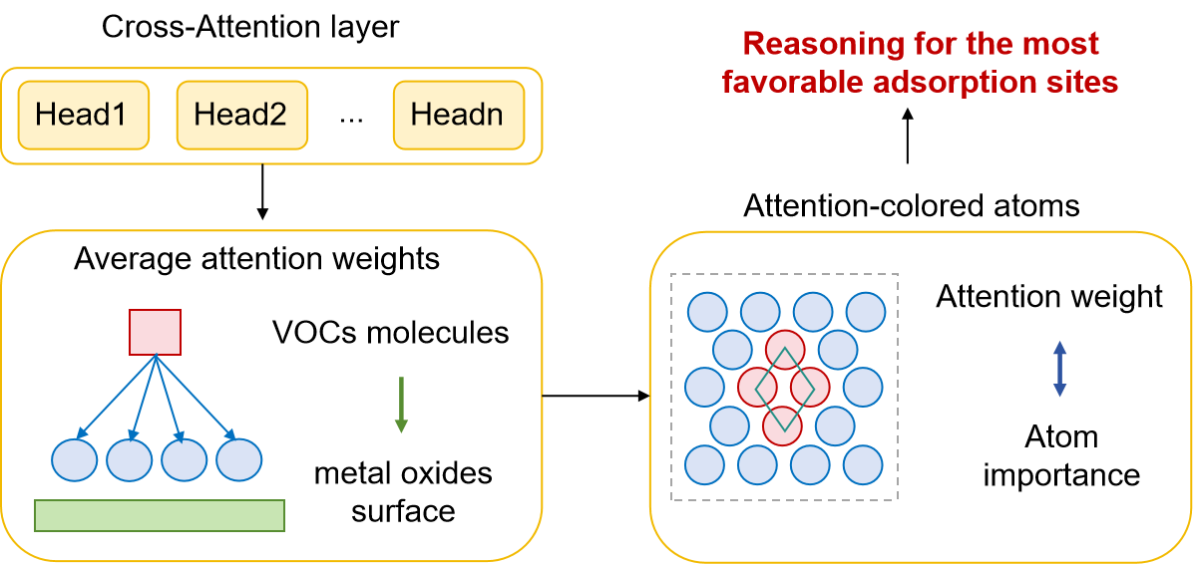
Figure S15. Cross-attention-based reasoning for adsorption site prediction. Multi-head attention scores between the adsorbate and surface atoms are averaged and visualized as an attention-colored surface, highlighting the most favorable adsorption sites.

The cross-attention layer integrates multiple attention heads and averages the attention scores to quantify the interaction importance between adsorbate atoms and surface atoms. The obtained atom-wise attention scores are visualized as attention-colored surface maps, which enable reasoning of the most favorable adsorption sites on the substrate.

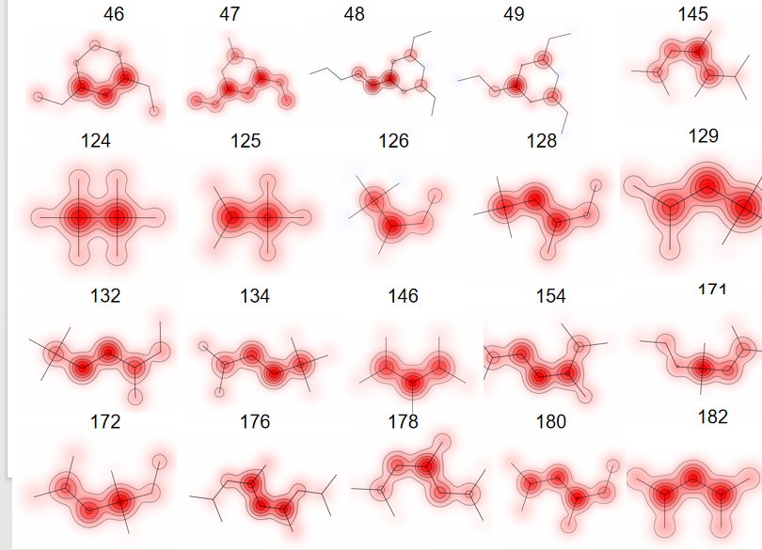
Figure S16. Visualization of singly bonded carbon (C1) atomic attention weights. The red heatmap intensity indicates the contribution magnitude of each atom to adsorption energy prediction, with darker colors representing higher attention weights.

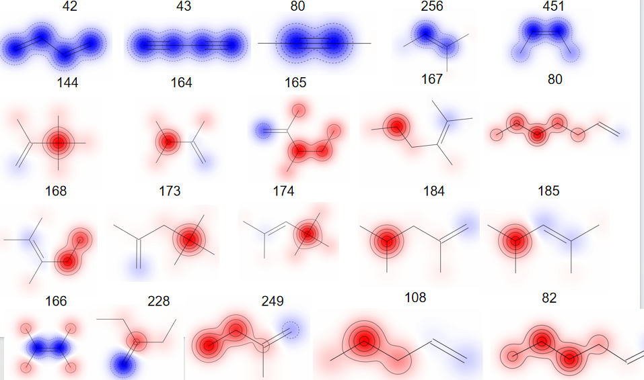
Figure S17. Visualization of double bonded carbon (C2) atomic attention weights.

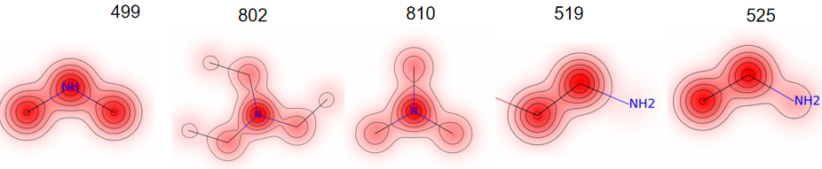
Figure S18. Visualization of singly bonded nitrogen (N1) atomic attention weights.

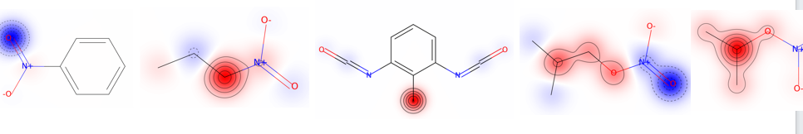Figure S19. Visualization of double bonded nitrogen (N2) atomic attention weights.

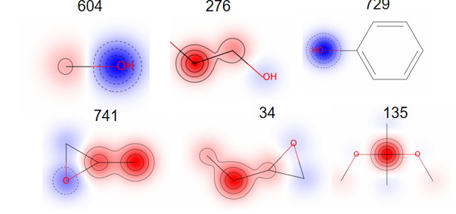
Figure S20. Visualization of singly bonded oxygen (O1) atomic attention weights.

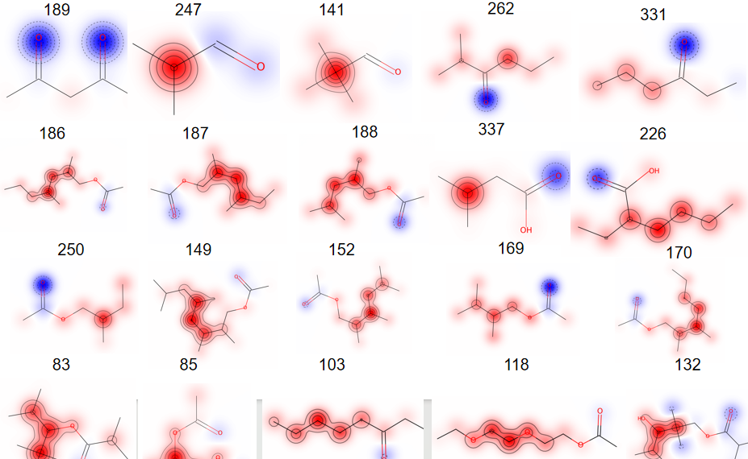
Figure S21. Visualization of double bonded oxygen (O2) atomic attention weights.

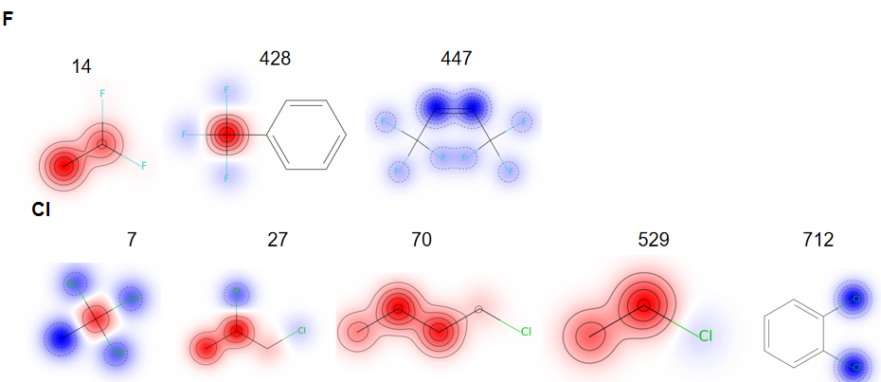Figure S22. Visualization of halogen atom (F, Cl, Br) attention weights.

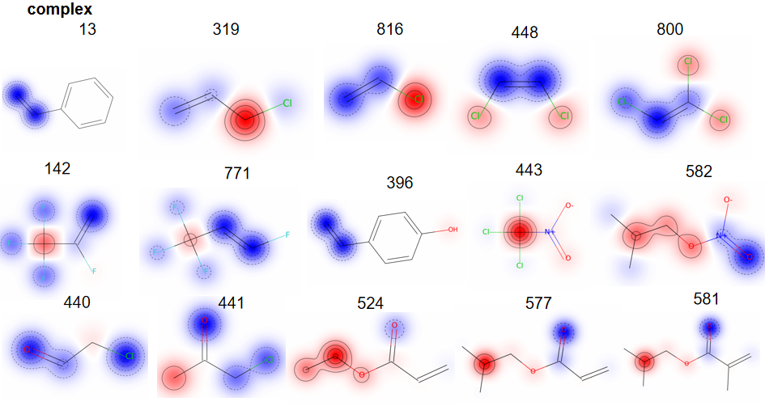Figure S23. Visualization of attention weights for multifunctional VOCs molecules.

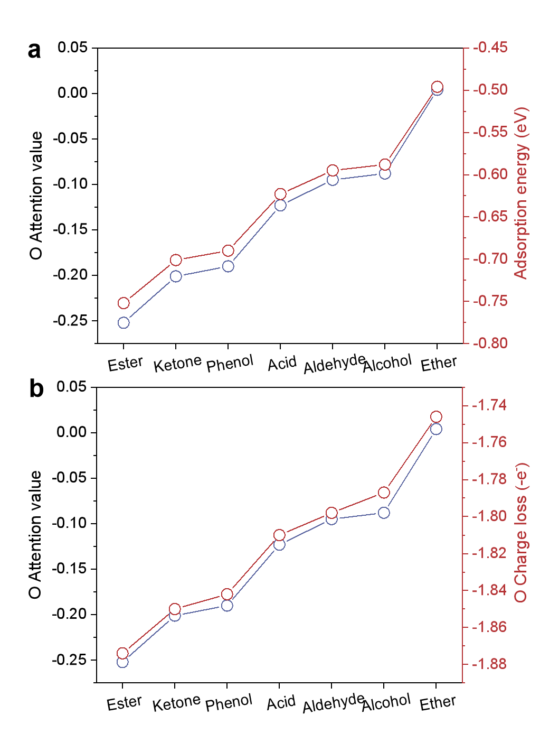
Figure S24. Correlation of oxygen attention values with (a) adsorption energy and (b) oxygen charge loss across different functional groups on TiO₂(Anatase, 101) surface.

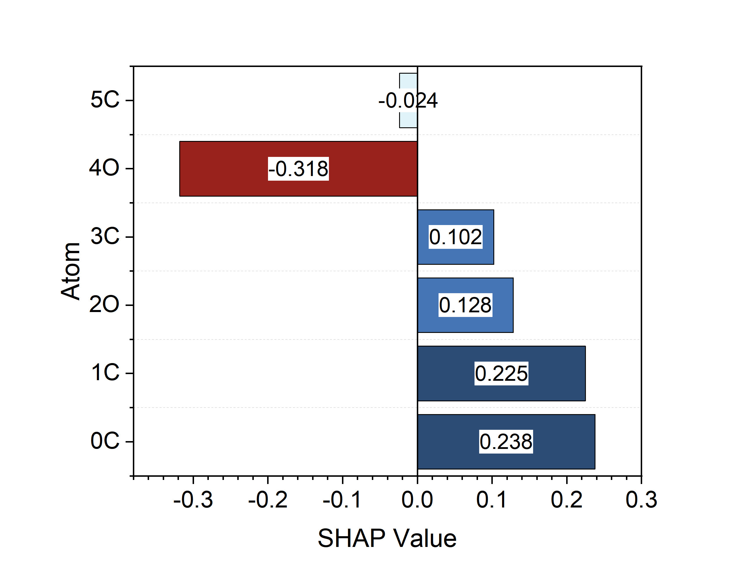
Figure S25. Atomic attention weights obtained from the graph convolutional network (GCN) model for ethyl acetate molecules adsorbed on TiO₂(Anatase, 101) surface. Positive SHAP values denote a promoting effect on the adsorption energy, while negative values correspond to an inhibiting effect. The magnitude of SHAP value indicates the importance of the corresponding atom.

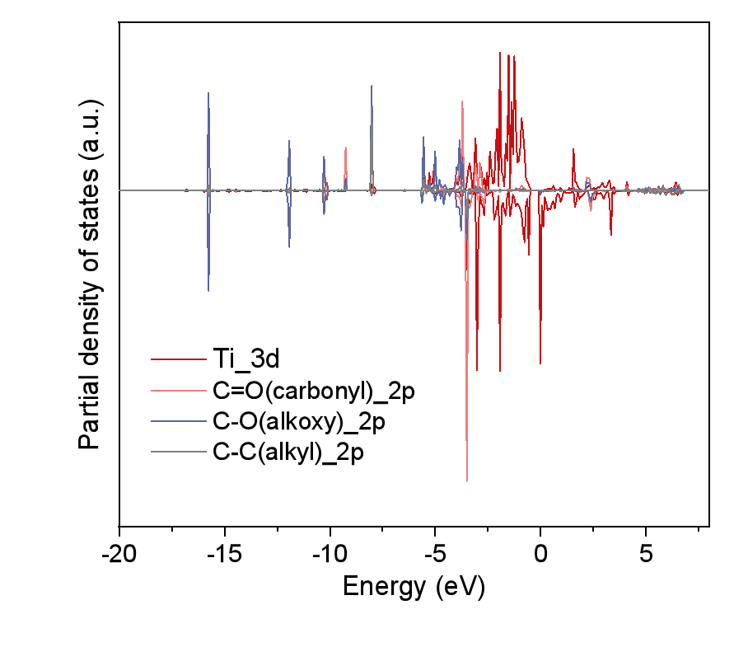
Figure S26. The projected density of states (PDOS) analysis of ethyl acetate adsorption on TiO₂(Anatase, 101) surface.

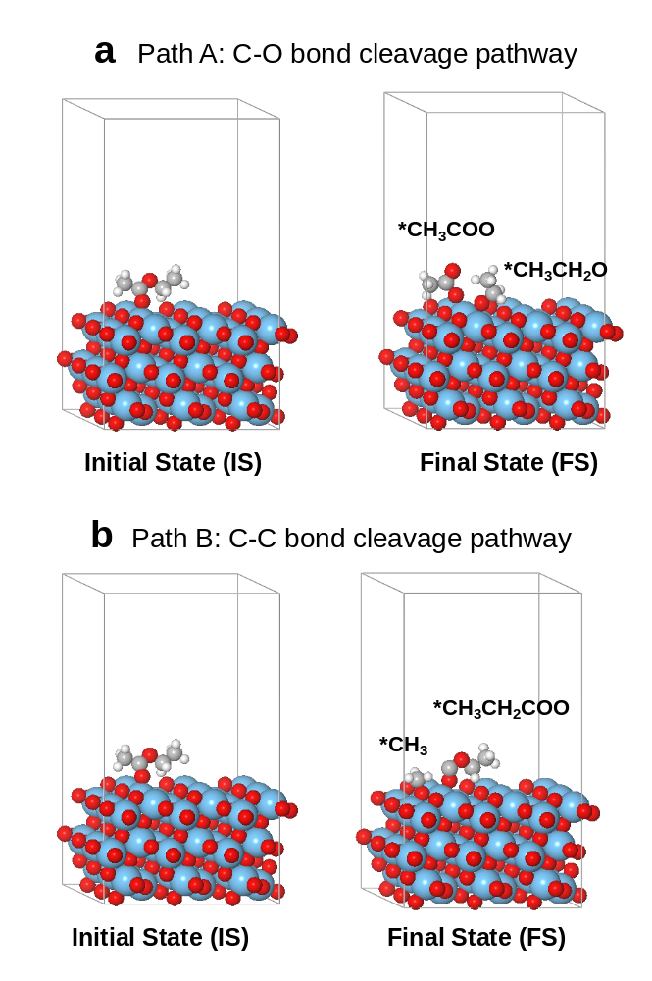
Figure S27. Theoretical reaction pathways for ethyl acetate activation on TiO₂(Anatase, 101) surface. (a) C-O bond cleavage pathway and (b) C-C bond cleavage pathway.

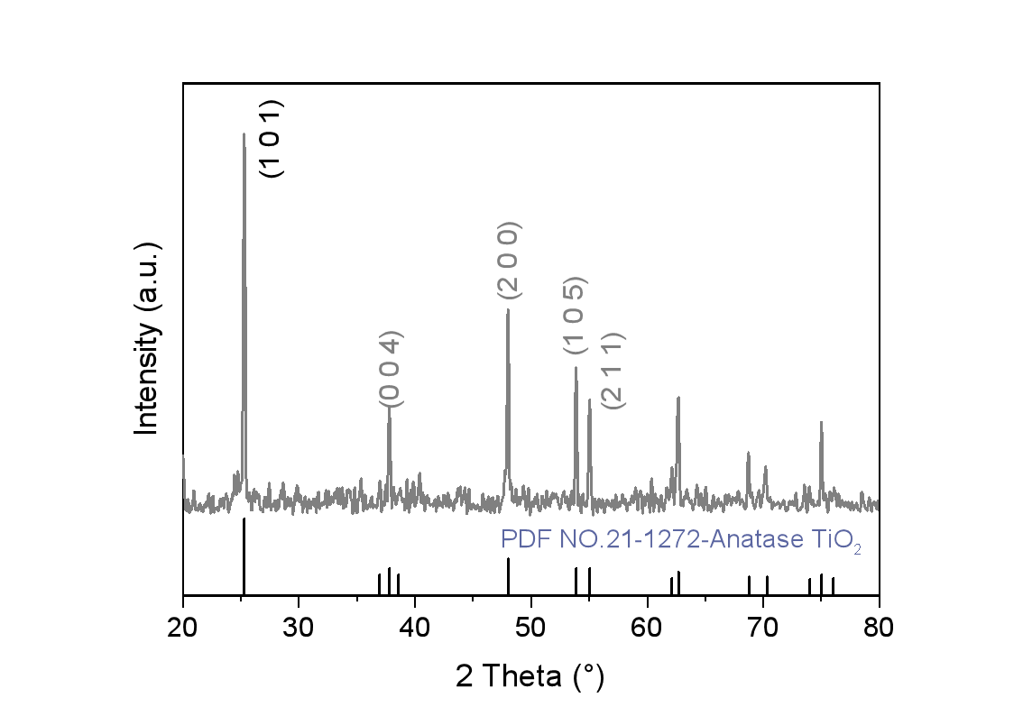
Figure S28. The XRD patterns of TiO₂_Anatase catalyst.

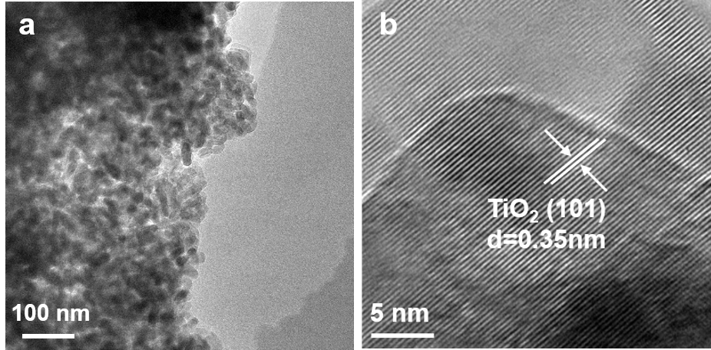
Figure S29. (a) TEM images and (b) the corresponding HRTEM images of TiO₂_Anatase catalyst.

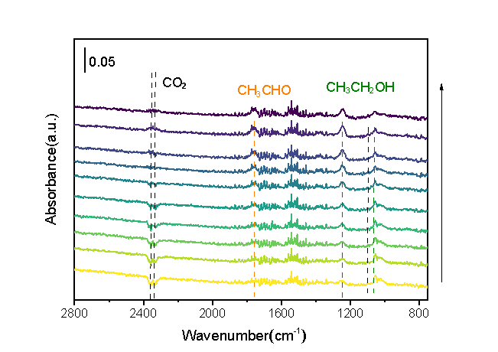
Figure S30. In situ DRIFTS of ethyl acetate adsorption over TiO₂_Anatase catalyst.

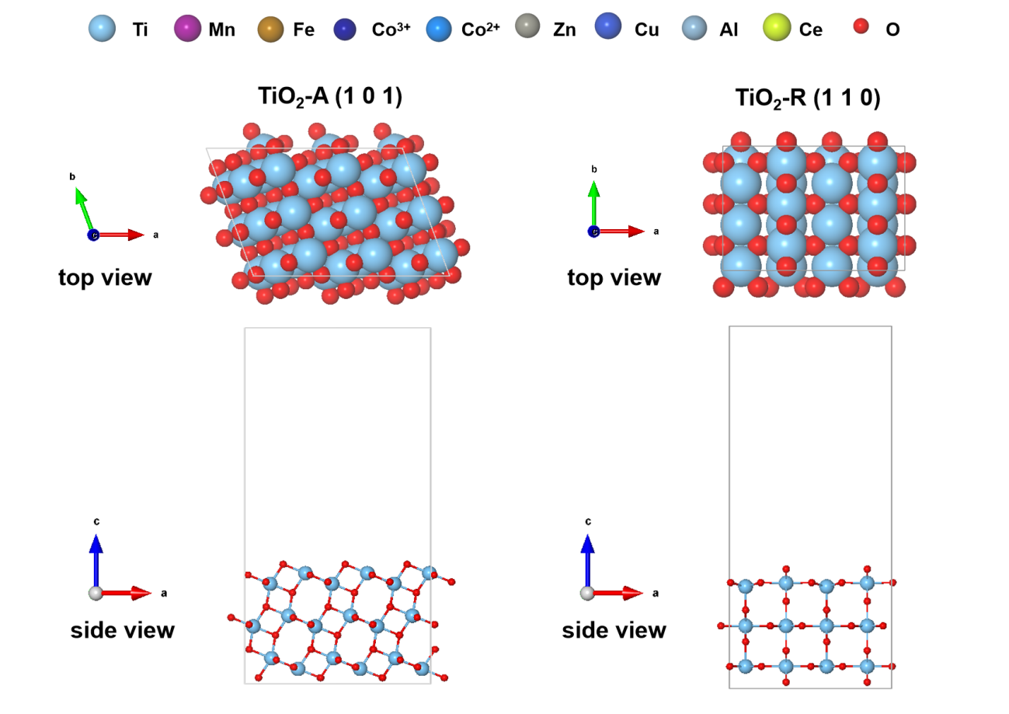
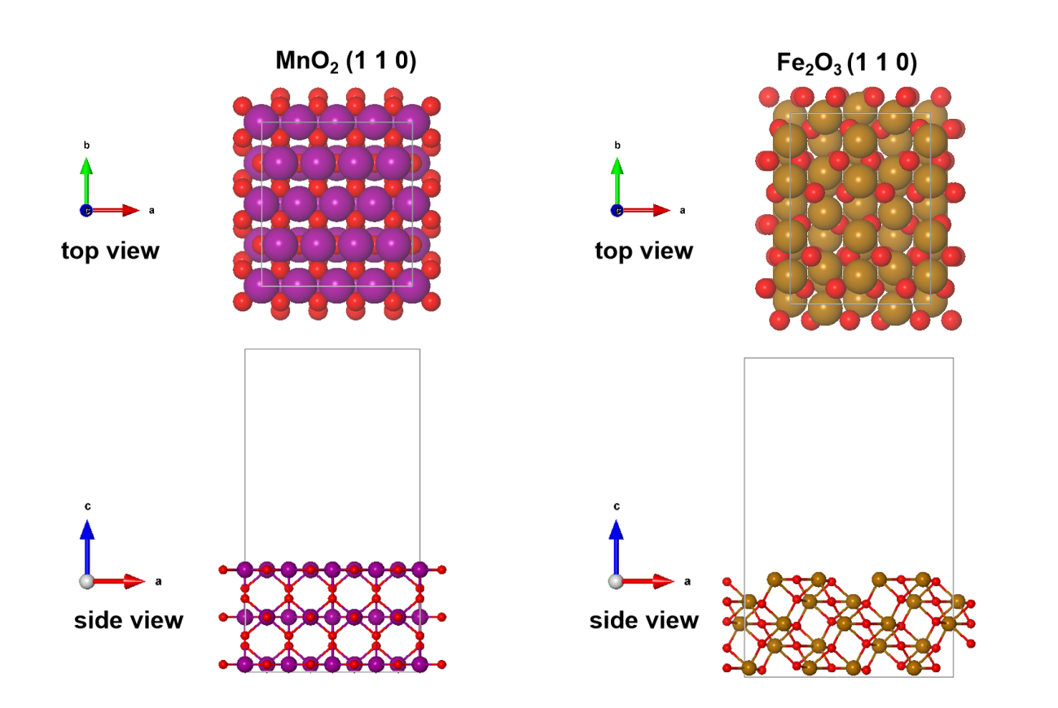
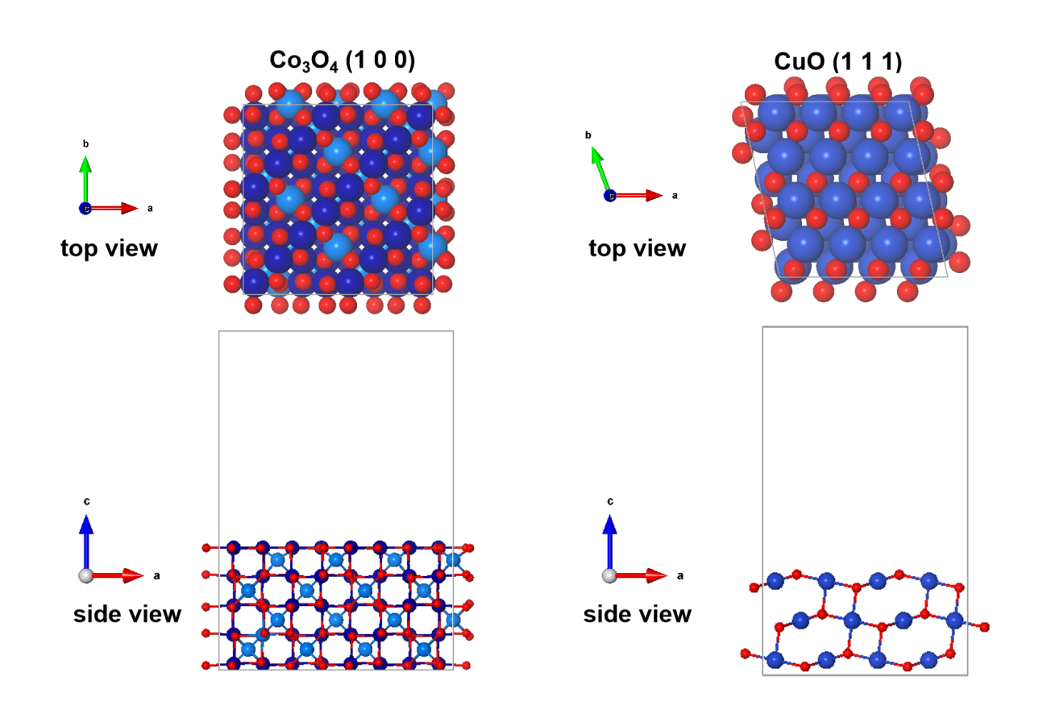
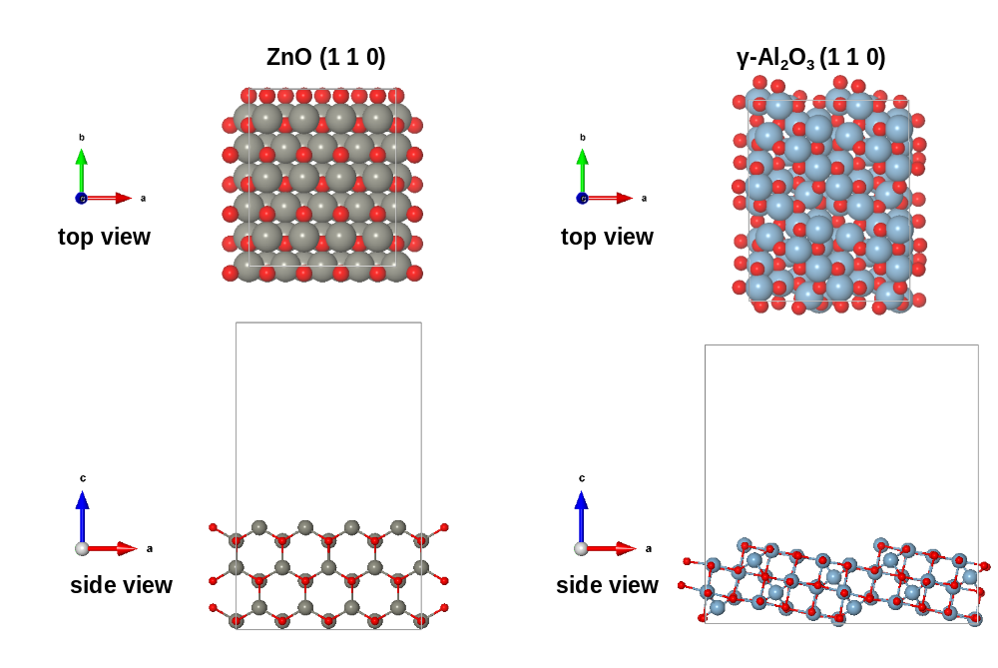

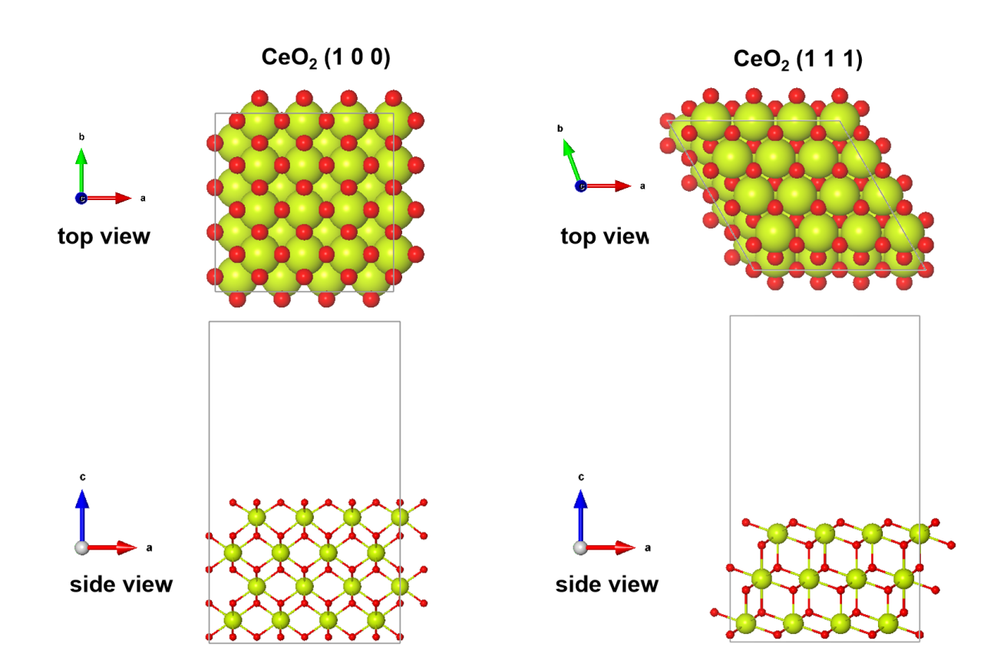
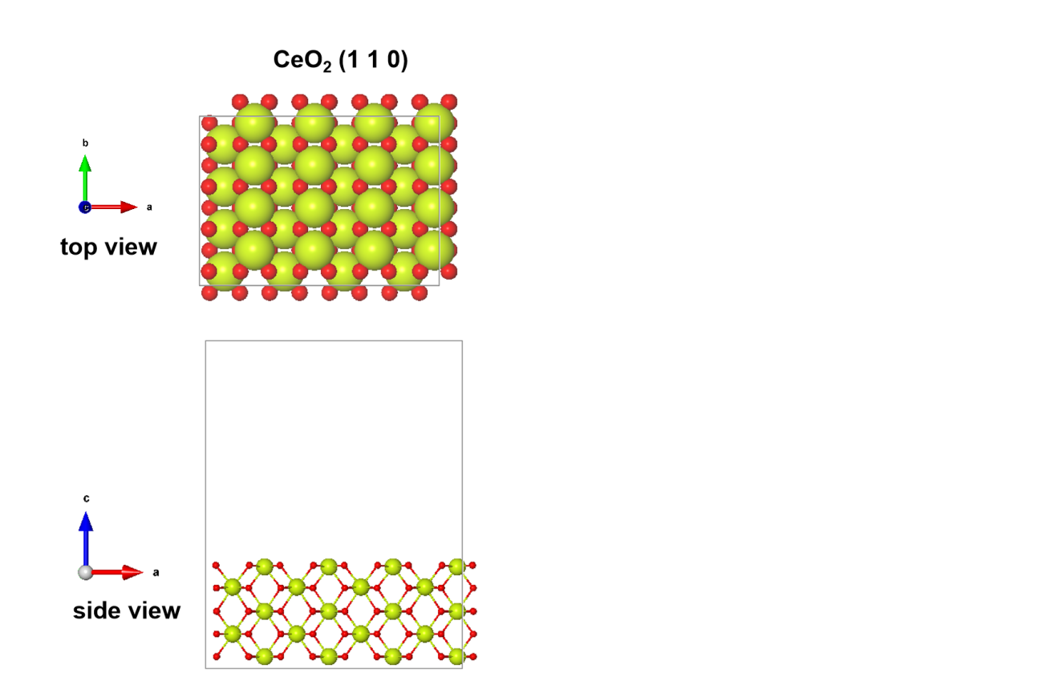
Figure S31. Side and top views of the surface structures of eight metal oxides. A total of 11 representative crystal facets were constructed and employed for VOC adsorption and activation analysis.

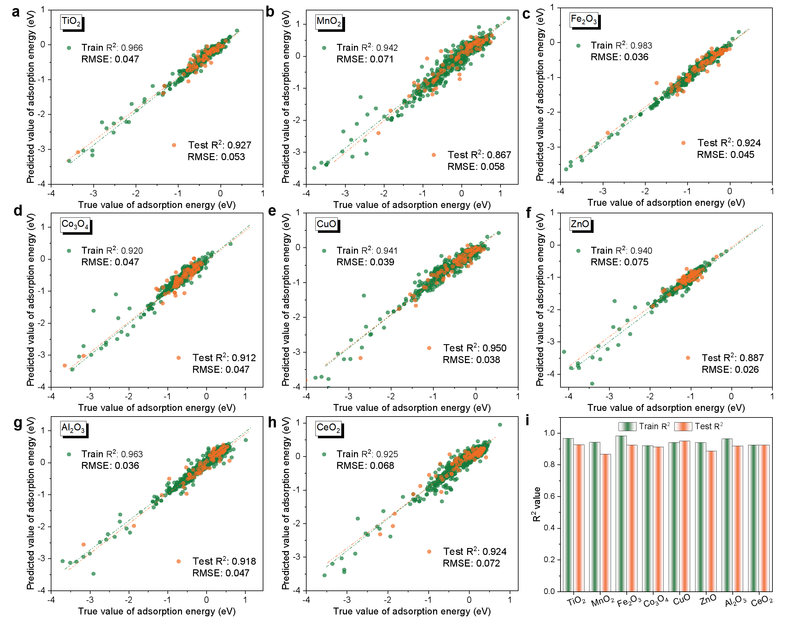
Figure S32. GCN model performance for adsorption energy prediction on eight metal oxides. (a-h) Predicted versus true adsorption energies, with green for training and orange for test data. (i) R2 comparison across all oxide

Supplementary Tables
Table S1. The hyperparameter specification table for AdsDT model

Graph encoder
Node embedding dimension | 128
Edge embedding dimension | 128
Number of attention layers | 3
Number of attention heads | 8
Cutoff of edge definition | 8.0
max neighbors | 12
Vector encoder
Hidden dimension | 128
Number of Linear layers | 2
Cross-modal encoder
Atom embedding dimension | 128
Vector embedding dimension | 128
Number of Gaussians for smearing | 100
Number of cross-attention heads | 4
Number of self-attention heads | 4
Number of attention layers | 1
Number of MLP layers for energy | 3
MLP hidden dimension for energy | 256
Activation function | ReLU
Training conditions
Batch size | 64
Initial learning rate | 0.001
Scheduler | Reduce LR On Plateau
Learning rate factor | 0.7
Learning rate patience | 10
Max epochs | 200

Table S2. Comparison of input requirements for adsorption energy prediction models.

Graph encoders | Relaxed adsorption structure | Adsorption site specification
CGCNN | Required | Required
SchNet | Required | Required
UniMol | Partially | Required
AdsDT (this work) | No required | No required

Table S3. Overall Test MAE results (eV) of AdsDT framework with different graph encoders on OC20-Dense datasets without transfer learning.
Graph encoders | Train set | Test set
CGCNN | 0.159±0.012 | 0.652±0.010
SchNet | 0.162±0.010 | 0.661±0.056
DimeNet++ | 0.152±0.010 | 0.671±0.073
GemNet-OC | 0.159±0.010 | 0.645±0.048
ET | 0.146±0.009 | 0.686±0.065
eSCN | 0.163±0.011 | 0.589±0.046
AdsMT | 0.143±0.008 | 0.571±0.057
AdsDT (this work) | 0.123±0.009 | 0.458±0.048

Table S4. Statistics of the DFT-constructed Alloys-VOCs dataset.
Alloys | Crystal plane | VOCs | Adsorption energy (eV)
Pt | 111 | methylamine | -1.120599
Pt | 111 | acetonitrile | -0.756503
Pt | 111 | methanethiol | -1.080381
Pt | 111 | thiophene | -0.507777
Pt | 111 | dichloromethane | -0.031741
Pt | 111 | chlorobenzene | 0.252378
Pd | 111 | methylamine | -0.954769
Pd | 111 | acetonitrile | -0.708273
Pd | 111 | methanethiol | -0.924821
Pd | 111 | thiophene | -0.510687
Pd | 111 | dichloromethane | -0.182671
Pd | 111 | chlorobenzene | 0.060338
Au | 111 | methylamine | -0.233339
Au | 111 | acetonitrile | 0.120237
Au | 111 | methanethiol | -0.075741
Au | 111 | thiophene | 0.113003
Au | 111 | dichloromethane | 0.033299
Au | 111 | chlorobenzene | 1.339928
Fe | 100 | methylamine | -1.685679
Fe | 100 | acetonitrile | -1.476273
Fe | 100 | methanethiol | -1.384221
Fe | 100 | thiophene | -1.024627
Fe | 100 | dichloromethane | -1.450111
Fe | 100 | chlorobenzene | -0.822562
Ti | 0001 | methylamine | -1.115409
Ti | 0001 | acetonitrile | -1.080303
Ti | 0001 | methanethiol | -1.446331
Ti | 0001 | thiophene | -0.885497
Ti | 0001 | dichloromethane | -1.953341
Ti | 0001 | chlorobenzene | -0.604192
Ag | 111 | methylamine | -0.260289
Ag | 111 | acetonitrile | 0.076157
Ag | 111 | methanethiol | -0.066541
Ag | 111 | thiophene | 0.216093
Ag | 111 | dichloromethane | 0.141929
Ag | 111 | chlorobenzene | 1.031678
Ni | 111 | methylamine | -7.827929
Ni | 111 | acetonitrile | -1.130883
Ni | 111 | methanethiol | -7.589471
Ni | 111 | thiophene | -7.163657
Ni | 111 | dichloromethane | -6.249091
Ni | 111 | chlorobenzene | -0.069902
Cu | 111 | methylamine | -0.662149
Cu | 111 | acetonitrile | -0.511533
Cu | 111 | methanethiol | -0.450461
Cu | 111 | thiophene | -0.135707
Cu | 111 | dichloromethane | -0.003341
Cu | 111 | chlorobenzene | 0.051658
Mo | 110 | methylamine | -1.053119
Mo | 110 | acetonitrile | -0.831823
Mo | 110 | methanethiol | -1.326651
Mo | 110 | thiophene | -0.855887
Mo | 110 | dichloromethane | -0.218601
Mo | 110 | chlorobenzene | -0.056872
Ru | 111 | methylamine | -1.027459
Ru | 111 | acetonitrile | -0.990143
Ru | 111 | methanethiol | -0.983781
Ru | 111 | thiophene | -0.663947
Ru | 111 | dichloromethane | -0.434401
Ru | 111 | chlorobenzene | -0.078642
PtRu | 100 | methylamine | -2.000278
PtRu | 100 | acetonitrile | -2.252783
PtRu | 100 | methanethiol | -2.580881
PtRu | 100 | thiophene | -1.875877
PtRu | 100 | dichloromethane | -3.144711
PtRu | 100 | chlorobenzene | -1.263232
ZnCu | 100 | methylamine | -0.695774
ZnCu | 100 | acetonitrile | -0.497678
ZnCu | 100 | methanethiol | -0.522866
ZnCu | 100 | thiophene | -0.233832
ZnCu | 100 | dichloromethane | -0.120238
ZnCu | 100 | chlorobenzene | 0.127023
FeCo | 210 | methylamine | -1.670159
FeCo | 210 | acetonitrile | -1.268723
FeCo | 210 | methanethiol | -5.812601
FeCo | 210 | thiophene | -0.712437
FeCo | 210 | dichloromethane | -0.795641
FeCo | 210 | chlorobenzene | 2.128668
CuAu | 111 | methylamine | -5.517419
CuAu | 111 | acetonitrile | -0.810463
CuAu | 111 | methanethiol | -5.049231
CuAu | 111 | thiophene | -4.700187
CuAu | 111 | dichloromethane | -4.592311
CuAu | 111 | chlorobenzene | -4.903722
PtBi | 111 | methylamine | -5.581289
PtBi | 111 | acetonitrile | -4.667963
PtBi | 111 | methanethiol | -1.488451
PtBi | 111 | thiophene | -5.005557
PtBi | 111 | dichloromethane | -5.167751
PtBi | 111 | chlorobenzene | -4.875032

Table S5. Statistics of the DFT-constructed metal oxides-VOCs dataset.
Metal oxides | Crystal plane | VOCs | Adsorption energy (eV)
SiO₂ | 100 | propylene | -0.32
SiO₂ | 100 | propane | -0.18
SiO₂ | 100 | toluene | -0.41
SiO₂ | 100 | methanol | -0.57
SiO₂ | 100 | ethyl acetate | -0.49
SiO₂ | 100 | acetonitrile | -0.53
MnO₂ | 110 | propylene | -1.07
MnO₂ | 110 | propane | -0.52
MnO₂ | 110 | toluene | -0.96
MnO₂ | 110 | methanol | -1.03
MnO₂ | 110 | ethyl acetate | -0.81
MnO₂ | 110 | acetonitrile | -0.88
CuO | 111 | propylene | -0.98
CuO | 111 | propane | -0.46
CuO | 111 | toluene | -1.05
CuO | 111 | methanol | -1.12
CuO | 111 | ethyl acetate | -0.93
CuO | 111 | acetonitrile | -0.97
TiO₂ | 110 | propylene | -0.83
TiO₂ | 110 | propane | -0.37
TiO₂ | 110 | toluene | -0.79
TiO₂ | 110 | methanol | -0.86
TiO₂ | 110 | ethyl acetate | -0.72
TiO₂ | 110 | acetonitrile | -0.94
Co₃O₄ | 100 | propylene | -1.23
Co₃O₄ | 100 | propane | -0.61
Co₃O₄ | 100 | toluene | -1.08
Co₃O₄ | 100 | methanol | -1.24
Co₃O₄ | 100 | ethyl acetate | -1.05
Co₃O₄ | 100 | acetonitrile | -1.09
CeO₂ | 100 | propylene | -0.94
CeO₂ | 100 | propane | -0.48
CeO₂ | 100 | toluene | -0.87
CeO₂ | 100 | methanol | -1.04
CeO₂ | 100 | ethyl acetate | -0.76
CeO₂ | 100 | acetonitrile | -0.91
CeO₂ | 111 | propylene | -0.71
CeO₂ | 111 | propane | -0.29
CeO₂ | 111 | toluene | -0.66
CeO₂ | 111 | methanol | -0.82
CeO₂ | 111 | ethyl acetate | -0.64
CeO₂ | 111 | acetonitrile | -0.73
CeO₂ | 110 | propylene | -1.05
CeO₂ | 110 | propane | -0.54
CeO₂ | 110 | toluene | -0.99
CeO₂ | 110 | methanol | -1.08
CeO₂ | 110 | ethyl acetate | -0.87
CeO₂ | 110 | acetonitrile | -1.02

Table S6. Performance table of progressive transfer learning fine-tuning path ablation.

Fine-tuning Strategy | Train R² | Test R² | MAE (eV)
Direc Training | 0.883 | 0.885 | 0.458±0.048
Alloy-VOCs only | 0.818 | 0.724 | 0.487±0.043
MOx-VOCs only | 0.744 | 0.825 | 0.211±0.009
Alloy-VOCs and MOx-VOCs | 0.908 | 0.778 | 0.458±0.048
MOx-VOCs to Alloy-VOCs | 0.791 | 0.720 | 0.429±0.037
Alloy-VOCs to MOx-VOCs  (This work) | 0.860 | 0.847 | 0.051±0.006

Table S7. Dataset size and adsorption energy distribution of three datasets.

Dataset | Dataset size | Surface/adsorbate class |  | Energy range (eV).
OC20-Dense | 1,281,040 | Metals, alloys | Small molecules | -8.14~8.92
Alloy-VOCs | 120 | Metals, alloys | VOCs | -7.65~3.85
MOx-VOCs | 72 | Metal oxides | VOCs | -3.55~1.79

Table S8. Adsorbate information for OC20-Dense dataset.
Adsorbate class | Adsorbates Num. | Adsorbate
O/H only | 4 | *H, *O, *OH, *H₂O
C₁ | 12 | *C,*CH, *CHO, *COH, *CH2, *CH2*O, *CHOH, *CH3,*OCH3, *CH2OH, *CH4, *OHCH3
C₂ | 37 | *C*C,*CCO,*CCH,*CHCO,*CCHO,*COCHO,*CCHOH,*CCH2, *CH*CH,CH2*CO,*CHCHO,*COCH2O, *CHO*CHO, *COHCHO, *COHCOH,*CCH3,*CHCH2,*COCH3,*CHCHOH,*CCH2OH,*CHOCHOH,*COCH2OH, *COHCHOH,*OCHCH3,*COHCH3,*CHOHCH2,*CHCH2OH, *OCH2CHOH,*CHOCH2OH,*COHCH2OH.*CHOHCHOH.*CH2CH3,*OCH2CH3,*CHOHCH3,*CH2CH2OH,*CHOHCH2OH, *OHCH2CH3
Nitrogen-based | 21 | *NH2N(CH3)2, *ONN(CH3)2, *OHNNCH3, *ONH,*NHNH, *N*NH, *NO2NO2, *N*NO, *N2, *ONNH2,*NH2,*NH3,*NONH,*NH,*NO2,*NO,*N,*NO3,*OHNH,,*ONOH, *CN
Surfur-based | 2 | *S, *SH
Fluorine-based | 1 | *F

Table S9. Adsorbate information for Alloys-VOCs and metal oxides-VOCs datasets.
Adsorbate class | Adsorbates Num. | Adsorbate
Alkene | 1 | *C₃H₆ (propene)
Alkane | 1 | *C₃H₈ (propane)
Aromatic | 1 | *C₇H₈ (toluene)
Alcohol | 1 | *CH₃OH (methanol)
Ester | 1 | *C₄H₈O₂ (ethyl acetate)
Amine | 1 | *CH₃NH₂ (methylamine)
Nitrile | 1 | *CH₃CN (acetonitrile)
Thiol | 1 | *CH₃SH (methanethiol)
Sulfide / Inorganic sulfur | 1 | *H₂S (hydrogen sulfide)
Heterocycle (S-containing) | 1 | *C₄H₄S (thiophene)
Halogen-containing | 2 | *CH₂Cl₂ (dichloromethane), *C₆H₅Cl (chlorobenzene)

Table S10. Chemical family distribution of adsorbates in the OC20-Dense dataset.
Chemical family | Adsorbates Num.
Hydrocarbons, alcohols, aldehydes, ketones and ethers | 32
Carbonates, carboxylic acids, and esters | 18
Amines and imines | 32
Amidines | 40
Thiols, thials, thioketones and thioethers | 19
Amides | 15
Oximes | 12
Carbamate esters | 15
Aromatic molecules | 24

Table S11. Chemical family distribution of adsorbates in the Alloys-VOCs and metal oxides-VOCs datasets.
Chemical family | Adsorbates Num.
Aliphatic hydrocarbons | 2
Aromatic compounds | 2
Alcohols | 1
Esters | 1
Amines/Nitrogen-containing | 2
Sulfur-containing | 3
Halogen-containing | 1
Aliphatic hydrocarbons | 2
Aromatic compounds | 2

Table S12. Verify the selected data information, predictions, and DFT adsorption energy.

Metal oxide surfaces | VOCs  SMILES | Predicted-  Energy (eV) | DFT-calculated energy (eV) | |E_{pre}-E_{DFT}|  (eV)
TiO₂ (101) | **CO** | -0.4006 | -0.493 | 0.0907
TiO₂ (101) | CCO | 0.0535 | -0.369 | 0.0675
TiO₂ (101) | CCCO | -0.1853 | -0.245 | 0.0452
TiO₂ (101) | CC(C)O | -0.327 | -0.124 | 0.0228
TiO₂ (101) | CCCCO | 0.4123 | 0.002 | 0.0007
TiO₂ (101) | CC(C)(C)O | -0.4873 | 0.122 | 0.0225
TiO₂ (101) | CC(C)CO | -0.3245 | 0.246 | 0.0451
TiO₂ (101) | C1CCCCC1O | -0.1602 | 0.365 | 0.0668
TiO₂ (101) | c1ccccc1O | 0.0259 | 0.491 | 0.0904
TiO₂ (101) | Cc1ccccc1O | -0.2228 | 0.614 | 0.1131
TiO₂ (101) | CCc1ccccc1O | 0.1616 | 0.735 | 0.1344
TiO₂ (101) | OC1CCCC1 | -0.2481 | 0.857 | 0.1575
TiO₂ (101) | OCCO | 0.2583 | 0.982 | 0.1808
TiO₂ (101) | OCCCO | 0.826 | 1.103 | 0.2022
TiO₂ (101) | CC(O)CO | 0.4975 | 1.224 | 0.2247
TiO₂ (101) | C=O | 0.4103 | 1.348 | 0.2493
TiO₂ (101) | CC=O | 1.1675 | 1.469 | 0.2699
TiO₂ (101) | **CCC=O** | 0.0731 | 1.592 | 0.2908
MnO₂ (110) | CC(C)C=O | -1.2804 | -1.59 | 0.2918
MnO₂ (110) | CCCC=O | -1.1715 | -1.47 | 0.2705
MnO₂ (110) | C1CCCCC1C=O | -1.477 | -1.348 | 0.2472
MnO₂ (110) | c1ccccc1C=O | -1.3411 | -1.227 | 0.2257
MnO₂ (110) | Cc1ccccc1C=O | -1.0368 | -1.103 | 0.2021
MnO₂ (110) | O=CC=O | -1.2937 | -0.979 | 0.1796
MnO₂ (110) | O=Cc1ccccc1O | -2.1817 | -2.574 | 0.4725
MnO₂ (110) | CC(=O)C | -1.9196 | -2.45 | 0.4502
MnO₂ (110) | CC(=O)CC | -2.5281 | -2.328 | 0.4277
MnO₂ (110) | CCC(=O)CC | -2.0577 | -2.203 | 0.4043
MnO₂ (110) | CC(=O)C(C)C | -2.0997 | -2.082 | 0.3826
MnO₂ (110) | C1CCCCC1C(=O)C | -2.2639 | -1.961 | 0.3598
MnO₂ (110) | CC(=O)c1ccccc1 | 0.3953 | 0.488 | 0.0898
MnO₂ (110) | CC(=O)Cc1ccccc1 | 0.5844 | 0.614 | 0.1128
MnO₂ (110) | C1CC(=O)CC1 | 0.4929 | 0.732 | 0.1327
MnO₂ (110) | **CO** | 0.5112 | 0.857 | 0.1573
MnO₂ (110) | O=C1CCCC1 | 0.7403 | 0.981 | 0.1805
MnO₂ (110) | CC(=O)C(=O)C | 0.3824 | 1.101 | 0.2021
Fe₂O₃ (110) | CC(=O)CC(C)=O | -0.6802 | -0.859 | 0.1577
Fe₂O₃ (110) | CC(=O)C1CCCCC1 | -0.4156 | -0.738 | 0.1358
Fe₂O₃ (110) | CCC(=O)C(C)C | -0.3579 | -0.612 | 0.1126
Fe₂O₃ (110) | CC(=O)c1ccc(C)cc1 | -0.4925 | -0.491 | 0.0901
Fe₂O₃ (110) | C1CC(=O)C1 | 0.0163 | -0.367 | 0.0672
Fe₂O₃ (110) | C(=O)O | -0.7536 | -0.247 | 0.0455
Fe₂O₃ (110) | CC(=O)O | -0.9998 | -1.225 | 0.2252
Fe₂O₃ (110) | CCC(=O)O | -0.8371 | -1.1 | 0.2013
Fe₂O₃ (110) | CCCC(=O)O | -0.3501 | -0.983 | 0.1806
Fe₂O₃ (110) | CC(C)C(=O)O | -0.4388 | -0.859 | 0.1579
Fe₂O₃ (110) | c1ccccc1C(=O)O | -0.387 | -0.735 | 0.1352
Fe₂O₃ (110) | Cc1ccccc1C(=O)O | -0.411 | -0.612 | 0.1125
Fe₂O₃ (110) | O=C(O)C(=O)O | -1.3835 | -1.714 | 0.3145
Fe₂O₃ (110) | O=C(O)CC(=O)O | -1.2962 | -1.594 | 0.2931
Fe₂O₃ (110) | C1CCCCC1C(=O)O | -1.4401 | -1.47 | 0.2702
Co₃O₄ (100) | **CCC=O** | -1.4536 | -1.347 | 0.2478
Co₃O₄ (100) | COC(=O)C | -1.3073 | -1.228 | 0.2257
Co₃O₄ (100) | CCOC(=O)C | -1.4538 | -1.103 | 0.2022
Co₃O₄ (100) | CCOC(=O)CC | -0.7847 | -0.979 | 0.1793
Co₃O₄ (100) | COC(=O)CC | -0.5295 | -0.858 | 0.1577
Co₃O₄ (100) | CC(C)OC(=O)C | -0.6395 | -0.733 | 0.1342
Co₃O₄ (100) | C1CCCCC1OC(=O)C | -0.6565 | -0.614 | 0.1125
Co₃O₄ (100) | c1ccccc1OC(=O)C | -0.3575 | -0.491 | 0.0901
Co₃O₄ (100) | COC(=O)c1ccccc1 | -0.7014 | -0.367 | 0.0672
Co₃O₄ (100) | CCOC(=O)c1ccccc1 | -1.2434 | -1.595 | 0.2925
Co₃O₄ (100) | COC(=O)CC(=O)OC | -1.3956 | -1.47 | 0.2701
Co₃O₄ (100) | CCOC(=O)CC(=O)OCC | -1.1047 | -1.349 | 0.2475
Co₃O₄ (100) | C1CC(=O)OC1 | -1.1363 | -1.228 | 0.2258
Co₃O₄ (100) | CC1CC(=O)OC1=O | -1.0086 | -1.102 | 0.2022
CuO (111) | COC(=O)C(C)C | -0.7274 | -0.981 | 0.1805
CuO (111) | CCOC(=O)C(C)C | 0.1391 | 0.12 | 0.0221
CuO (111) | Oc1ccccc1 | 0.3872 | 0.247 | 0.0457
CuO (111) | Oc1ccc(C)cc1 | 0.2266 | 0.367 | 0.0675
CuO (111) | **CC(=O)C(=O)C** | 0.375 | 0.49 | 0.0898
CuO (111) | Oc1cc(C)ccc1 | 0.5567 | 0.614 | 0.1128
CuO (111) | Oc1cccc(C)c1 | 0.2624 | 0.732 | 0.1325
CuO (111) | Oc1ccccc1C | -1.3427 | -1.591 | 0.2911
CuO (111) | Oc1ccc(C(C)C)cc1 | -1.2097 | -1.471 | 0.2698
CuO (111) | Oc1ccc(Cl)cc1 | -1.1206 | -1.348 | 0.2475
CuO (111) | Oc1ccc(F)cc1 | -1.1742 | -1.225 | 0.2252
CuO (111) | Oc1ccccc1O | -1.0211 | -1.1 | 0.2012
CuO (111) | Oc1ccc(O)cc1 | -1.319 | -0.981 | 0.1798
CuO (111) | COC | 0.4458 | 0.49 | 0.0898
CuO (111) | COCC | 0.7069 | 0.615 | 0.1127
CuO (111) | COC(C)C | 0.5346 | 0.732 | 0.1325
CuO (111) | C1CCCCC1OC | 0.5297 | 0.858 | 0.1571
CuO (111) | c1ccccc1OC | 0.9134 | 0.98 | 0.1802
CuO (111) | COCc1ccccc1 | 0.3431 | 1.104 | 0.2028
ZnO (100) | CCOC(C)C | -0.397 | -0.491 | 0.0905
ZnO (100) | C1COCCO1 | -0.3671 | -0.368 | 0.0678
ZnO (100) | C1CCOC1 | -0.2169 | -0.244 | 0.0452
ZnO (100) | **CCOC(=O)C** | -0.1815 | -0.122 | 0.0225
ZnO (100) | CCOCC | -0.0469 | 0 | 0.0002
ZnO (100) | CN | -0.1659 | 0.123 | 0.0225
ZnO (100) | CCN | -0.8475 | -1.1 | 0.2012
ZnO (100) | CCCN | -0.3891 | -0.981 | 0.1805
ZnO (100) | CC(C)N | -1.0056 | -0.86 | 0.1583
ZnO (100) | CCCCN | -0.8444 | -0.734 | 0.1341
ZnO (100) | c1ccccc1N | -0.3315 | -0.612 | 0.1125
ZnO (100) | Cc1ccccc1N | -0.9881 | -0.492 | 0.0908
Al₂O₃ (110) | CN(C)C | -1.1391 | -1.348 | 0.2475
Al₂O₃ (110) | CCN(C)C | -1.0821 | -1.225 | 0.2251
Al₂O₃ (110) | c1ccccc1CN | -0.991 | -1.1 | 0.2012
Al₂O₃ (110) | C=C | -1.0792 | -0.98 | 0.1798
Al₂O₃ (110) | CC=C | -0.8033 | -0.857 | 0.1574
Al₂O₃ (110) | C=CC | -1.1044 | -0.734 | 0.1341
Al₂O₃ (110) | C1=CCCC1 | -1.014 | -1.228 | 0.2257
Al₂O₃ (110) | C1=CC=CC=C1 | -0.8661 | -1.102 | 0.2022
Al₂O₃ (110) | CC=CC | -1.1484 | -0.981 | 0.1798
Al₂O₃ (110) | **Oc1cccc(C)c1** | -1.2519 | -0.861 | 0.1592
Al₂O₃ (110) | C#C | -0.6995 | -0.732 | 0.1325
Al₂O₃ (110) | CC#C | -1.3287 | -0.614 | 0.1128
Al₂O₃ (110) | C#CC | 0.2285 | 0.246 | 0.0455
Al₂O₃ (110) | C1=CCCCC1 | 0.4202 | 0.369 | 0.0678
Al₂O₃ (110) | CCl | 0.2865 | 0.49 | 0.0902
CeO₂ (111) | CBr | 0.4908 | 0.613 | 0.1125
CeO₂ (111) | CI | 0.7389 | 0.735 | 0.1352
CeO₂ (111) | CCCl | 0.3907 | 0.858 | 0.1574
CeO₂ (111) | CCBr | -1.5397 | -1.839 | 0.3378
CeO₂ (111) | CC(C)Cl | -1.2838 | -1.714 | 0.3145
CeO₂ (111) | C1CCCCC1Cl | -1.9143 | -1.595 | 0.2929
CeO₂ (111) | c1ccccc1Cl | -1.5947 | -1.47 | 0.2702
CeO₂ (111) | c1ccccc1F | -1.4835 | -1.348 | 0.2492
CeO₂ (111) | c1ccccc1Br | -1.8345 | -1.226 | 0.2255

Table S13. Adsorption energy predictions for 816 VOC molecules on TiO₂(Anatase, 101) surface by the transferable AdsDT model.

SMILES | Name |  | Adsorption Energy (eV)
CC1=CC(=CC(=C1)C(C)(C)C)C | 1,3,5-Trimethyl-2-tert-butylbenzene |  | -9.19E-05
CCCCOCCOCC(C)O | 1-[1-Methyl-2-(2-propenyloxy)ethoxy]-2-propanol |  | -0.19810009
C(C(C(F)(F)F)F)(C(C(F)(F)F)(F)F)F | 2-Fluoro-2-(trifluoromethyl)-3,3-bis(trifluoromethyl)propane |  | -0.606046677
C(C(F)(F)F)F | 1,1,1,2-Tetrafluoroethane |  | -0.968252242
CC(CC(F)(F)F)(F)F | 1,1,1,3,3-Pentafluorobutane |  | -0.822184801
C(C(F)F)C(F)(F)F | 1,1,1,3,3-Pentafluoropropane |  | -0.756012261
CC(Cl)(Cl)Cl | 1,1,1-Trichloroethane |  | -0.821821272
C(C(Cl)Cl)Cl | 1,1,2-Trichloroethane |  | -0.680818081
CC1CCCC1(C)C | 1-Methyl-1-isopropylcyclohexane |  | -0.140621424
CC1CCCC(C1)(C)C | 1,1,2-Trimethylcyclopentane |  | -0.214852571
CC1CCC(C1)(C)C | 1-Methyl-1-isopropylcyclopentane |  | -0.10657385
CC(Cl)Cl | 1,1-Dichloroethane |  | -0.687039673
C=C(Cl)Cl | 1,1-Dichloroethene |  | -0.966022193
CC(F)F | 1,1-Difluoroethane |  | -0.694769502
CC1(CCCCC1)C | 1,1-Dimethylcyclohexane |  | -0.147830725
CC1(CCCC1)C | 1,1-Dimethylcyclopentane |  | -0.219744384
CC1=C(C(=CC=C1)C)C |  | 1,4-Dimethylbenzene | -0.738592386
CC1CCCC(C1C)C |  | 1-Isopropyl-1-methylcyclohexane | -0.122713834
CC1CCC(C1C)C |  | 1-Isopropyl-1-methylcyclopentane | -0.126177102
CC1=CC(=C(C=C1)C)C |  | 1,3,5-Trimethylbenzene | -0.746987343
CC1CC(C(C1)C)C |  | 1-isopropyl-3-methylcyclopentane | -0.180014759
CC=C=C |  | 1,2-Butadien | -0.773476362
CCC(CO)O |  | 1,2-Butanediol | 0.0616108179092407
CC(=O)C1=CC=CC=C1C(=O)C |  | 1,4-Diacetylbenzene | -0.658244669
C(CBr)Br |  | 1,1,2-Tribromoethane | -0.793578923
C(CCl)Cl |  | 1,1,2-Trichloroethane | -0.680818081
CC(CCl)Cl |  | 1,2-Dichloropropane | -0.560841739
CCCCC(CO)O |  | 2-Methyl-2,4-pentanediol | -0.167913735
CC1CCCCC1C |  | 1,2-Dimethylcyclohexane | -0.207915694
CC1=C(CCCC1)C |  | 1-ethyl-2,4-dimethyl-Benzene | -0.689512372
CC1CCCC1C |  | 1-Ethyl-3,5-dimethylbenzene | -0.630259752
CCC1=CC=CC(=C1C)C |  | 1-Propyl-2,4-dimethylbenzene | -0.607090831
CCC1=CC(=C(C=C1)C)C |  | 1-Propyl-3,5-dimethylbenzene | -0.562846661
CCC1CO1 |  | 2-Ethyloxirane | -0.464762658
CCC=C=C |  | 1,2-pentadiene | -0.74189204
C=C=C |  | 1,2-Propadiene | -0.800262094
CC(COC(=O)C)OC(=O)C |  | 1,2-Diacetoxypropane | 0.191894233226776
CCC1CC(CC(C1)CC)CC |  | 1-Ethyl-2,4-dipropylcyclohexane | -0.150840551
CC1=CC(=CC(=C1)C)C |  | 1,3,5-Trimethylbenzene | -0.746987343
CC1CC(CC(C1)C)C |  | 1-Isopropyl-2-methylcyclopentane | -0.179658979
CCCC1CC(CC(C1)CCC)CCC |  | 1-Butyl-3-propylcyclohexane | -0.180541873
C=CC=C |  | 1,3-Butadiene | -3.022899628
C#CC#C |  | 1,3-Butadiyne | -0.920466363
CC(CCO)O |  | 2-Methylpropane-1,2-diol | -0.038806379
C(C(C(F)(F)Cl)(F)F)(F)Cl |  | 1,1,2,2-Tetrafluoro-1,2-dichloroethane | -1.215309143
CCC1CCCC(C1)CC |  | 1-Propyl-1-ethylcyclopentane | -0.116070837
CCC1CC(CC(C1)CC)C |  | 1-Propyl-1-ethylcyclopentane | -0.116041332
CCCCCC1CC(CC(C1)CC)CC |  | 1-hexyl-3-isopropylcyclohexane | -0.167893112
CCCC1CC(CC(C1)CC)CC |  | 3-butyl-1-(2-ethylpropyl)cyclopentane | -0.14653179
CC1CCCC(C1)C |  | 1,3-dimethylcyclopentane | -0.255898625
CC1CCC(C1)C |  | 1-Methylcyclobutane | -0.344052732
CCC1=C(C=CC=C1C)C |  | 1-Ethyl-2,4-dimethylbenzene | -0.689512372
CCC1=C(C=C(C=C1)C)C |  | 1-propyl-3,5-dimethylbenzene | -0.562846661
CCC1=CC(=CC(=C1)C)C |  | 1-Ethyl-3,5-dimethylbenzene | -0.630259752
CCCC1=CC(=CC=C1)CCC |  | 1-Propyl-4-butylbenzene | -0.343497813
C1COCO1 |  | 1,3-dioxolane | -0.546095788
CCCC1CC(CC)CC(CCC)C1 |  | 1-Butyl-4-ethylcyclohexane | -0.173296839
CCCCC1CC(CCC)CC(CCC)C1 |  | 1-pentyl-3,5-dipropylcyclohexane | -0.178478867
CC(C)C1=CC=C(C=C1)C(C)C |  | 1-Isopropyl-4-(propan-2-yl)benzene | -0.406528831
C(CCO)CO |  | 2-propoxy-1-propanol | -0.066951454
CCC1CCC(CC1)CC |  | 1-Ethyl-3-propylcyclopentane | -0.165879965
CC1CCC(CC1)C |  | 1-isopropyl-3-methylcyclopentane | -0.180014759
CCC1=C(C=CC(=C1)C)C |  | 1-Ethyl-2,5-dimethylbenzene | -0.685565531
C1COCCO1 |  | 1,4-Dioxane | 0.04904514551
C=CCC=C |  | Buta-1,3-diene | -3.022899628
CC(CN)O |  | 2-Aminopropan-1-ol | -0.269613862
C=CC#C |  | Buta-1-en-3-yne | -1.336951017
CCC=C |  | But-1-ene | -0.625386953
CCCCC1=CC=CC=C1C |  | 1-Pentyl-2-methylbenzene | -0.535236716
CCCCCl |  | 1-Chlorobutane | -0.34155187
CCCCCCCCCCO |  | Decan-1-ol | -0.127337784
CCCCCCCCC=C |  | Dec-1-ene | -0.351998627
CCCCCCCCCCC=C |  | Undec-1-ene | -0.332630694
CCOCC(C)O |  | 2-(1-Hydroxyethyl)oxyethane | -0.005027413
CCC1=CC=CC2=CC=CC=C21 |  | 1-Ethylnaphthalene | -0.512721598
CCCC1=CC=CC=C1CC |  | 1-Butyl-4-ethylbenzene | -0.360313118
CCCC1CCCCC1CC |  | 1-Butyl-2-ethylcyclohexane | -0.158721119
CCC1CCC(CC1)C |  | 1-Ethyl-3-methylcyclopentane | -0.181969196
CCCCCCCO |  | Heptan-1-ol | -0.15143016
CCCCCC=C |  | Hexan-1-ol | -0.164261609
CCCCCCO |  | Hept-1-ene | -0.438601136
CCCCC=C |  | Pent-1-ene | -0.537354708
CC(C)C(C(C)(C)CO)OC(=O)C(C)C |  | (2-Methylpropyl) 3-hydroxy-2,2-dimethylpropanoate | -0.15880543
CC(COC)O |  | 1-Methoxypropan-2-ol | -0.375825495
CC(COC)OC(=O)C |  | 1-Methoxyethyl acetate | 0.0564874410
CC1=CCCCC1 |  | Methylcyclohex-1-ene | -0.578509688
CC1=CCCC1 |  | Methylcyclopent-1-ene | -0.510001957
CC1=CC=CC2=CC=CC=C12 |  | 1-Methylnaphthalene | -0.642662346
CCCCCCC1CCCCC1C |  | 1-Heptyl-1-methylcyclopentane | -0.170501322
CCCC1=CC=CC=C1C |  | 1-Butyl-2-methylbenzene | -0.570053458
CCCCCCCCC1CCCCC1C |  | 1-Nonyl-1-methylcyclopentane | -0.15577963
CCC1=CC(=CC(=C1)C)CC |  | 1-Ethyl-3,5-dimethylbenzene | -0.630259752
CCC1CCC(C1)C |  | 1-Ethyl-3-methylcyclopentane | -0.181969196
CC1CCCC(C1)C(C)C |  | 1-(Propan-2-yl)-1-methylcyclopentane | -0.21320489
CCCCC1=CC=CC(=C1)C |  | 1-Pentyl-2-methylbenzene | -0.535236716
CCCC1=CC=CC(=C1)C |  | 1-Butyl-2-methylbenzene | -0.570053458
CC1=CC=C(C=C1)C(C)C |  | 1-Methyl-4-(propan-2-yl)benzene | -0.5506078
CCCCCCCCCC1CCC(CC1)C |  | 1-Decyl-3-ethylcyclopentane | -0.128008366
CCCC1=CC=C(C=C1)C |  | 1-Butyl-4-methylbenzene | -0.46189639
CCCCCC1CCC(CC1)C |  | 1-Hexyl-3-ethylcyclopentane | -0.142295271
CCC[N+](=O)[O-] |  | Nitropropane | -0.210604787
CCCCCCCC=C |  | Non-1-ene | -0.375872612
C=CCC(=O)CCCCC |  | Oct-2-en-1-one | -0.411337733
CCCCCCCCO |  | Octan-1-ol | -0.141513318
CCCCCCC=C |  | Oct-1-ene | -0.406260878
CCCCCCCCCCCCCC=C |  | Pentadec-1-ene | -0.273234725
CCCC=C |  | Pent-1-ene | -0.537354708
CC(COC1=CC=CC=C1)O |  | 2-Phenoxypropan-1-ol | -0.41363892
CCCOCC(C)O |  | 1-(1-Hydroxyethyl)oxypropane | 0.0055844783782959
CC(COC(C)(C)C)O |  | 2-(tert-Butoxy)propan-1-ol | -0.061724484
CCCCCCCCCCCCC=C |  | Tetradec-1-ene | -0.287106544
CCCCCCCCCCCC=C |  | Tridec-1-ene | -0.301299304
CCCCCCCCCC=C |  | Dodec-1-ene | -0.316357166
CC1=CC(=C(C=C1)C)C=O |  | 2,4-Dimethylbenzaldehyde | -0.746041417
CCCCOCCOCCOC(=O)C |  | 4-[2-(2-butoxyethoxy)ethoxy]butan-2-one | -0.091839015
CCCCOCCOCCO |  | 2-[2-(2-butoxyethoxy)ethoxy]ethanol | 0.0235812067985535
CCOCCOCCO |  | 2-[2-(2-ethoxyethoxy)ethoxy]ethanol | -0.020830631
CCOCCOCCOC(=O)C |  | 4-[2-(2-ethoxyethoxy)ethoxy]butan-2-one | -0.147855997
CCCCC(CC)COCCO |  | 2-(Hexan-3-yloxy)ethanol | 0.034690797328949
CCCCCCOCCOCCO |  | 2-[2-(2-hexyloxyethoxy)ethoxy]ethanol | 0.0240611433982849
COCCOCCO |  | 2-[2-(2-methoxyethoxy)ethoxy]ethanol | -0.125262439
CCCOCCOCCO |  | 2-[2-(2-propoxyethoxy)ethoxy]ethanol | 0.0102881789207458
C=C(CCl)CCl |  | 2,3-dichloromethylprop-1-ene | -0.939110279
CC(C)(C)C(C)(C)C |  | 2,2,3,3-Tetramethylbutane | -0.161500424
CC(C)C(C)(C)C |  | 2,2,3-Trimethylbutane | -0.243475556
CCC(C)C(C)(C)C |  | 2,2,3-Trimethylpentane | -0.214596093
CCCC(C)CC(C)(C)C |  | 2,2,3-Trimethylhexane | -0.20029062
CCC(C)CC(C)(C)C |  | 2,2,3-Trimethylpentane | -0.214596093
CC(C)CC(C)(C)C |  | 2,2,3-Trimethylbutane | -0.243475556
CC(C)C(C(C)(C)CO)O |  | 3-Hydroxy-2,2-dimethyl-3-(propan-2-yl)propan-1-ol | 0.0596520304679871
CC(C)C(C(C)(C)COC(=O)C(C)C)OC(=O)C(C)C |  | 3-(1-Acetoxy-2-methylpropan-2-yl)-2,2-dimethyl-3-(propan-2-yl)propyl acetate | -0.270229906
CC(C)C(C(C)(C)COC(=O)C(C)C)O |  | 3-(1-Acetoxy-2-methylpropan-2-yl)-2,2-dimethylbutan-1-ol | 0.0940072536468506
CCC(C)CCC(C)(C)C |  | 2,2,3-Trimethylhexane | -0.20029062
CC(C)CCC(C)(C)C |  | 2,2,3-Trimethylpentane | -0.214596093
CC(C)(OC)OC |  | 1,1-Dimethoxyethane | -0.378858268
CCC(C)(C)C |  | 2-Methylbutane | -0.244538754
CCCCCC(C)(C)C |  | 2,2-Dimethylheptane | -0.132066101
CCCCC(C)(C)C |  | 2,2-Dimethylhexane | -0.137276381
CCCCCCC(C)(C)C |  | 2,2-Dimethyloctane | -0.125140309
CCCC(C)(C)C |  | 2,2-Dimethylpentane | -0.11647591
CC(C)(C)C=O |  | 2,2-Dimethylpropanal | -0.295922518
C=C(C(F)(F)F)F |  | 2-Fluoro-3,3,3-trifluoropropene | -1.285198689
CCC(C)(C)C(C)C |  | 2,2,3-Trimethylbutane | -0.243475556
CC(=C)C(C)(C)C |  | 3,3-Dimethylbut-1-ene | -0.392500579
CC(C)CC(C)C(C)C(C)C |  | 2,3,4,5-Tetramethylhexane | -0.24615106
CC(C)C(C)C(C)C |  | 2,3-Dimethylpentane | -0.16209206
CC(C)CC(C)C(C)CC(C)C(C)COC(=O)C |  | 2,3,5,6,8-pentamethylnonyl acetate | -0.335465491
CC(C)CC(C)CC(C)C(C)C |  | 3,4,5-Trimethylheptane | -0.08610791
CC(C)CC(C)CC(C)C(C)COC(=O)C |  | 3,4,5-Trimethyl-7-acetoxyheptane | 0.00922662019729614
CC(C)CC(C)C(C)C |  | 2,3,4-Trimethylpentane | -0.202716768
CC1=CC(=C(C(=C1)O)C)C |  | 2,4,6-Trimethylphenol | -0.694864213
CC(=O)OCC(C)C(C)CC(C)C |  | 2,3,4-Trimethylpentyl acetate | -0.154683769
CC(C)CC(C(C)C)C(C)C(C)C |  | 2,3,4,5-Tetramethylheptane | -0.140381902
CC(C)CCC(C)C(C)C |  | 2,3,4-Trimethylhexane | -0.142923176
CC1=C(C(=C(C=C1)C)O)C |  | 2,4,6-Trimethylphenol | -0.694864213
CC(C(C)O)O |  | 2-Methylpropane-1,2-diol | -0.038806379
CC(C)C(C)C |  | 2,3-Dimethylbutane | -0.30256933
CCCCC(C)C(C)C |  | 2,3-Dimethylheptane | -0.178914219
CCCC(C)C(C)C |  | 2,3-Dimethylhexane | -0.165370047
CC1=CC2=CC=CC=C2C=C1C |  | 2-Methylnaphthalene | -0.755618095
CCCCCC(C)C(C)C |  | 2,3-Dimethyloctane | -0.172337443
CCC(C)C(C)C |  | 2,3-Dimethylpentane | -0.16209206
CC1=C(C(=CC=C1)O)C |  | 2,6-Dimethylphenol | -0.686612487
CC(C)C(=C)C |  | 3-Methylbut-1-ene | -0.507123053
CCC(C)C(=C)C |  | 3-Methylpent-1-ene | -0.34191367
CC(=C(C)C)C |  | 3,3-Dimethylbut-1-ene | -0.39248544
CCCC(=C(C)C)C |  | 4,4-Dimethylhex-1-ene | -0.334136277
CCC(=C(C)C)C |  | 4,4-Dimethylpent-1-ene | -0.403605878
CC(C)C(C)COC(=O)C |  | 2,3-Dimethylbutyl acetate | -0.306098312
CCCCC(C)C(C)COC(=O)C |  | 2,3-Dimethylheptyl acetate | -0.123555422
CCCC(C)(C)CC(C)C |  | 2,2,5-Trimethylheptane | -0.095660388
CCC(C)(C)CC(C)C |  | 2,2,5-Trimethylhexane | -0.177754879
CC(=C)CC(C)(C)C |  | 4,4-Dimethylpent-1-ene | -0.403605878
CC(=CC(C)(C)C)C |  | 3,3-Dimethylbut-1-ene | -0.392500579
CC(C)CC(C)C(C)C(C)CC(C)C |  | 3,4,5,6-Tetramethyloctane | -0.09296149
CC(C)CC(C)CC(C)CC(C)C |  | 3,4,5-Trimethyloctane | -0.085723639
CC(C)CC(C)CC(C)CC(C)COC(=O)C |  | 3,4,5-Trimethyl-8-acetoxyoctane | 0.0138548016548157
CC(C)CC(C)CC(C)C |  | 3,4-Dimethylhexane | -0.066077232
CCCC(C)CC(C)C |  | 3,4-Dimethylheptane | -0.068340302
CCC(C)CC(C)C |  | 3,4-Dimethylpentane | -0.250107408
CCCCC(C)CC(C)C |  | 3,4-Dimethylheptane | -0.068340302
CC(C)CC(C)C |  | 2,3-Dimethylbutane | -0.30256933
CC1=CC(=C(C=C1)O)C |  | 2,6-Dimethylphenol | -0.686612487
CC(C)CC(=C)C |  | 3-Methylpent-1-ene | -0.34191367
CC(C)C=C(C)C |  | 2-Methylbut-2-ene | -0.575952172
CCCC(C)CC(C)COC(=O)C |  | 3,4-Dimethylheptyl acetate | -0.099433601
CCC(C)CC(C)COC(=O)C |  | 3,4-Dimethylhexyl acetate | -0.1021685
CC(C)CC(C)COC(=O)C |  | 3,4-Dimethylpentyl acetate | -0.167954803
CC(=O)CC(=O)C |  | Pentane-2,4-dione | -0.671692312
CC1=C(C=C(C=C1)N=C=O)N=C=O |  | 1,3-Diisocyanato-2-methylbenzene | -0.792071462
CCC(C)(C)CCC(C)C |  | 2,2,5-Trimethylhexane | -0.177754879
COCCOCCOCCOCCO |  | Tetraethylene glycol methyl ether | -0.061705887
CC1=CC=C(O1)C |  | 2-Methylfuran | -0.956971645
CCC(C)CCC(C)C |  | 3,4-Dimethylhexane | -0.066077232
CC(C)CCC(C)C |  | 3,4-Dimethylpentane | -0.250107408
CCCC(C)CCC(C)C |  | 4,5-Dimethylheptane | -0.084858
CC1=CC(=C(C=C1)C)O |  | 2,4-Dimethylphenol | -0.759781361
CCC(C)CCC(C)COC(=O)C |  | 4,5-Dimethylhexyl acetate | -0.23631534
CC(C)CCC(C(C)C)C(C)CC(C)C |  | 3,4,5,6-Tetramethyloctane | -0.09296149
CC(C)CC(C)CC(=O)CC(C)C |  | 2,3,5,6-Tetramethylheptan-4-one | -0.187084019
CCC(C)CCCC(CC)CC |  | 3,6-Dimethyloctane | -0.134373575
CC(C)CCCC(C)C |  | 3,5-Dimethylheptane | -0.185755312
CCCC(C)CCCC(C)C |  | 4,6-Dimethylnonane | -0.174710482
CCC(C)CCCC(C)C |  | 3,6-Dimethylheptane | -0.225899041
CC1=C(C(=CC=C1)C)O |  | 2,6-dimethylphenol | -0.686612487
CC(C)CC(CC(C)C)O |  | 2,3,5-Trimethylhexan-2-ol | -0.146291643
CC1=CC(=C(C(=C1)C(C)(C)C)O)C(C)(C)C |  | 2,6-Di-tert-butyl-4-methylphenol | -0.27426073
CC1=C(C=CC=C1N=C=O)N=C=O |  | 1,3-Diisocyanato-2-methylbenzene | -0.792071462
CCCCOCCOCCOCCO |  | 1-[2-[2-(2-butoxyethoxy)ethoxy]ethoxy]ethane | 0.00203245878219604
CCOCCOCCOCCO |  | Tetraethylene glycol ethyl ether | 0.0183106064796448
COCCOCCOCCO |  | Tetraethylene glycol methyl ether | -0.061705887
CCCOCCOCCOCCO |  | Tetraethylene glycol propyl ether | 0.0389848351478577
CCC(CO)N |  | 2-Aminobutan-1-ol | -0.058717787
CCC(CO)(CO)N |  | 2-Aminobutane-2,3-diol | -0.068102539
CC(C)(CO)N |  | 2-Amino-2-methylpropan-1-ol | -0.277829528
CCCCOCCO |  | Diethylene glycol butyl ether | -0.0140872
CCCCOCCOC(=O)C |  | Butoxyethoxyethyl acetate | -0.072529435
CCC(C)O[N+](=O)[O-] |  | 2-Nitrobutan-2-ol | 0.224476158618927
CCCCC1CCCO1 |  | 2-Hexyloxirane | -0.303763717
CC#CC |  | But-1-yne | -0.782399297
CC1=CC=CC=C1Cl |  | 1-Chloro-2-methylbenzene | -0.920276523
CCCCCCCCC(=O)C |  | Decan-2-one | -0.263184786
CCOCCO |  | 2-(2-Ethoxyethoxy)ethanol | -0.086352885
CCOCCOC(=O)C |  | 2-(2-Ethoxyethoxy)ethyl acetate | -0.210918754
CCC1=CC=CO1 |  | 2-Ethylfuran | -0.754693568
CCCCC(CC)C(=O)O |  | 2-Methylheptanoic acid | -0.103494048
CCCC(C(CC)CO)O |  | 4-Ethyl-2-methylhexan-1-ol | -0.039729655
CCC(=C)CC |  | 3-Methylpent-1-ene | -0.341920912
CCCCC(CC)CO |  | 2-Methylheptan-1-ol | -0.146932721
CCCC[C@H](CC)COC(=O)C |  | (2S)-2-Methylheptyl acetate | -0.210682869
CCCCC(CC)COC(=O)C=C |  | 2-Methylheptyl acrylate | -0.25142923
CCCCC(CC)COC(=O)C1=CC=CC=C1 |  | 2-Methylheptyl benzoate | -0.273580581
CCCCCC(=O)C |  | Heptan-2-one | -0.323983938
CCCCC(C)O |  | Hexan-2-ol | -0.083341658
COCCO |  | 2-(2-Methoxyethoxy)ethanol | -0.236945927
CC(COC)OCC(C)OC |  | 1-Methoxy-2-(1-methoxyethoxy)propane | -0.200197816
CC(CO)OC |  | 1-Methoxypropan-2-ol | -0.375825495
CC(=O)OCCOC |  | 2-Ethoxyethyl acetate | -0.352432609
CCC(CC(C(C)C)C(C)C)C(C)C |  | 2,3,4,5-Tetramethylheptane | -0.140381902
CC1=CC=CO1 |  | 2-Methylfuran | -0.956971645
CCCCCC(C)C |  | 2-Methylheptane | -0.219428599
CCCCC(C)C |  | 2-Methylhexane | -0.230294317
CC1=CC2=CC=CC=C2C=C1 |  | 1-Methylnaphthalene | -0.642662346
CCCCCCCC(C)C |  | 2-Methylnonane | -0.194111347
CCCCCCC(C)C |  | 2-Methyloctane | -0.205103815
CCCC(C)C |  | 2-Methylpentane | -0.232401282
CC(C)C=O |  | 2-Methylpropanal | -0.391159296
CCC(C)CO |  | 2-Methylbutan-1-ol | -0.128496408
CCC(=C)C |  | 2-Methylbut-1-ene | -0.514185667
CCC(C)COC(=O)C |  | 2-Methylbutyl acetate | -0.244396061
CCCCCC(=C)C |  | 2-Methylhept-1-ene | -0.416220963
CCCCC(=C)C |  | 2-Methylhex-1-ene | -0.445230395
CCCC(=C)C |  | 2-Methylpent-1-ene | -0.499871492
CC(CC(C)(C)O)O |  | 3-Hydroxy-2,2-dimethylbutan-1-ol | 0.0128881335258484
CCC(C)(C)O |  | 2-Methylbutan-2-ol | -0.075939715
CC=C(C)C |  | 2-Methylpropene | -0.591300011
CCCCC=C(C)C |  | 2-Methylhex-1-ene | -0.445230395
CCCC=C(C)C |  | 2-Methylpent-1-ene | -0.499871492
CCC=C(C)C |  | 2-Methylbut-1-ene | -0.514185667
CC(C)(C=C)O |  | 2-Methylbut-3-en-2-ol | -0.293314278
CCCCC(CC)C(C)C |  | 2,3-Dimethylheptane | -0.178914219
CCCC(=O)C(C)C |  | 2-Methylheptan-2-one | -0.445334256
CCCCC(C)C=O |  | 2-Methylhexanal | -0.205621421
CCCCC(C)COC(=O)C |  | 2-Methylhexyl acetate | -0.233593285
CCCCCCC(C)COC(=O)C |  | 2-Methyloctyl acetate | -0.199461639
CCCC(C)COC(=O)C |  | 2-Methylpentyl acetate | -0.221524537
CC/C=C/C(C)C |  | (E)-4-Methylpent-2-ene | -0.517485261
COC(C)COC(C)=O |  | 1-Methoxy-2-acetoxypropane | -0.067211807
CCCCCCOCCO |  | 2-(2-Hexyloxyethoxy)ethanol | -0.014808416
CC(C)[N+](=O)[O-] |  | 2-Nitropropane | -0.152886569
CCCCCCCC(=O)C |  | Nonan-2-one | -0.282521486
CCCCCCC(C)O |  | Octan-2-ol | -0.076010764
CCCCCCC(=O)C |  | Octan-2-one | -0.301113307
CCCC(C)O |  | Pentan-2-ol | -0.049127102
CCCC(=O)C |  | Pentan-2-one | -0.388309181
C1=CC=C(C=C1)OCCO |  | 2-Phenoxyethanol | -0.485825628
CCCOCCO |  | 2-(2-Propoxyethoxy)ethanol | -0.035440445
CCCC1CCCCC1=O |  | 2-Hexylcyclohexan-1-one | -0.142028093
CC(CO)OC(C)(C)C |  | 2-tert-Butoxypropan-1-ol | -0.061724484
CC(C)(CCO)OC |  | 3-Methoxy-2,2-dimethylpropan-1-ol | -0.213985711
CCCCC(CC)CCl |  | 1-Chloro-2-methylheptane | -0.216264367
C(C(C(F)(F)F)(F)F)(Cl)Cl |  | 1,2-Dichloro-1,1,2,2-tetrafluoroethane | -1.194532156
CCC(CC)(CC)CC |  | 3-Ethyl-3-methylpentane | -0.045296311
CCCCC(C)(C)CC |  | 2,2-Dimethylheptane | -0.132066101
CCCC(C)(C)CC |  | 2,2-Dimethylhexane | -0.137276381
CCCCCC(C)(C)CC |  | 2,2-Dimethyloctane | -0.125140309
CCC(C)(C)CC |  | 2,2-Dimethylpentane | -0.11647591
CC(C)(C)C=C |  | 3,3-Dimethylbut-1-ene | -0.392500579
CCC(C)(C)C=C |  | 4,4-Dimethylpent-1-ene | -0.403605878
CCC(CC)C(CC)CC |  | 3-Ethyl-4-methylheptane | -0.02422452
CCC(CC)C(=CC)CC |  | 3-Ethyl-4-methylhept-3-ene | -0.323432177
CCCC(C)C(C)CC |  | 2,4-Dimethylheptane | -0.226134896
CCC(C)C(C)CC |  | 2,4-Dimethylhexane | -0.278863966
CC1=C(C=C(C=C1)O)C |  | 2,6-Dimethylphenol | -0.686612487
CC(C)C(C)C=C |  | 4,5-Dimethylhex-1-ene | -0.315481097
C/C=C(/C)\C(C)C |  | (Z)-4,5-Dimethylhex-2-ene | -0.257786542
CCC(C)C(C)CCOC(=O)C |  | 5,6-Dimethylheptyl acetate | -0.141194165
CC(=O)OCCC(C)CC(C)CCCC(C)C |  | 2,4,6-Trimethyloctyl acetate | -0.142408758
CCC(C)CC(C)CC(C)CCOC(=O)C |  | 5,7,8-Trimethyldecyl acetate | -0.082630098
CC(C)CC(C)CC(C)CCOC(=O)C |  | 4,6,7-Trimethylnonyl acetate | -0.080059707
CCC(CC)CC(CC)CC |  | 4,6-Dimethylnonane | -0.174710482
CCC(C)CC(C)CC |  | 3,5-Dimethylheptane | -0.185755312
CC1=CC(=CC(=C1)O)C |  | 2,4-Dimethylphenol | -0.759781361
CCC(C)CC(C)CCOC(=O)C |  | 5,6-Dimethyloctyl acetate | -0.094798028
CC(C)CC(C)CCOC(=O)C |  | 4,5-Dimethylheptyl acetate | -0.096162796
CC(C)CC(C)CCC(C)CCOC(=O)C |  | 5,6,8-Trimethyldecyl acetate | -0.070058703
CCCCOCCOCCOCCOCCO |  | Pentaethylene glycol butyl ether | 0.0651006102561951
CCCCC(C)CCC(C)CC |  | 2,6-Dimethylnonane | -0.163277686
CCCCCC(C)CCC(C)CC |  | 2,6-Dimethylundecane | -0.167817742
CC(C)CCC(C)CCOC(=O)C |  | 5,6-Dimethyloctyl acetate | -0.094798028
CCC(C)CCC(C)CCOC(=O)C |  | 5,6-Dimethylnonyl acetate | -0.094510853
CCC(CC)CCCC(CC)CC |  | 5,8-Dimethylundecane | -0.157814384
CCCCCC(C)CCCC(C)CC |  | 2,8-Dimethyltridecane | -0.162910998
CCCCCCC(C)CCCC(C)CC |  | 2,8-Dimethylpentadecane | -0.154267162
CC(C)CCCC(C)CCO |  | 2,6-Dimethyloctan-1-ol | -0.097905993
CCC(CC)CCCCC(CC)CC |  | 4,6-Dimethyldecane | -0.18979001
CCC(CC)CCCCCC(CC)CC |  | 4,8-Dimethyldodecane | -0.163058102
CC1=CCC2C(C1)C2(C)C |  | 1,7,7-Trimethylbicyclo[2.2.1]hept-2-ene | -0.339527249
C=CCCl |  | 3-Chloroprop-1-ene | -0.778727412
CCOCCCO |  | 3-Ethoxypropan-1-ol | -0.109879553
CCC(CC)C(C)C |  | 3-Methylhexane | -0.179231644
CCCCC(CC)CC |  | 4-Methylnonane | -0.19863975
CCC(CC)CC |  | 3-Methylhexane | -0.179231644
CCC(=CC)CC |  | 3-Methylhex-2-ene | -0.408371389
CCC(C)(CC)CC |  | 3,3-Dimethylhexane | -0.161983073
CCC(C)C(C)CCC(CC)CCOC(=O)C |  | 5,8-Dimethylundecyl acetate | -0.139249504
CCC(C)CCC(CC)CCOC(=O)C |  | 6,8-Dimethylundecyl acetate | -0.149984956
CCCCC(CC)CCOC(=O)C |  | 5-Methyldecyl acetate | -0.174672753
CCCC(CC)CCOC(=O)C |  | 5-Methylnonyl acetate | -0.183491439
CCC(CC)CCOC(=O)C |  | 5-Methyloctyl acetate | -0.168042123
CCCC(=O)CC |  | Heptan-4-one | -0.29114455
CC(C)C(=O)OCC(C)(C)C(O)C(C)C |  | 2,2,3-Trimethylbutyl 2-methylpropanoate | -0.120480329
CC(C)C1=CC(=CC=C1)C(C)C |  | 1,3-Diisopropylbenzene | -0.368263274
CCCCC(CCOC(=O)C)C(C)C |  | 6-Methyl-5-(propan-2-yl)heptyl acetate | -0.145725489
CC(CCO)OC |  | 1-Ethoxypropan-2-ol | -0.153215945
COCCCO |  | 3-Methoxypropan-1-ol | -0.343604654
CC(C)CC(=O)O |  | 3-Methylbutanoic acid | -0.305957228
CC1CCC=C1 |  | 3-Methylcyclopent-1-ene | -0.288031578
CCCCCCCC(C)CC |  | 2-Methyldecane | -0.184741139
CCCCCCCCCC(C)CC |  | 2-Methyltridecane | -0.165549695
CC1=COC=C1 |  | 2-Methylfuran | -0.956971645
CCCCC(C)CC |  | 2-Methylheptane | -0.219428599
CCCC(C)CC |  | 2-Methylhexane | -0.230294317
CCCCCCC(C)CC |  | 2-Methylnonane | -0.194111347
CCCCCC(C)CC |  | 2-Methyloctane | -0.205103815
CCCCCCCCCCCCC(C)CC |  | 2-Methylpentadecane | -0.155959368
CCC(C)CC |  | 2-Methylpentane | -0.232401282
CCCCCCCCCCCC(C)CC |  | 2-Methyltetradecane | -0.160928428
CCCCCCCCCCC(C)CC |  | 2-Methyltridecane | -0.165484309
CCCCCCCCC(C)CC |  | 2-Methyldodecane | -0.170833051
CC(=C=C)C |  | 3-Methylbut-1-en-1-yne | -0.712757945
CC(C)C=C |  | 3-Methylbut-1-ene | -0.507123053
CCCC(C)C=C |  | 3-Methylpent-1-ene | -0.34191367
CCC(C)C=C |  | 3-Methylbut-1-ene | -0.507123053
CC(C)C(C)O |  | 2,3-Dimethylbutan-2-ol | -0.146687448
CCCC(C)C(=O)C |  | 4-Methylpentan-2-one | -0.406738579
CC(C)C(=C)C(C)C |  | 2,3-Dimethylbut-2-ene | -0.55575937
CC(C)CC=O |  | 3-Methylbutanal | -0.371543288
CC/C=C(/C)\CC |  | (Z)-4-Methylhex-2-ene | -0.288842678
CCCCC(C)CCOC(=O)C |  | 5-Methylhexyl acetate | -0.291238546
CCCC(C)CCOC(=O)C |  | 4-Methylpentyl acetate | -0.325048
CCC(C)CCOC(=O)C |  | 3-Methylbutyl acetate | -0.358173907
CC/C=C(\C)/CC |  | (E)-4-Methylhex-2-ene | -0.429784596
CCCCCC(CC)O |  | 2-Methyloctan-2-ol | -0.025905907
CCC(CC)O |  | 3-Methylpentan-3-ol | 0.0108823776245117
CCC(=O)CC |  | Pentan-3-one | -0.361315966
CCCC(C)(C)CCC |  | 2,2,5-Trimethylhexane | -0.177754879
CCCCC(C)(C)CCC |  | 2,2,6-Trimethylheptane | -0.165088564
CC(C)(C)CC=C |  | 3,3-Dimethylbut-1-ene | -0.392500579
C/C=C\C(C)(C)C |  | (E)-2,4,4-trimethylpent-2-ene | -0.415364742
CCC(C)C(C)CCCOC(=O)C |  | 6,7-Dimethyloctyl acetate | -0.204065859
CC(C)C(C)CCCOC(=O)C |  | 5,6-Dimethylheptyl acetate | -0.141194165
CC(C)CC(C)CCCOC(=O)C |  | 5,7-Dimethyloctyl acetate | -0.161555946
CCC(C)CC(C)CCCOC(=O)C |  | 6,8-Dimethylnonyl acetate | -0.156824887
CC(C)CC(C)CCC(C)CCCOC(=O)C |  | 6,8,9-Trimethyldecyl acetate | -0.131152123
CCC(C)CCC(C)CCCOC(=O)C |  | 7,9-Dimethyldecyl acetate | -0.147848368
CCCCCCC(C)CCCC(C)CCC |  | 2,9-Dimethyltetradecane | -0.15839076
CCCC(CC)CCC |  | 4-Methyloctane | -0.20828706
CCCCC(CC)CCC |  | 5-Methylnonane | -0.208404571
CC1CCC=CC1 |  | 1-Methylcyclohex-1-ene | -0.578477323
CCCCCCC(C)CCC |  | 2-Methyldecane | -0.184741139
CCCC(C)CCC |  | 2-Methylheptane | -0.219428599
CCCCCC(C)CCC |  | 2-Methylnonane | -0.194111347
CCCCC(C)CCC |  | 2-Methyloctane | -0.205103815
CC(C)CC=C |  | 3-Methylbut-1-ene | -0.507123053
CC(C)CC(C)O |  | 3-Methylbutan-2-ol | -0.194000661
CC(C)CC(=O)C |  | 4-Methylpentan-2-one | -0.406738579
CCCC(C)CCCOC(=O)C |  | 5-Methylhexyl acetate | -0.291330189
CCC(C)CCCOC(=O)C |  | 4-Methylpentyl acetate | -0.325048
CCCCC(C)CCCOC(=O)C |  | 6-Methylheptyl acetate | -0.267195165
CC(C)CCCOC(=O)C |  | 3-Methylbutyl acetate | -0.358173907
CCCCC=CCCC |  | Non-4-ene | -0.368880749
CCCCC(CCC)O |  | 4-Methyloctan-4-ol | -0.068387568
CCCC1CCC(=O)CC1 |  | 5-Methylcyclohexan-1-one | -0.219047993
CCCC(CCC)CCC |  | 4-Methyloctane | -0.20828706
C=CC1=CC=C(C=C1)O |  | 4-Ethenylphenol | -3.236712456
CCC(CC(C)CCOC(=O)C)C(C)CC(C)C |  | 6,8,9-Trimethyldecyl acetate | -0.131152123
CCCCCCCC(C)CCCC |  | 2-Methyldodecane | -0.170833051
CCCCCCC(C)CCCC |  | 2-Methyltridecane | -0.165484309
CCC(C)CCCCO |  | 4-Methylhexan-1-ol | -0.111769497
CC(C)CCC(=O)C |  | 5-Methylhexan-2-one | -0.344571352
CCC(C)CCCCOC(=O)C |  | 5-Methylhexyl acetate | -0.291330189
CC(C)CCCCOC(=O)C |  | 4-Methylpentyl acetate | -0.325048
CCCC(C)CCCCOC(=O)C |  | 6-Methylheptyl acetate | -0.267195165
CCCCCCCCC(C)CCCCC |  | 2-Methylpentadecane | -0.155959368
CCCCCCCC(C)CCCCC |  | 2-Methyltetradecane | -0.160928428
CCCCCCCCC(C)CCCCCC |  | 2-Methylhexadecane | -0.151420802
CC(C)CCCCCCCO |  | 7-Methyloctan-1-ol | -0.193880081
CCOC(C)OCC |  | 1-Ethoxy-2-methoxyethane | -0.351539224
CC=O |  | Ethanal | -0.705688953
CC(=O)O |  | Ethanoic acid | -0.725640357
CC(=O)C |  | Propan-2-one | -0.596128285
C#C |  | Ethyne | -0.916148067
C=CC=O |  | Prop-2-enal | -2.521065474
C=CC(=O)O |  | Prop-2-enoic acid | -2.160257578
C=CC#N |  | Prop-2-enenitrile | -1.362112522
C(CCC(=O)O)CC(=O)O |  | Pentanedioic acid | -0.290232718
C=CCC1=CC=CC=C1 |  | But-3-en-1-ylbenzene | -0.641598046
CC1CCCO1 |  | 2-Methyloxirane | -0.681119561
CC1=CCC2CC1C2(C)C |  | 1,7,7-Trimethylbicyclo[2.2.1]hept-2-ene | -0.339532614
CC(=C)C1=CC=CC=C1 |  | 1-(1-methylvinyl)benzene | -0.65797478
CCCCCOC(=O)C |  | Pentyl acetate | -0.2630032
CCCCC/C(=C/C1=CC=CC=C1)/C=O |  | (E)-7-Phenylhept-5-en-2-one | -0.589871526
C/C=C/C1=CC=C(C=C1)OC |  | (E)-1-Methoxy-4-(pent-3-en-1-yl)benzene | -0.561757505
CC1=CC[C@H](CC1)C(C)(C)O |  | (R)-1-(1-methyl-1,2,3,4-tetrahydronaphthalen-4-yl)-2-methylpropan-2-ol | -0.170729697
C1=CC=C(C=C1)C=O |  | Benzaldehyde | -2.795548439
C1=CC=CC=C1 |  | Benzene | -2.687924385
C1=CC=C(C=C1)C(F)(F)F |  | 1-(Trifluoromethyl)benzene | -1.063695908
C1=CC=C(C=C1)CO |  | Phenylmethanol | -0.724439621
CC1(C2CCC(=C)C1C2)C |  | 3-Methylene-1,7,7-trimethylbicyclo[2.2.1]heptane | -0.393337667
CC(=O)C(=O)C |  | Butane-2,3-dione | -0.685323596
CCCC=O |  | Butanal | -0.426443219
CCCC(=O)O |  | Butanoic acid | -0.381835639
CCCCC1CCCCC1 |  | Pentylcyclohexane | -0.176491857
CCCCOC(=O)C(=C)C |  | Butyl 3-methylbut-2-enoate | -0.366308481
CCCCOC(=O)CC |  | Butyl propanoate | -0.076162934
CC1(C2CCC(C2)C1=C)C |  | 7,7-Dimethyl-2-methylidenebicyclo[2.2.1]heptane | -0.399460196
CC1(C2CCC1(C(=O)C2)C)C |  | 1,7,7-Trimethylbicyclo[2.2.1]heptan-2-one | -0.239850372
[C-]#[O+] |  | Carbon monoxide | -0.476133227
C(C=O)Cl |  | Chloroacetaldehyde | -0.797971129
CC(=O)CCl |  | 1-Chloropropan-2-one | -0.702095866
C(Cl)(Cl)Cl |  | Trichloromethane | -0.780504346
C([N+](=O)[O-])(Cl)(Cl)Cl |  | Trichloro(nitro)methane | -0.489978224
C1=CC=C(C=C1)/C=C/CO |  | (E)-3-Phenylprop-2-en-1-ol | -0.716442227
C1=CC=C(C=C1)/C=C/C=O |  | (E)-3-Phenylprop-2-enal | -3.572268963
C/C=C\C(C)C |  | (E)-4-Methylpent-2-ene | -0.517485261
C(=C\C(F)(F)F)\C(F)(F)F |  | (E)-1,2-Bis(trifluoromethyl)ethene | -1.320534468
C(=C\Cl)\Cl |  | (E)-1,2-Dichloroethene | -1.189472198
C(/C=C\Cl)Cl |  | (Z)-1,2-Dichloroethene | -1.349891424
C/C=C\C=C |  | (E)-Hexa-1,3-diene | -0.630746901
C/C=C\C |  | (E)-Pent-2-ene | -0.62393558
CCCC/C=C\C |  | (E)-Hept-3-ene | -0.451894283
CCC/C=C\C |  | (E)-Hex-3-ene | -0.507039547
CC/C=C\C |  | (E)-Pent-2-ene | -0.62393558
CCC/C=C\CC |  | (E)-Oct-4-ene | -0.404881835
CC/C=C\CC |  | (E)-Hept-3-ene | -0.451894283
CCC/C(=C\C)/C |  | (E)-4-Methylhex-3-ene | -0.372392118
CC/C(=C\C)/C |  | (E)-4-Methylpent-3-ene | -0.526774526
CCC/C=C\CCC |  | (E)-Non-4-ene | -0.368872613
CCCC/C=C\CCCC |  | (E)-Undec-5-ene | -0.31900543
C1CC[C@H]2CCC[C@H]2C1 |  | (1R,4S)-1,2,3,4-Tetrahydro-1,4-methanonaphthalene | -0.564317942
CC(CCC=C(C)C)CCO |  | 5-Methylhex-4-en-1-ol | -0.417908072
C/C=C/C=O |  | (E)-But-2-enal | -0.742129564
C1CCC1 |  | Cyclobutane | -0.33662203
C1CC(=O)C1 |  | Cyclobutanone | -0.327602625
C1CCCCCC1 |  | Cycloheptane | -0.196823716
C1CCCCC1 |  | Cyclohexane | -0.185635626
C1CCC(CC1)O |  | Cyclohexanol | -0.11584872
C1CCC(=O)CC1 |  | Cyclohexanone | -0.168533146
C1CCC=CC1 |  | Cyclohexene | -0.329729944
C1CCCCCCC1 |  | Cyclooctane | -0.134798467
C1C=CC=C1 |  | Cyclopentadiene | -0.64004457
C1CCCC1 |  | Cyclopentane | -0.201124847
C1CCC(C1)O |  | Cyclopentanol | -0.078803062
C1CCC(=O)C1 |  | Cyclopentanone | -0.175906211
C1CC=CC1 |  | Cyclopentene | -0.348831594
C1CC1 |  | Cyclopropane | -0.766346216
C[Si]1(O[Si](O[Si](O[Si](O1)(C)C)(C)C)(C)C)C |  | 1,1,2,2,3,3,4,4-octamethylcyclotetrasiloxane | -0.484460831
C[Si]1(O[Si](O[Si](O[Si](O[Si](O1)(C)C)(C)C)(C)C)(C)C)C |  | 1,1,2,2,3,3,4,4,5,5-decamethylcyclopentasiloxane | -0.26723206
CCCCCCCCCCC1CCCCC1 |  | Undecylcyclopentane | -0.146042824
CC(=O)CC(C)(C)O |  | 4-Hydroxy-4-methylpentan-2-one | -0.346612364
CCCCOC(=O)C1=CC=CC=C1C(=O)OCCCC |  | Dibutyl terephthalate | -0.153570712
C(Cl)Cl |  | Dichloromethane | -0.710412383
C(CO)NCCO |  | 2-(2-Hydroxyethylamino)ethanol | -0.009741187
CCOCC |  | 1-Ethoxyethane | -0.360388637
CCOC(=O)C1=CC=CC=C1C(=O)OCC |  | Diethyl terephthalate | -0.438535154
C(COCCO)O |  | 2-(2-Hydroxyethoxy)ethanol | -0.092791975
CCCCCCCC(=O)OCCOCCOC(=O)CCCCCCC |  | 2,2'-oxydiethyl dioctanoate | 0.0153880715370178
CCCCC(CC)COCCOCCO |  | 2-(2-(2-Methylheptyloxy)ethoxy)ethanol | -0.055477858
C(C(=O)CO)O |  | 2-hydroxypropanoic acid | -0.355064392
CC(C)COCC(C)C |  | 2-Isopropoxy-2-methylpropane | -0.150980592
CC(C)CC(=O)CC(C)C |  | 2,5-Dimethylhexan-3-one | -0.257976532
CC(C)OC(=O)CCCCC(=O)OC(C)C |  | Isopropyl pimelate | 0.0623301863670349
CC(C)OC(=O)OC(C)C |  | Isopropyl carbonate | 0.0517929196357727
CC(C)OC(C)C |  | 2-Isopropoxypropane | -0.105615914
CC(C)C(=O)C(C)C |  | 2,3-Dimethylbutan-2-one | -0.718712389
COCOC |  | 1,1-Dimethoxyethane | -0.378858268
COC(=O)CCCCC(=O)OC |  | Dimethyl pimelate | -0.260244906
CNC |  | N-Methylmethanamine | -0.634743929
COC(=O)OC |  | Dimethyl carbonate | -0.877056539
COC |  | Methoxymethane | -0.724234939
COC(=O)CCCC(=O)OC |  | Dimethyl glutarate | -0.382022381
CC(C)CCCC(C)(C)O |  | 6-Methylheptan-2-ol | -0.151340485
COC(=O)CCCCCCCCC(=O)OC |  | Dimethyl decanedioate | -0.162762284
COC(=O)CCC(=O)OC |  | Dimethyl succinate | -0.508911371
CS(=O)C |  | Dimethyl sulfoxide | -0.565447152
CN(C)CCO |  | N-Methyl-N-(2-hydroxyethyl)methanamine | 0.093537449836731
CCC(C)C(C)CO |  | 3,4-Dimethylpentan-1-ol | -0.089916408
CCCCOCCCC |  | Butyl butyl ether | -0.145759672
CCCCCOCCCCC |  | Pentyl pentyl ether | -0.129778296
CCCOCCC |  | Propyl propyl ether | -0.197095156
CCOC(C)COC(C)CO |  | 1,2-Bis(2-methoxypropoxy)ethane | -0.053940654
CCC(O)OC(CC)O |  | 1,1'-oxybis(propan-1-ol) | 0.102857291698456
COCC(C)OCC(C)O |  | 2-(2-Methoxypropoxy)propan-1-ol | -0.032087505
CC(CO)OCC(C)OC |  | 2-(1-Methoxyethoxy)-2-methylpropan-1-ol | 0.126052677631378
CC1=CC[C@@H](CC1)C(=C)C |  | (1S,4R)-4-Isopropyl-1-methylcyclohex-1-ene | -0.548607826
CC |  | Ethane | -0.634782374
CCO |  | Ethanol | -0.437006116
C(CO)N |  | 2-Aminoethanol | -0.397020221
C=C |  | Ethene | -1.975797176
CCOCCC(=O)OCC |  | Diethyl succinate | -0.100337148
CCOC(=O)C |  | Ethyl acetate | -0.574157059
CCC#C |  | But-1-yne | -0.782399297
CCOC(=O)C=C |  | Ethyl acrylate | -0.699835777
CCN |  | Ethanamine | -0.574368417
CCC1=CC=CC=C1 |  | Propylbenzene | -0.490982831
CCBr |  | Bromoethane | -0.625024259
CCCC(=O)OCC |  | Ethyl butanoate | -0.184916884
CCCl |  | Chloroethane | -0.637808323
CCC1CCCCC1 |  | Propylcyclohexane | -0.175613821
CCC1CCCC1 |  | Propylcyclopentane | -0.217650473
CCOC=O |  | Ethyl formate | -0.443386197
CCOC(C)C |  | 2-Ethoxypropane | -0.172792196
CCOC(=O)C(C)O |  | Ethyl lactate | -0.097226977
CCOC(=O)C(=C)C |  | Ethyl crotonate | -0.563245356
CCCCOCC |  | Butyl propyl ether | -0.167704105
CCC(=O)OCC |  | Ethyl propanoate | -0.194977045
CCOC(C)(C)C |  | Ethyl tert-butyl ether | -0.123162925
C(CO)O |  | Methanol | -0.836777449
CC(=O)OCCOC(=O)C |  | 2-Ethoxyethyl acetate | -0.352432609
CCOCCOCC |  | 2-Ethoxyethyl ethyl ether | -0.177193254
C1CO1 |  | Oxirane | -0.998766422
C=O |  | Formaldehyde | -1.127367258
C(=O)O |  | Formic acid | -1.597369909
C1=COC=C1 |  | Furan | -0.893838525
C1CC(=O)OC1 |  | Butyrolactone | -0.102938116
CC(=CCC/C(=C/CO)/C)C |  | 3,7-Dimethylocta-1,6-dien-3-ol | -0.35602206
C(CC=O)CC=O |  | Pentanedial | -0.345411897
C(C(CO)O)O |  | 1,2,3-Propanetriol | 0.0827274322509766
CC(=O)OCC(COC(=O)C)OC(=O)C |  | 2,3-Bis(acetyloxy)propyl acetate | 0.0165207386016846
CCCCOCC(C)OCC(C)O |  | 2-(2-Butoxypropoxy)propan-1-ol | 0.00395381450653076
C(C=O)O |  | Hydroxyacetaldehyde | -0.547095597
C(C(=O)O)O |  | Hydroxyethanoic acid | -0.429911673
C(=O)C=O |  | Ethanedial | -1.797459126
CCCCCCC=O |  | Heptanal | -0.261648387
CCCCCCCC1CCCCC1 |  | Octylcyclopentane | -0.162688255
C1(=C(C(=C(C(=C1F)F)F)F)F)F |  | Hexafluorobenzene | -0.575566828
C[Si](C)(C)O[Si](C)(C)C |  | Hexamethyldisiloxane | -0.401456892
CCCCCC=O |  | Hexanal | -0.294964969
CCCCCC/C(=C\C1=CC=CC=C1)/C=O |  | (E)-9-Phenylnon-8-en-2-one | -0.435094595
CCCCCCC1CCCCC1 |  | Heptylcyclopentane | -0.170710921
CC(=O)CO |  | Hydroxyacetone | -0.611936033
CC(CCCC(C)(C)O)CC=O |  | 6,6-Dimethylheptan-2-one | -0.251866519
C=C(C=O)CO |  | 4-Hydroxybut-2-enal | -0.754858613
CC(COC(=O)C=C)O |  | 3-Hydroxypropyl acrylate | -0.306819856
C1CC2=CC=CC=C2C1 |  | Indane | -0.577910542
C1C=CC2=CC=CC=C21 |  | Indene | -0.799228609
CC(C)CCOC(=O)C |  | 3-Methylbutyl acetate | -0.358173907
CC(C)CCO |  | 3-Methylbutan-1-ol | -0.280132383
CCCCCCCCCCCC(=O)OCCC(C)C |  | Isopropyl laurate | -0.062903285
CC(C)CCOC(=O)C(C)C |  | 3-Methylbutyl 2-methylpropanoate | -0.203711867
CCCCCCCC(=O)OCCC(C)C |  | Isopropyl octanoate | -0.060265243
CC(=C)C(=O)OC1CC2CCC1(C2(C)C)C |  | Bornyl acrylate | -0.302835554
CC(C)C |  | 2-Methylpropane | -0.352603406
CC(=C)C |  | Prop-1-en-2-yl | -0.756248057
CC(C)COC(=O)C |  | 2-Methylpropyl acetate | -0.432075918
CC(C)COC(=O)C=C |  | 2-Methylpropyl acrylate | -0.466252714
CC(C)CO |  | 2-Methylpropan-1-ol | -0.32835871
CC(C)CC1CCCCC1 |  | 2-Methylpropylcyclopentane | -0.252447546
CC(C)COC(=O)C(C)C |  | 2-Methylpropyl 2-methylpropanoate | -0.255174279
CC(C)COC(=O)C(=C)C |  | 2-Methylpropyl crotonate | -0.391790926
CC(C)CO[N+](=O)[O-] |  | 2-Nitro-2-methylpropan-1-ol | -0.24098888
CC(C)C(=O)O |  | 2-Methylpropanoic acid | -0.404570758
CCC(C)C |  | 2-Methylbutane | -0.244538754
CC1=CC(=O)CC(C1)(C)C |  | 2,2,6-Trimethylcyclohexan-1-one | -0.169671357
CC(=C)C=C |  | Buta-1,3-diene-2-yl | -2.21992898
CC(C)OC(=O)C |  | Isopropyl acetate | 0.170216500759125
CC(C)O |  | Propan-2-ol | -0.271223247
CC(C)N |  | Propan-2-amine | -0.336051106
CC(C)C1=CC=CC=C1 |  | Isopropylbenzene | -0.474232316
CC(C)C1CC1 |  | Isopropylcyclopropane | -0.425724149
CC(C)OC=O |  | Isopropyl formate | -0.089679837
CC(C)O[N+](=O)[O-] |  | 2-Nitropropane | -0.152886569
CCCCCCCCCCCCN1CCCC1=O |  | Dodecyl-2-pyrrolidinone | -0.081911504
CC(=CCCC(C)(C=C)O)C |  | 6,10-Dimethylundeca-5,9-dien-2-ol | -0.329912931
C(C(C(=O)O)O)C(=O)O |  | 2-Hydroxypropane-1,2,3-tricarboxylic acid | 0.394936263561249
CC1=CC(=CC=C1)O |  | 2-Methylphenol | -0.787197649
CC1=CC(=CC=C1)C(C)C |  | 1,3-Diisopropylbenzene | -0.368263274
CCC1=CC(=CC=C1)CC |  | 1,3-Dipropylbenzene | -0.406214088
CC1CCC(C(C1)O)C(C)C |  | 4-Isopropyl-1-methylcyclohexan-1-ol | -0.060982227
CC(=CC(=O)C)C |  | 4-Methylpent-3-en-2-one | -0.723125637
CC(=C)C=O |  | 3-Methylbut-2-enal | -0.704413474
CC(=C)C(=O)O |  | 3-Methylbut-2-enoic acid | -0.649705946
CO |  | Methanol | -0.836777449
CC(=O)COC |  | 2-Methoxyethyl acetate | -0.547091544
COC1=CC=CC=C1 |  | Methoxybenzene | -0.776969612
COC(C(C(C(F)(F)F)(F)F)(F)F)(F)F |  | Methyl perfluoro-tert-butyl ether | -0.45469439
COC(C(C(F)(F)F)(C(F)(F)F)F)(F)F |  | Methyl perfluoroisopropyl ether | -0.973333597
CCC(OC)OC(=O)C |  | Methyl ethyl carbonate acetate | -0.662483692
CC(=O)OC |  | Methyl acetate | -0.701457143
CC#C |  | Propyne | -0.824413359
COC(=O)C=C |  | Methyl acrylate | -0.960124075
CC(C)CC(C)OC(=O)C |  | 3-Methylbutyl 2-methylpropanoate | -0.203711867
CBr |  | Bromomethane | -0.767151237
CCCC(=O)OC |  | Methyl butanoate | -0.442131758
CCl |  | Chloromethane | -0.781684339
CCCCCCC/C=C\CCCCCCCC(=O)OC |  | Methyl (E)-octadec-9-enoate | -0.214204788
CCCCCC/C=C\CCCCCCCC(=O)OC |  | Methyl (E)-hexadec-9-enoate | -0.232016385
CCCCCCCC/C=C\CCCCCCCC(=O)OC |  | Methyl (E)-eicos-11-enoate | -0.199635893
CCCCCC=CCCCCCCCC(=O)OC |  | Methyl octadec-9-enoate | -0.21417886
CC1CCCCC1 |  | Methylcyclopentane | -0.287723631
CC1CCCC1 |  | Methylcyclobutane | -0.34405905
CCCCCCCCCC(=O)OC |  | Methyl decanoate | -0.176970661
CCCCCCCCCCCC(=O)OC |  | Methyl dodecanoate | -0.158401489
CCC(=O)C |  | Butan-2-one | -0.413919002
COC=O |  | Methyl formate | -0.750986814
CC(=O)C=O |  | Methylglyoxal | -0.791433275
CCCCCCCCCCCCCCCCC(=O)OC |  | Methyl heptadecanoate | -0.133745134
CCCCCCC(=O)OC |  | Methyl heptanoate | -0.227633595
CCCCCCCCCCCCCCCC(=O)OC |  | Methyl hexadecanoate | -0.137429148
CCCCCC(=O)OC |  | Methyl hexanoate | -0.258786708
CC(C)C(=O)OC |  | Methyl isobutyrate | -0.499814093
CC(C)OC(=O)OC |  | Methyl isopropyl carbonate | -0.037121654
CC(C)C(=O)C |  | 3-Methylbutan-2-one | -0.357834756
CC(C(=O)OC)O |  | Methyl lactate | -0.499820679
CCCCC/C=C\C/C=C\CCCCCCCC(=O)OC |  | Methyl (E,E)-octadeca-9,12-dienoate | -0.292183757
CC/C=C\C/C=C\C/C=C\CCCCCCCC(=O)OC |  | Methyl (E,E,E)-octadeca-9,12,15-trienoate | -0.370462358
CC(=C)C(=O)OC |  | Methyl methacrylate | -0.889036
CCCCCCCCCCCCCC(=O)OC |  | Methyl tetradecanoate | -0.146443427
CCCCOC |  | Butyl methyl ether | -0.373235524
CCCCC(=O)C |  | Hexan-2-one | -0.34639731
CON=O |  | Methyl nitrite | -0.614716649
CCCCCCCCC(=O)OC |  | Methyl nonanoate | -0.189501792
CCCCCCCCCCCCCCCCCC(=O)OC |  | Methyl octadecanoate | -0.130220592
CCCCCCCC(=O)OC |  | Methyl octanoate | -0.204720676
CCCCCCCCCCCCCCC(=O)OC |  | Methyl pentadecanoate | -0.14160955
CCCCC(=O)OC |  | Methyl pentanoate | -0.314315438
CC(C)(C)C(=O)OC |  | Methyl pivalate | -0.378339112
CCC(=O)OC |  | Methyl propanoate | -0.509522855
CC(C)(C)OC |  | Methyl tert-butyl ether | -0.157411873
CCC(C)(C)OC |  | Methyl tert-pentyl ether | -0.02903986
CC(=O)C(C)(C)C |  | 3,3-Dimethylbutan-2-one | -0.292257369
CCC1=CC=CC(=C1)C |  | 1-Ethyl-3-methylbenzene | -0.614930749
CCCCCCCCCCCCC(=O)OC |  | Methyl tridecanoate | -0.151721567
CCCCCCCCCCC(=O)OC |  | Methyl undecanoate | -0.166484356
CN |  | Methanamine | -0.863738775
COC(=O)C1=CC=C(C=C1)O |  | Methyl 4-hydroxybenzoate | -0.842036724
CC(=O)C=C |  | But-3-en-2-one | -0.754220843
CC1=CC(=CC=C1)[N+](=O)[O-] |  | 2-Methyl-1-nitrobenzene | -0.737263024
CCSC(=O)N1CCCCCC1 |  | N-Cyclohexyl-2-(methylthio)acetamide | -0.305793375
C1=CC=C(C=C1)Cl |  | Chlorobenzene | -2.096223593
C1COCCN1 |  | Morpholine | 0.0293035507202148
CC1=CC(=CC=C1)C=O |  | 2-Methylbenzaldehyde | -0.759267926
CC1=CC(=CC=C1)C |  | 1,2,4-Trimethylbenzene | -0.703796327
C1=CC=C2C=CC=CC2=C1 |  | Naphthalene | -0.726392508
CCCC |  | Butane | -0.369803905
CCCCOCC(C)O |  | 2-(Butoxy)propan-1-ol | -0.070551574
CCCCOC(=O)C |  | Butyl acetate | -0.311685175
CCCCOC(=O)C=C |  | Butyl acrylate | -0.336733758
CCCCO |  | Butan-1-ol | -0.219771236
CCCCC1=CC=CC=C1 |  | Pentylbenzene | -0.391803443
CCCCBr |  | 1-Bromobutane | -0.32912758
CCCCOC(=O)CCC |  | Butyl butanoate | -0.119685471
CCCCOC=O |  | Butyl formate | -0.291153044
CCCCCCCCCC |  | Decane | -0.208785832
CCCCCCCCCCCC |  | Dodecane | -0.187926024
CC(C)(C)C |  | 2,2-Dimethylpropane | -0.323448062
CCCCCCC |  | Heptane | -0.258877903
CCCCCCCOC(=O)C |  | Heptyl acetate | -0.210347414
CCCCCC |  | Hexane | -0.286166608
CCCCCCOC(=O)C |  | Hexyl acetate | -0.230785966
[N]=O |  | Nitric oxide | -0.255979121
C1=CC=C(C=C1)[N+](=O)[O-] |  | Nitrobenzene | -2.344286442
CC[N+](=O)[O-] |  | Nitroethane | -0.191927731
N(=O)[O] |  | Nitrous acid | -0.578234196
C[N+](=O)[O-] |  | Nitromethane | -0.427110195
N(=O)O |  | Nitrous acid | -0.578234196
CN1CCCC1=O |  | 1-Methyl-2-pyrrolidinone | -0.306983531
CCCCCCCCC |  | Nonane | -0.222243786
CCCCCCCCCOC(=O)C |  | Nonyl acetate | -0.181860149
CCCCCCCC |  | Octane | -0.238081604
CCCCCCCCOC(=O)C |  | Octyl acetate | -0.194795221
CCCCCCCCCC1CCCCC1 |  | Decylcyclopentane | -0.150832891
CCCCCCCCCCCCCCC |  | Pentadecane | -0.167084098
CCCCC |  | Pentane | -0.32441175
CCCCCC1=CC=CC=C1 |  | Hexylbenzene | -0.363864958
CCCCCOC(=O)CC |  | Butyl butanoate | -0.119685471
CCCOCCCO |  | 2-Propoxyethan-1-ol | -0.132312238
CCCO |  | Propan-1-ol | -0.28164506
CCCC1=CC=CC=C1 |  | Butylbenzene | -0.428663343
CCCBr |  | 1-Bromopropane | -0.427113533
CCCC(=O)OCCC |  | Propyl butanoate | -0.136452407
CCCOC=O |  | Propyl formate | -0.412853003
CCCOC(=O)CC |  | Propyl propanoate | -0.117640644
CCCCCCCCCCCCCC |  | Tetradecane | -0.173175097
CCCCCCCCCCCCC |  | Tridecane | -0.180051774
CCCCCCCCCCC |  | Undecane | -0.197005421
CC1=CC=CC=C1O |  | 2-Methylphenol | -0.787197649
CCCCCCCC=O |  | Octanal | -0.235939801
CCCCCCCCC1CCCCC1 |  | Nonylcyclopentane | -0.156230628
CC1=CC=CC=C1C(C)C |  | 1,2-Diisopropylbenzene | -0.505405903
C1=CC=C(C(=C1)Cl)Cl |  | 1,2-Dichlorobenzene | -1.788744926
CCC1=CC=CC=C1CC |  | 1,3-Dipropylbenzene | -0.406214088
CCC1=CC=CC=C1C |  | 1-Ethyl-3-methylbenzene | -0.614930749
CC1=CC=CC=C1C(C)(C)C |  | 1-Methyl-2-tert-butylbenzene | -0.519400775
CC1=CC=CC=C1C=O |  | 2-Methylbenzaldehyde | -0.759267926
CC(=O)OCCCCCCC=O |  | Heptyl acetate | -0.210347414
CC1=CC=CC=C1C |  | 1,2,4-Trimethylbenzene | -0.703796327
CC1=CC=C(C=C1)O |  | 2-Methylphenol | -0.787197649
CCC1=CC=C(C=C1)CC |  | 1,4-Dipropylbenzene | -0.367245436
CCCCN(CC)C(=O)SCCC |  | N,N-Dipropyl-2-sulfanylacetamide | -0.222821206
C(C(CO)(CO)CO)O |  | 2,2-Bis(hydroxymethyl)propane-1,3-diol | 0.143504798412323
CCCCC=O |  | Pentanal | -0.340704441
CCCCCO |  | Pentan-1-ol | -0.182238966
CCCCCC1CCCCC1 |  | Hexylcyclopentane | -0.180324584
C(=C(Cl)Cl)(Cl)Cl |  | Tetrachloroethene | -0.75267446
CC(=O)OO |  | Peroxyacetic acid | -0.554015517
CCC1=CC=C(C=C1)C |  | 1-Ethyl-4-methylbenzene | -0.585923016
C1=CC=C(C=C1)O |  | Phenol | -2.517084122
C1=CC=C2C(=C1)C(=O)OC2=O |  | Phthalic anhydride | -0.844164371
CC1=CC=C(C=C1)CC(C)C |  | 1-Isopropyl-4-methylbenzene | -0.51613009
CCC |  | Propane | -0.450295627
CC=C |  | Propene | -0.647283971
CCC=O |  | Propanal | -0.49455598
CCC(=O)O |  | Propanoic acid | -0.485144556
CCCOC(=O)C |  | Propyl acetate | -0.413076282
CCCC1CCCCC1 |  | Butylcyclopentane | -0.204053968
CCCC1CCCC1 |  | Butylcyclobutane | -0.254267752
CC1COC(=O)O1 |  | 4-Methyl-1,3-dioxolan-2-one | -0.216581911
CC(CO)O |  | 2-Methylpropane-1,2-diol | -0.038781345
CC1CO1 |  | 2-Methyloxirane | -0.681119561
CCCOC(=O)C1=CC=C(C=C1)O |  | Propyl 4-hydroxybenzoate | -0.406994045
CC1=CC=C(C=C1)N=C=O |  | 2-Isocyanatotoluene | -0.867697716
C1=CC(=CC=C1C(F)(F)F)Cl |  | 1-Chloro-4-(trifluoromethyl)benzene | -1.192385674
CC1=CC=C(C=C1)C |  | 1,2,4-Trimethylbenzene | -0.703796327
CC(C)C12CCC(=C)C1C2 |  | 2,2,3-Trimethylbicyclo[2.2.1]hept-5-ene | -0.326045871
CCC(C)OC(=O)C |  | Isopropyl propanoate | -0.030364692
CCC(C)O |  | Butan-2-ol | -0.05538553
CCC(C)C1=CC=CC=C1 |  | Isopropylbenzene | -0.474232316
CCC(C)C1CCCCC1 |  | Isopropylcyclopentane | -0.196224928
C/C=C/C1=CC=CC=C1 |  | (E)-1-Phenylprop-1-ene | -0.724685371
C1=CC=C(C=C1)CCO |  | 2-Phenylethan-1-ol | -0.557695568
C=CC1=CC=CC=C1 |  | phenylethene | -3.361465693
CC1(CCC(CC1)C(C)(C)O)O |  | 2,2,6-Trimethylcyclohexane-1,3-diol | 0.0296384692192078
CC1=CCC(=C(C)C)CC1 |  | 1,5,5-Trimethylcyclohex-1-ene | -0.362371325
CC(=O)OC(C)(C)C |  | tert-Butyl acetate | -0.238334984
CC(C)(C)O |  | 2-Methylpropan-2-ol | -0.230205178
CC(C)(C)N |  | 2-Methylpropan-2-amine | -0.292283386
CC(C)(C)C1=CC=CC=C1 |  | tert-Butylbenzene | -0.385310769
C(COCCOCCOCCO)O |  | 2-[2-[2-(2-(hydroxymethoxy)ethoxy)ethoxy]ethoxy]ethanol | 0.0376351475715637
C1CC(OC1)CO |  | 2-(Oxolan-2-yl)ethan-1-ol | -0.026587903
C1CCOC1 |  | 1,3-epoxypropane | -0.479413509
C1CCOCC1 |  | 1,4-Dioxane | 0.0490451455116272
C1CCC2=CC=CC=C2C1 |  | 1,2,3,4-Tetrahydronaphthalene | -0.404451668
CCN(CC)C(=O)SCC1=CC=C(C=C1)Cl |  | N,N-Diethyl-2-((4-chlorophenyl)thio)acetamide | -0.46235913
CC1=CC=C(C=C1)C=O |  | 2-Methylbenzaldehyde | -0.759267926
CC1=CC=CC=C1 |  | ethylbenzene | -0.569696605
C/C=C/C=C/C |  | (E)-Hepta-2,4-diene | -0.615400195
C(=C/C(F)(F)F)\C(F)(F)F |  | (E)-1,2-Bis(trifluoromethyl)ethene | -1.320534468
C(=C/Cl)\Cl |  | (E)-1,2-Dichloroethene | -1.189472198
C(=C/F)\C(F)(F)F |  | (E)-1-Fluoro-2-(trifluoromethyl)ethene | -1.065357208
C(/C=C/Cl)Cl |  | (Z)-1,2-Dichloroethene | -1.349922895
CC/C=C/C=C |  | (E)-Hepta-2,4-diene | -0.615541339
C/C=C/C=C |  | (E)-Hexa-2,4-diene | -0.707751215
C/C=C/CC=C |  | (E)-Hepta-1,4-diene | -0.620539367
CCCCCCCC1CCC(CC1)C |  | 2-Pentyl-1-propylcyclopentane | -0.170680344
CC/C=C/C(C)(C)C |  | (E)-4,4-Dimethylpent-2-ene | -0.431991518
CC(C)/C=C/C(C)C |  | (E)-4,5-Dimethylhex-2-ene | -0.366769969
C/C=C/C |  | (E)-Pent-2-ene | -0.62393558
CCCC/C=C/C |  | (E)-Hept-3-ene | -0.451884538
CCC/C=C/C |  | (E)-Hex-3-ene | -0.507039547
CCCCC/C=C/C |  | (E)-Oct-3-ene | -0.410147697
CC/C=C/C |  | (E)-Pent-2-ene | -0.62393558
CCC/C=C/CC |  | (E)-Oct-4-ene | -0.404864579
CC/C=C/CC |  | (E)-Hept-3-ene | -0.451884538
CCC/C(=C/C)/C |  | (E)-4-Methylhex-3-ene | -0.372392118
CC/C(=C/C)/C |  | (E)-4-Methylpent-3-ene | -0.526781857
CCCC/C=C/CC |  | (E)-Non-4-ene | -0.368868411
C/C=C/C(C)(C)C |  | (E)-4,4-Dimethylpent-2-ene | -0.431991518
CCCCC/C=C/CCC |  | (E)-Dec-4-ene | -0.345410049
CCC(C)/C=C/C |  | (E)-4-Methylhex-3-ene | -0.372392118
C/C=C/C(C)C |  | (E)-4-Methylpent-2-ene | -0.517485261
CCCC/C=C/CCC |  | (E)-Non-4-ene | -0.368880749
CCC/C=C/CCC |  | (E)-Oct-4-ene | -0.404881835
CCCCCC/C=C/CCCC |  | (E)-Dodec-5-ene | -0.298683673
CCCCCCCCC/C=C/CCCC |  | (E)-Hexadec-8-ene | -0.246769816
CCCCCCCC/C=C/CCCC |  | (E)-Pentadec-7-ene | -0.256806701
CCCCCCC/C=C/CCCC |  | (E)-Tetradec-6-ene | -0.268398046
CCCCC/C=C/CCCC |  | (E)-Tridec-5-ene | -0.28249827
C(=C(Cl)Cl)Cl |  | Trichloroethene | -0.914442599
C(CO)N(CCO)CCO |  | N,N-Bis(2-hydroxyethyl)-2-aminoethanol | 0.199940323829651
CCN(CC)CC |  | triethylamine | -0.007382095
CCOC(=O)CC(CC(=O)OCC)(C(=O)OCC)O |  | Triethyl 2-hydroxy-2-methylpropane-1,3-dicarboxylate | 0.233026683330536
C1CN2CCN1CC2 |  | 1,4-Diazabicyclo[2.2.2]octane | 0.0896045565605164
C(COCCOCCO)O |  | Triethylene glycol | -0.003726661
CCCCCCCCCC(=O)OCCOCCOCCOC(=O)CCCCCCCCC |  | 2-(2-(2-nonanoyloxyethoxy)ethoxy)ethyl decanoate | 0.0273742079734802
CCCCCCCC(=O)OCCOCCOCCOC(=O)CCCCCCC |  | 2,2'-[oxybis(ethane-1,2-diyloxy)]bis(ethyl octanoate) | 0.0195828080177307
CCCCCCCC(=O)OCCOCCOCCO |  | Triethylene glycol octyl ether | 0.0151422023773193
CC(CN(CC(C)O)CC(C)O)O |  | tris(2-hydroxypropyl)amine | 0.123435914516449
CN(C)C |  | trimethylamine | -0.428957999
CC1CC(CC(C1)(C)C)O |  | 2,2,6-Trimethylcyclohexan-1-ol | -0.0664621
C1COC1 |  | oxirane | -0.998766422
CC(C)CC(C)CC(CC(C)C)O |  | 2,6,8-Trimethylnonan-4-ol | -0.352168232
CC(CO)OCC(C)OCC(C)OC |  | 2-(2-Isopropoxy-1-methylethoxy)-2-methylpropan-1-ol | -0.331714451
CC(=O)OC=C |  | Vinyl acetate | -0.954453111
C=CCl |  | Chloroethene | -1.460444689

Table S14. Atom-level attention weights extracted from the transferable AdsDT model for 816 VOC molecules adsorbed on the TiO₂_Anatase (101) surface.

Atom | Attetion value
C1 | 0.407
C2 | -0.188
O1 | 0.112
O2 | -0.157
N1 | -0.032
N2 | -0.219
F | -0.094
Cl | -0.078
Br | -0.045
S | -0.052

Table S15. In situ DRIFTS peak assignments for ethyl acetate on TiO₂

Wavenumber（cm⁻¹） | Ascription | Characteristic
990  1052  1246  1748 | C-H  C-O  C-O-C  C=O | Ethyl acetate
1302  1538 and 1573 | C-O  -COO- | Acetate species
1091  1380 | C-O  O-H | Ethoxide species
1780 | C=O | aldehyde
2358 and 2336 |  | CO₂

Table S16. Structural details of eight metal oxide surfaces. All slabs: 15 Å vacuum, bottom layers fixed.

Metal Oxides | Crystal plane | Coordination number  of surface metal sites
TiO₂ | 101 | 5
MnO₂ | 110 | 4
Fe₂O₃ | 110 | 4/5
Co₃O₄ | 100 | 4/6
CuO | 111 | 3/4
ZnO | 100 | 4
γ-Al₂O₃ | 110 | 4/5
CeO₂ | 111 | 6

Table S17. Complete performance metrics of the GCN model on training and test sets for eight metal oxide surfaces.

Metal oxide surfaces | Train R² | Test R² | MAE (eV) | RMSE (eV)
TiO₂(101) | 0.966 | 0.927 | 0.035 | 0.047
MnO₂(110) | 0.942 | 0.867 | 0.039 | 0.053
Fe₂O₃(110) | 0.983 | 0.924 | 0.054 | 0.071
Co₃O₄(100) | 0.92 | 0.912 | 0.043 | 0.058
CuO(111) | 0.941 | 0.95 | 0.027 | 0.036
ZnO(100) | 0.94 | 0.887 | 0.034 | 0.045
γ-Al₂O₃(110) | 0.963 | 0.918 | 0.036 | 0.047
CeO₂(111) | 0.925 | 0.924 | 0.035 | 0.047

Table S18. Average atomic attention weights of different atomic environments for VOC molecules on eight metal oxides surfaces.

Metal oxide surfaces | C1 | C2 | N1 | N2 | O1 | O2 | F | Cl | S
TiO₂(101) | 0.407 | -0.188 | 0.112 | -0.157 | -0.032 | -0.219 | -0.094 | -0.078 | -0.052
MnO₂(110) | 0.374 | -0.202 | 0.125 | -0.128 | -0.071 | -0.298 | -0.022 | -0.138 | -0.087
Fe₂O₃(110) | 0.391 | -0.163 | 0.101 | -0.085 | -0.034 | -0.197 | -0.117 | -0.069 | -0.029
Co₃O₄(100) | 0.360 | -0.148 | 0.108 | -0.103 | -0.062 | -0.198 | -0.067 | -0.051 | -0.034
CuO(111) | 0.365 | -0.138 | 0.079 | -0.117 | -0.079 | -0.205 | -0.063 | -0.092 | -0.068
ZnO(100) | 0.416 | -0.198 | 0.134 | -0.058 | -0.099 | -0.234 | -0.061 | -0.031 | -0.034
Al₂O₃(110) | 0.376 | -0.178 | 0.076 | -0.120 | -0.041 | -0.203 | -0.130 | -0.079 | -0.058
CeO₂(111) | 0.442 | -0.135 | 0.153 | -0.106 | -0.035 | -0.187 | -0.039 | -0.053 | -0.018

C1, N1 and O1 denote atoms participating predominantly in single bonds, whereas C2, N2 and O2 represent atoms involved in double bonds. The values correspond to the average atomic attention weights calculated from the GCN model.

Table S19. Calculated bond activation scores for all chemical bonds in ethanol on TiO2(anatase, 101) surface.

Bond | w_{i} | w_{j} | |χ_{i}-χ_{j}| | BDEij | A_{ij} | E_{ij} | P_{ij} | S_{bond, ij}
C1-C2 | 0.17349 | 0.10494 | 0 | 347 | 4.06 | 0.526 | 1.00 | 0.42
C1-O1 | 0.10494 | 0.09124 | -0.89 | 358 | 3.21 | 0.518 | 2.06 | 0.56
C1-H2 | 0.10494 | 0 | 0.35 | 414 | 1.00 | 0.482 | 1.42 | 0.76
O1-H1 | 0.09124 | 0 | 1.24 | 464 | 1.00 | 0.453 | 2.48 | 0.69

Reference
1. Mamun, O. et al. High-throughput calculations of catalytic properties of bimetallic alloy surfaces. Sci. Data 6, 76 (2019).
2. Pablo-García, S. et al. Fast evaluation of the adsorption energy of organic molecules on metals via graph neural networks. Nat. Comput. Sci. 3, 433-442 (2023).
3. Lan, J. et al. AdsorbML: a leap in efficiency for adsorption energy calculations using generalizable machine learning potentials. npj Comput. Mater. 9, 172 (2023).
4. Chanussot, L. et al. Open Catalyst 2020 (OC20) dataset and community challenges. ACS Catal. 11, 6059-6072 (2021).
5. McInnes, L. et al. UMAP: uniform manifold approximation and projection for dimension reduction. Preprint at arXiv:1802.03426 (2018).
6. McInnes, L. et al. UMAP: uniform manifold approximation and projection. J. Open Source Softw. 3, 861 (2018).
7. Bartók, A. P. et al. On representing chemical environments. Phys. Rev. B 87, 184115 (2013).
8. De, S. et al. Comparing molecules and solids across structural and alchemical space. Phys. Chem. Chem. Phys. 18, 13754-13769 (2016).
9. Landrum, G. et al. RDKit: a software suite for cheminformatics, computational chemistry, and predictive modeling. Release version release-2022.09.5 (2022).
10. Himanen, L. et al. DScribe: library of descriptors for machine learning in materials science. Comput. Phys. Commun. 247, 106949 (2020).
11. Laakso, J. et al. Updates to the dscribe library: new descriptors and derivatives. J. Chem. Phys. 158, 23 (2023).
12. Luo, Y. et al. Calibrated geometric deep learning improves kinase-drug binding predictions. Nat. Mach. Intell. 5, 1390-1401 (2023).
13. Ashukha, A. et al. Pitfalls of in-domain uncertainty estimation and ensembling in deep learning. In 8th International Conference on Learning Representations (2020).
14. Kuleshov, V. et al. Accurate uncertainties for deep learning using calibrated regression. In Proceedings of the 35th International Conference on Machine Learning Vol. 80, 2801-2809 (PMLR, 2018).
15. Scalia, G. et al. Evaluating scalable uncertainty estimation methods for deep learning-based molecular property prediction. J. Chem. Inf. Model. 60, 2697-2717 (2020).
16. Tran, K. et al. Methods for comparing uncertainty quantifications for material property predictions. Mach. Learn.: Sci. Technol. 1, 025006 (2020).
17. Chung, Y. et al. Uncertainty Toolbox: an open-source library for assessing, visualizing, and improving uncertainty quantification. Preprint at arXiv:2109.10254 (2021).
18. Levi, D. et al. Evaluating and calibrating uncertainty prediction in regression tasks. Sensors 22, 5540 (2022).
19. Brent, R. P. An algorithm with guaranteed convergence for finding a zero of a function. Comput. J. 14, 422-425 (1971).
20. Gasteiger, J. et al. GemNet-OC: developing graph neural networks for large and diverse molecular simulation datasets. Preprint at arXiv:2204.02782 (2022).

