Supplementary Figure list
Figure S1. Structure diagram of the upstream and downstream regions of sucA and sucC
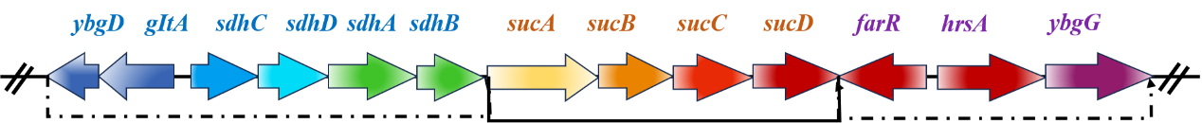

Figure S2. Hydrophobicity and hydrophilicity analysis of proteins encoded by sucA and sucC
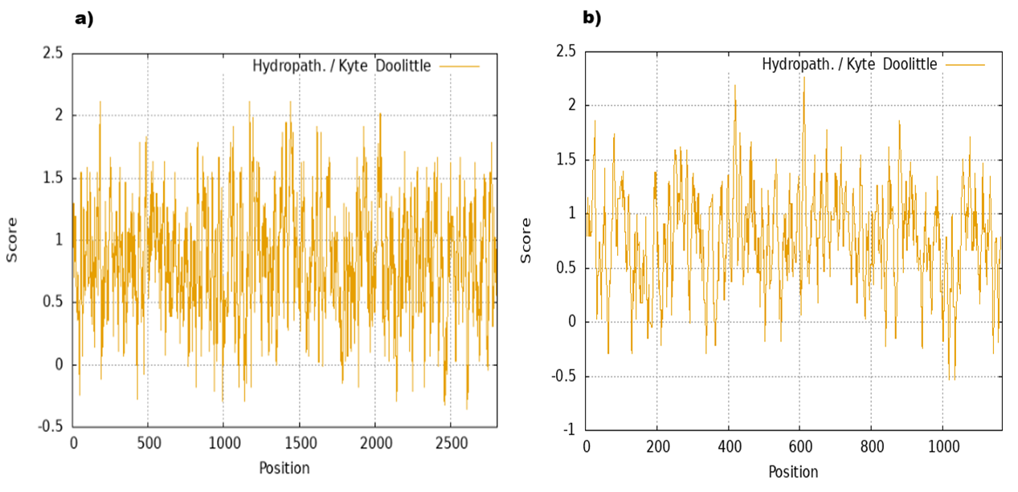
a) Hydrophobicity and hydrophilicity analysis of proteins encoded by sucA; b) Hydrophobicity and hydrophilicity analysis of proteins encoded by sucC

Figure S3. Secondary structure of proteins encoded by sucA and sucC
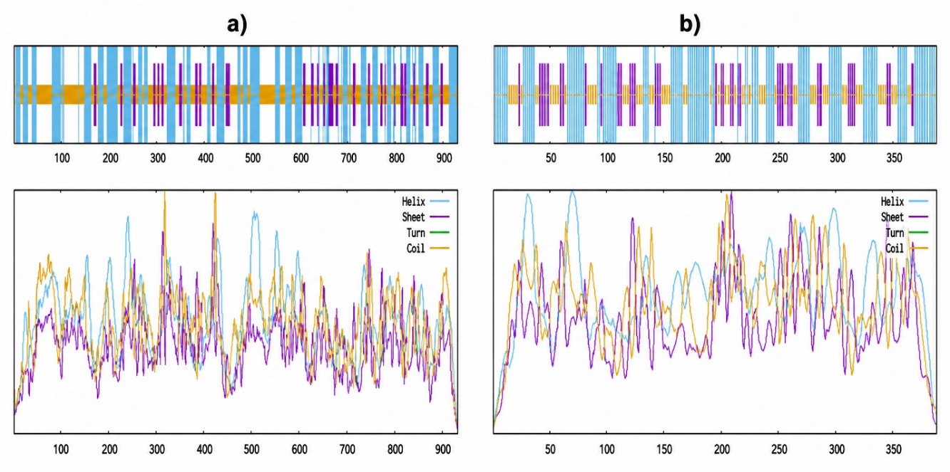
a) Secondary structure of proteins encoded by sucA; b) Secondary structure of proteins encoded by sucC

Figure S4. Domain analysis of proteins encoded by sucA and sucC
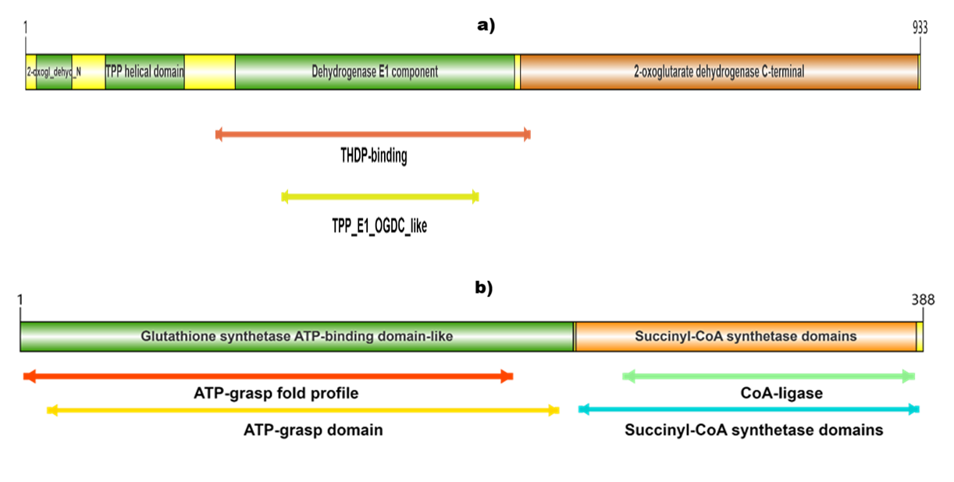
a) Domain analysis of proteins encoded by sucA; b) Domain analysis of proteins encoded by sucC

Figure S5. Construction of pUC-sucA cloning vector
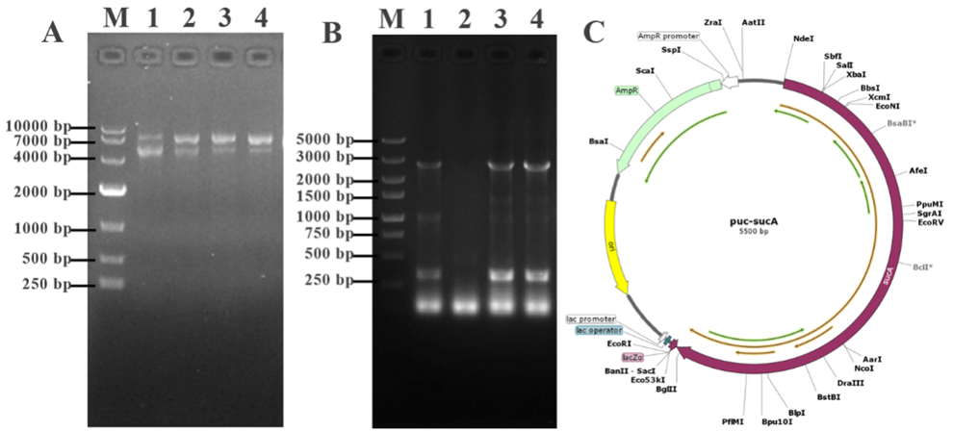
a) recombinant plasmid; b) double digestion result of the recombinant plasmid; c) map of the recombinant plasmid.

Figure S6. Construction of pUC-sucC cloning vector
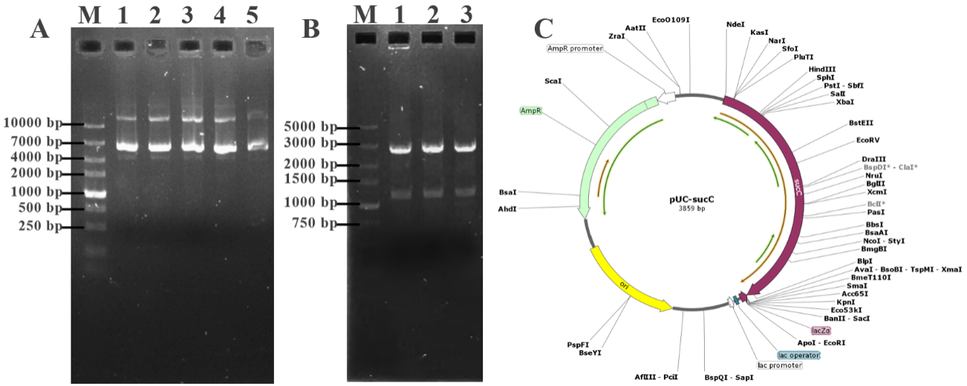
a) recombinant plasmid; b) double digestion result of the recombinant plasmid; c) map of the recombinant plasmid.

Figure S7. Gel electrophoresis results of recombinant plasmid pET-sucAC
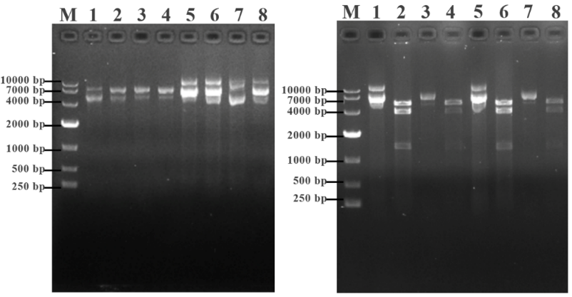
a) M: DL 10,000 DNA Marker; 1-8: recombinant plasmids; b) M: DL 10,000 DNA Marker; 1, 3, 5, 7: recombinant plasmids; 2, 4, 6, 8: double digestion results.

Figure S8. PCR verification results of gel electrophoresis after knockout
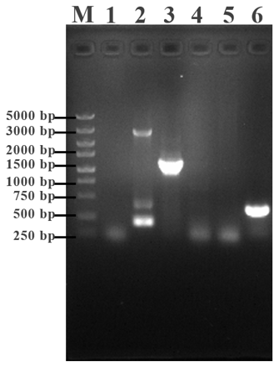
M: DL 10,000 DNA Marker; Lane 1 served as a blank control with ddH₂O as the template for both primer pairs primers sucC-F/sucC-R (lanes 2 and 3) and cm-F/cm-R (lane 4). Lanes 2, 3, and 4 used E. coli K-12 as the template, while lanes 5 and 6 used E. coli ΔsucC as the template.

Figure. S9 Gel electrophoresis results of the complemented strain
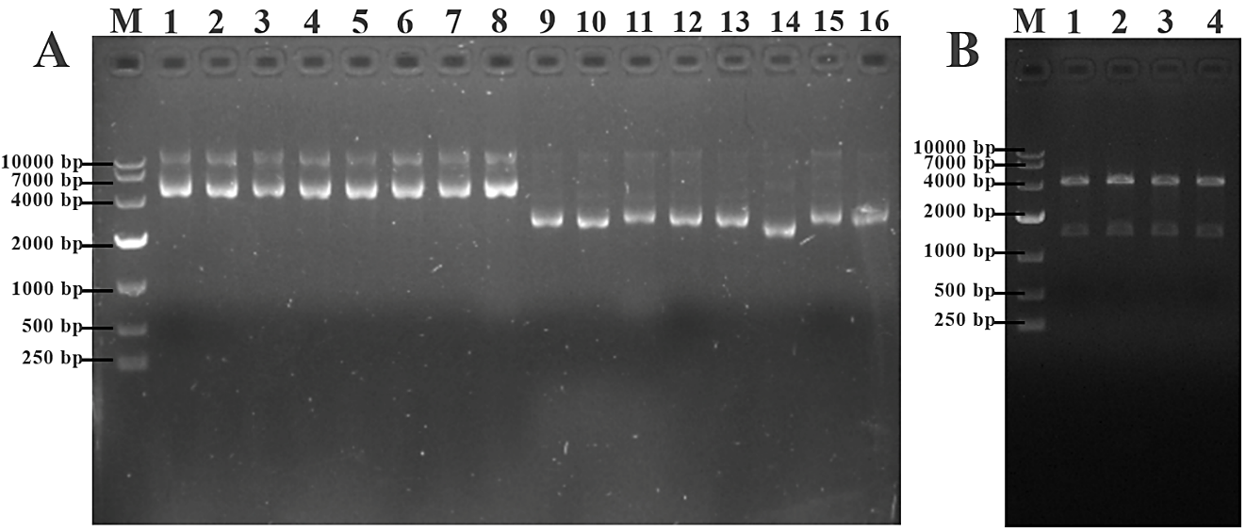
M: DL 10,000 DNA Marker; a) gel electrophoresis result of the complemented strain plasmid; b) double digestion result of the complemented strain.

Supplementary Table list
Table S1. Bacterial strains and plasmids
Bacterial strains and plasmids | Characteristics | Source
Escherichia coli K12 | Wild-type strain | TaKaRa, Beijing, China
Enterobacter kobei P3 | Wild-type strain | Kindly support by Professor Heba Abdel-motaal form ARC, Egypt
E. coli BL21 | Expressing host bacteria | TaKaRa, Beijing, China
E. coli BL21/pET28a | Carrying recombinant plasmid pET28a | TaKaRa, Beijing, China
E. coli K12/pKD3 | Carrying recombinant plasmid pKD3 | TaKaRa, Beijing, China
E. coli K12/pKD46 | Carrying recombinant plasmid pKD46 | TaKaRa, Beijing, China
E. coli K12/pCP20 | Carrying recombinant plasmid pCP20 | TaKaRa, Beijing, China
E. coli BL21/pET-sucAC | Carrying recombinant plasmid pET-sucAC | This study
E. coliΔsucC | Deletion mutant of sucC | This study
ΔsucC/pET-sucAC | Complemented strain with pET28a-sucAC | This study
pET28a | Expression vector | TaKaRa, Beijing, China
pKD3 | Helper plasmid for homologous recombination | TaKaRa, Beijing, China
pKD46 | Helper plasmid for λ Red recombination | TaKaRa, Beijing, China
pCP20 | Helper plasmid for FLP recombinase | TaKaRa, Beijing, China
pET-sucAC | pET28a carrying the sucAC gene | This study

Table S2. PCR Conditions Summary
PCR | Conditions Summary
16S rRNA Gene Amplification | - Initial denaturation: 95 °C for 2 min  - 35 cycles: 95 °C for 30 s, 54 °C for 90 s, 72 °C for 30 s  - Final extension: 72 °C for 5 min
sucA Gene Amplification | - Initial denaturation: 95 °C for 2 min  - 35 cycles: 95 °C for 30 s, 55 °C for 90 s, 72 °C for 30 s  - Final extension: 72 °C for 5 min
sucC Gene Amplification | - Initial denaturation: 95 °C for 2 min  - 35 cycles: 95 °C for 30 s, 53 °C for 90 s, 72 °C for 30 s  - Final extension: 72 °C for 5 min
Homologous Arm + sucA Primers (for pUC18/pET28a recombination) | - Initial denaturation: 95 °C for 2 min  - 35 cycles: 95 °C for 30 s, 58 °C for 90 s, 72 °C for 30 s  - Final extension: 72 °C for 5 min
Homologous Arm + sucC Primers (for pUC18/pET28a recombination) | - Initial denaturation: 95 °C for 2 min  - 35 cycles: 95 °C for 30 s, 55 °C for 90 s, 72 °C for 30 s  - Final extension: 72 °C for 5 min
sucAC Fusion PCR | - Initial denaturation: 95 °C for 2 min  - 35 cycles: 95 °C for 30 s, 53 °C for 90 s, 72 °C for 30 s  - Final extension: 72 °C for 5 min
Chloramphenicol Resistance Gene (cat) | - Initial denaturation: 95 °C for 2 min  - 35 cycles: 95 °C for 30 s, 55 °C for 90 s, 72 °C for 30 s  - Final extension: 72 °C for 5 min
cat + Homologous Arm (Targeting Segment) | - Initial denaturation: 95 °C for 2 min  - 35 cycles: 95 °C for 30 s, 58 °C for 90 s, 72 °C for 30 s  - Final extension: 72 °C for 5 min

