Supplementary Material

Integrated metabolomic and genomic characterization of antifungal Streptomyces halstedii S14 from Melipona mondury larval food
Yuri Ribeiro Diogo¹, Luciana Teresa Dias Cappelini², Keith Dayane Leite Lira³, Ana Calheiros de Carvalho⁴, Nubia Gonçalves dos Santos³, Vitor Gonçalves Vital³, Jullio Kennedy Castro Soares⁵, Fernanda Kaori Kuriki³, Lívia Soman de Medeiros^{3,5}, Tiago Mauricio Francoy⁴, Suzan Pantaroto de Vasconcellos³, Michelle Manfrini Morais^{1, 3}
¹ Biotechnology Program, Universidade Federal de São Paulo, Diadema, SP, Brazil
² Institute of Environment, Freshwater Resources Division, Florida International University, Miami, FL, USA
³ Institute of Environmental, Chemical and Pharmaceutical Sciences, Universidade Federal de São Paulo, Diadema, SP, Brazil
⁴ School of Arts, Sciences and Humanities, Universidade de São Paulo, São Paulo, SP, Brazil
⁵ Chemical Biology Program, Universidade Federal de São Paulo, Diadema, SP, Brazil

Supplementary Figures
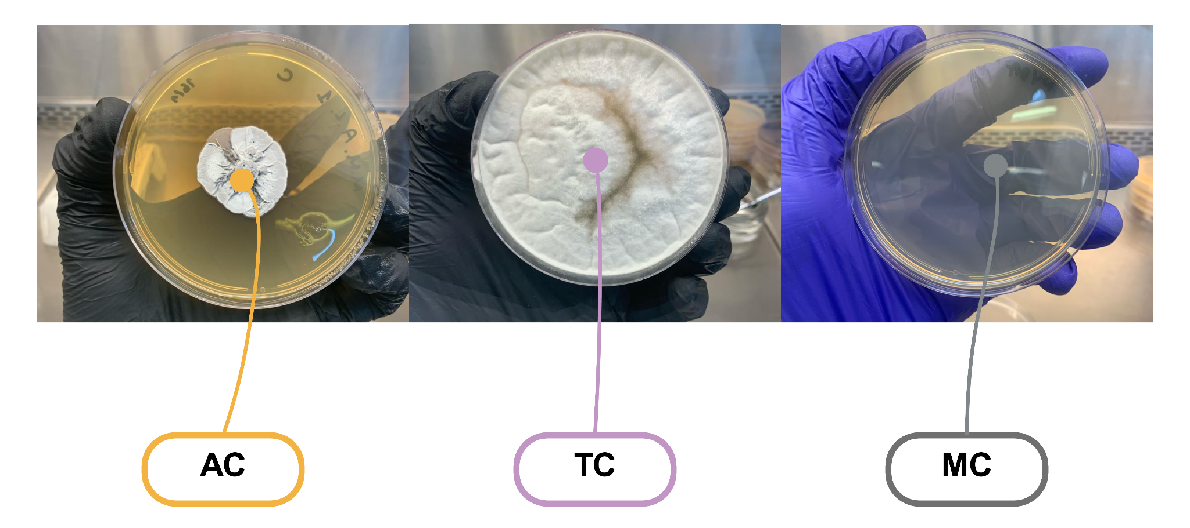
Supplementary Figure S1. Control plates included in the UHPLC-HRMS sampling design. The image shows the culture-medium control, actinobacterial axenic control and fungal axenic control used to distinguish signals associated with microbial growth from medium/background signals.

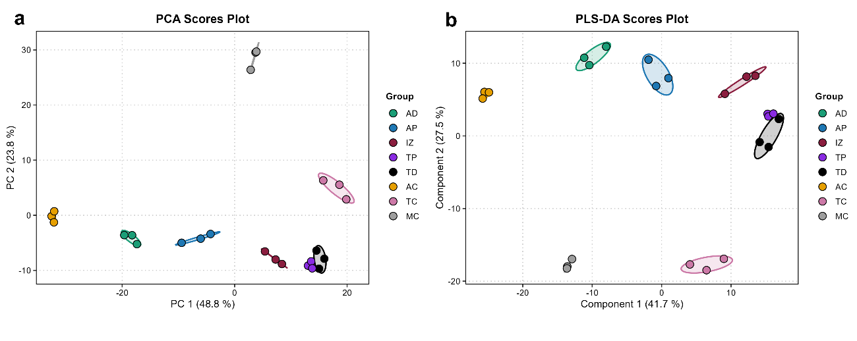
Supplementary Figure S2. Exploratory multivariate analyses of experimental samples. (a) PCA score plot based on the MetaboAnalyst-processed UHPLC-HRMS matrix. (b) PLS-DA score plot, interpreted only as a supervised exploratory visualization because each experimental group contained three independent samples.

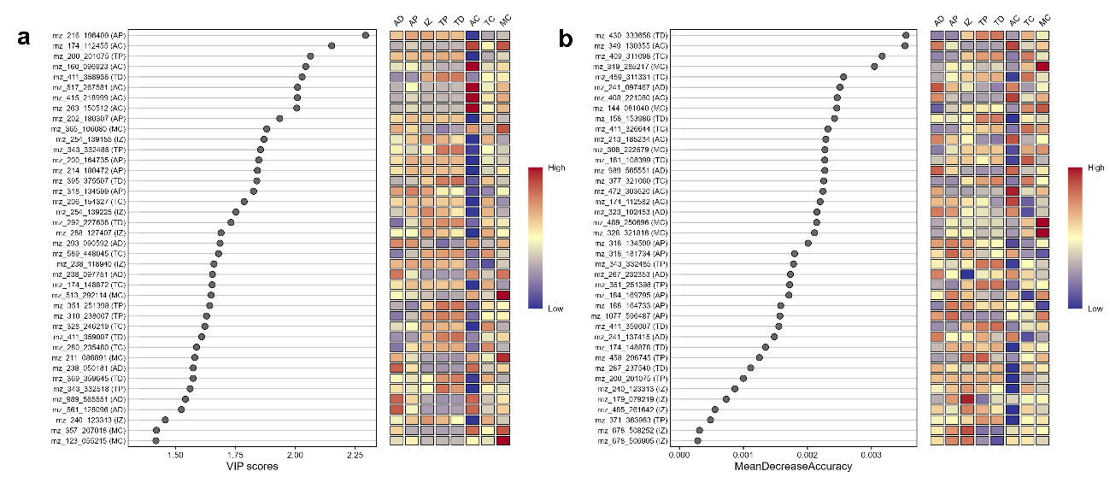
Supplementary Figure S3. Exploratory feature-prioritization analyses. (a) VIP scores from the PLS-DA model. (b) Random Forest variable-importance ranking based on Mean Decrease Accuracy. These supervised analyses were retained exclusively as exploratory rankings and were not used as inferential criteria for robust IZ- or TP-associated candidate classification.

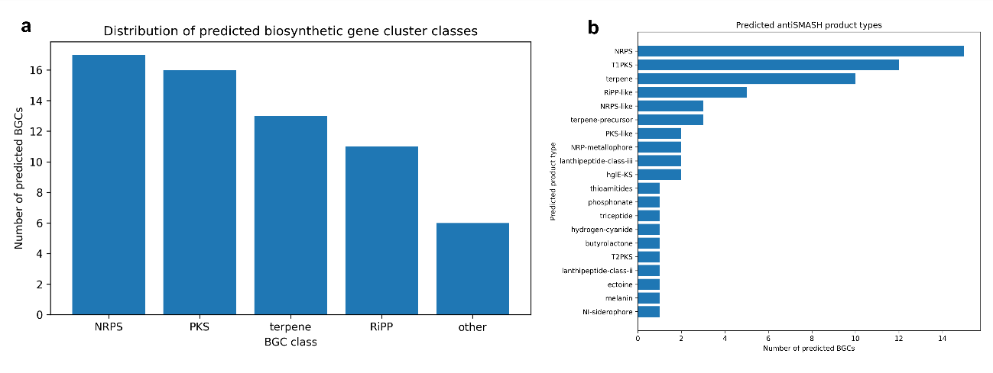
Supplementary Figure S4. (a) Distribution of biosynthetic gene cluster classes and predicted product types identified by antiSMASH. Major BGC classes predicted in the draft genome assembly of Streptomyces halstedii S14. (b) Predicted product types detected by antiSMASH. Hybrid clusters were counted in more than one class when applicable.

Supplementary Tables
Supplementary Table S1. Inhibition halo measurements and descriptive summary for the co-culture assay against Trichoderma atroviride.
Plate | Individual measurements (cm) | Plate mean / summary (cm)
1 | 1.07; 0.54; 0.98 | 0.86
2 | 1.33; 1.52; 1.30 | 1.38
3 | 1.64; 1.74; 1.42 | 1.60
Overall mean ± SD (plate means) | — | 1.28 ± 0.38
Raw measurement range | — | 0.54–1.74

Supplementary Table S2. Complete list of antiSMASH-predicted BGC regions in the draft genome assembly of Streptomyces halstedii S14.
Region | Products | BGC class | BGC length (bp) | Contig edge | KnownClusterBlast product | KnownClusterBlast similarity (%)
NODE_1_length_64926.region001 | NRPS-like | NRPS | 42454 | False | amicetin | 75.0
NODE_5_length_44926.region001 | terpene | terpene | 25160 | True | cyslabdan A/cyslabdan B/cyslabdan C | 63.0
NODE_8_length_42246.region001 | NRPS; T1PKS | NRPS; PKS | 37127 | True | 10-epi-HSAF/10-epi-3-deOH-HSAF/10-epi-maltophilin/10-epi-xanthobaccin C/10-epi-hydroxymaltophilin/10-epi-FI-2 | 100.0
NODE_11_length_39776.region001 | thioamitides | RiPP | 22396 | True
NODE_14_length_38462.region001 | NRPS; NRPS-like; PKS-like | NRPS; PKS | 38462 | True | thiazostatin/watasemycin A/watasemycin B/2-hydroxyphenylthiazoline enantiopyochelin/isopyochelin | 26.0
NODE_17_length_35044.region001 | terpene | terpene | 14545 | True | geosmin | 100.0
NODE_21_length_33153.region001 | NRPS | NRPS | 33153 | True | malonomycin | 38.0
NODE_25_length_30404.region001 | NRPS-like; T1PKS | NRPS; PKS | 24664 | True | arginomycin | 13.0
NODE_37_length_27769.region001 | terpene-precursor | terpene | 21185 | False | prejadomycin/rabelomycin/gaudimycin C/gaudimycin D/UWM6/gaudimycin A | 6.0
NODE_49_length_24871.region001 | phosphonate | other | 13084 | True
NODE_50_length_24826.region001 | NRP-metallophore; NRPS | NRPS | 24826 | True | coelichelin | 100.0
NODE_51_length_24793.region001 | triceptide | RiPP | 20880 | True | madurastatin D1/madurastatin D2/(-)-Madurastatin C1 | 2.0
NODE_61_length_22840.region001 | terpene | terpene | 15225 | True
NODE_65_length_21471.region001 | terpene-precursor | terpene | 13905 | True
NODE_75_length_20526.region001 | RiPP-like | RiPP | 10367 | True | dudomycin A | 8.0
NODE_93_length_18575.region001 | terpene | terpene | 13166 | True | steffimycin D | 8.0
NODE_97_length_18159.region001 | NRPS | NRPS | 18159 | True | microtermolide A | 13.0
NODE_100_length_18081.region001 | NRPS | NRPS | 18081 | True | marformycin A/marformycin B/marformycin C/marformycin D/marformycin E/marformycin F | 8.0
NODE_105_length_17675.region001 | terpene | terpene | 13415 | True | hopene | 23.0
NODE_108_length_17517.region001 | hydrogen-cyanide | other | 7903 | True | aborycin | 21.0
NODE_110_length_17394.region001 | butyrolactone | other | 10954 | True | lactonamycin | 5.0
NODE_113_length_17218.region001 | T2PKS | PKS | 17218 | True | spore pigment | 66.0
NODE_118_length_16760.region001 | T1PKS | PKS | 16760 | True | bafilomycin B1 | 66.0
NODE_126_length_16007.region001 | NRP-metallophore; NRPS | NRPS | 16007 | True | paenibactin | 83.0
NODE_130_length_15698.region001 | lanthipeptide-class-iii | RiPP | 15698 | True | AmfS | 100.0
NODE_135_length_15386.region001 | lanthipeptide-class-iii | RiPP | 14474 | True
NODE_147_length_14744.region001 | T1PKS | PKS | 14744 | True | bafilomycin B1 | 27.0
NODE_176_length_13361.region001 | T1PKS | PKS | 13361 | True | desertomycin B/desertomycin A/desertomycin G | 14.0
NODE_183_length_13114.region001 | NRPS | NRPS | 13114 | True
NODE_185_length_13079.region001 | lanthipeptide-class-ii | RiPP | 13079 | True
NODE_195_length_12705.region001 | NRPS | NRPS | 12705 | True | thiazostatin/watasemycin A/watasemycin B/2-hydroxyphenylthiazoline enantiopyochelin/isopyochelin | 40.0
NODE_216_length_11911.region001 | ectoine | other | 6749 | True | ectoine | 75.0
NODE_226_length_11560.region001 | NRPS | NRPS | 11560 | True | mirubactin | 42.0
NODE_234_length_11390.region001 | melanin | other | 8788 | True | melanin | 100.0
NODE_236_length_11331.region001 | NRPS | NRPS | 11331 | True | coelibactin | 36.0
NODE_250_length_11048.region001 | terpene | terpene | 11048 | True | isorenieratene | 57.0
NODE_268_length_10611.region001 | RiPP-like | RiPP | 10611 | True
NODE_269_length_10598.region001 | NRPS; T1PKS | NRPS; PKS | 10598 | True | rakicidin A/rakicidin B | 40.0
NODE_275_length_10346.region001 | T1PKS; hglE-KS | PKS | 10346 | True
NODE_307_length_9304.region001 | terpene-precursor | terpene | 9304 | True | herbimycin A | 6.0
NODE_355_length_8151.region001 | NRPS | NRPS | 8151 | True | bonnevillamide D/bonnevillamide E | 6.0
NODE_360_length_7951.region001 | T1PKS | PKS | 7951 | True
NODE_370_length_7743.region001 | NI-siderophore | other | 7743 | True | schizokinen | 25.0
NODE_385_length_7238.region001 | terpene | terpene | 7238 | True | hopene | 46.0
NODE_394_length_6999.region001 | terpene | terpene | 6999 | True
NODE_426_length_6457.region001 | NRPS | NRPS | 6457 | True
NODE_432_length_6408.region001 | RiPP-like | RiPP | 6408 | True | 14-hydroxyisochainin | 11.0
NODE_443_length_6156.region001 | T1PKS | PKS | 6156 | True
NODE_458_length_5981.region001 | NRPS | NRPS | 5981 | True | coelibactin | 18.0
NODE_482_length_5650.region001 | T1PKS | PKS | 5650 | True
NODE_547_length_4624.region001 | RRE-containing | RiPP | 4624 | True
NODE_555_length_4522.region001 | hglE-KS | PKS | 4522 | True
NODE_563_length_4479.region001 | T1PKS | PKS | 4479 | True
NODE_577_length_4357.region001 | terpene | terpene | 4357 | True | isorenieratene | 37.0
NODE_598_length_4212.region001 | PKS-like | PKS | 4212 | True | caboxamycin | 33.0
NODE_677_length_3011.region001 | RiPP-like | RiPP | 3011 | True
NODE_680_length_2982.region001 | T1PKS | PKS | 2982 | True
NODE_752_length_2083.region001 | RiPP-like | RiPP | 2083 | True
NODE_762_length_1964.region001 | terpene | terpene | 1964 | True

Supplementary Table S3. Robust IZ- and TP-associated UHPLC-HRMS molecular features identified using the plate-blocked targeted contrasts.
Feature | Region | Retention time (min) | Contrast effect (log10) | Fold ratio | Region-specific BH-FDR | Highest mean group | Putative annotation
m/z 678.5083 | IZ | 11.87 | 1.879 | 75.71 | 1.17e-03 | IZ
m/z 692.5239 | IZ | 13.72 | 1.960 | 91.15 | 1.44e-03 | IZ
m/z 678.5069 | IZ | 12.10 | 1.919 | 83.02 | 2.79e-03 | IZ
m/z 179.0792 | IZ | 0.87 | 0.466 | 2.92 | 3.16e-03 | IZ
m/z 704.5241 | IZ | 13.02 | 1.722 | 52.78 | 8.89e-03 | IZ
m/z 295.1294 | IZ | 1.11 | 0.483 | 3.04 | 1.60e-02 | IZ | Glutamylphenylalanine-like
m/z 288.1274 | IZ | 3.72 | 0.791 | 6.17 | 2.89e-02 | IZ
m/z 351.2514 | TP | 12.83 | 1.395 | 24.85 | 2.58e-05 | TP
m/z 522.3565 | TP | 9.98 | 1.465 | 29.20 | 2.11e-04 | TP | 1-oleoyl-lysophosphatidylcholine-like (phosphocholine/lyso-PC-like)
m/z 380.1710 | TP | 6.68 | 0.912 | 8.17 | 4.15e-03 | TP
m/z 343.3325 | TP | 6.90 | 0.986 | 9.68 | 5.87e-03 | TP
m/z 371.3640 | TP | 7.87 | 0.423 | 2.65 | 6.67e-03 | TP
m/z 310.2380 | TP | 4.41 | 1.160 | 14.46 | 7.07e-03 | TP
m/z 611.4297 | TP | 10.20 | 1.102 | 12.64 | 8.69e-03 | TP
m/z 458.2987 | TP | 3.99 | 1.480 | 30.18 | 1.07e-02 | TP
m/z 343.3325 | TP | 6.97 | 0.852 | 7.12 | 1.31e-02 | TP
m/z 341.3169 | TP | 6.84 | 0.731 | 5.39 | 1.62e-02 | TP
m/z 198.1856 | TP | 8.17 | 0.153 | 1.42 | 4.91e-02 | TP

Candidates were classified using the following criteria: BH-FDR < 0.05 for the corresponding two-sided targeted contrast, positive contrast estimate, highest mean abundance in the target region across AD, AP, IZ, TP, TD, AC, TC, and MC, and no detection in any analytical blank before imputation. The blocked omnibus region test was considered complementary rather than mandatory. Seventeen of the 18 candidates also showed a significant blocked omnibus region effect, and all 18 remained BH-FDR < 0.05 in the corresponding non-moderated sensitivity contrast. Chemical annotation, VIP score, Random Forest rank, molecular-network position, and genomic evidence were not required for candidate classification.
Supplementary Table S4. Summary of S14–MIBiG connectivity across BiG-SCAPE distance cutoffs.
BiG-SCAPE distance cutoff | S14 BGCs with direct MIBiG edge | Direct S14–MIBiG edges | Same-GCF-only S14 BGCs | S14-only GCF BGCs | Singletons
0.3 | 8/59 | 10 | 0 | 0 | 51
0.4 | 12/59 | 18 | 0 | 2 | 45
0.5 | 20/59 | 100 | 2 | 0 | 37
0.6 | 36/59 | 369 | 1 | 0 | 22
0.7 | 43/59 | 1236 | 2 | 0 | 14

