Supplementary figures and tables

Supplementary Figure S1. Flow diagram of the independent external validation cohort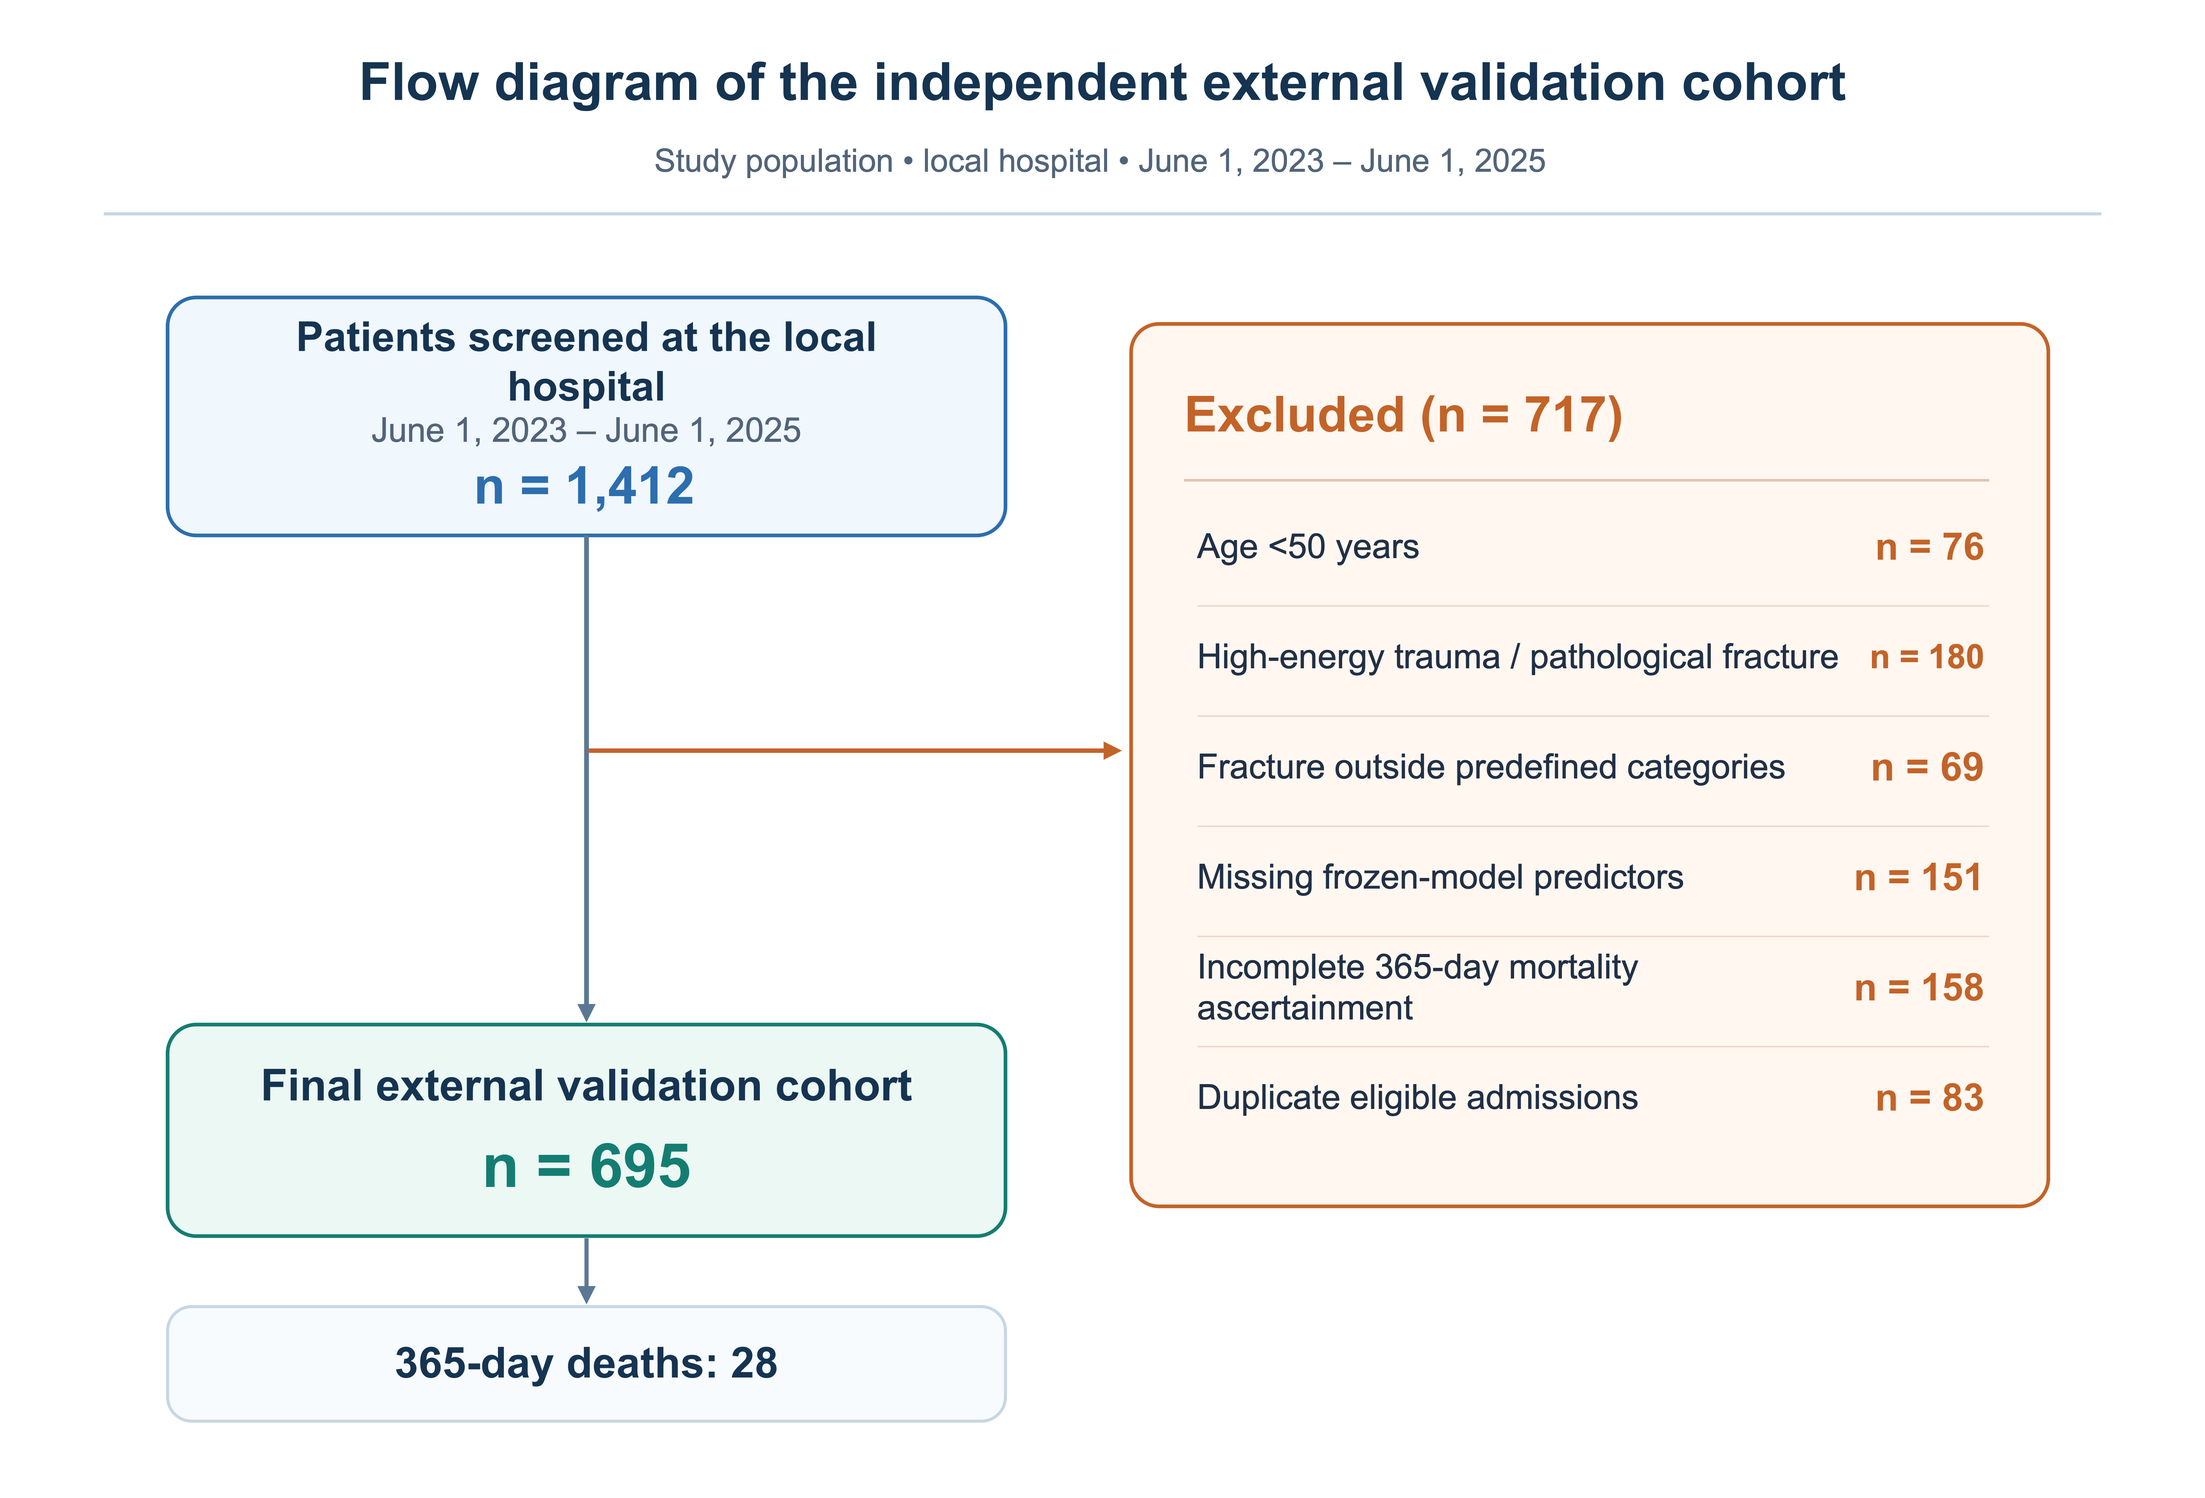
Figure S2. Development-cohort construction, predictor completeness, and outcome availability.
A, Detailed construction of the 4,773-patient development cohort and the three parallel analytical modules with outcome-specific time scales.
B, Missingness of the frozen-model predictors before multiple imputation. BMI had the highest proportion of missing values (15.8%), followed by albumin (3.2%), haemoglobin (1.9%), and creatinine (1.2%).
C, Availability of major outcomes across the development and external validation analyses, including long-term mortality, common-cutoff mortality, first refracture, post-refracture death, and 1-year mortality. Bars show observed events relative to the corresponding eligible denominator.
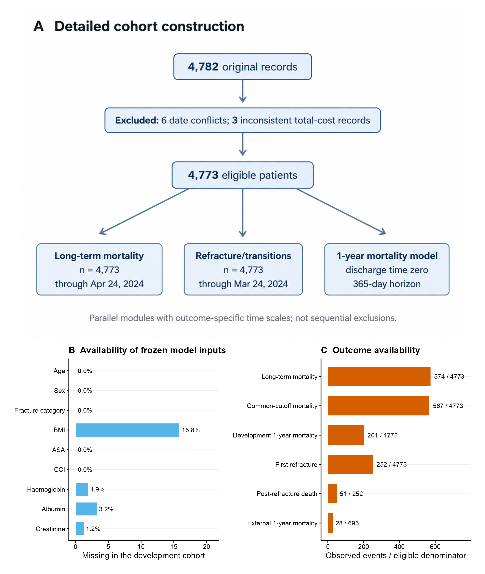

Figure S3. Mortality according to category.
A, Kaplan–Meier cumulative all-cause mortality from index admission across the five fracture categories.
B, Five-year cumulative mortality by fracture category. Points represent risk estimates and horizontal bars 95% confidence intervals. These estimates are unadjusted and describe the absolute mortality burden within each fracture category.
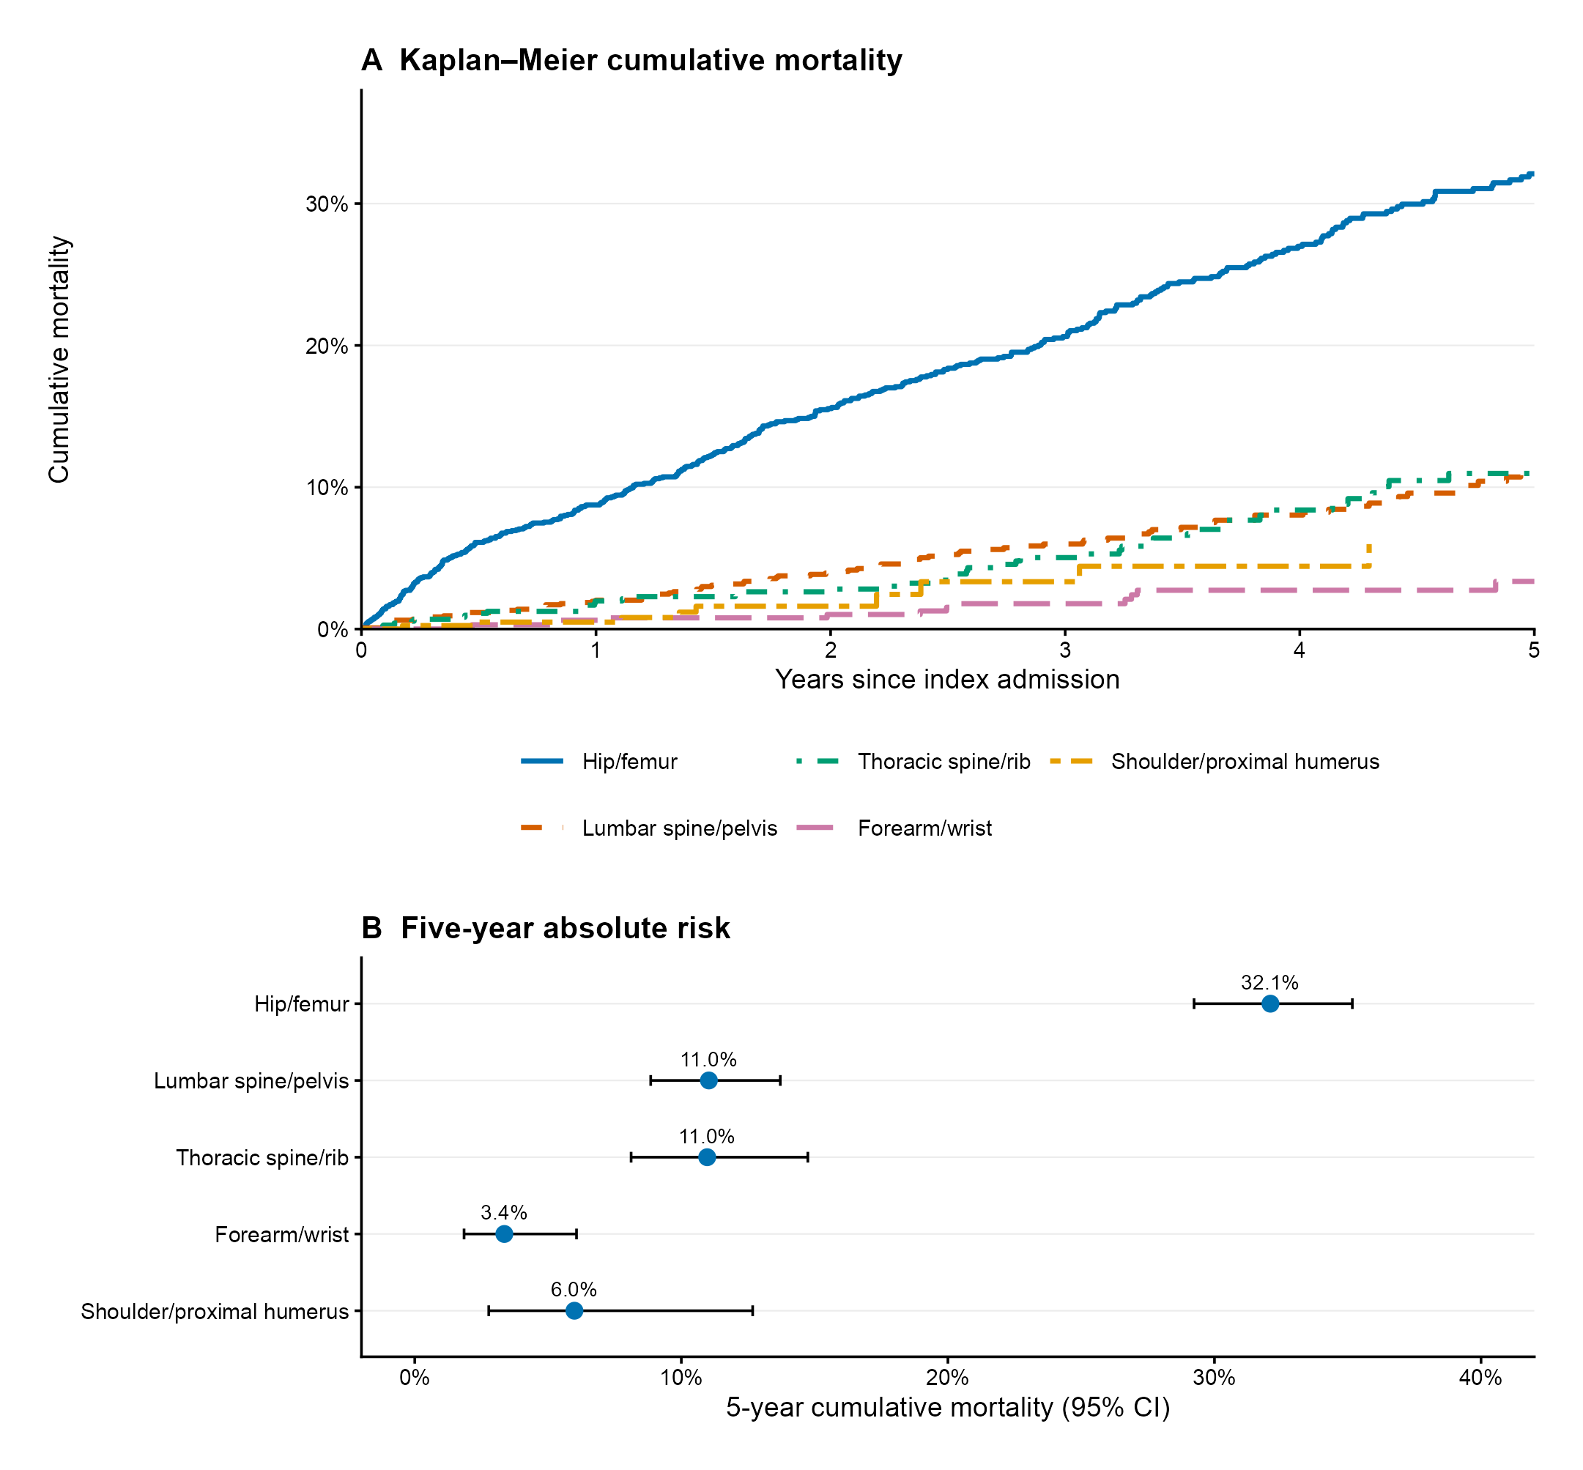
Figure S4. First-refracture cumulative incidence according to index fracture category.
A, Cumulative incidence of first refracture across the five fracture categories, with death treated as a competing event.
B, Five-year competing-risk estimates of first refracture by fracture category. Points represent cumulative incidence estimates and horizontal bars 95% confidence intervals.
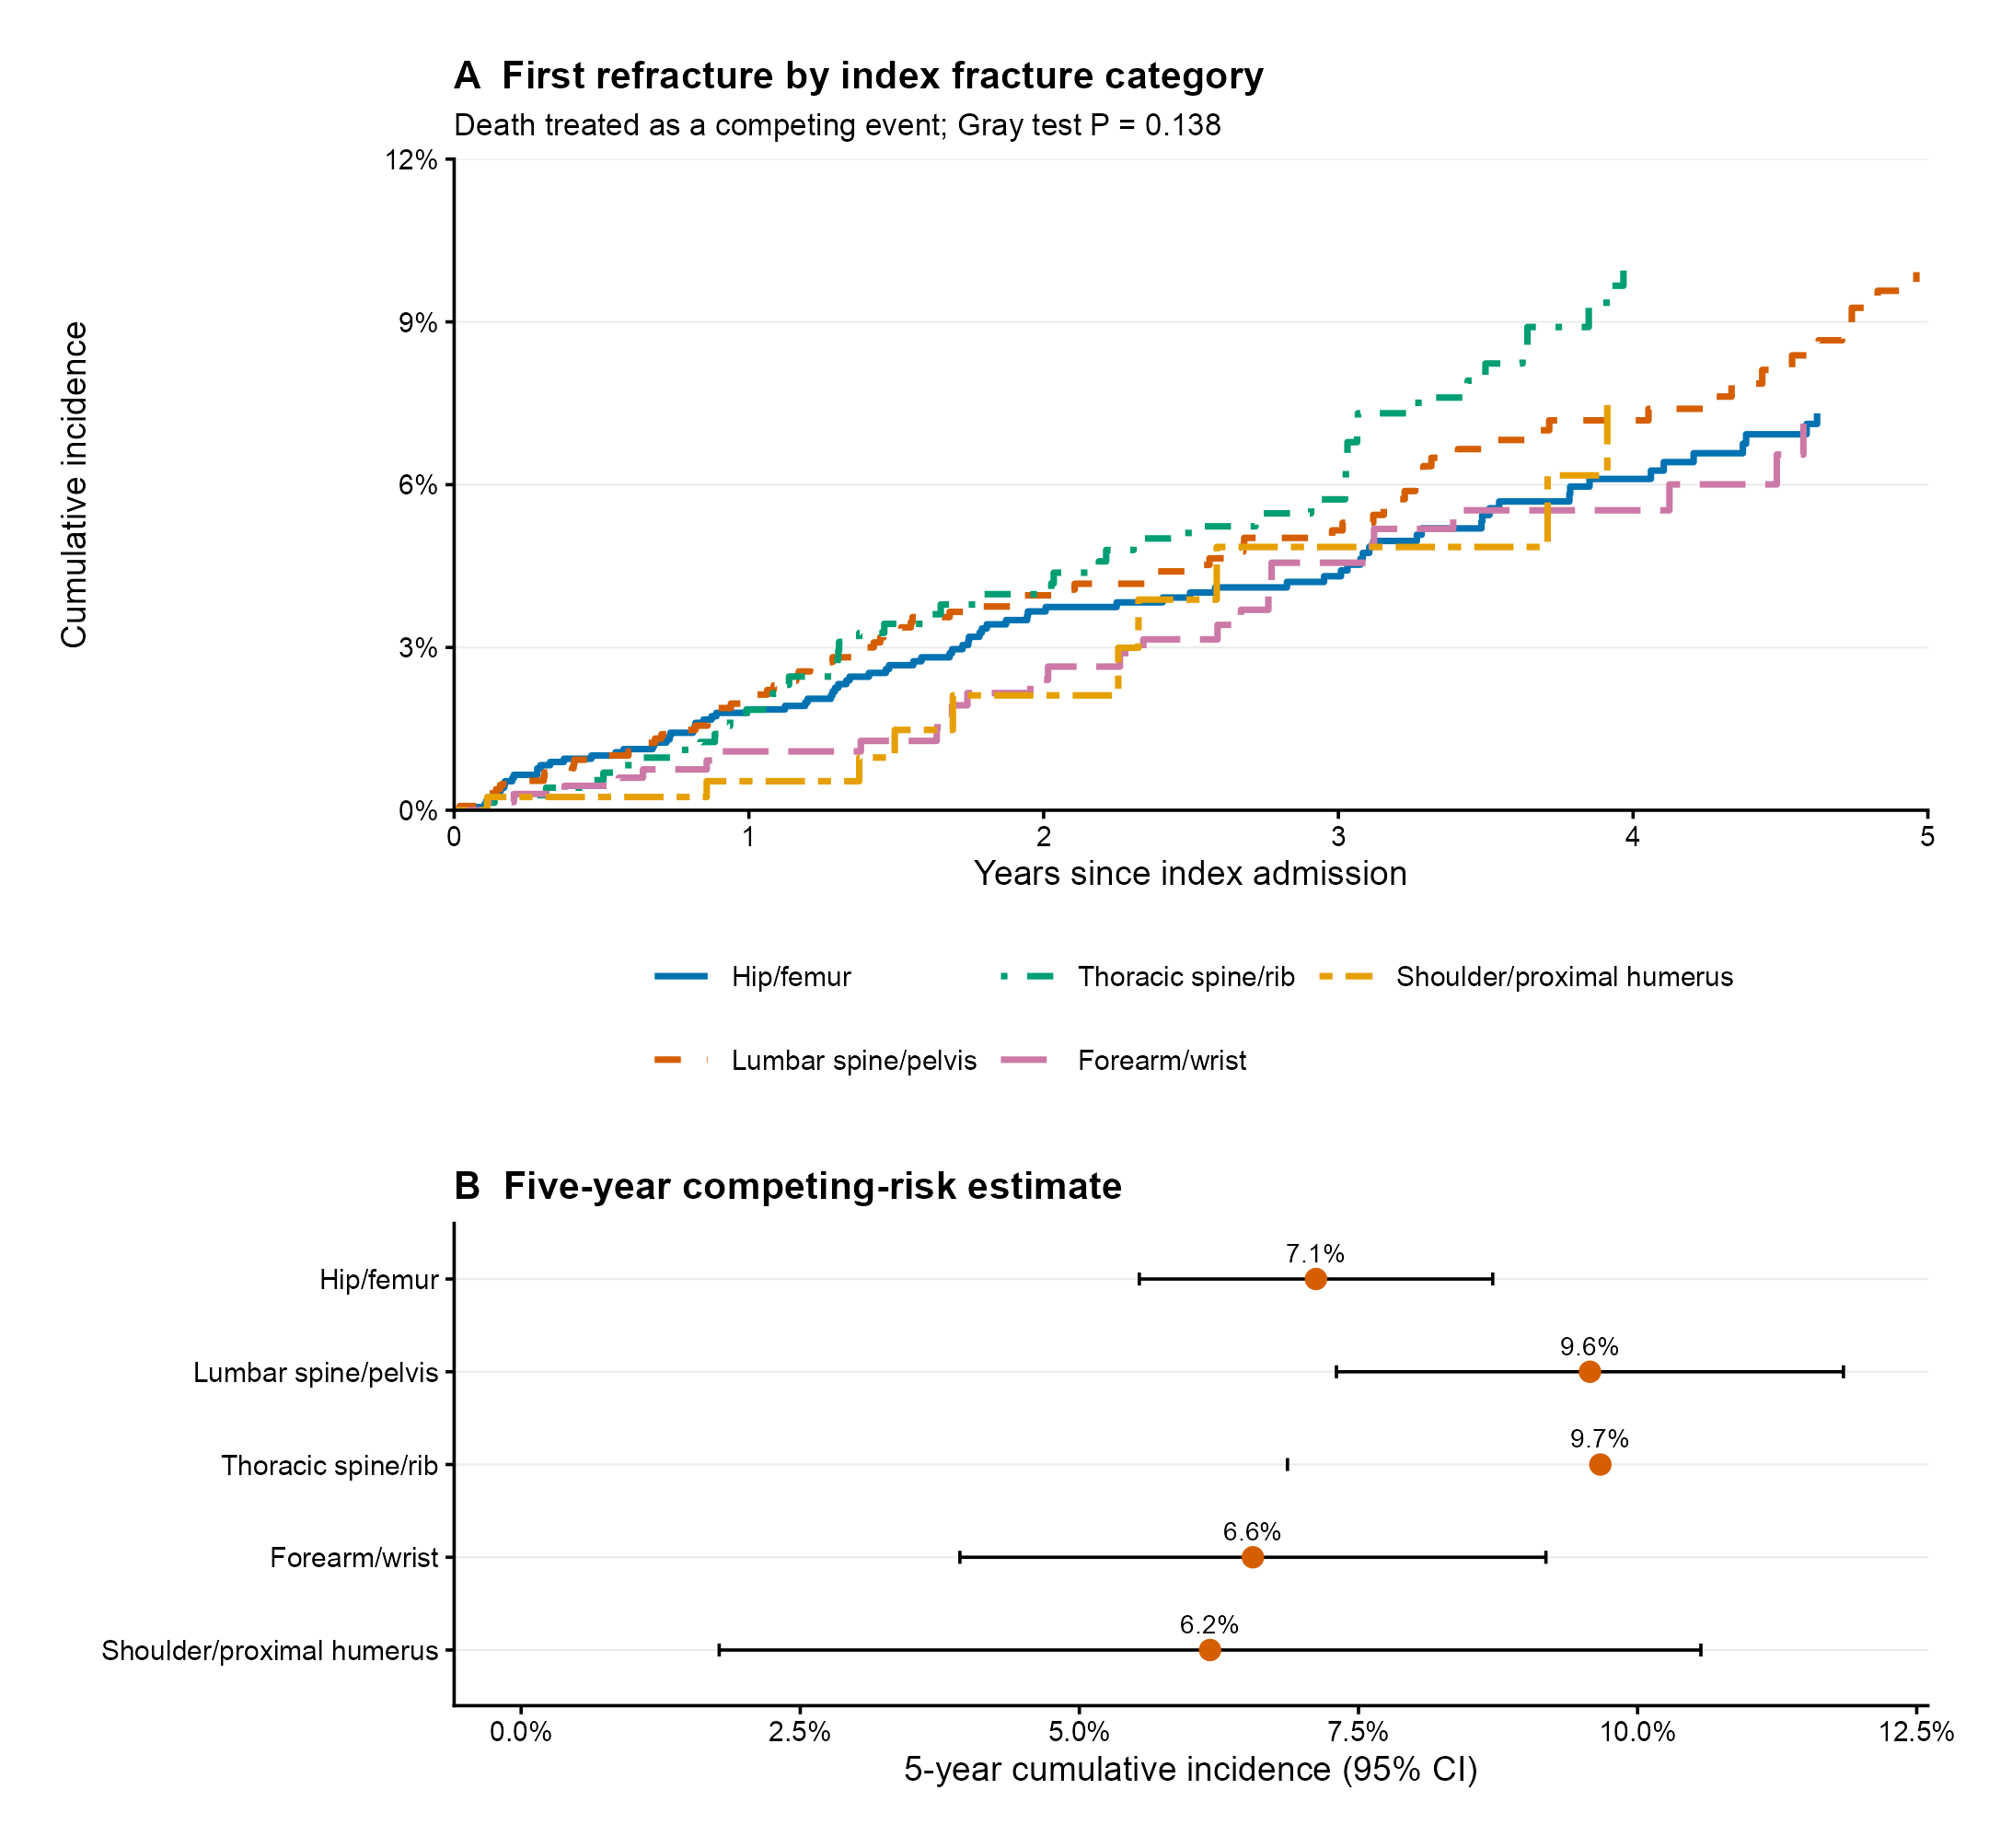
Figure S5. Model diagnostics for the long-term mortality analysis.
A, Nonlinear association between age and adjusted all-cause mortality estimated using restricted cubic splines, with 68 years as the reference; shading represents the 95% confidence interval.
B, Proportional-hazards diagnostics based on median Schoenfeld-residual test P values across 30 imputed datasets; the dashed vertical line marks P = 0.05.
C, Adjusted mortality hazard ratios for continuous predictor contrasts. Points represent hazard-ratio estimates and horizontal bars 95% confidence intervals. Inclusion of these variables in the prediction model does not by itself imply an independent prognostic association.
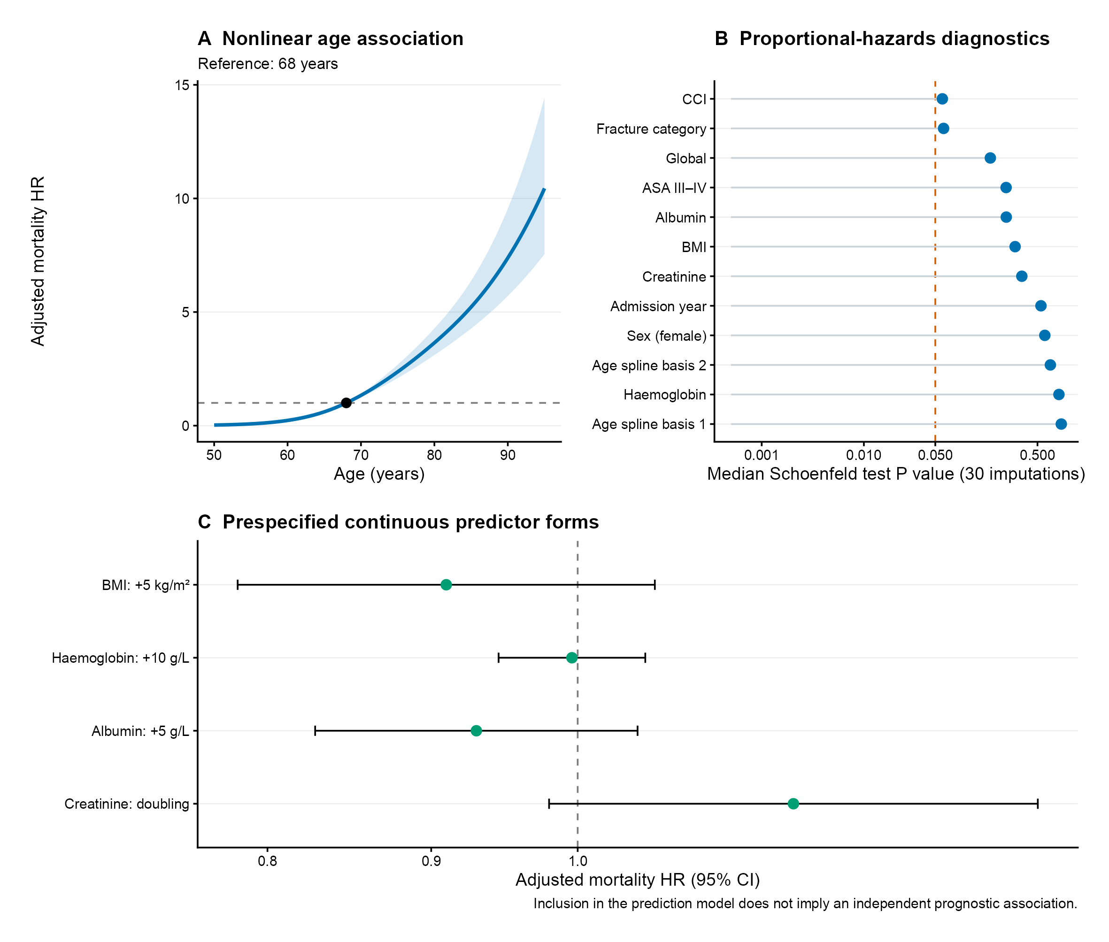
Figure S6. Internal validation and external calibration of the 365-day mortality model.
A, Distribution of optimism-corrected 365-day AUC values across 500 bootstrap repetitions. The solid vertical line indicates the final optimism-corrected AUC of 0.860.
B, Distribution of optimism-corrected calibration slopes across 500 bootstrap repetitions. The solid vertical line indicates the final corrected slope of 0.958, and the dashed line denotes the ideal slope of 1.
C, Grouped external calibration in the independent validation cohort, comparing observed with mean predicted 365-day mortality across predicted-risk groups. Error bars represent 95% confidence intervals; the dashed diagonal indicates perfect calibration.
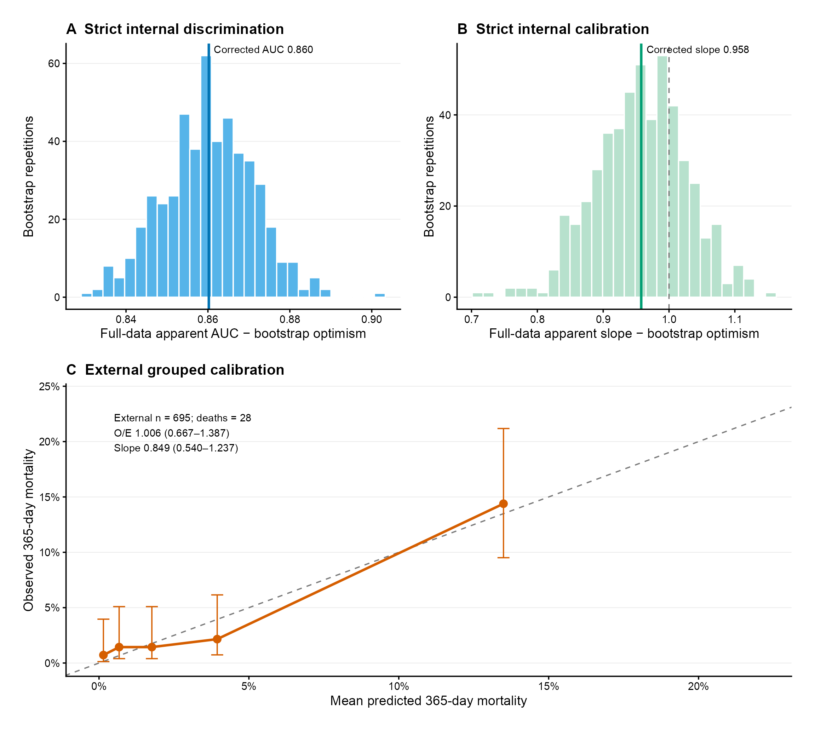
Figure S7. Exploratory decision-curve analysis of the frozen 365-day mortality model.
A, Net benefit of the frozen model across risk thresholds compared with treat-all and treat-none strategies. Shading represents 95% bootstrap intervals from 2,000 patient-level resamples.
B, Difference in net benefit between the frozen model and the better default strategy at each threshold. Positive values favour the model; highlighted points indicate thresholds at which the 95% bootstrap interval excluded zero. Given the limited number of external deaths and the absence of a prespecified clinical intervention threshold, these analyses were considered exploratory.
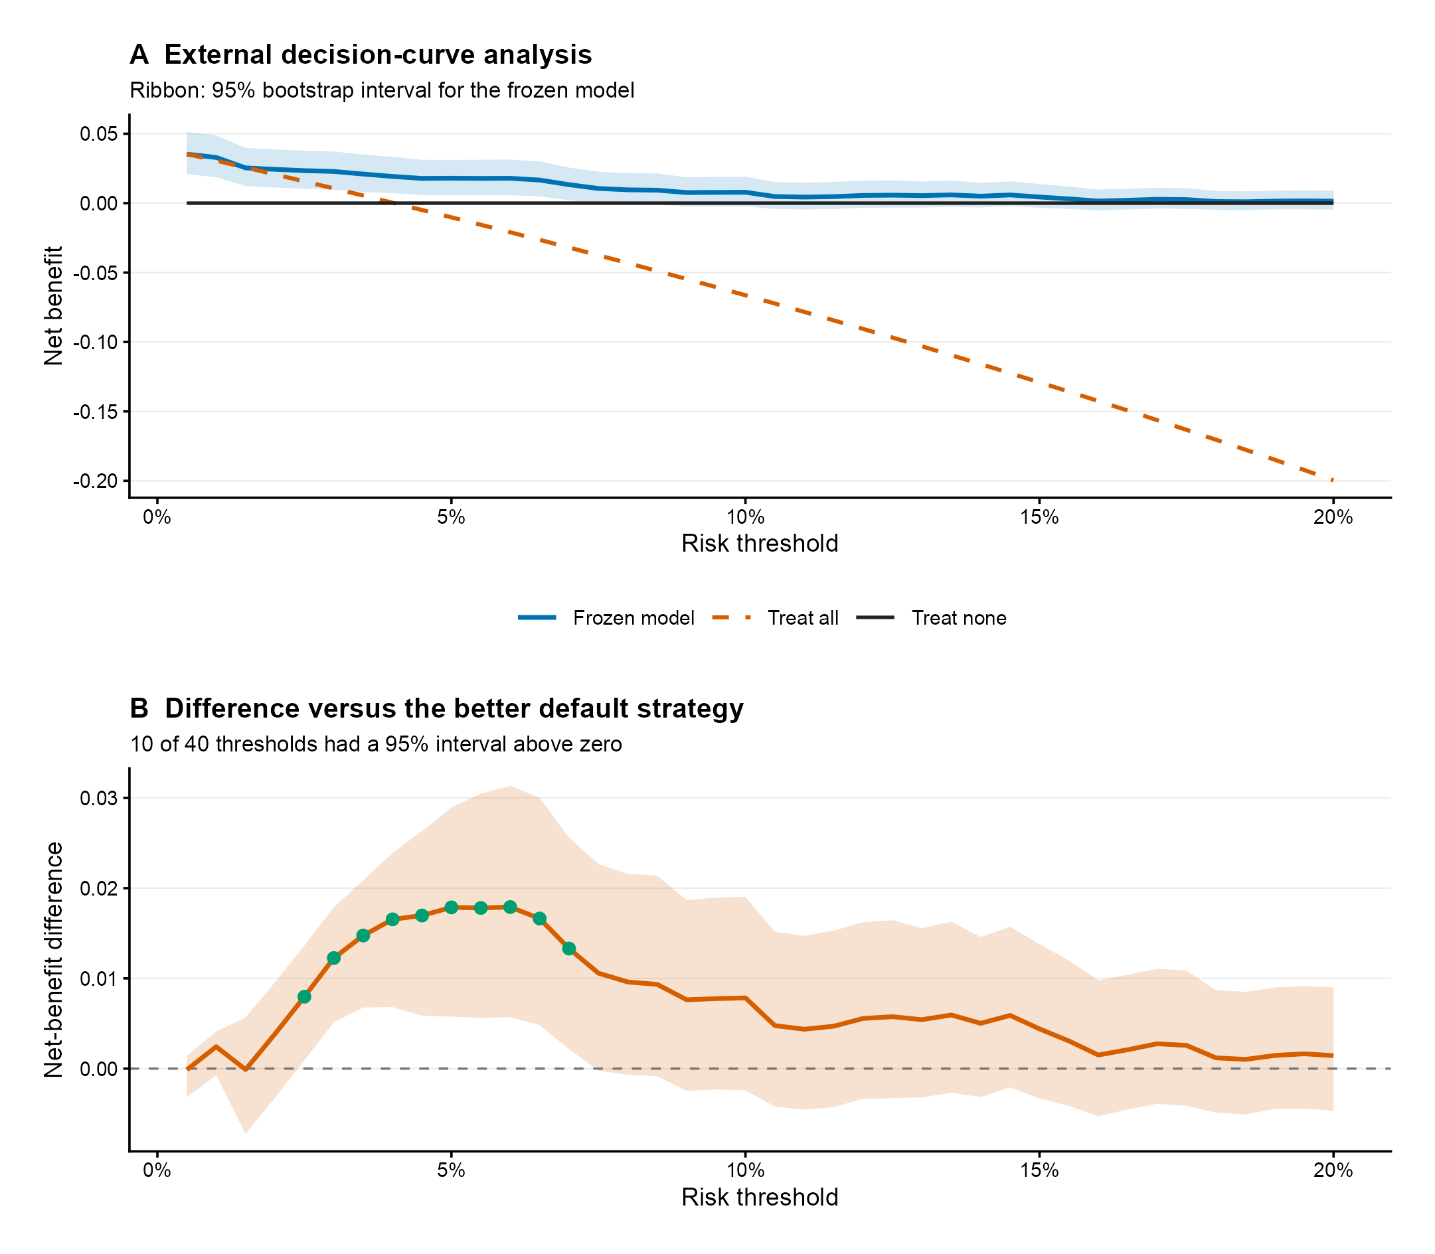
Supplementary Table S1 Definitions of predictors and outcomes
Variable | Definition | Unit/coding | Analysis
Age | Age at index admission | Years; restricted cubic spline knots 54, 68, 85 in mortality models | Prognostic and prediction models
Sex | Recorded sex | Female = 1; male = 0 | Prognostic and prediction models
Fracture category | Index fracture category | Hip/femur; lumbar spine/pelvis; thoracic spine/rib; forearm/wrist; shoulder/proximal humerus | All modules
BMI | Body mass index at baseline | kg/m² | Adjustment and prediction
ASA | American Society of Anesthesiologists physical-status class | I–IV; prediction uses III–IV vs I–II | Adjustment and prediction
CCI | Source-provided Charlson Comorbidity Index without age points | Integer score | Adjustment and prediction
Haemoglobin | Baseline haemoglobin | g/L | Adjustment and prediction
Albumin | Baseline serum albumin | g/L | Adjustment and prediction
Creatinine | Baseline serum creatinine | µmol/L; log2 transformation in models | Adjustment and prediction
Long-term mortality | All-cause mortality after the index admission | Time from index admission; follow-up through April 24, 2024 | Kaplan–Meier and Cox
First refracture | First recorded refracture after the index fracture | Time from index admission; death is a competing event; common censoring March 24, 2024 | CIF, cause-specific Cox, Fine–Gray
Prediction outcome | All-cause mortality within 365 days after discharge | Time-to-event endpoint from hospital discharge to all-cause death, evaluated at 365 days; patients with shorter available follow-up were censored at last observation | Frozen 1-year mortality model

Supplementary Table S2 Full adjusted mortality model
Term | Adjusted HR (95% CI) | P value
Age, restricted cubic spline | Interpret jointly in Figure S5A; reference age 68 years | Overall <0.001; nonlinearity <0.001
Female vs male | 0.64 (0.54–0.76) | <0.001
Lumbar spine/pelvis vs hip/femur | 0.78 (0.62–0.98) | 0.037
Thoracic spine/rib vs hip/femur | 0.65 (0.48–0.88) | 0.005
Forearm/wrist vs hip/femur | 0.47 (0.28–0.80) | 0.006
Shoulder/proximal humerus vs hip/femur | 0.36 (0.19–0.71) | 0.003
BMI, per 5 kg/m2 | 0.91 (0.78–1.06) | 0.217
ASA III-IV vs I-II | 1.57 (1.31–1.90) | <0.001
CCI, per point | 1.31 (1.19–1.44) | <0.001
Haemoglobin, per 10 g/L | 1.00 (0.94–1.05) | 0.878
Albumin, per 5 g/L | 0.93 (0.83–1.04) | 0.218
Creatinine, per doubling | 1.17 (0.98–1.39) | 0.084
Admission year, per year | 0.99 (0.94–1.05) | 0.791

Note. Age was modeled as a restricted cubic spline. The two basis coefficients are not presented as separate clinical effects; the overall and nonlinearity P values are joint model-based tests from the frozen pooled coefficient vector and covariance matrix.
Supplementary Table S3 Full competing-risk refracture models
Term | Cause-specific HR | Fine–Gray sHR
Age, per 10 years | 1.45 (1.26–1.67) | 1.36 (1.18–1.57)
Female vs male | 1.47 (1.09–1.98) | 1.54 (1.14–2.08)
Lumbar spine/pelvis vs hip/femur | 1.61 (1.15–2.24) | 1.69 (1.17–2.44)
Thoracic spine/rib vs hip/femur | 1.61 (1.11–2.34) | 1.73 (1.17–2.55)
Forearm/wrist vs hip/femur | 1.26 (0.79–2.02) | 1.32 (0.81–2.15)
Shoulder/proximal humerus vs hip/femur | 0.99 (0.50–1.93) | 1.07 (0.54–2.14)
BMI, per 5 kg/m2 | 0.93 (0.75–1.16) | 0.94 (0.75–1.17)
ASA III-IV vs I-II | 1.08 (0.79–1.49) | 1.01 (0.72–1.41)
CCI, per point | 1.25 (1.05–1.50) | 1.20 (0.99–1.44)
Haemoglobin, per 10 g/L | 0.93 (0.86–1.01) | 0.94 (0.86–1.02)
Albumin, per 5 g/L | 1.00 (0.84–1.19) | 1.01 (0.85–1.19)
Creatinine, per doubling | 0.84 (0.64–1.11) | 0.82 (0.64–1.06)
Admission year, per year | 0.90 (0.83–0.97) | 0.87 (0.81–0.94)

Supplementary Table S4 State-transition counts and person-time
Transition | Events | Person-time, years | Rate per 1,000 person-years (95% CI)
Alive without refracture → first refracture | 252 | 14016.3 | 18.0 (15.8–20.3)
Alive without refracture → direct death | 516 | 14016.3 | 36.8 (33.7–40.1)
Refracture → death | 51 | 542.9 | 93.9 (69.9–123.5)

Note. Transition rates are crude descriptive rates and should not be interpreted as causal contrasts.
Supplementary Table S5 Frozen prediction model specification
Term | Coefficient | Center | Transformation
Age, RCS basis 1 | 0.18140691873656 | 68.7540331028703 | Hmisc::rcspline.eval(age, knots=c(54,68,85), inclx=TRUE, norm=2), basis 1
Age, RCS basis 2 | -0.0854664164180374 | 7.01454131674929 | Hmisc::rcspline.eval(age, knots=c(54,68,85), inclx=TRUE, norm=2), basis 2
Female | -0.547602392705363 | 0.67672323486277 | Female = 1; male reference
Lumbar spine/pelvis | -0.526383166201681 | 0.270060758432851 | Indicator; hip/femur reference
Thoracic spine/rib | -0.692159642284934 | 0.151267546616384 | Indicator; hip/femur reference
Forearm/wrist | -0.821412533551208 | 0.139744395558349 | Indicator; hip/femur reference
Shoulder/proximal humerus | -1.69588681771102 | 0.085690341504295 | Indicator; hip/femur reference
BMI | -0.00761166041093751 | 23.2743175466916 | Identity; per 1 kg/m²
ASA III–IV | 0.56506649166179 | 0.223549130525875 | ASA III–IV = 1; ASA I–II reference
CCI | 0.288521468196176 | 0.160276555625393 | Identity; per point
Haemoglobin | -0.00284607293979383 | 125.094665828618 | Identity; per 1 g/L
Albumin | -0.0228068475062984 | 39.9311886304925 | Identity; per 1 g/L
log₂(creatinine) | 0.284444261892893 | 5.95975607169204 | log₂; per doubling
Centered baseline survival at 365 days | 0.987891407990899 | — | Risk = 1 - S0(365)^exp(sum(beta_j * (x_j - center_j)))

Note. The age basis was generated with Hmisc::rcspline.eval(age, knots = c(54, 68, 85), inclx = TRUE, norm = 2). Centers and coefficients are shown at full exported precision for independent reconstruction.
Supplementary Table S6 Strict internal validation procedure
Item | Specification
Candidate model | Single frozen clinical Cox model; no repeated variable or algorithm selection
Primary resampling | 500 patient-level bootstrap samples
Within each bootstrap sample | Re-estimate the multiple-imputation model for missing predictors and generate 5 imputations
Evaluation | Fit in the bootstrap sample and test in the original sample
Optimism correction | Apparent performance minus mean bootstrap optimism
Completed repetitions | 500/500 primary runs without recorded errors
Original imputation-model inputs | 17 baseline variables: 9 model inputs plus admission year, hypertension, diabetes, heart disease, cerebrovascular disease, chronic kidney disease, surgery, and anti-osteoporosis treatment
Original imputation methods | Predictive mean matching for BMI, haemoglobin, albumin, and creatinine; all other baseline variables observed
Outcome-informed MI sensitivity | Same 17 baseline variables plus the 365-day death indicator and standardized Nelson-Aalen cumulative hazard as auxiliary predictors; 30 imputations; frozen model terms and spline knots unchanged
Outcome-informed sensitivity result | Frozen model retained: external AUC 0.802 versus 0.801; slope 0.849 versus 0.849; O/E 1.006 versus 1.011
Primary corrected 365-day AUC | 0.86022
Primary corrected 365-day Brier score | 0.03695
Primary corrected Calibration intercept | -0.01779
Primary corrected Calibration slope | 0.95778
Primary corrected Harrell C | 0.85719
Primary corrected Integrated Brier score | 0.02287
Primary corrected Mean predicted risk | 0.04244
Primary corrected Observed risk | 0.04258
Primary corrected O/E ratio | 1.00801
Sensitivity validation | 100 bootstrap repetitions × 10 imputations; corrected AUC 0.86258; slope 0.96825

Note. The original imputation structure used 17 baseline variables. BMI, haemoglobin, albumin, and creatinine were imputed with predictive mean matching. A sensitivity analysis added the 365-day death indicator and standardized Nelson-Aalen cumulative hazard; the frozen predictor terms and spline knots were unchanged.
Supplementary Table S7 External cohort transportability and risk distribution
Section | Item | Development | External | Comparison
A. Linear-predictor transportability | LP SD | 1.794 | 1.671 | External/development SD ratio 0.931 (95% CI 0.883–0.978); LP SMD 0.097
B. Predictor transportability | Age, years | 68.8 (11.2) | 69.3 (10.6) | Signed SMD 0.054; SD ratio 0.943
B. Predictor transportability | BMI, kg/m² | 23.3 (3.3) | 23.2 (3.3) | Signed SMD -0.017; SD ratio 1.015
B. Predictor transportability | Source-provided CCI | 0.0 [0.0, 0.0] | 0.0 [0.0, 0.0] | Signed SMD 0.170; SD ratio 0.964
B. Predictor transportability | Haemoglobin, g/L | 125.1 (18.3) | 124.1 (17.9) | Signed SMD -0.054; SD ratio 0.982
B. Predictor transportability | Albumin, g/L | 39.9 (4.4) | 40.0 (4.1) | Signed SMD 0.001; SD ratio 0.935
B. Predictor transportability | Creatinine, µmol/L | 61.0 [51.0, 74.0] | 63.4 [45.9, 86.7] | Signed SMD 0.114; SD ratio 0.889
B. Predictor transportability | Sex (female) | 3230 (67.7%) | 470 (67.6%) | Signed SMD -0.001; SD ratio 1.000
B. Predictor transportability | Fracture type (global) | Five-category distribution | Five-category distribution | Signed SMD 0.064
B. Predictor transportability | ASA III-IV | 1067 (22.4%) | 156 (22.4%) | Signed SMD 0.002; SD ratio 1.001
C. External risk quintiles | Q1 | — | 1/139 deaths (0.72%) | Mean predicted risk 0.15%
C. External risk quintiles | Q2 | — | 2/139 deaths (1.44%) | Mean predicted risk 0.67%
C. External risk quintiles | Q3 | — | 2/139 deaths (1.44%) | Mean predicted risk 1.76%
C. External risk quintiles | Q4 | — | 3/139 deaths (2.16%) | Mean predicted risk 3.94%
C. External risk quintiles | Q5 | — | 20/139 deaths (14.39%) | Mean predicted risk 13.49%

Note. Continuous signed SMDs were recalculated once from unrounded, available-case observations before development-cohort imputation; the absolute values are those reported in main Table 1. Continuous summaries are mean (SD), except CCI and creatinine, which are median [Q1, Q3]. Category-level SMDs are binary contrasts; fracture type uses the global multinomial SMD.
Supplementary Table S8 Model updating analyses
Model | Role | Update intercept (95% CI) | Update slope (95% CI) | AUC | Apparent Brier | Optimism-corrected Brier | O/E | Decision
M0 | Primary frozen model | Fixed at 0 | Fixed at 1 | 0.802 | 0.03552 | 0.03552 | 1.006 | Retain as the primary external validation result
M1 | Secondary baseline-only update | -0.001 (-0.436–0.343) | Fixed at 1 | 0.802 | 0.03552 | 0.03579 | 1.008 | Negligible apparent improvement; not retained
M2 | Exploratory baseline-plus-slope update | -0.371 (-1.407–0.508) | 0.849 (0.540–1.237) | 0.802 | 0.03548 | 0.03600 | 0.998 | Exploratory and unstable with 28 events; not retained

Note. Fixed values are prespecified model-update parameters rather than estimates with confidence intervals. M0 is the unchanged frozen model; M1 fixes the slope at 1 and estimates only the intercept.

