Supplementary Information for

Biochar reduces PFAS mobility in contaminated soils: a global meta-analysis

Behrouz Gholamahmadi, Erlend Sørmo, Gerard Cornelissen

Corresponding author: Behrouz Gholamahmadi (behrouzg@ua.pt)

Contents
Supplementary Methods
Supplementary Results
Supplementary Table S1-S14
Supplementary Figures S1-S6
References to included studies

Supplementary Methods
S1. Literature search and study selection
Scopus, Web of Science Core Collection and Google Scholar were searched for experimental studies evaluating biochar application to PFAS-contaminated soils or soil–plant systems. Search terms combined concepts related to biochar, PFAS and soil, with syntax adapted to each platform (Table S1). The literature search was completed on 14 June 2026.
After consolidation of search results and complementary checks, 144 unique records entered title and abstract screening. Of these, 117 were excluded, 27 reports were sought for retrieval, one could not be retrieved, and 26 were assessed at full text. Six full-text reports were excluded because they did not meet the soil–biochar scope, lacked an eligible comparator or PFAS fate endpoint, or were non-English full texts. Twenty primary studies were included in the systematic review (Fig. S1). Web of Science identified no additional unique eligible study, and screening of the first 200 Google Scholar results identified no additional eligible study.
Water-only adsorption studies without a soil phase were excluded. Eligibility for the systematic review was broader than eligibility for individual quantitative analyses; studies remained eligible when they provided relevant experimental or mechanistic evidence but lacked sufficient information for reconstruction of a quantitative treatment–control effect.
S2. Eligibility and experimental-unit rules
Eligible systems included soil batch incubations, soil columns, lysimeters, pots/greenhouse experiments, field enclosures and field trials. The intervention had to contain biochar applied to soil or biosolids-amended soil, with a matched no-biochar comparator under the same PFAS/soil context. Pristine, activated and modified biochars were eligible. The true experimental unit governed replication. Analytical duplicates, nested tissue samples, repeated time points within the same column or lysimeter, and method-imputed measurement uncertainty were not treated as independent treatment replication.
For repeated experiments, a terminal or cumulative endpoint was selected for the main analysis whenever possible. Repeated time points remained available for trajectory or sensitivity analyses, but they were not counted as independent studies. Single-column or single-lysimeter treatments remained eligible for the systematic review and the variance-agnostic study-level synthesis, but not for conventional inverse-variance weighting.
S3. Outcome hierarchy and direction of benefit
The primary outcome was PFAS mobility. The prespecified hierarchy prioritised cumulative PFAS mass or fraction leached, followed by flow-weighted or terminal leachate/porewater/DGT concentration, and then water-extractable or operationally leachable fraction. This hierarchy favoured cumulative mass/fraction where available because concentration can be affected by hydrological changes independently of PFAS mass export. Plant uptake/transfer and soil retention/accessibility were analysed as separate secondary domains.
For matched treatment-control contrasts, the raw log response ratio was lnRR = ln(mean_biochar / mean_control). For mobility and plant-uptake outcomes, lower values indicate benefit, so analyses and figures used benefit-aligned lnRR = -lnRR. For retention endpoints in which higher retention represented benefit, the direction was aligned accordingly. Percentage reductions were calculated as 100 × [1 - exp(-benefit lnRR)].
S4. Sampling variance and shared controls
Where true treatment and control means, standard deviations and independent replicate numbers were available, sampling variance was calculated from the usual delta-method variance of the log response ratio. For effect sizes sharing the same control, the control contribution to the variance was entered as an off-diagonal covariance rather than assuming independence. Variance provenance was audited study by study. Reported standard errors were converted to standard deviations only when the relevant independent n was explicit; analytical or nested sample counts were not substituted for randomised experimental-unit replication.
S5. Variance-supported mobility synthesis
Six independent studies provided experimental unit variance that could be directly reported or defensibly reconstructed.
Two complementary random-effects analyses were conducted. First, eligible effects were balanced within experimental context and aggregated to one estimate per study. Dependence among PFAS effects within a shared context was represented using a working compound-symmetry correlation of (ρ=0.50), and study-level estimates were synthesised using restricted maximum likelihood (REML) with Hartung–Knapp inference.
Second, the effect-level data were analysed using a multilevel REML model accounting for clustering within study and experimental context. Small-sample inference was obtained using CR2 cluster-robust variance estimation with study as the clustering unit.
Sensitivity analyses evaluated alternative within-context correlations (ρ=0, 0.30, 0.50, 0.80) and alternative dependence specifications. Because only six independent studies contributed suitable sampling variances, these models were treated as sensitivity analyses rather than the primary synthesis.
S6. Missing-variance sensitivity
Two additional studies had genuine independent experimental replication and exact treatment–control mobility effects but lacked usable endpoint-specific sampling variances. These studies were incorporated in a separate eight-study sensitivity analysis in which missing uncertainty, but not the observed effect size, was imputed.
Coefficients of variation were sampled from the empirical distribution of study-level median coefficients of variation among variance-resolved donor studies and propagated across 5,000 imputations. Observed treatment and control means and the resulting ln RR values were unchanged. Results were combined across imputations, with additional checks based on donor-distribution quartiles and Monte Carlo split-half stability.
S7. Study-level all-evidence mobility synthesis
To include studies with quantitative mobility information but incomplete sampling variance, each independent study was reduced to one prespecified benefit-aligned mobility summary after balancing eligible PFAS, biochar treatments and experimental contexts.
For the 15 studies with exact point estimates, the cross-study effect was summarised using the sample median. Uncertainty was quantified using an exact distribution-free order-statistic confidence interval, and directionality was evaluated using a two-sided exact sign test. Each independent study therefore contributed equally regardless of the number of compounds, doses or treatment combinations reported.
One additional study provided only an interval-censored mobility estimate. Its lower and upper limits were retained throughout the analysis without midpoint substitution. Bounds on the overall median were obtained by propagating the interval limits through the relevant sample-median order statistics. The observed overall median remained point identified because the censored interval did not alter the median rank.
S8. PFAS chemistry mechanism analyses
PFAS identities were harmonised to canonical compound name, chemical group, headgroup and total carbon number (Table S13). Primary chain-length analyses were restricted to terminal PFCAs and PFSAs for which consistent chain classification could be applied.
For the long- versus short-chain analysis, mobility effects were first paired within the same study and experimental context. Median benefit-aligned effects were calculated separately for long- and short-chain compounds, and their difference was subsequently collapsed to one independent contrast per study. The cross-study median contrast and its exact distribution-free confidence interval were calculated, and consistency of direction was evaluated using an exact sign test.
A headgroup-adjusted sensitivity was calculated for long-versus-short contrasts separately within PFCA and PFSA strata before combining them within study.
The continuous carbon-number analysis retained the molecular gradient without imposing a binary chain threshold. Headgroup-stratified Theil–Sen slopes relating benefit-aligned ln RR to total carbon number were calculated within eligible study contexts and collapsed to one median slope per independent study. Cross-study inference was based on the median study slope, its exact distribution-free confidence interval and an exact sign test.
PFSA–PFCA differences were evaluated using analogous paired within-context contrasts and one independent summary per study.
S9. Moderator and contextual analyses
Moderator analyses were based on independent-study summaries rather than individual effect-size rows.
Biochar dose, soil total organic carbon (TOC) and pyrolysis temperature had sufficient study coverage for the main moderator analyses. Between-study relationships were evaluated using Spearman rank correlation and descriptive Theil–Sen slopes based on one moderator value and one response summary per study. When genuine variation in a moderator occurred within a study, study-specific Theil–Sen slopes were additionally calculated and their directional consistency evaluated using exact sign tests.
Contamination regime and experimental system were analysed as categorical study-level comparisons using exact permutation tests. These analyses were interpreted as contextual associations rather than causal moderator effects.
Specific surface area measured by N₂-BET and CO₂-DFT was analysed separately because the two methods probe different pore domains and cannot be treated as directly interchangeable. N₂-BET SSA, CO₂-DFT SSA and experimental duration/aging were retained as supplementary descriptive moderators because each was represented by fewer than 10 independent studies (Table S10). Feedstock, activation/modification and soil texture were not quantitatively pooled because category representation was insufficiently balanced across independent studies.
S10. Secondary outcomes
Soil retention/accessibility and plant uptake/bioavailability were analysed separately from mobility. Effect directions were harmonised so that positive benefit-aligned values represented greater stabilisation.
Within each study and outcome domain, dependent observations were balanced across experimental contexts and combined using available sampling covariance, including covariance arising from shared controls where recoverable.
Only two independent variance-supported studies contributed to each secondary domain. Consequently, no cross-study random-effects estimate was calculated. Study-specific effects and confidence intervals are reported in Table S11 and Fig. S4.
S11. Influence and small-study-effect diagnostics
Leave-one-study-out analyses were conducted for the exact study-level mobility synthesis, the long-versus-short-chain analysis, the continuous carbon-number analysis and the variance-supported multilevel model. Each analysis was repeated after sequential omission of one independent study.
Formal precision-based small-study-effect tests were not performed because the variance-supported mobility evidence comprised only six independent studies. This was below the prespecified minimum of 10 independent studies considered necessary for interpretable regression-based funnel-asymmetry assessment. Leave-one-study-out results are reported in Table S12 and Fig. S2.
Supplementary Results
S13. Evidence coverage
The quantitative evidence available for each analytical component is summarised in Table S4. Study-level experimental design and variance provenance are reported in Tables S2–S3. The compound-resolved mobility dataset contained 598 exact terminal PFCA/PFSA treatment–control effects from 14 studies; all cross-study analyses were based on study-balanced summaries rather than treating these rows as independent observations.
S14. Sensitivity and supplementary moderator analyses
Results from the variance-supported mobility models and missing-variance sensitivity are provided in Tables S5–S6 and Fig. S3. Alternative dependence assumptions produced similar benefit-aligned point estimates, although uncertainty remained large because of the small number of variance-supported studies.

Supplementary moderator analyses were limited by independent-study coverage. N₂-BET SSA was available for seven studies, CO₂-DFT SSA for five studies and experimental duration/aging for eight studies (Table S10). These associations were therefore treated as descriptive. The apparently strong negative CO₂-DFT association should be interpreted cautiously because it was based on only five independent studies.
S15. Robustness and secondary outcomes
The exact study-level mobility estimate, long-versus-short-chain contrast and carbon-number gradient remained benefit-aligned in every leave-one-study-out analysis (Table S12; Fig. S2). The variance-supported multilevel model likewise remained directionally positive under sequential study omission, although confidence intervals remained wide.
Study-specific soil-retention/accessibility and plant-transfer effects are reported in Table S11 and Fig. S4. No cross-study estimate was calculated because each secondary outcome domain was represented by only two independent studies.

Supplementary Tables
Table S1. Search strategy and search-source audit.
Source | Search status | Archived count | Use in review
Scopus | Primary database export / consolidated screening set | 144 unique records entered title/abstract screening; all 20 included studies were captured | Primary screening set; selection flow summarised in Fig. S1.
Web of Science Core Collection | Complementary database search | No additional unique eligible study identified | Cross-checking and candidate identification.
Google Scholar | Complementary search and citation chasing | First 200 results checked; no additional eligible study identified | Cross-checking and citation chasing.

Search string used across platforms (adapted to platform syntax):
(biochar OR "activated biochar" OR "modified biochar" OR "engineered biochar") AND (PFAS OR "per- and polyfluoroalkyl substances" OR perfluoroalkyl OR polyfluoroalkyl OR perfluorinated OR PFOS OR PFOA OR PFBS OR PFBA OR PFHxS OR PFHxA OR PFNA OR PFDA OR GenX OR HFPO-DA) AND (soil OR soils OR "soil amendment" OR "soil remediation" OR "contaminated soil" OR "soil column" OR lysimeter OR leaching OR leachate OR porewater OR rhizosphere OR crop OR plant)

Table S2. Characteristics of the 20 included primary studies.
Study | Experimental system | Soil/contamination context | PFAS scope | Biochar intervention | Dose | Primary endpoint
Kupryianchyk et al. (2016) | Batch soil amendment/porewater | Three native PFAS-contaminated airport soils (BER, EVE, KRI) | PFOS; PFOA; PFHxS plus site PFAS | Mixed-wood + paper-mill-waste biochars | 4% w/w | Porewater PFAS / soil-water LogKd
Silvani et al. (2019) | Batch soil leaching | Two native AFFF-impacted soils; TOC 1.61% and 34.2% | Multiple PFAS; PFOS/PFHxS/PFOA/PFHxA emphasised | Waste-timber BC; activated coconut-shell biochar | 0; 1; 2; 5; 10; 20% w/w | Leachate relative concentration Cw/C0
Askeland et al. (2020) | Batch soil sorption/desorption | Two controlled soils: loamy sand and sandy clay loam | PFOS; PFOA; PFHxS; PFHxA | Pine P750 biochar, 750°C | 0–5% w/w | Residual aqueous PFAS fraction at equilibrium
Sørmo et al. (2021) | Laboratory batch soil leaching (modified EN 12457) | Rygge Airport AFFF-contaminated podzol; low-TOC mineral horizon 1.6% and high-TOC O horizon 34.2% | 22 PFAS analysed; 6 focal PFAS: PFBS, PFHxS, PFOS, PFBA, PFHxA, PFOA | 8 waste-timber biochars: non-activated plus steam/CO2 activated variants | 0; 0.1; 0.5; 1; 2; 5% w/w | Leachate PFAS concentration/percentage reduction
Zhang & Liang (2022a) | Laboratory soil stabilisation; sequential water + SPLP leaching; ageing | Experimentally PFAS-spiked sandy-loam agricultural soil | 10 PFAS: PFBS, PFHxA, GenX, PFHpA, PFHxS, PFOA, PFNA, PFOS, PFDA, PFUdA | Forest-wood-waste biochar; 1000°C; ~800 m²/g | 2% w/w | Water- and SPLP-leachable PFAS fraction
Navarro et al. (2023) | Long-term soil stabilisation with multiple standard leaching protocols | Two historically AFFF-contaminated soils: clay loam TO and loamy sand TW | Up to 28 PFAS; PFHxS, PFOS and PFOA emphasised | B1 fine hardwood biochar; B2 GAC-biochar mixture (plus AC comparators not extracted as biochar effects) | 6%; 1% w/w | PFAS leaching reduction over time
Kabiri et al. (2023) | Batch solution screening + soil ASLP immobilisation | Native AFFF-contaminated sandy soil | Multiple AFFF PFAS | 4 biochars among a 28-sorbent carbon panel | 1% w/w | Operational Kd / retained fraction from ASLP
Sørmo et al. (2024) | Up-flow soil columns; 15 d; ~16 pore volumes | Native sandy AFFF-contaminated soil; TOC 0.57±0.04% | 39 targets; 10 focal PFAS; PFOS dominant | 6 wood/sludge biochars including CO2-activated waste timber | 1% w/w | Leachate PFAS reduction / modelled partitioning
Holly et al. (2024) | Undisturbed soil columns + 24 weekly simulated-rainfall events | Four Wisconsin agricultural soils with contrasting biosolids histories | 28 PFAS measured; 15 analytes in exact flow-weighted concentration table | Carbon Tera wood biochar co-applied with biosolids | 38 t/há | Flow-weighted leachate PFAS concentration over 24 weeks
Openiyi et al. (2025) | Triplicate packed unsaturated columns; weekly 4-d wetting/3-d drying cycles for 24 weeks | Low-OM sandy soil (0.6% OM) + 3 wt% Class A biosolids | 52 PFAS monitored; 24 exact compound mass-balance contrasts retained | Biosolids-derived biochar produced at 350°C under N2 | 1.5% w/w | Cumulative PFAS leaching / cumulative mass fraction leached
Battisti et al. (2025) | Field horticultural trial; six 6-m² plots (3 biochar, 3 control); tomato followed by red chicory | PFAS-contaminated calcareous Cambisol irrigated with contaminated groundwater | 13 PFAS targeted | Mixed-oak woody biochar; slow pyrolysis at 550°C | 80 t/ha | Plant-tissue PFAS concentration; separate final-soil PFAS concentration
Jiang et al. (2025) | Greenhouse planted + unplanted soil systems; 2% adsorbent; alfalfa harvested on days 56 and 98 | Albany sandy-loam soil + vermiculite; eight PFAS freshly spiked at 300 µg/kg each | PFHxA, PFHpA, PFOA, PFNA, PFBS, PFHxS, PFOS, GenX | Two commercial biochars among six adsorbents (~800 and ~82 m²/g) | 2% w/w | Water-leachable PFAS and alfalfa uptake
Fu et al. (2025) | Replicated 360-d soil–lettuce rainfall-leaching columns; two growing seasons | Two agricultural soils; PFOA spiked then aged 120 d before biochar addition | PFOA | Rice-husk biochar selected after four-feedstock screening | 2% and 4% w/w | Cumulative 360-d PFOA leaching loss
Hubert et al. (2025) | Nine outdoor field-scale unsaturated lysimeters; seasonal weather; 347-d observed experiment + separate 1D modelling | Loamy sand B-horizon soil spiked with AFFF + 18 target PFAS | 18 PFAS: 11 PFCAs, PFBS/PFHxS/PFOS, 4:2/6:2/8:2 FTS, FOSA | Waste-timber and sewage-sludge biochars; both non-activated, 800°C | 1% and 4% w/w | Observed normalised accumulated PFAS mass leached
Kabiri et al. (2026) | Accelerated ageing of sorbents alone and sorbent-treated soils followed by ASLP leaching | Two native PFAS-contaminated soils, each studied undiluted (~20 mg/kg) and 10× diluted (~2–4 mg/kg) | 28 target PFAS; 16 detected PFAS emphasised in immobilisation outputs | Almond-derived biochar (sorbent F) among six sorbents | 1% w/w | PFAS leaching reduction/immobilisation efficiency
Zhang et al. (2026) | Paddy soil–water–rice field enclosures; repeated irrigation; DGT/HR-Peeper + batch adsorption | Paddy field soil; PFAS introduced through irrigation water | PFBA; PFOA | Rice-husk biochar (RBC); montmorillonite-modified biochar (MBC) | 3% w/w | DGT/depth-resolved PFAS mobility and SWI diffusion flux
Hu et al. (2026) | Batch adsorption/desorption + oxidative aging + 12-d soil-column leaching | Silty clay loam and sandy loam | PFOA | Pristine corn-stalk biochar; KHCO3-modified biochar (KBC); oxidatively aged KBC (OKBC) | 0.5% w/w | PFOA adsorption/immobilization and leaching stability
Skjennum et al. (2026) | Fifteen outdoor 48-kg unsaturated columns; 2-y field exposure | Historically AFFF-contaminated silty-sand soil; Σ27PFAS 1624±276 µg/kg | Target PFAS + precursors | Three sewage-sludge biochars (RSS-1, DSS-1, RSS-2); RSS-2 also tested as basal barrier | 1% w/w | Temporal leachate PFAS concentration at true-replicate dates
Zhang & Liang (2022b) | Replicated greenhouse pot/plant experiment in PFAS-spiked biosolids-amended sandy-loam soil | Albany sandy loam + vermiculite; PFAS-spiked biosolids applied at 0.17 kg biosolids/kg dry soil | 10 PFAS (PFHxA, PFHpA, PFOA, PFNA, PFDA, PFUnDA, PFBS, PFHxS, PFOS, GenX) + ΣPFAS | Commercial forest-wood-waste biochar (Biochar Supreme; >85% organic C; ~800 m²/g) | 0.2% and 2% w/w | Day-80 SPLP-leachable PFAS (% of spiked mass)
Xin et al. (2025) | Batch soil adsorption plus aged PFAS–metal-oxyanion co-contaminated soil remediation/washing experiments | Yunnan, Guangdong and Ningxia soils; PFAS + heavy-metal oxyanion co-contamination | 14 PFAS in adsorption work; PFOA/PFNA/PFDA emphasised in aged-soil remediation | Walnut-, coconut- and apricot-shell biochars (HTK/YK/XK) | 1% and 5% w/w | No defensible single primary meta-analytic endpoint; retained for mechanistic synthesis.

Table S3. Experimental-unit and variance-provenance audit.
Study | Independent replication n | Quantitative role
Kupryianchyk et al. (2016) | 3 | Missing-variance sensitivity + all-evidence mobility synthesis.
Silvani et al. (2019) | 3 | Variance-supported mobility + all-evidence synthesis.
Askeland et al. (2020) | 3 | Variance-supported mobility + all-evidence synthesis.
Sørmo et al. (2021) | 3 | All-evidence mobility synthesis.
Zhang & Liang (2022a) | NA | All-evidence mobility synthesis.
Navarro et al. (2023) | 3 | All-evidence mobility synthesis.
Kabiri et al. (2023) | 3 | Interval-censored all-evidence mobility synthesis.
Sørmo et al. (2024) | Replication varied | All-evidence mobility synthesis.
Holly et al. (2024) | Replication varied | Variance-supported mobility + all-evidence synthesis.
Openiyi et al. (2025) | 3 | Missing-variance sensitivity + all-evidence mobility synthesis.
Battisti et al. (2025) | 6 | Direct secondary soil-retention estimate; plant evidence descriptive/sensitivity only.
Jiang et al. (2025) | NA | All-evidence mobility synthesis.
Fu et al. (2025) | 3 | Variance-supported mobility + direct secondary retention/plant estimates.
Hubert et al. (2025) | 1 | All-evidence mobility synthesis.
Kabiri et al. (2026) | 3 | Narrative/mechanistic synthesis only.
Zhang et al. (2026) | 6 | All-evidence mobility synthesis.
Hu et al. (2026) | 3 | Mechanistic synthesis + secondary retention sensitivity only.
Skjennum et al. (2026) | 3 | Variance-supported mobility + all-evidence synthesis.
Zhang & Liang (2022b) | 3 | Variance-supported mobility + direct plant-transfer estimate.
Xin et al. (2025) | 3 | Narrative/mechanistic synthesis only.

Table S4. Quantitative synthesis architecture and evidence coverage
Evidence set | Independent studies (k) | Definition | Use in synthesis
Systematic review corpus | 20 | All eligible primary soil and soil–plant studies | Systematic review
Quantitative evidence base | 18 | Studies contributing a quantitatively usable primary or secondary endpoint | Quantitative analyses
Broad mobility synthesis | 16 | 15 exact study-level estimates plus one interval-censored estimate | Primary overall mobility synthesis
Exact-point mobility synthesis | 15 | One exact study-level mobility estimate per study | Sensitivity analysis
Variance-supported mobility subset | 6 | Studies with observed or recoverable experimental-unit sampling variance | Random-effects sensitivity analyses
Missing-variance sensitivity | 8 | Variance-supported subset plus two independently replicated studies with imputed sampling variance | Variance sensitivity analysis
Compound-resolved mobility dataset | 14 | 598 exact terminal PFCA/PFSA biochar–control effect-size rows | Compound-specific and molecular-structure analyses
Long- vs short-chain analysis | 12 | One paired long-minus-short contrast per independent study | Chain-class analysis
Carbon-number analysis | 12 | One headgroup-adjusted carbon-number slope per independent study | Continuous molecular-structure analysis
PFSA vs PFCA analysis | 12 | One paired PFSA-minus-PFCA contrast per independent study | Headgroup analysis
Secondary outcomes | 3 | Studies contributing quantitative soil-retention/accessibility and/or plant-transfer outcomes | Study-specific secondary analyses

Note: k denotes independent studies. The 598 compound-resolved effect-size rows were collapsed within study before cross-study inference and were not treated as independent observations.

Table S5. Variance-supported mobility analyses and robustness checks.
Specification | k | Benefit lnRR | 95% CI | tau² | I² (%) | Point reduction (%)
Study-level REML + Hartung-Knapp (ρ=0.0) | 6 | 2.351 | -0.460 to 5.162 | 7.13 | 100 | 90.5
Study-level REML + Hartung-Knapp (ρ=0.3) | 6 | 2.351 | -0.461 to 5.162 | 7.11 | 99.9 | 90.5
Study-level REML + Hartung-Knapp (ρ=0.5) | 6 | 2.35 | -0.461 to 5.162 | 7.09 | 99.8 | 90.5
Study-level REML + Hartung-Knapp (ρ=0.8) | 6 | 2.35 | -0.462 to 5.162 | 7.07 | 99.8 | 90.5
Four-level REML + study-clustered CR2 | 6 | 2.431 | -0.337 to 5.199 | 11.88 | — | 91.2
Three-level REML + study-clustered CR2 | 6 | 2 | -0.437 to 4.437 | 10.13 | — | 86.5
Askeland et al. (2020): reported ± treated as SD | 6 | 2.431 | -0.337 to 5.199 | 11.88 | — | 91.2
Askeland et al. (2020): reported ± treated as SE | 6 | 2.431 | -0.337 to 5.199 | 11.88 | — | 91.2

Note: The study-level Hartung-Knapp model uses one aggregated effect per independent study. The multilevel CR2 model uses the effect-level dataset with study-clustered inference. These are sensitivity analyses; the broad study-level median synthesis is the primary overall result.

Table S6. Missing-variance expansion to eight independently replicated studies.
Specification | k | Benefit lnRR | 95% CI | Point reduction (%) | tau² | I² (%)
5,000-imputation pooled estimate | 8 | 1.847 | -0.196 to 3.891 | 84.2 | 5.89 | 99.8
Donor CV sensitivity: Q1 | 8 | 1.845 | -0.197 to 3.888 | 84.2 | 5.89 | 99.9
Donor CV sensitivity: Median | 8 | 1.846 | -0.197 to 3.890 | 84.2 | 5.89 | 99.8
Donor CV sensitivity: Q3 | 8 | 1.848 | -0.196 to 3.892 | 84.2 | 5.89 | 99.8

Note: Only sampling variance was imputed. Observed study point estimates were unchanged. Monte Carlo split-half estimates were identical to three decimals (1.847 in each half).

Table S7. Study-level evidence used in the interval-aware all-evidence mobility synthesis.
Study | Study-level effect type | Benefit lnRR | Back-transformed interpretation
Kabiri et al. (2023) | interval | 0.010 to 0.693 | 1.0-50.0% lower mobility (interval-censored)
Zhang & Liang (2022b) | exact | 0.119 | 11.3% lower mobility
Kupryianchyk et al. (2016) | exact | 0.288 | 25.0% lower mobility
Openiyi et al. (2025) | exact | 0.426 | 34.7% lower mobility
Silvani et al. (2019) | exact | 0.464 | 37.1% lower mobility
Askeland et al. (2020) | exact | 0.701 | 50.4% lower mobility
Holly et al. (2024) | exact | 0.708 | 50.7% lower mobility
Sørmo et al. (2024) | exact | 0.775 | 53.9% lower mobility
Sørmo et al. (2021) | exact | 0.968 | 62.0% lower mobility
Navarro et al. (2023) | exact | 1.249 | 71.3% lower mobility
Skjennum et al. (2026) | exact | 1.711 | 81.9% lower mobility
Jiang et al. (2025) | exact | 2.275 | 89.7% lower mobility
Zhang et al. (2026) | exact | 2.355 | 90.5% lower mobility
Zhang & Liang (2022a) | exact | 2.76 | 93.7% lower mobility
Hubert et al. (2025) | exact | 5.974 | 99.7% lower mobility
Fu et al. (2025) | exact | 7.281 | 99.9% lower mobility

Table S8. PFAS-specific study-balanced mobility summaries.
PFAS | Class | Chain class | k studies | Median mobility change | Exact median interval
PFOS | PFSA | Long | 11 | 79.3% lower | 38.3% to 94.0% lower
PFHpS | PFSA | Long | 6 | 76.2% lower | 26.2% to 92.9% lower
PFHxS | PFSA | Long | 11 | 71.7% lower | 16.2% to 93.4% lower
PFHpA | PFCA | Short | 9 | 62.6% lower | 14.1% to 80.9% lower
PFOA | PFCA | Long | 13 | 62.1% lower | 12.2% to 90.5% lower
PFDA | PFCA | Long | 7 | 47.7% lower | 9.2% to 77.8% lower
PFBS | PFSA | Short | 11 | 43.7% lower | 19.1% to 87.8% lower
PFNA | PFCA | Long | 9 | 42.7% lower | 9.3% to 80.3% lower
PFHxA | PFCA | Short | 12 | 29.6% lower | 23.1% to 65.1% lower
PFBA | PFCA | Short | 8 | 20.4% lower | -1.4% to 86.9% lower
PFPeA | PFCA | Short | 7 | 14.0% lower | -224.3% to 55.9% lower

Table S9. Molecular-structure mechanism analyses and sensitivities.
Analysis | k | Central effect | Exact median interval | Directional evidence
Long vs short chain — primary paired analysis | 12 | 0.369 | 0.305 to 0.638 | 11/12 long-chain stronger; P=0.0063
Long vs short — headgroup-adjusted sensitivity | 12 | 0.327 | — | 11/12 long-chain stronger; P=0.0063
Long vs short within PFCA | 12 | 0.312 | — | 10/12 long-chain stronger; P=0.0386
Long vs short within PFSA | 10 | 0.278 | — | 7/10 long-chain stronger; P=0.3438
Carbon-number gradient — headgroup-adjusted primary | 12 | 0.0863 | 0.0183 to 0.2062 | 11/12 positive; P=0.0063
Carbon-number gradient — unadjusted sensitivity | 13 | 0.0815 | — | 10/13 positive; sign P=0.0923
PFSA vs PFCA paired headgroup contrast | 12 | 0.367 | -0.022 to 0.505 | 9/12 PFSA stronger; P=0.1460

Table S10. Supplementary moderator analyses not shown in the main text
Moderator | k | Scale | Spearman ρ | P | Theil–Sen slope (benefit lnRR)
N₂-BET specific surface area | 7 | m² g⁻¹ | −0.357 | 0.432 | −0.00131 per m² g⁻¹
CO₂-DFT specific surface area | 5 | m² g⁻¹ | −0.900 | 0.037 | −0.000943 per m² g⁻¹
Experiment duration / aging | 8 | days | 0.635 | 0.091 | 0.00286 per day

Note: k denotes independent studies. Associations are descriptive because each moderator was represented by fewer than 10 independent studies. N₂-BET and CO₂-DFT surface-area measurements were analysed separately. Positive slopes indicate greater biochar-associated PFAS immobilisation with increasing moderator values.
Table S11. Secondary soil-retention/accessibility and plant-transfer/bioavailability outcomes.
Study | Outcome domain | Benefit lnRR | 95% CI | Effect rows | Contexts | Translation
Fu et al. (2025) | Plant uptake | 4.278 | 3.961 to 4.596 | 2 | 1 | 98.6% reduction (CI 98.1 to 99.0%)
Zhang & Liang (2022b) | Plant uptake | -0.594 | -0.780 to -0.408 | 1 | 1 | 81.1% increase (CI 50.4 to 118.1%)
Battisti et al. (2025) | Soil retention | 0.262 | -0.004 to 0.527 | 10 | 2 | 29.9% signed change in beneficial endpoint (CI -0.4 to 69.5%)
Fu et al. (2025) | Soil retention | 1.768 | 1.582 to 1.954 | 8 | 2 | Benefit-aligned lnRR only (mixed endpoint direction types)

Note: No pooled random-effects estimate was calculated because each direct secondary domain had only two independent studies. Shared-control covariance increased the variance of the large one-year retention summary by about 77% relative to naïve independence and increased its SE by about 33%.

Table S12. Influence and publication-bias diagnostics.
Analysis | k | Leave-one-study-out result
Overall mobility | 15 | Median reduction remained 58.2–67.0% under all study omissions
Long- vs short-chain contrast | 12 | Median contrast remained positive under all omissions; exact sign-test P ≤ 0.0117
Carbon-number gradient | 12 | Median slope remained positive under all omissions; exact sign-test P ≤ 0.0117
Multilevel variance-supported model | 6 | Point estimate remained benefit-aligned under all study omissions

Table S13. PFAS harmonisation and molecular classification
PFAS | Full name | PFAS group | Headgroup | Total carbon count | Chain class
PFBA | Perfluorobutanoic acid | PFCA | Carboxylate | 4 | Short
PFPeA | Perfluoropentanoic acid | PFCA | Carboxylate | 5 | Short
PFHxA | Perfluorohexanoic acid | PFCA | Carboxylate | 6 | Short
PFHpA | Perfluoroheptanoic acid | PFCA | Carboxylate | 7 | Short
PFOA | Perfluorooctanoic acid | PFCA | Carboxylate | 8 | Long
PFNA | Perfluorononanoic acid | PFCA | Carboxylate | 9 | Long
PFDA | Perfluorodecanoic acid | PFCA | Carboxylate | 10 | Long
PFUnDA | Perfluoroundecanoic acid | PFCA | Carboxylate | 11 | Long
PFDoDA | Perfluorododecanoic acid | PFCA | Carboxylate | 12 | Long
PFTrDA | Perfluorotridecanoic acid | PFCA | Carboxylate | 13 | Long
PFTeDA | Perfluorotetradecanoic acid | PFCA | Carboxylate | 14 | Long
PFPrS | Perfluoropropane sulfonate | PFSA | Sulfonate | 3 | Short
PFBS | Perfluorobutane sulfonate | PFSA | Sulfonate | 4 | Short
PFPeS | Perfluoropentane sulfonate | PFSA | Sulfonate | 5 | Short
PFHxS | Perfluorohexane sulfonate | PFSA | Sulfonate | 6 | Long
PFHpS | Perfluoroheptane sulfonate | PFSA | Sulfonate | 7 | Long
PFOS | Perfluorooctane sulfonate | PFSA | Sulfonate | 8 | Long
PFNS | Perfluorononane sulfonate | PFSA | Sulfonate | 9 | Long
PFDS | Perfluorodecane sulfonate | PFSA | Sulfonate | 10 | Long
HFPO-DA (GenX) | Hexafluoropropylene oxide dimer acid | PFECA | Carboxylate | 6 | —
4:2 FTS | 4:2 fluorotelomer sulfonate | Fluorotelomer precursor | Sulfonate | 6 | —
6:2 FTS | 6:2 fluorotelomer sulfonate | Fluorotelomer precursor | Sulfonate | 8 | —
8:2 FTS | 8:2 fluorotelomer sulfonate | Fluorotelomer precursor | Sulfonate | 10 | —
5:3 FTCA | 5:3 fluorotelomer carboxylic acid | Fluorotelomer precursor | Carboxylate | 8 | —
7:3 FTCA | 7:3 fluorotelomer carboxylic acid | Fluorotelomer precursor | Carboxylate | 10 | —
FOSA / PFOSA | Perfluorooctane sulfonamide | PFSA precursor | Sulfonamide | 8 | —
MeFOSAA | N-methyl perfluorooctane sulfonamidoacetic acid | PFSA precursor | Sulfonamidoacetate | 10 | —
EtFOSAA | N-ethyl perfluorooctane sulfonamidoacetic acid | PFSA precursor | Sulfonamidoacetate | 11 | —
EtFOSA | N-ethyl perfluorooctane sulfonamide | PFSA precursor | Sulfonamide | 10 | —

Table S14. Study-balanced mechanistic and contextual controls on biochar performance for PFAS immobilisation
Moderator | Evidence structure | Range/groups | Study-balanced estimate | Back-transformed interpretation | Inference / within-study evidence
PFSA vs PFCA | k=12 paired studies; 12 paired study contrasts | Paired classes | Median contrast=0.367 benefit lnRR | 30.7% lower PFSA mobility ratio | 9/12 PFSA stronger; exact sign P=0.146; suggestive
Biochar dose | k=11; nES=520 exact rows; within-study slopes k=4 | 0.1-6% w/w | Spearman ρ=0.334; Theil-Sen=0.1369 lnRR per +1% | 12.8% lower mobility ratio per +1% w/w | Between-study P=0.315; 4/4 within-study slopes positive, sign P=0.125
Soil TOC | k=12; nES=578 exact rows; within-study slopes k=7 | 0.4-34.2% | Spearman ρ=-0.550; Theil-Sen=-0.0617 per +1 %-point | 6.4% higher mobility ratio per +1 %-point TOC | Between-study P=0.064; 7/7 within-study slopes negative, sign P=0.0156
Pyrolysis temperature | k=11; nES=393 exact rows; within-study slopes k=4 | 350-1000 °C | Spearman ρ=-0.112; Theil-Sen=-0.000782 per °C | 8.1% higher mobility ratio per +100 °C | Between-study P=0.743; 2/4 within-study slopes positive, sign P=1.000
Contamination regime | k=15 study medians; native/legacy k=6, introduced k=9 | Native/legacy vs introduced | Median benefit lnRR 0.871 vs 2.280; difference=1.408 | 75.5% lower mobility ratio in introduced-contamination studies | Exact permutation P=0.096; contextual
Experimental system | k=12 study medians; batch k=6, column/lysimeter k=6 | Batch/stabilization vs column/lysimeter | Median benefit lnRR 0.835 vs 1.242; difference=0.408 | 33.5% lower mobility ratio in column/lysimeter studies | Exact permutation P=0.481; contextual
Note: nES denotes exact compound-resolved effect-size rows available in the corresponding moderator universe. These rows were collapsed to study-balanced summaries and are not independent replicates. Continuous moderator slopes are descriptive associations, not causal dose-response functions.
Supplementary Figures

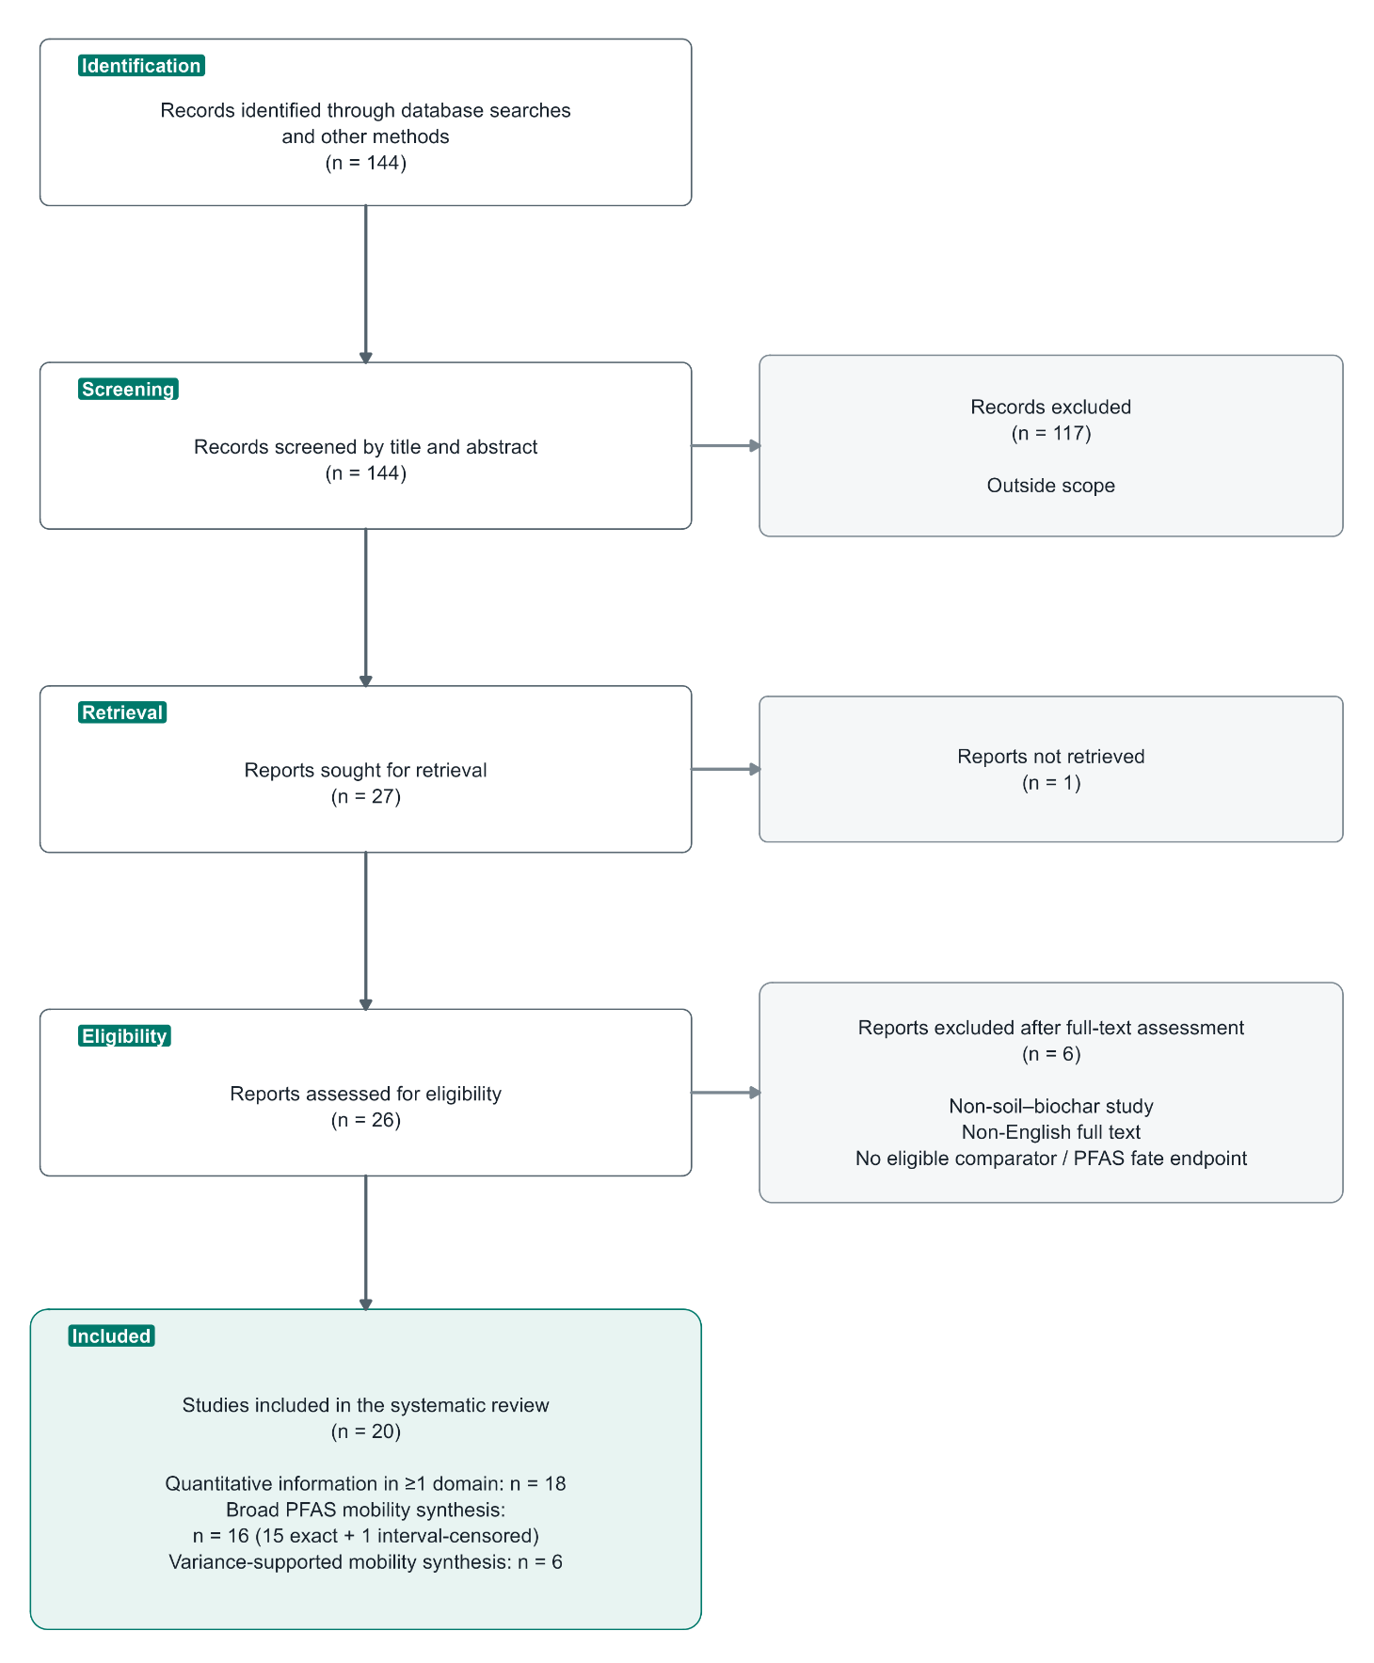

Figure S1. PRISMA 2020 flow diagram for study identification, screening, eligibility and inclusion. The flow comprises 144 screened records, 117 title/abstract exclusions, 27 reports sought for retrieval, one report not retrieved, 26 full-text reports assessed, six full-text exclusions and 20 included primary studies. The included corpus contains 18 studies with quantitative information in at least one domain, 16 studies in the broad mobility synthesis and six in the variance-supported mobility core.

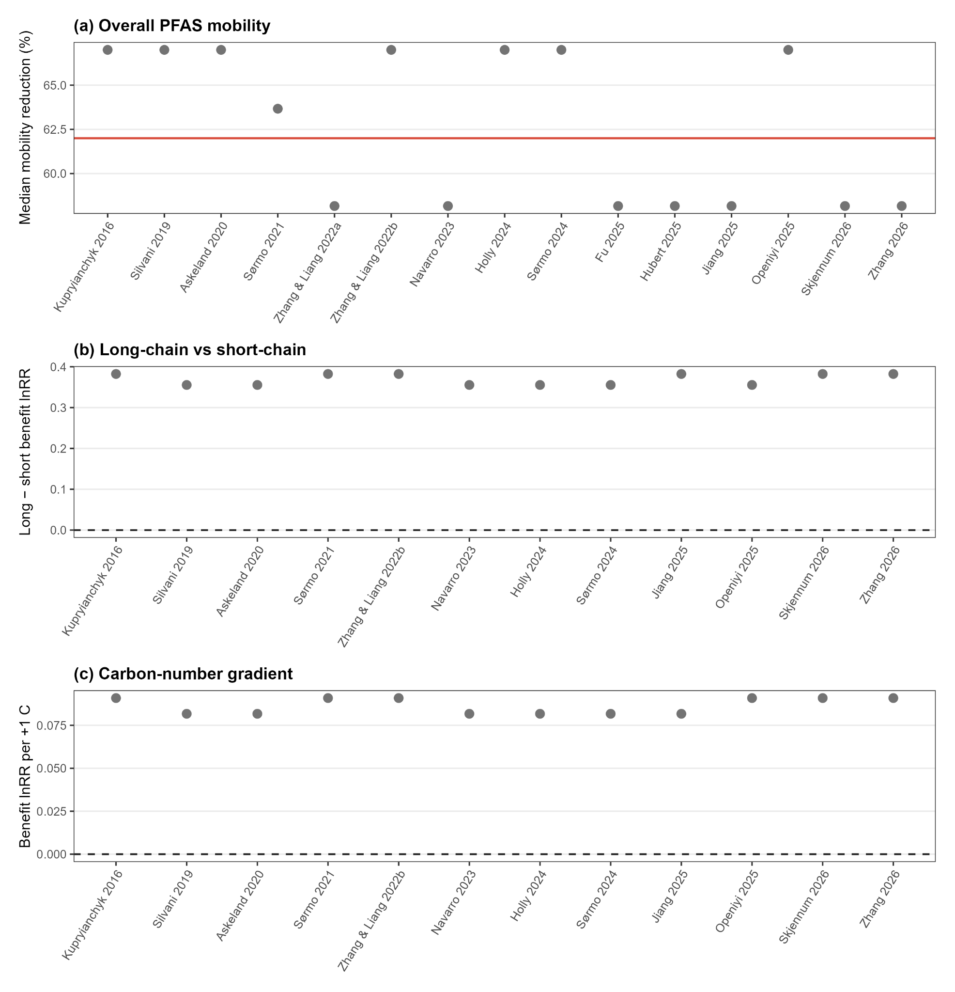

Figure S2. Leave-one-study-out robustness of the study-balanced mobility and molecular-structure analyses. Panel (a) shows the exact-point study-level median mobility reduction after omitting each independent study; the horizontal reference line is the full-data exact median (62.0% lower mobility). Panels (b) and (c) show omission-specific medians for the long-minus-short chain contrast and the headgroup-adjusted carbon-number slope, respectively. The dashed zero line denotes no chain-class difference or no carbon-number gradient. Both molecular-structure conclusions remained positive under every study omission.

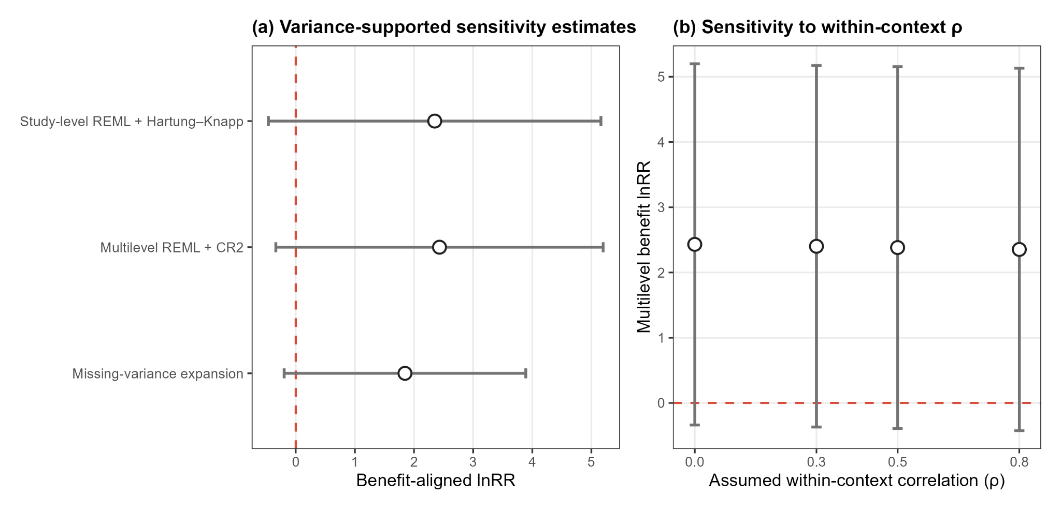
Figure S3. Variance-supported sensitivity analyses. Panel a compares the study-level REML + Hartung-Knapp estimate, the multilevel REML + study-clustered CR2 estimate and the eight-study missing-variance expansion. Error bars are 95% confidence intervals on the benefit-aligned lnRR scale; zero denotes no effect. Panel b shows the multilevel estimate across assumed within-context correlations from 0 to 0.8. The point estimate was insensitive to this working-correlation assumption.

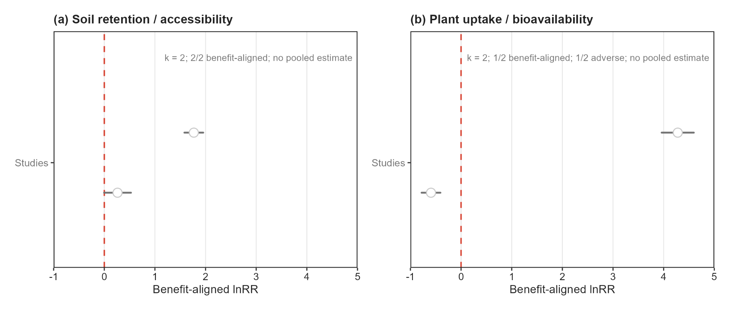
Figure S4. Study-level evidence for secondary soil-retention/accessibility and plant-uptake/bioavailability outcomes. Each point is a study-level, context-balanced estimate with a 95% confidence interval. Positive benefit-aligned lnRR denotes a favourable stabilisation outcome. Soil retention/accessibility had two benefit-aligned study estimates, whereas plant uptake/bioavailability had one favourable and one adverse study estimate under a stabilisation objective. No pooled estimate is shown because each domain had only two independent studies.

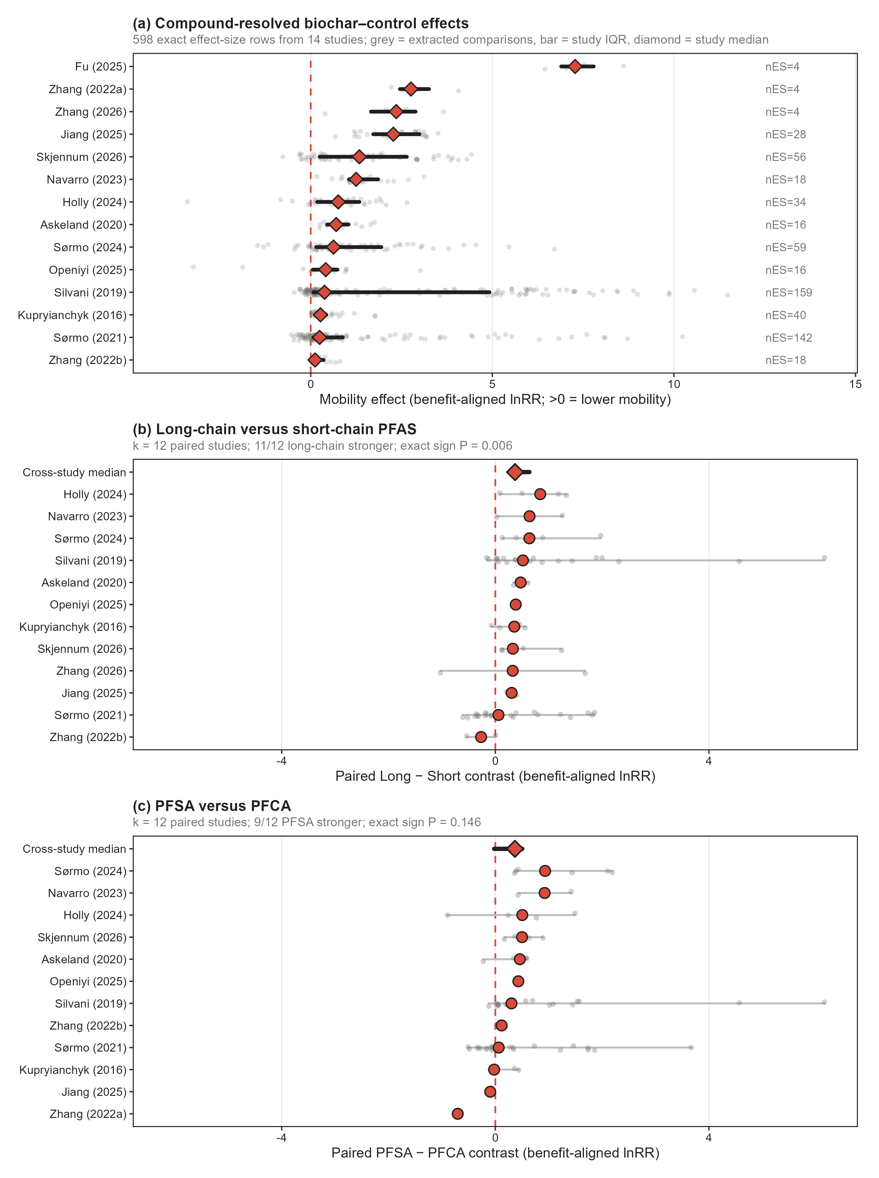
Figure S5. Orchard-style view of the extracted and paired evidence supporting PFAS mobility mechanisms. Panel a shows the 598 exact compound-resolved biochar-control effect-size rows from 14 studies as descriptive evidence density, with study-level medians providing the independent visual anchor. Panel b shows context-specific long-minus-short paired contrasts within each study, collapsed to one independent study median and summarised across 12 paired studies. Panel c shows the analogous PFSA-minus-PFCA paired contrasts across 12 studies. Row-level and context-level points are displayed to show the underlying evidence structure but are not treated as independent replicates; cross-study inference remains study-balanced. The vertical reference line denotes no effect or no paired difference, as appropriate.

Distribution of studies
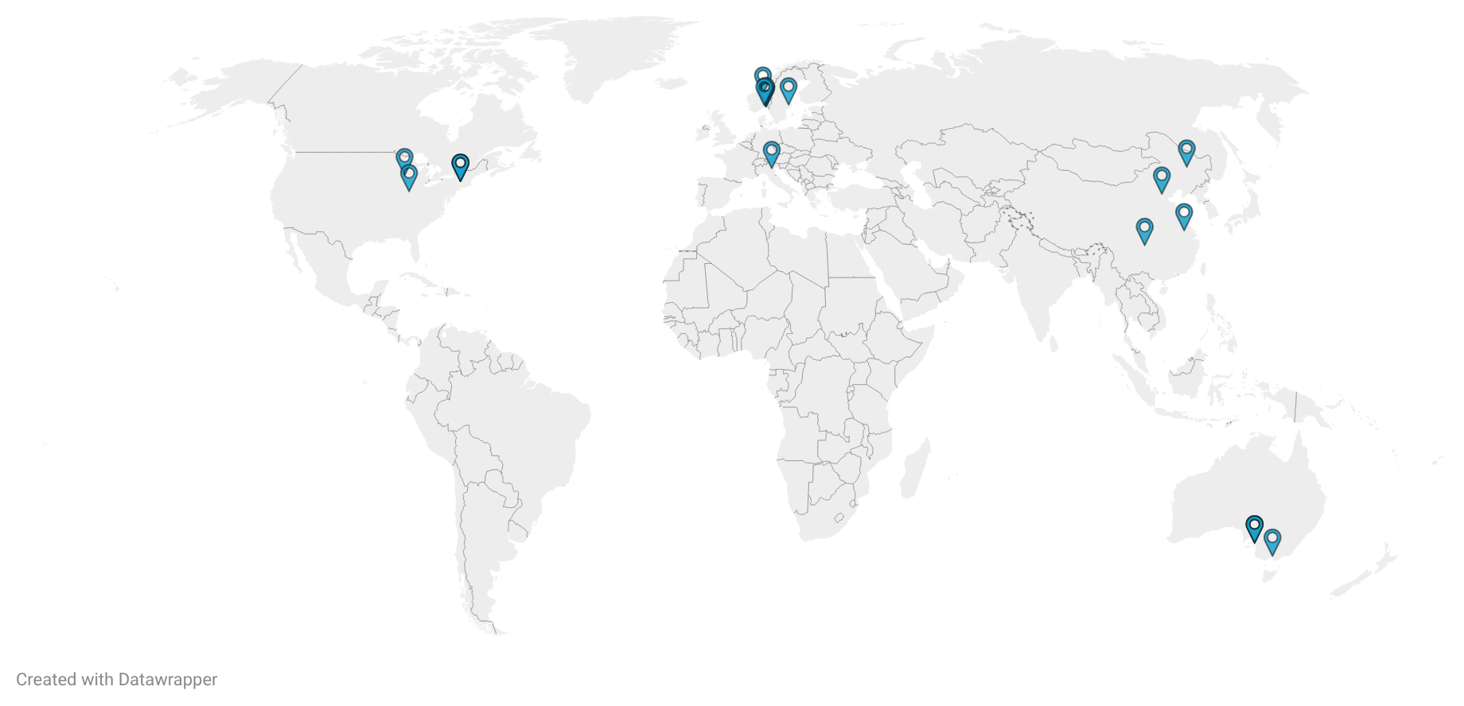
Figure S6. Global distribution of independent studies in the meta-analysis. Link to the Interactive map: https://datawrapper.dwcdn.net/0Lqo5/1/

References to included studies
1. Kupryianchyk D., Hale S.E., Breedveld G.D., Cornelissen G.. Treatment of sites contaminated with perfluorinated compounds using biochar amendment. Chemosphere (2016), 142, 35-40. https://doi.org/10.1016/j.chemosphere.2015.04.085
2. Silvani L., Cornelissen G., Botnen Smebye A., Zhang Y., Okkenhaug G., Zimmerman A.R., Thune G., Sævarsson H., Hale S.E.. Can biochar and designer biochar be used to remediate per- and polyfluorinated alkyl substances (PFAS) and lead and antimony contaminated soils?. Science of the Total Environment (2019), 694, 133693. https://doi.org/10.1016/j.scitotenv.2019.133693
3. Askeland M., Clarke B.O., Cheema S.A., Mendez A., Gasco G., Paz-Ferreiro J.. Biochar sorption of PFOS, PFOA, PFHxS and PFHxA in two soils with contrasting texture. Chemosphere (2020), 249, 126072. https://doi.org/10.1016/j.chemosphere.2020.126072
4. Sørmo E., Silvani L., Bjerkli N., Hagemann N., Zimmerman A.R., Hale S.E., Hansen C.B., Hartnik T., Cornelissen G.. Stabilization of PFAS-contaminated soil with activated biochar. Science of the Total Environment (2021), 763, 144034. https://doi.org/10.1016/j.scitotenv.2020.144034
5. Zhang W., Liang Y.. Performance of different sorbents toward stabilizing per- and polyfluoroalkyl substances (PFAS) in soil. Environmental Advances (2022), 8, 100217. https://doi.org/10.1016/j.envadv.2022.100217
6. Navarro D.A., Kabiri S., Ho J., Bowles K.C., Davis G., McLaughlin M.J., Kookana R.S.. Stabilisation of PFAS in soils: Long-term effectiveness of carbon-based soil amendments. Environmental Pollution (2023), 323, 121249. https://doi.org/10.1016/j.envpol.2023.121249
7. Kabiri S., Navarro D.A., Hamad S.A., Grimison C., Higgins C.P., Mueller J.F., Kookana R.S., McLaughlin M.J.. Physical and chemical properties of carbon-based sorbents that affect the removal of per- and polyfluoroalkyl substances from solution and soil. Science of the Total Environment (2023), 875, 162653. https://doi.org/10.1016/j.scitotenv.2023.162653
8. Sørmo E., Lade C.B.M., Zhang J., Asimakopoulos A.G., Åsli G.W., Hubert M., Goranov A.I., Arp H.P.H., Cornelissen G.. Stabilization of PFAS-contaminated soil with sewage sludge- and wood-based biochar sorbents. Science of the Total Environment (2024), 922, 170971. https://doi.org/10.1016/j.scitotenv.2024.170971
9. Holly M.A., Gunn K.M., Keymer D., Sanford J.R.. Evaluation of Per- and Polyfluoroalkyl Substances Leaching from Biosolids and Mitigation Potential of Biochar through Undisturbed Soil Columns. ACS ES and T Water (2024), 4(2), 413-426. https://doi.org/10.1021/acsestwater.3c00414
10. Openiyi E.O., Lee L.S., Alukkal C.R.. Evaluating sorbents for reducing per- and polyfluoroalkyl substance mobility in biosolids-amended soil columns. Journal of Environmental Quality (2025), 54(1), 118-131. https://doi.org/10.1002/jeq2.20658
11. Battisti I., Trentin A.R., Sabia A., Masi A., Renella G.. Soil Amendment with Biochar Reduces the Uptake and Translocation of Perfluoroalkyl Substances by Horticultural Plants Grown in a Polluted Area. Soil Systems (2025), 9(3), 100. https://doi.org/10.3390/soilsystems9030100
12. Jiang T., Pervez M.N., Ilango A.K., Liang Y.. Stabilizing per- and polyfluoroalkyl substances (PFAS) through amending an adsorbent to contaminated soil planted with alfalfa. Science of the Total Environment (2025), 1000, 180430. https://doi.org/10.1016/j.scitotenv.2025.180430
13. Fu J., Lyu X., Xiao F., Wang Y., Gao B., Wu J., Sun Y.. A one-year study of biochar in immobilizing PFOA in soil-plant rainfall leaching systems: Residue fraction and metabolomics perspectives. Journal of Hazardous Materials (2025), 495, 139101. https://doi.org/10.1016/j.jhazmat.2025.139101
14. Hubert M., Bonnet B., Hale S.E., Sørmo E., Cornelissen G., Ahrens L., Arp H.P.H.. Measurement and modelling of sorbent-amendment impacts on seasonal and long-term PFAS transport through unsaturated soil lysimeters. Journal of Hazardous Materials (2025), 494, 138662. https://doi.org/10.1016/j.jhazmat.2025.138662
15. Kabiri S., Bowles K.C., Bhat S., Navarro D.A.. Effect of physical, chemical, and biological aging on activated carbon and biochar properties and PFAS immobilisation in soils. Journal of Hazardous Materials (2026), 511, 142258. https://doi.org/10.1016/j.jhazmat.2026.142258
16. Zhang J., Hou R., Su A., Wang M., Sun H., Xu H., Huang W., Peng F., Zhao S.. Study on the regulatory effect of biochar-based materials on the migration and accumulation of perfluoroalkyl substances in paddy soil-water-plant systems. Agricultural Water Management (2026), 323, 110041. https://doi.org/10.1016/j.agwat.2025.110041
17. Hu T., Liu Y., Wu J., Chen J.. Enhanced immobilization of perfluorooctanoic acid in modified biochar-amended soils: Insights into effects of oxidative ageing and soil property. Journal of Soils and Sediments (2026), 26(4), 131. https://doi.org/10.1007/s11368-026-04345-2
18. Skjennum K.A., Mulder J., Breedveld G.D., Hartnik T., Estoppey N., Sørmo E.. Long-term efficiency of biochar amendment in PFAS-contaminated soil under unsaturated field conditions. Journal of Hazardous Materials (2026), 510, 142119. https://doi.org/10.1016/j.jhazmat.2026.142119
19. Zhang W., Liang Y.. Changing bioavailability of per- and polyfluoroalkyl substances (PFAS) to plant in biosolids amended soil through stabilization or mobilization. Environmental Pollution (2022), 308, 119724. https://doi.org/10.1016/j.envpol.2022.119724
20. Xin Z., Ruan C., Wang J., Tong J., Deng Z., Zhang H., Zhang C., Zhang Y., Shi J.. Nut shell biochar effectively repairs mixed pollution of heavy metal anions and PFAS in soil. Journal of Environmental Chemical Engineering (2025), 13(5), 118241. https://doi.org/10.1016/j.jece.2025.118241

