Supplementary Information
Age and outcomes of keratorefractive lenticule extraction: visual recovery, refractive accuracy, enhancement and the contribution of an age-banded nomogram
Contents (one file, .docx): Supplementary Figure S1 (study population), Supplementary Figure S2 (age as a continuous variable), Supplementary Figures S3 and S4 (standard graphs at 12 months by age group), Supplementary Figure S5 (postoperative SEQ against the applied offset), Supplementary Table S1 (outcomes by age band and visit), Supplementary Table S2 (adjusted models), Supplementary Table S3 (nomogram era and the common-offset recomputation), Supplementary Table S4 (optical quality by age group).
Supplementary Figure S1. Study population: registry screening, exclusions, the registry set used for the enhancement analysis, the outcome set and the number of eyes with a record at each visit. Patient counts do not sum across boxes because a patient may have one eye excluded and the fellow eye retained.
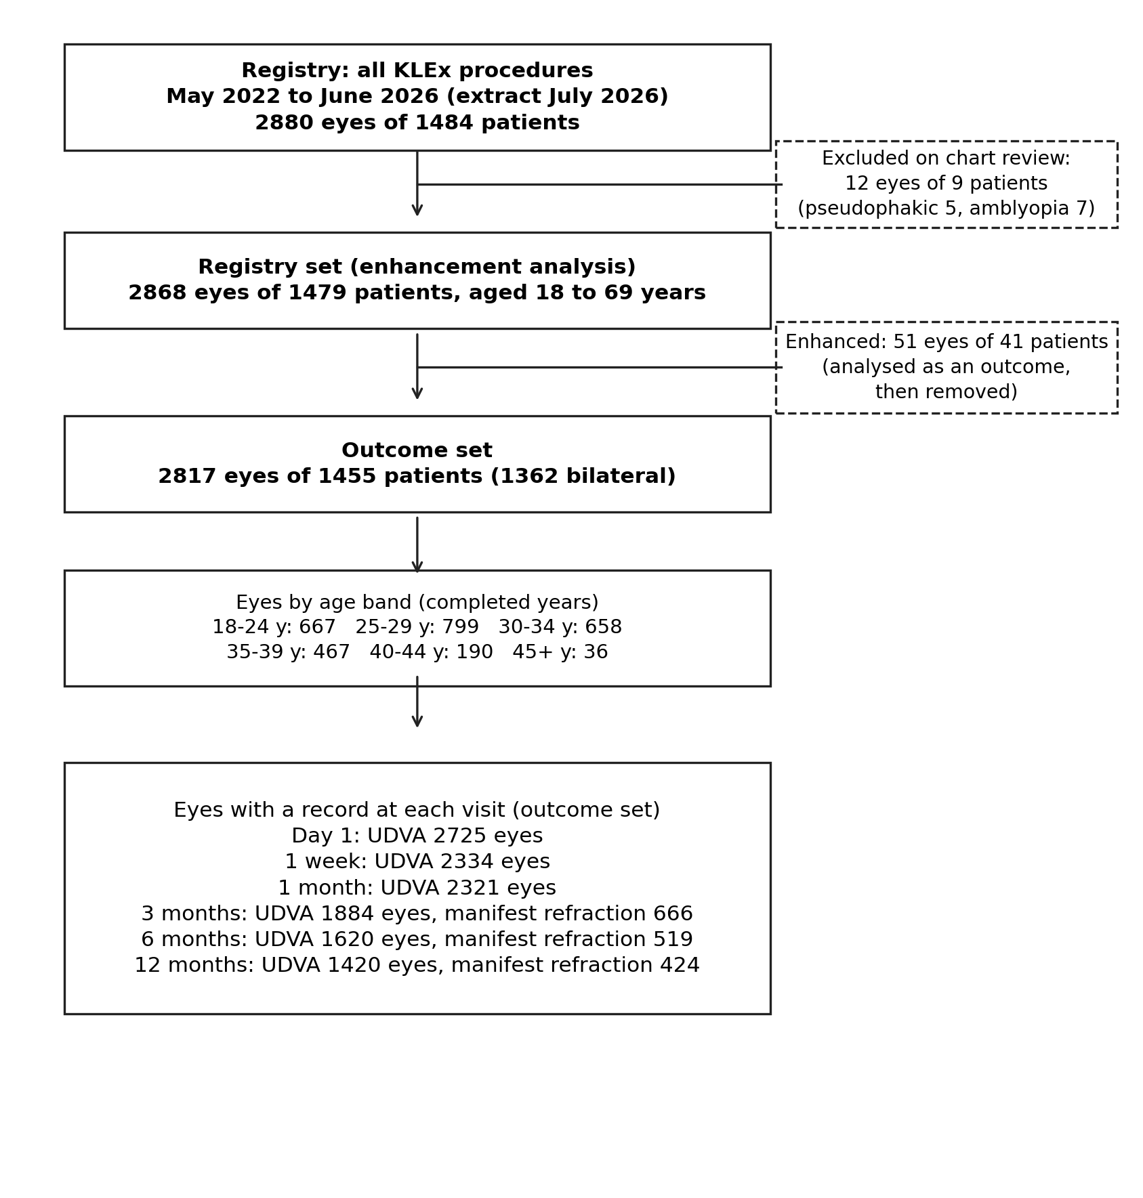

Supplementary Figure S2. Age as a continuous variable. (A) Adjusted probability of UDVA of 20/20 or better at 3 months (N = 1874) and (B) adjusted manifest SEQ at 12 months (N = 424) from patient-clustered models with a restricted cubic spline of age (four knots at the 5th, 35th, 65th and 95th percentiles) and attempted SEQ, cylinder, profile version, optical zone and nomogram era at their means; shaded bands are 95% confidence intervals; the curve is drawn to the 99th percentile of age (46 years). Points are the unadjusted band estimates with 95% patient-cluster bootstrap confidence intervals, plotted at the median age of each band (bands with fewer than 10 eyes omitted in B). The dashed line in B marks −0.50 D.
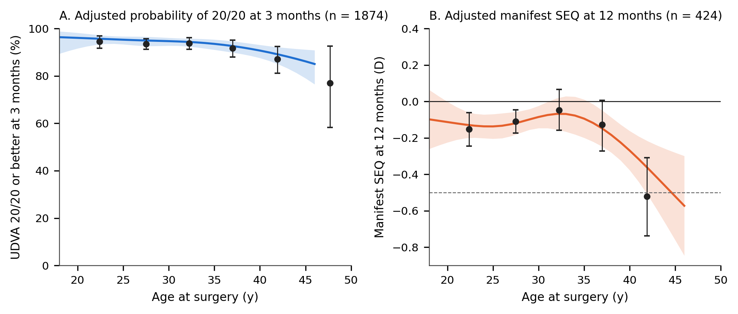

Supplementary Figure S3. Standard graphs for refractive surgery outcomes at 12 months in eyes aged 40 years or older. (A) Cumulative UDVA (N = 119) and preoperative CDVA (N = 119). (B) Postoperative UDVA minus preoperative CDVA in Snellen lines (N = 119). (C) Change in CDVA (N = 119); preoperative CDVA was recorded as 20/20 once that line was read, so gains partly reflect this recording ceiling. (D) Attempted versus achieved SEQ correction; the solid black line is identity, the coloured dashed line the regression, grey dashed lines ±0.50 D and dotted lines ±1.00 D (N = 46). (E) SEQ accuracy relative to the emmetropic target (N = 46). (F) Stability: mean manifest SEQ at 3, 6 and 12 months; error bars are SD; N is given above each point. Enhanced eyes are excluded.
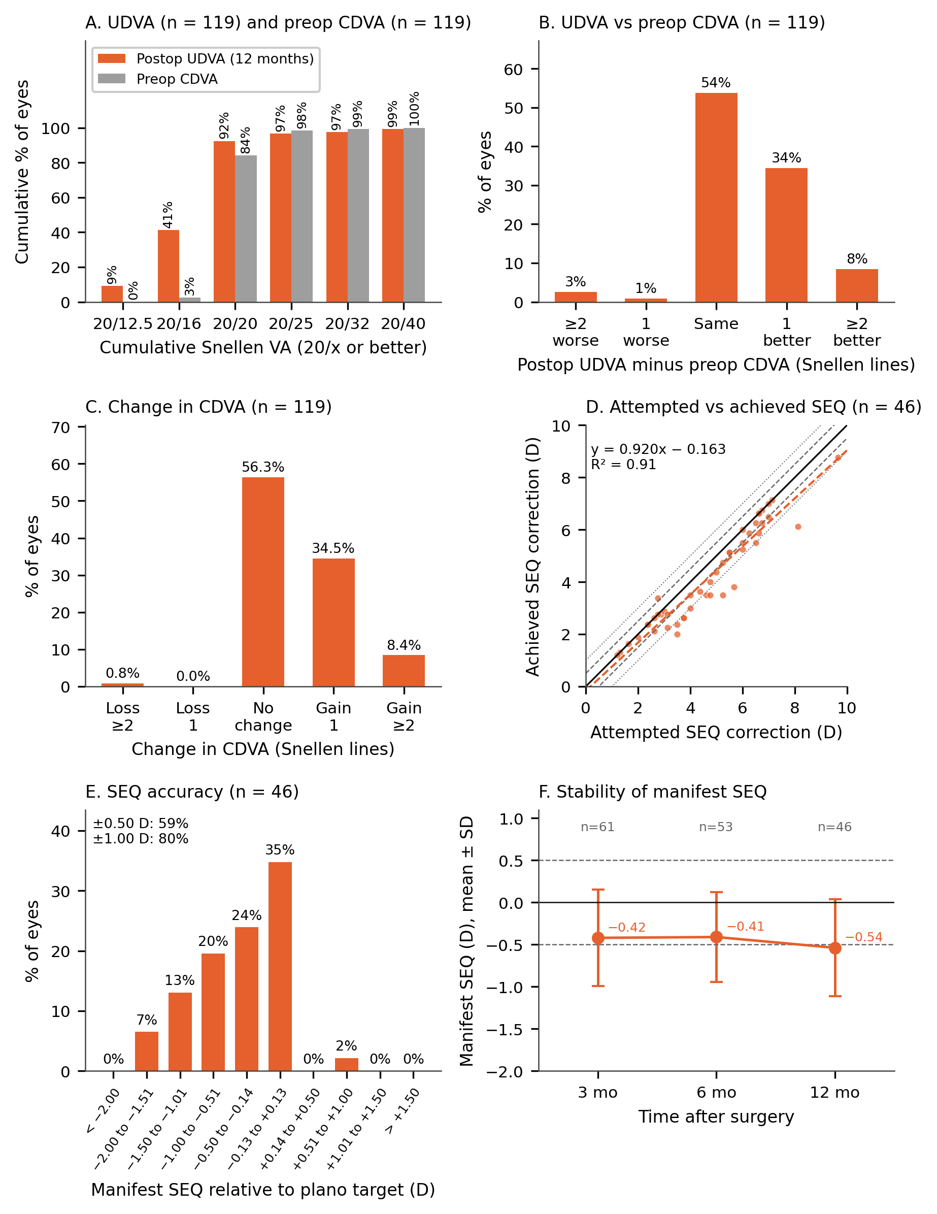

Supplementary Figure S4. Standard graphs for refractive surgery outcomes at 12 months in eyes under 40 years. (A) Cumulative UDVA (N = 1301) and preoperative CDVA (N = 1281). (B) Postoperative UDVA minus preoperative CDVA in Snellen lines (N = 1281). (C) Change in CDVA (N = 1243); preoperative CDVA was recorded as 20/20 once that line was read, so gains partly reflect this recording ceiling. (D) Attempted versus achieved SEQ correction; the solid black line is identity, the coloured dashed line the regression, grey dashed lines ±0.50 D and dotted lines ±1.00 D (N = 378). (E) SEQ accuracy relative to the emmetropic target (N = 378). (F) Stability: mean manifest SEQ at 3, 6 and 12 months; error bars are SD; N is given above each point. Enhanced eyes are excluded.
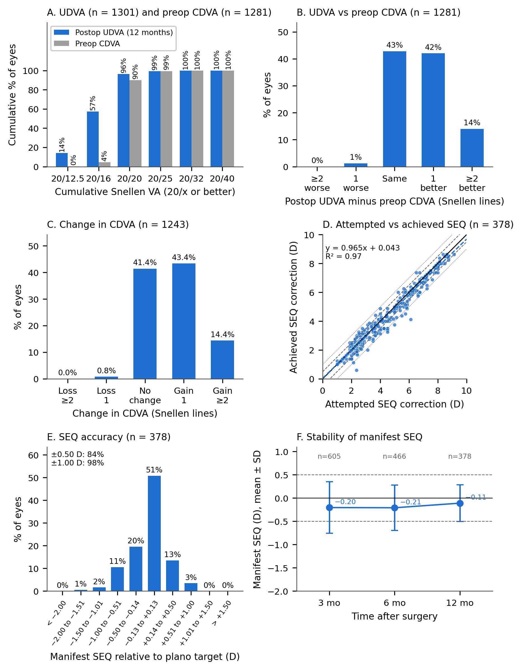

Supplementary Figure S5. Postoperative spherical equivalent (SEQ) against the applied age-banded offset, one point per eye. (A) Day-1 objective SEQ of all eyes measured. (B) Manifest SEQ at 12 months of refracted eyes. Grey squares: first era (no offset, all ages); blue circles: second era, in which the offset is a function of age (none from 45 years, 0.50 D from 35, 0.60 D from 30, 0.75 D from 25, 1.00 D under 25). Horizontal bars are group means; the dashed line marks −0.50 D; n is the number of eyes. Within the second era the offset encodes age, so the plot cannot separate the two; it shows the endpoint that each offset and age band reached.
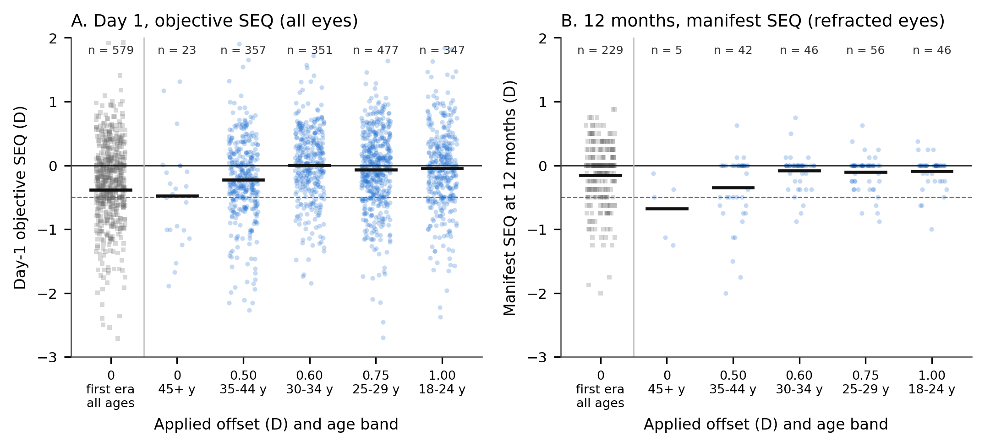

Supplementary Table S1. Outcomes by age band and visit (enhanced eyes excluded except in the enhancement row)
Visit / outcome | 18-24 y | 25-29 y | 30-34 y | 35-39 y | 40-44 y | 45+ y
Day 1
UDVA 20/20 or better, n/N (%) | 385/644 (60%) | 472/772 (61%) | 414/636 (65%) | 251/455 (55%) | 104/184 (57%) | 12/34 (35%)
UDVA worse than 20/25, % | 19% | 17% | 15% | 21% | 23% | 29%
UDVA, logMAR, mean ± SD | 0.02 ± 0.17 | 0.02 ± 0.17 | 0.01 ± 0.15 | 0.04 ± 0.18 | 0.04 ± 0.17 | 0.07 ± 0.12
CDVA loss ≥1 line, n/N (%) | 81/554 (14.6%) | 89/698 (12.8%) | 75/543 (13.8%) | 57/383 (14.9%) | 25/162 (15.4%) | 2/29 (6.9%)
CDVA loss ≥2 lines, n/N | 38/554 | 35/698 | 26/543 | 28/383 | 11/162 | 1/29
1 week
UDVA 20/20 or better, n/N (%) | 421/562 (75%) | 517/662 (78%) | 427/547 (78%) | 269/383 (70%) | 100/149 (67%) | 17/31 (55%)
UDVA worse than 20/25, % | 8% | 8% | 7% | 11% | 11% | 23%
UDVA, logMAR, mean ± SD | −0.03 ± 0.12 | −0.04 ± 0.13 | −0.04 ± 0.13 | −0.03 ± 0.14 | −0.02 ± 0.13 | 0.00 ± 0.14
CDVA loss ≥1 line, n/N (%) | 31/476 (6.5%) | 27/585 (4.6%) | 28/465 (6.0%) | 28/310 (9.0%) | 12/126 (9.5%) | 2/26 (7.7%)
CDVA loss ≥2 lines, n/N | 6/476 | 5/585 | 6/465 | 9/310 | 5/126 | 0/26
1 month
UDVA 20/20 or better, n/N (%) | 476/553 (86%) | 546/640 (85%) | 499/564 (88%) | 308/382 (81%) | 117/155 (75%) | 18/27 (67%)
UDVA worse than 20/25, % | 3% | 3% | 3% | 5% | 5% | 7%
UDVA, logMAR, mean ± SD | −0.07 ± 0.11 | −0.08 ± 0.10 | −0.08 ± 0.10 | −0.06 ± 0.11 | −0.06 ± 0.11 | −0.04 ± 0.11
CDVA loss ≥1 line, n/N (%) | 7/440 (1.6%) | 8/528 (1.5%) | 4/447 (0.9%) | 11/301 (3.7%) | 5/125 (4.0%) | 1/21 (4.8%)
CDVA loss ≥2 lines, n/N | 0/440 | 3/528 | 1/447 | 3/301 | 1/125 | 0/21
3 months
UDVA 20/20 or better, n/N (%) | 394/417 (94%) | 535/572 (94%) | 410/437 (94%) | 276/301 (92%) | 114/131 (87%) | 20/26 (77%)
UDVA worse than 20/25, % | 1% | 1% | 1% | 2% | 2% | 4%
UDVA, logMAR, mean ± SD | −0.11 ± 0.09 | −0.10 ± 0.08 | −0.11 ± 0.08 | −0.10 ± 0.09 | −0.09 ± 0.09 | −0.07 ± 0.10
CDVA loss ≥1 line, n/N (%) | 6/377 (1.6%) | 3/515 (0.6%) | 2/406 (0.5%) | 1/273 (0.4%) | 1/120 (0.8%) | 0/24 (0.0%)
CDVA loss ≥2 lines, n/N | 0/377 | 0/515 | 0/406 | 0/273 | 0/120 | 0/24
Manifest SEQ, D, mean ± SD (N) | −0.14 ± 0.43 (160) | −0.26 ± 0.59 (210) | −0.10 ± 0.51 (144) | −0.37 ± 0.66 (91) | −0.39 ± 0.58 (55) | −0.67 ± 0.54 (6)
SEQ within ±0.50 D, % | 79% | 72% | 72% | 57% | 75% | 33%
SEQ undercorrected > 0.50 D, % | 17% | 23% | 16% | 36% | 25% | 67%
Attendance, attended / time-eligible (%) | 407/603 (67%) | 560/761 (74%) | 423/587 (72%) | 295/419 (70%) | 126/179 (70%) | 24/29 (83%)
6 months
UDVA 20/20 or better, n/N (%) | 363/383 (95%) | 461/487 (95%) | 338/349 (97%) | 244/264 (92%) | 107/119 (90%) | 16/18 (89%)
UDVA worse than 20/25, % | 1% | 1% | 1% | 2% | 4% | 6%
UDVA, logMAR, mean ± SD | −0.11 ± 0.08 | −0.11 ± 0.08 | −0.13 ± 0.08 | −0.11 ± 0.09 | −0.08 ± 0.11 | −0.10 ± 0.10
CDVA loss ≥1 line, n/N (%) | 3/355 (0.8%) | 4/448 (0.9%) | 1/328 (0.3%) | 0/238 (0.0%) | 2/113 (1.8%) | 0/18 (0.0%)
CDVA loss ≥2 lines, n/N | 0/355 | 1/448 | 0/328 | 0/238 | 0/113 | 0/18
Manifest SEQ, D, mean ± SD (N) | −0.24 ± 0.43 (109) | −0.21 ± 0.52 (159) | −0.12 ± 0.47 (120) | −0.31 ± 0.52 (78) | −0.34 ± 0.51 (46) | −0.88 ± 0.48 (7)
SEQ within ±0.50 D, % | 80% | 71% | 75% | 69% | 65% | 29%
SEQ undercorrected > 0.50 D, % | 18% | 23% | 17% | 26% | 33% | 71%
12 months
UDVA 20/20 or better, n/N (%) | 304/316 (96%) | 424/438 (97%) | 304/312 (97%) | 220/235 (94%) | 98/104 (94%) | 12/15 (80%)
UDVA worse than 20/25, % | 1% | 1% | 0% | 1% | 2% | 13%
UDVA, logMAR, mean ± SD | −0.11 ± 0.07 | −0.11 ± 0.08 | −0.11 ± 0.07 | −0.10 ± 0.08 | −0.09 ± 0.09 | −0.05 ± 0.13
CDVA loss ≥1 line, n/N (%) | 4/308 (1.3%) | 4/421 (1.0%) | 1/293 (0.3%) | 1/221 (0.5%) | 1/104 (1.0%) | 0/15 (0.0%)
CDVA loss ≥2 lines, n/N | 0/308 | 0/421 | 0/293 | 0/221 | 1/104 | 0/15
Manifest SEQ, D, mean ± SD (N) | −0.15 ± 0.40 (100) | −0.11 ± 0.32 (123) | −0.05 ± 0.41 (89) | −0.13 ± 0.48 (66) | −0.52 ± 0.59 (41) | −0.68 ± 0.49 (5)
SEQ within ±0.50 D, % | 86% | 90% | 76% | 79% | 59% | 60%
SEQ undercorrected > 0.50 D, % | 13% | 9% | 15% | 17% | 39% | 40%
Attendance, attended / time-eligible (%) | 205/365 (56%) | 301/459 (66%) | 230/398 (58%) | 151/256 (59%) | 76/113 (67%) | 11/19 (58%)
Enhancement, n/N (%) | 8/675 (1.2%) | 19/818 (2.3%) | 9/667 (1.3%) | 7/474 (1.5%) | 8/198 (4.0%) | 0/36 (0.0%)
CDVA = corrected distance visual acuity; D = dioptre; SD = standard deviation; SEQ = spherical equivalent refraction (manifest refraction of refracted eyes); UDVA = uncorrected distance visual acuity; y = years (bands in completed years). Time-eligible = visit window closed before the extract (surgery more than 135 days before the extract for 3 months, 460 days for 12 months).

Supplementary Table S2. Adjusted models for the primary outcome and for manifest spherical equivalent at 12 months
Model and term | Estimate (95% CI) | P
UDVA 20/20 or better at 3 months, logistic, OR
Age 40 y or older (vs under 40) | 0.43 (0.25 to 0.74) | 0.002
Attempted SEQ, per dioptre | 0.83 (0.74 to 0.93) | 0.002
Attempted cylinder, per dioptre | 0.65 (0.55 to 0.77) | < 0.001
NOVA workflow (vs original) | 1.10 (0.67 to 1.82) | 0.705
Optical zone, per mm | 1.35 (0.60 to 3.02) | 0.469
From July 2024 (vs before) | 1.08 (0.68 to 1.73) | 0.747
Age, per decade (separate model, N = 1874) | 0.59 (0.43 to 0.80) | < 0.001
Band 25-29 y vs 18-24 y (band model, N = 1874) | 0.73 (0.39 to 1.37) | 0.332
Band 30-34 y vs 18-24 y (band model, N = 1874) | 0.73 (0.38 to 1.40) | 0.340
Band 35-39 y vs 18-24 y (band model, N = 1874) | 0.55 (0.27 to 1.09) | 0.087
Band 40-44 y vs 18-24 y (band model, N = 1874) | 0.38 (0.18 to 0.81) | 0.012
Band 45+ y vs 18-24 y (band model, N = 1874) | 0.15 (0.05 to 0.50) | 0.002
Age 40 y or older, before July 2024 (N = 593) | 0.45 (0.20 to 1.02) | 0.056
Age 40 y or older, from July 2024 (N = 1281) | 0.42 (0.21 to 0.84) | 0.014
Manifest SEQ at 12 months, linear, D
Age 40 y or older (vs under 40) | −0.42 (−0.61 to −0.23) | < 0.001
Attempted SEQ, per dioptre | −0.04 (−0.06 to −0.02) | 0.001
Attempted cylinder, per dioptre | +0.02 (−0.03 to +0.06) | 0.485
NOVA workflow (vs original) | +0.10 (−0.01 to +0.22) | 0.084
Optical zone, per mm | +0.01 (−0.14 to +0.16) | 0.916
From July 2024 (vs before) | −0.00 (−0.10 to +0.09) | 0.954
Age, per decade (separate model, N = 424) | −0.12 (−0.20 to −0.04) | 0.002
Band 25-29 y vs 18-24 y (band model, N = 424) | +0.01 (−0.10 to +0.12) | 0.880
Band 30-34 y vs 18-24 y (band model, N = 424) | +0.09 (−0.06 to +0.23) | 0.241
Band 35-39 y vs 18-24 y (band model, N = 424) | −0.00 (−0.18 to +0.17) | 0.974
Band 40-44 y vs 18-24 y (band model, N = 424) | −0.37 (−0.59 to −0.16) | < 0.001
Band 45+ y vs 18-24 y (band model, N = 424) | −0.57 (−1.03 to −0.11) | 0.015
Age 40 y or older, before July 2024 (N = 229) | −0.32 (−0.60 to −0.04) | 0.025
Age 40 y or older, from July 2024 (N = 195) | −0.52 (−0.77 to −0.27) | < 0.001
Age 40 y or older × attempted SEQ (interaction, N = 424) | −0.05 (−0.13 to +0.04) | 0.264
CI = confidence interval; D = dioptre; OR = odds ratio; SEQ = spherical equivalent refraction; UDVA = uncorrected distance visual acuity; y = years. Patient-clustered logistic and linear models; the full covariate set is shown for the dichotomy models; the per-decade, band and era-specific models use the same covariates (era-specific models omit the era term, and the pre-July 2024 models omit the NOVA term because NOVA was introduced in April 2025). Enhanced eyes are excluded.

Supplementary Table S3. Postoperative spherical equivalent by nomogram era, and the second era recomputed as if every eye had received the 0.60 D offset of the 30 to 34 band
Visit and estimate | Before July 2024 (no age-dependent offset) | From July 2024, observed | From July 2024, common 0.60 D offset
Day 1, objective SEQ
Mean, under 40 y (N) | −0.38 (543) | −0.06 (1419) | −0.19 (1419)
Mean, 40 y or older (N) | −0.42 (36) | −0.37 (136) | −0.18 (136)
Adjusted difference, 40 y or older vs under 40, D | −0.01 (−0.30 to +0.27); P = 0.927 | −0.28 (−0.42 to −0.15); P < 0.001 | +0.02 (−0.12 to +0.16); P = 0.793
Adjusted slope per decade, D | −0.09 (−0.24 to +0.06); P = 0.263 | −0.14 (−0.20 to −0.08); P < 0.001 | +0.14 (+0.07 to +0.20); P < 0.001
Model N | 579 | 1543 | 1543
Mean by band, 18-24 y (N) | −0.36 (139) | −0.05 (347) | −0.45 (347)
Mean by band, 25-29 y (N) | −0.36 (159) | −0.07 (477) | −0.22 (477)
Mean by band, 30-34 y (N) | −0.23 (150) | +0.01 (351) | +0.01 (351)
Mean by band, 35-39 y (N) | −0.67 (95) | −0.17 (244) | −0.07 (244)
Mean by band, 40-44 y (N) | −0.42 (36) | −0.34 (113) | −0.24 (113)
Mean by band, 45+ y (N) | – | −0.48 (23) | +0.12 (23)
3 months, manifest SEQ
Mean, under 40 y (N) | −0.20 (238) | −0.20 (367) | −0.35 (367)
Mean, 40 y or older (N) | −0.38 (18) | −0.44 (43) | −0.27 (43)
Adjusted difference, 40 y or older vs under 40, D | −0.16 (−0.42 to +0.10); P = 0.220 | −0.19 (−0.39 to −0.00); P = 0.048 | +0.11 (−0.07 to +0.29); P = 0.223
Adjusted slope per decade, D | −0.04 (−0.16 to +0.07); P = 0.469 | −0.16 (−0.25 to −0.07); P < 0.001 | +0.11 (+0.02 to +0.20); P = 0.015
Model N | 256 | 409 | 409
Mean by band, 18-24 y (N) | −0.26 (64) | −0.06 (96) | −0.46 (96)
Mean by band, 25-29 y (N) | −0.17 (77) | −0.31 (133) | −0.46 (133)
Mean by band, 30-34 y (N) | −0.12 (57) | −0.08 (87) | −0.08 (87)
Mean by band, 35-39 y (N) | −0.31 (40) | −0.41 (51) | −0.31 (51)
Mean by band, 40-44 y (N) | −0.38 (18) | −0.40 (37) | −0.30 (37)
Mean by band, 45+ y (N) | – | −0.67 (6) | −0.07 (6)
12 months, manifest SEQ
Mean, under 40 y (N) | −0.12 (208) | −0.10 (170) | −0.24 (170)
Mean, 40 y or older (N) | −0.46 (21) | −0.60 (25) | −0.41 (25)
Adjusted difference, 40 y or older vs under 40, D | −0.32 (−0.60 to −0.04); P = 0.025 | −0.52 (−0.77 to −0.27); P < 0.001 | −0.19 (−0.45 to +0.07); P = 0.158
Adjusted slope per decade, D | −0.05 (−0.18 to +0.08); P = 0.432 | −0.18 (−0.27 to −0.10); P < 0.001 | +0.07 (−0.02 to +0.16); P = 0.125
Model N | 229 | 195 | 195
Mean by band, 18-24 y (N) | −0.21 (54) | −0.09 (46) | −0.49 (46)
Mean by band, 25-29 y (N) | −0.12 (67) | −0.10 (56) | −0.25 (56)
Mean by band, 30-34 y (N) | −0.01 (43) | −0.08 (46) | −0.08 (46)
Mean by band, 35-39 y (N) | −0.13 (44) | −0.12 (22) | −0.03 (22)
Mean by band, 40-44 y (N) | −0.46 (21) | −0.59 (20) | −0.49 (20)
Mean by band, 45+ y (N) | – | −0.68 (5) | −0.08 (5)
Within the shared 0.50 D offset band (35 to 44 y): 40 to 44 y vs 35 to 39 y, adjusted difference, D (model N)
Day 1 | +0.42 (−0.23 to +1.06); P = 0.209 (131) | −0.15 (−0.31 to +0.01); P = 0.067 (356) | both eras: +0.00 (−0.22 to +0.22); P = 0.968 (487)
3 months | −0.04 (−0.40 to +0.32); P = 0.825 (58) | +0.04 (−0.24 to +0.33); P = 0.771 (87) | both eras: +0.02 (−0.21 to +0.24); P = 0.893 (145)
12 months | −0.33 (−0.67 to +0.01); P = 0.059 (65) | −0.46 (−0.84 to −0.08); P = 0.019 (42) | both eras: −0.37 (−0.62 to −0.12); P = 0.004 (107)
Efficiency model: SEQ on programmed correction (attempted SEQ plus offset, D), age (per decade, centred at 30 y) and their product
Day 1, per programmed dioptre | −0.08 (−0.18 to +0.01); P = 0.082 (579) | −0.06 (−0.09 to −0.04); P < 0.001 (1543) | both eras: −0.06 (−0.09 to −0.04); P < 0.001 (2122)
Day 1, age offset per decade | +0.41 (−0.16 to +0.98); P = 0.157 | −0.12 (−0.27 to +0.04); P = 0.143 | both eras: −0.00 (−0.15 to +0.15); P = 0.969
Day 1, programmed dioptre × decade | −0.13 (−0.29 to +0.04); P = 0.131 | −0.01 (−0.04 to +0.02); P = 0.586 | both eras: −0.03 (−0.07 to +0.01); P = 0.097
3 months, per programmed dioptre | −0.01 (−0.06 to +0.03); P = 0.570 (256) | −0.07 (−0.10 to −0.03); P < 0.001 (409) | both eras: −0.05 (−0.08 to −0.02); P < 0.001 (665)
3 months, age offset per decade | +0.07 (−0.19 to +0.33); P = 0.598 | −0.01 (−0.25 to +0.22); P = 0.903 | both eras: +0.05 (−0.15 to +0.25); P = 0.630
3 months, programmed dioptre × decade | −0.03 (−0.08 to +0.03); P = 0.362 | −0.03 (−0.08 to +0.02); P = 0.192 | both eras: −0.04 (−0.08 to +0.01); P = 0.087
12 months, per programmed dioptre | −0.06 (−0.10 to −0.03); P < 0.001 (229) | −0.03 (−0.06 to −0.00); P = 0.025 (195) | both eras: −0.04 (−0.07 to −0.02); P < 0.001 (424)
12 months, age offset per decade | −0.00 (−0.27 to +0.26); P = 0.983 | −0.14 (−0.30 to +0.01); P = 0.074 | both eras: −0.04 (−0.19 to +0.11); P = 0.590
12 months, programmed dioptre × decade | −0.01 (−0.07 to +0.04); P = 0.690 | −0.01 (−0.04 to +0.02); P = 0.595 | both eras: −0.02 (−0.05 to +0.01); P = 0.228
D = dioptre; SEQ = spherical equivalent refraction; y = years. From 1 July 2024 the nomogram added myopic correction at the corneal plane that decreased with age: 1.00 D under 25 years, 0.75 D from 25, 0.60 D from 30, 0.50 D from 35 and none from 45. The offset is not stored per eye and was reconstructed from age. Recomputed SEQ = observed SEQ + (0.60 D − offset), assuming one-to-one transfer of programmed correction into postoperative refraction. Adjusted estimates are from patient-clustered linear models with attempted SEQ, attempted cylinder and optical zone (and profile version in the second era) as covariates; within the second era age and offset are collinear, so no model can hold both. Means are unadjusted with the number of eyes in brackets; manifest SEQ is that of refracted eyes, day-1 SEQ the objective aberrometer refraction of all eyes measured. The within-band rows compare the 40 to 44 and 35 to 39 bands, which received the same 0.50 D offset, adjusted as above (plus era when pooled); the last column pools both eras. The efficiency model regresses SEQ on the programmed myopic correction (attempted SEQ magnitude plus the offset), age and their product, with cylinder and optical zone (and profile version, and era when pooled): the product term tests whether the refractive response per programmed dioptre changes with age. – = no eyes with a record.

Supplementary Table S4. Optical quality by age group: change from the preoperative value in the micro-aberration scatter index (MASI) and in 6-mm corneal (total corneal wavefront, vertex-centred) and ocular (pyramidal aberrometer, pupil-centred) wavefront aberrations
Measure | Under 40 y, mean (95% CI), N | 40 y and older, mean (95% CI), N
Change in MASI (×1000), Day 1 | +21.3 (+20.5 to +22.2), 1818 | +21.5 (+18.1 to +25.2), 172
Change in MASI (×1000), 1 week | +12.8 (+12.0 to +13.7), 1379 | +12.1 (+9.3 to +14.6), 124
Change in MASI (×1000), 1 month | +9.0 (+8.2 to +9.7), 1258 | +8.0 (+5.8 to +10.1), 126
Change in MASI (×1000), 3 months | +5.3 (+3.8 to +6.5), 462 | +4.5 (−1.6 to +9.0), 42
Change in MASI (×1000), 12 months | +1.0 (−1.3 to +2.7), 198 | +0.6 (−9.0 to +7.9), 26
Change in corneal Z(4,0) at 6 mm, µm, Day 1 | −0.14 (−0.15 to −0.12), 1157 | −0.14 (−0.21 to −0.06), 95
Change in corneal HOA RMS at 6 mm, µm, Day 1 | +0.16 (+0.14 to +0.19), 1157 | +0.28 (+0.19 to +0.37), 95
Change in corneal coma RMS at 6 mm, µm, Day 1 | +0.15 (+0.14 to +0.17), 1157 | +0.21 (+0.14 to +0.29), 95
Change in corneal Z(4,0) at 6 mm, µm, 1 week | −0.07 (−0.09 to −0.05), 844 | −0.06 (−0.15 to +0.03), 64
Change in corneal HOA RMS at 6 mm, µm, 1 week | +0.16 (+0.13 to +0.18), 844 | +0.27 (+0.16 to +0.38), 64
Change in corneal coma RMS at 6 mm, µm, 1 week | +0.15 (+0.13 to +0.17), 844 | +0.21 (+0.12 to +0.29), 64
Change in corneal Z(4,0) at 6 mm, µm, 1 month | −0.06 (−0.08 to −0.04), 811 | +0.01 (−0.07 to +0.09), 72
Change in corneal HOA RMS at 6 mm, µm, 1 month | +0.16 (+0.14 to +0.18), 811 | +0.27 (+0.19 to +0.37), 72
Change in corneal coma RMS at 6 mm, µm, 1 month | +0.16 (+0.14 to +0.18), 811 | +0.21 (+0.12 to +0.30), 72
Change in corneal Z(4,0) at 6 mm, µm, 3 months | −0.05 (−0.08 to −0.02), 290 | −0.12 (−0.24 to −0.01), 27
Change in corneal HOA RMS at 6 mm, µm, 3 months | +0.14 (+0.09 to +0.18), 290 | +0.21 (+0.08 to +0.36), 27
Change in corneal coma RMS at 6 mm, µm, 3 months | +0.14 (+0.10 to +0.17), 290 | +0.18 (+0.06 to +0.32), 27
Change in ocular Z(4,0) at 6 mm, µm, Day 1 | −0.18 (−0.20 to −0.17), 1159 | −0.21 (−0.29 to −0.14), 60
Change in ocular HOA RMS at 6 mm, µm, Day 1 | +0.15 (+0.14 to +0.17), 1159 | +0.23 (+0.15 to +0.31), 60
Change in ocular coma RMS at 6 mm, µm, Day 1 | +0.10 (+0.09 to +0.11), 1159 | +0.14 (+0.09 to +0.19), 60
Change in ocular Z(4,0) at 6 mm, µm, 1 week | −0.13 (−0.14 to −0.12), 989 | −0.09 (−0.14 to −0.03), 54
Change in ocular HOA RMS at 6 mm, µm, 1 week | +0.14 (+0.12 to +0.16), 989 | +0.16 (+0.11 to +0.22), 54
Change in ocular coma RMS at 6 mm, µm, 1 week | +0.11 (+0.10 to +0.13), 989 | +0.10 (+0.06 to +0.14), 54
Change in ocular Z(4,0) at 6 mm, µm, 1 month | −0.12 (−0.13 to −0.10), 888 | −0.06 (−0.13 to +0.02), 46
Change in ocular HOA RMS at 6 mm, µm, 1 month | +0.13 (+0.11 to +0.15), 888 | +0.18 (+0.12 to +0.24), 46
Change in ocular coma RMS at 6 mm, µm, 1 month | +0.11 (+0.10 to +0.13), 888 | +0.11 (+0.07 to +0.17), 46
Adjusted difference (40 y or older minus under 40) in corneal HOA RMS change, µm, Day 1 (N = 1242) |  | +0.05 (−0.03 to +0.12), P = 0.213
Adjusted difference (40 y or older minus under 40) in corneal HOA RMS change, µm, 3 months (N = 315) |  | +0.04 (−0.08 to +0.16), P = 0.542
CI = patient-cluster bootstrap confidence interval; HOA = higher-order aberration; MASI = micro-aberration scatter index (×1000); RMS = root mean square; SEQ = spherical equivalent refraction; y = years; Z(4,0) = primary spherical aberration in the Optical Society of America/American National Standards Institute sign convention. Corneal pairs are within the same Zernike fit order; ocular scans required a pupil of 6 mm or more, so older eyes are a selected subgroup; visits with fewer than 15 paired scans in the older group are omitted. The adjusted differences are from patient-clustered linear models on the same-fit-order pairs with attempted SEQ, attempted cylinder, profile version, optical zone and nomogram era as covariates.

