Supplementary Material
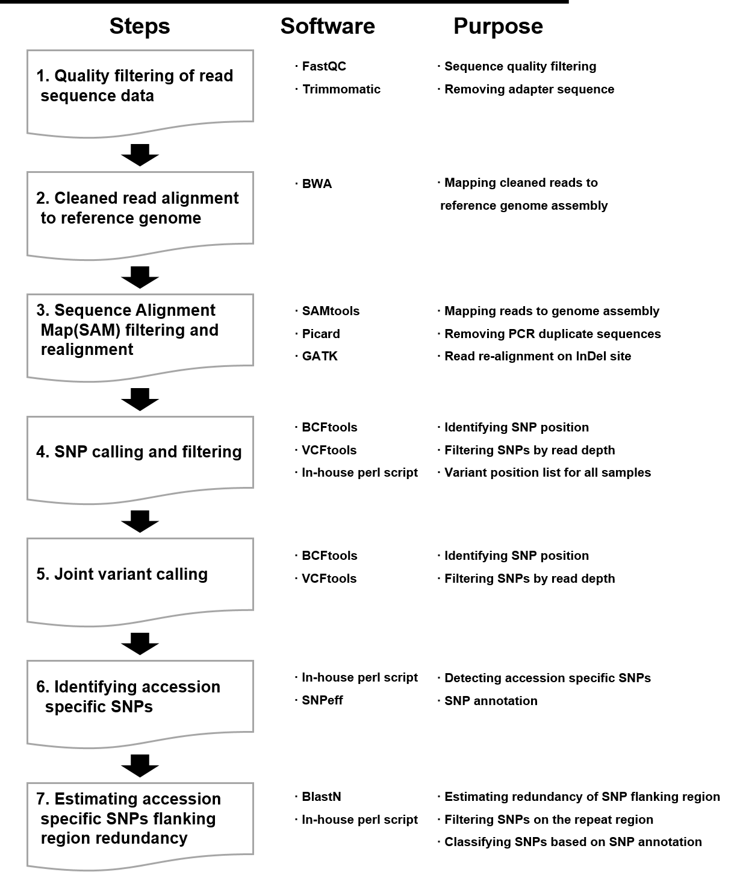
Supplementary Figure 1. Construction of pipeline for developing accession-specific markers

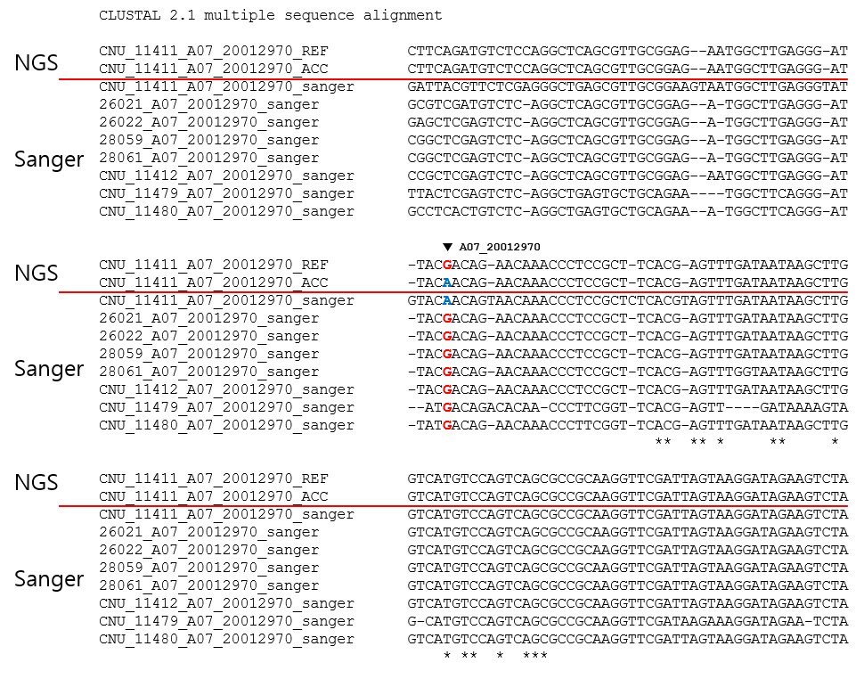
Supplementary Figure 2. Validation of accession-specific SNP (20,012,970 in chromosome 7) in accession CNU_11411 using B. rapa reference genome (ver 3.0). REF, ACC, and Sanger stands for reference genome, resequencing result of individual accessions, and sanger sequencing result, respectively.

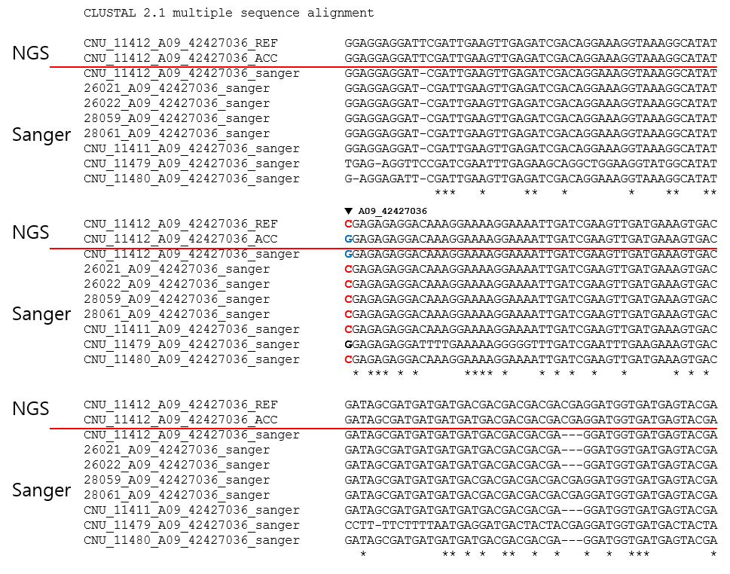
Supplementary Figure 3. Validation of accession-specific SNP (42,427,036 in chromosome 9) in accession CNU_11412 using B. rapa reference genome (ver 3.0). REF, ACC, and Sanger stands for reference genome, resequencing result of individual accessions, and sanger sequencing result, respectively.

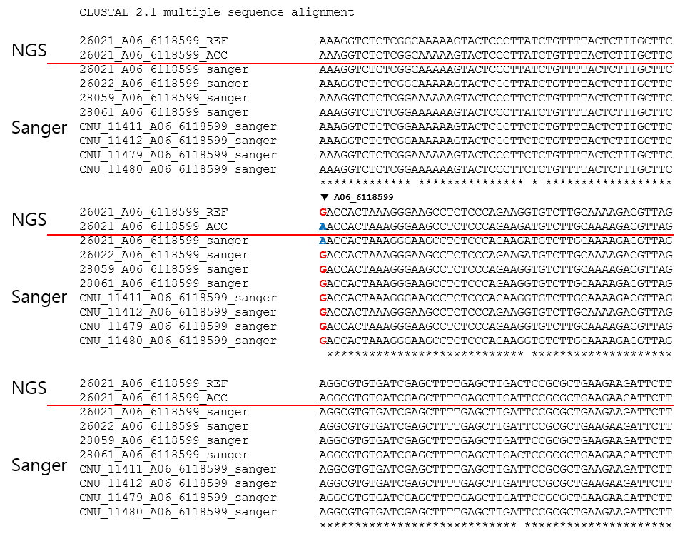
Supplementary Figure 4. Validation of accession-specific SNP (6,118,599 in chromosome 6) in accession 26021 using B. rapa reference genome (ver 3.0). REF, ACC, and Sanger stands for reference genome, resequencing result of individual accessions, and sanger sequencing result, respectively.

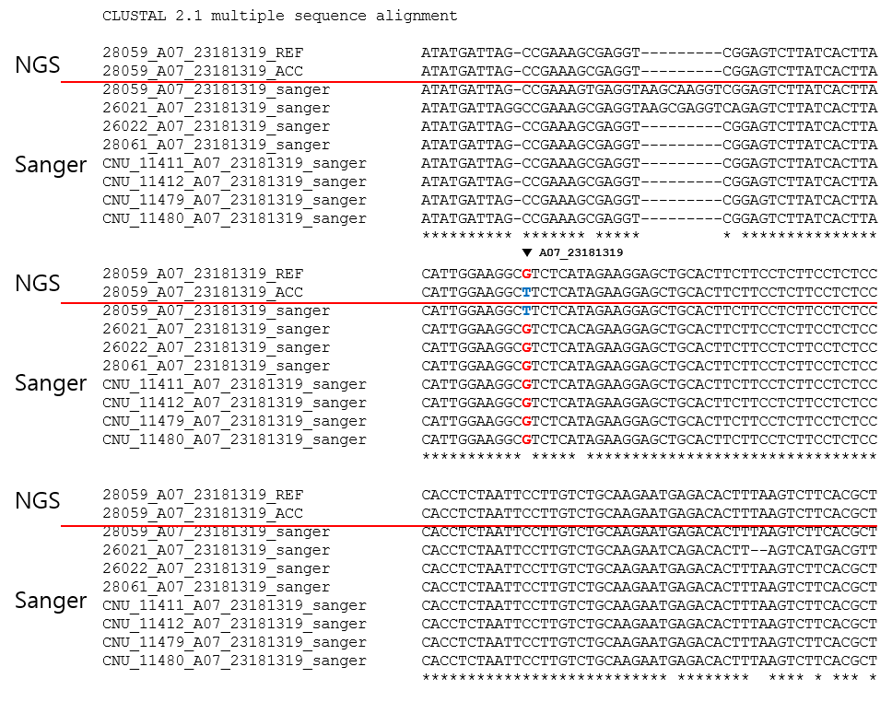
Supplementary Figure 5. Validation of accession-specific SNP (23,181,319 in chromosome 7) in accession 28059 using B. rapa reference genome (ver 3.0). REF, ACC, and Sanger stands for reference genome, resequencing result of individual accessions, and sanger sequencing result, respectively.

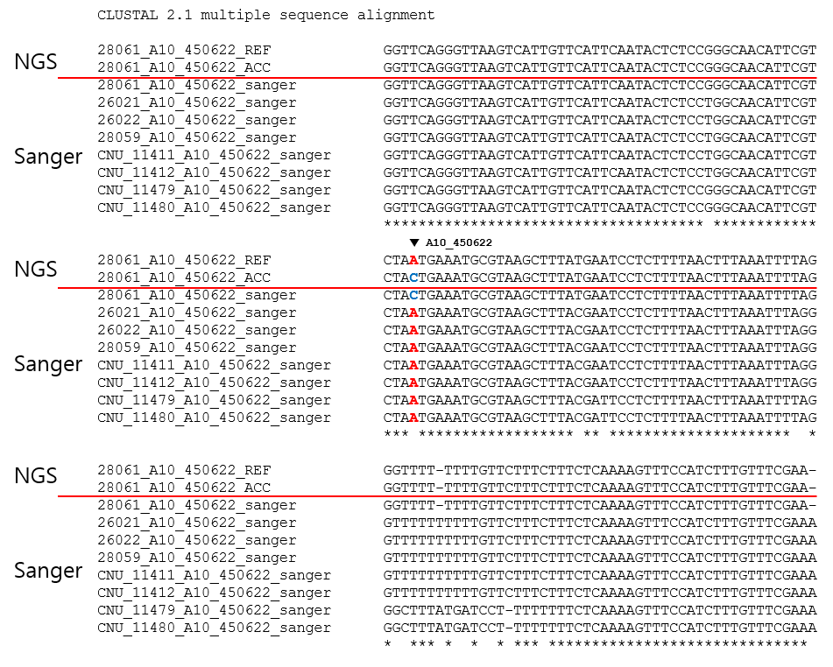
Supplementary Figure 6. Validation of accession-specific SNP (450,622 in chromosome 10) in accession 28061 using B. rapa reference genome (ver 3.0). REF, ACC, and Sanger stands for reference genome, resequencing result of individual accessions, and sanger sequencing result, respectively.

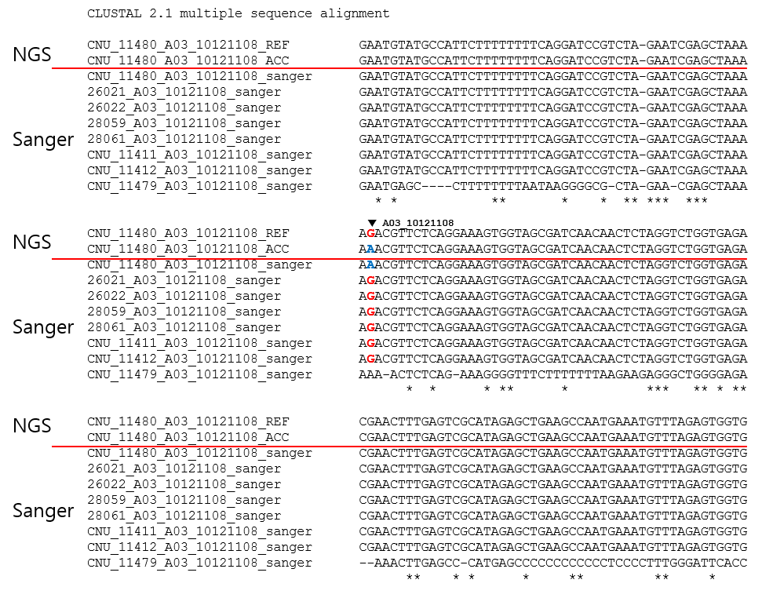
Supplementary Figure 7. Validation of accession-specific SNP (10,121,108 in chromosome 3) in accession CNU_11480 using B. rapa reference genome (ver 3.0). REF, ACC, and Sanger stands for reference genome, resequencing result of individual accessions, and sanger sequencing result, respectively.

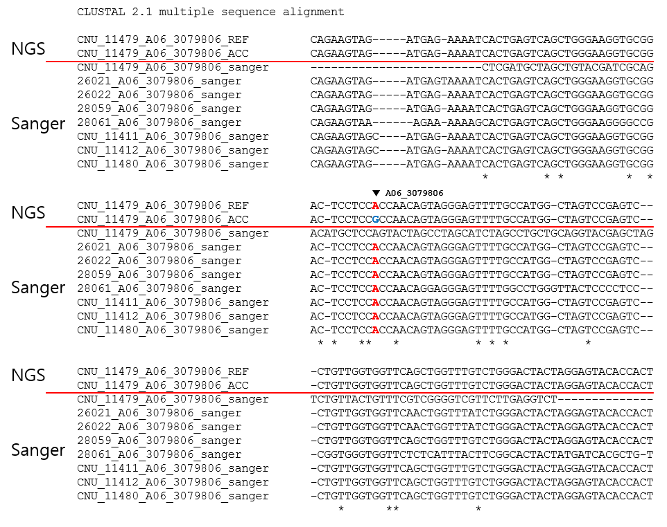
Supplementary Figure 8. Validation of accession-specific SNP (3,079,806 in chromosome 6) in accession CNU_11479 using B. rapa reference genome (ver 3.0). REF, ACC, and Sanger stands for reference genome, resequencing result of individual accessions, and sanger sequencing result, respectively.

