Supplementary Information
Pathways to Sustainable Forestry Leisure Tourism in China: Efficiency Dynamics, Spatial Spillovers, and Configurational Evidence
Submission ID 0b2ffc0a-36ff-462a-b3c9-9d2873befdd4
This Supplementary Information describes the datasets, processing steps, model inputs, code files and supplementary figure supplied for editorial and peer-review scrutiny. The accompanying data and code archive contains the machine-readable files referenced below.

Supplementary Methods

S1 Data structure and panel construction
The analytical panel contains 341 province-year observations for 31 Chinese provinces from 2013 to 2023. Each observation is uniquely identified by province and year. The clean panel supplied with the data archive contains no missing cells or duplicate province-year records. The source statistical series and indicator definitions follow the main manuscript.

S2 Global Super SBM data and implementation
Forestry leisure tourism development efficiency was calculated using four inputs and two desirable outputs. The inputs were expenditure on culture, sports and media, urban employment in culture, sports and entertainment, total park area, and the number of A-rated tourist attractions. The desirable outputs were forestry leisure tourism visits and forestry leisure tourism revenue.
The supplied compatibility workbook contains the 341 model observations, MATLAB-formatted input, 2012 auxiliary observations, an imputation log and the model settings. The recorded model specification is a Global Super-SBM model under constant returns to scale, with super-efficiency and decomposition options enabled. The 341 efficiency estimates in the supplied output file match the FLTE values in the level-form panel by province and year.
For forestry leisure tourism visits, the supplied processing log records the 2022 value as the province-specific mean for 2012-2021 and the 2023 value as the province-specific mean for 2013-2022. The corresponding verification log contains two records for each province.

S3 Spatial econometric data and code
The spatial econometric dataset contains the natural logarithms of FLTE and the five explanatory variables. Exponentiating the Stata variables reproduces the level-form panel values for all 341 observations to numerical precision. The archive includes the spatial-weight file, the original Stata command file and a package-relative version of the analysis sequence. The Stata analysis calls community-contributed commands for spatial diagnostics, model selection and spatial Durbin estimation.

S4 fsQCA data and calibration
The archive provides the case-level fsQCA input and a machine-readable calibration table. Direct calibration uses the 75th percentile for full membership, the 50th percentile for the crossover and the 25th percentile for full non-membership. Membership scores equal to exactly 0.500 are adjusted to 0.501. The fsQCA outcome series is stored separately from the Global Super-SBM panel series and corresponds to the revised configurational analysis reported in the manuscript.

S5 XGBoost SHAP input and figure
The XGBoost-SHAP input contains FLTE, province coordinates and the five level-form predictors. The FLTE and predictor values match the level-form panel by province and year. The supplied TIFF figure is 7200 × 3300 pixels at 600 dpi. SHAP values are interpreted as predictive contributions rather than causal effects.
Supplementary Table S1 Data and code files supplied for peer review
File | Contents | Analysis
Raw_SuperSBM_Inputs.xlsx | Compiled province-year input and output indicators for efficiency estimation | Super-SBM
SuperSBM_Compatibility_Data.xlsx | MATLAB input, auxiliary data, imputation log and model settings | Super-SBM
Panel_Data_Level.xlsx | Level-form FLTE and five explanatory variables | SDM and XGBoost
SDM_Log_Transformed_Data.dta | Natural logarithms of FLTE and x1-x5 | SDM
Spatial_Weights.dta | Original 31 by 31 spatial-weight file | SDM
fsQCA_Raw_Input.csv | Case-level outcome and condition data | fsQCA
fsQCA_Calibration_Anchors.csv | Full-membership, crossover and full-non-membership anchors | fsQCA
XGBoost_SHAP_Input.csv | FLTE, coordinates and five predictors | XGBoost-SHAP
Run_Global_Super_SBM_CRS.m | Package-relative model wrapper | Super-SBM
SDM_analysis_portable.do | Package-relative Stata analysis sequence | SDM
SuperSBM_Efficiency.xls | Efficiency estimates and slacks | Super-SBM
SuperSBM_Productivity_Index.xls | Annual productivity-index records | GML
Supplementary Table S2 Variable definitions
Variable | Definition | Unit or coding | Transformation or note
id | Province identifier | Integer 1-31 | Consistent across the supplied panel files
province | Province name | Text | 31 provincial-level regions
year | Observation year | Calendar year | 2013-2023 study period
Input1 | Culture sports and media expenditure | 100 million yuan | Super-SBM input
Input2 | Urban-unit employees in culture sports and entertainment | 10 thousand persons | Super-SBM input
Input3 | Total park area | Hectares | Super-SBM input
Input4 | Number of A-level scenic attractions | Count | Super-SBM input
Output1 | Forestry leisure tourism visits | Visits | Super-SBM desirable output
Output2 | Forestry leisure tourism revenue | 10 thousand yuan | Super-SBM desirable output
FLTE | Forestry leisure tourism development efficiency | Efficiency score | Global Super-SBM CRS efficiency output
x1 / URB | Urbanization level | Proportion or rate | Level form in Excel and natural logarithm in SDM_Log_Transformed_Data.dta
x2 / TDL | Tourism development level | Index or rate | Level form in Excel and natural logarithm in SDM_Log_Transformed_Data.dta
x3 / IS | Industrial structure | Index or proportion | Level form in Excel and natural logarithm in SDM_Log_Transformed_Data.dta
x4 / LD | Leisure demand level | Index or proportion | Level form in Excel and natural logarithm in SDM_Log_Transformed_Data.dta
x5 / NDVI | Annual mean normalized difference vegetation index | Index | Level form in Excel and natural logarithm in SDM_Log_Transformed_Data.dta
lon | Province coordinate longitude | Decimal degrees | Used for geographic identification or spatial interpretation
lat | Province coordinate latitude | Decimal degrees | Used for geographic identification or spatial interpretation
row and column values | Spatial-weight matrix elements | Numeric 31 by 31 matrix | Original analysis file preserved unchanged
full membership | Threshold for full set membership | Fuzzy-set anchor | 75th percentile reported in the manuscript
crossover | Maximum-ambiguity threshold | Fuzzy-set anchor | 50th percentile reported in the manuscript
full non-membership | Threshold for full non-membership | Fuzzy-set anchor | 25th percentile reported in the manuscript
Supplementary Table S3 fsQCA calibration anchors
Variable | Full membership | Crossover | Full non-membership
FLTE | 0.242 | 0.077 | 0.029
URB | 0.667 | 0.593 | 0.526
TDL | 0.16 | 0.121 | 0.087
IS | 0.554 | 0.515 | 0.465
LD | 0.116 | 0.108 | 0.099
NDVI | 0.823 | 0.788 | 0.687
Note: Direct calibration uses the 75th, 50th and 25th percentiles. Membership scores equal to 0.500 are adjusted to 0.501.

Supplementary Figure
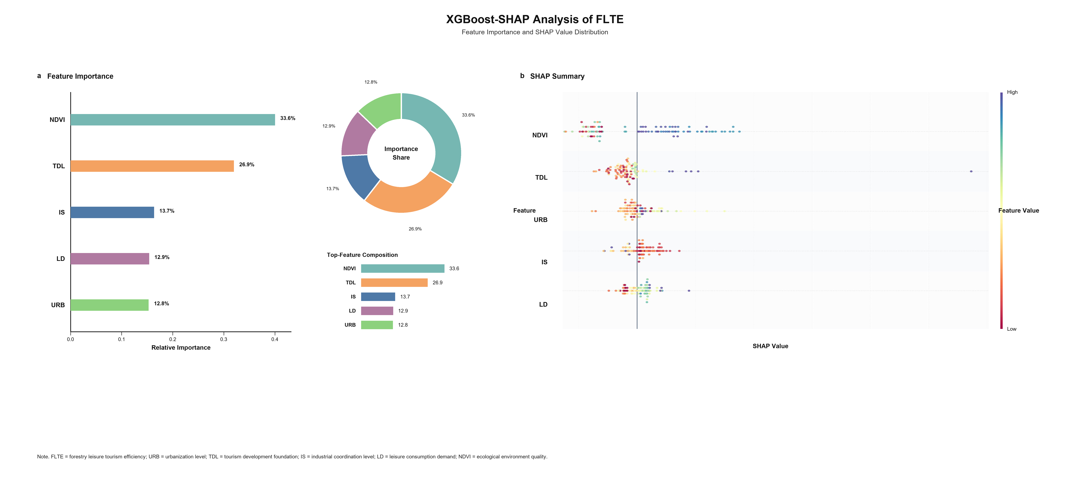
Supplementary Figure S1. XGBoost-SHAP feature importance and SHAP value distribution for forestry leisure tourism development efficiency. SHAP values represent predictive contributions and do not establish causal effects.

Data and Code Availability
The province-year datasets and supporting materials used in this study are provided in the accompanying Supplementary Data and Code archive. The archive includes the raw and MATLAB-compatible data used for the Global Super-SBM analysis; the corresponding efficiency and productivity-index outputs; the level-form and natural-log panel datasets, spatial-weight matrix and Stata command file used for the spatial econometric analysis; the case-level input data and calibration anchors used for the fsQCA analysis; and the XGBoost-SHAP input data and corresponding figure. The principal study datasets contain 341 observations covering 31 Chinese provinces from 2013 to 2023. The underlying statistical series were compiled from the sources described in the manuscript. No human-participant or personally identifiable data are included.

