Gene Ontology enrichment analysis and differentially expressed genes identified in Plasmodium falciparum 3D7 ring-stage cultures following GBPS340 exposure.
Tables S2 and S3 show enriched GO terms at H24 and H48, respectively, including the number of annotated genes, DEGs, adjusted p-values, and GO identifiers.
Tables S4–S8 list the DEGs associated with the enriched GO terms inner membrane pellicle complex, host cell, cell surface, and entry into host, together with log2 fold changes, adjusted p-values, and predicted protein products.

RING-STAGE CULTURES

Table S2. Gene Ontology enrichment analysis at H24
GO term |  | Number of genes | Number of DEGs | adj. p-value
ID | Description | Number of genes | Number of DEGs | adj. p-value
GO:0070258 | Inner membrane pellicle complex | 28 | 20 (see Table 3) | 4.21 × 10⁻⁵
GO:0043657 | Host cell | 33 | 20 (see Table 4) | 6.15 × 10⁻³
GO:0009986 | Cell surface | 78 | 30 | 2.45 × 10⁻¹
GO:0045177 | Apical part of cell | 24 | 13 | 2.45 × 10⁻¹
GO:0045178 | Basal part of cell | 5 | 5 | 2.45 × 10⁻¹
GO:0044409 | Entry into host | 37 | 17 | 3.36 × 10⁻¹
GO:0030430 | Host cell cytoplasm | 23 | 12 | 4.08 × 10⁻¹
GO:0008017 | Microtubule binding | 15 | 9 | 4.42 × 10⁻¹
GO:0020008 | Rhoptry | 10 | 7 | 4.42 × 10⁻¹
GO:0044228 | Host cell surface | 16 | 9 | 7.09 × 10⁻¹

Table S3. Gene Ontology enrichment analysis at H48
GO term |  | Number of genes | Number of DEGs | adj. p-value
ID | Description | Number of genes | Number of DEGs | adj. p-value
GO:0070258 | Inner membrane pellicle complex | 28 | 19 (see Table 5) | 3.95 × 10⁻⁵
GO:0009986 | Cell surface | 82 | 39 (see Table 6) | 3.95 × 10⁻⁵
GO:0044409 | Entry into host | 39 | 20 (see Table 7) | 2.00 × 10⁻³
GO:0020008 | Rhoptry | 10 | 8 | 6.59 × 10⁻²
GO:0045177 | Apical part of cell | 24 | 13 | 9.96 × 10⁻²
GO:0046658 | Anchored component of plasma membrane | 10 | 7 | 2.80 × 10⁻¹
GO:0005515 | Protein binding | 316 | 86 | 2.80 × 10⁻¹
GO:0000786 | Nucleosome | 6 | 5 | 2.80 × 10⁻¹
GO:0046982 | Protein heterodimerization activity | 9 | 6 | 5.41 × 10⁻¹
GO:0003779 | Actin binding | 9 | 6 | 6.22 × 10⁻¹

DEGs, differentially expressed genes

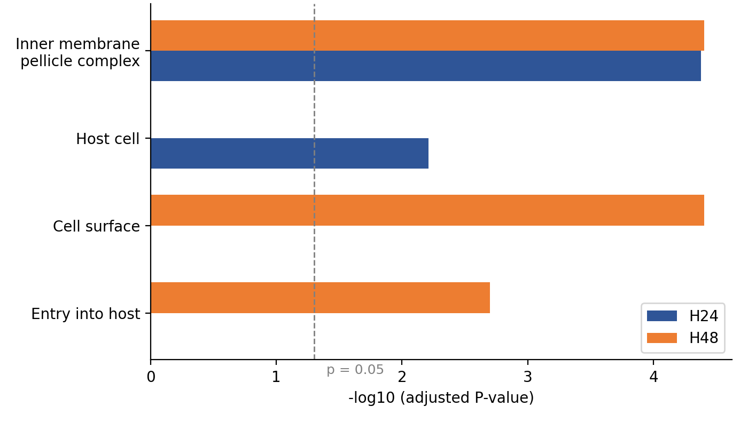
Figure S1. Significantly enriched GO terms GBPS340-treated vs. untreated ring-stage cultures.

Table S4. Differentially expressed genes in the GO term "Inner membrane pellicle complex" (GO:0070258) at H24
Gene ID | FC (log2) | adj. P-value | Expression product
PF3D7_0303400 | -3,92 | 3,05E-05 | palmitoyltransferase DHHC1
PF3D7_1205200 | -3,66 | 4,65E-03 | HAD domain ookinete protein, putative
PF3D7_1323700 | -3,46 | 2,18E-13 | glideosome associated protein with multiple membrane spans 1
PF3D7_0918000 | -3,39 | 4,23E-26 | glideosome-associated protein 50
PF3D7_0611600 | -3,21 | 3,51E-13 | basal complex transmembrane protein 1
PF3D7_0515700 | -3,10 | 2,76E-14 | glideosome-associated protein 40, putative
PF3D7_1229300 | -3,06 | 6,90E-16 | conserved Plasmodium protein, unknown function
PF3D7_1406800 | -2,98 | 1,95E-14 | glideosome associated protein with multiple membrane spans 3
PF3D7_0530300 | -2,65 | 1,14E-15 | conserved Plasmodium membrane protein, unknown function
PF3D7_0423500 | -2,46 | 3,31E-13 | glideosome associated protein with multiple membrane spans 2
PF3D7_0704100 | -2,39 | 3,86-03 | basal complex transmembrane protein 2
PF3D7_0522600 | -2,32 | 2,88E-05 | inner membrane complex protein
PF3D7_0722900 | -2,32 | 6,43E-05 | conserved protein, unknown function
PF3D7_0609800 | -2,28 | 1,13E-07 | palmitoyltransferase DHHC2, putative
PF3D7_1431900 | -1,51 | 6,51E-04 | inner membrane complex suture component, putative
PF3D7_1341800 | -1,32 | 1,11E-03 | inner membrane complex protein 1k, putative
PF3D7_0702500 | 1,25 | 9,31E-07 | Plasmodium exported protein, unknown function
PF3D7_1447500 | 1,47 | 1,28E-02 | inner membrane complex protein, putative
PF3D7_1355600 | 1,60 | 6,11E-05 | PhIL1 interacting protein PIP1
PF3D7_0510300 | 1,86 | 6,2E-06 | stripes inner membrane complex protein, putative

Table S5. Differentially expressed genes in the GO term "Host cell" (GO:000043657) at H24
Gene ID | FC (log2) | adj. P-value | Expression product
PF3D7_0935500 | -1,76 | 1,72E-11 | Plasmodium exported protein, unknown function
PF3D7_0830700 | 1,32 | 2,98E-05 | Plasmodium exported protein (hyp9), unknown function
PF3D7_0220200 | 1,36 | 1,23E-06 | Plasmodium exported protein, unknown function
PF3D7_0936200 | 1,36 | 6,34E-06 | Plasmodium exported protein (hyp11), unknown function
PF3D7_0201500 | 1,38 | 1,89E-04 | Plasmodium exported protein (hyp9), unknown function
PF3D7_0220600 | 1,48 | 5,15E-07 | Plasmodium exported protein (hyp9), unknown function
PF3D7_0631100 | 1,53 | 3,41E-03 | Plasmodium exported protein (PHISTb), unknown function
PF3D7_0830900 | 1,56 | 1,64E-07 | Plasmodium exported protein, unknown function
PF3D7_1301500 | 1,80 | 1,33E-07 | Plasmodium exported protein (PHISTa), unknown function
PF3D7_1201400 | 2,02 | 4,86E-10 | Plasmodium exported protein, unknown function
PF3D7_1016500 | 2,13 | 1,69E-10 | Plasmodium exported protein (PHISTc), unknown function
PF3D7_0202300 | 2,20 | 1,26E-08 | Plasmodium exported protein (hyp11), unknown function
PF3D7_0730900 | 2,23 | 7,48E-10 | EMP1-trafficking protein
PF3D7_0601500 | 2,30 | 4,07E-09 | Plasmodium exported protein (PHISTb), unknown function
PF3D7_0730800 | 2,32 | 4,38E-12 | #N/A
PF3D7_0831000 | 2,50 | 1,64E-11 | Plasmodium exported protein (PHISTb), unknown function
PF3D7_1477200 | 2,99 | 7,80E-09 | Plasmodium exported protein (hyp15), unknown function
PF3D7_0113400 | 3,13 | 1,16E-20 | Plasmodium exported protein, unknown function
PF3D7_0221000 | 4,20 | 3,98E-02 | Plasmodium exported protein, unknown function
PF3D7_1102200 | 6,72 | 5,38E-04 | DnaJ protein, putative

Table S6. Differentially expressed genes in the GO term "Inner membrane pellicle complex" (GO:0070258) at H48
Gene ID | FC (log2) | adj. P-value | Expression product
PF3D7_1323700 | -3,27 | 1,20E-10 | glideosome associated protein with multiple membrane spans 1
PF3D7_1406800 | -2,88 | 5,91E-12 | glideosome associated protein with multiple membrane spans 3
PF3D7_0515700 | -2,87 | 8,21E-11 | glideosome-associated protein 40, putative
PF3D7_1341800 | -2,65 | 1,42E-02 | inner membrane complex protein 1k, putative
PF3D7_1431100 | -2,11 | 1,67E-06 | PhIL1 interacting protein PIP2
PF3D7_0609800 | -2,08 | 2,53E-08 | palmitoyltransferase DHHC2, putative
PF3D7_0522600 | -1,94 | 1,35E-05 | inner membrane complex protein
PF3D7_0918000 | -1,86 | 3,63E-07 | glideosome-associated protein 50
PF3D7_0423500 | -1,85 | 4,44E-06 | glideosome associated protein with multiple membrane spans 2
PF3D7_1431900 | -1,77 | 7,70E-04 | inner membrane complex suture component, putative
PF3D7_1229300 | -1,58 | 2,37E-04 | conserved Plasmodium protein, unknown function
PF3D7_1430800 | -1,52 | 3,62E-05 | PhIL1 interacting protein PIP3
PF3D7_0816500 | -1,42 | 1,18E-02 | small heat shock protein HSP20, putative
PF3D7_0722900 | -1,37 | 1,43E-02 | conserved protein, unknown function
PF3D7_0611600 | -1,26 | 1,82E-02 | basal complex transmembrane protein 1
PF3D7_0530300 | -1,11 | 3,14E-02 | conserved Plasmodium membrane protein, unknown function
PF3D7_0410600 | -1,07 | 5,55E-03 | conserved protein, unknown function
PF3D7_0704100 | -1,04 | 3,77E-02 | basal complex transmembrane protein 2
PF3D7_1355600 | 1,40 | 3,23E-06 | PhIL1 interacting protein PIP1

Table S7. Differentially expressed genes in the GO term "Cell surface" (GO: 0009986) at H48
Gene ID | FC (log2) |  | adj. P-value | Expression product
PF3D7_0905400 | -3,85 |  | 3,23E-05 | high molecular weight rhoptry protein 3
PF3D7_1140400 | -3,64 |  | 6,30E-11 | conserved Plasmodium protein, unknown function
PF3D7_1323700 | -3,27 |  | 1,20E-10 | glideosome associated protein with multiple membrane spans 1
PF3D7_1252100 | -3,13 |  | 1,45E-03 | rhoptry neck protein 3
PF3D7_0909500 | -3,13 |  | 2,97E-07 | subpellicular microtubule protein 1, putative
PF3D7_1228600 | -3,11 |  | 2,38E-06 | acidic basic repeat antigen
PF3D7_1246200 | -2,90 |  | 7,00E-22 | actin I
PF3D7_1406800 | -2,88 |  | 5,91E-12 | glideosome associated protein with multiple membrane spans 3
PF3D7_0515700 | -2,87 |  | 8,21E-11 | glideosome-associated protein 40, putative
PF3D7_1031000 | -2,64 |  | 1,09E-12 | ookinete surface protein P25
PF3D7_0506900 | -2,58 |  | 1,01E-08 | rhomboid protease ROM4
PF3D7_0404900 | -2,48 |  | 2,99E-07 | 6-cysteine protein P41
PF3D7_1146300 | -2,40 |  | 1,75E-02 | conserved Plasmodium protein, unknown function
PF3D7_0508000 | -2,37 |  | 1,38E-05 | 6-cysteine protein
PF3D7_1437300 | -2,29 |  | 3,75E-07 | conserved Plasmodium protein, unknown function
PF3D7_1409400 | -2,21 |  | 5,16E-16 | conserved protein, unknown function
PF3D7_0404400 | -1,94 |  | 4,85E-05 | 6-cysteine protein P36
PF3D7_1204400 | -1,93 |  | 2,86E-05 | sexual stage-specific protein G37, putative
PF3D7_0918000 | -1,86 |  | 3,63E-07 | glideosome-associated protein 50
PF3D7_1444800 | -1,86 |  | 3,86E-08 | fructose-bisphosphate aldolase
PF3D7_0423500 | -1,85 |  | 4,44E-06 | glideosome associated protein with multiple membrane spans 2
PF3D7_1431900 | -1,77 |  | 7,70E-04 | inner membrane complex suture component, putative
PF3D7_0104100 | -1,63 |  | 1,71E-03 | conserved Plasmodium membrane protein, unknown function
PF3D7_0919500 | -1,45 |  | 4,61E-04 | major facilitator superfamily domain-containing protein, putative
PF3D7_0816500 | -1,42 |  | 1,18E-02 | small heat shock protein HSP20, putative
PF3D7_1238000 | -1,41 |  | 1,14E-02 | COPI associated protein, putative
PF3D7_1414400 | -1,34 |  | 2,89E-06 | serine/threonine protein phosphatase PP1
PF3D7_1110100 | -1,29 |  | 1,39E-04 | conserved Plasmodium protein, unknown function
PF3D7_1132800 | -1,23 |  | 1,79E-06 | aquaglyceroporin
PF3D7_1346700 | -1,05 |  | 6,26E-04 | 6-cysteine protein
PF3D7_0513700 | 1,03 |  | 1,29E-02 | secreted ookinete protein, putative
PF3D7_0904300 | 1,07 |  | 2,45E-02 | conserved protein, unknown function
PF3D7_0113100 | 1,16 |  | 9,65E-04 | surface-associated interspersed protein 1.1 (SURFIN 1.1)
PF3D7_0115000 | 1,23 |  | 2,05E-03 | surface-associated interspersed protein 1.3 (SURFIN 1.3)
PF3D7_0831100 | 1,27 |  | 9,32E-05 | surface-associated interspersed protein 8.1 (SURFIN 8.1)
PF3D7_0208900 | 1,56 |  | 1,47E-05 | 6-cysteine protein P230p
PF3D7_1477600 | 1,75 |  | 9,90E-05 | surface-associated interspersed protein 14.1 (SURFIN 14.1)
PF3D7_0107700 | 2,12 |  | 2,10E-05 | dolichyl-diphosphooligosaccharide--protein glycosyltransferase subunit OST3/OST6, putative
PF3D7_1335300 |  | 3,94 | 4,60E-02 |  | reticulocyte binding protein 2 homologue b

Table S8. Differentially expressed genes in the GO term "Entry into host" (GO: 0044409) at H48
Gene ID | FC (log2) | adj. P-value | Expression product
PF3D7_0423400 | -4,30 | 6,55E-06 | apical asparagine-rich protein AARP
PF3D7_0905400 | -3,85 | 3,23E-05 | high molecular weight rhoptry protein 3
PF3D7_0929400 | -3,27 | 1,00E-13 | high molecular weight rhoptry protein 2
PF3D7_1252100 | -3,13 | 1,45E-03 | rhoptry neck protein 3
PF3D7_1027300 | -3,01 | 5,07E-17 | peroxiredoxin
PF3D7_1246200 | -2,90 | 7,00E-22 | actin I
PF3D7_0932200 | -2,90 | 2,67E-13 | profilin
PF3D7_0515700 | -2,87 | 8,21E-11 | glideosome-associated protein 40, putative
PF3D7_0404900 | -2,48 | 2,99E-07 | 6-cysteine protein P41
PF3D7_0508000 | -2,37 | 1,38E-05 | 6-cysteine protein
PF3D7_0404400 | -1,94 | 4,85E-05 | 6-cysteine protein P36
PF3D7_0423500 | -1,85 | 4,44E-06 | glideosome associated protein with multiple membrane spans 2
PF3D7_1243900 | -1,60 | 2,88E-05 | uncharacterized protein
PF3D7_1451700 | -1,40 | 3,65E-04 | calcineurin subunit B
PF3D7_1232700 | -1,37 | 4,48E-04 | conserved Plasmodium protein, unknown function
PF3D7_1414400 | -1,34 | 2,89E-06 | serine/threonine protein phosphatase PP1
PF3D7_1110100 | -1,29 | 1,39E-04 | conserved Plasmodium protein, unknown function
PF3D7_1434200 | -1,04 | 7,63E-03 | calmodulin
PF3D7_0818200 | -1,02 | 1,59E-03 | 14-3-3 protein
PF3D7_0208900 | 1,56 | 1,47E-05 | 6-cysteine protein P230p

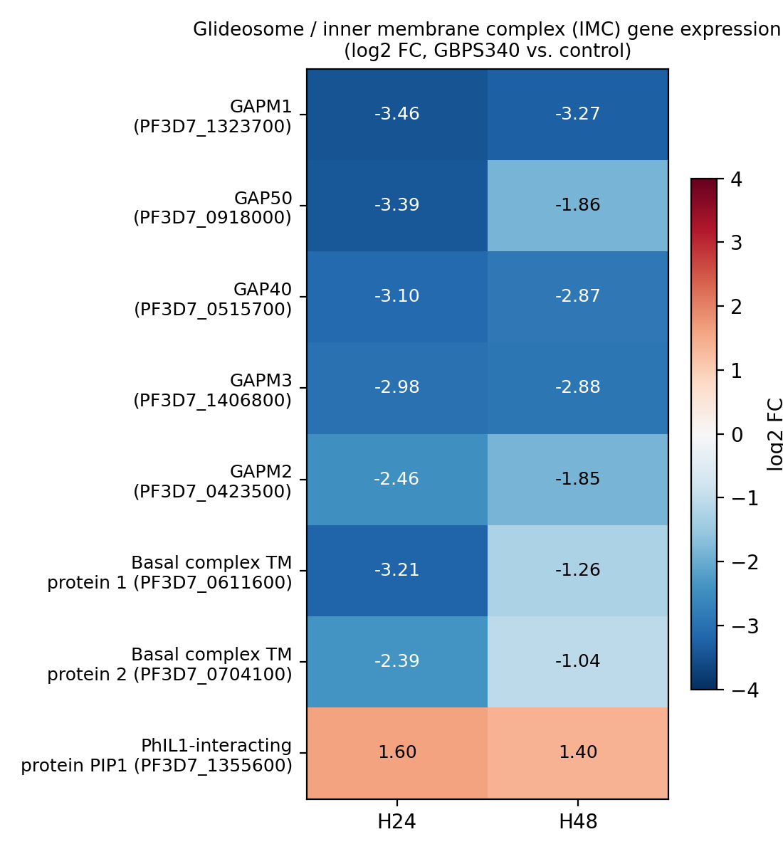

Figure S2. Glideosome / inner membrane complex gene expression (log2FC, GBPS340 vs. control).
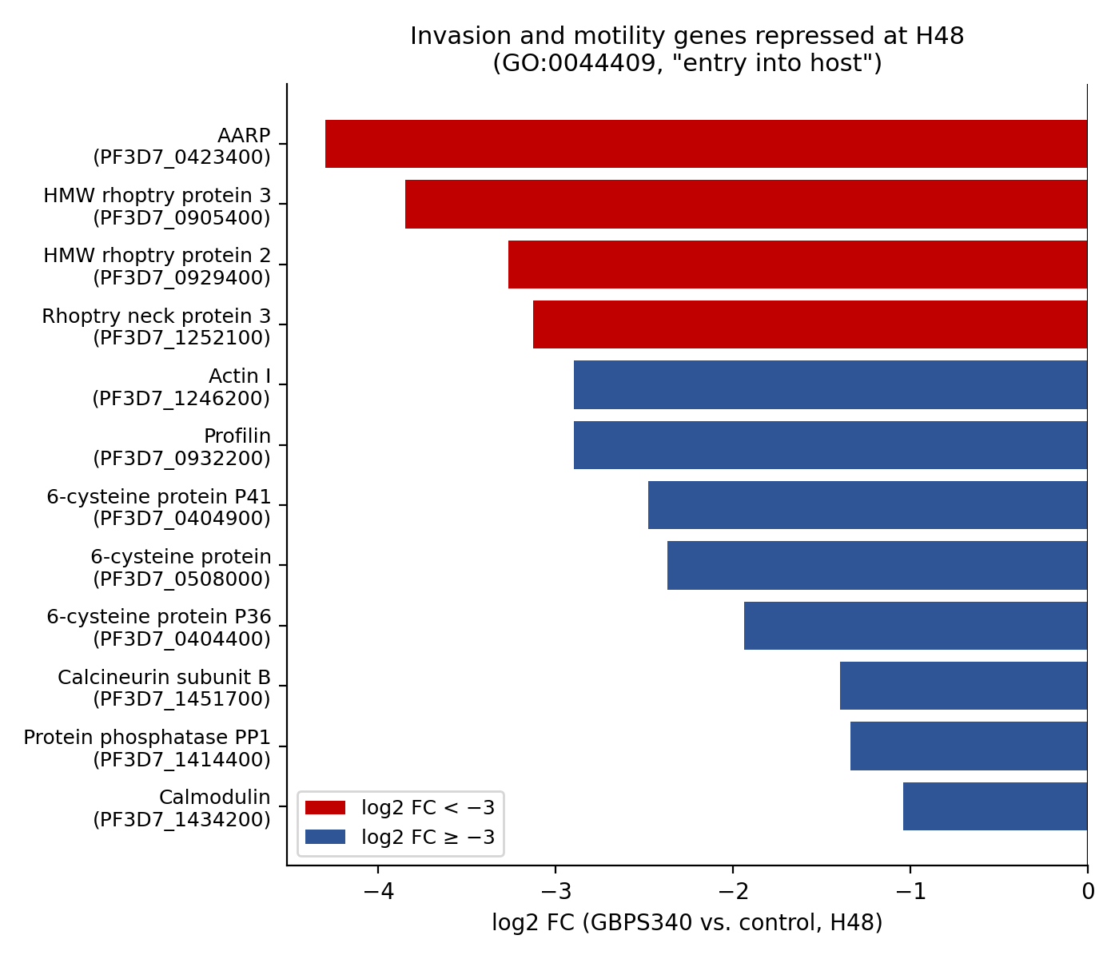

Figure S3. Invasion and motility genes repressed at H48 (GO:004409, “entry into host”).
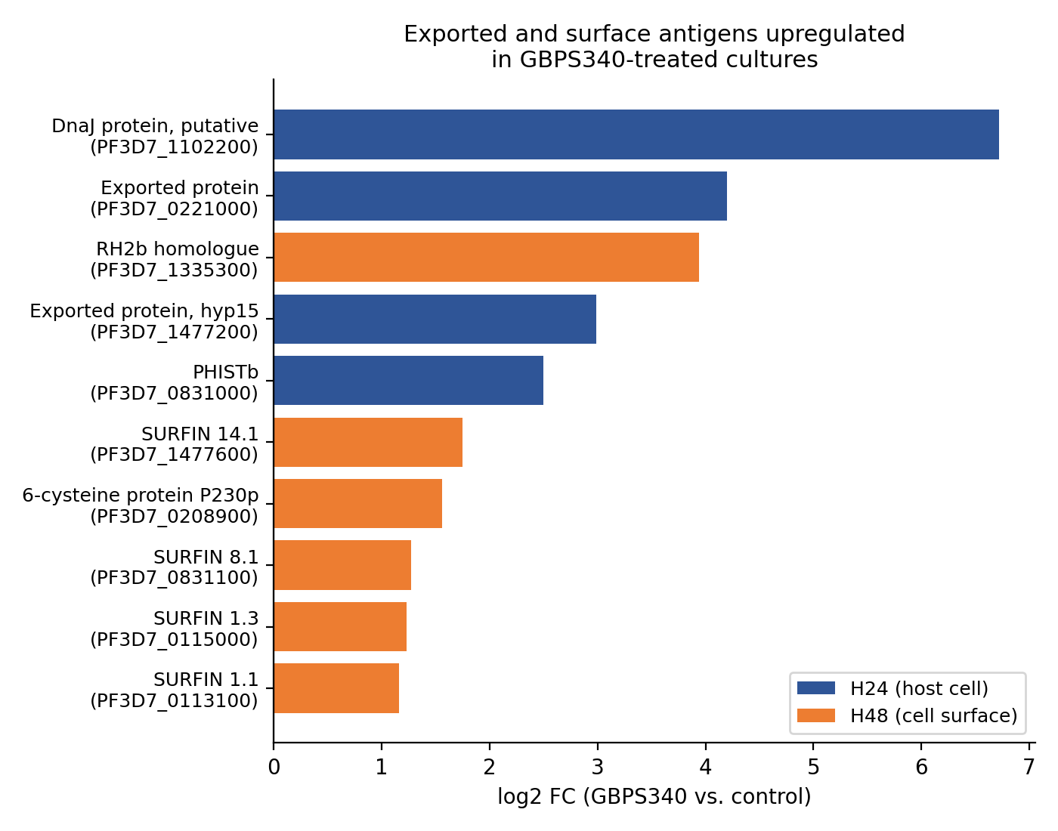

Figure S4. Exported and surface antigens upregulated in GBPS340-treated cultures.

