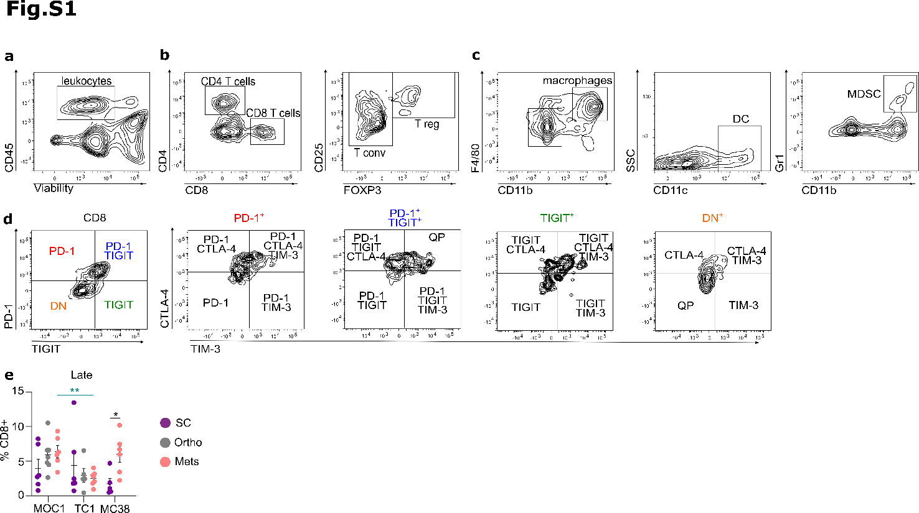

Fig. S1. Flow cytometry gating strategy and late CD8⁺ T-cell infiltration across tumor models. Example of gating strategy from a day (D)10 subcutaneous (SC) CT26 tumor dissociated from a Balb/c mouse. (a) All populations were gated on live CD45⁺ leukocytes. Gating of (b) CD8⁺ T cells and CD4⁺ conventional (T conv; CD25⁺/FOXP3⁻) and regulatory (T reg; CD25⁺/FOXP3⁺) T cells, (c) macrophages (F4/80⁺/CD11b⁺), dendritic cells (DC; F4/80⁻/CD11b⁻/CD11c⁺) and myeloid-derived suppressive cells (MDSC; Gr1⁺/CD11b⁺) and (d) gating of CD8⁺ T cell exhausted subpopulations based on the expression of the four immune checkpoints: PD-1, TIGIT, TIM-3, CTLA-4 (QP = quadruple positive). (e) Percentage of CD8⁺ T cells infiltrating MOC1, TC1 and MC38 SC, orthotopic (Ortho) and metastatic (Mets) tumors at late stage (n = 5-7). Each dot represents an individual mouse. One-way ANOVA with Tukey’s test was used. *P ≤ 0.05 and **P < 0.01.

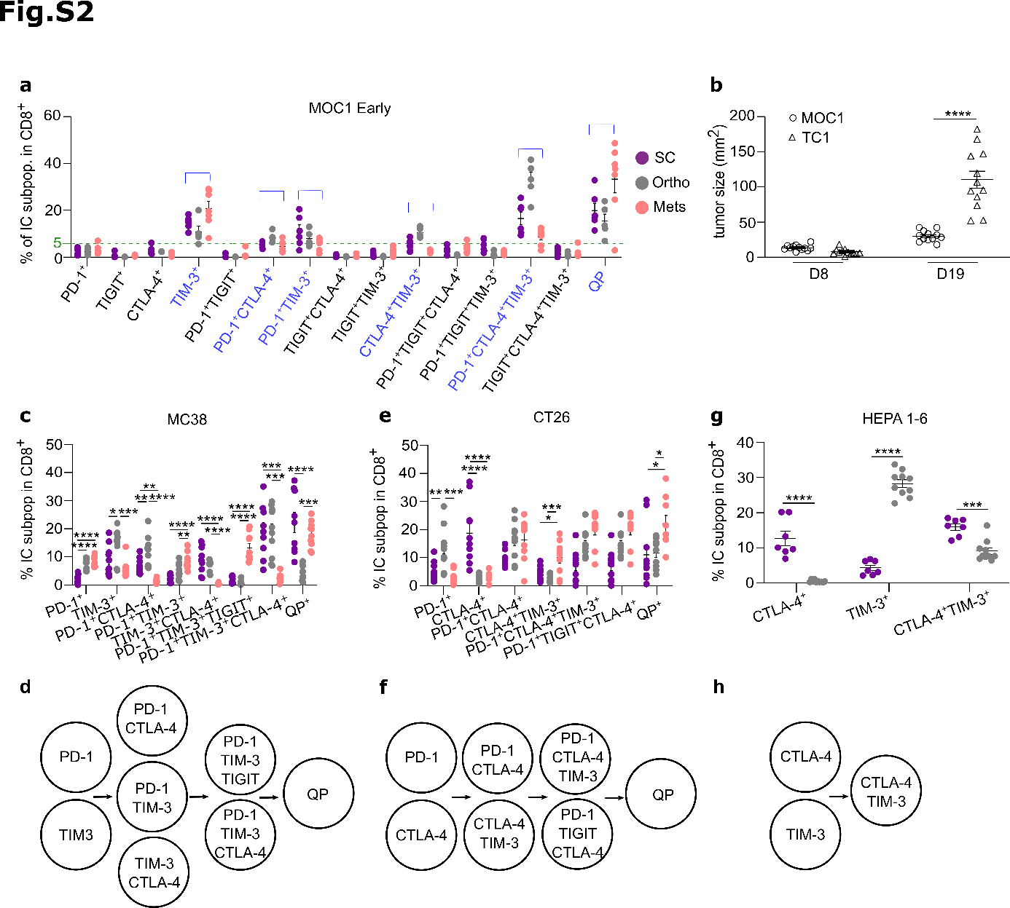

Fig. S2. Immune checkpoints acquisition in colorectal and hepatocarcinoma tumor models. Mice were implanted with tumors as described in Fig 1a. (a) Percentage of immune checkpoints (IC)-expressing CD8⁺ T cell subpopulations (subpop) in MOC1 tumors at early stages. Subpopulations with a mean frequency >5% (green dotted bar) across one of the three implantation sites (written in blue) were considered for analyses as previously described [28]. (b) MOC1 and TC1 SC tumor sizes at early (D8) and late (D19) stages. (c, e, g) Percentage and (d, f, h) representation of IC-expressing CD8⁺ T cell subpopulations in (c, d) MC38 (n = 9-10), (e, f) CT26 (n = 9-10), and (g, h) HEPA 1-6 (n = 7-10) early stages tumors implanted in SC, orthotopic (Ortho) and metastatic (Mets) sites. Each dot represents an individual mouse. One-way ANOVA with Tukey’s test was used. *P ≤ 0.05, **P < 0.01, ***P < 0.001, and ****P < 0.0001.

