Supplementary figures
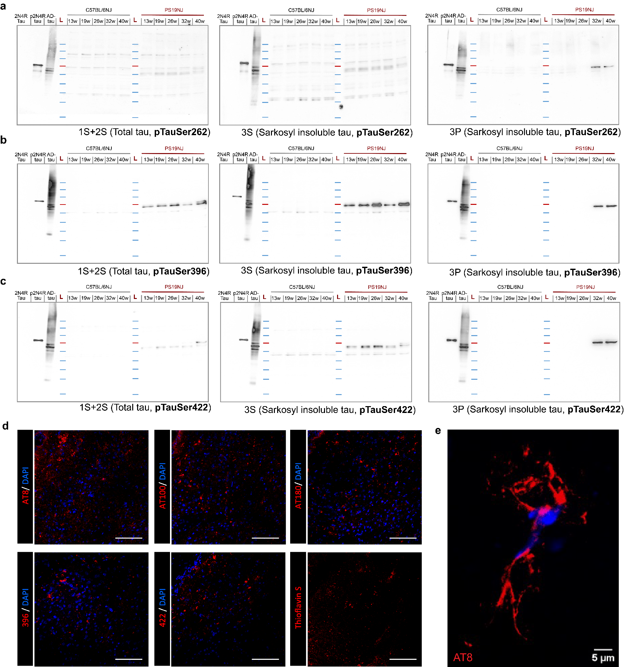
Supplementary Figure S1. Age-dependent biochemical and histological accumulation of multisite phosphorylated tau in PS19NJ mice. Representative immunoblots of total brain lysate (1S + 2S), sarkosyl-soluble (3S) and sarkosyl-insoluble (3P) fractions from C57BL/6NJ control and PS19NJ mice collected at 13, 19, 26, 32 and 39/40 weeks of age. Membranes were probed for tau phosphorylated at Ser262 (a), Ser396 (b) or Ser422 (c). Phospho-tau immunoreactivity was detectable in the total and sarkosyl-soluble fractions of PS19NJ mice, whereas prominent 3P immunoreactivity was observed principally at 32 and 39/40 weeks and was not evident in C57BL/6NJ controls. Recombinant human 2N4R tau and Alzheimer’s disease-derived tau (AD-tau) were included as reference controls. L, molecular-weight ladder; molecular masses are indicated in kDa. (d) Representative fluorescence images from 39/40-week-old PS19NJ mouse brain showing AT8 (pSer202/pThr205), AT100 (pThr212/pSer214), AT180 (pThr231), pSer396 and pSer422 immunoreactivity (red), together with Thioflavin S-positive β-sheet-rich deposits displayed in red. Nuclei were counterstained with DAPI (blue). Scale bars, 50 µm. (e) Higher-magnification image of a phospho-tau-positive neuronal profile showing somatic and process-associated immunoreactivity. Nuclei were counterstained with DAPI (blue). Scale bar, 5 µm. Immunoblots were evaluated qualitatively and were not subjected to densitometric analysis.

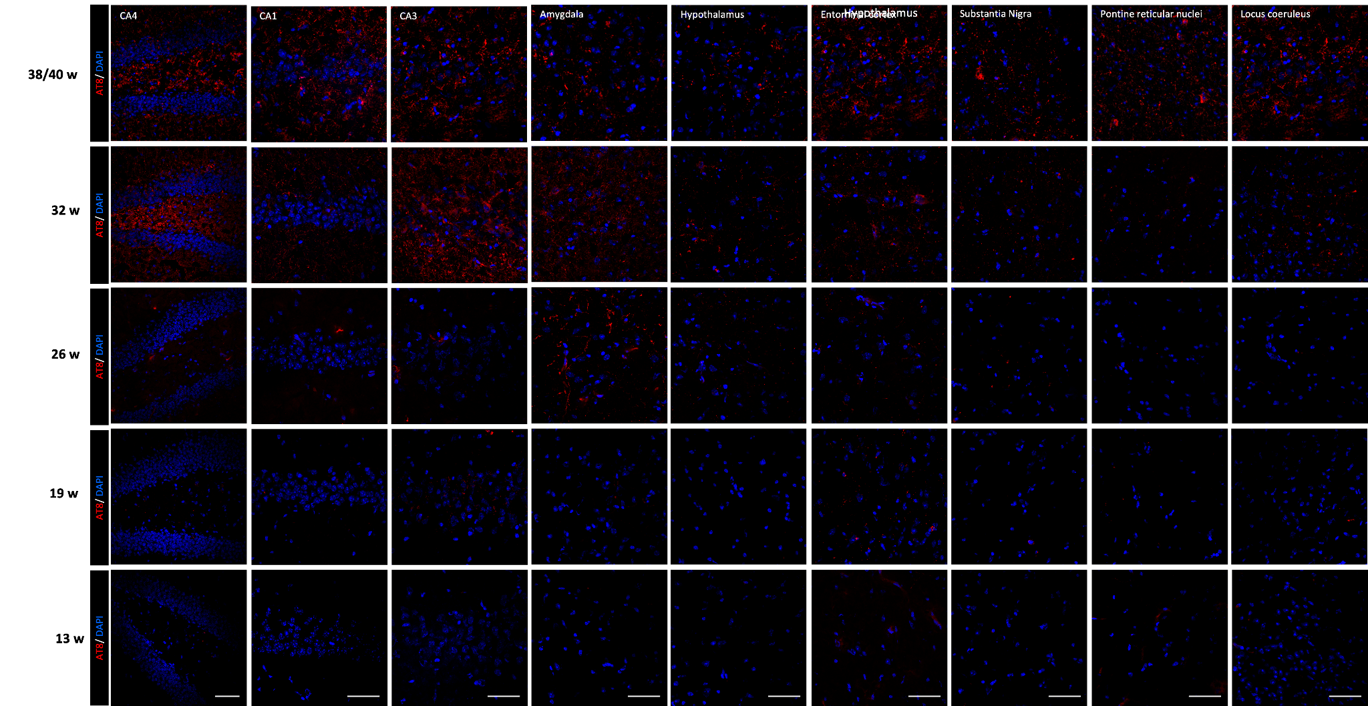
Supplementary figure 2. Regional distribution of AT8-positive phospho-tau pathology in terminal-age PS19NJ mice. Representative immunofluorescence images showing AT8-positive tau phosphorylated at Ser202/Thr205 (red) in the CA1, CA3 and CA4 hippocampal regions, amygdala, hypothalamus, entorhinal cortex, substantia nigra, pontine reticular nuclei and locus coeruleus of 39/40-week-old PS19NJ mice. Nuclei were counterstained with DAPI (blue). AT8 immunoreactivity was distributed across neuronal somata and neuropil-associated processes, demonstrating widespread phospho-tau pathology across forebrain, midbrain and brainstem regions at the terminal age. Scale bar, 50 µm.
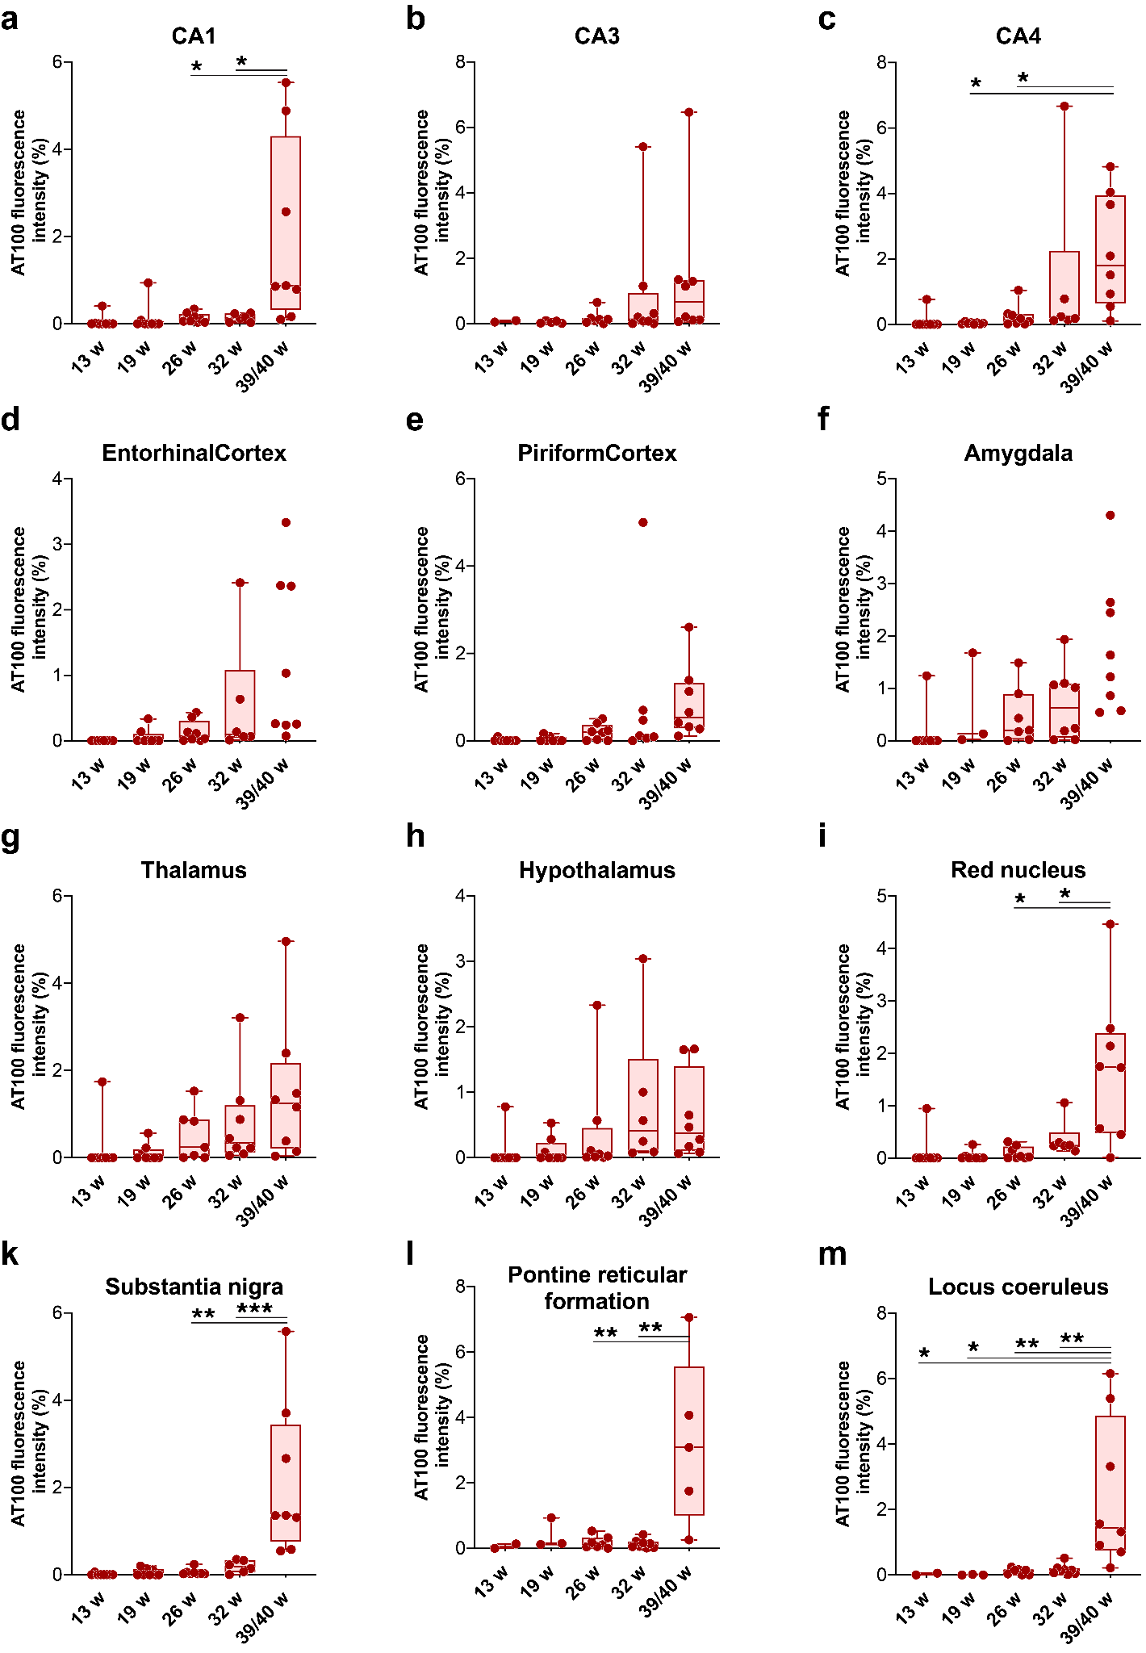
Supplementary Figure S3. Age-dependent regional progression of AT100-positive phospho-tau immunoreactivity in PS19NJ mice. AT100-positive area, detecting tau phosphorylated at Thr212/Ser214, was quantified in CA1 (a), CA3 (b), CA4 (c), entorhinal cortex (d), piriform cortex (e), amygdala (f), thalamus (g), hypothalamus (h), red nucleus (i), substantia nigra (k), pontine reticular formation (l) and locus coeruleus (m) at 13, 19, 26, 32 and 39/40 weeks of age. AT100 immunoreactivity was low at early ages and increased across multiple regions, with the greatest burden generally observed at 39/40 weeks. Points represent individual animals; boxes indicate the median and interquartile range, and whiskers show the observed range. Data are expressed as AT100-positive area (%). Significance was assessed using two-sided Mann–Whitney U tests with Benjamini–Hochberg FDR-adjusted P values; P<0.05, P<0.01, and P<0.001.
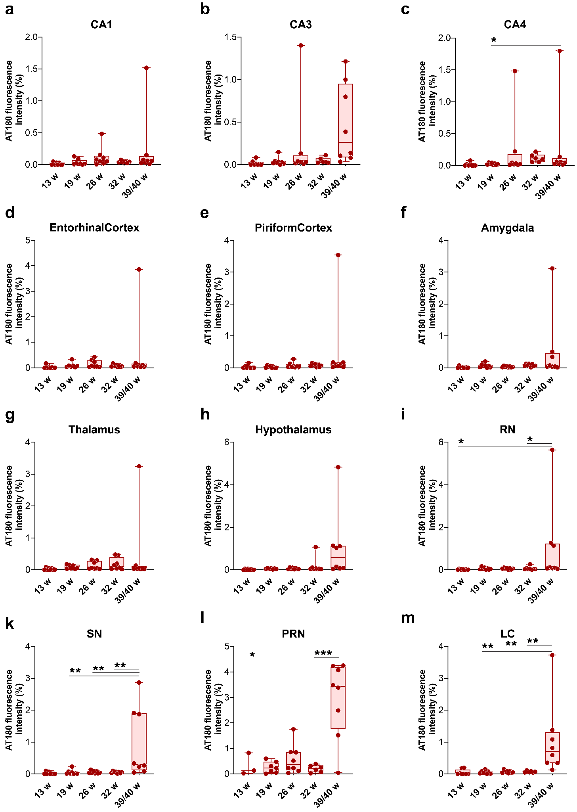
Supplementary Figure S4. Age-dependent regional progression of AT180-positive phospho-tau immunoreactivity in PS19NJ mice. AT180-positive area, detecting tau phosphorylated at Thr231, was quantified in CA1 (a), CA3 (b), CA4 (c), entorhinal cortex (d), piriform cortex (e), amygdala (f), thalamus (g), hypothalamus (h), red nucleus (RN; i), substantia nigra (SN; k), pontine reticular nucleus (PRN; l) and locus coeruleus (LC; m) at 13, 19, 26, 32 and 39/40 weeks of age. AT180 immunoreactivity was generally low at early ages and increased at 39/40 weeks across hippocampal, cortical, limbic, diencephalic, midbrain and brainstem regions. Points represent individual animals; boxes indicate the median and interquartile range, and whiskers show the observed range. Data are expressed as AT180-positive area (%). Significance was assessed using two-sided Mann–Whitney U tests with Benjamini–Hochberg FDR-adjusted P values; P<0.05, P<0.01, and P<0.001.
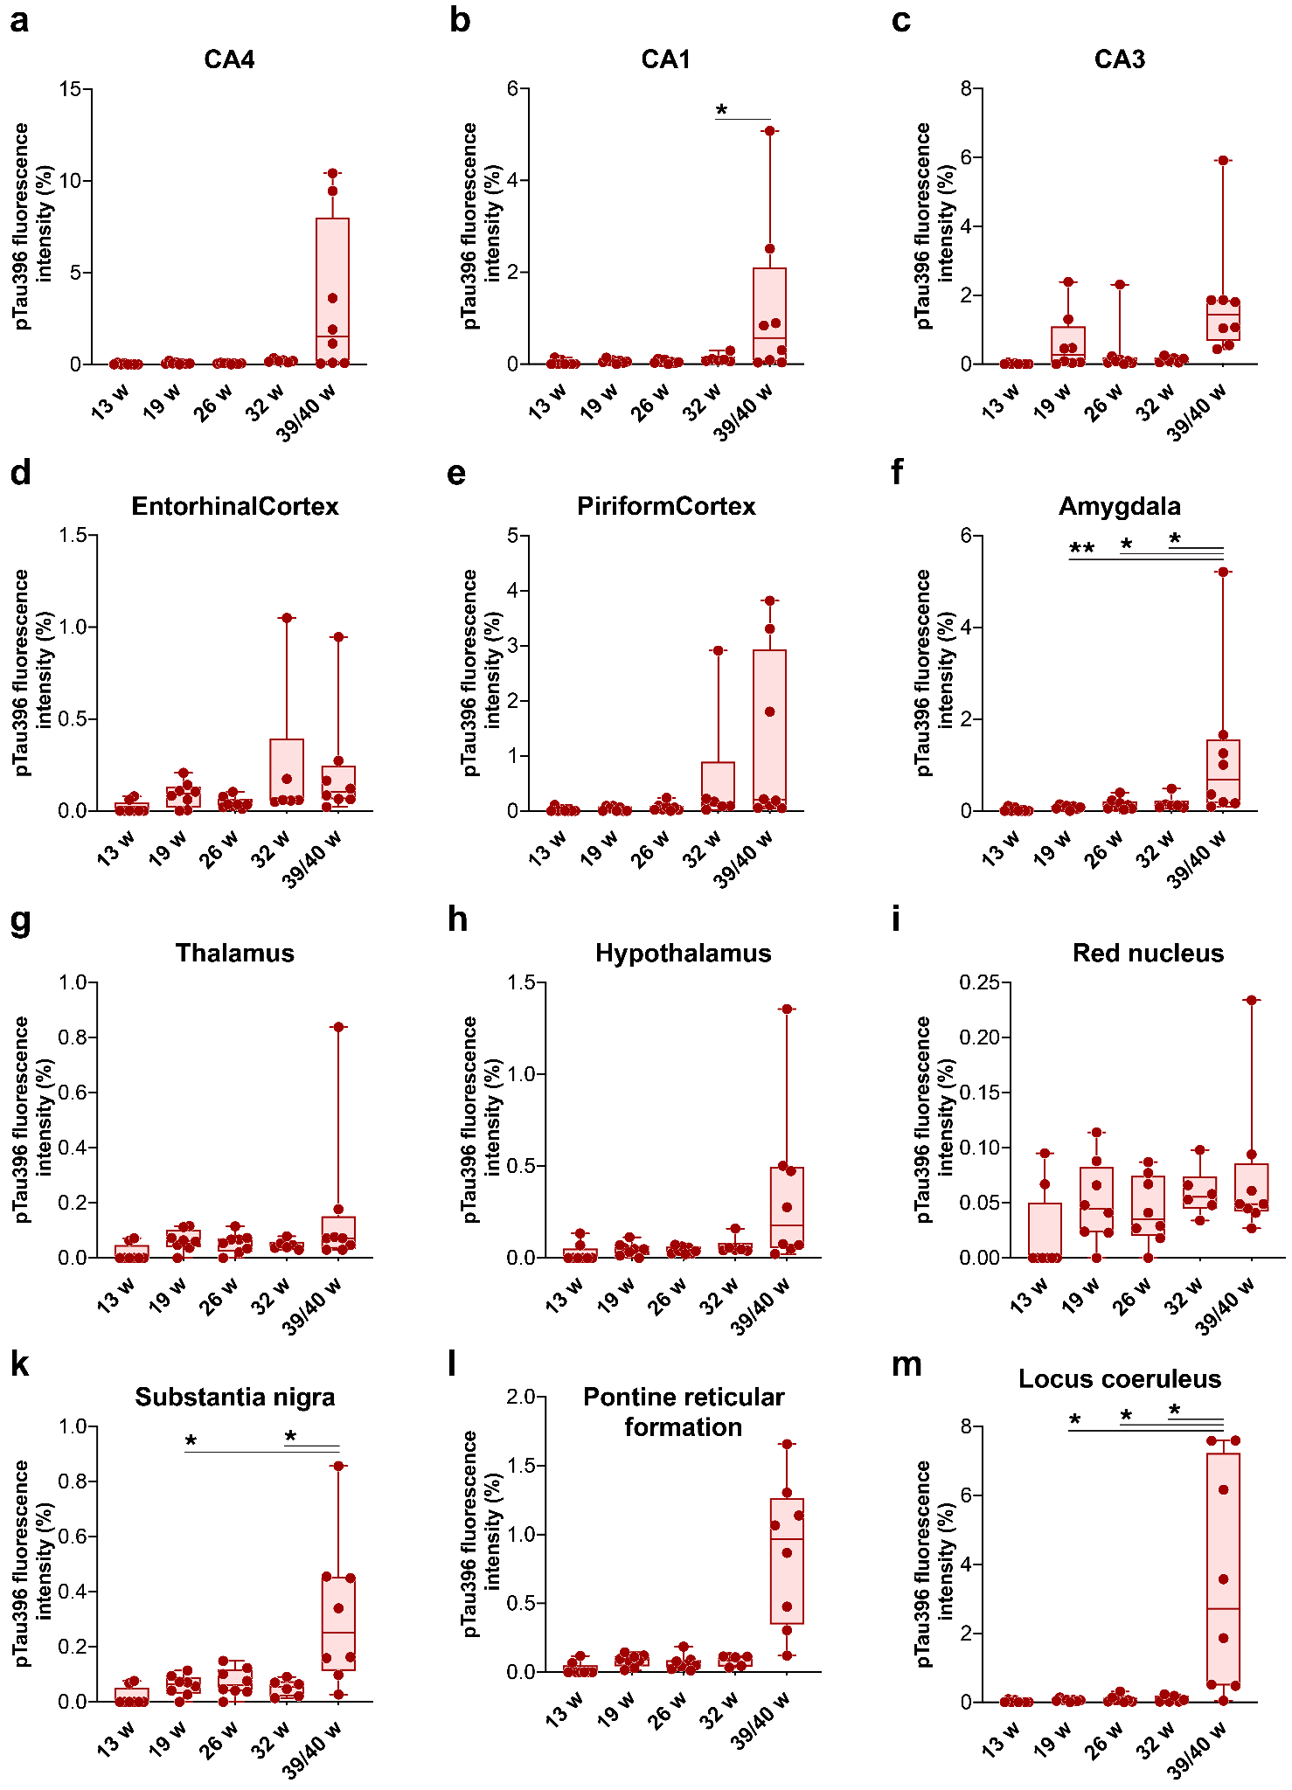
Supplementary Figure S5. Age-dependent regional progression of pSer396-positive tau immunoreactivity in PS19NJ mice. Tau phosphorylated at Ser396 was quantified in CA4 (a), CA1 (b), CA3 (c), entorhinal cortex (d), piriform cortex (e), amygdala (f), thalamus (g), hypothalamus (h), red nucleus (i), substantia nigra (k), pontine reticular formation (l) and locus coeruleus (m) at 13, 19, 26, 32 and 39/40 weeks of age. pSer396 immunoreactivity was low at early ages and increased across multiple regions, with the most prominent accumulation generally observed at 39/40 weeks. Points represent individual animals; boxes indicate the median and interquartile range, and whiskers show the observed range. Data are expressed as pSer396-positive area (%). Significance was assessed using two-sided Mann–Whitney U tests with Benjamini–Hochberg FDR-adjusted P values; P<0.05, P<0.01, and P<0.001.
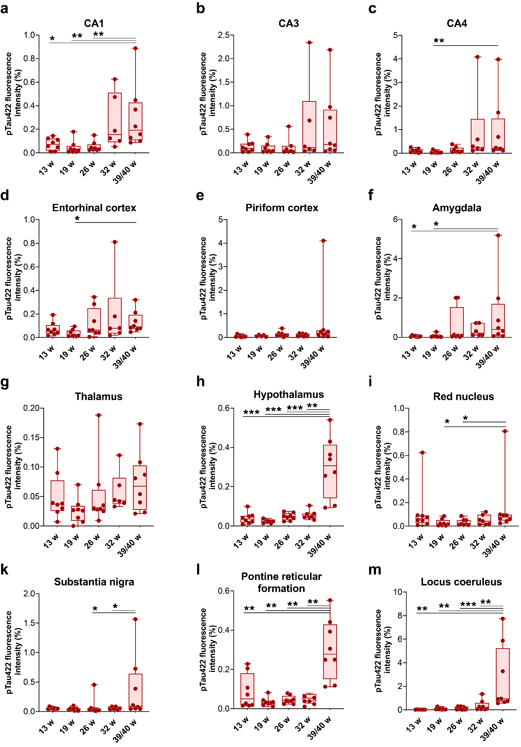

Supplementary Figure S6. Age-dependent regional progression of pSer422-positive tau immunoreactivity in PS19NJ mice. Tau phosphorylated at Ser422 was quantified in CA1 (a), CA3 (b), CA4 (c), entorhinal cortex (d), piriform cortex (e), amygdala (f), thalamus (g), hypothalamus (h), red nucleus (i), substantia nigra (k), pontine reticular formation (l) and locus coeruleus (m) at 13, 19, 26, 32 and 39/40 weeks of age. pSer422 showed a more anatomically restricted age-dependent increase than the other phospho-tau epitopes examined, with prominent terminal accumulation in selected hippocampal, limbic, hypothalamic and brainstem regions. Points represent individual animals; boxes indicate the median and interquartile range, and whiskers show the observed range. Data are expressed as pSer422-positive area (%). Significance was assessed using two-sided Mann–Whitney U tests with Benjamini–Hochberg FDR-adjusted P values; P<0.05, P<0.01, and P<0.001.
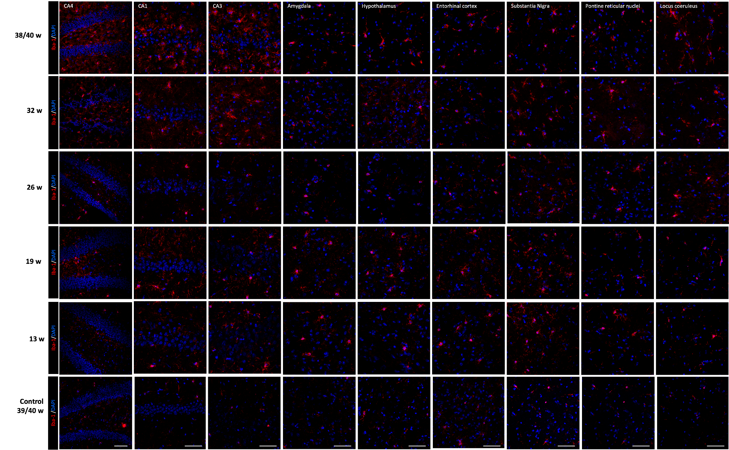Supplementary Figure S7. Age-dependent regional distribution of Iba1 immunoreactivity in PS19NJ mice. Representative immunofluorescence images showing Iba1-positive microglia (red) in CA4, CA1, CA3, amygdala, hypothalamus, entorhinal cortex, substantia nigra, pontine reticular nuclei and locus coeruleus of PS19NJ mice at 13, 19, 26, 32 and 39/40 weeks of age, arranged from top to bottom. Nuclei were counterstained with DAPI (blue). Iba1 immunoreactivity was relatively limited at early ages and became more prominent and widespread at 32 and 39/40 weeks across forebrain, midbrain and brainstem regions. Scale bars, 50 µm.
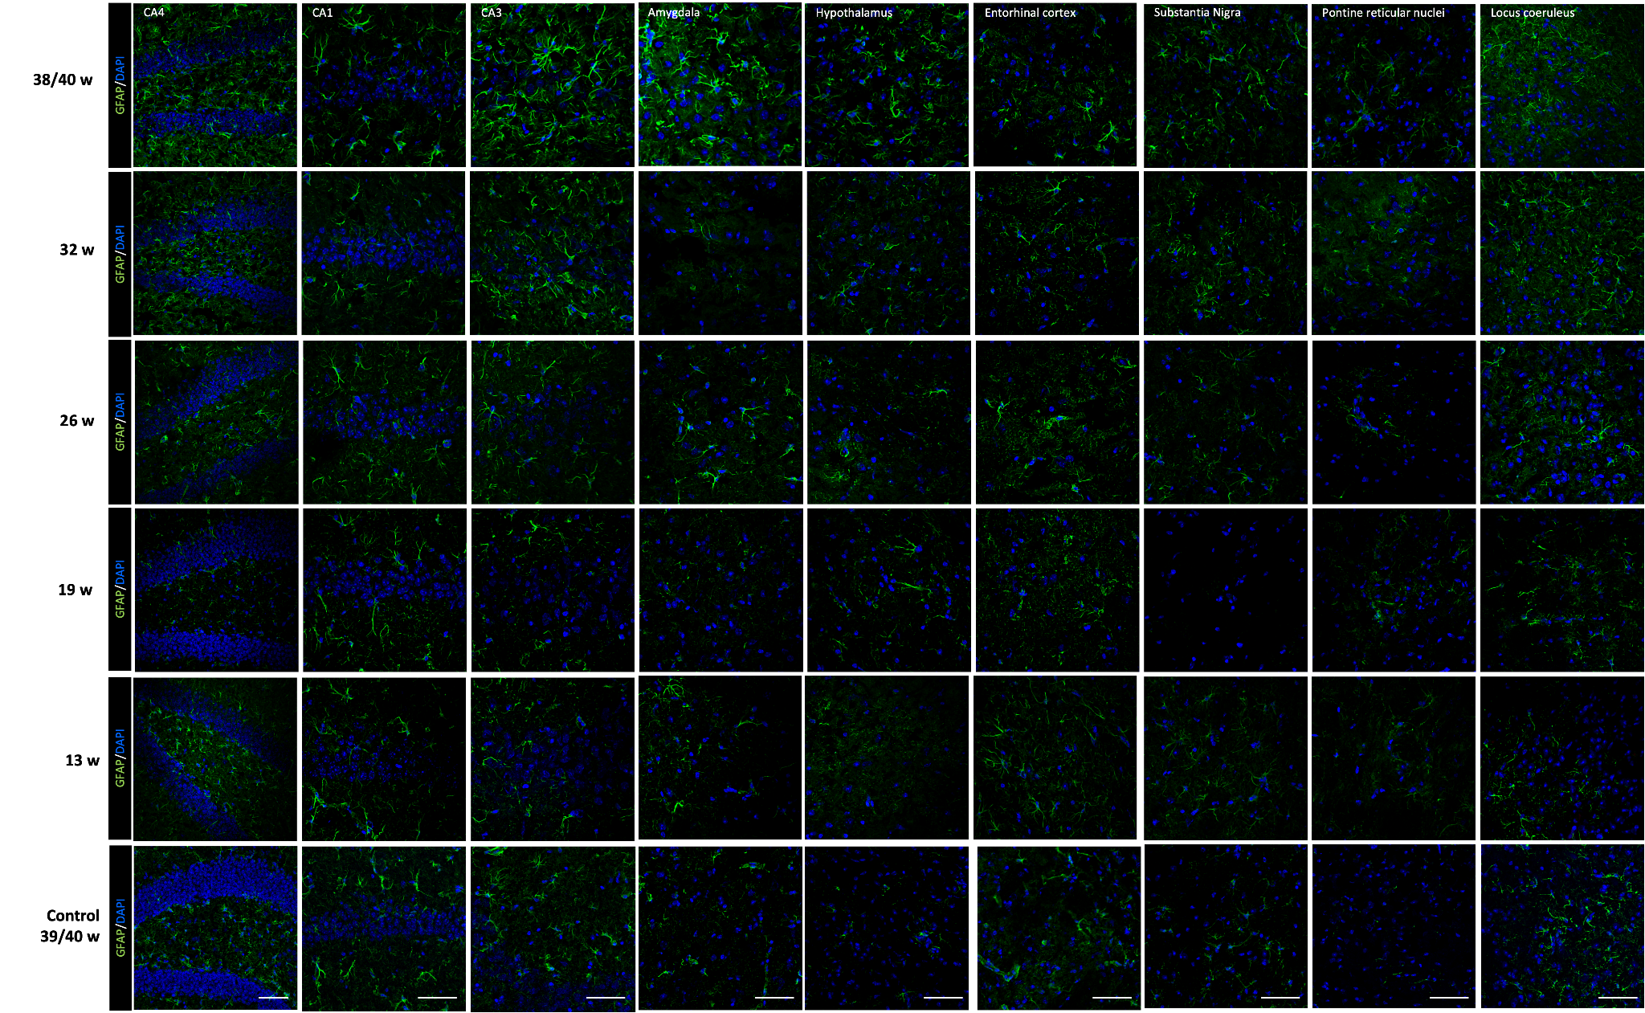Supplementary Figure S8. Age-dependent regional distribution of GFAP immunoreactivity in PS19NJ mice. Representative immunofluorescence images showing GFAP-positive astrocytes (green) in CA4, CA1, CA3, amygdala, hypothalamus, entorhinal cortex, substantia nigra, pontine reticular nuclei and locus coeruleus of PS19NJ mice at 13, 19, 26, 32 and 39/40 weeks of age, arranged from top to bottom. Nuclei were counterstained with DAPI (blue). GFAP immunoreactivity showed regionally heterogeneous changes across age, with more prominent increases in selected hippocampal, limbic and midbrain regions at 32 and 39/40 weeks. Scale bars, 50 µm.

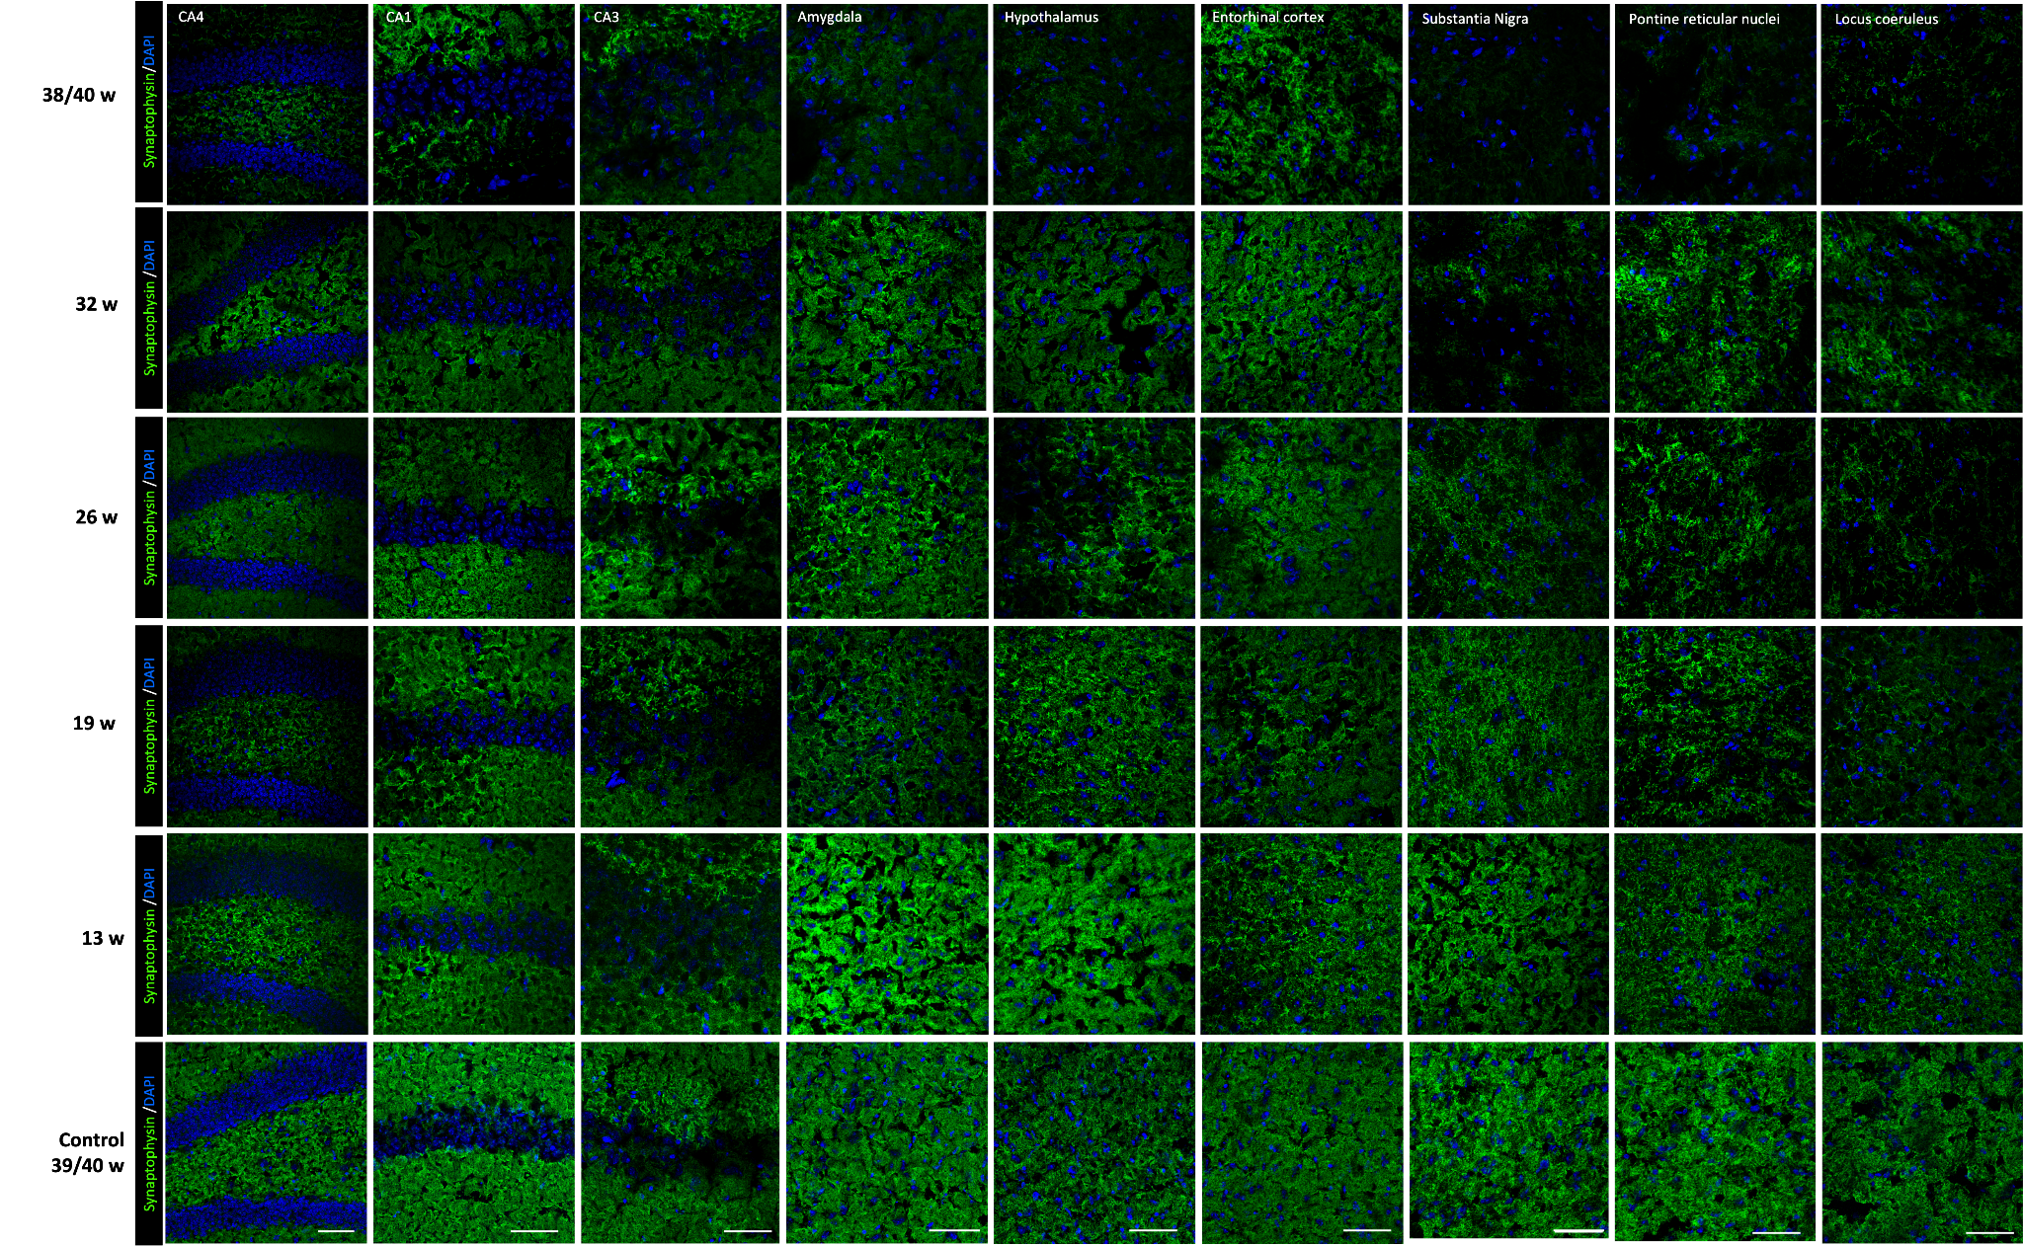
Supplementary Figure S9. Age-dependent regional changes in synaptophysin immunoreactivity in PS19NJ mice. Representative immunofluorescence images showing synaptophysin immunoreactivity (green) in CA4, CA1, CA3, amygdala, hypothalamus, entorhinal cortex, substantia nigra, pontine reticular nuclei and locus coeruleus of PS19NJ mice at 39/40, 32, 26, 19 and 13 weeks of age, arranged from top to bottom. Nuclei were counterstained with DAPI (blue). Synaptophysin labelling was reduced at later ages across multiple hippocampal, cortical, limbic, hypothalamic, midbrain and brainstem regions. Scale bars, 50 µm.

Tables
Table S1. List of primary antibodies utilized.
No | Item Name | Catalogue Number | Company | Host Species
1 | Monoclonal Phospho-tau Ser202, Thr205 (AT8) | MN1020 | Invitrogen | Mouse
2 | Monoclonal Phospho-PHF-tau pThr212, Ser214 (AT100) | MN1060 | Invitrogen | Mouse
3 | Monoclonal Phospho-tau Thr231 (AT180) | MN1040 | Thermo Fisher | Mouse
4 | Polyclonal Phospho-tau Ser396 | 44-752G | Invitrogen | Rabbit
5 | Polyclonal Phospho-tau Ser262 | 44-750G | Invitrogen | Rabbit
6 | Polyclonal Phospho-tau Ser422 | 44-764G | Invitrogen | Rabbit
7 | Polyclonal anti-GFAP | ab7260 | Abcam | Rabbit
8 | Polyclonal anti-Iba1 | 019-19741 | Fujifilm Wako | Rabbit
9 | Monoclonal anti-synaptophysin | ab32127 | Abcam | Rabbit
10 | DC25 (full-length 2N4R tau) |  | AXON Neuroscience SE | Mouse
11 | DC11 (tau 321-384 aa) |  | AXON Neuroscience SE | Mouse

Table S2. Principal age-dependent pathological changes in PS19NJ mice.
Outcome | 13 weeks, median (IQR) | 39/40 weeks, median (IQR) | Age effect | Regional extent | Terminal PS19NJ vs. C57BL/6NJ
Sarkosyl-insoluble AT8, ng/mL | 0.445 (0.000–1.198) | 476.880 (334.105–667.617) | H(4) = 29.18; q < 0.0001 | — | 476.880 vs. 0.000; r= 1.00; q = 0.010
Sarkosyl-insoluble DC25, µg/mL | 0.735 (0.667–0.778) | 2.900 (2.100–3.435) | H(4) = 20.22; q = 0.0014 | — | 2.900 vs. 0.110; r = 1.00; q = 0.010
Phospho-tau IHC: AT8, AT100, AT180, pSer396 and pSer422 | Low across all epitopes | Increased across all epitopes | All q ≤ 1.25 × 10⁻⁴ | 6–11 of 12 regions, depending on epitope | Not assessed
Iba1-positive area, % | 0.687 (0.615–0.776) | 4.401 (3.581–5.399) | H(4) = 23.91; q < 0.0001 | 12 of 12 regions | 4.401% vs. 0.620%; r = 0.94; q = 0.012
GFAP-positive area, % | 3.405 (2.308–4.259) | 4.946 (4.720–5.582) | H(4) = 13.13; q = 0.0106 | 4 of 12 regions | 4.946% vs. 3.436%; r = 0.75; q = 0.048
Synaptophysin-positive area, % | 28.829 (27.343–30.118) | 18.134 (17.206–19.016) | H(4) = 18.00; q = 0.0014 | 11 of 12 regions | 18.134% vs. 31.409%; r = −1.00; q= 0.012

Values are medians with interquartile ranges. Age effects were tested using two-sided Kruskal–Wallis tests. Terminal genotype comparisons used two-sided Mann–Whitney tests, with rank-biserial correlation (r) as the effect size. Reported q values were corrected using the Benjamini–Hochberg procedure within the prespecified test family. For PS19NJ mice, n= 8 per age, except for GFAP, Iba1 and synaptophysin at 32 weeks, for which n = 6. Terminal C57BL/6NJ control groups comprised four animals.

