Additional file 1

Supplementary tables and figures
Development of clinical prediction models for dyssynergic defecation and rectal sensitivity in patients with functional constipation using patient-reported outcomes

Table S1. Complete anorectal manometric characteristics according to dyssynergic defecation status
Characteristic | Non-DD  (n = 32) | DD  (n = 98) | Statistic | P value
Rectal resting pressure (mmHg) | 16.05 (8.75, 25.25) | 15.50 (8.30, 23.80) | Z=-0.014 | 0.989
Anal resting pressure (mmHg) | 73.45 (57.55, 85.10) | 68.00 (49.70, 78.80) | Z=1.116 | 0.264
Anal sphincter length (cm) | 3.60 (2.90, 3.95) | 4.20 (3.40, 4.70) | Z=-3.508 | <0.001
Functional anal sphincter length (cm) | 2.50 (2.20, 3.00) | 2.80 (1.80, 3.60) | Z=-0.392 | 0.695
Distance from sphincter margin to centre (cm) | 1.65 (1.20, 2.20) | 1.80 (1.50, 2.40) | Z=-1.917 | 0.055
Maximum squeeze pressure (mmHg) | 123.10 (89.30, 164.90) | 117.90 (93.00, 148.10) | Z=0.557 | 0.578
Squeeze duration (s) | 13.90 (12.80, 15.20) | 14.75 (13.70, 15.70) | Z=-2.211 | 0.027
Rectal pressure during defecation (mmHg) | 47.45 (39.85, 57.70) | 54.45 (40.70, 68.30) | Z=-1.540 | 0.123
First sensation threshold (mL) | 20.00 (20.00, 37.50) | 30.00 (20.00, 40.00) | Z=-1.148 | 0.251
Desire to defecate threshold (mL) | 60.00 (50.00, 70.00) | 60.00 (50.00, 75.00) | Z=-0.457 | 0.647
Maximum tolerated volume (mL) | 125.00 (100.00, 165.00) | 140.00 (110.00, 180.00) | Z=-1.197 | 0.232

Table S2. Complete anorectal manometric characteristics according to rectal sensory phenotype
Characteristic | Normal  (n = 36) | Hyposensitivity  (n = 40) | Hypersensitivity  (n = 47) | Statistic | P value
Rectal resting pressure (mmHg) | 15.30 (9.10, 24.20) | 17.00 (9.25, 22.55) | 14.90 (7.00, 24.00) | H=0.801 | 0.670
Anal resting pressure (mmHg) | 65.00 (46.15, 76.25) | 73.85 (59.20, 81.85) | 65.60 (52.30, 87.50) | H=2.751 | 0.253
Anal sphincter length (cm) | 3.80 (3.15, 4.60) | 4.15 (3.20, 4.80) | 3.90 (3.40, 4.30) | H=0.733 | 0.693
Functional anal sphincter length (cm) | 2.40 (2.05, 3.35) | 2.85 (1.90, 3.65) | 2.80 (2.00, 3.30) | H=0.880 | 0.644
Distance from sphincter margin to centre (cm) | 1.75 (1.45, 2.40) | 1.70 (1.45, 2.25) | 1.70 (1.50, 2.30) | H=0.051 | 0.975
Maximum squeeze pressure (mmHg) | 120.10 (86.75, 173.75) | 121.45 (99.20, 140.20) | 117.00 (91.00, 148.10) | H=0.098 | 0.952
Squeeze duration (s) | 14.00 (13.30, 15.20) | 15.30 (13.90, 16.35) | 13.90 (13.10, 15.20) | H=7.334 | 0.026
Rectal pressure during defecation (mmHg) | 51.80 (41.30, 58.45) | 54.60 (39.90, 66.40) | 52.40 (40.60, 64.50) | H=0.754 | 0.686
First sensation threshold (mL) | 20.00 (20.00, 30.00) | 40.00 (40.00, 50.00) | 20.00 (20.00, 30.00) | H=64.923 | <0.001
Desire to defecate threshold (mL) | 60.00 (50.00, 70.00) | 80.00 (70.00, 100.00) | 50.00 (40.00, 50.00) | H=75.328 | <0.001
Maximum tolerated volume (mL) | 140.00 (130.00, 175.00) | 180.00 (140.00, 190.00) | 110.00 (90.00, 140.00) | H=42.363 | <0.001

Table S3. Univariable logistic regression analyses for all candidate predictors

HR-ARM-defined DD
Predictor | n | OR | 95% CI | P value
Male versus female | 130 | 0.926 | 0.405–2.116 | 0.855
Age, per year | 130 | 1.042 | 1.014–1.072 | 0.004
BMI, per kg/m² | 130 | 0.975 | 0.851–1.116 | 0.711
Smoking history | 130 | 0.722 | 0.281–1.854 | 0.498
Alcohol use | 130 | 1.133 | 0.382–3.364 | 0.822
Hypertension | 130 | 0.920 | 0.364–2.324 | 0.860
Family history of similar constipation | 130 | 1.820 | 0.741–4.468 | 0.192
Childbirth history as coded | 130 | 1.689 | 0.707–4.033 | 0.238
Diabetes | 130 | 3.148 | 0.686–14.449 | 0.140
Bristol score, per point | 130 | 0.496 | 0.330–0.745 | <0.001
Constipation duration, per year | 130 | 1.018 | 0.920–1.126 | 0.736
PAC-SYM total score, per point | 130 | 9.154 | 2.107–39.777 | 0.003
PAC-SYM stool score, per point | 130 | 4.417 | 2.050–9.516 | <0.001
PAC-SYM rectal score, per point | 130 | 0.629 | 0.309–1.280 | 0.201
PAC-SYM abdominal score, per point | 130 | 1.108 | 0.557–2.204 | 0.771
PAC-QOL total score, per point | 130 | 0.630 | 0.319–1.243 | 0.183
Anxiety (SAS-positive) | 130 | 3.269 | 1.372–7.785 | 0.007
Depression (SDS-positive) | 130 | 1.820 | 0.741–4.468 | 0.192

Rectal hypersensitivity
Predictor | n | OR | 95% CI | P value
Male versus female | 83 | 0.594 | 0.239–1.477 | 0.262
Age, per year | 83 | 1.010 | 0.982–1.039 | 0.481
BMI, per kg/m² | 83 | 0.941 | 0.808–1.097 | 0.438
Smoking history | 83 | 1.351 | 0.441–4.145 | 0.599
Alcohol use | 83 | 1.184 | 0.379–3.697 | 0.771
Hypertension | 83 | 0.981 | 0.327–2.947 | 0.973
Family history of similar constipation | 83 | 1.032 | 0.412–2.587 | 0.946
Childbirth history as coded | 83 | 1.066 | 0.439–2.591 | 0.887
Diabetes | 83 | 1.610 | 0.374–6.930 | 0.523
Bristol score, per point | 83 | 0.996 | 0.666–1.490 | 0.986
Constipation duration, per year | 83 | 1.079 | 0.948–1.227 | 0.250
PAC-SYM total score, per point | 83 | 0.553 | 0.119–2.580 | 0.451
PAC-SYM stool score, per point | 83 | 0.260 | 0.100–0.671 | 0.005
PAC-SYM rectal score, per point | 83 | 0.796 | 0.358–1.770 | 0.576
PAC-SYM abdominal score, per point | 83 | 3.835 | 1.490–9.869 | 0.005
PAC-QOL total score, per point | 83 | 3.420 | 1.483–7.890 | 0.004
Anxiety (SAS-positive) | 83 | 3.529 | 1.416–8.798 | 0.007
Depression (SDS-positive) | 83 | 1.481 | 0.601–3.653 | 0.393

Rectal hyposensitivity
Predictor | n | OR | 95% CI | P value
Male versus female | 76 | 0.933 | 0.373–2.333 | 0.883
Age, per year | 76 | 1.052 | 1.016–1.089 | 0.005
BMI, per kg/m² | 76 | 0.943 | 0.805–1.104 | 0.463
Smoking history | 76 | 1.452 | 0.460–4.578 | 0.525
Alcohol use | 76 | 1.061 | 0.320–3.512 | 0.923
Hypertension | 76 | 1.571 | 0.535–4.620 | 0.411
Family history of similar constipation | 76 | 1.200 | 0.467–3.082 | 0.705
Childbirth history as coded | 76 | 0.846 | 0.333–2.152 | 0.726
Diabetes | 76 | 3.667 | 0.921–14.599 | 0.065
Bristol score, per point | 76 | 0.292 | 0.149–0.574 | <0.001
Constipation duration, per year | 76 | 1.070 | 0.944–1.213 | 0.291
PAC-SYM total score, per point | 76 | 2.669 | 0.739–9.636 | 0.134
PAC-SYM stool score, per point | 76 | 4.889 | 1.948–12.269 | <0.001
PAC-SYM rectal score, per point | 76 | 0.493 | 0.211–1.150 | 0.102
PAC-SYM abdominal score, per point | 76 | 0.656 | 0.301–1.431 | 0.289
PAC-QOL total score, per point | 76 | 0.997 | 0.458–2.171 | 0.995
Anxiety (SAS-positive) | 76 | 2.000 | 0.789–5.067 | 0.144
Depression (SDS-positive) | 76 | 0.963 | 0.369–2.510 | 0.938

Table S4. Definitions and coding of candidate predictors
Predictor | Analysis variable | Definition or coding | Unit or qualification
Sex | gender_male | Male = 1; female = 0 | Per category
Age | age | Age at assessment | Years
Body mass index | bmi | Body weight divided by squared height | kg/m²
Smoking history | smoking | Yes = 1; no = 0 | Definition of exposure to confirm
Alcohol use | drinking | Yes = 1; no = 0 | Definition of exposure to confirm
Hypertension | hypertension | History present = 1; absent = 0 | Diagnostic definition to confirm
Family history | family_history | Similar constipation in family = 1; absent = 0 | Relationship definition to confirm
Childbirth history | delivery | Yes = 1; no = 0; men coded 0 in modelling data | Mode of delivery and coding to confirm
Diabetes | diabetes | History present = 1; absent = 0 | Diagnostic definition to confirm
Stool form | bristol | Bristol Stool Form Scale score, entered numerically | Per one-point increase
Constipation duration | disease_year | Recorded duration of constipation | Years
PAC-SYM total | pac_sym_std | Raw total divided by 12 | Item mean; per point
PAC-SYM stool | stool_std | Raw stool-domain total divided by 5 | Item mean; per point
PAC-SYM rectal | rectal_std | Raw rectal-domain total divided by 3 | Item mean; per point
PAC-SYM abdominal | abdominal_std | Raw abdominal-domain total divided by 4 | Item mean; per point
PAC-QOL total | pac_qol_std | Raw total divided by 28 | Item mean; per point
Anxiety status | sas_positive | SAS standard score ≥50 = 1; <50 = 0 | Negative status is the reference
Depression status | sds_positive | SDS standard score ≥53 = 1; <53 = 0 | Negative status is the reference

Figure S1. LASSO variable selection for the dyssynergic defecation model
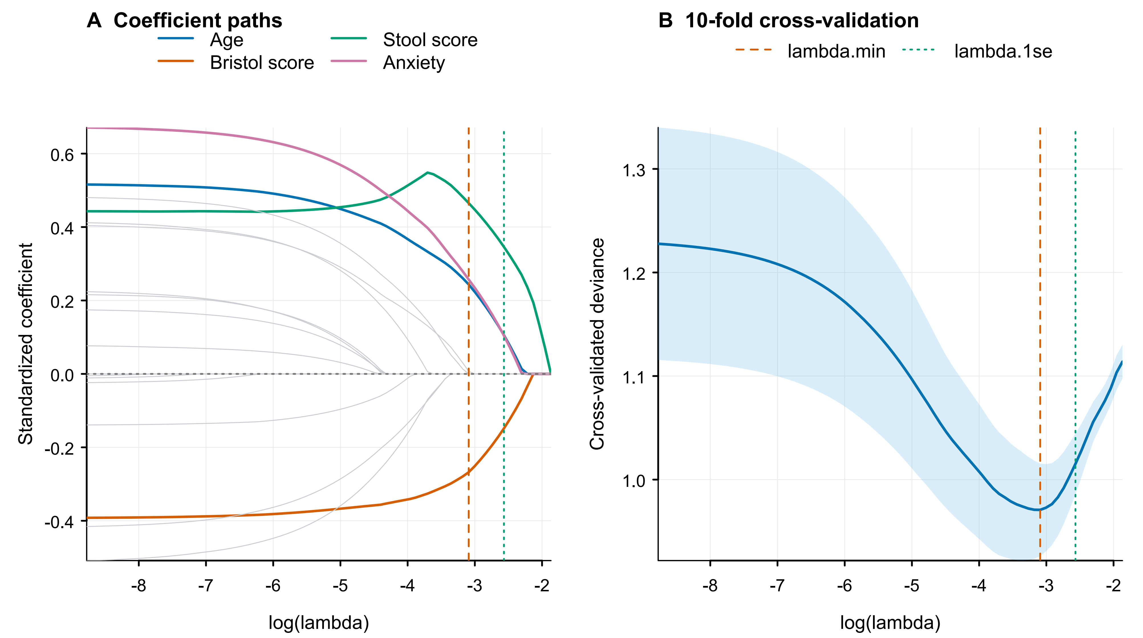
A, coefficient paths; highlighted variables correspond to the final predictors. B, 10-fold cross-validation curve. Shading indicates ±1 standard error of the mean deviance. Dashed orange and dotted green vertical lines mark lambda.min and lambda.1se, respectively. The selected penalty was lambda.1se. The analysis included 130 participants. Stool and abdominal scores refer to the corresponding PAC-SYM domains; PAC-QOL score refers to its total item-mean score. Anxiety is SAS-positive status.

Figure S2. LASSO variable selection for the rectal hypersensitivity model
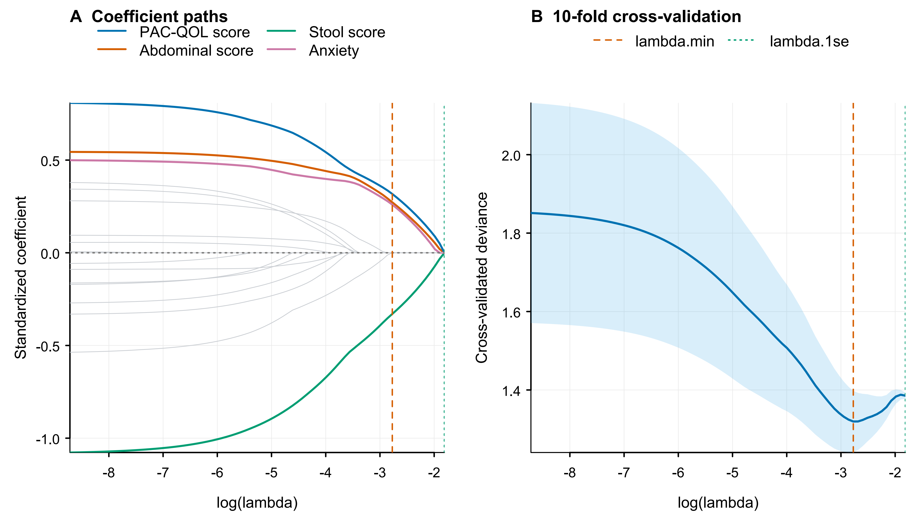
A, coefficient paths; highlighted variables correspond to the final predictors. B, 10-fold cross-validation curve. Shading indicates ±1 standard error of the mean deviance. Dashed orange and dotted green vertical lines mark lambda.min and lambda.1se, respectively. The selected penalty was lambda.min. The analysis included 83 participants. Stool and abdominal scores refer to the corresponding PAC-SYM domains; PAC-QOL score refers to its total item-mean score. Anxiety is SAS-positive status.

Figure S3. LASSO variable selection for the rectal hyposensitivity model
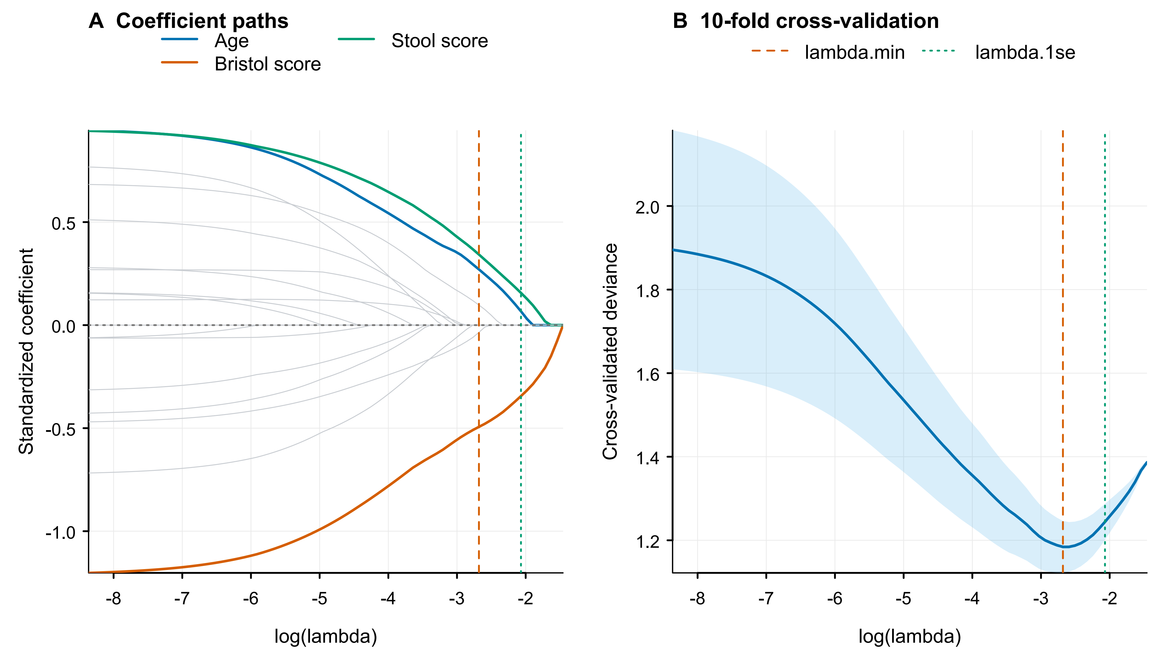
A, coefficient paths; highlighted variables correspond to the final predictors. B, 10-fold cross-validation curve. Shading indicates ±1 standard error of the mean deviance. Dashed orange and dotted green vertical lines mark lambda.min and lambda.1se, respectively. The selected penalty was lambda.1se. The analysis included 76 participants. Stool and abdominal scores refer to the corresponding PAC-SYM domains; PAC-QOL score refers to its total item-mean score. Anxiety is SAS-positive status.

