Additional file 1
Tables S1–S5 and Figs. S1–S3. Numbers are taken from 03_结果表 and match the main manuscript.

Supplementary Table S1. Cohort flow
MIMIC-IV v3.1 | n | eICU-CRD 2.0 | n
ICU stays in the source file | 94,458 | ICU admissions in the source file | 200,859
Hospitalizations with both HF and AF | 37,517 | Analytic cohort | 2,588
ICU stays in those hospitalizations | 13,790 | In-hospital deaths | 414
Age ≥18 years | 13,790
First ICU stay | 9,001
Stay ≥24 h (analytic cohort) | 7,562
In-hospital deaths | 1,222
Mortality | 16.2% | Mortality | 16.0%
The eICU-CRD export does not store the counts removed between the source file and the analytic cohort. MIMIC-IV diagnosis codes: HF, ICD-9 428.* or ICD-10 I50.; AF, ICD-9 427.31 or ICD-10 I48..

Supplementary Table S2. Per-1-SD associations of the three axes
Rubin-pooled across m = 10 imputations. Age- and sex-adjusted models are not unadjusted. Fully adjusted models add the axis to the 43-variable reference model.
Cohort | Model | Variable | OR per SD | 95% CI | P
MIMIC-IV | Age and sex | PNI | 0.785 | 0.712–0.865 | <0.001
MIMIC-IV | Age and sex | log NLR | 1.296 | 1.159–1.451 | <0.001
MIMIC-IV | Age and sex | dLCR | 0.821 | 0.773–0.872 | <0.001
MIMIC-IV | Fully adjusted | PNI | 0.953 | 0.784–1.157 | 0.624
MIMIC-IV | Fully adjusted | log NLR | 1.087 | 0.948–1.246 | 0.233
MIMIC-IV | Fully adjusted | dLCR | 0.791 | 0.734–0.853 | <0.001
eICU-CRD | Age and sex | PNI | 0.799 | 0.685–0.931 | 0.004
eICU-CRD | Age and sex | log NLR | 1.227 | 1.067–1.413 | 0.004
eICU-CRD | Age and sex | dLCR | 0.894 | 0.787–1.015 | 0.084
eICU-CRD | Fully adjusted | PNI | 1.039 | 0.662–1.630 | 0.868
eICU-CRD | Fully adjusted | log NLR | 1.119 | 0.848–1.477 | 0.428
eICU-CRD | Fully adjusted | dLCR | 0.894 | 0.772–1.035 | 0.132
Source: axes_association.csv. Odds ratios are given to three decimals here and rounded to two decimals in the main text.

Supplementary Table S3. Reclassification on the MIMIC-IV test set
Comparison is the continuous three-axis specification (A5) versus the reference model, not the 0–3 score. Categorical net reclassification uses cuts at 10% and 20% predicted risk.
Algorithm | NRI categorical | 95% CI | NRI continuous | 95% CI | IDI | 95% CI
Logistic | −0.0005 | −0.031 to 0.031 | 0.014 | −0.089 to 0.118 | 0.0094 | 0.0039 to 0.0157
Random forest | 0.019 | −0.015 to 0.050 | 0.0018 | −0.107 to 0.109 | 0.0013 | −0.0005 to 0.0032
Source: nri_idi.csv.

Supplementary Table S4. Coverage inside the analysis window (−24 h to +48 h)
Variable | MIMIC-IV | eICU-CRD
PNI | 28.8% (2,173 / 7,562) | 61.3% (1,587 / 2,588)
Albumin | 46.4% | 73.3%
NLR | 52.4% | 76.4%
dLCR (two lactate values) | 60.5% (4,559 / 7,562) | 23.8% (617 / 2,588)
Lactate, at least one value | 76.6% | 44.6%
All three axes observed | 20.9% (1,580 / 7,562) | 17.3% (448 / 2,588)
Sources: missingness_mimic.csv, coverage_eicu.csv, score_card.csv.

Supplementary Table S5. Largest coefficients in the A5 model, one imputation
Fit on the first imputed MIMIC-IV data set of the continuous three-axis model. These are not Rubin-pooled and are not the reference-model coefficients. Shown for description only.
Variable | Coefficient per SD | OR per SD
Urine output, 24 h | −0.345 | 0.708
Age | 0.310 | 1.363
Mechanical ventilation | 0.304 | 1.355
Urea nitrogen | 0.301 | 1.351
Chloride | −0.292 | 0.747
Red-cell distribution width | 0.284 | 1.329
Glasgow Coma Scale | −0.255 | 0.775
Maximum heart rate | 0.205 | 1.227
dLCR | −0.202 | 0.817
Albumin | −0.171 | 0.843
Source: coefficients_final.csv.

Figure legends
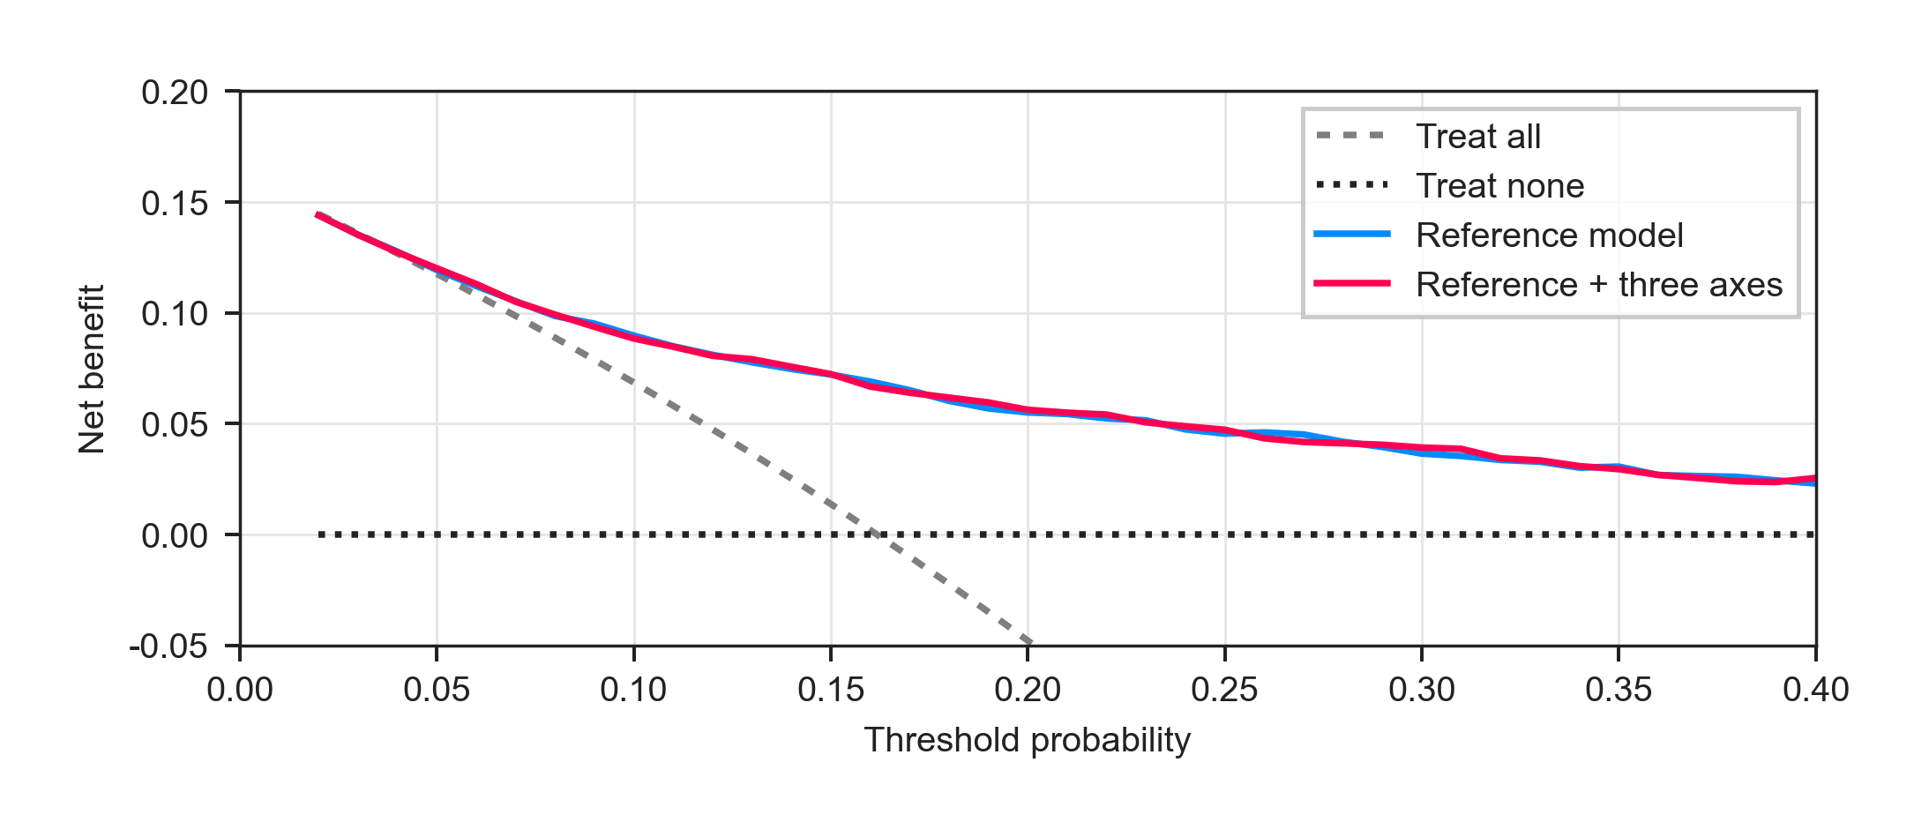
Fig. S1 Decision curve on the MIMIC-IV test set.
Net benefit of the reference model and of the reference model plus the three continuous axes, against treat-all and treat-none. The vertical scale stops at −0.05 so the model curves remain readable; treat-all is more negative above a threshold of about 0.20.
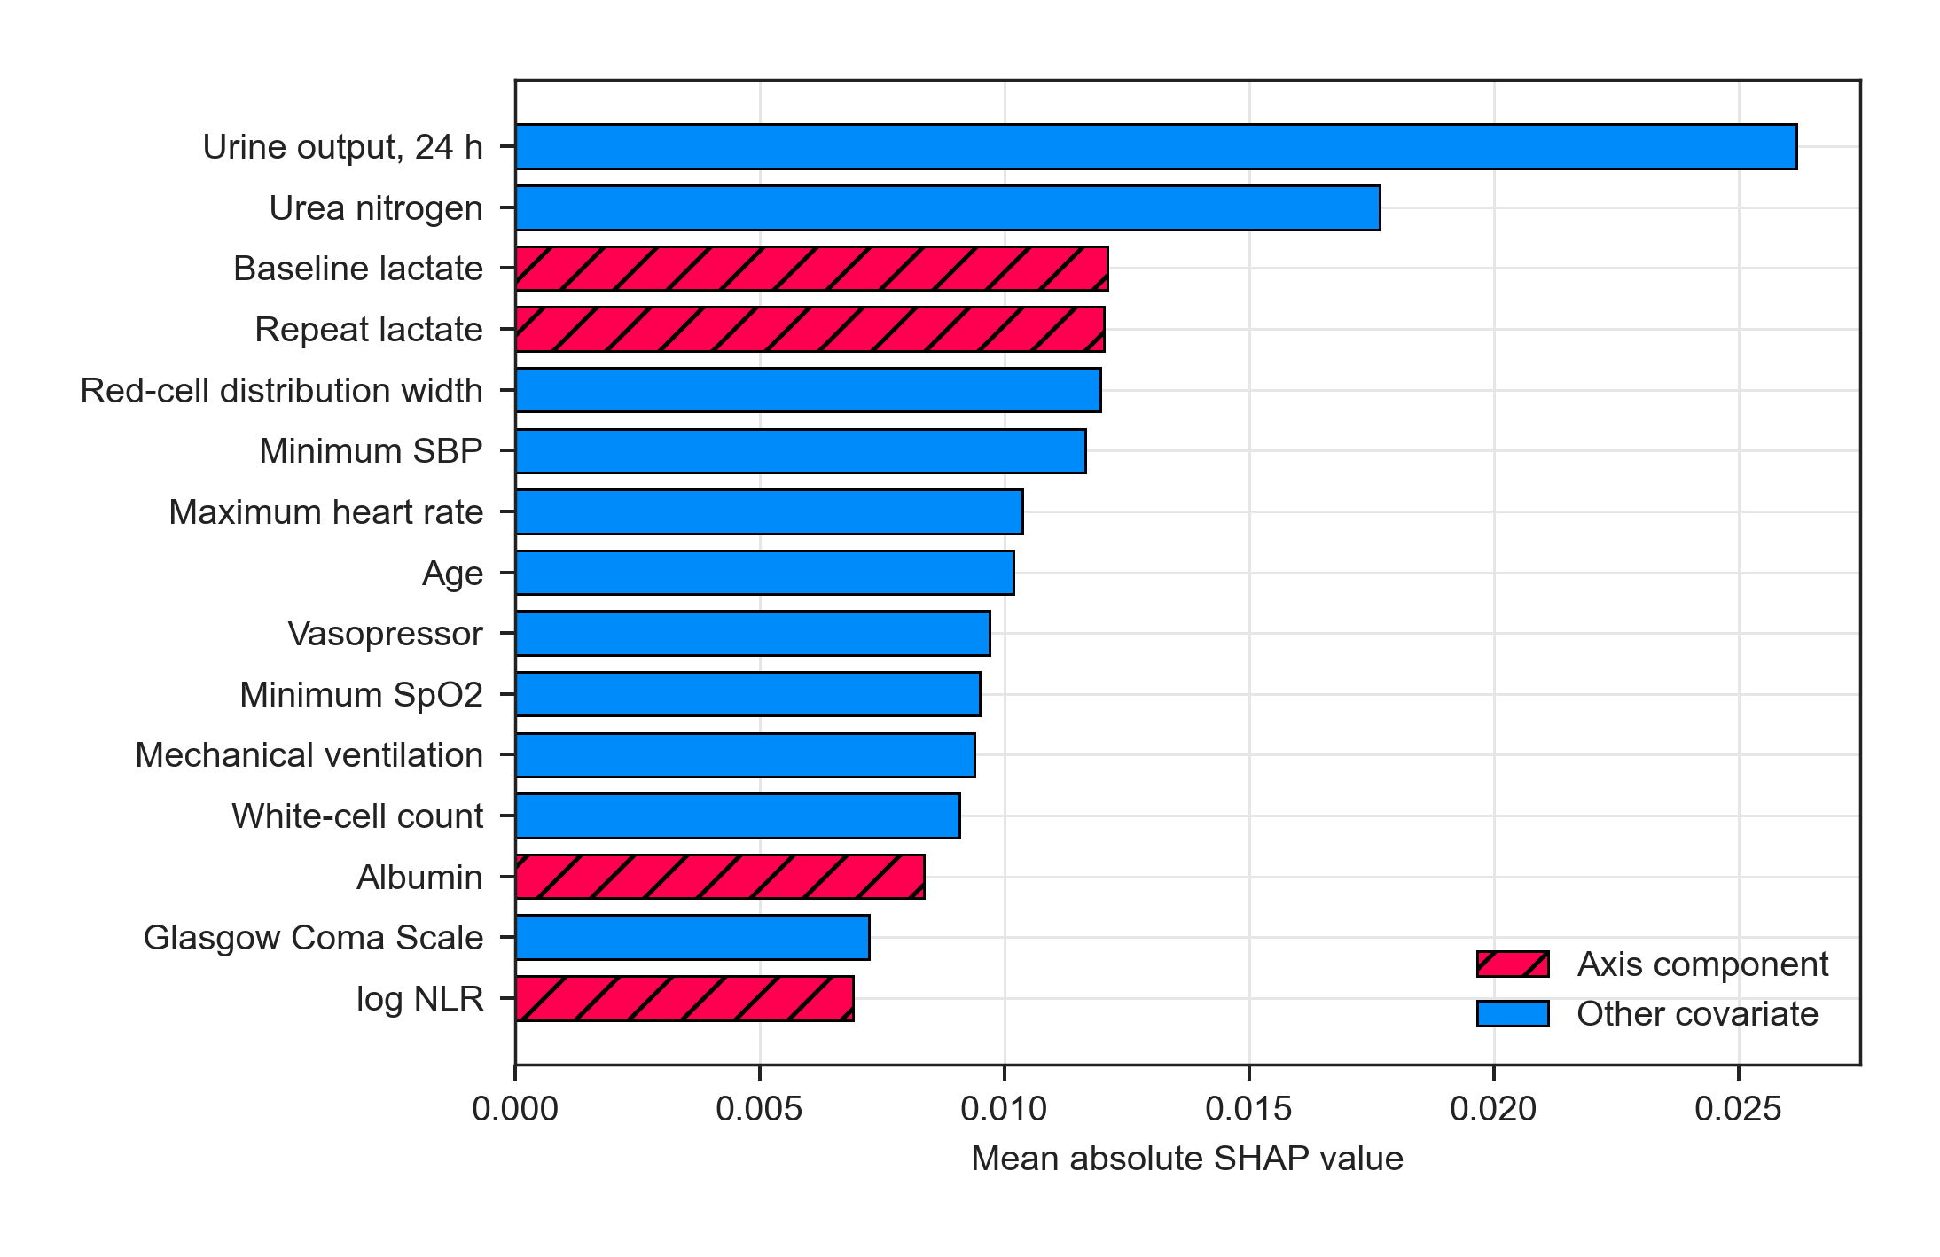
Fig. S2 Mean absolute SHAP values in MIMIC-IV.
The fifteen largest mean absolute values are shown. Hatched bars are axis components that fall inside this ranking (baseline lactate, repeat lactate, albumin, log NLR). Values come from a random forest of the A5 specification, fit on the first imputed data set and a subsample of 800 stays. They are not Rubin-pooled. Raw SHAP values for a beeswarm plot were not archived.
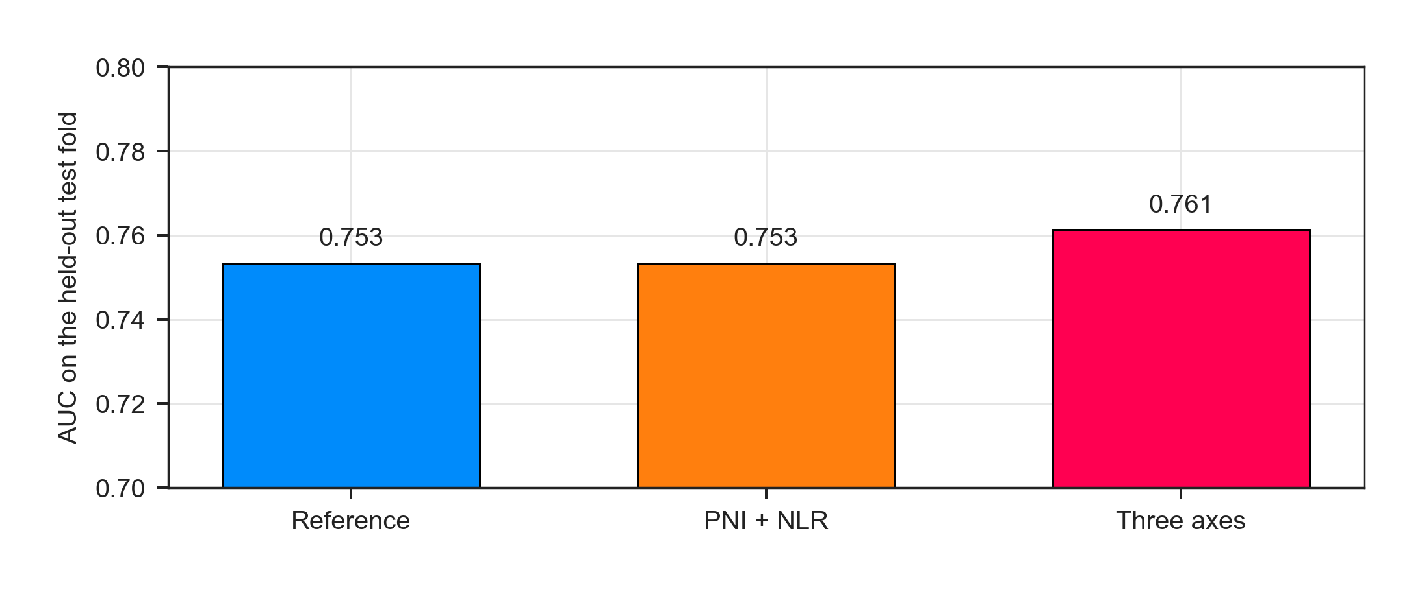
Fig. S3 Held-out AUC when A5 covariates are complete.
n = 1,456 stays, 363 deaths. This subset is not the 1,580 stays with the three axes observed. The vertical axis starts at 0.70.

