Supporting Information
Constructed a stable coordination polymer for highly efficient and selective capture of thorium
Qing-Hua Hu^{a,1}*, Ye-Liang Gao^{a,1}, Jin Guoª, and Li-Min Liu^{a,b}**
ª College of Chemistry and Chemical Engineering, Jinggangshan University, Ji’an, China
^{b} College of Chemistry and Materials, Jiangxi Normal University, 99 Ziyang Road, Nanchang, 330022, China
*Corresponding authors. ** Corresponding author.
E-mail: huqinghua@jgsu.edu.cn, llm24@126.com.
Hu Qinghua and Gao Yeliang made the same contribution to this work.

Contents
1. Experimental Section
2. Supplementary Figures
3. Supplementary Tables
4. Supplementary References
1. Experimental Section
1.1 Characterizations and Methods
Materials. All reagents and solvents used in the experiment were of analytical grade and used directly without further purification. Nickel(II) acetate tetrahydrate (Ni(OAc)₂·4H₂O, 98%) was purchased from Anhui Senmei Technology Co., Ltd. (3Achem); 4-trifluoromethylnicotinic acid (Htfc, 98%) was purchased from Shanghai Titan Scientific Co., Ltd. (damas-beta); other metal nitrates were obtained from Shanghai Titan Scientific Co., Ltd. All were commercial products and used as received; methanol (99.5%) was purchased from Xilong Scientific Co., Ltd.; deionized water was prepared in the laboratory. All reagents were of analytical grade and used as received without further purification.
Synthesis of Ni-tfc-CP. Nickel(II) acetate tetrahydrate (Ni(OAc)₂·4H₂O, 0.1 mmol, 24.9 mg) and 4-trifluoromethylnicotinic acid (Htfc, 0.1 mmol, 19.1 mg) were dissolved in a mixed solvent of 3 mL deionized water and 1 mL methanol, and stirred at room temperature until completely dissolved. The mixed solution was transferred to a stainless steel autoclave with a Teflon liner, heated to 140 °C and reacted at a constant temperature for 72 h, then cooled to room temperature by programmed cooling (24 h). After the reaction, the green transparent block crystals were obtained by filtration, washed several times with deionized water and methanol, and dried in an oven at 75 °C to obtain the target coordination polymer Ni-tfc-CP.
Instruments. The pH values in the experiment were measured using a PHS-3E pH meter (Shanghai Leici). X-ray photoelectron spectroscopy (XPS) measurements were performed on an X-ray photoelectron spectrometer. The content of thorium (Th) in the samples was quantitatively analyzed by inductively coupled plasma emission spectroscopy (ICP). The surface morphology and microstructure of the samples were characterized and the elemental distribution was analyzed by scanning electron microscopy (SEM) equipped with an energy-dispersive X-ray spectroscopy (EDS) detector. Thermal stability was tested by thermogravimetric analysis (TGA) under a nitrogen atmosphere. Fourier transform infrared spectroscopy (FT-IR) was recorded on an infrared spectrometer. The crystal phase structure was characterized by X-ray powder diffraction (PXRD). Adsorption experiments were carried out in a TOS-100 constant temperature shaker (Titan). Sample drying was performed using a BPG-9056A precision blast drying oven.
1.2 Sorption experiments
The aqueous solutions of Th(IV) with different concentrations were obtained by
diluting the stock ions solution with the proper amount of ultra-pure water unless otherwise indicated. The pH levels of the solutions were adjusted by HNO3 or NaOH aqueous solution. The concentrations of Th(IV) during all the experiments were detected by ICP-MS for extra low concentrations. All the adsorption experiments were performed at ambient conditions.
Effect of Initial pH. The effect of initial solution pH on the adsorption performance of Ni-tfc-CP toward Th(IV) was investigated over the pH range of 2.0–4.5 (2.0, 2.5, 3.0, 3.5, 4.0, and 4.5). In each batch experiment, 10 mg of Ni-tfc-CP was added to 10 mL of Th(IV) solution (20 ppm). The mixture was shaken at 300 rpm for 24 h to reach adsorption equilibrium. After centrifugation or filtration, the residual concentration of Th(IV) in the supernatant was measured by inductively coupled plasma optical emission spectrometry (ICP-OES) or inductively coupled plasma mass spectrometry (ICP-MS).
Th (IV) Adsorption Isotherm Experiments.Adsorption experiments were carried out according to the reported method. In this work, a 1000 mg/L standard Th(IV) solution was used as the stock solution, and Th(IV) solutions of other concentrations were diluted from this stock solution. The pH of the solution was adjusted with aqueous HNO₃ (0.1 M) or NaOH (0.1 M) solution. Th(IV) adsorption tests were conducted by adding an appropriate amount of Ni-tfc-CP to Th(IV) solutions with different initial concentrations at pH 4.0, followed by shaking at 300 rpm. After reaching equilibrium, the treated solution was filtered through a 0.22 μm membrane filter, and the remaining Th(IV) content was collected and analyzed by ICP-MS. The adsorption capacity was calculated using Equation (1). The theoretical maximum adsorption capacity can be calculated by the Langmuir and Freundlich adsorption isotherms, as shown in Equations (2) and (3).
$q_{e}=\frac{\left(c_{0}-c_{e}\right)×V}{m}$ (1)

$\frac{{\text{C}}_{\text{e}}}{{\text{q}}_{\text{e}}}\text{=}\frac{\text{1}}{{\text{q}}_{\text{m}}{\text{k}}_{\text{L}}}\text{+}\frac{{\text{C}}_{\text{e}}}{{\text{q}}_{\text{m}}}$ (2)

$lnq_{e}=\ln{k_{F}}+\frac{1}{n}\ln{C_{e}}$ (3)
where V is the volume of the treated solution (L), m is the dosage of the adsorbent (g), C₀ is the initial concentration of Th(IV) (mg/L), C_{e} is the equilibrium concentration of Th(IV) (mg/L), q_{e} (mg/g) is the equilibrium adsorption capacity, q_{m} (mg/g) is the maximum adsorption capacity, k_{L}(L mg⁻¹) is a constant indirectly related to the adsorption capacity and adsorption energy, which reflects the affinity between the adsorbate and the adsorbent, and k_{F} and n are the Freundlich constants related to the adsorption capacity and adsorption intensity, respectively.
Th (IV) Adsorption Kinetics Experiments. Kinetic experiments were carried out under specific conditions: the initial concentration of the thorium solution was 25 mg/L, and the pH was adjusted to 4.0. 25 mg of the adsorbent was added to 25 mL of Th(IV) solution and shaken at 300 rpm for set times (5, 10, 20, 30, 40, 50, 60 and 120 min). Subsequently, the solution was filtered through a 0.22 μm organic nylon membrane, and the Th(IV) concentration was determined by ICP-MS. The adsorption capacity at a given contact time (q_{t}, mg/g) was calculated by Equation (4). Simplified kinetic models (pseudo-first-order and pseudo-second-order kinetic models) were used to evaluate the adsorption kinetic behavior, described by Equations (5) and (6), respectively.
${\text{q}}_{\text{t}}\text{=}\frac{\text{(}{\text{C}}_{\text{0}}\text{-}{\text{C}}_{\text{t}}\text{)}}{\text{m}}\text{×}\text{V}$ (4)

$\text{ln}{\text{(}}{\text{q}}_{\text{e}}\text{-}{\text{q}}_{\text{t}}\text{)=}\text{ln}{{\text{q}}_{\text{e}}}\text{-}{\text{k}}_{\text{1}}\text{t}$ (5)

$\frac{\text{t}}{{\text{q}}_{\text{t}}}\text{=}\frac{\text{1}}{{\text{k}}_{\text{2}}{\text{q}}_{\text{e}}^{\text{2}}}\text{+}\frac{\text{t}}{{\text{q}}_{\text{e}}}$ (6)

where q_{e} is the adsorption capacity at equilibrium (mg/g), q_{t} is the adsorption capacity at time t (mg/g); k₁(min⁻¹) is the pseudo-first-order kinetic rate constant, and k₂ (g/(mg·min)) is the pseudo-second-order kinetic rate constant.
Adsorption Selectivity Experiments. In the adsorption selectivity experiment, 10 mg of Ni-tfc-CP adsorbent was added to 10 mL of aqueous solution at pH 4.0 containing 5 ppm Th(IV) and 5 ppm of each competing metal ion, including Na(I), Mg(II), Al(III), K(I), Ca(II), Cr(III), Mn(II), Fe(III), Co(II), Cu(II), Zn(II), Pd(II), Cd(II), Hg(II), Pb(II), La(III), Ce(III), Pr(III), Nd(III), Sm(III), Eu(III), Tb(III), Dy(III), Ho(III), Er(III), Lu(III). The mixture was shaken at 300 rpm for 12 h, then separated by a 0.22 μm nylon membrane filter, and the residual concentration of each metal ion in the supernatant was determined by inductively coupled plasma mass spectrometry (ICP-MS). The adsorption selectivity of Ni-tfc-CP for Th(IV) was evaluated by calculating the distribution coefficient (K_{d}).
$K_{d}=\frac{C_{o}-C_{e}}{C_{e}}×\frac{V}{m}$ (7)

Recyclability Test. Adsorption-desorption cycle experiments were used to evaluate the reusability of Ni-tfc-CP, with a total of 5 cycles performed. In each cycle, 100 mg of the adsorbent was mixed with 100 mL of 25 ppm Th(IV) solution and shaken at 300 rpm for 12 h to complete adsorption; after adsorption, the adsorbent was eluted and regenerated with 0.1 mol/L Na₂CO₃ solution, washed with deionized water, dried and used for the next cycle. The reusability of the material was evaluated by determining the adsorption capacity in each cycle.

- Supplementary Figures
Fig. S1. SEM photo of Ni-tfc-CP.

Fig. S2. PXRD patterns of Ni-tfc-CP after immersion in aqueous solutions with different pH values ranging from 2 to 13.

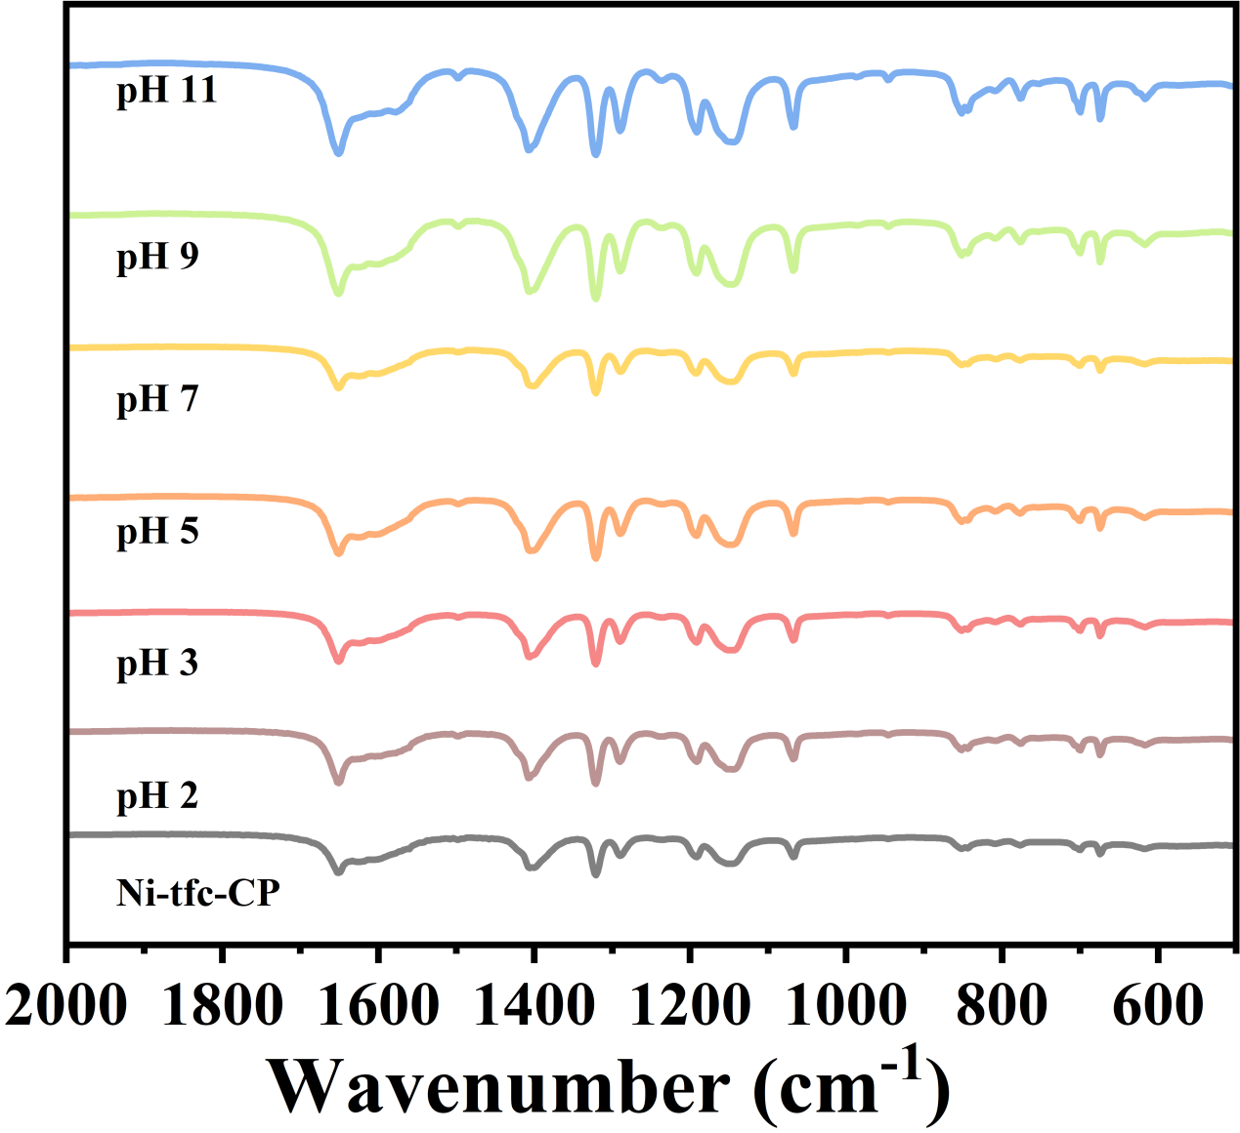
Fig. S3. FT-IR of Ni-tfc-CP after immersion in aqueous solutions with different pH values ranging from 2 to 11.
.
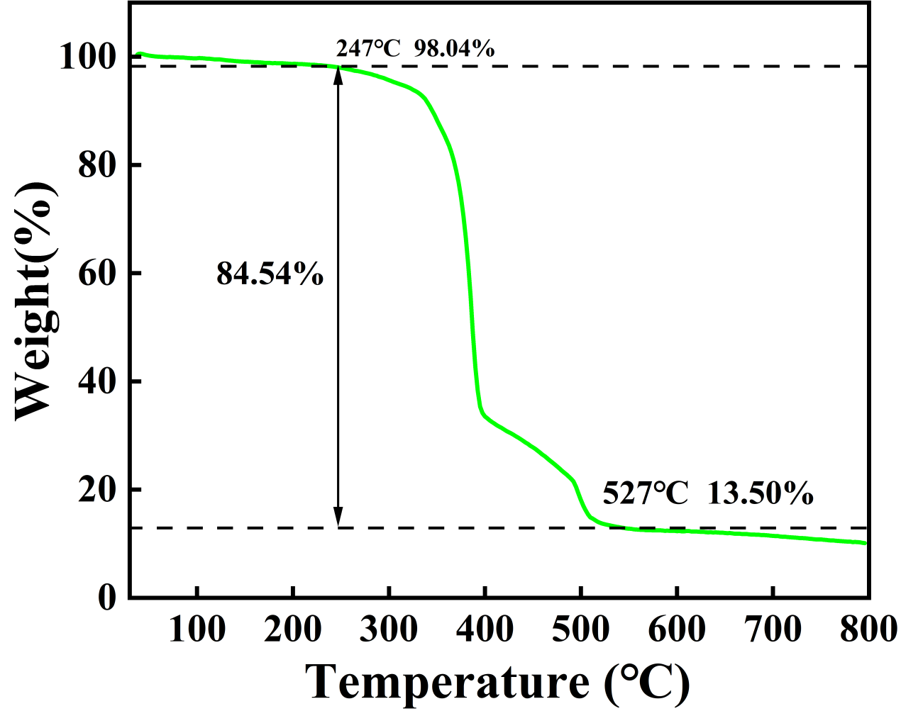
Fig. S4. TGA curve of Ni-tfc-CP under N₂ atmosphere.

Fig. S5. The elemental distribution mappings of Ni-tfc-CP before and after adsorbing Th(IV).

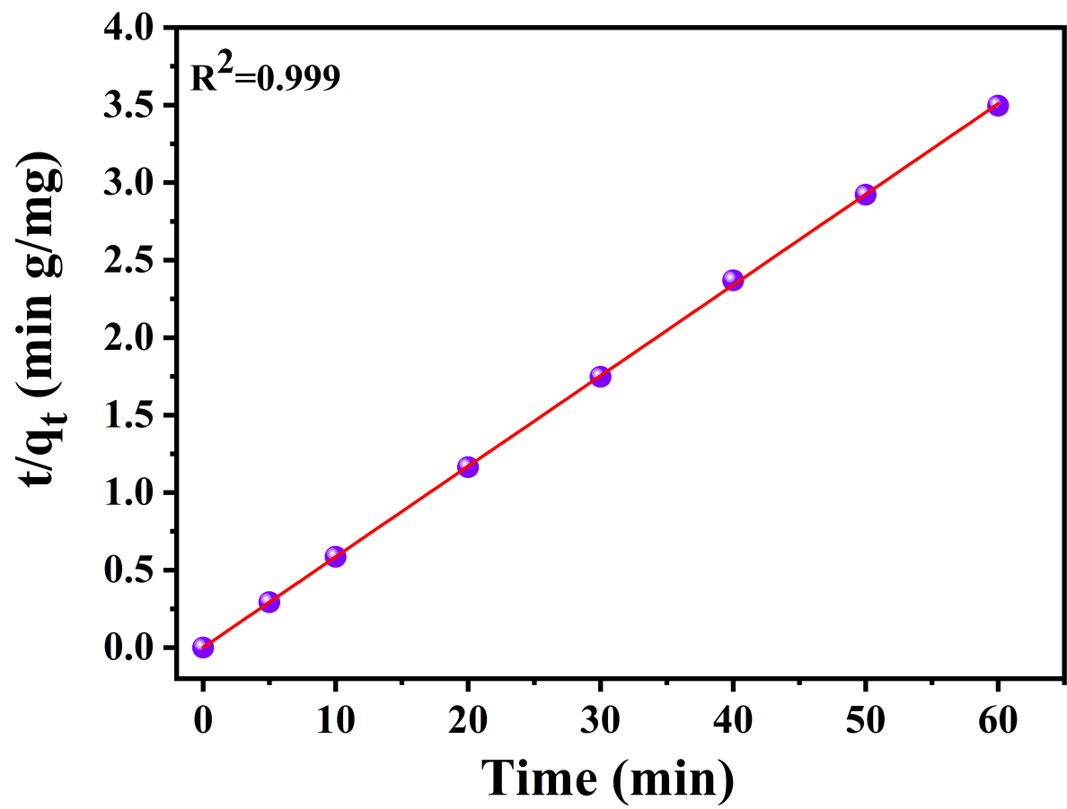
Fig. S6. Dynamic second-order linear fitting of Ni-tfc-CP.

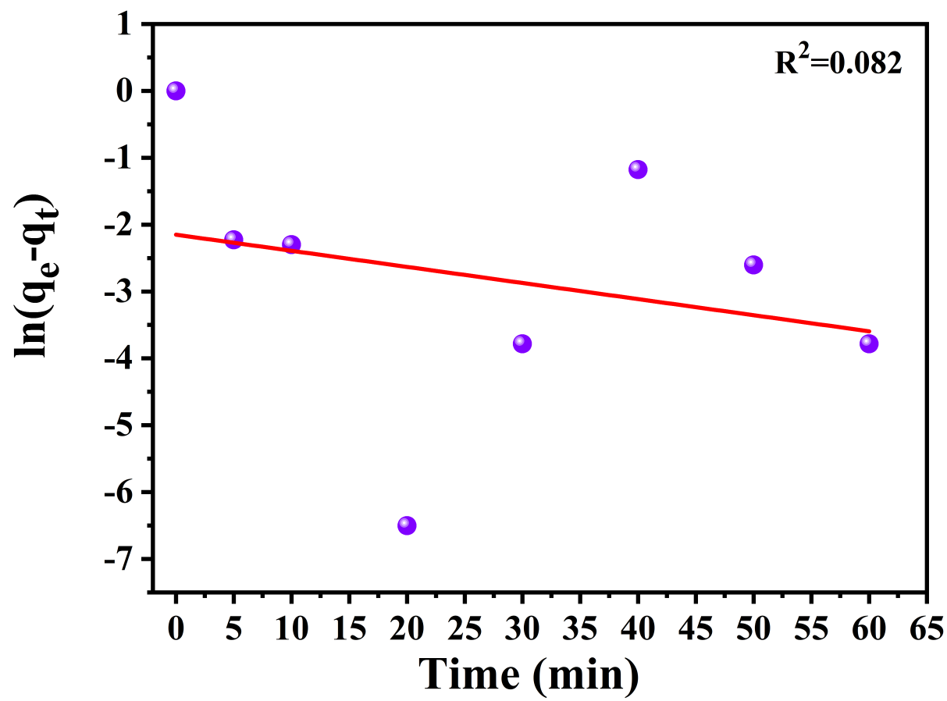
Fig. S7. Dynamic first-order linear fitting of Ni-tfc-CP.

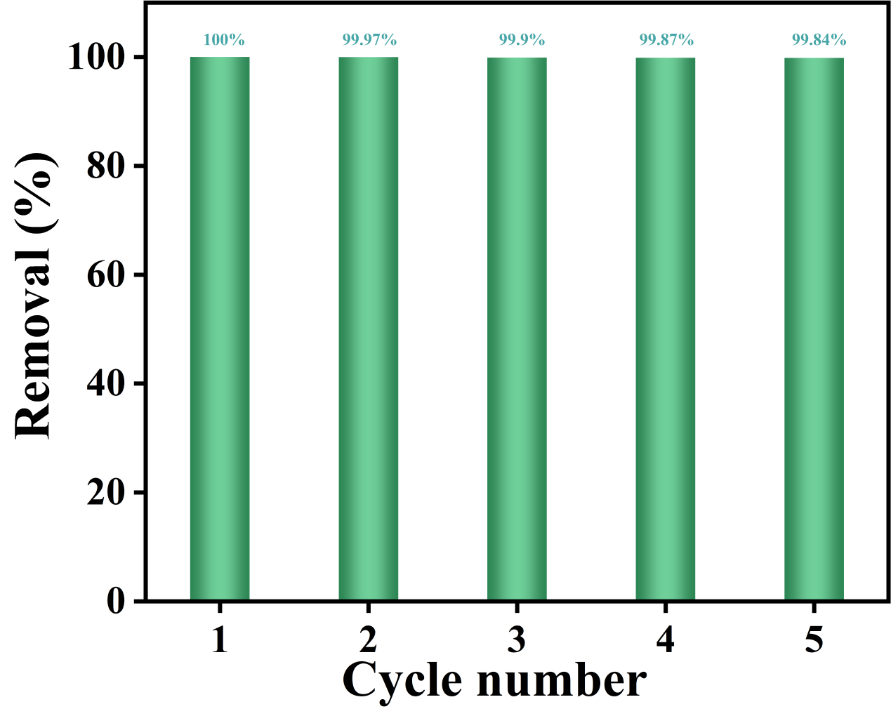
Fig. S8. Recycling performance of the Ni-tfc-CP for target pollutant removal over 5 consecutive cycles.

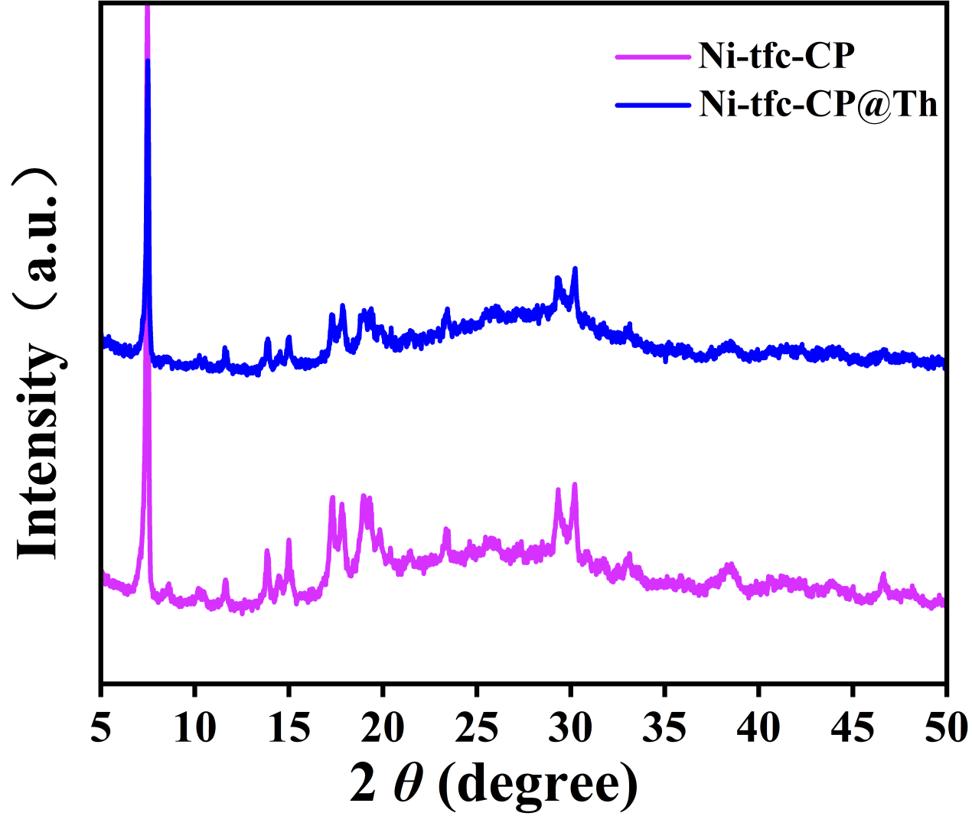

Fig. S9. PXRD patterns of Ni-tfc-CP before and after Th(IV) adsorption.

3. Supplementary Tables

Table S1. Chemical element content of Ni-tfc-CP obtained from XPS analysis.
Sample |  |  |  | Elements (atomic %)
Sample | C | N | O |  | F | Ni
Zn-Vlm₆ | 68.83 | 4.66 | 11.08 |  | 14.12 | 1.51
The above table showed that the atomic content ratio of N and O to Ni was about 3:1, 7:1, respectively. The monomer Htfc contained one N and two O atoms, indicating that one Ni atom coordinated with three Htfc and one water molecule in the self-assembly that formed a six-coordinated metal coordination polymer.

Table S2. Fitting results of Ni-tfc-CP adsorption Th(IV) is based on the Langmuir and Freundlich models

Langmuir models |  |  | Freundlich models
q_{m} (mg g⁻¹) | K_{L} (L mg⁻¹) | R² | K_{F} | n | R²
518.9 | 0.25 | 0.94 | 143.5 | 3.98 | 0.78

Table S2. Fitting result of Ni-tfc-CP adsorption Th(IV) is based on the Pseudo first-order kinetic and Pseudo-second-order kinetic models.
Pseudo-first-order |  | Pseudo-second-order
k₁ (min^{–1}) | R² | k₂ (g (mg min)^{–1}) | R²
0.024 | 0.082 | 3.11 | 0.99

Table S3. Comparison of the adsorption kinetics for various adsorbents.
Adsorbents | Equilibrium time (min) | Ref.
Ca-NDA | 50 | [1]
DBT-DHTA-Cd | 30 | [2]
IEF-11 | 100 | [3]
SZ-7 | 30 | [4]
MOF303 | 420 | [5]
Al-MOF | 180 | [6]
UiO-66-(COOH)₂ | 60 | [7]
Py-TFIm-25 | 4 | [8]
TAPT-DHTA | 60 | [9]
Ni-tfc-CP | 5 | This work

4. Supplementary Reference
[1] M.-J. Yang, A.-M. Song, Q. Yang, Z. Wu, B. Lin, R.-P. Liang, J.-D. Qiu, One-step open-ring strategy for constructing sandwich-like metal–organic framework with highly selective removal of thorium, Chem. Eng. J. 505 (2025) 159718.
[2] A.-M. Song, M.-J. Yang, Z. Wu, Q. Yang, B. Lin, R.-P. Liang, J.-D. Qiu, Rational designed metal–organic framework with nanocavity traps for selectively recognizing and separating of radioactive thorium in rare earth wastewater, Adv. Funct. Mater. 34 (2024) 2406932.
[3] X. Chen, G. Li, S. Xiao, W. Xue, X. Zhao, Q. Yang, Efficient capture of Th(IV) and U(VI) by radiation-resistant oxygen-rich ion traps based on a metal–organic framework, ACS Appl. Mater. Interfaces 15 (2023) 25029-25040.
[4] X. He, L. Xu, J. Zhang, L. Zeng, W. Peng, Z. Chen, G. Huang, Selective capture of thorium from highly acidic nuclear wastewater by a zirconium phosphonate framework: Towards sustainable nuclear waste management, J. Environ. Chem. Eng. 14 (2026) 121670.
[5] X. Chen, X. Liu, S. Xiao, W. Xue, X. Zhao, Q. Yang, A β-ray irradiation resistant MOF-based trap for efficient capture of Th(IV) ion, Sep. Purif. Technol. 297 (2022) 121517.
[6] X. Ding, Z. Zhang, X. Li, K. Ma, T. Jin, Z. Feng, T. Lan, J. Zhao, S. Xiao, Highly radiation-resistant Al-MOF selected based on the radiation stability rules of metal–organic frameworks with ultra-high thorium ion adsorption capacity, Environ. Sci. Nano 11 (2024) 2103-2111.
[7] N. Zhang, L.-Y. Yuan, W.-L. Guo, S.-Z. Luo, Z.-F. Chai, W.-Q. Shi, Extending the use of highly porous and functionalized MOFs to Th(IV) capture, ACS Appl. Mater. Interfaces 9 (2017) 25216-25224.
[8] X. Liu, F. Gao, T. Jin, K. Ma, H. Shi, M. Wang, Y. Gao, W. Xue, J. Zhao, S. Xiao, Y. Ouyang, G. Ye, Efficient and selective capture of thorium ions by a covalent organic framework, Nat. Commun. 14 (2023) 5097.
[9] W. Zhong, M. Wang, H. Hu, J. Qian, S. Wang, X. Su, S. Xiao, H. Xu, Y. Gao, Ultrahigh-efficient N,O-functionalized covalent organic framework towards thorium adsorption from uranium and rare earth elements, Sep. Purif. Technol. 347 (2024) 127603.

