Supplementary Materials for

The Dark Side of Photosymbiosis: Extremely Divergent Repeats Made the Largest Bilaterian Mitogenome

This PDF file includes:

Figs. S1 to S16
Table S1 to S7
Supplementary Text S1

Other Supplementary Materials for this manuscript include the following:

Data S1 to S5

Figure S1: Circular visualization of Fragum fragum mitogenome. The region shaded salmon pink in the mitogenome denotes the position and proportion of the major NCR in relation to the whole mitogenome.

Figure S2: Circular visualization of Fragum whitleyi mitogenome. The region shaded salmon pink in the mitogenome denotes the position and proportion of the major NCR in relation to the whole mitogenome.

Figure S3: Circular visualization of Fragum sueziense mitogenome. The region shaded salmon pink in the mitogenome denotes the position and proportion of the major NCR in relation to the whole mitogenome.

Figure S4: Circular visualization of Tridacna crocea mitogenome. The region shaded salmon pink in the mitogenome denotes the position and proportion of the major NCR in relation to the whole mitogenome.

Figure S5: Circular visualization of Tridacna derasa mitogenome. The region shaded salmon pink in the mitogenome denotes the position and proportion of the major NCR in relation to the whole mitogenome.

Figure S6: Circular visualization of Tridacna gigas mitogenome. The region shaded salmon pink in the mitogenome denotes the position and proportion of the major NCR in relation to the whole mitogenome.

Figure S7: Circular visualization of Hippopus hippopus mitogenome. The region shaded salmon pink in the mitogenome denotes the position and proportion of the major NCR in relation to the whole mitogenome.

Figure S8: Circular visualization of Fulvia mutica mitogenome. The region shaded salmon pink in the mitogenome denotes the position and proportion of the major NCR in relation to the whole mitogenome.

Figure S9: Circular visualization of Laevicardium crassum mitogenome. The region shaded salmon pink in the mitogenome denotes the position and proportion of the major NCR in relation to the whole mitogenome.

Figure S10: Circular visualization of Acanthocardia tuberculata mitogenome. The region shaded salmon pink in the mitogenome denotes the position and proportion of the major NCR in relation to the whole mitogenome.

Figure S11: Circular visualization of Cerastoderma edule mitogenome. The region shaded salmon pink in the mitogenome denotes the position and proportion of the major NCR in relation to the whole mitogenome.

Figure S12: Circular visualization of Cerastoderma glaucum mitogenome. The region shaded salmon pink in the mitogenome denotes the position and proportion of the major NCR in relation to the whole mitogenome.

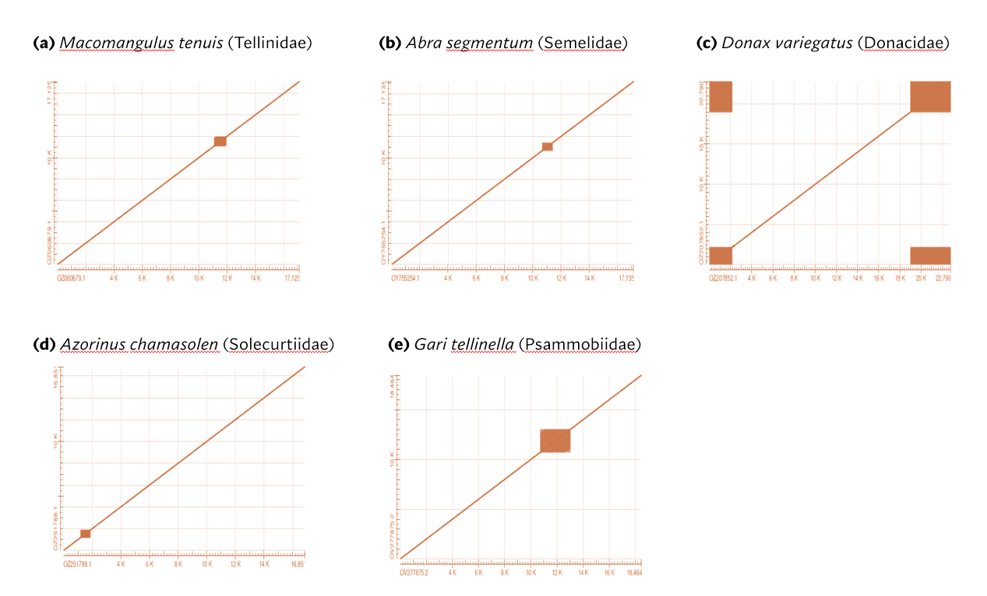

Fig. S13. Representative dot plots showing microsatellite patterns in mitogenomes of outgroup taxa in this study.

Figure S14: (Continuation of Figure 2 in the main text) Comparative linearized visualization of mitochondrial architectures and multi-layered annotation landscapes for photosymbiotic (A-G) and non-phtoosymbiotic (H-L) cardiid species. For each assembly, the multi-track annotations depict: (top row) PCGs and putative origin of replications, (second row) structural partitioning between coding regions and major NCR (blue dashed box) and tandem repeats patterns (blue blocks), (bottow two rows): relative density and overlap of predicted ORFs (purple) and TEs (orange). The red inverted triangle marks the relative position of the cox1 gene across all assemblies. Nucleotide positions are indicated along the horizontal axis in base pairs (bp).

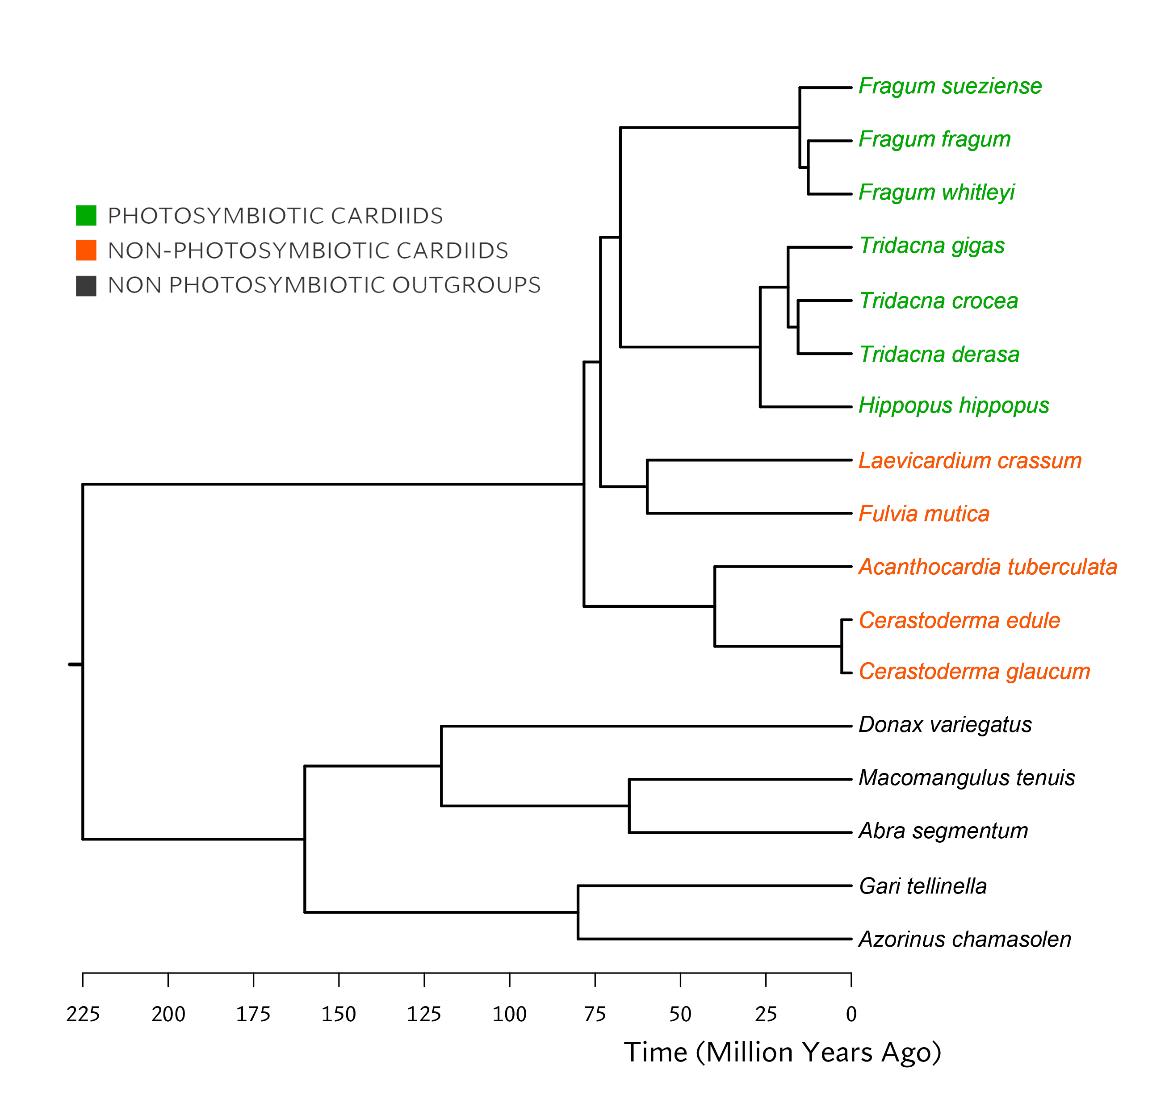

Figure S15: Ultrametric, time-calibrated phylogeny modified from Crouch et al. (2021) and Li et al.(2020) .tre file format as follow:
((((Abra_segmentum:65.00,Macomangulus_tenuis:65.00):55.00,Donax_variegatus:120.00):40.00,(Azorinus_chamasolen:80.00,Gari_tellinella:80.00):80.00):65.00,((Acanthocardia_tuberculata:39.96,(Cerastoderma_glaucum:2.80,Cerastoderma_edule:2.80):37.16):38.31,((Laevicardium_crassum:59.73,Fulvia_mutica:59.73):13.70,((((Tridacna_derasa:15.58,Tridacna_crocea:15.58):2.92,Tridacna_gigas:18.50):8.16,Hippopus_hippopus:26.66):40.93,((Fragum_whitleyi:12.60,Fragum_fragum:12.60):2.47,Fragum_sueziense:15.07):52.52):5.84):4.84):146.73);

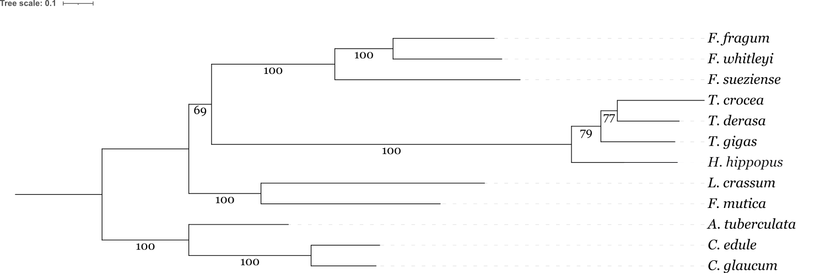
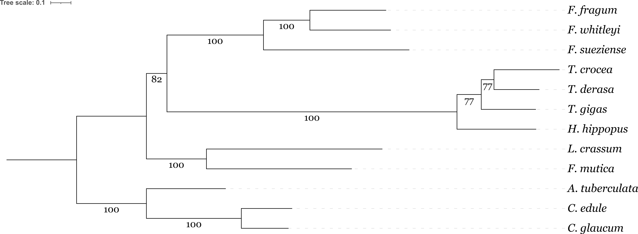
(a)
(b)

Figure S16: 15 mt-gene phylogenies. The phylogenies reconstructed using (a) IQ-Tree version 3 (Wong et al., 2026), with ultrafast boostrap and SH-aLRT branch test, each with 1000 replicates, and (b) RAxML (Stamatakis, 2014), with standard bootstrapping for 1000x. These phylogenies were reconstructed with a 12,185-nucleotide-concatenation of 13 mitochondrial PCGs and 2 rRNAs in the following order: atp6, atp8, cox1-3, nad1-6, 16S, and 12S, using the GTR+ γ + i models. The partition file for model gene model in RAxML is included below. The fasta file for concatenated sequence is included as supplementary data S5.

Partition.nex:

#nexus
begin sets;
charset ATP6 = 1-1217;
charset ATP8 = 1218-1331;
charset COX1 = 1332-2890;
charset COX2 = 2891-3579;
charset COX3 = 3580-4410;
charset NAD1 = 4411-5320;
charset NAD2 = 5321-6291;
charset NAD3 = 6292-6648;
charset NAD4 = 6649-8007;
charset NAD4L = 8008-8283;
charset NAD5 = 8284-9965;
charset NAD6 = 9966-10447;
charset rrnL = 10448-11515;
charset rrnS = 11516-12185;
end;

Phylogeny reconstruction references:

Thomas K F Wong, Nhan Ly-Trong, Huaiyan Ren, Piyumal Demotte, Hector Baños, Andrew J Roger, Edward Susko, Chris Bielow, Nicola De Maio, Nick Goldman, Matthew W Hahn, Mario dos Reis, Le Sy Vinh, Gavin Huttley, Robert Lanfear, Bui Quang Minh, IQ-TREE 3: phylogenomic inference software using complex evolutionary models, Molecular Biology and Evolution, Volume 43, Issue 5, May 2026, msag117, https://doi.org/10.1093/molbev/msag117

Alexandros Stamatakis, RAxML version 8: a tool for phylogenetic analysis and post-analysis of large phylogenies, Bioinformatics, Volume 30, Issue 9, May 2014, Pages 1312–1313, https://doi.org/10.1093/bioinformatics/btu033

Table S1. Information of all mitogenomes analyzed in this study, including NCBI GenBank Accession number, sequencing technology and genome coverage. (a) for the focal groups of Cardiidae bivalves in this study and (b) for the outgroups from non-Cardiidae Cardiida bivalves.

(a) Focal Group of Photosymbiotic and Non-Photosymbiotic Cardiidae Bivalves
GenBank Accession | Ecology | Species | Subfamily | Sequencing Technology | Genome Coverage
OX336384.1 | P | Fragum fragum (Linnaeus, 1758) | Fraginae | PB + Hi-C + IL | 14
OX411561.1 | P | Fragum whitleyi Iredale, 1929 | Fraginae | PB + Hi-C + IL | 43
OY804611.1 | P | Fragum sueziense (Issel, 1869) | Fraginae | PB + Hi-C | 34
OX031074.1 | P | Tridacna crocea Lamarck, 1819 | Tridacninae | PB + Hi-C | 42
OY723432.1 | P | Tridacna derasa (Röding, 1798) | Tridacninae | PB + Hi-C | 49
OX244045.2 | P | Tridacna gigas (Linnaeus, 1758) | Tridacninae | PB + Hi-C | 36
OZ250879.1 | P | Hippopus hippopus (Linnaeus, 1758) | Tridacninae | PB + Hi-C | 81
OZ212067.1 | NP | Laevicardium crissum (Gmelin, 1791) | Laevicardiinae | PB + Hi-C | 59
NC_022194.1 | NP | Fulvia mutica (Reeve, 1844) | Cardiinae | PW-PCR | -
NC_008452.1 | NP | Acanthocardia tuberculata (Linnaeus, 1758) | Lymnocardiinae | IL | -
OX401423.1 | NP | Cerastoderma edule (Linnaeus, 1758) | Lymnocardiinae | ONT+IL | -
OZ022487.1 | NP | Cerastoderma edule (Linnaeus, 1758) | Lymnocardiinae | PB + Hi-C | 42
OZ205200.1 | NP | Cerastoderma glaucum (Bruguière, 1789) | Lymnocardiinae | PB + Hi-C | 45

(b) Outgroup of Cardiida Bivalves
GenBank Accession | Ecology | Species | Family | Sequencing Technology | Genome Coverage
OZ060679.1 | NP | Macomangulus tenuis (da Costa, 1778) | Tellinidae | PB + Hi-C | 54
OZ251788.1 | NP | Abra segmentum (Récluz, 1843) | Semelidae | PB + Hi-C | 46
OZ207852.1 | NP | Donax variegatus (Gmelin, 1781) | Donacidae | PB + Hi-C | 72
OY755254.1 | NP | Azorinus chamasolen (da Costa, 1778) | Solencurtiidae | PB + Hi-C | 35
OV277875.2 | NP | Gari tellinella (Lamarck, 1818) | Psammobiidae | PB + Hi-C | 34

PB: PacBio Long-Read Sequencing; IL: Illumina Short-Read Sequencing; PW-PCR: Primer-Walking PCR; ONT: Oxford Nanopore Technologies. P: photosymbiotic, NP: non-photosymbiotic.
Note: Despite the genome note for H. hippopus by Li et al (2024). The genome sequence of the horse’s hoof clam, Hippopus hippopus (Linnaeus, 1758). Wellcome Open Research 9:131 (https://doi.org/10.12688/wellcomeopenres.21137.1) having been retracted due to clerical error that led to misupload of genomic sequence that turned out to be a member of the Tridacna genus, the error has been corrected for the mitogenome and reverified with blasting for percent identities of mitochondrial gene from OZ250879.1 to other available Hippopus hippopus and Hippopus porcellanus sequences available on NCBI GenBank.

Supplementary Text S1:
The short or absence of huge NCR(s) in most of the non-photosymbiotic cardiids in this study is unlikely to arise from a sequencing or assembly error. Mitogenomes for the non-photosymbiotic species in our study are sequenced through three distinct sequencing techniques: (1) the mitogenome for the two Cerastoderma spp., and L. crassum was sequenced through long-read sequencing coupled with Illumina short-reads for assembly. As such, the coding regions can be confidently bridged with long sequences that would cover the entirety of the NCR; (2) careful primer-walking PCR of 21 Fu. mutica individuals manage to span through the entire, albeit short, NCRs [1]; (3) the mitogenome of A. tuberculata was sequenced and assembled with only Illumina short reads. Mapping the raw reads back to the assembled mitogenome did not show coverage in the NCR exceeding the genome-wide mean, indicating that the NCR assembly is complete and unlikely to contain abundant repeats.

Table S2. Summary table of genes annotated for all species.

Species | PCG | rRNA | OH | OL | TE in NCR | Total TE | miRNA | sRNA | snoRNA | tRNA | additional tRNA copies
 |  |  |  |  |  |  |  |  |  |  | M | N | S | K | L | C | other (x1)
Fragum fragum | 13 | 2 | - | - | 18 | 47 | 23 | 15 | 1 | 35 | 1 | - | 11 | - | - | - | H
Fragum whitleyi | 13 | 2 | - | 21 | 9 | 43 | 136 | 19 | 3 | 26 | 1 | - | 1 | - | 1 | - | Y
Fragum sueziense | 13 | 2 | 1 | 31 | 306 | 332 | 131 | 32 | 1 | 46 | 1 | 10 | 11 | - | - | - | G, I
Tridacna crocea | 13 | 2 | - | - | 62 | 94 | 28 | 10 | 3 | 25 | 1 | - | - | - | 1 | - | F
Tridacna derasa | 13 | 2 | 15 | - | 9 | 29 | 61 | 29 | 30 | 23 | 1 | - | - | - | - | - | -
Tridacna gigas | 13 | 2 | - | - | 17 | 43 | 211 | 16 | 21 | 27 | 1 | 1 | - | - | 1 | - | I, R
Hippopus hippopus | 13 | 2 | - | - | 7 | 29 | 51 | 3 | 6 | 29 | 2 | - | 2 | - | - | - | A, I, P
Fulvia mutica | 13 | 2 | 1 | - | 13 | 39 | 123 | 7 | 12 | 30 | 2 | - | - | - | - | 4 | F, I
Laevicardium crassum | 13 | 2 | - | - | 10 | 32 | 4 | 1 | 5 | 37 | 1 | 1 | 1 | 9 | 1 | - | D, G
Acanthocardia tuberculata | 13 | 2 | - | 1 | 3 | 33 | 6 | 6 | 3 | 23 | 1 | - | - | - | - | - | -
Cerastoderma edule | 13 | 2 | 1 | - | 1 | 32 | 13 | 4 | 3 | 26 | 1 | - | - | - | - | - | A,G,T
Cerastoderma glaucum | 13 | 2 | - | - | 0 | 30 | 15 | 3 | 6 | 25 | 1 | - | - | - | 2 | - | -

PCG: Protein-coding genes; rRNA: ribosomal RNA; OH: Origin of replication on the heavy strand; OL: Origin of replication on the light strand; TE: Transposable elements; miRNA: microRNA; sRNA: small RNA; snoRNA: Small Nucleolar RNAs; tRNA: Transfer RNA.

Table S3. Summary table of TE fragments counts by types.

Species | LTR/  Copia | LTR/  Gypsy | LTR/  ERV-type | LTR/  Pao | LINE/  L1 | RC/  Helitron | LTR | LINE | DNA transposon | TE in NCR | Total TE
Fragum fragum | 16 | 16 | 0 | 1 | 4 | 1 | 35 | 7 | 4 | 18 | 47
Fragum whitleyi | 8 | 15 | 4 | 2 | 4 | 1 | 29 | 10 | 3 | 9 | 43
Fragum sueziense | 55 | 54 | 6 | 22 | 16 | 9 | 160 | 53 | 74 | 306 | 332
Tridacna crocea | 19 | 5 | 2 | 3 | 56 | 0 | 29 | 57 | 8 | 62 | 94
Tridacna derasa | 4 | 4 | 1 | 1 | 1 | 9 | 10 | 3 | 4 | 9 | 29
Tridacna gigas | 6 | 6 | 17 | 2 | 1 | 0 | 32 | 5 | 6 | 17 | 43
Hippopus hippopus | 7 | 4 | 2 | 2 | 4 | 2 | 16 | 7 | 4 | 7 | 29
Laevicardium crassum | 8 | 5 | 2 | 2 | 5 | 0 | 18 | 19 | 2 | 13 | 39
Fulvia mutica | 5 | 5 | 3 | 2 | 2 | 0 | 17 | 12 | 3 | 10 | 32
Acanthocardia tuberculata | 10 | 3 | 1 | 4 | 3 | 1 | 18 | 9 | 5 | 3 | 33
Cerastoderma edule | 9 | 6 | 2 | 2 | 2 | 1 | 19 | 8 | 2 | 1 | 32
Cerastoderma glaucum | 6 | 6 | 2 | 3 | 1 | 1 | 17 | 9 | 4 | 0 | 30

The first six columns after species are most prevalent types detected. TE: Transposable Elements; LTR: Long Terminal Repeats retrotransposons; LINE: Long Interpresed Nuclear Elements.

Table S4. Statistical assessment of phylogenetic signals and correlations of mitogenomic traits.

Genome Traits | Mitogenome size | NCR size | NCR Proportion | ORF count | TE count
Data Transformation | log | log | logit | NA | NA
PGLS $λ$(residual) | 0 | 0 | D0 | 0 | 0
P-value photosymbiotic | 0.004962 | 0.001142 | 0.001414 | 0.005882 | 0.1124
F-statistic | 10.82 | 16.06 | 15.23 | 10.28 | 2.844
df | 15 | 15 | 15 | 15 | 15
Trait $λ$(BM if =1, random if =0)
Phylogenetic signal lambda | 7.42E-05 | 0.93115 | 0.933208 | 7.42E-05 | 7.42E-05
Log-likelihood test ($λ$) | 5.00009 | -13.1786 | -26.8937 | -110.864 | -98.7522
LR ($λ$=0) | -0.0001399 | 4.84564 | 4.76526 | -8.62E-05 | -0.00055494
P-value (based on LR test) | 1 | 0.0277161 | 0.02904 | 1 | 1
Bloomberg's K
Phylogenetic signal K | 0.226144 | 0.548642 | 0.546527 | 0.238845 | 0.142463
P-value (based on 1000 randomizations) | 0.4025 | 0.0024 | 0.0036 | 0.3647 | 0.6003

The relationship between a photosymbiotic lifestyle and five genomic parameters: total mitogenome size, NCR size, NCR proportion within the mitogenome, ORF count, and TE count. Phylogenetic Generalized Least Squares (PGLS) models indicate significant ecological effects (bolded) for all traits except TE count. Phylogenetic signal for each trait is quantified via Pagel’s and Blomberg’s K phylogenetic signal tests. Data transformations (log or logit) applied to satisfy model assumptions are indicated for each trait.
Table S5: Nucleotide composition for focal cardiid mitogenomes in full.

Species | * | Genome Size | A% | T% | G% | C% | (G+C)% | (A+T)% | A | T | G | C | AT skew | GC skew
Fragum fragum | P | 22,357 | 23 | 35 | 26 | 16 | 42 | 58 | 5226 | 7719 | 5838 | 3574 | -0.1926 | 0.2405
Fragum whitleyi | P | 30,336 | 24 | 29 | 28 | 19s5 | 47 | 53 | 7214 | 8804 | 8573 | 5745 | -0.0993 | 0.1975
Fragum sueziense | P | 92,770 | 29 | 30 | 21 | 20 | 41 | 59 | 27234 | 27786 | 19618 | 18132 | -0.0100 | 0.0394
Hippopus hippopus | P | 21,808 | 27 | 34 | 25 | 15 | 40 | 60 | 5815 | 7313 | 5344 | 3336 | -0.1141 | 0.2313
Tridacna crocea | P | 29,009 | 27 | 33 | 22 | 18 | 40 | 60 | 7721 | 9702 | 6455 | 5131 | -0.1137 | 0.1143
Tridacna derasa | P | 24,955 | 29 | 36 | 21 | 14 | 35 | 65 | 7212 | 9012 | 5298 | 3433 | -0.1109 | 0.2136
Tridacna gigas | P | 25,335 | 26 | 30 | 25 | 19 | 44 | 56 | 6525 | 7571 | 6337 | 4902 | -0.0742 | 0.1277
Fulvia mutica | NP | 19,110 | 28 | 37 | 23 | 13 | 35 | 65 | 5335 | 6992 | 4340 | 2443 | -0.1344 | 0.2797
Laevicardium crassum | NP | 21,427 | 35 | 23 | 17 | 25 | 42 | 58 | 7516 | 4997 | 3647 | 5267 | 0.2013 | -0.1817
Cerastoderma edule | NP | 14,943 | 24 | 34 | 24 | 18 | 42 | 58 | 3581 | 5135 | 3571 | 2656 | -0.1783 | 0.1469
Cerastoderma glaucum | NP | 14,950 | 24 | 36 | 24 | 17 | 40 | 60 | 3583 | 5314 | 3558 | 2495 | -0.1946 | 0.1756
Acanthocardia tuberculata | NP | 16,104 | 25 | 35 | 23 | 17 | 40 | 60 | 3954 | 5693 | 3784 | 2673 | -0.1803 | 0.1721

For each assembly, the total genome size (bp), raw nucleotide counts (A,T,G,C), and their respective relative abundances (%) and base compositional biases represented by (G+C)% and (A+T)%, alongside AT skew [(A−T)/(A+T)] and GC skew [(G−C)/(G+C)] are listed. Species are categorized by ecological state (*): P: photosymbiotic, and NP: non-photosymbiotic lineages.

Table S6: Nucleotide composition for focal cardiid mitogenomes with their major NCR removed.

Species | * | Genome Size | A% | T% | G% | C% | (G+C)% | (A+T)% | A | T | G | C | AT skew | GC skew
Fragum fragum | P | 15,718 | 23 | 36 | 26 | 15 | 40 | 60 | 3660 | 5703 | 4035 | 2320 | -0.2182 | 0.2699
Fragum whitleyi | P | 16,583 | 22 | 34 | 28 | 16 | 44 | 56 | 3720 | 5562 | 4616 | 2685 | -0.1984 | 0.2645
Fragum sueziense | P | 17,115 | 25 | 34 | 23 | 18 | 41 | 59 | 4350 | 5744 | 3964 | 3057 | -0.1381 | 0.1292
Hippopus hippopus | P | 14,997 | 26 | 35 | 25 | 14 | 39 | 61 | 3872 | 5259 | 3742 | 2124 | -0.1519 | 0.2758
Tridacna crocea | P | 17,925 | 27 | 35 | 24 | 14 | 38 | 62 | 4803 | 6341 | 4283 | 2498 | -0.1380 | 0.2632
Tridacna derasa | P | 17,844 | 28 | 37 | 23 | 12 | 35 | 65 | 5053 | 6568 | 4076 | 2147 | -0.1304 | 0.3100
Tridacna gigas | P | 16,549 | 26 | 33 | 26 | 15 | 41 | 59 | 4233 | 5510 | 4312 | 2494 | -0.1311 | 0.2671
Fulvia mutica | NP | 16,497 | 26 | 38 | 23 | 13 | 36 | 64 | 4353 | 6247 | 3758 | 2139 | -0.1787 | 0.2745
Laevicardium crassum | NP | 14,910 | 23 | 36 | 25 | 16 | 40 | 60 | 3479 | 5414 | 3662 | 2355 | -0.2176 | 0.2172
Cerastoderma edule | NP | 14,675 | 24 | 35 | 24 | 18 | 42 | 58 | 3509 | 5071 | 3504 | 2591 | -0.1821 | 0.1498
Cerastoderma glaucum | NP | 14,682 | 24 | 36 | 24 | 17 | 40 | 60 | 3516 | 5250 | 3486 | 2430 | -0.1978 | 0.1785
Acanthocardia tuberculata | NP | 15,002 | 24 | 36 | 24 | 16 | 40 | 60 | 3586 | 5410 | 3547 | 2459 | -0.2028 | 0.1812

For each assembly, the total genome size (bp), raw nucleotide counts (A,T,G,C), and their respective relative abundances (%) and base compositional biases represented by (G+C)% and (A+T)%, alongside AT skew [(A−T)/(A+T)] and GC skew [(G−C)/(G+C)] are listed. Species are categorized by ecological state (*): P: photosymbiotic, and NP: non-photosymbiotic lineages.

Table S7: Nucleotide composition for the major NCR of each focal cardiid mitogenomes.

Species | * | Genome Size | A% | T% | G% | C% | (G+C)% | (A+T)% | A | T | G | C | AT skew | GC skew
Fragum fragum | P | 6,732 | 24 | 30 | 27 | 19 | 46 | 54 | 1591 | 2034 | 1826 | 1281 | -0.1222 | 0.1754
Fragum whitleyi | P | 13,882 | 25 | 24 | 29 | 22 | 51 | 49 | 3531 | 3280 | 3987 | 3084 | 0.0369 | 0.1277
Fragum sueziense | P | 76,691 | 30 | 29 | 21 | 20 | 41 | 59 | 23175 | 22394 | 15871 | 15251 | 0.0171 | 0.0199
Hippopus hippopus | P | 6,811 | 29 | 30 | 24 | 18 | 41 | 59 | 1943 | 2054 | 1602 | 1212 | -0.0278 | 0.1386
Tridacna crocea | P | 11,222 | 26 | 30 | 20 | 24 | 43 | 57 | 2961 | 3416 | 2192 | 2653 | -0.0714 | -0.0951
Tridacna derasa | P | 7,111 | 30 | 34 | 17 | 18 | 35 | 65 | 2159 | 2444 | 1222 | 1286 | -0.0619 | -0.0255
Tridacna gigas | P | 8,922 | 26 | 24 | 23 | 27 | 50 | 50 | 2327 | 2115 | 2054 | 2426 | 0.0477 | -0.0830
Fulvia mutica | NP | 2,851 | 37 | 29 | 22 | 12 | 34 | 66 | 1061 | 817 | 632 | 341 | 0.1299 | 0.2991
Laevicardium crassum | NP | 6,517 | 23 | 32 | 25 | 20 | 44 | 56 | 1518 | 2102 | 1605 | 1292 | -0.1613 | 0.1080
Cerastoderma edule | NP | 268 | 27 | 24 | 25 | 24 | 49 | 51 | 72 | 64 | 67 | 65 | 0.0588 | 0.0152
Cerastoderma glaucum | NP | 268 | 25 | 24 | 27 | 24 | 51 | 49 | 67 | 64 | 72 | 65 | 0.0229 | 0.0511
Acanthocardia tuberculata | NP | 1,109 | 33 | 26 | 22 | 19 | 41 | 59 | 371 | 285 | 239 | 214 | 0.1311 | 0.0552

For each assembly, the total genome size (bp), raw nucleotide counts (A,T,G,C), and their respective relative abundances (%) and base compositional biases represented by (G+C)% and (A+T)%, alongside AT skew [(A−T)/(A+T)] and GC skew [(G−C)/(G+C)] are listed. Species are categorized by ecological state (*): P: photosymbiotic, and NP: non-photosymbiotic lineages.

Data S1. (separate file)
Individual full mitogenome annotations by species.

Data S2. (separate file)
Tandem repeat annotation output from Tandem Repeat Finder Program v4.09.

Data S3. (separate file)
Transposable element (TE) and simple repeat annotations by species, output from the Interspersed Repeat Protein Making Based on Protein Similarity program on RepeatMasker

Data S4. (separate file)
List opening reading frames (> 75 nt in size) detected, output from NCBI ORFFinder

Data S5. (separate file)
Fasta file of the concatenated (15-mitogene) sequences.

