Supplementary Information for
Serum Albumin Hydrogen Bond-Driven Fluorescence Switching of Gold Nanoclusters for Ultrasensitive and Real-Time Visual Detection of Meat Freshness
Yiran Wang ¹, Xiaochun Zhu ¹, Furong Ran ¹, Panar Entemak ^{1,2}, Liang Ma ^{1,2}, Yaqin Chai ^{1*}, Ying Zhou ^{1,2*}, Ruo Yuan ^{1*}
¹ Key Laboratory of Luminescence Analysis and Molecular Sensing (Southwest University), Ministry of Education, College of Chemistry and Chemical Engineering, Southwest University, Chongqing 400715, PR China.
² College of Food Science, Southwest University, Chongqing Key Laboratory of Speciality Food Co-Built by Sichuan and Chongqing, Chongqing 400715, PR China.
*Correspondence to: yqchai@swu.edu.cn; yingzhou@swu.edu.cn; yuanruo@swu.edu.cn

Supplementary Section S1 Morphology and bonding characterization of materials
Transmission electron microscopy (TEM) analysis confirmed that ATT-Au NCs (Supplementary Fig. 1A) and BSA-Au NCs (Supplementary Fig. 1B) exhibited spherical morphology with an average diameter of 2.2 nm (Supplementary Fig. 1A, insert) and 2.0 nm (Supplementary Fig. 1B, insert). Meanwhile, the crystal lattice distances of the prepared Au NCs were about 0.202 nm and 0.212 nm, as shown in the high-resolution TEM (HRTEM) images (insert of Supplementary Fig. 1A and 1B), in accordance with the lattice spacing of the (111) plane in face-centered-cubic (fcc) Au NCs. Furthermore, the SEM image (Fig. S1C) shown the thin-layer and porous microstructure of the PVA hydrogel film. Upon incorporation of the dual-color Au NCs, Au NCs appeared as dark spots dispersed within the porous PVA hydrogel, as further confirmed by the TEM image (Supplementary Fig. 1C). Moreover, Fourier transform infrared (FT-IR) spectroscopy (Supplementary Fig. 1D, blue curve) of the biochromatic hydrogel film (Au NCs/PVA hydrogel) has a reduced hydroxyl peak at 3261 cm-1 and a new carbonyl band at 1714 cm-1 compared to pure PVA (green curve), indicating stable covalent bonds formed between PVA and the Au NCs. More importantly, in the 2500–3400 cm⁻¹ region, –OH band appeared broader and lower while –NH2 band was sharper and higher. Thus, these abundant –OH and –NH2 can serve as hydrogen bonding sites in biochromatic hydrogel.

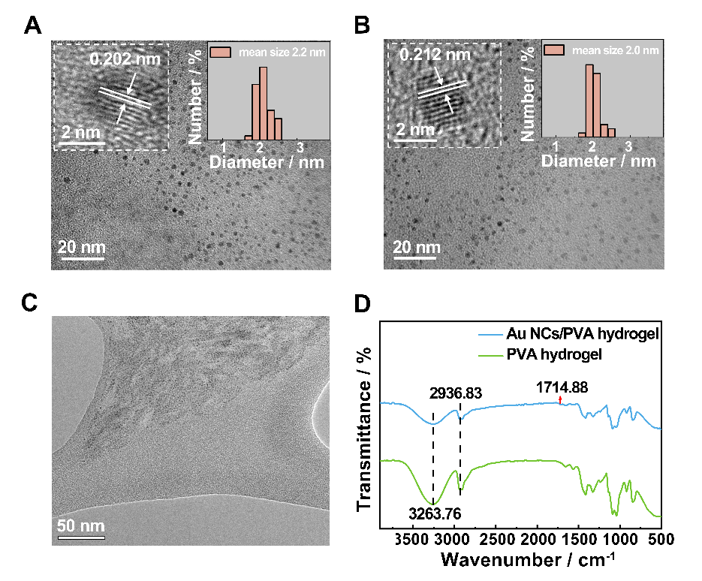
Supplementary Fig. 1 (A) TEM image of BSA-Au NCs; insert: HRTEM image and the size distribution of BSA-Au NCs, (B) TEM image of BSA-Au NCs; insert: insert: HRTEM image and the size distribution of ATT-Au NCs. (C) SEM image of Au NCs within PVA hydrogel. (D) FT-IR spectra of Au NCs/PVA hydrogel (blue curve) and PVA hydrogel (green curve).

Supplementary Section S2 Mechanistic Investigation of the FL switch on/off
Förster resonance energy transfer (FRET) was first considered as a possible mechanism of FL switch on/off, but the absence of spectral overlap between the emission band of BSA-Au NCs and the excitation band of ATT-Au NCs precluded FRET as the enhancement mechanism (Supplementary Fig. 2A and B). Furthermore, the Au (4f_{5/2}) electron (88.1 eV) and Au (4f_{7/2}) electron (84.5 eV) of the ATT-Au NCs and BSA-Au NCs + ATT-Au NCs (Supplementary Fig. 2E) appeared at the same position in the high-definition X-ray photoelectron spectroscopy (XPS) spectra, indicating no change of electronic structure around the Au core. Having excluded both FRET and core-level electronic effects, we next investigated the role of the ligand environment. Given that BSA is a macromolecular protein, changes in electrostatic interactions may represent a reasonable explanation. Under different concentrations of NaCl (0-600 mM), the FL responses of BSA + ATT-Au NCs (curves a and b) and BSA +ATT-Au NCs+ SPE (curve c) were recorded to verify whether electrostatic attraction dominated the FL on-off switch. As shown in Supplementary Fig. 2F, the FL turn-on and turn-off of ATT-Au NCs remained unchanged even under high ionic strength conditions, which effectively shielded electrostatic interactions, confirming that electrostatic attraction was not the driving force.
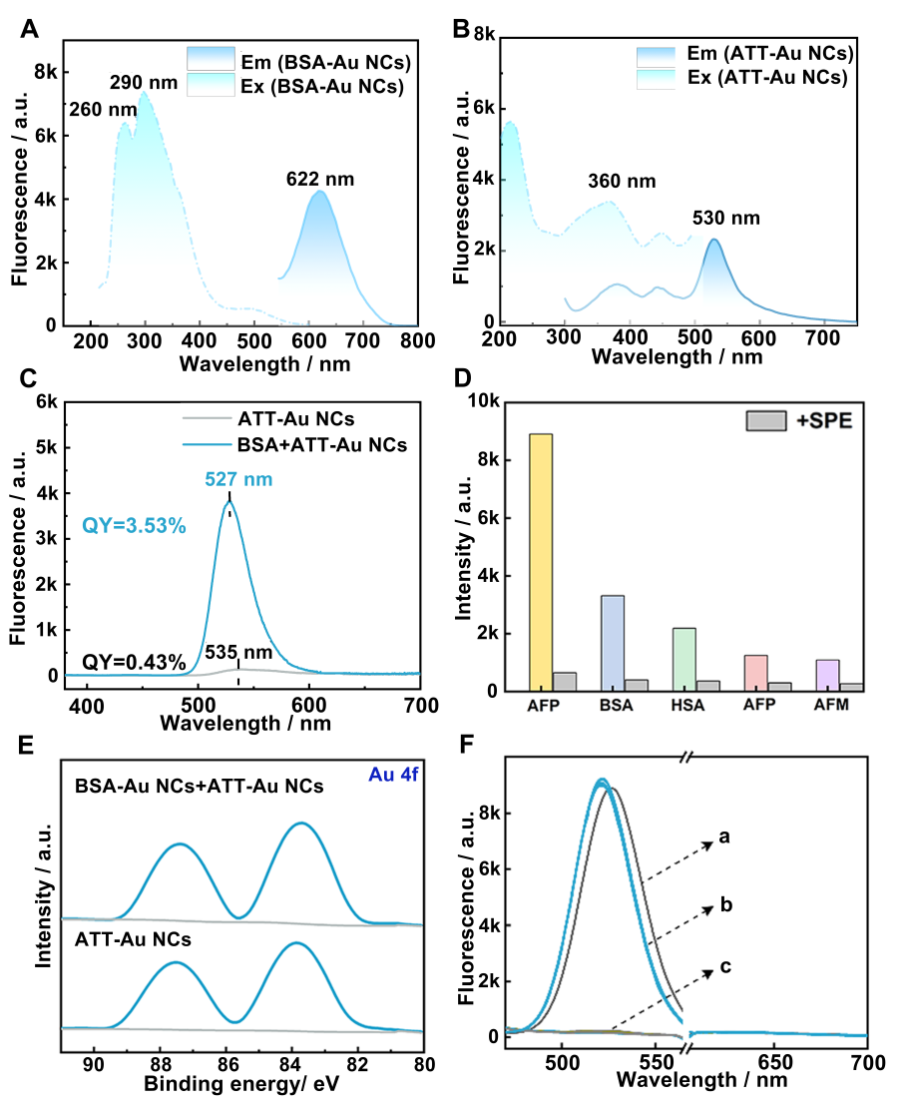
Supplementary Fig. 2 FL excitation and emission spectra of (A) BSA-Au NCs and (B) ATT-Au NCs. (C) FL emission spectra of BSA + ATT-Au NCs and ATT-Au NCs. (D) FL intensity of ATT-Au NCs at 530 nm in the presence of various serum proteins: AFP (yellow bar), BSA (blue bar), HSA (green bar), MSA (pink bar), and AFM (purple bar) before and after (gray bars) the addition of SPE. The FL of ATT-Au NCs was significantly quenched upon the addition of SPE. (E) High-resolution XPS spectra of Au (4f) of ATT-Au NCs and BSA-Au NCs+ ATT-Au NCs. (F) FL emission spectra of (a) BSA + ATT-Au NCs, (b) BSA + ATT-Au NCs in the presence of increasing concentration of NaCl (0-600 mM), and (c) BSA + ATT-Au NCs + SPE in the presence of increasing concentration of NaCl (0-600 mM).
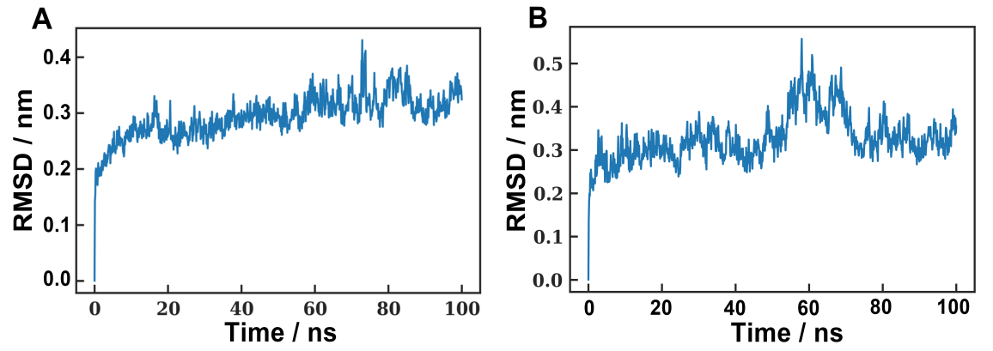

Supplementary Fig. 3 Root Mean Square Deviation of (A) BSA-ATT complex, (B) BSA-SPE complex.

Supplementary Section S4 Determination of Binding Constants (K_{a}) and Stoichiometry (n) for ATT-Au NCs/BSA-Au NCs and SPE/BSA-Au NCs Systems via FL Titration
The binding constant (K_{a}) and stoichiometry (n) for the interaction between ATT-Au NCs and BSA-Au NCs were determined by monitoring the FL enhancement of ATT-Au NCs upon incremental addition of BSA-Au NCs. Given the hydrogen-bonding-induced FL enhancement, the titration data were fitted to the Benesi–Hildebrand equation (R>0.98):
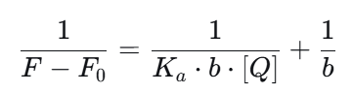
F₀ and F are the FL intensities of ATT-Au NCs in the absence and presence of BSA-Au NCs, respectively, and [Q] is the concentration of BSA-Au NCs. The value of K_{a} was calculated as 3.35×10² from the ratio of the intercept to the slope of the linear plot. The stoichiometry (n) was determined to be approximately 1.5 from the molar ratio of BSA-Au NCs to ATT-Au NCs at which the FL enhancement reached a plateau (Supplementary Fig. S4).
In contrast, the binding parameters for the interaction between SPE and BSA-Au NCs were determined by monitoring the FL decrease of the biochromatic system upon SPE addition The data were initially fitted to the Stern–Volmer equation and subsequently analyzed using the double-logarithmic equation (R>0.97):
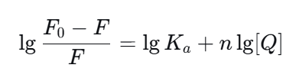
F₀ and F are the FL intensities of biochromatic Au NCs in the absence and presence of SPE, respectively, and [Q] is the concentration of SPE. The value of K_{a} was calculated as 5.01×10² from the ratio of the intercept to the slope of the linear plot. The stoichiometry (n) was calculated to be approximately 1 from the slop.
The FL intensity of ATT-Au NCs gradually increased upon incremental addition of BSA-Au NCs, reached a maximum at a BSA-Au NCs: ATT-Au NCs molar ratio of 3: 2, and decreased with further addition, corresponding to a binding stoichiometry (n) of approximately 1.5 (ATT-Au NCs to BSA-Au NCs).
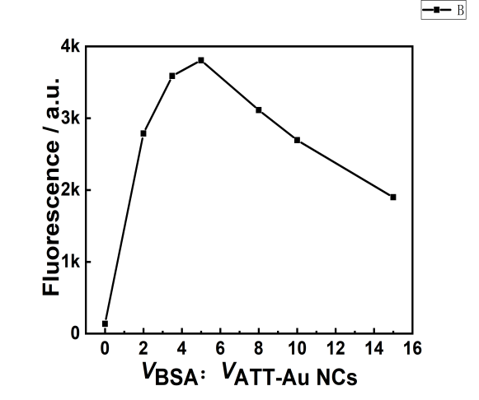
Supplementary Fig. 4 FL intensity changes of ATT-Au NCs at 530 nm upon incremental addition of BSA, plotted as a function of the volume ratio V_{BSA}: V_{ATT-Au NCs} ranging from 0 to 12. The FL intensity gradually increased with increasing BSA and reached a plateau at a volume ratio of approximately 3:2 (V_{BSA}: V_{ATT-Au NCs}).
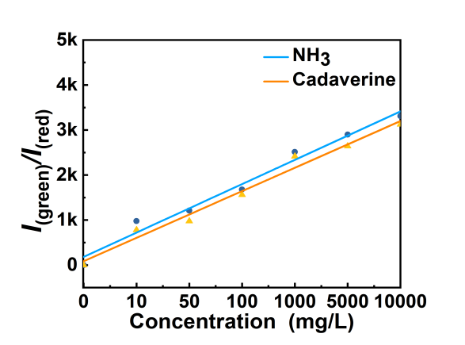
Supplementary Fig.5 FL response of the biochromatic Au NCs to cadaverine and NH₃ (0-10000 ppm).

