Electronic Supplementary Material

Interpretable Noninvasive Blood pH Prediction in Critically Ill Pediatric Patients with Respiratory Failure

Junzi Dong¹, Minnan Xu-Wilson¹, Bryan Conroy¹, Robinder Khemani^{2,3}, Christopher Newth^{2,3}

Affiliations: ¹Acute Care Solutions Team, Philips Research North America, Cambridge, MA; ²Department of Anesthesiology and Critical Care Medicine, Children’s Hospital Los Angeles, Los Angeles, CA; ³Department of Pediatrics, Keck School of Medicine, University of Southern California, Los Angeles, CA.

Contents

eMethods
- Dataset and cross-validation
- Data extraction
- Resampling to balance pH distribution
- Linking blood gas measurements in time
- Multiple samples from the same patient
- Model building
- Personalized measurement importance ranking
- Quantifying performance deviation
- Patient sub-groups

eResults
- Detailed results for PaCO₂ prediction
- Global interpretation of the General Population Model (GPM)
- Patient sub-groups can be predicted more accurately by the GPM

Summary of terms
ABPd: diastolic arterial blood pressure
ABPm: mean arterial blood pressure
ABPs: systolic arterial blood pressure
FiO₂: fraction of inspired oxygen
HR: heart rate
NBPd: diastolic noninvasive blood pressure
NBPm: mean noninvasive blood pressure
NBPs: systolic noninvasive blood pressure
MAP: mean airway pressure
OSI: oxygen saturation index = ${100×FiO_{2}×MAP}/{SpO_{2}}$
OI: oxygen index = ${100×FiO_{2}×MAP}/{PaO_{2}}$
PetCO₂: exhaled end-tidal CO₂
PEEP: positive end expiratory pressure
PIP: peak inspiratory pressure
PF ratio: ${PaO_{2}}/{FiO_{2}}$
SpO₂: pulse oximetry saturation
SF ratio: ${SpO_{2}}/{FiO_{2}}$
TV: tidal volume
% leak: % leak around endotracheal tube

eMethods
Dataset and cross-validation
Data from September 2012 to May 2017 were used for algorithm development, while data from June to December 2017 were used for validation. Validation data was queried after model development. Patients present in the derivation dataset were excluded from analysis in the validation dataset. Patient demographics after data processing are shown in eTable 1.
 | Derivation dataset | Validation dataset
Final # of patients | 1883 | 286
Final # of BG samples | 12344 | 4030
Age (months) | 50 ± 73 | 40 ± 62
CTICU* | 60% of patients | 57% of patients
PICU** | 41% of patients*** | 43% of patients
Before rejection sampling | 11% pH < 7.3  71% 7.3 ≤ pH < 7.45  18% pH ≥ 7.45 | 7% pH ≤ 7.3  71% 7.3 ≤ pH < 7.45  22% pH ≥ 7.45
Post rejection sampling and processing | 17% pH <7.3  54% 7.3 ≤ pH < 7.45  29% pH ≥ 7.45 | NA****
Blood gas type | 90% arterial  10% capillary
Female | 44%
eTable 1 Summary of derivation and validation datasets. Numbers for post-processed data are shown, except for pH range data. *CTICU: Cardiothoracic ICU. **PICU: Pediatric (multidisciplinary, medical-surgical) ICU. ***Patients may have stayed in both ICUs. ****Validation dataset was not resampled.
The performance of machine learning models can vary greatly when trained or tested on new data. In this study, cross-validation was used to quantify how model performance deviates when it is trained and tested on different segments of the derivation data. To this end, the derivation dataset was split into five folds (subsets) while preserving the balance of low pH patients in each fold. During algorithm development, each of the five folds was used alternately for testing, while the remaining four folds were combined into a working training dataset for parameter and input feature selection. The use of five folds enabled the observation of deviation in model performance arising from using real-world datasets, and the quantification of performance deviations in the validation results. (Performance variation on the derivation dataset is shown as mean ± deviation in Table 2 of the main text and in eTable 5 here). When algorithm development was completed, we trained the final models using all derivation data, and tested them on the unseen validation data.
Data extraction
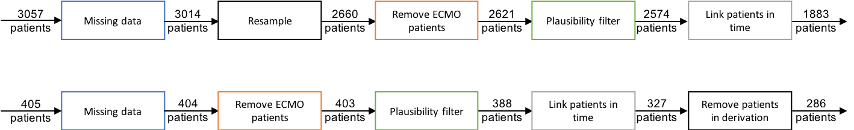
eFigure 1 Data extraction pipelines and cohort sizes for derivation and validation data.
Data extraction began with a dataset containing sample rows of blood gas measurements, granular physiological, and ventilator data collected within ±1 minute of each other. The key steps of data processing are shown in eFig. 1. First, samples with missing information in PetCO₂ measurement or medical record number (MRN) were removed. Derivation data was then resampled to balance pH distribution; this step was skipped for validation data. Next, patients on extracorporeal membrane oxygenation (ECMO) support were removed from modeling. Measurement values then went through a plausibility check, as shown in eTable 2. Samples for the same patient were linked in time, and samples without a prior blood gas measurement within 24 hours were removed. For the validation data, patients already present in the derivation data were removed.
Bound | PetCO₂ | HCO₃⁻ | PIP | pH | SpO₂ | OSI* | FiO₂ | ABPd | PEEP | SF*
Lower | 15 | 10 | 8 | 6.75 | 70 | 0 | 21 | 10 | 0 | 100
Upper | 145 | 50 | 45 | 7.65 | 100 | 45 | 100 | 120 | 25 | 425
eTable 2 Plausibility range of measurements used to perform plausibility filtering during data extraction. *Only SpO₂ values of 97 or less were used to calculate OSI and SF ratio.^{E1}
Resampling to balance pH distribution
To correct the unbalanced distribution of pH and avoid training models that are biased towards mid-pH predictions, we applied resampling as shown in eFig. 2. Samples from under-represented regions (low- and high-pH) were sampled with a resampling probability of 1, meaning that all low- and high-pH samples were kept. Meanwhile, samples from the over-represented region were resampled with pre-specified probability (gray dotted line in eFig. 2b), so that some of the mid-pH samples were rejected. This method generated a dataset that was more balanced across pH regions for training the prediction models, as shown in eFig. 2 and eTable 1.
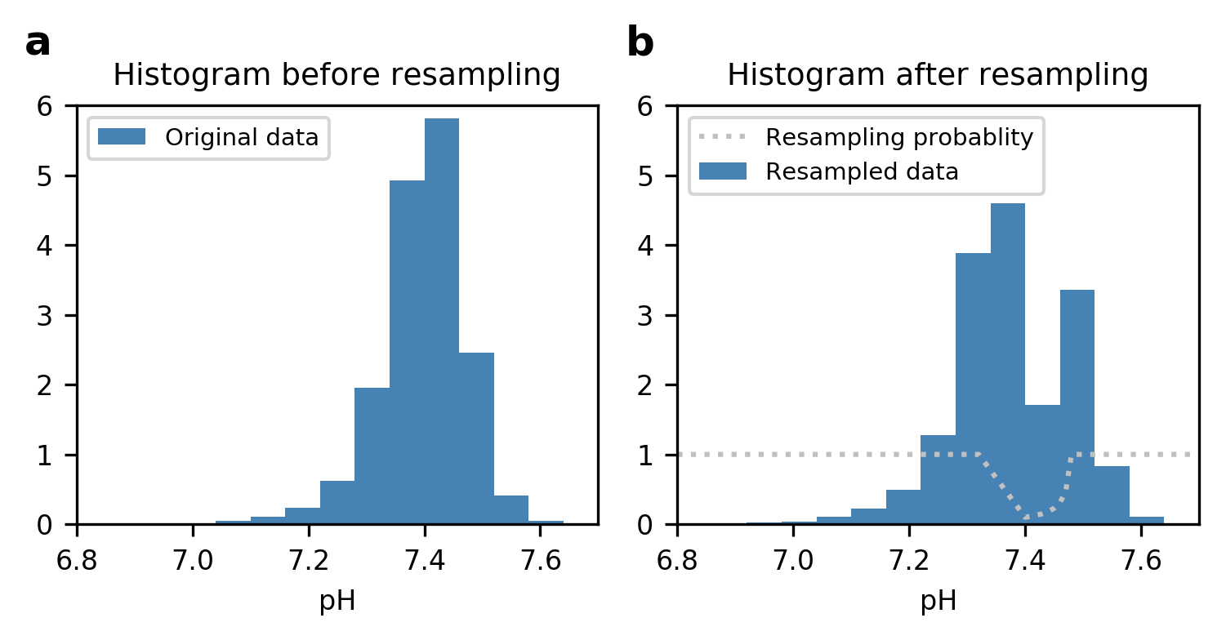
eFigure 2 Demonstrating the resampling technique used to achieve a more balanced dataset in pH. a) Histogram of the original dataset shows that the majority of samples are between 7.3 and 7.45. b) Each pH region was sampled using the specified resampling probability. Low- and high-pH samples were resampled with a probability of 1, so all samples in these ranges were resampled. In the mid-pH region, the further away a pH value was from low- and high-pH borders, the less likely it was to be resampled.
Linking blood gas measurements in time
We linked blood gas measurements of the same patient chronologically. To predict a blood gas value, the previous blood gas values were used as an input. Since patient states in critical care can change quickly, we limited the interval between time of prediction and the previous blood gas sample to less than 24 hours. For example, if a patient had three blood gases in 24 hours, the second blood gas values would be predicted based on the first, and the third blood gas predicted based on the second. Additionally, we tried using only the first blood gas measurement to predict all future blood gas pH.
Multiple samples from the same patient
All samples from the same patient were assigned to the same validation fold. Therefore, samples from the same patient could only be in one data subset and the models did not test patients they had been trained on.
Model building
Linear regression, random forest, and multivariate adaptive regression splines (MARS)^{E2} were tested as potential models to predict blood gas pH. Linear regression performed similarly to the more complex models, so we chose to use linear regression due to its simplicity and ease of interpretation.
We present four prediction models as discussed in the main paper, two of which were novel models developed in this study. An inclusive list of input parameters to the models are shown in Table 1 of the main paper. The results of all models are shown and compared in Fig. 1 and Table 2 of the main text, and in eTable 5 here.
Physiology-based approach: Alveolar dead-space fraction (AVDSf) model
We first implemented an existing physiology-based model to establish a baseline for comparison. The AVDSf model uses the alveolar dead-space fraction ($AVDSf= {(PaCO_{2}-PetCO_{2})}/{PaCO_{2}}$) calculated from the previous blood gas to estimate the current PaCO₂ based on the current PetCO₂. Once the current estimate for PaCO₂ is derived, it is used along with the previous HCO₃⁻ value to estimate the current pH using the Henderson-Hasselbalch equation.
Machine learning approach: Arterial Line Model (ALM)
To fit a linear regression model for pH prediction, we started out with a list of 22 features, shown in eTable 3, and used Ridge Regression to select for the most important features. The machine learning approach generated the ALM, which gave the best performance of the models presented in this study. Due to the inclusion of arterial diastolic blood pressure, this model was applicable only to patients with arterial lines, who represented about 30% of the patients in this dataset.
ABPd | FiO₂ | NBPd | PetCO₂ | SpO₂ | Weight
ABPm | Height | NBPm | PEEP | SF ratio | % Leak
ABPs | HR | NBPs | PICU location | TV inspired
Age (months) | MAP | OSI | PIP | TV expired
eTable 3 Summary of all input measurements considered. Input measurements in bold were used in the models.
Joint approach: General Population Model (GPM)
We combined physiology-based and machine learning approaches in an effort to develop an algorithm that predicts accurately, is applicable to all patients, and is readily interpretable by clinicians. We reasoned that we could measure how a patient’s physiological state has changed by comparing current and past measurements, quantify that change ($∆$), and use it to predict the current pH. Using this approach, we calculated the change in key physiological measurements and ventilation parameters: subtracting the previous value (taken at time $t-1$) from the current value (taken at time $t$) creates a new ‘delta’ ($∆$) measurement, e.g., $∆SpO_{2}=SpO_{2} [t]-SpO_{2}[t-1]$.
The GPM predicts pH by weighting the change in input variables. Specifically, the predicted pH is expressed as a sum of weighted inputs:
Equation 1:
$\hat{pH}[t]= w_{0}+ {w_{1}∙pH\left[t-1\right]+ w}_{2}∙{{HCO}_{3}}^{-}[t-1]+w_{3}∙{PaCO}_{2}[t-1]+w_{4}∙∆{etCO}_{2}+w_{5}∙∆{FiO}_{2}+w_{6}∙∆PEEP+w_{7}∙∆PIP+w_{8}∙∆MnAwP+w_{9}∙∆SpO_{2}$,
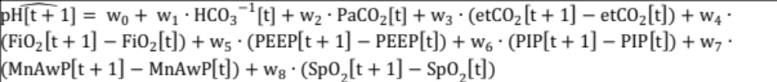where $w_{i}, i=0, 1, 2, …, 8$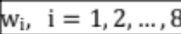 are coefficients of input measurements. Coefficients $w_{i}$ can be positive or negative.
This model can be interpreted by looking at the normalized coefficients of each measurement —when the weight of a ‘delta’ ($∆$) input is positive, it indicates that increases in this measurement contribute to increases in blood pH. eFigure 3 illustrates the relative importance and impact of each input measurement by plotting the its model coefficient normalized by the standard deviation of its measurement value.
As the model was applicable to most patients, we dubbed it the General Population Model (GPM). Due to its applicability to most patients and its accurate performance, the GPM is seen as the model with most potential for clinical implementation.
Personalized measurement importance ranking
While looking at normalized measurement coefficients sheds light on how important individual measurements are on average, global importance cannot provide insight on how a specific estimate is made. Ranking the top patient measurements that contribute to a prediction allows clinical interpretability for individual predictions, as demonstrated in Fig. 3 of the main text.
The core of the method is the calculation of prediction-specific feature importance (FI) scores, which can then be ranked to display the features (input measurements) with most impact on a specific prediction. Representing a linear regression model as $pH= β_{0}+ f_{1}\left(x_{1}\right)+ f_{2}\left(x_{2}\right)+⋯+ f_{m}(x_{m})$, the predicted pH is the sum of functions of individual input measurements $f_{i}\left(x_{i}\right)$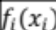, where $x_{i}$ is the value of the $i$th feature (input measurement) for this sample and $f_{i}( )$ is the feature-specific prediction function.
The FI for the $i$th feature of a specific sample $\overset{⃑}{x}=[x_{1}, x_{2}, …, x_{m}]$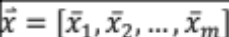 is expressed as:
${FI}_{i}= f_{i}\left(x_{i}\right)- f_{i}\left({\overline{x}}_{i}\right)$,
where ${\overline{x}}_{i}$ is the population mean of the $i$th feature.
Here, ${\overline{x}}_{i}$ represents a typical uninformative background value. When $x_{i}$ is close to the population mean ${\overline{x}}_{i}$, ${FI}_{i}$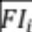 will be equal or close to 0, which means input $i$ contributes little to the overall prediction of sample $\overset{⃑}{x}=[x_{1}, x_{2}, …, x_{m}]$. When $x_{i}$ deviates from the typical population mean ${\overline{x}}_{i}$, ${FI}_{i}$ shifts away from 0 to highlight the contribution of the input to the prediction at hand.
Quantifying performance deviation
Predictions on the five folds of the derivation dataset were assessed separately to test model stability, and then used to estimate the mean and standard deviation of the prediction error on the derivation dataset. In Table 2 of the main text and eTable 5 here, the standard deviation of performance across derivation folds is shown. This is an approximation of expected errors when the algorithm is deployed and applied to unseen data.
Criteria | - PF O2 ratio ≤ 300, or  - SF O2 ratio ≤ 264  OR  - OI ≥ 4, or  - OSI ≥ 5  AND  - 2 serial samples fulfilling above criteria >= 4 hours apart  AND  - PICU
Sample prevalence | 13.6%
eTable 4 Criteria for pediatric acute respiratory distress syndrome (PARDS).
Patient sub-groups
We tested the performance of models on different sub-groups of patients as specified in the Methods section of the main text, to understand whether blood gas prediction is more applicable to some patients. eTable 4 lists the criteria for classification of the pediatric acute respiratory distress syndrome (PARDS) patient group.

eResults
Detailed results for PaCO₂ prediction
PaCO₂ 95% PI  (± mmHg) | AVDSf Model |  | Arterial Line Model |  | General Population Model |  | Baudin et. al
PaCO₂ 95% PI  (± mmHg) | derivation | validation | derivation | validation | derivation | validation | validation
all | 13.34 | 11.89 | 9.87 ± 0.31 | 10.06 | 11.09 ± 0.55 | 10.21 | 11.68
20 – 35 | 9.28 | 9.07 | 10.08 ± 1.17 | 9.50 | 10.81 ± 0.40 | 9.86 | 11.70
35 – 60 | 10.70 | 9.83 | 9.02 ± 0.36 | 9.24 | 9.88 ± 0.65 | 9.18 | 10.89
60 – 120 | 25.59 | 21.59 | 14.22 ± 2.07 | 14.58 | 20.27 ± 1.57 | 19.07 | 19.36
eTable 5 Blood gas PaCO₂ prediction performance of the four models.
Detailed results for PaCO₂ prediction are shown in Fig. 1 of the main text, and quantified in more detail in eTable 5. ALM and GPM outperform comparison models, especially in the low-low and high-PaCO₂ range.
Global interpretation of the General Population Model (GPM)
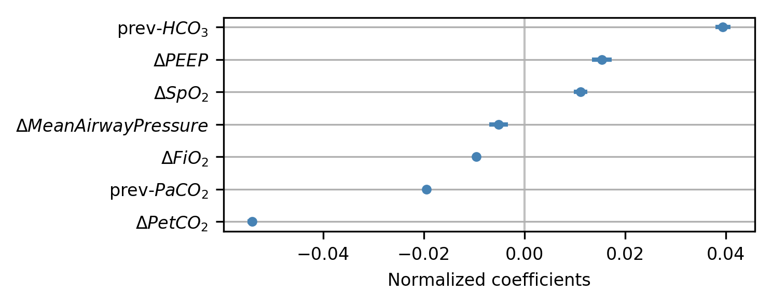
eFigure 3 Normalized coefficients of input variable to the General Population Model (GPM). The GPM calculates pH by weighting each input measurement using its model coefficient, as shown in Equation 1, and then summing all weighted inputs. Larger absolute coefficient values indicate stronger effects on pH. Positive weights contribute to increases in predicted pH, while negatively weighted variables contribute to lower predicted pH. For instance, $∆PetCO_{2}$ has negative weights, which means that when it is positive ($PetCO_{2}$ increased), it contributes to a lower predicted pH. To test model stability, the GPM was trained on five different folds of the derivation data, each of which generated a different set of weights. The standard deviation of the weights from each data subset is shown by error bars. In many cases, the deviation is so small that the error bars are not observable in the plot, indicating that GPM finds similar patterns on different data subsets.
The GPM calculates current pH by quantitatively assessing how much change in patient state has occurred since the baseline (previous) blood gas. This is done by applying weighting coefficients to input variables and then summing them, as shown in Equation 1. eFigure 3 shows the normalized coefficients, or approximate contribution, of all input variables, which illustrates how much importance is placed on each type of input measurement globally.
The error bars show coefficient variance when the GPM is trained on different folds or subsets of derivation data. For an algorithm to be generally application to new data, the variation in coefficients should be small when trained on different data, meaning that the stable weights are reflecting real physiological trends rather than the peculiarities of different sub-populations or data subsets. The small error bars in eFig. 3 demonstrate that the model is capturing real trends in the data, and will likely remain stable when applied to novel prospective data.
Patient sub-groups can be predicted more accurately by the GPM
Patients over 24 months of age, around 40% of the patients in the validation dataset, had their pHs predicted more accurately in the low pH range, as discussed in more detail in the main text. In the other patient groups tested, patients in CTICU were predicted more accurately than those in PICU, and patients with severe PARDS were predicted more accurately than those without. These two trends emerged in the derivation data, but were not replicated strongly in the validation data, so we did not highlight them in the main text. Though the model is applicable to all patients regardless of category, clinicians can use this information and their own judgment to make decisions about when to use pH predictions.

eReferences
E1. Khemani, R. G., Patel, N. R., Bart III, R. D., & Newth, C. J. (2009). Comparison of the pulse oximetric saturation/fraction of inspired oxygen ratio and the PaO2/fraction of inspired oxygen ratio in children. Chest, 135(3), 662-668.
E2. Friedman JH. Multivariate adaptive regression splines. The annals of statistics. 1991 Mar 1:1-67.
E3. Baudin F, Bourgoin P, Brossier D, et al. Noninvasive Estimation of Arterial CO2 From End-Tidal CO2 in Mechanically Ventilated Children: The GRAeDIENT Pilot Study. Pediatr Crit Care Med 2016;17(12):1117–1123.

