Supporting Information for
Ultrasound-Activated Piezocatalytic Microneedles Rescue Calcitonin Gene-Related Peptide-Dependent Neuroimmune Homeostasis to Promote Regeneration of Infected Diabetic Wounds

Experimental Methods

Materials and Reagents
Bismuth(III) chloride (BiCl₃), sodium sulfide nonahydrate (Na₂S·9H₂O), chloroauric acid (HAuCl₄·4H₂O), polyvinylpyrrolidone (PVP, K30), collagenase, hydrogen peroxide (H₂O₂, 30%), glucose, and phosphate-buffered saline (PBS, pH 7.4) were purchased from Shanghai Aladdin Biochemical Technology Co., Ltd. Calcitonin gene-related peptide (CGRP, human) was obtained from Sigma-Aldrich. L929 fibroblasts, PC12 neuronal-like cells, and human umbilical vein endothelial cells (HUVECs) were purchased from the Cell Bank of the Chinese Academy of Sciences. Staphylococcus aureus (ATCC 25923) was used for all bacterial infection experiments. All cell culture media, fetal bovine serum (FBS), penicillin–streptomycin solution, and trypsin were supplied by Gibco. Primary antibodies against TRPV1, CGRP, β-tubulin, NEFM, GAP43, and β-actin, as well as corresponding secondary antibodies, were purchased from Abcam. Fluorescent staining kits (EdU, JC-1, MitoSOX, Annexin V-FITC/PI) were obtained from Thermo Fisher Scientific. All reagents were of analytical grade and used without further purification.

Synthesis of Bi₂S₃ Nanorods
Uniform Bi₂S₃ nanorods were synthesized via a facile hydrothermal method. Typically, 0.5 mmol of BiCl₃ and 1.0 g of PVP were dissolved in 30 mL of deionized water under continuous magnetic stirring for 30 min to form a homogeneous transparent solution. Subsequently, 1.5 mmol of Na₂S·9H₂O was added to the solution, and the mixture was stirred vigorously for 1 h at room temperature. The resulting suspension was transferred into a 50 mL Teflon-lined stainless-steel autoclave, heated to 180 °C, and maintained for 12 h. After cooling naturally to room temperature, the black precipitate was centrifuged at 8000 rpm for 10 min, washed three times with deionized water and ethanol alternately, and dried at 60 °C for 12 h to obtain pure Bi₂S₃ nanorods.

Fabrication of Au-Decorated Bi₂S₃ (Au-Bi₂S₃) Heterostructures
Au nanoparticles were in-situ deposited on the surface of Bi₂S₃ nanorods via chemical reduction of HAuCl₄. First, 100 mg of Bi₂S₃ nanorods was dispersed in 50 mL of deionized water by ultrasonic treatment for 30 min. Then, 2 mL of 10 mM HAuCl₄ aqueous solution was slowly dropped into the dispersion under continuous stirring. The mixture was stirred at room temperature for 4 h to complete the reduction reaction. The obtained Au-Bi₂S₃ composite was centrifuged, washed with deionized water and ethanol repeatedly, and dried overnight at 60 °C for subsequent use.

Preparation of Protease-Responsive ABC/BC/C Microneedles
Three types of hydrogel microneedles were fabricated using a PVP-based hydrogel matrix with protease-responsive degradation properties:
ABC microneedles: 0.8 g PVP was fully dissolved in 2 mL deionized water, followed by the addition of 20 mg Au-Bi₂S₃ heterostructures and 100 μg CGRP peptide. The mixture was ultrasonically dispersed uniformly for 20 min to obtain a homogeneous casting solution. The solution was injected into a standard microneedle mold (10 × 10 needle array, needle height 600 μm, tip diameter 20 μm), centrifuged at 3000 rpm for 5 min to remove bubbles and fill the mold cavity completely, and dried at 37 °C for 24 h. Finally, the microneedle patch was gently demolded for use.
BC microneedles: Prepared by the same procedure as ABC microneedles, with pure Bi₂S₃ nanorods replacing Au-Bi₂S₃ composites, while retaining the same CGRP loading amount.
C microneedles: Pure CGRP-loaded microneedles without piezocatalytic nanomaterials, only PVP hydrogel matrix and equivalent CGRP peptide were used for fabrication.

Physicochemical Characterization of Materials and Microneedles
The morphology and microstructure of Bi₂S₃ and Au-Bi₂S₃ were observed by transmission electron microscopy (TEM, JEM-2100F) and scanning electron microscopy (SEM, SU8010). Elemental distribution was analyzed by energy-dispersive X-ray spectroscopy (EDS) equipped on SEM/TEM. Particle size distribution and zeta potential were measured by dynamic light scattering (DLS, Malvern Zetasizer Nano ZS). X-ray diffraction (XRD, Bruker D8 Advance) was used to characterize the crystal structure of nanomaterials with a scanning range of 10°–80°. X-ray photoelectron spectroscopy (XPS, Thermo ESCALAB 250Xi) was performed to analyze the surface chemical composition and valence state of elements. Piezoresponse force microscopy (PFM, Asylum Research MFP-3D) was used to test the piezoelectric response of nanomaterials under applied voltage. The distribution of FITC-labeled CGRP in microneedles was observed by fluorescence microscopy (Olympus BX53).

Ultrasound-Triggered Piezocatalytic Performance Tests
A clinical ultrasonic therapeutic instrument (frequency 1 MHz, power intensity 1.0 W cm⁻²) was used for all ultrasound (US) stimulation experiments. The piezocatalytic performances of materials and microneedles were evaluated by detecting H₂O₂ scavenging, oxygen (O₂) release, hydrogen (H₂) production, and glucose oxidation capacity.
For H₂O₂ scavenging experiments: 1 mg mL⁻¹ of Bi₂S₃ or Au-Bi₂S₃ dispersion (or equivalent microneedle samples) was mixed with 100 μM H₂O₂ solution, treated with US for different durations, and the residual H₂O₂ content was detected via titanium sulfate colorimetric method. For dissolved O₂ and H₂ detection: real-time changes of dissolved gas in the solution under US stimulation were recorded by a portable dissolved oxygen meter and hydrogen detector. For glucose oxidation detection: high-performance liquid chromatography (HPLC) was used to detect the production of glucose oxidation products after US treatment of glucose-containing wound-mimicking solution.

In Vitro Microneedle Degradation and CGRP Release Assay
To verify the protease-responsive degradation property, ABC microneedles were incubated in pure PBS and PBS containing 100 U mL⁻¹ collagenase at 37 °C for 96 min. The residual mass of microneedles at different time points was weighed and recorded to calculate the degradation rate.
For CGRP release detection: FITC-labeled CGRP-loaded ABC microneedles were immersed in PBS with/without collagenase. The supernatant was collected at preset time intervals, and the fluorescence intensity was measured by a microplate reader to calculate the cumulative release rate of CGRP peptide.

Bacterial Culture and Biofilm Eradication Experiments
Staphylococcus aureus was cultured in Luria-Bertani (LB) liquid medium at 37 °C with constant shaking (180 rpm) to logarithmic growth phase. The bacterial suspension was diluted to 1 × 10⁸ CFU mL⁻¹ for subsequent experiments.
For antibacterial activity detection: Bacterial suspensions were co-cultured with different microneedle samples with/without US stimulation for 4 h. After treatment, the bacterial solution was diluted and spread on LB agar plates, and the colony number was counted after 24 h incubation to calculate bacterial viability.
For biofilm elimination experiments: S. aureus was cultured in 24-well plates for 48 h to form mature biofilms. After different treatments, biofilm biomass was quantified by crystal violet staining. The biofilm morphology and bacterial activity were observed by SEM, TEM, and confocal laser scanning microscopy (CLSM) with live/dead bacterial staining kits.

Cell Culture and In Vitro Functional Experiments
L929 fibroblasts, PC12 cells, and HUVECs were cultured in high-glucose DMEM medium supplemented with 10% FBS and 1% penicillin–streptomycin at 37 °C in a 5% CO₂ humidified incubator.
Bacteria-cell co-culture model: For fibroblast and neuronal cell injury models, 1 × 10⁵ cells per well were seeded in 6-well plates and cultured for 24 h, then co-cultured with S. aureus (MOI = 10) for 6 h, followed by different microneedle + US treatments.
Cell proliferation and viability detection: EdU staining was used to detect cell proliferation activity, and live/dead fluorescence staining was performed to evaluate cell viability.
Neuronal function detection: PC12 cell neurite outgrowth was observed by β-tubulin immunofluorescence staining; CGRP expression level was detected by fluorescence intensity quantification. Mitochondrial function was evaluated by JC-1 mitochondrial membrane potential staining and MitoSOX mitochondrial superoxide staining. Cell apoptosis was detected by Annexin V-FITC/PI flow cytometry.
Paracrine effect experiment: The culture supernatant of PC12 cells after different treatments was collected as conditioned medium, which was transferred to HUVECs, neutrophils, and macrophages. HUVEC migration (scratch assay) and tube formation were detected to evaluate angiogenic capacity. The inflammatory phenotype of neutrophils and macrophages was analyzed by flow cytometry and RT-qPCR.

RNA Sequencing and Bioinformatic Analysis
Total RNA of PC12 cells and wound tissue samples was extracted using Trizol reagent. RNA purity and integrity were detected by Nanodrop and agarose gel electrophoresis. Qualified RNA samples were used for library construction and high-throughput transcriptome sequencing (Illumina NovaSeq platform). Differential expressed genes (DEGs) were screened with |log2FC| > 1 and P < 0.05. Gene Set Enrichment Analysis (GSEA), Kyoto Encyclopedia of Genes and Genomes (KEGG) pathway enrichment analysis, heatmap, volcano plot, chord diagram, and Sankey diagram analysis were performed using R software and online bioinformatics tools. Human diabetic foot ulcer single-cell RNA-seq data were downloaded from public GEO databases for neuroimmune signaling difference analysis.

Quantitative Real-Time PCR (RT-qPCR) and Western Blotting
Total cellular and tissue RNA was reverse-transcribed into cDNA using a reverse transcription kit. RT-qPCR was performed with SYBR Green qPCR Master Mix on a real-time PCR system. The relative gene expression level was calculated by the 2⁻ΔΔCt method with β-actin as the internal reference.
For western blotting: Total protein was extracted from PC12 cells using RIPA lysis buffer containing protease inhibitors. Protein concentration was quantified by BCA method. Equal amounts of protein samples were separated by SDS-PAGE electrophoresis, transferred to PVDF membranes, blocked with 5% skim milk, incubated with primary and secondary antibodies successively, and finally visualized by ECL chemiluminescence reagent.

In Vivo Diabetic Infected Wound Model and Therapeutic Treatment
All animal experiments were approved by the Animal Ethics Committee of the institution and performed in accordance with the National Guidelines for Animal Care and Use. Male C57BL/6 mice (6–8 weeks old) were used to establish the diabetic wound model. Diabetes was induced by intraperitoneal injection of streptozotocin (STZ, 50 mg kg⁻¹) for 5 consecutive days. Mice with blood glucose levels consistently higher than 16.7 mmol L⁻¹ were selected for subsequent experiments.
After anesthesia, a full-thickness circular wound (diameter 6 mm) was made on the dorsal skin of diabetic mice. 10 μL of S. aureus suspension (1 × 10⁹ CFU mL⁻¹) was dropped on the wound surface to construct an infected diabetic wound model. Mice were randomly divided into 5 groups: Control group, US alone group, BC needle + US group, ABC needle alone group, ABC needle + US group. The treatment was performed once every 2 days for 14 days. The wound area was photographed and recorded regularly, and the wound healing rate was calculated.

In Vivo Histological and Immunofluorescence Staining
On day 3 and day 10 after treatment, wound tissue samples were collected, fixed with 4% paraformaldehyde, dehydrated, embedded in paraffin, and sliced continuously. Hematoxylin-eosin (H&E) staining was used to observe tissue inflammation and re-epithelialization; Masson’s trichrome staining was performed to detect collagen deposition; Giemsa staining was used to observe residual bacterial distribution in wound tissue.
For immunofluorescence staining: Tissue sections were deparaffinized, antigen-repaired, blocked, and incubated with primary antibodies against TRPV1 and CGRP overnight at 4 °C, followed by fluorescent secondary antibody incubation. Nuclei were stained with DAPI. The fluorescence intensity was observed and quantified by laser confocal microscopy. Wound blood flow perfusion was detected by color Doppler ultrasound imaging.

Statistical Analysis
All experimental data were expressed as mean ± standard deviation (SD). Statistical analysis was performed using GraphPad Prism 9.0 software. One-way or two-way analysis of variance (ANOVA) was used for multi-group comparison, and Student’s t-test was used for two-group comparison. P < 0.05 was considered statistically significant.

Supporting Figures
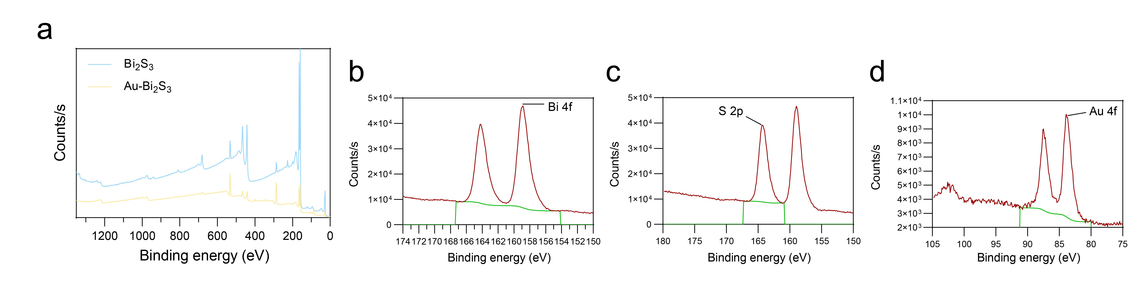
Figure S1. Supplementary chemical characterization of Bi₂S₃ and Au-Bi₂S₃ nanocomposites. (a) XPS full survey spectra of pure Bi₂S₃ and Au-Bi₂S₃ heterostructures. High-resolution XPS spectra of (b) Bi 4f, (c) S 2p, and (d) Au 4f in Au-Bi₂S₃ composites. XPS results further confirm the successful synthesis of Au-Bi₂S₃ heterostructures and verify the elemental valence state changes after Au modification, proving the formation of heterogeneous interfaces.

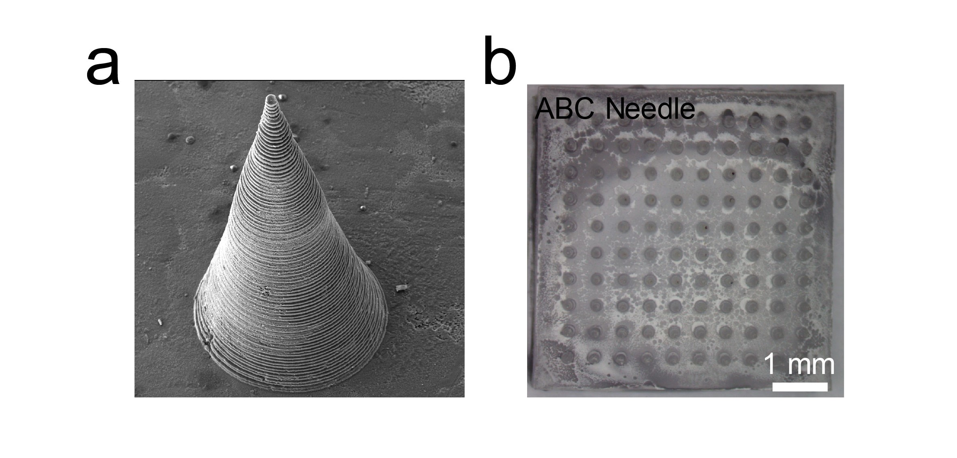
Figure S2. Macroscopic and microscopic morphology of ABC microneedle arrays. (a) Low-magnification SEM image of large-area ABC microneedle array, showing highly ordered and uniform needle structure. (b) Side-view SEM image of a single ABC microneedle, confirming sharp tip and complete structure suitable for skin penetration.

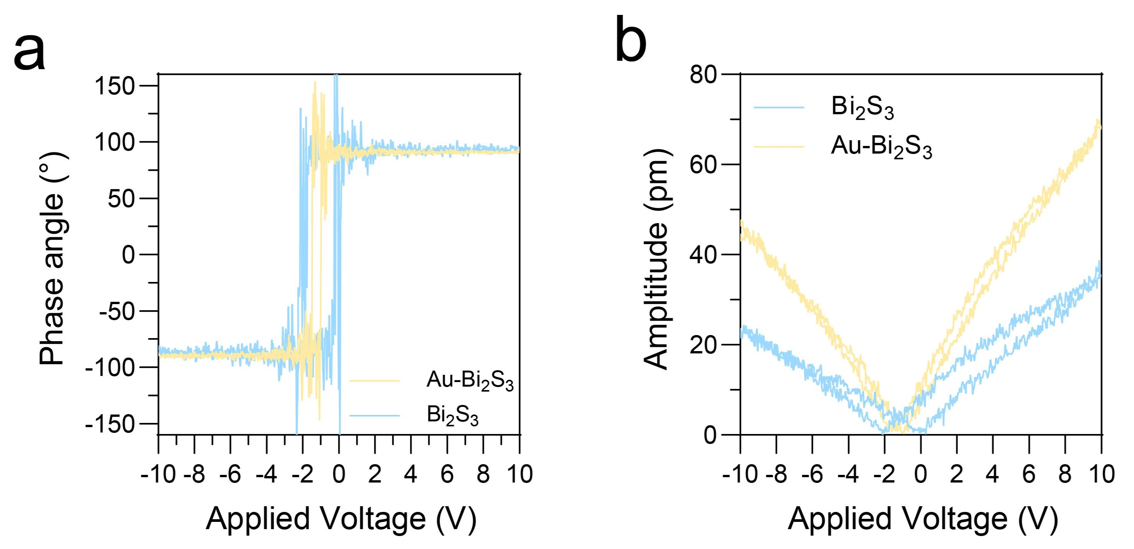
Figure S3. Piezoresponse performance of Bi₂S₃ and Au-Bi₂S₃ nanomaterials. (a) PFM phase hysteresis loops and (b) amplitude curves of pure Bi₂S₃ and Au-Bi₂S₃ under applied voltage. Au-Bi₂S₃ exhibits significantly enhanced piezoresponse amplitude and better piezoelectric polarization performance, which is attributed to the Schottky junction-induced charge separation effect.

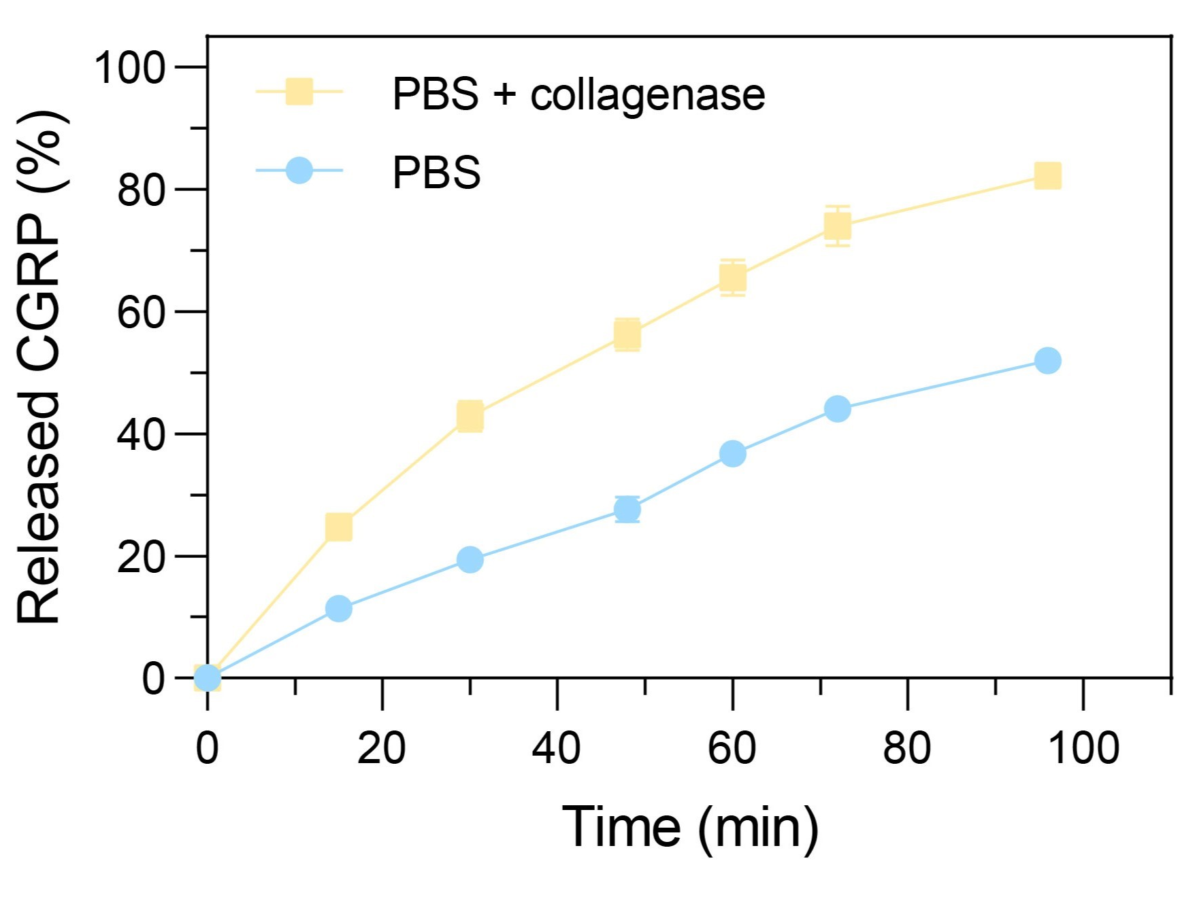
Figure S4. Time-dependent cumulative release curve of CGRP from ABC microneedles. CGRP release behavior of ABC microneedles incubated in pure PBS and collagenase-containing PBS within 96 h. The release rate of CGRP is significantly accelerated in the protease-containing microenvironment, verifying the protease-responsive controlled release property of the hydrogel microneedle matrix.

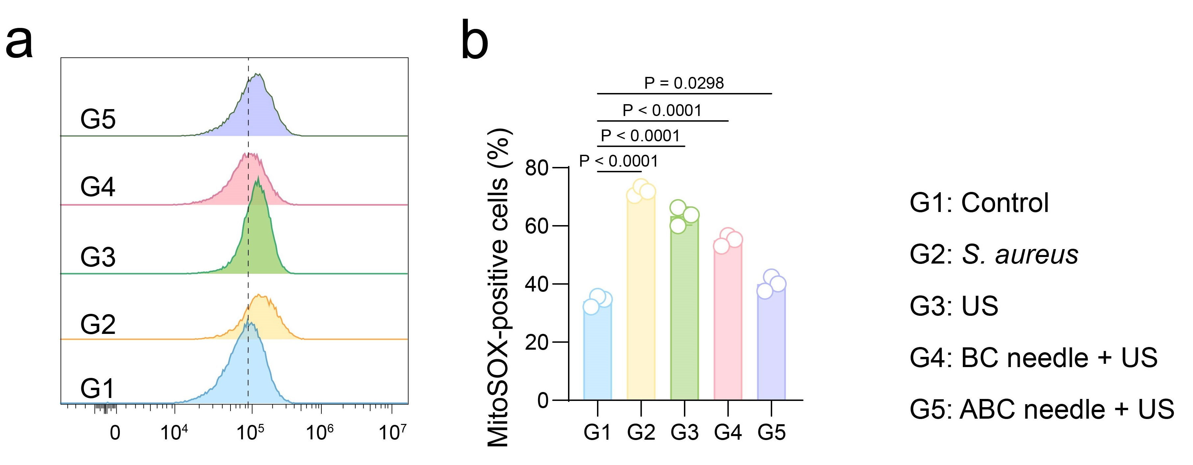
Figure S5. Mitochondrial superoxide level of PC12 cells after different treatments. (a) Representative MitoSOX fluorescence staining images of PC12 cells in each group. (b) Quantitative analysis of MitoSOX-positive cell proportion. ABC needle + US treatment significantly reduces mitochondrial superoxide accumulation and alleviates bacterial infection-induced mitochondrial oxidative damage.

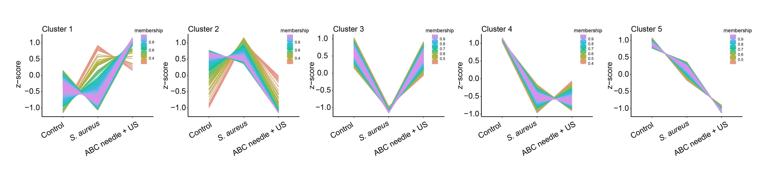
Figure S6. Transcriptional clustering analysis of PC12 cell samples. Unsupervised hierarchical clustering heatmap of all differentially expressed genes in control, S. aureus-infected, and ABC needle + US treatment groups, showing obvious transcriptional profile differences among groups and treatment-induced transcriptional reprogramming.

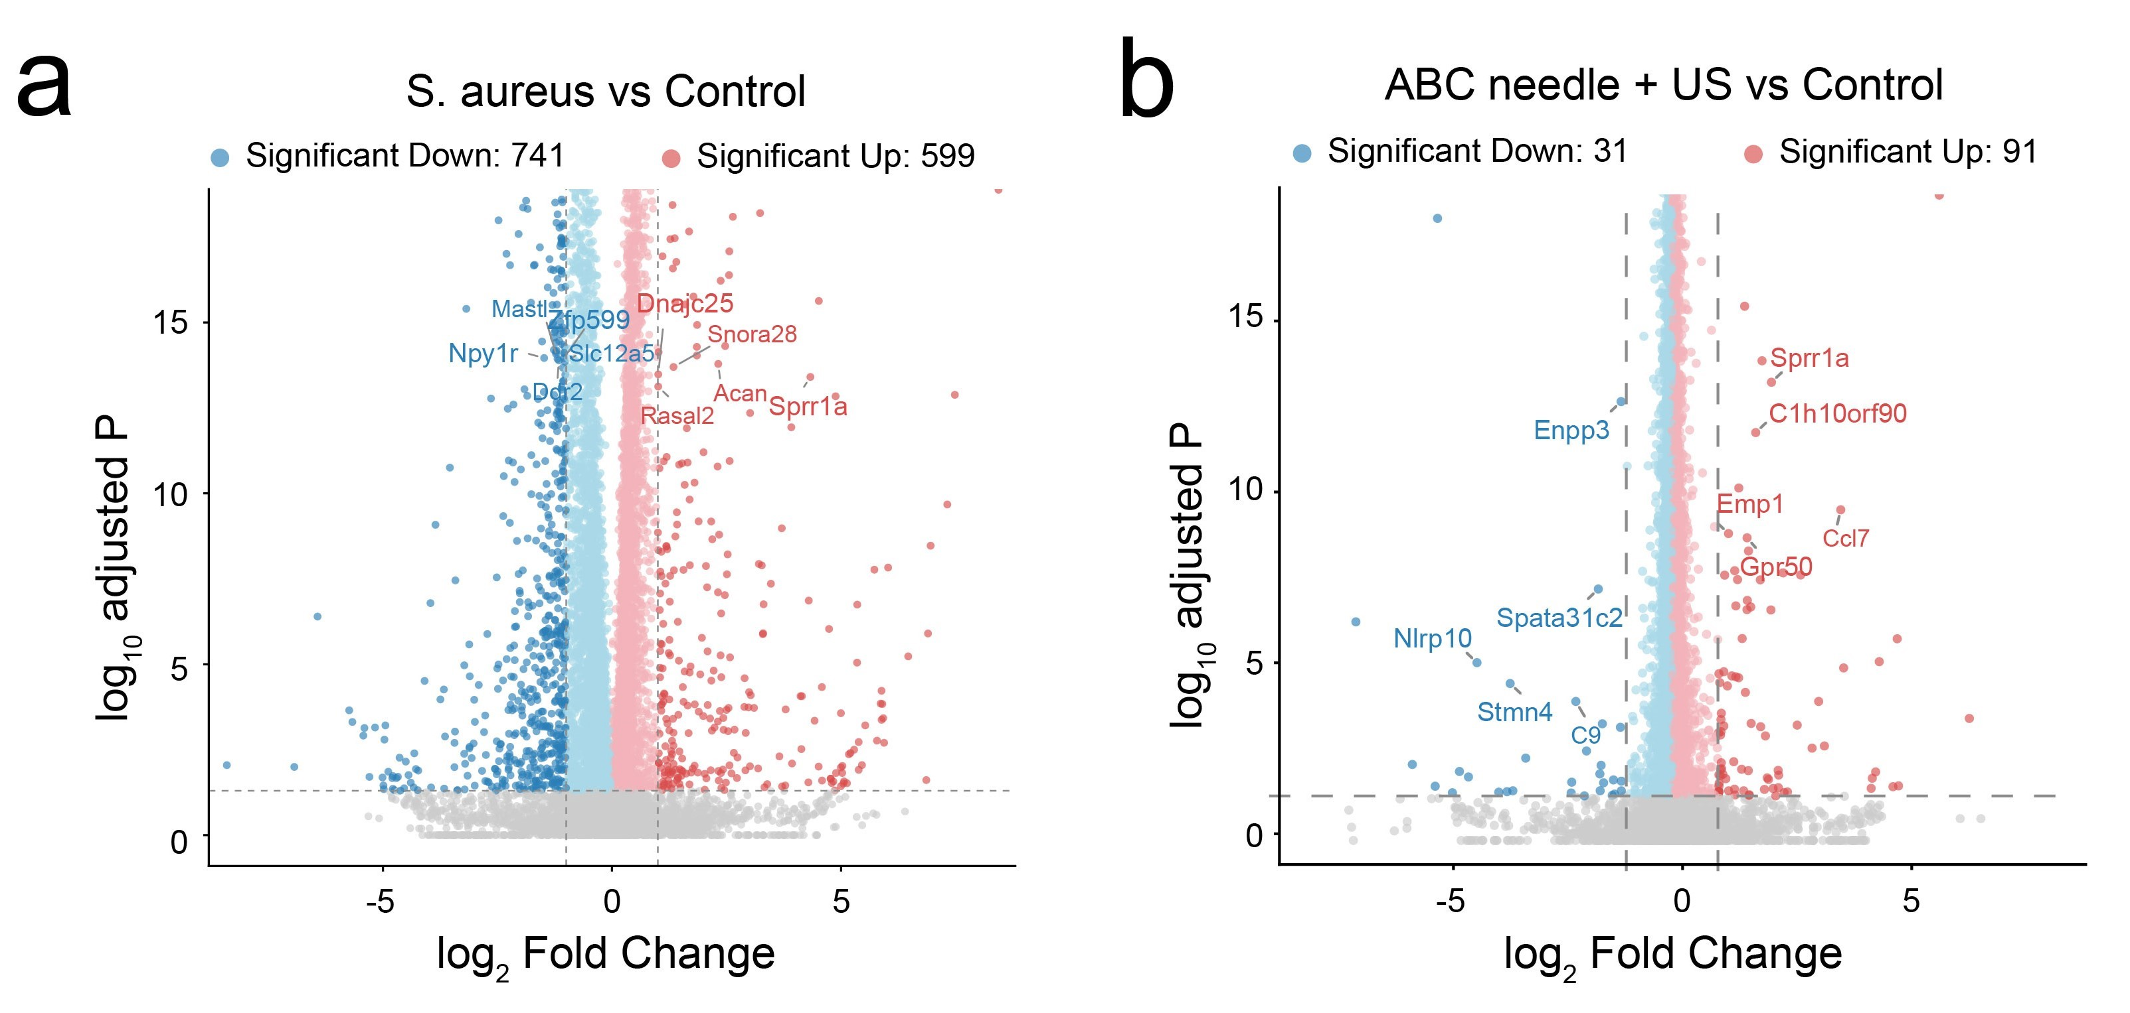
Figure S7. Statistical analysis of differentially expressed genes in PC12 cells. Venn diagram of DEGs among (a) control vsS. aureus and (b) ABC needle vs ABC needle + US groups, indicating that ABC microneedle treatment can largely reverse the transcriptional disturbance caused by bacterial infection.

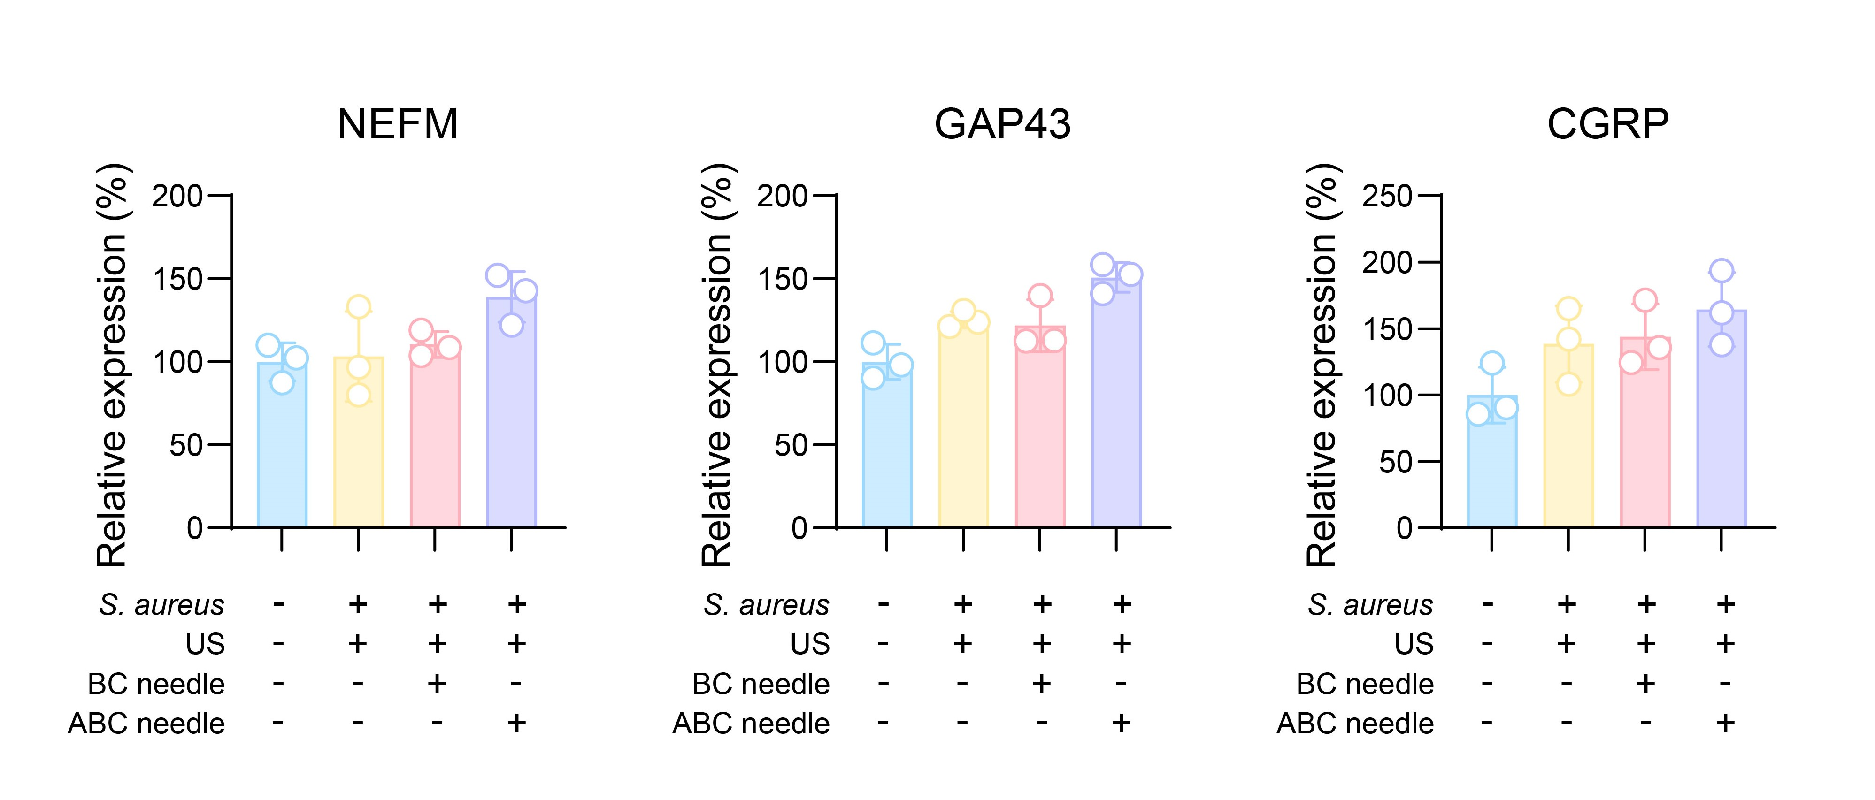
Figure S8. Full western blot images of NEFM, GAP43, CGRP and β-actin in PC12 cells. Complete uncropped western blot bands corresponding to Figure 5n, verifying the consistent upregulation of neuronal regeneration and CGRP-related proteins after ABC needle + US treatment.
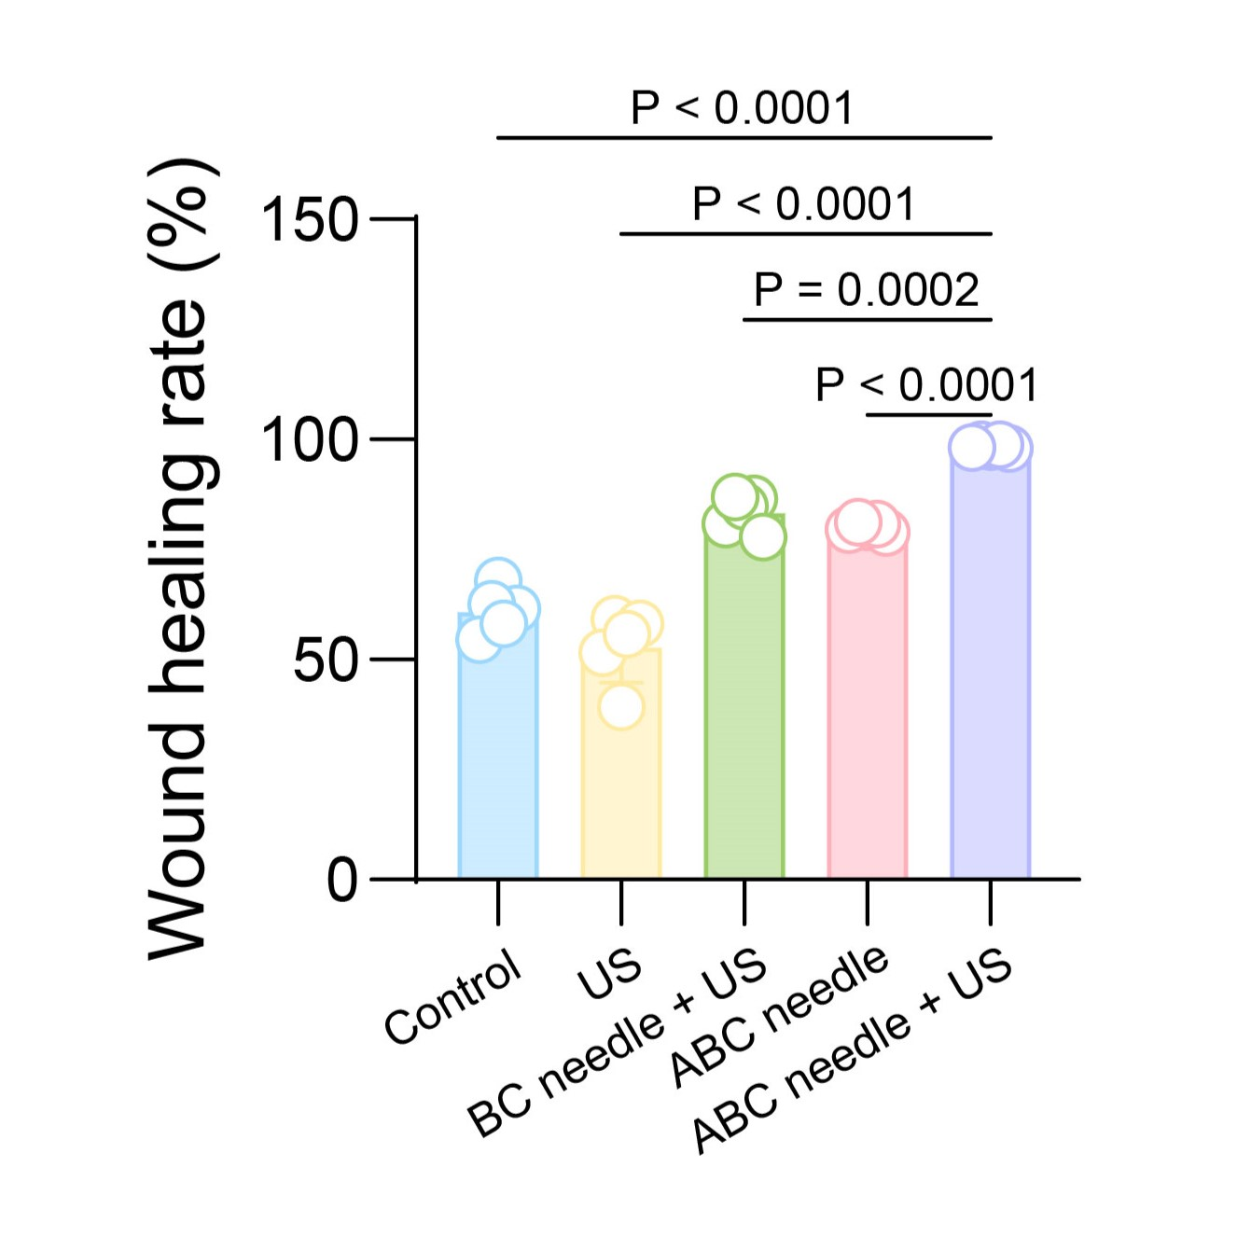
Figure S9. Statistical curve of wound healing rate within 14 days. Dynamic wound closure rate of mice in each experimental group from day 1 to day 14, showing that the ABC needle + US synergistic group has the fastest wound healing speed and the best repair effect.

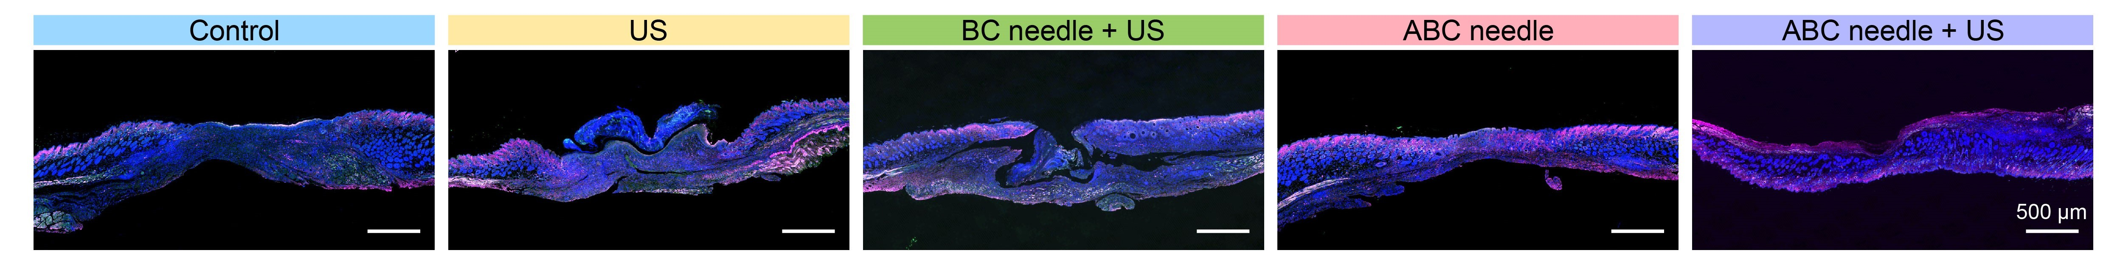
Figure S10. Wide-field fluorescence imaging of CGRP and TRPV1 in wound tissue. Large-area scanning fluorescence images of TRPV1 (green) and CGRP (magenta) in wound sections of each group, confirming that ABC needle + US treatment significantly restores the overall distribution and expression level of cutaneous sensory neuropeptide signals.

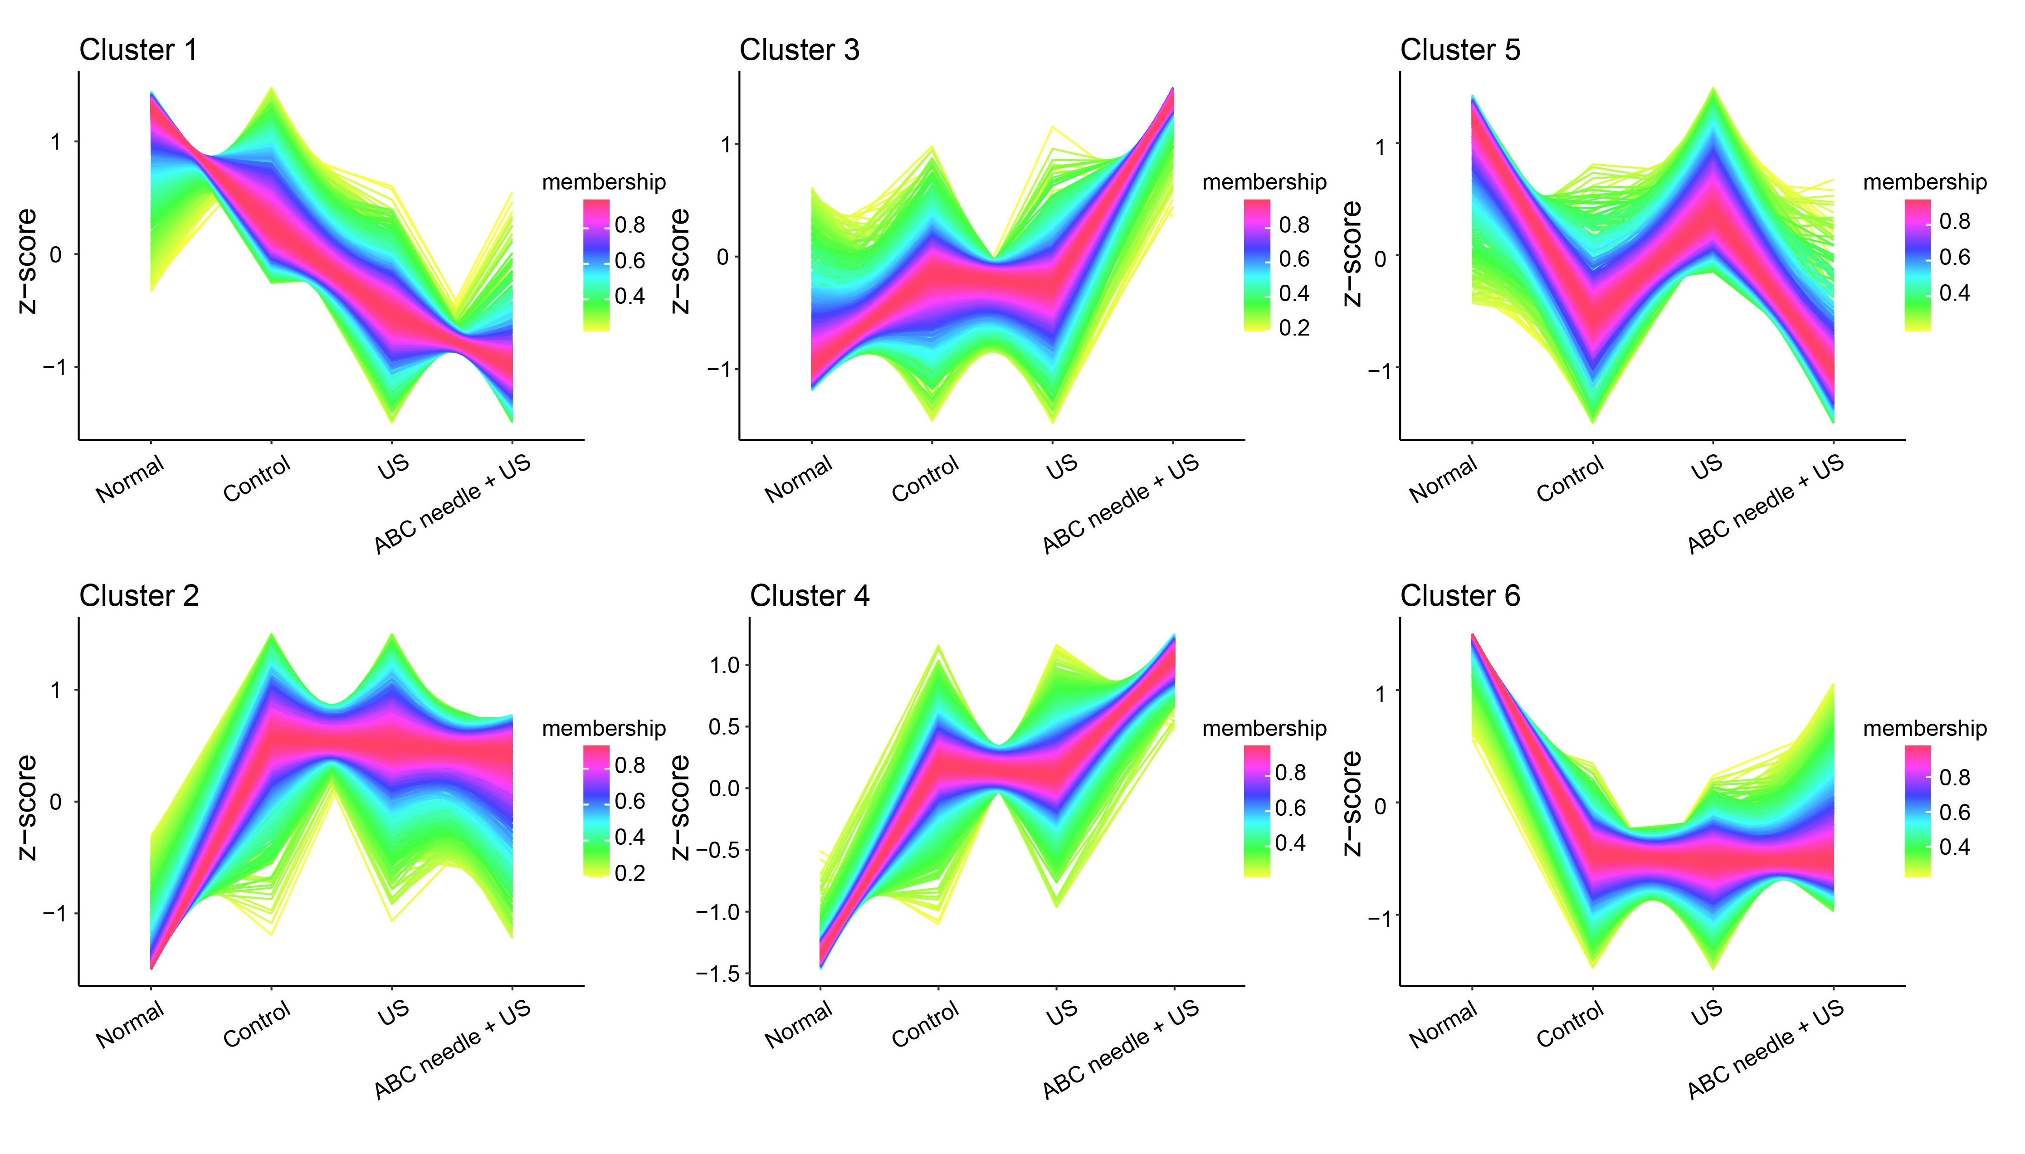
Figure S11. Transcriptome clustering of wound tissue samples. PCA analysis of transcriptional profiles of normal skin and wound tissues in different treatment groups, demonstrating that ABC microneedle ultrasound treatment remodels the wound transcriptome into a unique repair-oriented state rather than simply restoring normal skin homeostasis.

