Supplemental Table 1. Primer and probe sequences for the detection of SARS-CoV-2 by RT-PCR.
Assay/use | Oligonucleotide | Sequenceª
RdRP gene | RdRp_SARSr-F | GTGARATGGTCATGTGTGGCGG
RdRP gene | RdRp_SARSr-P2 | FAM-CAGGTGGAACCTCATCAGGAGATGC-BBQ
RdRP gene | RdRP_SARSr-P1 | FAM-CCAGGTGGWACRTCATCMGGTGATGC-BBQ
RdRP gene | RdRp_SARSr-R | CARATGTTAAASACACTATTAGCATA
E gene | E_Sarbeco_F | ACAGGTACGTTAATAGTTAATAGCGT
E gene | E_Sarbeco_P1 | FAM-ACACTAGCCATCCTTACTGCGCTTCG-BBQ
E gene | E_Sarbeco_R | ATATTGCAGCAGTACGCACACA
N gene | N_Sarbeco_F | CACATTGGCACCCGCAATC
N gene | N_Sarbeco_P | FAM-ACTTCCTCAAGGAACAACATTGCCA-BBQ
N gene | N_Sarbeco_R | GAGGAACGAGAAGAGGCTTG
ªW is A/T; R is G/A; M is A/C; S is G/C. FAM: 6-carboxyfluorescein; BBQ: blackberry quencher.

Supplemental Table 2. Clinical characteristics and laboratory parameters of COVID-19 and influenza patients according to their disease outcome
Characteristic | Influenza |  |  | COVID-19
Characteristic | Survivors  N = 52 | Deceased  N = 16 | p-value | Survivors  N = 14 | Deceased  N = 10 | p-value
Age (years), median (range) | 48 (20-57) | 49 (37-75) | 0.5397 | 54 (28-71) | 48 (36-73) | 0.9889
Males | 37 (71.1) | 11 (68.7) | >0.9999 | 10 (71.4) | 8 (80) | >0.9999
BMI | 33.4 (30-38.1) | 33.3 (29.7-44.4) | 0.7603 | 28.5 (25.3-30.1) | 29.6 (24.8-31.4) | 0.7961
Comorbidities  Smoking  Diabetes  SAH  OSA  COPD | 19 (36.5)  10 (19.2)  13 (25)  2 (3.8)  1 (1.9) | 8 (50)  4 (25)  5 (31.2)  2 (12.5)  2 (12.5) | 0.3889  0.7255  0.7472  0.2334  0.1357 | 2 (14.2)  5 (35.7)  5 (35.7)  0 (0)  1 (7.1) | 3 (30)  2 (20)  0 (0)  0 (0)  0 (0) | 0.6146  0.6529  0.0530  >0.9999  >0.9999
Symptoms at onset  Fever  Myalgia  Arthralgia  Headache  Dyspnea  Nasal congestion  Rhinorrhea  Sore throat  Thoracic pain  Cough  Sputum  Dry cough  Fatigue  Diarrhea  Nausea  Vomit | 47 (90.3)  44 (84.6)  41 (80.3)  26 (50)  49 (94.2)  7 (13.4)  18 (34.6)  22 (43.1)  6 (11.5)  50 (96.1)  29 (55.7)  20 (39.2)  37 (71.1)  4 (7.6)  2 (3.8)  2 (3.8) | 15 (93.7)  12 (75)  12 (75)  7 (43.7)  16 (100)  6 (37.5)  8 (50)  2 (12.5)  3 (18.7)  16 (100)  9 (56.2)  7 (43.7)  12 (75)  1 (6.2)  2 (12.5)  0 (0) | >0.9999  0.4564  0.7395  0.7776  0.3362  0.0630  0.3783  0.0372  0.4299  >0.9999  >0.9999  0.7742  >0.9999  >0.9999  0.2334  >0.9999 | 11 (78.5)  10 (71.4)  8 (57.1)  6 (42.8)  6 (42.8)  0 (0)  2 (14.2)  2 (14.2)  0 (0)  12 (85.7)  2 (14.2)  10 (71.4)  10 (71.4)  3 (21.4)  3 (21.4)  3 (21.4) | 7 (70)  8 (80)  8 (80)  5 (50)  10 (100)  1 (10)  1 (10)  2 (20)  0 (0)  9 (90)  0 (0)  9 (90)  8 (80)  2 (20)  0 (0)  1 (10) | 0.6653  >0.9999  0.3875  >0.9999  0.0064  0.4167  >0.9999  >0.9999  >0.9999  >0.9999  0.4928  0.3577  >0.9999  >0.9999  0.2391  0.6146
Illness onset - hospital admission  (days) | 7.5 (5-12) | 7.5 (6-11) | 0.9513 | 5.5 (3-11) | 6 (5-11) | 0.4776
Vital signs at admission  Body temperature (ºC)  Respiratory rate (bpm)  Hearth rate (bpm)  MAP (mmHg) | 38 (37-38)  25 (20-30)  96 (85-109)  86.1 (75-93.5) | 38 (37-38)  24 (20-27)  98 (88-104)  82.8 (74.1-96.5) | 0.9196  0.4427  0.7069  0.9344 | 37 (36.6-37.6)  24 (20-26)  88 (81-99)  81 (75-87.2) | 37 (37-37)  24 (22-26)  78 (69-88)  71.5 (69.5-88.5) | 0.9883  0.9435  0.1185  0.1331
Glucose (mg/dL) | 140 (111.9-207.6) | 179.7 (135.5-277) | 0.0534 | 202 (150.8-281.8) | 124.3 (98.4-179.8) | 0.7521
Blood count  White blood cells (10⁹/L)  Neutrophils (10⁹/L)  Lymphocytes (10⁹/L)  NLR  Hgb (g/dL)  Platelets (10⁹/L) | 7.2 (5.9-22.5)  5.7 (4.6-7.7)  0.8 (0.5-1.1)  8.3 (4.9-12.6)  14.7 (13.2-17.1)  186 (154.3-220.3) | 7.1 (5.1-13.4)  5.8 (4.2-11.4)  0.8 (0.5-0.9)  10.2 (6.9-12.7)  16.4 (14-18.7)  139 (112.3-211.5) | 0.9629  0.7883  0.6951  0.2201  0.1034  0.0342 | 7.7 (4.1-10)  4.7 (2.7-8.9)  0.8 (0.6-1.0)  6.8 (3.2 – 12.5)  14.6 (13.4-16.2)  202 (150.8-281.8) | 9.8 (6.9-14.5)  9.0 (5.9-12.7)  0.8 (0.5-1.2)  12.6 (4.8-17.5)  13.2 (12.2-15.4)  200 (137.8-246.3) | 0.0926  0.0643  0.7409  0.1375  0.0576  0.7961
Renal function  Cr (mg/dL)  BUN (mg/dL)  Na (mmol/L)  K (mmol/L) | 0.9 (0.7-1.3)  20.3 (13.7-33.1)  137.4(133.3-140.5)  4 (3.8-4.3) | 1.1 (0.9-2.3)  29.9 (26.5-54.6)  137.4(134.9-142.2)  4.5 (4-4.7) | 0.1034  0.0014  0.6441  0.0242 | 1.0 (0.8-1.3)  17.5 (13.3-25.9)  137 (135-139.2)  4.1 (3.9-4.3) | 0.9 (0.6-1.5)  20.4 (14.3-32.8)  141.1(138.8-142.4)  4.1 (3.9-4.4) | 0.3948  0.4622  0.0111  0.8744
Liver function  Total bilirubin (mg/dL)  AST (U/L)  ALT (U/L) | 0.5 (0.4-0.8)  60.9 (43-81.8)  37.7 (25.1-51.4) | 0.6 (0.5-0.8)  71.8 (53.4-113.3)  44 (29.9-63.4) | 0.5283  0.0756  0.2042 | 0.4 (0.3-0.7)  32.4 (21.5-46)  29.6 (19.9-41.4) | 0.5 (0.4-0.8)  58.5 (25.5-106.8)  41 (27.3-63) | 0.6559  0.2408  0.1674
Other biomarkers  LDH (U/L)  ALP (U/L)  CPK (U/L)  Procalcitonin (ng/mL) | 616 (461.8-811.1)  118 (98.2-161.1)  274.4 (108-738.6)  0.3 (0.1-1.4) | 800.8 (555.9-1151)  125.1 (97.4-171.1)  248.1 (109.1-506.6)  1.3 (0.4-4.7) | 0.0733  0.5626  0.6444  0.0442 | 289.5(189.5-439.2)  77.9 (69.2-86.8)  83.5 (47.4-429.6)  0.1 (0.05-0.1) | 373 (314.6-504.5)  80.1 (61.3-92.9)  601.3 (69.5-2136)  0.1 (0.08-0.1) | 0.1083  0.8408  0.1721  0.8727
PaO₂/FiO₂ | 92.5 (59.9-149) | 76.2 (57.9-129) | 0.4665 | 129.2 (73.9-314) | 113.2 (97.3-172.1) | 0.5233
Severity of illness scores  SOFA  APACHE II | 7 (5-8)  9 (7-15) | 8 (7-12)  14 (9-20) | 0.0369  0.1008 | 3 (2-6)  6 (4-8) | 6 (3-8)  7 (5-12) | 0.0323  0.5932
Respiratory support  High flow nasal cannula  MV  Prone position  ECMO | 0 (0)  52 (100)  30 (57.6)  4 (7.6) | 0 (0)  16 (100)  10 (62.5)  3 (18.7) | >0.9999  >0.9999  0.7797  0.3423 | 7 (50)  7 (50)  3 (21.4)  0 (0) | 0 (0)  10 (100)  5 (50)  0 (0) | 0.0188  0.0188  0.2038  >0.9999
Renal replacement therapy | 5 (9.6) | 11 (68.7) | <0.0001 | 2 (14.2) | 0 (0) | 0.4928
Data are displayed as n (%) or median (IQR). N is the total number of patients with available data. ALP, alkaline phosphatase; APACHE-II, Acute Physiology And Chronic Health Evaluation II; AST, aspartate aminotransferase; ALT, alanine aminotransferase; BMI, body mass index; bpm, breaths/beats per minute; BUN, blood ureic nitrogen; COPD, chronic obstructive pulmonary disease; CPK, creatine phosphokinase; Cr, creatinine; ECMO, extra-corporeal membrane oxygenation; FiO2, fraction of inspired oxygen; HCO3, bicarbonate; Hgb, hemoglobin; IQR, interquartile range; ICU, intensive care unit; LDH, lactate dehydrogenase; MAP, mean arterial pressure; MV, mechanical ventilation; ND, not determined; NLR, neutrophil/lymphocyte ration; OSA, obstructive sleep apnea syndrome; PaO2, partial pressure of oxygen in arterial blood; PCO2, partial pressure of carbon dioxide in blood; SAH, systemic arterial hypertension; SD, standard deviation; SOFA, Sequential Organ Failure Assessment. Differences in continuous variables were estimated using the Mann Whitney U test. Differences in categorical variables were calculated using the Fisher’s exact or the Chi square test as appropriate.

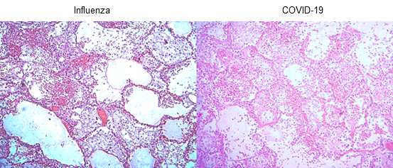
Supplemental Figure 1. Histological characteristics of the lungs of patients with pandemic influenza A(H1N1) and COVID-19. Lung tissue autopsy specimens were obtained from patients that succumbed to influenza and COVID-19. Left panel: Inflammatory infiltrates occupying the alveolar space and composed of macrophages, polymorphonuclear cells, fibrin deposits, as well as hemorrhages were observed in influenza patients. Right panel: Morphological changes of COVID-19 consisted of extensive inflammation, thickening of the alveolar walls, and partial loss of the histological architecture. H&E staining, X100.

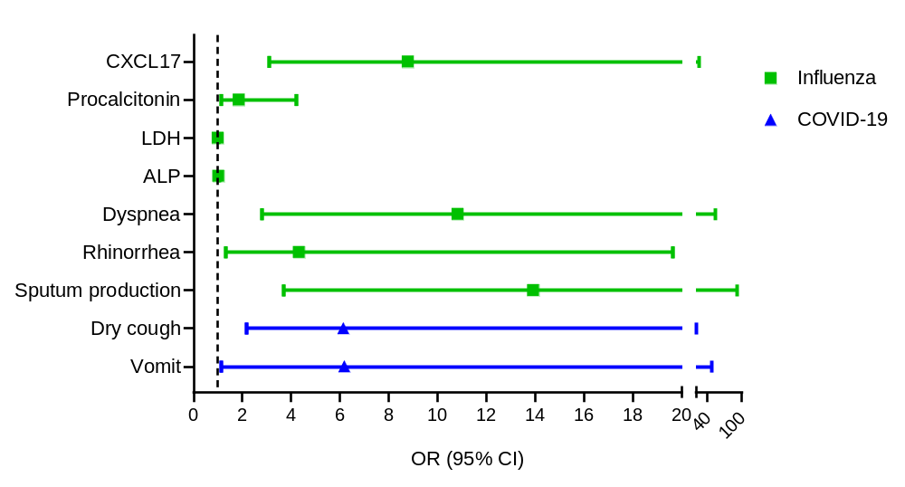
Supplemental Figure 2. Diagnostic value of clinical factors and serum CXCL17 levels to distinguish between influenza and COVID-19. Bivariate logistic regression analysis of the factors predicting the causative pathogen in patients with severe acute respiratory illness. The forest plots show the odds ratio (OR) and 95% CI interval values that were significant for influenza (green squares) and COVID-19 (blue triangles).

