Supplementary Information to Monolithic all-optical phase regenerator via parity-time symmetry
Zhuang Fan^{1†}, Yukun Huang^{1†}, Wuqiang Chi^{1†}, Wenchan Dong¹, Haodong Yang¹, Jiahao Hu², Yizheng Chen¹, Kunpeng Zhai³, Kun Qiu², Ninghua Zhu³, Xinliang Zhang^{1,4}, Huashun Wen^{3,5,6,7*}, Heng Zhou^{2,8*}, Jing Xu^{1,4,9*}
¹School of Optical and Electronic Information and Wuhan National Laboratory for Optoelectronics, Huazhong University of Science and Technology, Wuhan 430074, China
²Key Lab of Optical Fiber Sensing and Communication Networks, School of Information and Communication Engineering, University of Electronic Science and Technology of China, Chengdu 611731, China
³ Institute of Intelligent Photonics, Nankai University, Tianjin 300071, China
⁴Optics Valley Laboratory, Hubei 430074, China
⁵ National Key Laboratory of Semiconductor Laser, Nankai University, Tianjin 300071, China
⁶ Academy for Advanced Interdisciplinary Studies, Nankai University, Tianjin 300071, China
⁷Corresponding author: whs@nankai.edu.cn
⁸Corresponding author: zhouheng@uestc.edu.cn
⁹Corresponding author: jing_xu@hust.edu.cn
†These authors contributed equally
context
S1. Theoretical frameworks of the coupled cavity system 2
S2. Nonlinear theoretical framework for KIS and regeneration 6
S3. Numerical simulation of KIS via idler injection 9
S4. Additional data for locking range 12
S5. Numerical simulation of phase-squeezing 12
S6. Additional data for constellation diagrams 14
Reference 15

S1. Theoretical frameworks of the coupled cavity system
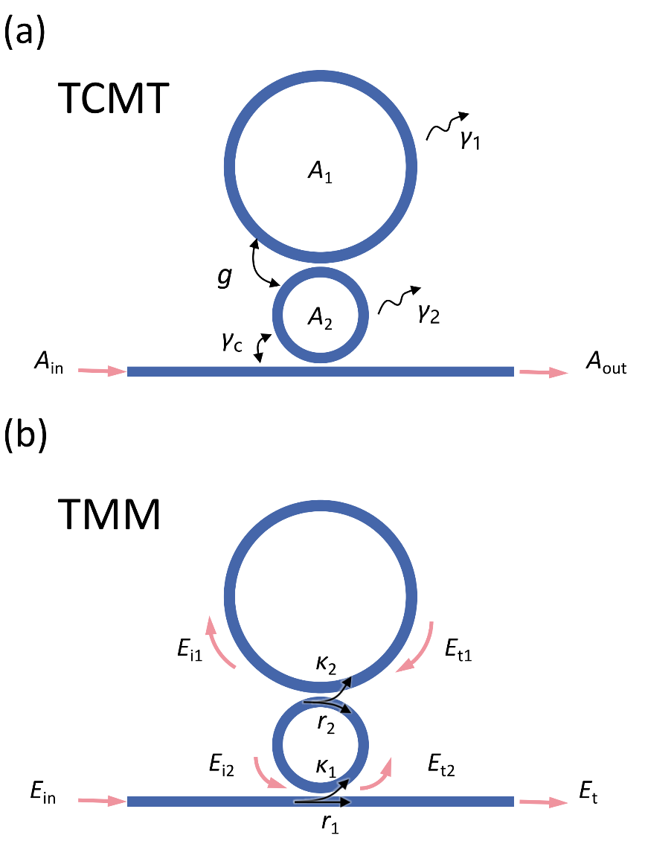
Fig. S1. Schematic diagrams of two different linear models of the coupled cavity system. (a) Temporal coupled mode theory (TCMT) (b) Transfer matrix method (TMM).
Figure S1 presents the schematic diagrams of the theoretical frameworks of the coupled cavity, with the meanings of different symbols annotated in the illustration. From the basis of temporal coupled mode theory (TCMT, Fig. S1a) ¹, we define the intracavity mode field of the main cavity as $A_{1}$, the intracavity mode field of the auxiliary cavity as $A_{2}$, the resonance angular frequency as $ω_{0}$, the energy coupling rate between the main cavity and the auxiliary cavity as $g$, the coupling rate between the auxiliary cavity and the bus waveguide as $γ_{c}$, the intrinsic decay rates of the main cavity and auxiliary cavity as $γ_{1}$ and $γ_{2}$, the input field as $A_{in}$, and the output field as $A_{out}$.
The coupled mode equations can be written as:
$$\begin{aligned}\begin{matrix}\frac{dA_{1}}{dt}=−iω_{0}A_{1}−\frac{γ_{1}}{2}A_{1}−{igA}_{2}, \\ \begin{matrix}\frac{dA_{2}}{dt}=−iω_{0}A_{2}−\frac{γ_{2}+γ_{c}}{2}A_{2}−{igA}_{1}−\sqrt{γ_{c}}A_{in}, \\ A_{out}=A_{in}+\sqrt{γ_{c}}A_{2}.\end{matrix}\end{matrix}\#\left(S1\right)\end{aligned}$$
The non-Hermitian Hamiltonian of the coupled cavity system then reads $\hat{H}=\left[\begin{matrix}ω_{0}−i\frac{γ_{1}}{2} & g \\ g & ω_{0}−i\frac{γ_{2}+γ_{c}}{2}\end{matrix}\right]$. When the two cavities have identical intrinsic decay rates $γ_{1}=γ_{2}≪γ_{c}$, and the system operates in the vicinity of the exceptional point, namely $γ_{c}≈4g$, we can obtain the approximate eigen-frequencies $ω_{+}=ω_{−}≈ω_{0}−iγ_{c}/4$. These eigenstates give rise to the broad, low‑Q resonances discussed in the main text.
The transfer matrix method (TMM, Fig. S1b) is another widely adopted technique for analyzing the transmission spectra and intracavity field enhancement of coupled microcavities, which can be applied to fit the transmission spectra of microcavities for extracting microring parameters such as coupling coefficients and calculate the field enhancement within microrings ². It considers the phase shift and optical loss accumulated as light completes one full round trip inside microresonators. With the lossless approximation adopted for the coupling region — i.e., assuming the coupling process conserves energy — the following equation can be derived for the coupled double cavities described above:³:
$\left[\begin{matrix}E_{t} \\ E_{t2}\end{matrix}\right]=\left[\begin{matrix}r_{1} & −iκ_{1} \\ −iκ_{1} & r_{1}\end{matrix}\right]\left[\begin{matrix}E_{in} \\ E_{i2}\end{matrix}\right]$, (S2)
$\left[\begin{matrix}E_{i1} \\ E_{i2}{a_{2}}^{−\frac{1}{2}}e^{−i\frac{φ_{2}}{2}}\end{matrix}\right]=\left[\begin{matrix}r_{2} & −iκ_{2} \\ −iκ_{2} & r_{2}\end{matrix}\right]\left[\begin{matrix}E_{i1}a_{1}e^{iφ_{1}} \\ E_{t2}{a_{2}}^{\frac{1}{2}}e^{i\frac{φ_{2}}{2}}\end{matrix}\right]$, (S3)
where $E_{in}$ is the input field, $E_{t}$ is the output field at the bus waveguide, $κ_{1}$is the field coupling coefficient between the auxiliary resonator and the waveguide, $κ_{2}$ is the field coupling coefficient between the resonators, $r_{j=1,2}$is the transmission coefficient, and ${r_{i}}^{2}+{κ_{i}}^{2}=1$. $E_{i1}, E_{t1}$ are the fields in the main resonator, $E_{i2}, E_{t2}$ are the fields in the auxiliary resonator. $a_{i=1,2}=e^{−α_{0}L_{i}/2}$ are the roundtrip field attenuation factor of the resonators, where $α_{0}$ is the transmission loss per unit length, and $L_{i=1,2}$ are the perimeter of the resonators. $φ_{i=1,2}$ are the phase shift of input light traveling per roundtrip in the resonators, and indices 1 and 2 refers to the main and auxiliary resonator, respectively.
From Eq.(S2) and Eq.(S3), the transmission spectrum of the coupled cavity can be derived as:
$$\begin{aligned}T={\left|\frac{E_{out}}{E_{in}}\right|}^{2}={\left|\frac{r_{2}−a_{1}τexp\left({iφ}_{1}\right)}{1−r_{2}a_{1}τexp\left({iφ}_{1}\right)}\right|}^{2},\#(S4)\end{aligned}$$
where $τ=\frac{r_{1}−a_{2}τexp\left({iφ}_{2}\right)}{1−r_{1}a_{2}τexp\left({iφ}_{2}\right)}.$ Analytical expression of the transmission spectrum can also be found using TCMT, which matches TMM under weak coupling and low loss approximations. More comparison can be found in Ref. 3.
To extract the coupling parameters of the microcavity, the measured transmission spectrum of the device with a 7.1 GHz broadband bandwidth was fitted using Eq. (S4), as shown by the black dashed line in Fig. 2 of the main text. Table S1 lists the TMM parameters obtained by fitting with Eq. (S4). The TCMT parameters ($g$, $γ_{c}$, $γ_{1}$), which are also listed in Table S1, are derived from TMM parameters using the conversion relations given in Table S2 (assuming $γ_{1}=γ_{2}$). Figure S2 presents the locations of different devices in the parameter space. The 7.1 GHz device is located at the PT‑symmetry‑broken regime, where no mode/frequency splitting takes place. By tuning the parameters $γ_{c}$ and g, we can design devices that occupy distinct positions in the parameter space. The 12.5 GHz and 15.1 GHz devices lie in the PT‑symmetric regime but close to EP, where slightly mode splitting occurs and the bandwidth is increased. Nevertheless, as shown below, their field enhancement is reduced compared with the 7.1 GHz device. Figure S3a and S3b shows the fitted curves alongside the experimentally measured transmission spectra for devices with 12.5 and 15.1 bandwidths, respectively.

Table S1. TMM and TCMT parameters of the coupled microring resonators
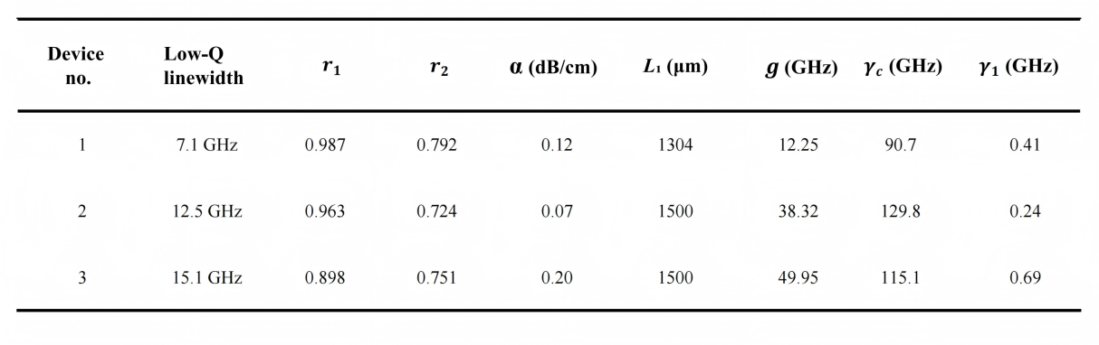
Table S2. The relationships between the parameters of the TMM and TCMT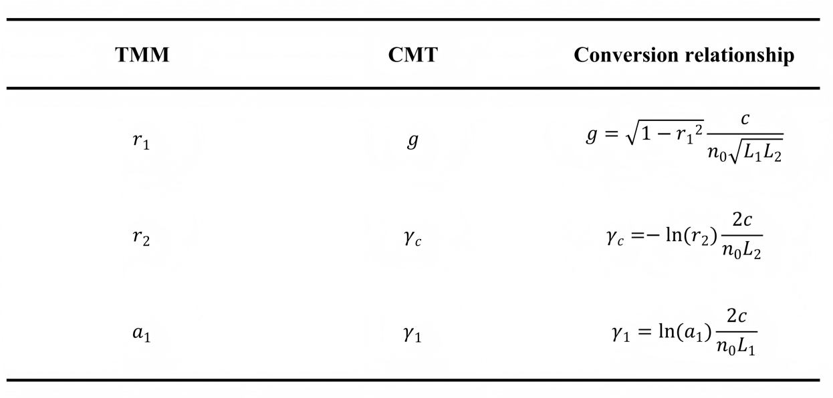
* The c refers to the speed of light and n₀ refers to the effective mode index of the resonators.

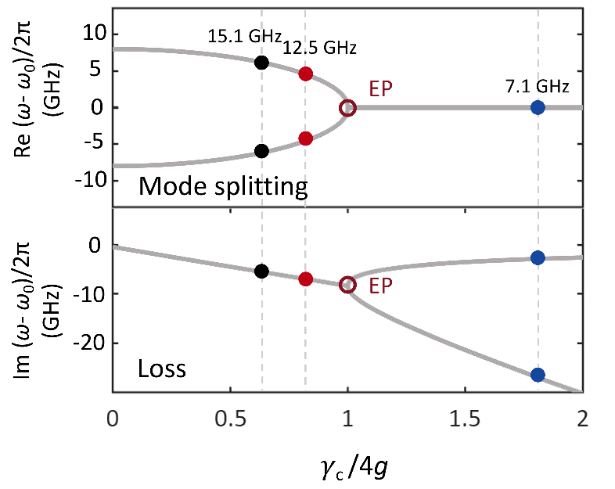
Fig. S2. Different locations of devices with different bandwidths in the parameter space
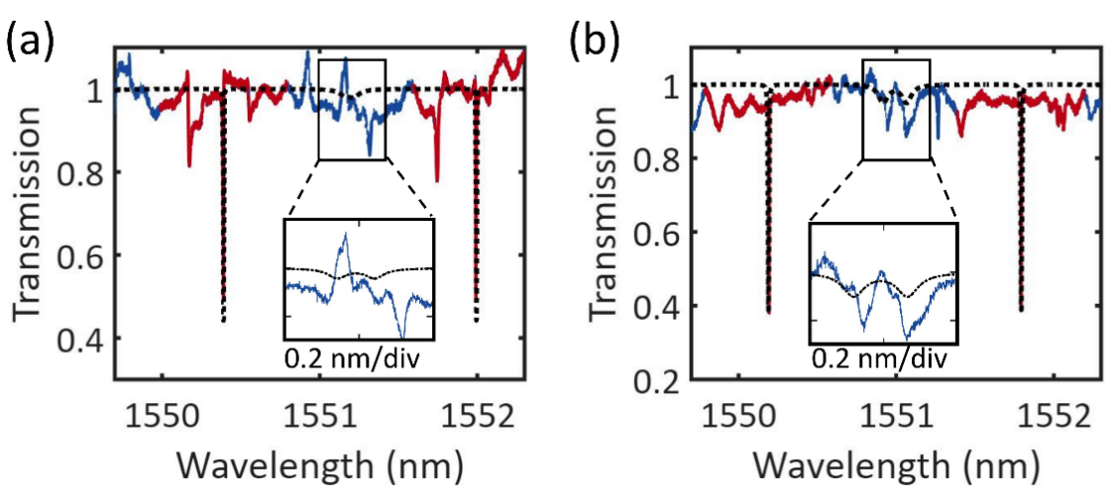
Fig. S3. Comparison of the measured transmission spectrum with the TMM analytical fit. (a) The transmission spectrum and fitted curve of the 12.5 GHz device. (b) The transmission spectrum and fitted curve of the 15.1 GHz device.

From Eq.(S2) and Eq.(S3), the field enhancement factor in the main cavity, which is defined as $\left|\frac{E_{i1}}{E_{in}}\right|$, can be derived as:
$$\begin{aligned}FE=\left|\frac{−κ_{1}κ_{2}\sqrt{a_{2}}\exp{(}iφ_{2}/2)}{1−r_{2}a_{1}\exp{(}iφ_{1})−r_{1}r_{2}a_{2}\exp{(}iφ_{2})+r_{1}a_{1}a_{2}\exp{(}iφ_{1}{+iφ}_{2})}\right|, \#\left(S5\right)\end{aligned}$$
By substituting the parameters extracted from the above fitting into the Eq. (S5) equation, we obtained the field enhancement for devices with different low-Q linewidths, as shown in Fig. S4. The main cavity perimeter $L_{1}$ of all devices is set to 1500 μm, with all other physical parameters kept unchanged. Note that the field enhancements are functions of wavelength, where the enhancement at central wavelength of the narrow and broad resonances, i.e., ${FE}_{n}$ and ${FE}_{b}$, respectively, are used in the following analysis. The power of the injected idler generated via FWM satisfies the relation $P_{i}={\left(γP_{s}L_{eff}\right)}^{2}{{FE}_{n}}^{4}{{FE}_{b}}^{4}P_{p}$⁴, where ${L_{eff}}^{2}={L_{1}}^{2}e^{−αL}{\left|\frac{1−e^{−αL_{1}}}{αL}\right|}^{2}$, and $γ$ denotes the nonlinear coefficient. Under identical pump power and nonlinear coefficient, the differences in idler power among distinct devices are dominated by the product of field enhancement factors ${{FE}_{n}}^{4}{{FE}_{b}}^{4}$. Simulation results indicate that regarding the 7.1 GHz device, this product is 5 dB and 16 dB higher than that for the 12.5 GHz and 15.1 GHz devices, respectively. This accounts for the differences in locking range among various devices under the same probe optical power, as presented in the main text.

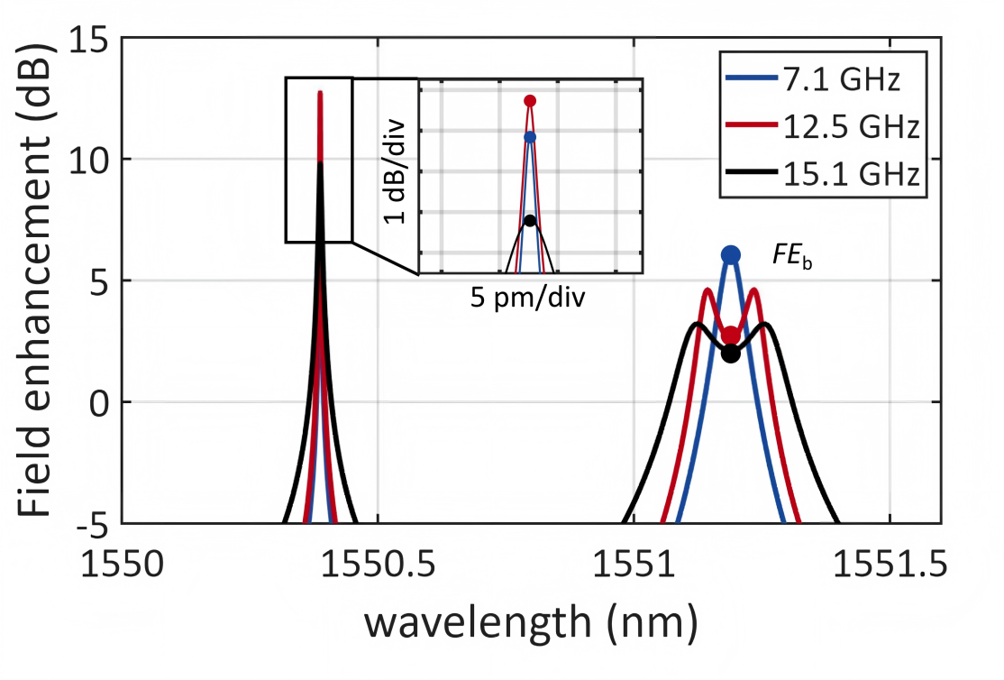
Fig. S4. The field enhancement of the main cavity in the coupled microcavity

S2. Nonlinear theoretical framework for KIS and regeneration
The following nonlinear coupled-mode equations form the theoretical model to describe the dynamics of the nonlinear PT-symmetric coupled microcavities, which comprise two input optical fields^{5–7}:
$$\begin{aligned}\frac{∂a_{μ}}{∂t}= \left(−\frac{κ_{μ}}{2}+iζ_{μ}\right)a_{μ}+δ_{μ0}\sqrt{κ_{ext0}}s_{p}+δ_{μ9}\sqrt{κ_{ext1}}s_{s}e^{−i\left(ω_{s}−ω_{p}−μD_{1}\right)t} \\ +ig\sum_{μ^{'},μ^{''},μ^{'''}}{a_{μ^{'}}}a_{μ^{''}}a_{μ^{'''}}^{∗} ,\#\left(S6\right)\end{aligned}$$
where $a_{μ}$ denotes the normalized mode amplitude, and ${\left|a_{μ}\right|}^{2}$ corresponds to the optical energy of mode $μ$ inside the microresonator. All mode numbers $μ$ are defined relative to the pumped mode $μ$ = 0, where odd indices correspond to low-Q modes and even indices correspond to high-Q modes, owing to the spectral interval distribution of high-Q and low-Q modes in PT-symmetric coupled microcavities. $κ_{μ}$ denotes the cavity decay rate, ${κ_{μ}=κ}_{i}+κ_{ext1}$ holds for odd modes while $κ_{μ}=κ_{i}+κ_{ext0}$ holds for even modes, $κ_{i}$ denotes the intrinsic decay rate, and $κ_{ext1}$, $κ_{ext0}$ represent the external decay rates, with $κ_{ext1}≫κ_{ext0}$. This disparity arises because the auxiliary ring effectively introduces an additional coupling loss exclusively for low-Q modes. $ζ_{μ}=ω_{μ} − ω_{p}− μD_{1}$ denotes the detuning of pump wave, where $ω_{μ}$ is the cold cavity eigenmodes frequencies, $ω_{p}$ denotes the frequency of pump wave, and $D_{1}$ is the FSR of main cavity. $ω_{s}$ denotes the frequency of signal wave. $s_{p}=\sqrt{P_{p}}$ and $s_{s}=\sqrt{P_{s}}$ denote the amplitude of the pump power $P_{p}$ and the noisy signal power $P_{s}$ coupled to the cavity and $δ_{μ0}, δ_{μ1}$ are Kronecker deltas. The cubic nonlinear of the resonant system is quantified by the nonlinear coupling coefficient $g$, defined as
$$\begin{aligned}g=γL{\left(\frac{D_{1}}{2π}\right)}^{2} ,\#\left(S7\right)\end{aligned}$$
where $γ$ denotes the nonlinear coefficient of the waveguide that constitute the microresonators, $L$ the perimeter of the resonator. The summation is done for all $μ^{'}$, $μ^{''}$, $μ^{'''}$ respecting the relation $μ=μ^{'}+μ^{''}−μ^{'''}$.
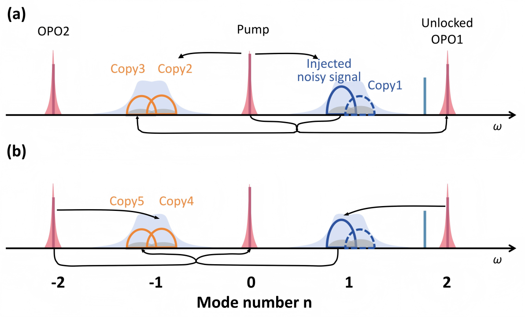
Fig. S5. Schematic diagram of the generation process of copy waves. (a) The generation process of copy2 and copy3. (b) The generation process of copy4 and copy5.
Since injection locking and regeneration primarily involve five modes ($μ=−18,−9,0,9,18$), the model can be truncated to these modes alone, as shown in Fig. S5. Figure S5a is the same as shown in Fig. 2b in the main text, which is shown here for ease of comparison, while Fig. S5b illustrates the additional parametric components contributed from the presence of OPO2, i.e., copy 4 and 5, whose impact will be discussed later. Renumbering the modes as n= -2, -1, 0, 1, 2 gives rise to a five‑mode system, see Eqs. (S8)–(S12).

$$\begin{aligned}\begin{matrix}\frac{da_{0}}{dt} & = & −\left[\frac{κ_{0}}{2}−iζ_{0}−iA_{0}\right]a_{0}+2iga_{1}a_{−1}a_{0}^{∗} \\ & & +2iga_{2}a_{−2}a_{0}^{∗}+ 2iga_{1}a_{−2}a_{−1}^{∗}+2iga_{−1}a_{2}a_{1}^{∗} \\ & & + iga_{1}a_{1}a_{−2}^{∗}+iga_{−1}a_{−1}a_{2}^{∗}+s_{p}\sqrt{κ_{\text{ext}\text{0}}} \\ & & \end{matrix} \#\left(S8\right)\end{aligned}$$
$$\begin{aligned}\begin{matrix}\frac{da_{1}}{dt} & = & −\left[\frac{κ_{1}}{2}−iζ_{1}−iA_{1}\right]a_{1}+2iga_{0}a_{2}a_{1}^{∗} \\ & & +2iga_{−1}a_{2}a_{0}^{∗}+ 2iga_{2}a_{−2}a_{−1}^{∗}+2iga_{0}a_{−1}a_{−2}^{∗} \\ & & + iga_{0}a_{0}a_{−1}^{∗}+s_{s}\exp^{−i\left(∆ω_{s}\right)t}\sqrt{κ_{\text{ext}\text{1}}}\end{matrix}\#\left(S9\right)\end{aligned}$$
$$\begin{aligned}\begin{matrix}\frac{da_{−1}}{dt} & = & −\left[\frac{κ_{−1}}{2}−iζ_{−1}−iA_{−1}\right]a_{−1}+2iga_{0}a_{−2}a_{−1}^{∗} \\ & & +2iga_{1}a_{−2}a_{0}^{∗}+ 2iga_{2}a_{−2}a_{1}^{∗}+2iga_{0}a_{1}a_{2}^{∗} \\ & & + iga_{0}a_{0}a_{1}^{∗}\end{matrix} \#\left(S10\right)\end{aligned}$$
$$\begin{aligned}\begin{matrix}\frac{da_{2}}{dt} & = & −\left[\frac{κ_{2}}{2}−iζ_{2}−iA_{2}\right]a_{2}+2iga_{1}a_{0}a_{−1}^{∗} \\ & & +2iga_{−1}a_{1}a_{−2}^{∗}+ iga_{0}a_{0}a_{−2}^{∗}+iga_{1}a_{1}a_{0}^{∗}\end{matrix} \#\left(S11\right)\end{aligned}$$
$$\begin{aligned}\begin{matrix}\frac{da_{−2}}{dt} & = & −\left[\frac{κ_{−2}}{2}−iζ_{−2}−iA_{−2}\right]a_{−2}+2iga_{−1}a_{0}a_{1}^{∗} \\ & & +2iga_{−1}a_{1}a_{2}^{∗}+ iga_{0}a_{0}a_{2}^{∗}+iga_{−1}a_{−1}a_{0}^{∗}\end{matrix}\# \left(S12\right)\end{aligned}$$
Here$A_{n}=2g\left(|a_{−2}|^{2}+|a_{−1}|^{2}+|a_{0}|^{2}+|a_{1}|^{2}+|a_{2}|^{2}\right)−g|a_{n}|^{2}$is the frequency shift induced by self-phase modulation and cross-phase modulation. $∆ω_{s}=ω_{s}−ω_{p}−9D_{1}$ denotes the detuning of the noisy signal. Equation (S10) governs the evolution of the regenerated signal. The last five terms on the right side of Eq. (S10) correspond to the FWM processes that generate light in the regenerated signal mode. Two of these processes ($2iga_{0}a_{1}a_{2}^{∗}$and$iga_{0}a_{0}a_{1}^{∗}$), which generate copy 2 and copy 3, are discussed in the main text. Here we analyze the other three processes in detail. First, the term $2iga_{0}a_{−2}a_{−1}^{∗}$ involves $a_{−1}^{∗}$, whose power is far lower than that of the other modes. Therefore, this process is extremely inefficient and can be neglected.
As mentioned in the main text, here we discuss the impact of the presence of OPO2. Terms $2iga_{2}a_{−2}a_{1}^{∗}$ and $2iga_{1}a_{−2}a_{0}^{∗}$ correspond to the two nonlinear processes generating copy 4 and copy 5, whose schematic diagrams are shown in Fig. S5b. Copy 4 is generated by the FWM process between OPO1, OPO2 and the noisy signal, while copy 5 is generated by the FWM between the pump, OPO2 and the noisy signal. Copy 4 and copy 5 generated by these two processes have phases of $φ_{\text{copy4}}=φ_{\text{opo2}}+φ_{\text{opo1}}−φ_{s}$ and $φ_{\text{copy5}}=φ_{\text{opo2}}−φ_{p}+φ_{s}$, respectively. As discussed in the main text, the phases of Copy 2 and Copy 3 are given by $φ_{copy2}=2φ_{p}−φ_{s}$ and $φ_{copy3}=φ_{p}−φ_{opo1}+φ_{s}$. The phase difference between copy 4 and copy 5 is identical to that between copy 3 and copy 2; specifically, $φ_{copy2}−φ_{copy3}=φ_{copy4}−φ_{copy5}=φ_{p}+φ_{opo1}−2φ_{s}$. Accordingly, after injection locking, their phase difference also satisfies Eq. (1) in the main text, and their coherent superposition produces the same phase regeneration effect. Notably, even in the absence of injection locking, copy 5 and copy 3, as well as copy 4 and copy 2, remain frequency-degenerate and cannot be distinguished via beat-note spectroscopy.

S3. Numerical simulation of KIS via idler injection
We perform numerical simulations of the idler injection locking process based on Eqs. (S8)–(S12). The parameters adopted in the simulations are listed as follows: pump power $P_{p}=151 mW$, pump detuning $ζ_{0}=1.66 GHz$. Notably, no signal or noise is loaded onto the probe light in this simulation. And the detuning of probe light $∆ω_{s}$ swept from -1.22 GHz to 1.22 GHz within $40 μs$. The intrinsic decay rate $κ_{0}/2π=194 MHz$, coupling decay rate of the high-Q mode $κ_{ext0}/2π=127 MHz$, and coupling decay rate of the low-Q mode $κ_{ext1}/2π=6.84 GHz$. The nonlinear coupling coefficient $g=1.98×{10}^{19} {J^{−1}}/s$ (corresponding to $γ=1{W^{−1}}/m$). The system starts with initial conditions $a_{1}=0$ and $a_{−1}=0$. The initial values of $a_{0}$, $a_{2}$, and $a_{−2}$ are taken as the steady-state solutions of parametric oscillation. Their values are obtained by setting the reference light power to zero, initializing all modal amplitudes to zero, and injecting pump light with a detuning of $ζ_{0}$ into mode $a_{0}$. We then extract the steady-state values of $a_{0}$, $a_{2}$, and $a_{−2}$. Afterwards, the time evolution of optical fields for all five modes can be calculated by numerically solving Eqs. (S8)–(S12) with the probe power fixed at 200 mW, as illustrated in Fig. S6. Fourier transform is applied to the power of $a_{−1}$, yielding the beat note spectral evolution as a function of probe detuning. Figure S7 illustrates this result for various probe optical powers. We then extract locking bandwidth values from the beat spectra. As illustrated in Fig. S8, the locking bandwidth comparison demonstrates close agreement between numerical simulations and experimental measurements.

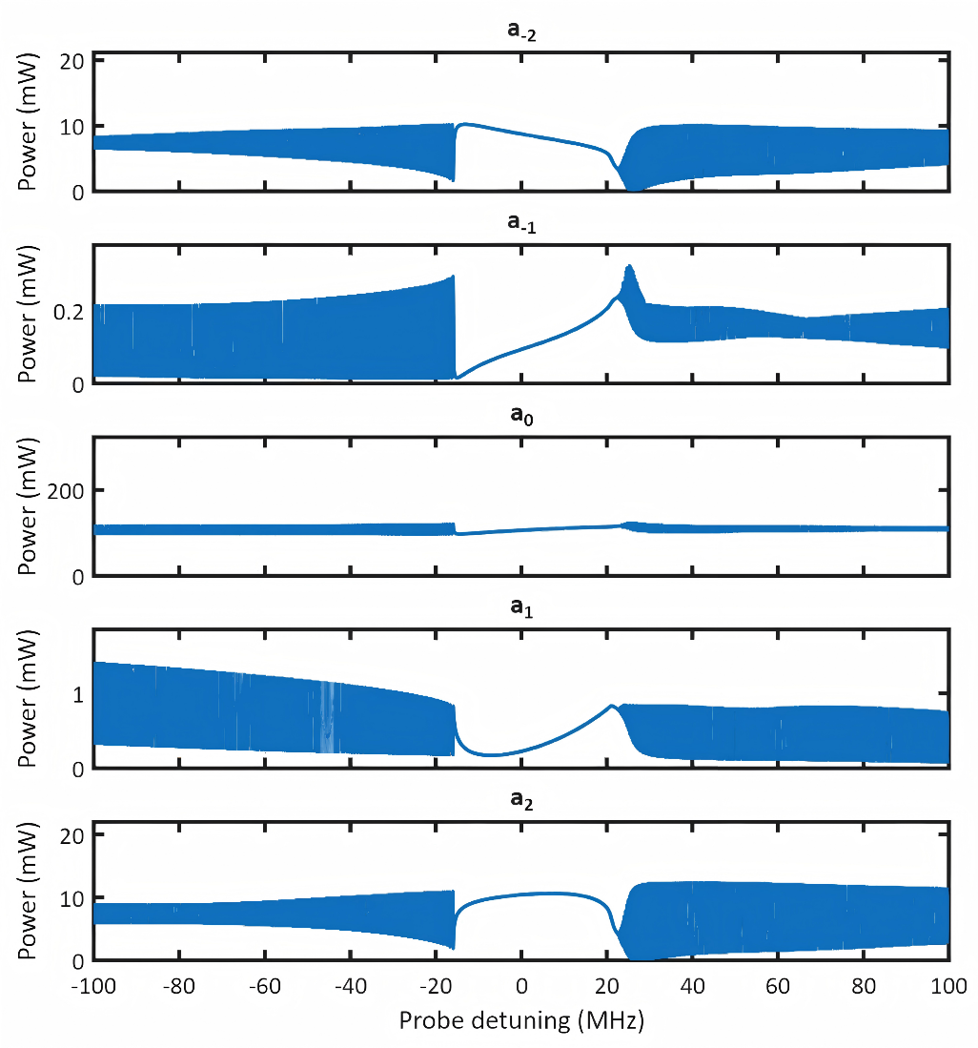
Fig. S6. Numerical simulation results for the optical power evolutions of the five modes as a function of probe detuning.

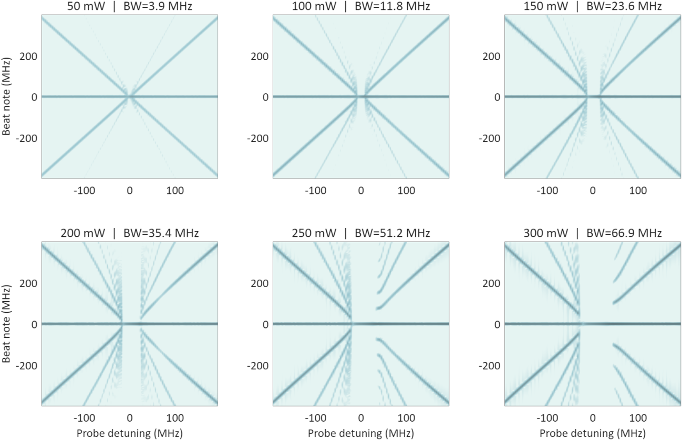
Fig. S7. Numerical simulation results for the beat notes of mode $a_{−1}$ as a function of probe detuning.
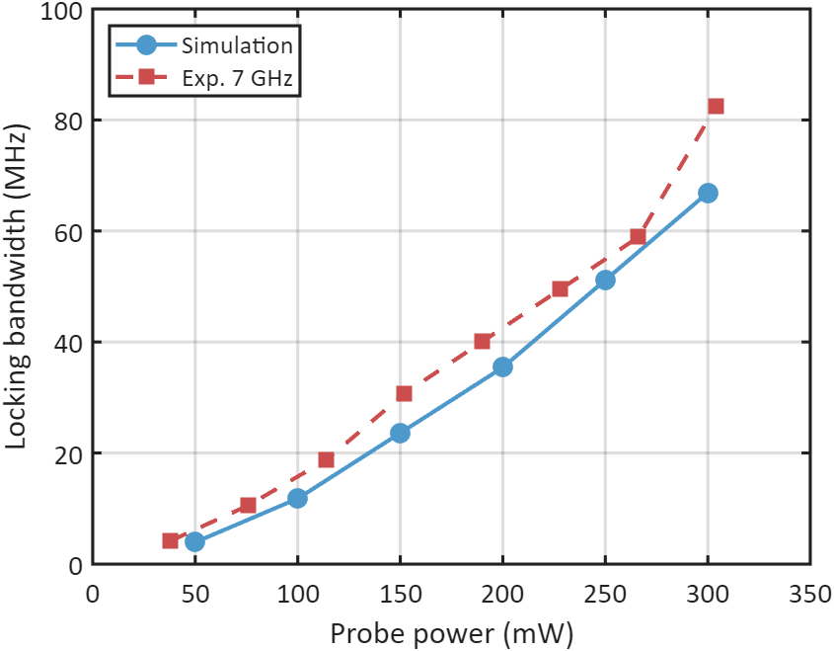
Fig. S8. Comparison between numerical simulation and experimental results of the locking bandwidth.

S4. Additional data for locking range
As described in the main text, we measure the locking range of idler injection by detecting the beat power using an oscilloscope and present the evolution of beat power for the 7.1 GHz device under different injection powers. As shown in Fig. S9, we further include the beat power evolution of the 12.5 GHz and 15.1 GHz devices. The discrepancy in locking range between these sets of data originates from the difference in field enhancement among different devices mentioned below.
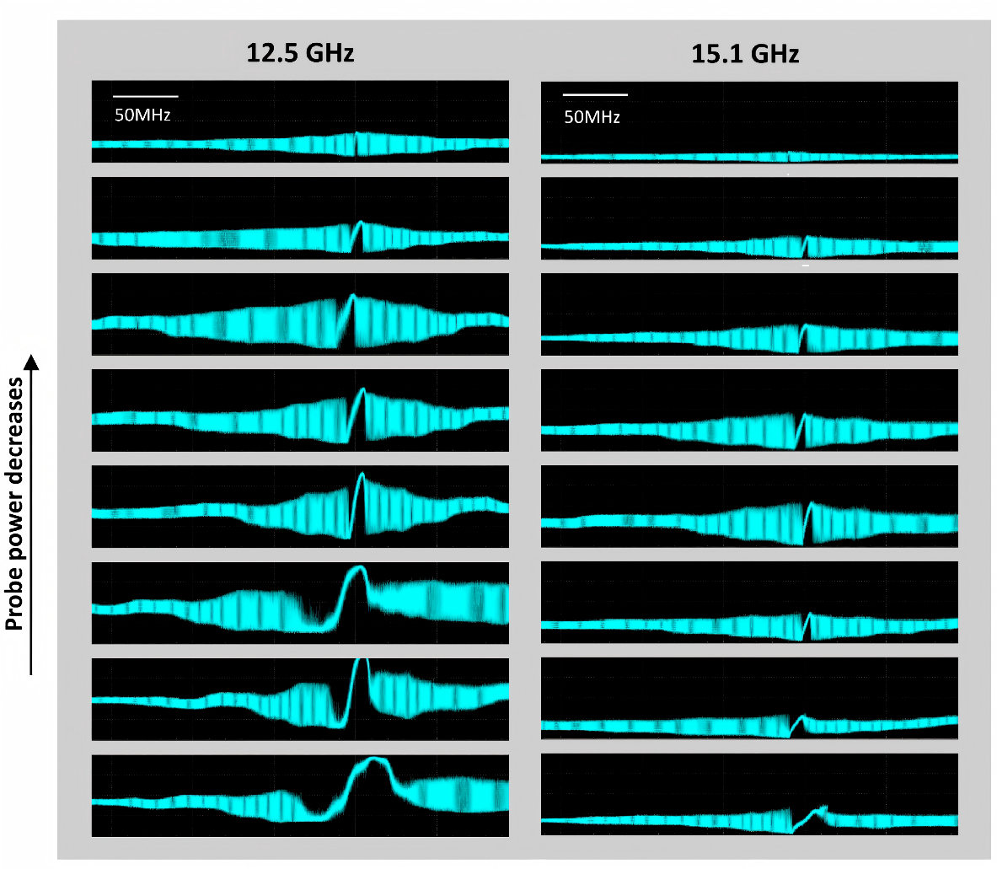
Fig. S9. Oscilloscope traces of PD signals for the 12.5 GHz and 15.1 GHz device.

S5. Numerical simulation of phase-squeezing
The phase squeezing performance of the system is simulated by utilizing Eqs. (S8)–(S12) and the same parameters employed for idler injection locking. The probe light is replaced by a signal carrier loaded with a 5 Gbit/s DPSK signal and 10 Gbit/s band-limited white noise. The input signal power is set to 400 mW. Fig. S10 shows the time-domain waveforms and constellation diagrams of the noisy input signal and regenerated output signal.
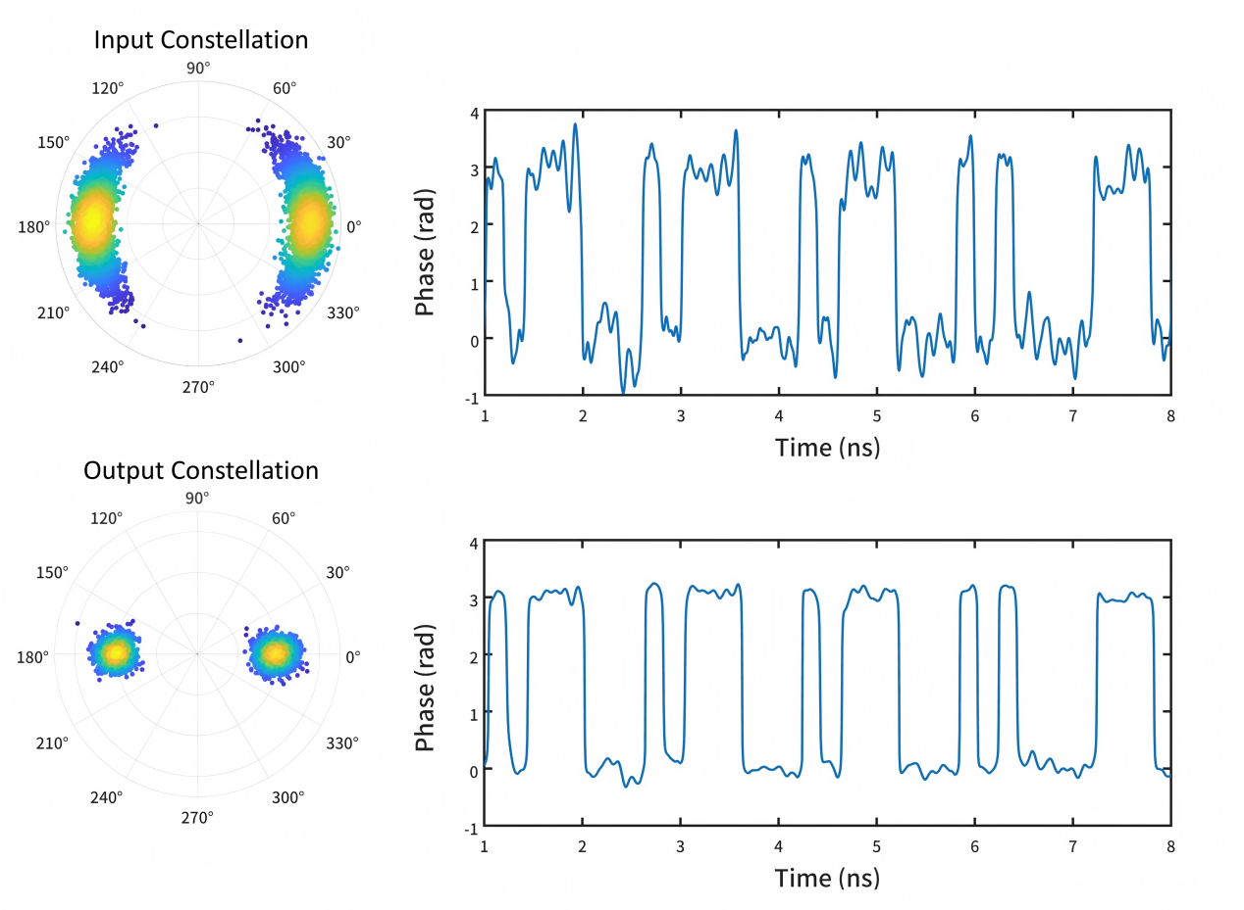
Fig. S10. Time-domain waveform and constellation diagram of input noisy signal and output regenerated signal.
As mentioned in the main text, the phase of copy 2 and copy 3 can be written as $φ_{copy2}=2φ_{p}−φ_{s}$ and $φ_{copy3}=φ_{p}−φ_{opo1}+φ_{s}$. By considering the relationship $φ_{idler}=2φ_{ref}−φ_{p}$ and $φ_{opo1}−φ_{idler}=φ_{const}$, $φ_{copy2}−φ_{copy3}$ can be written as
$$\begin{aligned}φ_{copy2}−φ_{copy3}=2φ_{ref}−φ_{const}−2φ_{s}, \#(S13)\#\end{aligned}$$
which leads to Eq. (1) in the main text, and can be rewritten as follows
$φ_{copy2}−φ_{copy3}=\left\{\begin{matrix}0 & φ_{s}=φ_{ref}+nπ+\frac{φ_{const}}{2} \\ π & { φ}_{s}=φ_{ref}+\left(n+\frac{1}{2}\right)π+\frac{φ_{const}}{2}\end{matrix}\right. ,$ (S14)
where $n$ denotes an arbitrary integer. Equation (S14) indicates that ${φ_{const}}/2$ characterizes an angular offset between the squeezing phase ($φ_{ref}+\frac{φ_{const}}{2}$) and the carrier phase ($φ_{ref}$). By tuning the relative frequency of the signal light $∆ω_{s}$, the constant phase offset can be tuned ⁸. As shown in Fig. S11, with the presence of $φ_{const}$, the overall compressed constellation diagram takes on an elliptical shape, with the major axis (represents squeezing phase) oriented at an angle relative to the x-axis (represent carrier phase). By finding the major axis of the ellipse of compressed constellation diagram, $φ_{const}$ can be extracted, as indicated in Fig. S11. It shows that effective phase signal regeneration is achieved when $φ_{const}$ approaches zero. Therefore, suitable detuning $∆ω_{s}$ in experiments and simulations are used to achieve $φ_{const}=0$, to optimize the effect of signal regeneration. For simulation in Fig. S10, $∆ω_{s}$ is set to 45 MHz. In our experiment, this is achieved through slightly tuning the pump frequency $ω_{p}$ as well as the thermal heating the microring resonator to ensure a suitable detuning $∆ω_{s}=ω_{s}−ω_{p}−9D_{1}$ that corresponding to $φ_{const}$ approaches zero.
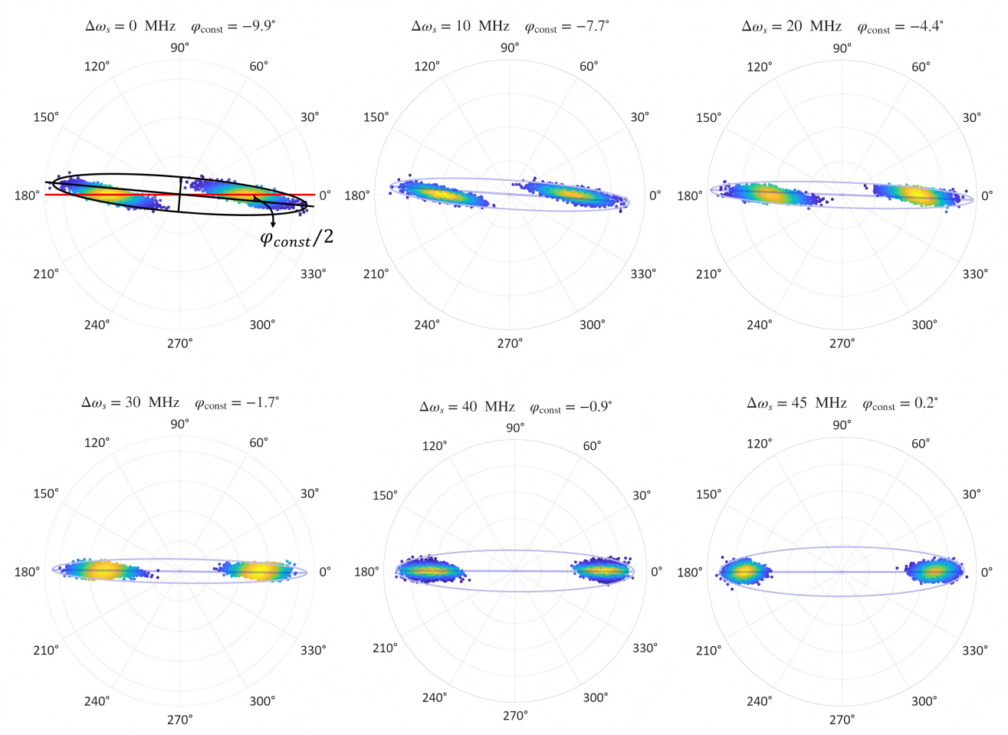
Fig. S11. Constellation diagrams of the output signal under different signal detuning values.

S6. Additional data for constellation diagrams
As described in the main text, we characterize signal regeneration performance by capturing constellation diagrams and supplement the measured constellation diagrams for the 7.1 GHz device under different received powers before and after regeneration. As shown in Fig. S12, these results cover various received power conditions. The constellation diagrams presented in Fig. 5 correspond to a received power of -21 dBm.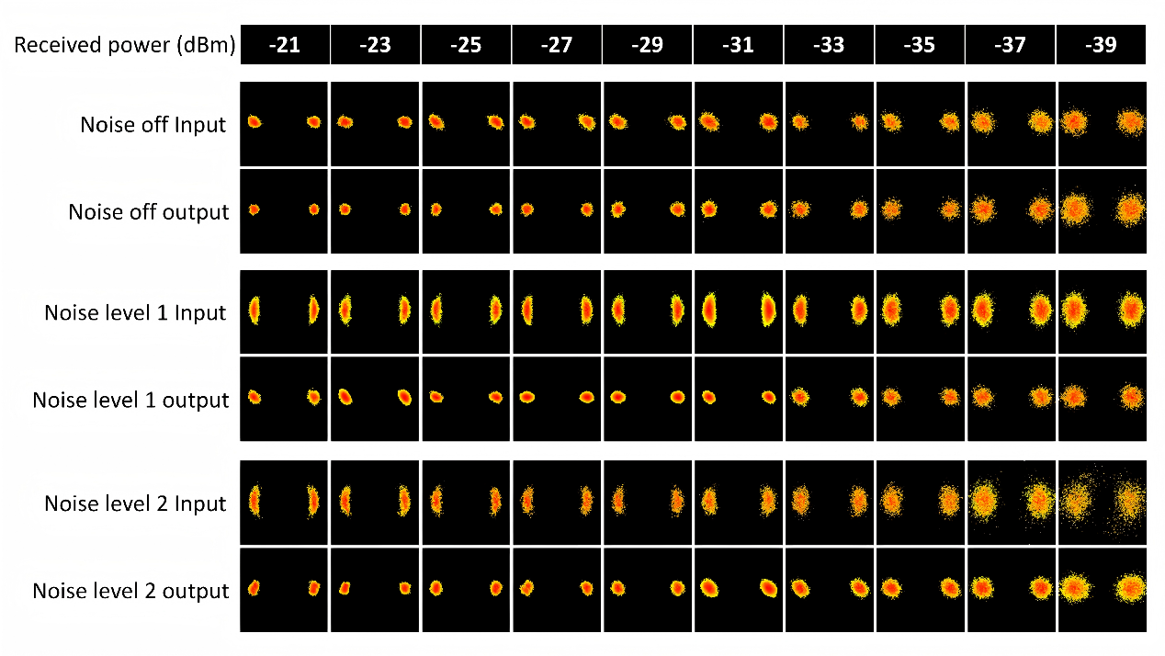
Fig. S12. constellation diagrams of signals with different received power before and after regeneration

Reference
1. Peng, B. et al. Parity–time-symmetric whispering-gallery microcavities. Nat. Phys. 10, 394–398 (2014).
2. Van, V. Optical Microring Resonators: Theory, Techniques, and Applications. (CRC Press, Boca Raton, 2016).
3. Kim, C. et al. Parity-time symmetry enabled ultra-efficient nonlinear optical signal processing. eLight 4, 6 (2024).
4. Turner, A. C., Foster, M. A., Gaeta, A. L. & Lipson, M. Ultra-low power parametric frequency conversion in a silicon microring resonator. Opt. Express 16, 4881 (2008).
5. Herr, T. et al. Universal formation dynamics and noise of Kerr-frequency combs in microresonators. Nat. Photonics 6, 480–487 (2012).
6. Zhao, Y. et al. Large regenerative parametric amplification on chip at ultra-low pump powers. Optica 10, 819 (2023).
7. Chembo, Y. K. & Yu, N. Modal expansion approach to optical-frequency-comb generation with monolithic whispering-gallery-mode resonators. Phys. Rev. A 82, 033801 (2010).
8. Moille, G. et al. Kerr-induced synchronization of a cavity soliton to an optical reference. Nature 624, 267–274 (2023).

