Supporting Information of
Alcohol-Mediated Controlled Cationic Photopolymerization of Vinyl Ethers for Programmable Additive Manufacturing
Yuan Wang^{a†}, Xiaofeng Pan^{a†,} Juntao Hu^{a†,}, Wenhui Liª, Xiangqiang Panª, Jiajia Li, ª* and Jian Zhuª*
ª State and Local Joint Engineering Laboratory for Novel Functional Polymeric Materials, Jiangsu Key Laboratory of Innovative Fiber Materials, Department of Polymer Science and Engineering, College of Chemistry, Chemical Engineering and Materials Science, Soochow University, Suzhou 215123, China.
E-mail: chemjjli@suda.edu.cn (Jiajia Li); chemzhujian@suda.edu.cn (Jian Zhu)

Content
Experimental Section 3
Materials 3
Characterization 3
Synthesis of bis(2-(vinyloxy)ethyl) isophthalate (bi-VEB). 5
Synthesis of the Difunctional Vinyl Ether Monomer (IP-VE). 5
General procedure for photopolymerization of IBVE 5
Chain extension of IBVE in situ 5
Photopolymerization of Printing printing Resins resins for Online online Infrared infrared Analysis analysis 6
3D printing procedure 6
Conduction of Jacob test 6
Dumbbell-shaped mold samples for tensile testing 6
Additional data 8
The SEC curves of PIBVE obtained in Table 1. 8
¹H NMR spectra for the model reaction 8
Characterization of PIBVE (M_{n} = 2300, Ɖ = 1.53) 9
Polymerization of various alcohols 9
The SEC curves of polymerization of IBVE mediated by different alcohols. 9
Mechanical properties of printed samples. 10
The cost of the printing resin 15
Data points used in the property comparison in Figure 5D. 16
The Jacob test of printing resin 17
Printing speed of the printing resin. 17
Stability of printed samples 18
Images of printed samples after different storage periods. 18
¹H NMR spectrum (in CDCl₃) of bi-VEB. 19
¹H NMR spectrum (in DMSO-d₆) of IP-VE. 19

Experimental Section

Materials
Isobutyl vinyl ether (IBVE, 98%, Adamas), diethylene glycol divinyl ether (DDE, 98%, Yuanye), cyclohexyl vinyl ether (CVE, 98%, Energy-chemical), 1,4-Butanediol divinyl ether (DVBE, 98%, Energy-chemical), 1,4-Cyclohexanedimethanol divinyl ether (CHDVE, 98%, Energy-chemical), 2,3-dihydrofuran (DHF, 99%, Yuanye), benzyl vinyl ether (BVE, 98%, Energy-chemical), diphenyliodonium hexafluorophosphate (DPI ≥98%, Yuanye), 2-isopropyl-thioxanthone (ITX, 98%, Macklin), methanol (99.9%, Extra Dry, with molecular sieves, Energy-chemical), ethanol (99.5%, Extra Dry, with molecular sieves, Energy-chemical), 1-heptanol (99%,Innochem), isopropyl alcohol (99.5%, water≤50 ppm, Rhawn chemical), benzyl alcohol (>99.0%,TCL), L-Menthol (≥99%, Psaitong), linalool (98%, innochem), phenol (AR, Meryer), cyclohexanol (≥99%, Yuanye), cyclohexanemethanol (≥99%, Yuanye), 1,4-cyclohexanedimethanol (99%, Aladdin), furfuryl alcohol (99%, Adamas), oleyl alcohol (80%, Adamas), triethylene glycol monomethyl ether (98%, Zancheng Tianjin Technology ), 4,4'-oxydiphenol (98%, Energy-chemical), bisphenol A (99%, Acmec), castor oil (Pharm Pure, Aladdin), poly(tetrahydrofuran) (average M_{n} ~1000, Adamas), polypropylene glycol (average M_{n} ~400, Aladdin), diethylene glycol (≥99%, Yuanye), ethylene glycol (>99.5%, TCl), glycerol (≥99.5%, Energy-chemical), gallic acid (99%, J&K Scientific), protocatechuic acid (99%, Amethyst), 2,5-furandimethanol (98%, Bidepharm), 3-pentadecylphenol (90%, Yuanye), trimethylamine (AR, Qiangsheng), 2-(vinyloxy) ethanol (98%, Macklin), isophthaloyl chloride (99%, Macklin), 1,3,5-benzenetricarbonyl trichloride (99%, Innochem), isophorone diisocyanate (IPDI, 99%, Aladdin), 4-hydroxybutyl vinyl ether (HBVE, 98%, Macklin), dibutyltin dilaurate (DBTDL,95%, Aladdin), calcium hydride (CaH₂, 98.5%, Macklin), dichloromethane (DCM, 99%, Qiangsheng), trichloromethane (AR, Qiangsheng), petroleum ether (PE, 99%, Qiangsheng), ethyl acetate (EA, 99%, Qiangsheng), acetone (99%, Qiangsheng), methanol (MeOH, 99%, Qiangsheng), tetrahydrofuran (THF, 99%, Qiangsheng). All monomers were used as received unless otherwise indicated.
The 405 nm LED light used in polymerization (λ_{max} = 405 nm, 60 W m⁻¹) was purchased from Shenzhen Huahe Lighting Co., Ltd China. The light intensity to the polymerization solution was 3.0 mW cm⁻². The DLP 3D printer (Anycubic Photon D2) with a purple LED light (λ_{max} = 405 nm, 1.0 mW cm⁻²) was purchased from Shenzhen Anycubic Technology Co., Ltd, China. The photocuring oven (λ_{max} = 405 nm, rated power = 60 W) (Cure 3D) was purchased from MAKEX TECHNOLOGY.

Characterization
NMR
The nuclear magnetic resonance (NMR) spectrum was recorded on a Bruker 300 MHz nuclear magnetic resonance instrument using CDCl₃ and Dimethyl sulfoxide-d₆ as the solvent and tetramethylsilane as an internal standard.
SEC
The number-average molecular weight (M_{n}) and molecular weight distribution (Ð) of polymers were determined by TOSOH HLC-8320 Size Exclusion Chromatography (SEC) equipped with refractive index and UV detectors using two TSKgel SuperMultiporeHZ-N (4.6 × 150 mm) columns arranged in series, which can separate polymers in the molecular weight range of 500 - 1.9 × 10⁵ g mol⁻¹. Tetrahydrofuran (THF) served as the eluent with a flow rate of 0.35 mL min⁻¹ at 40 °C. SEC samples were injected using a TOSOH HLC-8320 SEC plus auto sampler. Data acquisition was performed using EcoSEC software and molecular weights were calculated with polystyrene (PS) standards.
MALDI-TOF MS
The matrix-assisted laser desorption/ionization time of flight mass spectrometry (MALDI-TOF MS) was performed using a Bruker Daltonics Ultraflex in the positive ion and reflection mode with a 337 nm nitrogen laser. trans-2-[3-(4-tert-Butylphenyl)-2-methyl-2-propenylidene]malononitrile (DCTB) was used as the matrix and sodium trifluoroacetate (NaTFA) was used as the ionization agent. The concentration of the polymer solution was 10 mg mL⁻¹ in THF.
ATR-FTIR
The C=C conversion of the different monomers in the study on polymerization of DDE and CVE was monitored by an online infrared analyzer Nicolet iS20. Monomer conversion was calculated based on the reduction in intensity of the C=C vibration peak at approximately 1619 cm⁻¹.
SEM
Morphology of the precision model sample was characterized via a Hitachi SU8010 scanning electron microscope (SEM) with an operation voltage of 5 kV.
DMA
Mechanical properties of the 3D-printed materials were measured using a TA Instruments Q850 dynamic mechanical analyzer (DMA). A gas cooling accessory (GCA) was used to equilibrate the temperature to -60 °C, followed by an isothermal hold for 2 min. Subsequently, the temperature was ramped to 100 °C at a heating rate of 3 K/min under a constant frequency of 1 Hz with a displacement amplitude of 50 μm. The dumbbell-shaped specimens used for testing were fabricated using a DLP 3D printer. The glass transition temperature (T_{g}) was determined as the peak temperature of the tan δ curve at 1 Hz.
Mechanical Properties Testing
The mechanical tests were carried on an electronic tensile machine (TopHung) with a 500 N load cell. Tensile tests were performed at room temperature under a crosshead speed of 2.0 mm min⁻¹. The testing samples were prepared by 3D printing (a length of 50 mm, a gage length of 16 mm, a width of 8.3 mm, a gage width of 4 mm and a thickness of 2.0 mm). Tensile strength was calculated by dividing the maximum load (N) by the average original cross-sectional area (m²) in the gage length segment of the specimen and elongation at break was obtained by dividing the extension at the point of specimen rupture by the original gage length and multiplying by 100.

Synthesis of bis(2-(vinyloxy)ethyl) isophthalate (bi-VEB).
Trimethylamine (29.91 g, 295.5 mmol) and 2-(vinyloxy) ethanol (26.04g, 295.5 mmol) were dissolved in 200 mL of dichloromethane by stirring in a 500 mL flask in an ice water bath. A solution of isophthaloyl chloride (20 g, 98.5mmol) in dichloromethane (100 mL) was added dropwise and allowed to react for 30 minutes. Then the mixture was stirred under room temperature for 12 hours. After the filtration, the solution was concentrated by rotary evaporator. Next, the concentrated mixture was washed with deionized water and saturated brine and extracted by dichloromethane for twice. The organic phase was dried over Na₂SO₄ and evaporated to dryness to obtain a pale yellow-green and transparent liquid(82% yield). ¹H NMR (Figure S10, CDCl₃, 300 MHz), δ: 8.72 (t, 1H), 8.26(m, 2H), 7.54 (m, 1H), 6.52 (dd, 2H), 4.59 (dd, 4H), 4.25 (dd, 2H), 4.06 (m, 6H).

Synthesis of the Difunctional Vinyl Ether Monomer (IP-VE).
Isophorone diisocyanate (IPDI) (0.2 mol) was charged into a 500 mL three-neck round-bottom flask. 4-hydroxybutyl vinyl ether (HBVE) (0.4 mol) was placed in a pressure-equalizing addition funnel, and dibutyltin dilaurate (DBTDL) (0.05 wt %) was added as a catalyst. HBVE was added dropwise to the IPDI solution under argon with vigorous stirring at 50 °C. After the addition was complete, the reaction was maintained at 50 °C for 2 h. ¹H NMR (Figure S11, DMSO-d₆, 300MHz), 7.18-6.84(m, 2H), 6.49(q, 2H), 4.18(d, 2H), 3.96(m, 6H), 3.68(t, 4H), 3.57(m, 1H), 2.72(m ,2H), 1.62(m, 8H), 1.45( m, 2H), 1.16-0.80(m, 13H)

General procedure for photopolymerization of IBVE
All polymerizations were conducted in a nitrogen-filled glovebox. Monomers were dried over CaH₂ for at least 12 hours, distilled under nitrogen, subjected to three freeze–pump–thaw cycles, and stored in the glovebox. In a typical experiment, IBVE (1.00 g, 10 mmol), CH₃OH (3.20 mg, 0.1 mmol), DPI (0.426 mg, 1.0 × 10⁻³ mmol), ITX (0.254 mg, 1.0 × 10⁻³ mmol) and DCM (0.5 mL) were added to a 4 mL Teflon vial ([IBVE]₀:[ CH₃OH]₀:[DPI]₀:[ITX]= 100:1:0.01:0.01). The mixture was irradiated with a 405 nm LED (3.0 mW cm⁻²) at 25 °C under stirring for the desired time. The reaction was quenched by dilution with THF and addition of trace triethylamine. Monomer conversion was determined gravimetrically.

Chain extension of IBVE in situ
The first stage of polymerization was carried out according to the above steps with a molar ratio of [IBVE]₀:[CH₃OH]₀:[DPI]₀:[ITX]₀ = 20:1:0.002:0.002. After a predetermined time (2 min), a small amount of the polymer was taken for SEC testing, and 0.5 mL of the purified monomer was added into the reaction mixture. The polymerization was continued for 30 min, and then a small amount of the polymer was taken for SEC testing.

Photopolymerization of printing resins for online infrared analysis
Printing resins for online infrared analysis were prepared by mixing different proportions of DDE, CVE, CH₃OH, DPI and ITX. The mixture was uniformly mixed and dissolved by an oscillator for online infrared analysis under 405 nm LED light irradiation of the DLP 3D printer (1.0 mW cm⁻²) and open to air.

3D printing procedure
A resin mixture (≈ 30 mL) containing DDE, CVE, CH₃OH, DPI and ITX with a molar ratio of [DDE]₀:[CVE]₀:[CH₃OH]₀:[DPI]₀:[ITX]₀= 50:50:5:0.1:0.1 was poured into the sink of the DLP 3D printer. Then, the mold.stl file was imported into the printer. The printing parameters were set as follow: exposure time per layer: 6 s; target per layer thickness: 0.1 mm; 1 bottom layer and 8 s exposure time for bottom layer; 2 for anti-alias; 5 mm Z lift height; 2 mm s⁻¹ Z lift speed; 2 mm s⁻¹ Z retract step speed. Then the printing process was started. Printed objects were washed with ethyl acetate and post-cured under 405 nm irradiation (60 mW cm⁻²) for 2 hour.

Conduction of Jacob test
To determine the exposure time per layer in the printing process, a Jacob test was conducted, which involved printing elements in the form of 1 × 1 mm discs at various exposure times, each at the same light intensity specific to each compound. After printing, the discs were initially cleaned of uncured material using ethyl acetate, and their thickness was measured at five different points using a micrometre screw. This allowed for the determination of the average thickness. Next, based on the ratio of the curing time of each disc to the intensity of light irradiating the printed disc, the values of E₀(the light energy per unit area expressed in mJ/cm³) were calculated. The averaged value of C_{d} (Equation 1) was then plotted on a logarithmic graph as a function of C_{d} = f(E₀), which enabled the determination of D_{p} as the slope of the curve and E_{c} as the intersection point with the x- axis.
$\text{C}\text{d }\text{= D}\text{p}\text{*}\text{ln}{\text{(}}\frac{\text{E}}{\text{E}\text{c}}\text{)}$ (Equation S1)

Dumbbell-shaped mold samples for tensile testing
Printing resin (≈ 30 mL) containing DDE/DVBE/CHDVE, IBVE/DHF/CHVE/BVE, Alcohol, DPI and ITX at various molar ratios was prepared and poured into the sink of the DLP 3D printer. A dumbbell-shaped mold (.stl file) was imported into the printer. The printing parameters were set as follow, the exposure time per layer was adjusted according to the minimum curing time required to obtain well-defined objects; target per layer thickness: 0.1 mm; one bottom layer and exposure time (same exposure time for per layer) for bottom layer; 2 for anti-alias; 5 mm Z lift height; 2 mm s⁻¹ Z lift speed; 2 mm s⁻¹ Z retract step speed. After printing, the specimens were removed, washed with ethyl acetate, and post-cured under 405 nm LED irradiation (60 mW cm⁻²) for 2 hour.

Additional data
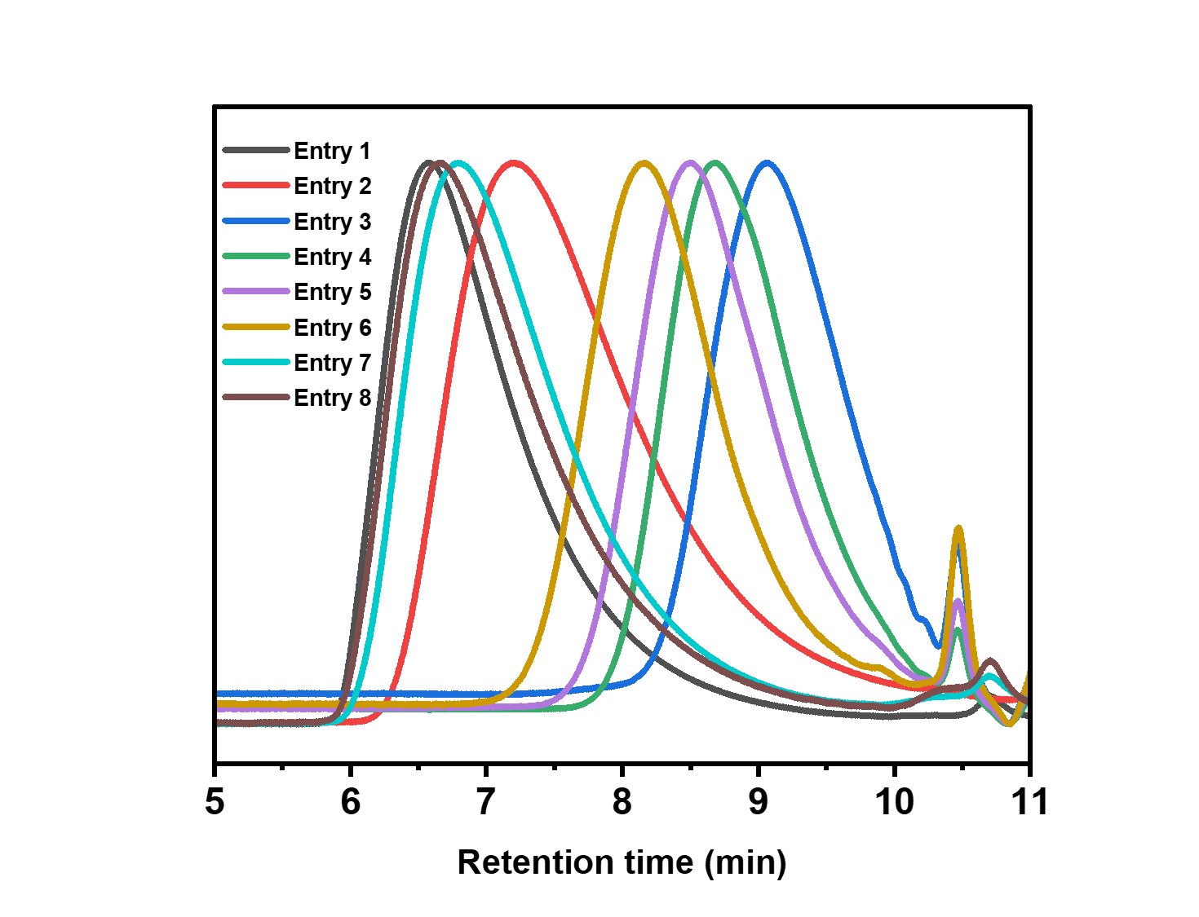

Figure S1. The SEC curves of PIBVE obtained in Table 1.

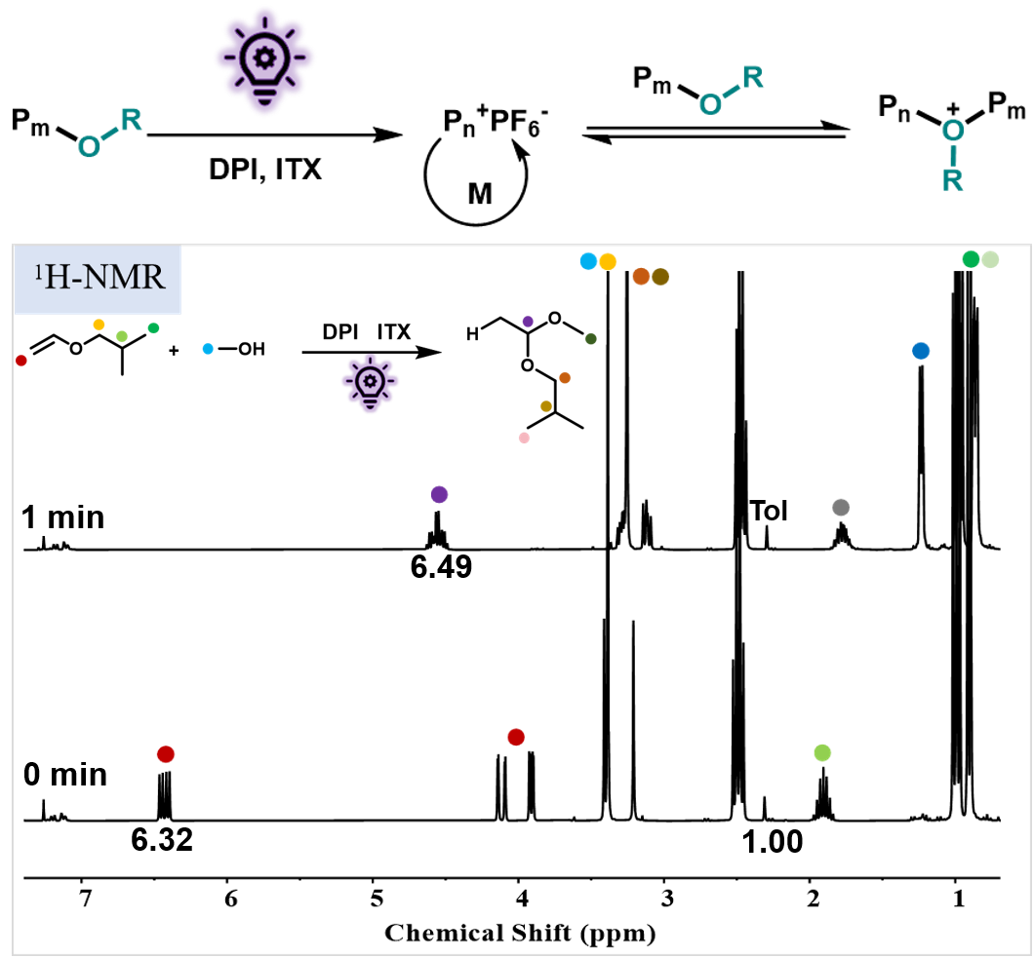

Figure S2. ¹H NMR spectra for the model reaction of [IBVE]₀:[MeOH]₀:[DPI]₀:[ITX]₀ = 1:1:0.005:0.005 under a 405 nm LED light (3.0 mW cm-2) at 25 °C.
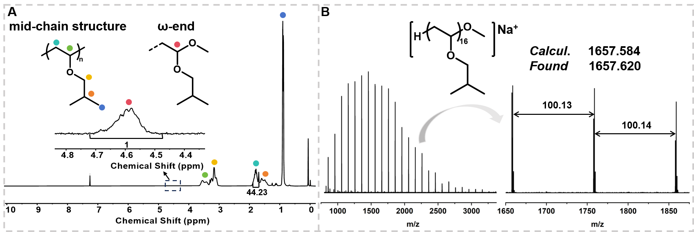

Figure S3. Characterization of PIBVE (M_{n} = 2300, Ɖ = 1.53) (A) ¹H NMR spectrum. (B) MALDI–TOF MS spectrum.

Table S1. Polymerization of various alcohols in DCM with [IBVE]₀:[alcohol]₀:[DPI]₀:[ITX]₀ = 100:1:0.01:0.01 at 25 °C under a 405 nm LED, n_{IBVE} = 0.01 mol, V_{DCM} = 0.5 mL.
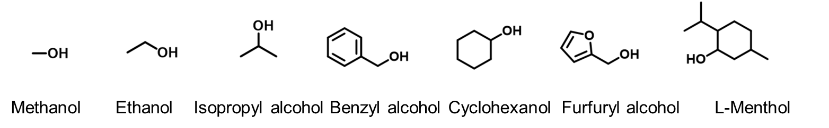
Entry | alcohol | Time (min) | Conv. (%) | M_{n,th}^{a)} | M_{n,SEC}^{b)} | Ɖ
1 | Methanol | 2 | 99 | 10000 | 14400 | 1.75
2 | Ethanol | 1.5 | 99 | 10000 | 17600 | 1.97
3 | Isopropyl alcohol | 1.5 | 99 | 10000 | 18500 | 2.09
4 | Benzyl alcohol | 1.5 | 99 | 10000 | 16800 | 2.28
5 | Cyclohexanol | 2 | 99 | 11000 | 18200 | 2.30
6 | Furfuryl alcohol | 2 | 80 | 8100 | 24700 | 1.82
7 | L-Menthol | 20 | 70 | 7100 | 18000 | 2.81
a) Calculated based on conversion (M_{n,th} = [M]₀/[MeOH]₀ × M_{IBVE} × conversion + M_{MeOH}); b) determined by tetrahydrofuran (THF) SEC using polystyrene (PS) calibration.

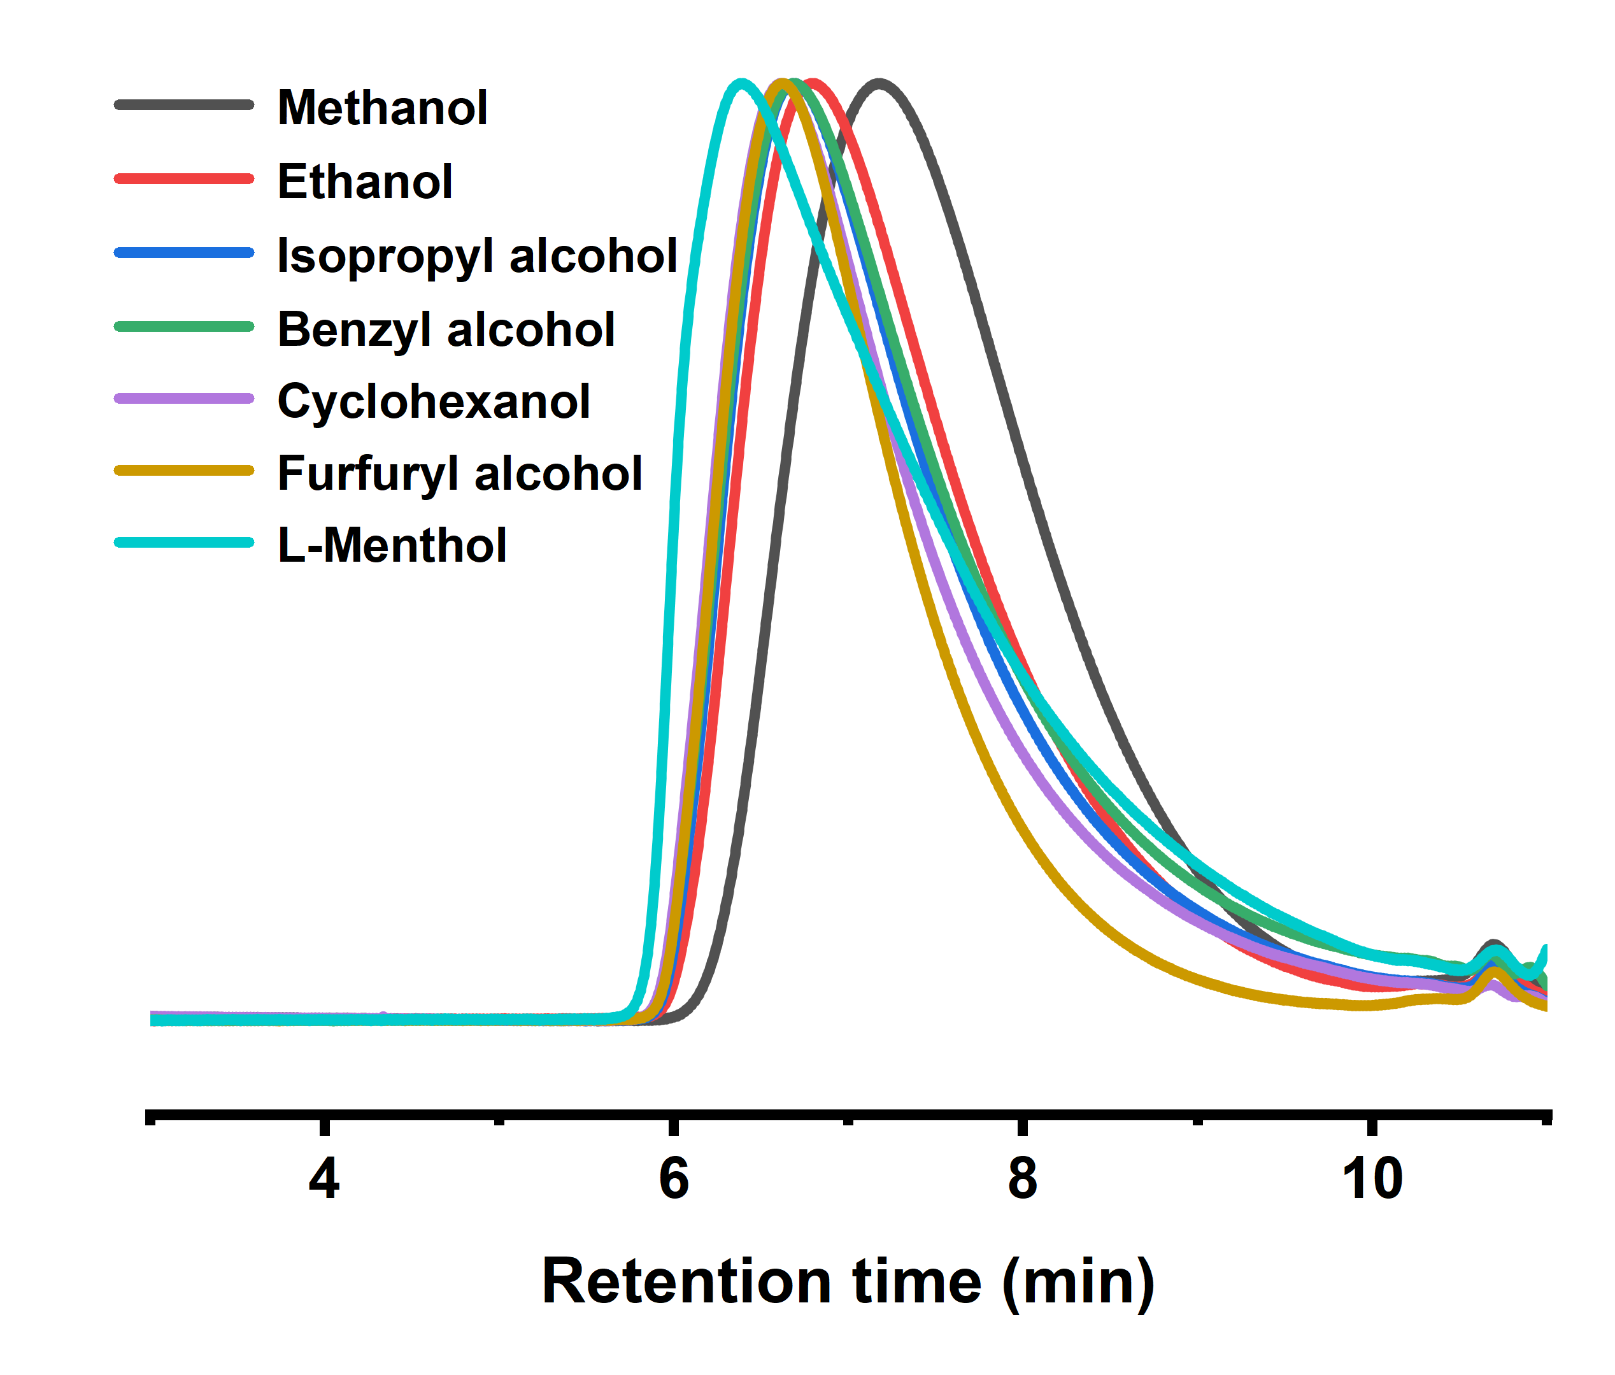

Figure S4. The SEC curves of polymerization of IBVE mediated by different alcohols.

Table S2. Mechanical properties of printed samples in Figure 3C using printing resin consisting of [DDE]₀:[CVE]₀:[CH₃OH]₀:[DPI]₀:[ITX]₀ = 50:50:X:0.1:0.1.
Entry | [DDE]₀:[CVE]₀:[CH₃OH]₀:[DPI]₀:[ITX]₀ | Strain at break  ε_{b} (%) | Stress at break  σ_{b} (MPa) | Young’s modulus  (MPa)
1 | 50:50:2:0.1:0.1 | 26.7 ± 1.6 | 17.8 ± 1.2 | 267 ± 18
2 | 50:50:5:0.1:0.1 | 30 ± 3 | 12.08 ± 0.76 | 142 ± 10
3 | 50:50:10:0.1:0.1 | 26.2 ± 1.1 | 10.49 ± 0.45 | 86 ± 6
4 | 50:50:20:0.1:0.1 | 23.4 ± 1.7 | 3.43 ± 0.31 | 16.21 ± 0.69

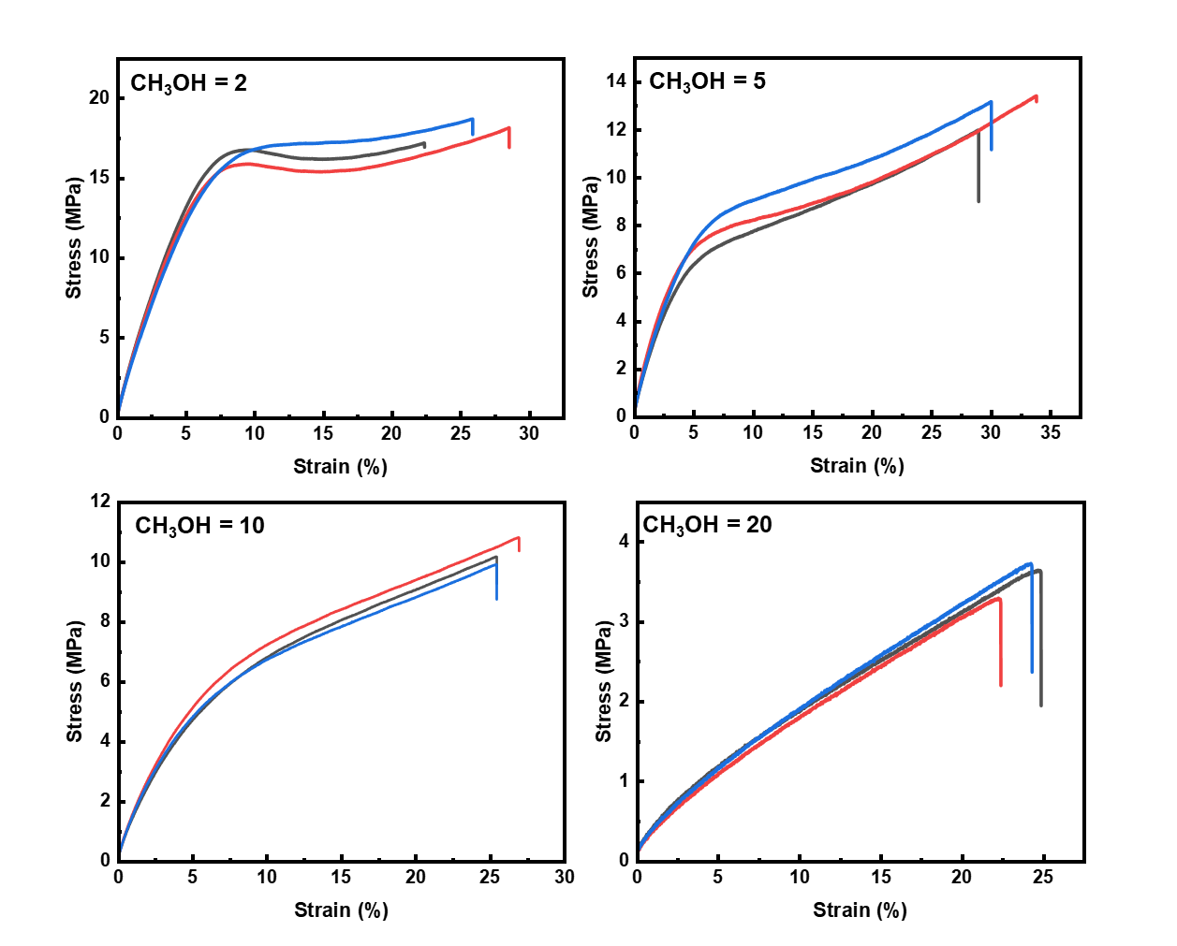
Figure S5. The stress and strain curves of printed samples in Figure 3C using printing resin consisting of [DDE]₀:[CVE]₀:[CH₃OH]₀:[DPI]₀:[ITX]₀ = 50:50:X:0.1:0.1.

Table S3. Mechanical properties of printed samples in Figure 4A using printing resin consisting of [DDE]₀:[CVE]₀:[CH₃OH]₀:[DPI]₀:[ITX]₀ = x:y:5:0.1:0.1.
Entry | [DDE]₀:[CVE]₀:[CH₃OH]₀:[DPI]₀:[ITX]₀ | Strain at break  ε_{b} (%) | Stress at break  σ_{b} (MPa) | Young’s modulus  (MPa)
1 | 20:80:5:0.1:0.1 | 91 ± 4 | 3.24 ± 0.13 | 3.14 ± 0.22
2 | 25:75:5:0.1:0.1 | 87 ± 4 | 8.67 ± 0.35 | 10.40 ± 0.90
3 | 30:70:5:0.1:0.1 | 57 ± 4 | 11.7 ± 1.6 | 73 ± 8
4 | 40:60:5:0.1:0.1 | 43 ± 3 | 13.5 ± 1.3 | 71 ± 6
5 | 50:50:5:0.1:0.1 | 30 ± 3 | 12.08 ± 0.76 | 142 ± 10
6 | 70:30:5:0.1:0.1 | 19.3 ± 1.5 | 19.4 ± 2.6 | 302 ± 19
7 | 80:20:5:0.1:0.1 | 12.9 ± 1.4 | 20.06 ± 0.48 | 406 ± 13
8 | 90:10:5:0.1:0.1 | 10.43 ± 2.10 | 24.42 ± 0.75 | 480 ± 6

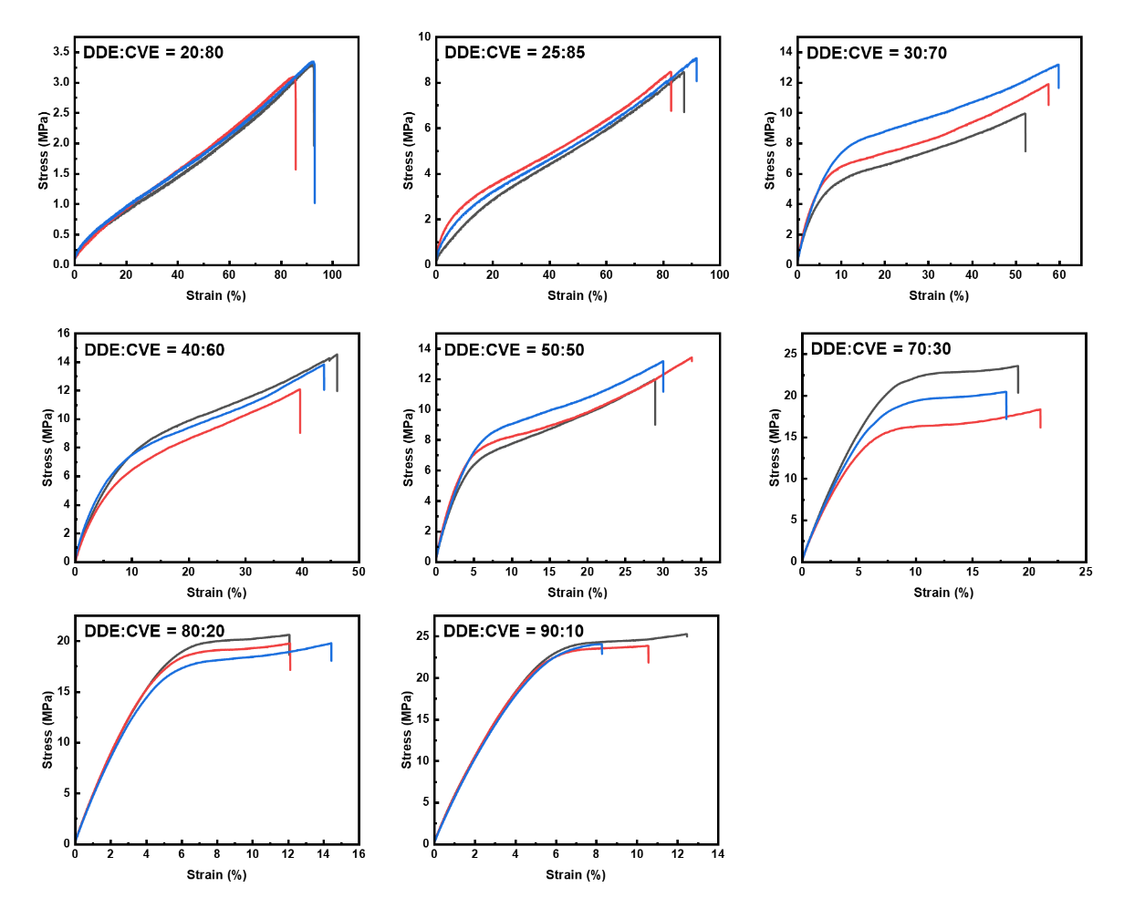
Figure S6. The stress and strain curves of printed samples in Figure 4A using printing resin consisting of [DDE]₀:[CVE]₀:[CH₃OH]₀:[DPI]₀:[ITX]₀ = x:y:5:0.1:0.1.

Table S4. Mechanical properties of printed samples in Figure 4C using printing resin consisting of different monomers under a fixed molar ratio of [DDE]₀:[CVE]₀:[Monomer]₀:[DPI]₀:[ITX]₀ = 50:50:10:0.1:0.1.
Entry | Monomer | Strain at break  ε_{b} (%) | Stress at break  σ_{b} (MPa) | Young’s modulus  (MPa)
1 | CVE | 26.2 ± 1.1 | 10.49 ± 0.45 | 86 ± 6
2 | DHF | 16.32 ± 0.67 | 13.50 ± 0.57 | 240± 10
3 | IBVE | 20.2 ± 2.4 | 8.94 ± 0.80 | 72 ± 6
4 | BVE | 18.0 ± 1.6 | 3.89 ± 0.19 | 23.7 ± 2.1

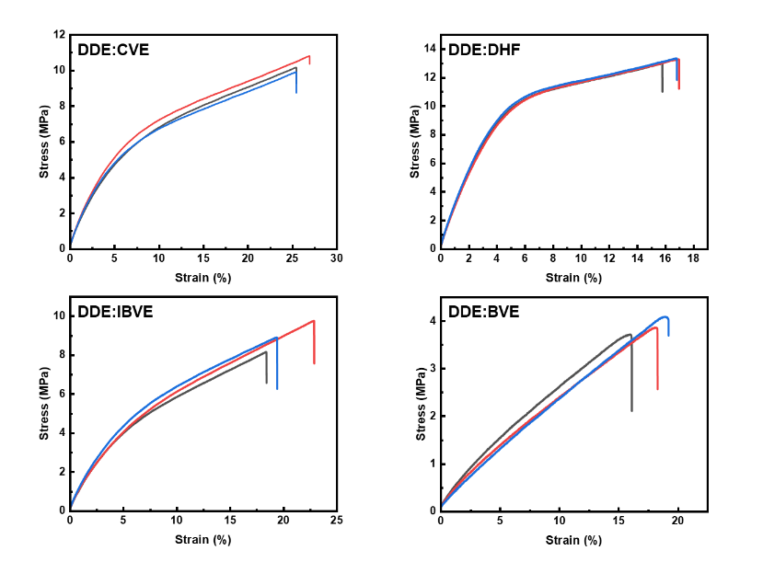
Figure S7. The stress and strain curves of printed samples in Figure 4C using printing resin consisting of different monomers under a fixed molar ratio of [DDE]₀:[CVE]₀:[Monomer]₀:[DPI]₀:[ITX]₀ = 50:50:10:0.1:0.1.

Table S5. Mechanical properties of printed samples in Figure 4D using printing resin consisting of different crosslinkers under a fixed molar ratio of [Crosslinker]₀:[DHF]₀:[CH₃OH]₀:[DPI]₀:[ITX]₀ = 20:80:5:0.1:0.1.
Entry | Monomer | Strain at break  ε_{b} (%) | Stress at break  σ_{b} (MPa) | Young’s modulus  (MPa)
1 | DDE | 29 ± 7 | 28.1 ± 2.2 | 517 ± 13
2 | DVBE | 11.80 ± 0.58 | 21.1 ± 1.2 | 445 ± 7
3 | CHDVE | 12.28 ± 0.34 | 42.83 ± 0.75 | 584.92 ± 0.68

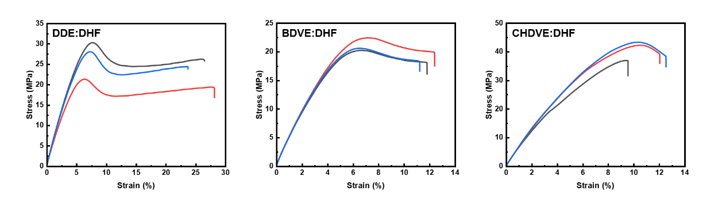
Figure S8. The stress and strain curves of printed samples in Figure 4D using printing resin consisting of different crosslinkers under a fixed molar ratio of [Crosslinker]₀:[DHF]₀:[CH₃OH]₀:[DPI]₀:[ITX]₀ = 20:80:5:0.1:0.1.

Table S6. Mechanical properties of printed samples in Figure 4E using printing resin consisting of DDE, CVE, DPI, ITX and different alcohols.
Entry | [DDE]₀:[CVE]₀:[X]₀:[DPI]₀:[ITX]₀ | X | Strain at break  ε_{b} (%) | Stress at break  σ_{b} (MPa) | Young’s modulus  (MPa)
1 | 50:50:10:0.1:0.1 | Methanol | 26.2 ± 1.1 | 10.49 ± 0.45 | 86 ± 6
2 | 50:50:10:0.1:0.1 | Ethanol | 24.0 ± 2.1 | 9.85 ± 0.34 | 87.20 ± 0.99
3 | 50:50:10:0.1:0.1 | 1-Heptanol | 27.1 ± 1.1 | 5.68 ± 0.51 | 22.5 ± 2.2
4 | 50:50:10:0.1:0.1 | Isopropyl alcohol | 27.5 ± 2.2 | 7.45 ± 0.41 | 32.0 ± 1.5
5 | 50:50:10:0.1:0.1 | Benzyl alcohol | 30 ± 4 | 8.42 ± 0.89 | 37 ± 4
6 | 50:50:10:0.1:0.1 | L-Menthol | 19.76 ± 0.51 | 3.92 ± 0.24 | 20.95 ± 0.60
7 | 50:50:10:0.1:0.1 | Linalool | 19.02 ± 0.61 | 2.04 ± 0.07 | 10.90 ± 0.15
8 | 50:50:10:0.1:0.1 | Phenol | 24.4 ± 2.4 | 7.52 ± 0.95 | 64 ± 3
9 | 50:50:10:0.1:0.1 | Cyclohexanol | 35.1 ± 1.8 | 5.27 ± 0.13 | 14.50 ± 0.60
10 | 50:50:10:0.1:0.1 | Cyclohexanem-ethanol | 21.99 ± 0.49 | 3.07 ± 0.07 | 13.94 ± 0.47
11 | 50:50:10:0.1:0.1 | Furfuryl alcohol | 23.86 ± 0.86 | 6.11 ± 0.33 | 36.6 ± 1.9
12 | 50:50:10:0.1:0.1 | Oleyl alcohol | 22.46 ± 0.71 | 1.07 ± 0.04 | 4.52 ± 0.15
13 | 50:50:10:0.1:0.1 | Triethylene-glycol monomethyl- ether | 20.6 ± 1.8 | 3.68 ± 0.39 | 19.98±1.15
14 | 50:50:10:0.1:0.1 | 1,4-Cyclohexanedi-methanol | 30.4 ± 2.3 | 15.56 ± 0.47 | 180 ± 13
15 | 50:50:10:0.1:0.1 | 4,4’-Oxydiphenol | 25.9 ± 2.8 | 11.05 ± 0.94 | 111 ± 8
16 | 50:50:10:0.1:0.1 | Bisphenol A | 30 ± 3 | 14.2± 1.2 | 151 ± 26
17 | 50:50:10:0.1:0.1 | Castor oil | 29.1 ± 1.1 | 4.46 ± 0.19 | 16.52 ± 0.98
18 | 50:50:10:0.1:0.1 | Poly(tetrahydrofuran) | 30.2 ± 1.4 | 3.02 ± 0.11 | 9.91 ± 0.31
19 | 50:50:10:0.1:0.1 | Polypropylene glycol | 20.6 ± 1.6 | 3.37 ± 0.19 | 18.89 ± 0.12
20 | 50:50:5:0.1:0.1 | Cardanol | 24.0 ± 1.9 | 6.79 ± 0.28 | 38.1 ± 2.0

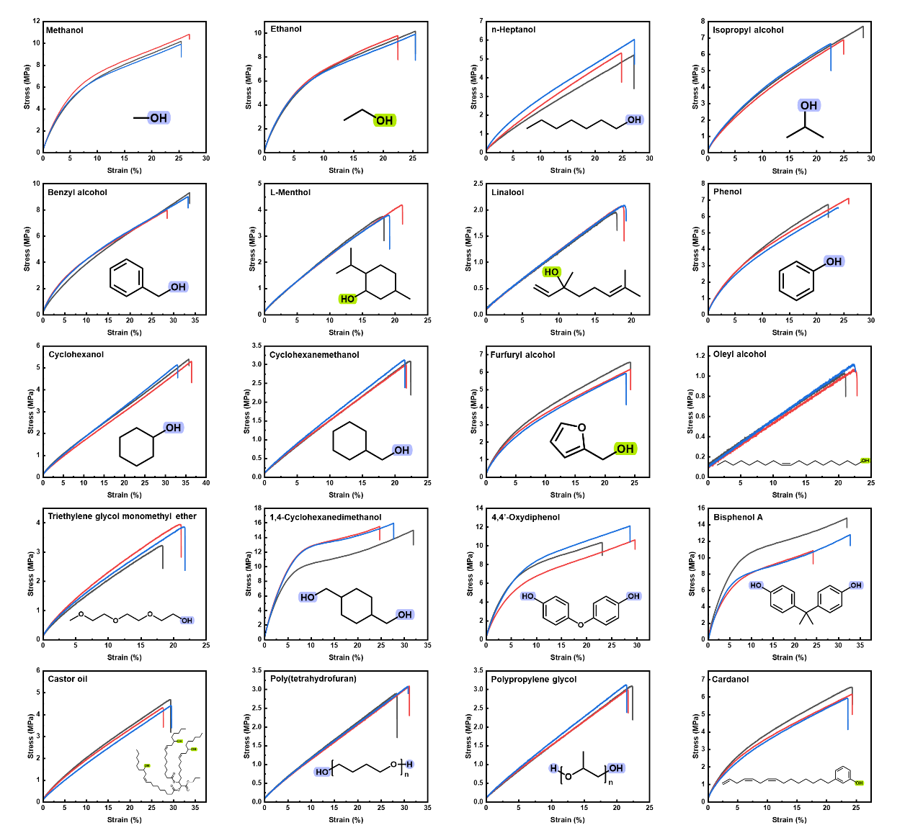
Figure S9. The stress and strain curves of printed samples in Figure 4E using printing resin consisting of DDE, CVE, DPI, ITX and different alcohols.

Table S7. Mechanical properties of printed samples in Figure 4E using printing resin consisting of DDE, CVE, EtOH, DPI, ITX and different alcohols.
Entry | [DDE]₀:[CVE]₀:[X]₀:  [EtOH]₀:[DPI]₀:[ITX]₀ | X | Strain at break  ε_{b} (%) | Stress at break  σ_{b} (MPa) | Young’s modulus  (MPa)
1 | 50:50:5:5:0.1:0.1 | Diethylene glycol | 20.1 ± 1.9 | 5.74 ± 0.73 | 47 ± 6
2 | 50:50:5:5:0.1:0.1 | Ethylene glycol | 26.3 ± 1.5 | 5.62 ± 0.35 | 23.44 ± 0.62
3 | 50:50:5:5:0.1:0.1 | Glycerol | 23.4 ± 2.4 | 5.83 ± 0.45 | 33 ± 4
4 | 50:50:1:9:0.1:0.1 | Gallic acid | 25.8 ± 2.9 | 4.33 ± 0.46 | 17.66 ± 0.43
5 | 50:50:1:9:0.1:0.1 | Protocatec-huic acid | 23.5 ± 2.0 | 4.23 ± 0.21 | 19.7 ± 1.4
6 | 50:50:1:9:0.1:0.1 | Furan-2,5-diyldimeth-anol | 26.6 ± 2.2 | 5.81 ± 0.38 | 25.24 ± 0.49
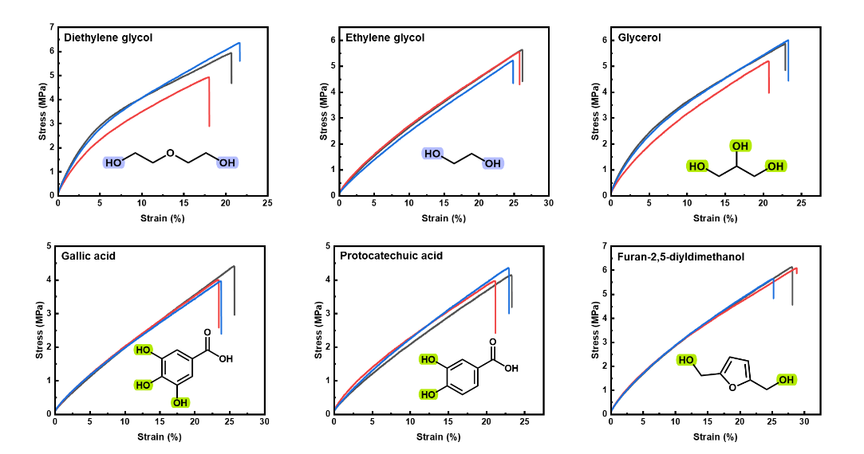
Figure S10. Mechanical properties of printed samples in Figure 4E using printing resin consisting of DDE, CVE, EtOH, DPI, ITX and different alcohols.

Table S8. The cost of the printing resin consisting of DDE, CVE, CH₃OH, DPI and ITX
Reagent | CAS Registry Number | Wholesale price (USD/1 t) | Cost (USD/t)
DDE | 764-99-8 | 2,500^{a)} | 50:50:5:0.1:0.1 = 2,880
CVE | 2182-55-0 | 2,900 ^{a)} | 50:50:5:0.1:0.1 = 2,880
Methanol | 67-56-1 | 400 ^{b)} | 50:50:5:0.1:0.1 = 2,880
DPI | 58109-40-3 | ~59,000 ^{a)} | 50:50:5:0.1:0.1 = 2,880
ITX | 5495-84-1 | ~14,700 ^{a)} | 50:50:5:0.1:0.1 = 2,880
- https://china.guidechem.com
- https://me.100ppi.com

Table S9. The prices of the common commercial printing resin
Brand | Resin category | Wholesale price (USD/t)
eSUN^{a)} | Basic standard resin | 8,500~9,600
eSUN^{a)} | ABS high-strength resin | 12,000~13,300
eSUN^{a)} | TPU flexible soft rubber resin | 20,700~25,100
Anycubic ^{b)} | Basic standard resin | 9,100~10,600
Prismlab ^{c)} | Industrial rigid resin | 22,200~28,000
Prismlab ^{c)} | High-temperature resistant resin | 76,800~96,000
Prismlab ^{c)} | Dental temporary crown resin | 56,100~70,900
BASF Forward AM ^{d)} | High Rigidity Resin | 115,000~140,000
BASF Forward AM ^{d)} | High-toughness resin | 100,000~127,000
BASF Forward AM ^{d)} | High-temperature resistant resin | 147,000~192,000
Formlabs^{e)} | General-purpose rigid resin | 81,200~106,000
Formlabs^{e)} | Dental biocompatible resin | 147,000~236,000
Ekimate ^{f)} | Low yellowing optical transparent resin | 162,000~206,000
- https://www.esunchina.net/
- https://www.anycubic.com/
- https://www.prismlab.cn/
- https://forward-am.com/
- https://formlabs.com/
- https://exmatelab.com/

Table S10. Data points used in the property comparison of this work with commercial thermosets in Figure 5D.
Thermoset | Young’s modulus (MPa) | Stress at break (MPa)
Epoxy^{[1-4]} | 10400 | 179
Epoxy^{[1-4]} | 1800 | 56
Epoxy^{[1-4]} | 827 | 9
Epoxy^{[1-4]} | 3540 | 118
Silicone^{[5-8]} | 0.6 | 0.8
Silicone^{[5-8]} | 0.5 | 0.1
Silicone^{[5-8]} | 1 | 4
Silicone^{[5-8]} | 62 | 11
Polyurethane foam^{[9-11]} | 16 | 0.6
Polyurethane foam^{[9-11]} | 56 | 1
Polyurethane foam^{[9-11]} | 114 | 3
Polyurethane foam^{[9-11]} | 399 | 9
Polyurethane foam^{[9-11]} | 1000 | 19
Polyimide foam^{[12, 13]} | 107 | 4
Polyimide foam^{[12, 13]} | 521 | 26
Polyimide foam^{[12, 13]} | 29 | 1
This work | 267 | 18
This work | 16 | 3
This work | 3 | 3
This work | 517 | 28
This work | 240 | 14
This work | 24 | 4
This work | 584.9 | 43
This work | 4.5 | 1
This work | 179.5 | 16
This work | 73.1 | 12

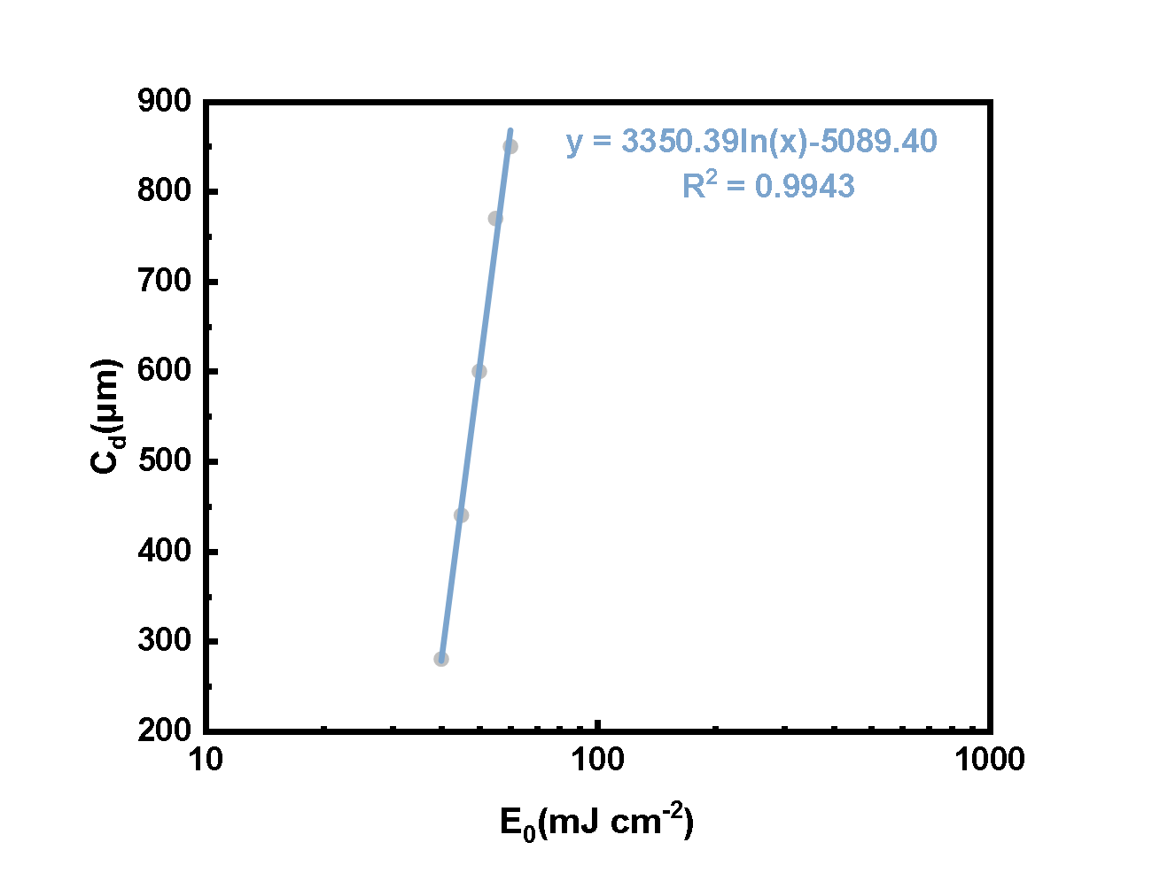

Figure S11. The Jacob test of printing resin consisting of [DDE]₀:[CVE]₀:[CH₃OH]₀:[DPI]₀:[ITX]₀ = 70:30:5:0.1:0.1.

Table S11. Printing speed of the printing resin under a fixed molar ratio of [DDE]₀:[CVE]₀:[CH₃OH]₀:[DPI]₀:[ITX]₀ = 50:50:2:0.1:0.1.
Entry | Exposure time per layer (s) | Printing thickness per layer (mm) | Target thickness (mm) | Actual thickness (mm) | Printing speed (cm h⁻¹)
1 | 7 | 0.05 | 2.0 | 1.87 | 2.10
2 | 7 | 0.1 | 2.0 | 1.84 | 4.14
3 | 7 | 0.2 | 2.0 | 1.82 | 8.21

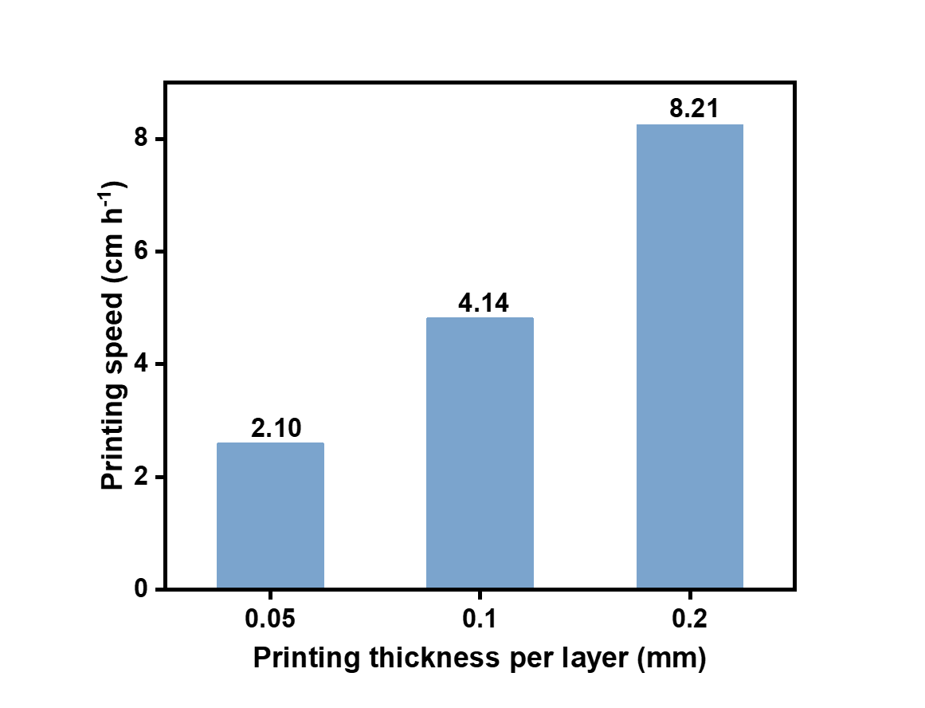

Figure S12. Printing speed of the printing resin under a fixed molar ratio of [DDE]₀:[CVE]₀:[CH₃OH]₀:[DPI]₀:[ITX]₀ = 50:50:2:0.1:0.1.

Table S12. Stability of printed samples using printing resin consisting of [DDE]₀:[CVE]₀:[CH₃OH]₀:[DPI]₀:[ITX]₀ = 50:50:5:0.1:0.1.
Entry | Time (Day) | Strain at break  ε_{b} (%) | Stress at break  σ_{b} (MPa)
1 | 0 | 30 ± 3 | 12.08 ± 0.76
2 | 1 | 33.7 ± 1.4 | 13.02 ± 0.91
3 | 2 | 32.5 ± 2.4 | 10.91 ± 0.83
4 | 3 | 29.84 ± 0.64 | 9.85 ± 0.38
5 | 4 | 38.5 ± 1.1 | 9.38 ± 0.72
6 | 5 | 33.1 ± 1.6 | 11.36 ± 0.67
7 | 6 | 34.14 ± 0.68 | 12.25 ± 0.93
8 | 7 | 37.1 ± 2.2 | 11.59 ± 0.40

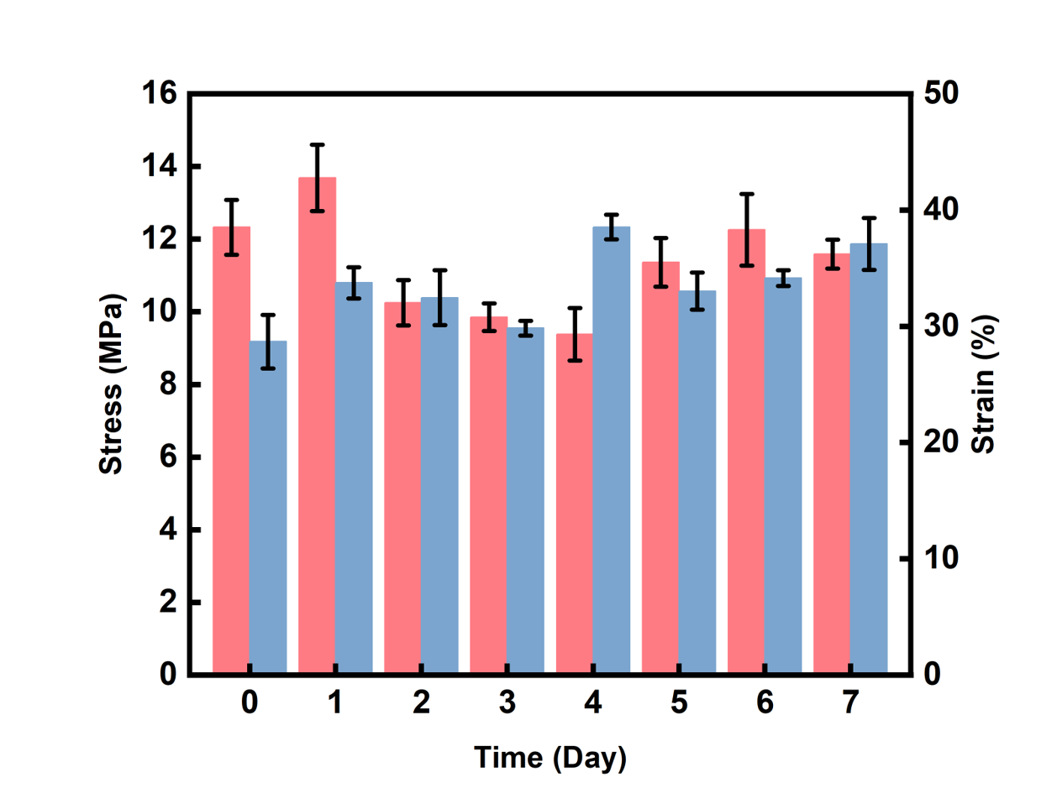

Figure S13. Stability of printed samples using printing resin consisting of [DDE]₀:[CVE]₀:[CH₃OH]₀:[DPI]₀:[ITX]₀ = 50:50:5:0.1:0.1.

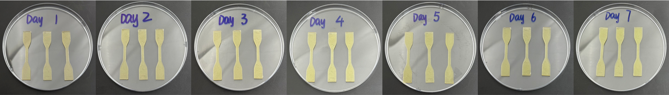

Figure S14. Images of printed samples after different storage periods.

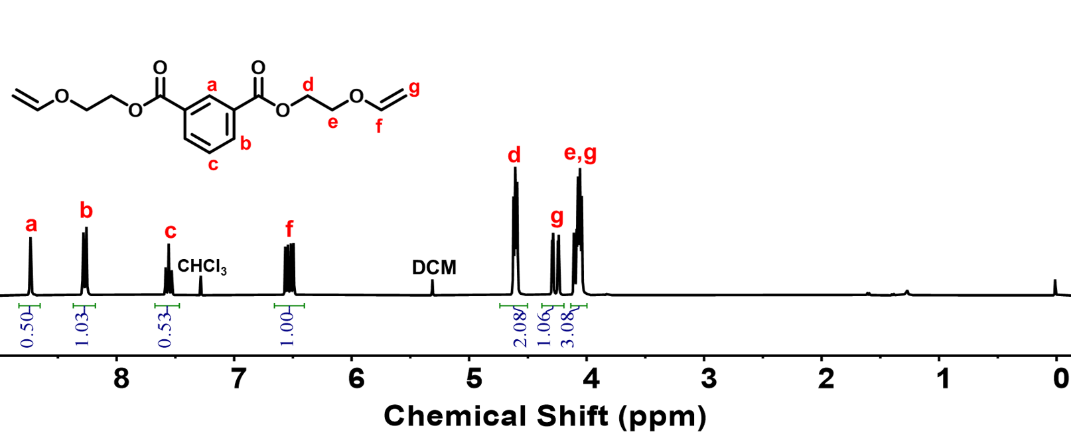

Figure S15. ¹H NMR spectrum (in CDCl₃) of bi-VEB.

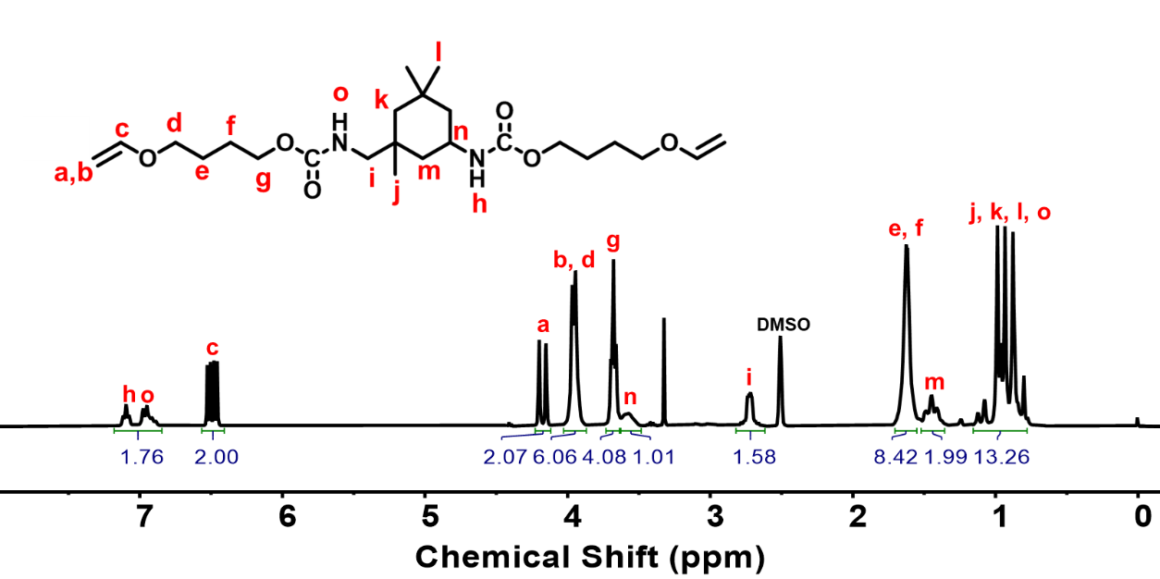

Figure S16. ¹H NMR spectrum (in DMSO-d₆) of IP-VE.

- Xie H, Bao F, Zhang H., Ultratough, robustness, and reprocessable thermoset epoxy resins synergistically enhanced by hierarchical coordination interactions and dynamic covalent networks. Advanced Functional Materials, 2024, 34, 2408411.
- Mostovoy A., Yakovlev A., Tseluikin V., Epoxy Nanocomposites reinforced with functionalized carbon nanotubes. Polymers, 2020, 12,1816.
- Yilin T., Preparation and properties of high strength and high moduli epoxy resin composites. Journal of Physics: Conference Series. 2025, 3057, 012019.
- Songhan. Plastic Technology. Co., Lotd. Master-Bond-EP40-High-Shear-and-Peel-Strength-Two-Component-Flexible-Epoxy.
- Maiti, A., Weisgraber, T., Gee, R. Modeling the mechanical and aging properties of
silicone rubber and foam - stockpile-historical & additively manufactured materials. 2014, 1252645
- Muslov, S. A., Polyakov, D. I., Lotkov, A. I., Stepanov, A. G. & Arutyunov, S. D.
Measurement and calculation of mechanical properties of silicone rubber. Russ Phys J. 2021, 63, 1525-1529
- S. Li, J. Zhang, J. He, W. Liu, Y. Wang, Z. Huang, H. Pang, Y. Chen, Functional PDMS elastomers: bulk composites, surface engineering, and precision fabrication. Adv. Sci. 2023, 10, 2304506.
- Feng, L., Li, S., Feng, S. Preparation and characterization of silicone rubber with high modulus via tension spring-type crosslinking. RSC Adv. 2017, 7, 13130-13137.
- Sawbones. Solid rigid polyurethane foam meets ASTM F1839-08 material specification-Datasheet.
- Vantadori S., Carpinteri A., Cerioni R. Fracture toughness of a rigid polyurethane foam: experimental and numerical investigation by varying the specimen sizes. Fatigue Fract Eng Mater Struct. 2023; 46(10): 3654-3666.
- Ye H., Qiu C., Ni L. Development of multi-functional rigid polyurethane foam with thermal insulation, mechanical and vibration damping properties through molecular chain design. Polymer, 2025, 339, 129115.
- He D., Liu X., Jiao F. Investigation on flame‐retardant, thermal and mechanical properties of glass fiber reinforced polyimide composites. Polymer Composites, 2023, 45(1),350-359.
- Shi Y., Hua, Wang Z. Closed-Cell Rigid Polyimide Foams for High-Temperature Applications: The Effect of Structure on Combined Properties. Polymers, 2021, 13, 4434.

