Supplementary Materials for

Asynchronous crop expansions reveal spatial opportunity structures in Holocene China
This file includes:
Figs S1 to S7
Table S1
References

Supplementary Figures
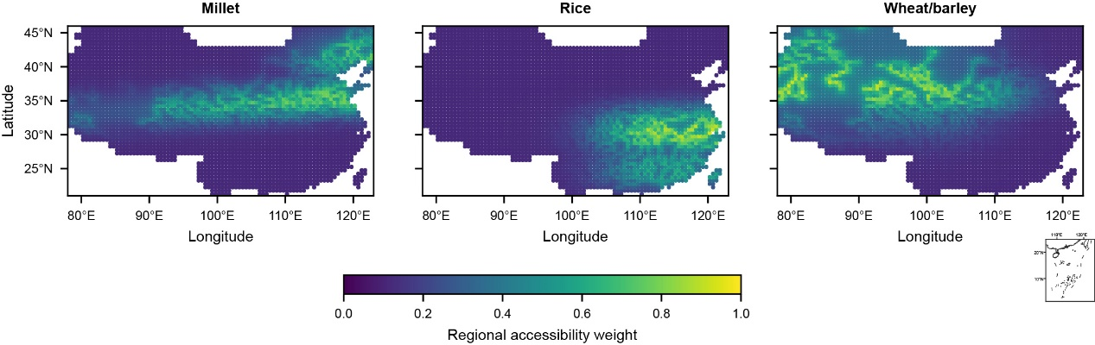
Supplementary Fig. S1 | Fixed regional accessibility weights used in the diffusion kernel. Maps show the fixed crop-specific regional accessibility weights used as weak spatial modifiers in the non-local diffusion kernel for millet, rice and wheat/barley. The weights represent broad prior geographic expectations, including northern dryland and Yellow River-related accessibility for millet, Yangtze and southern humid lowland accessibility for rice, and northwest–Hexi–Gansu-Qinghai–northern accessibility for wheat/barley. They are continuous and non-exclusive, and should be interpreted as weak predictive accessibility modifiers rather than predefined routes or direct reconstructions of crop transmission pathways.
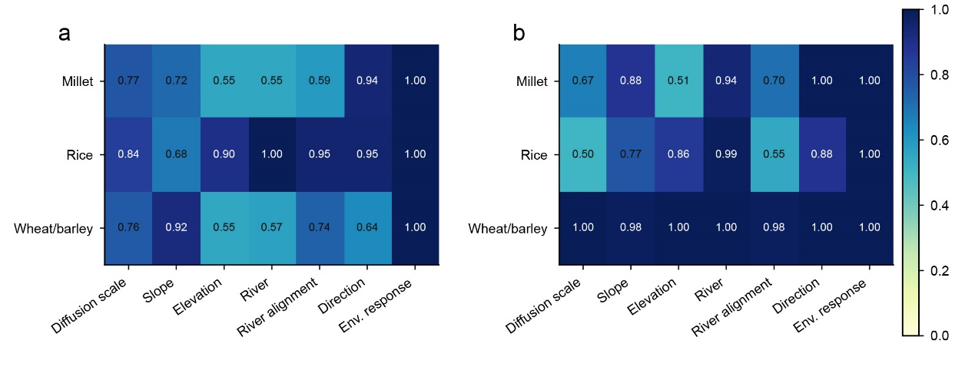Supplementary Fig. S2 | Parameter stability and identifiability. a, Bootstrap support for selected model parameters. b, Pseudo-posterior support for the same parameter groups. Values range from 0 to 1 and indicate parameter support or selection stability, not environmental suitability values or crop-occurrence probabilities. "Climate profile" denotes the selected crop-specific environmental-suitability response to precipitation, P-E, NPP, temperature and lake-hydrological conditions.

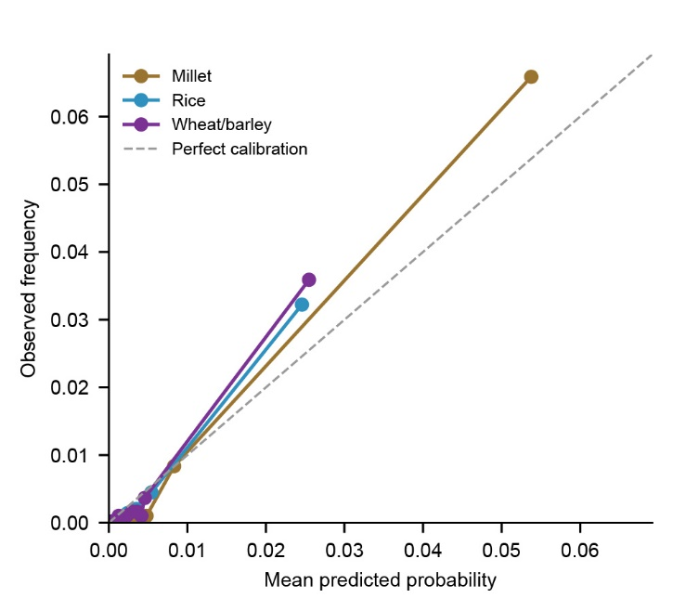
Supplementary Fig. S3 | Reliability diagram for one-step crop-record predictions. Reliability diagrams compare mean predicted probability with observed crop-record frequency for one-step predictions of millet, rice and wheat/barley. Candidate grid cells were grouped into predicted-probability quantile bins for each crop system because positive crop-record cells are sparse and fixed-width probability bins would concentrate most cells in the lowest bin. The dashed line indicates perfect calibration. Observed crop-record frequency generally increased with predicted probability, indicating that the model probabilities contain relative calibration information. Deviations from the perfect-calibration line show that predicted probabilities should be interpreted as relative probabilities of archaeologically visible crop-record occurrence, not as absolute probabilities of true crop cultivation or complete agricultural presence.
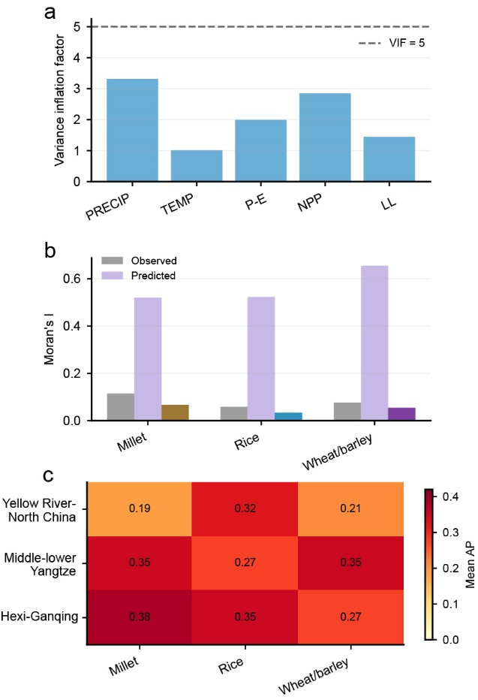
Supplementary Fig. S4 | Additional robustness checks for the dynamic crop-record model. a, Environmental-variable collinearity diagnostics. Bars show variance inflation factors (VIF) for precipitation (PRECIP), temperature (TEMP), precipitation minus evaporation (P-E), net primary productivity (NPP) and lake-hydrological variables (LAKE); the dashed line marks VIF = 5. b, Residual spatial structure. Moran's I is shown for observed records, predicted probability surfaces and residuals. c, Regional validation performance across the Yellow River-North China region, middle-lower Yangtze region and Hexi-Ganqing corridor. Values indicate regional mean AP. Regional AP values should be interpreted relative to their corresponding random AP baselines because AP depends on the proportion of positive records.
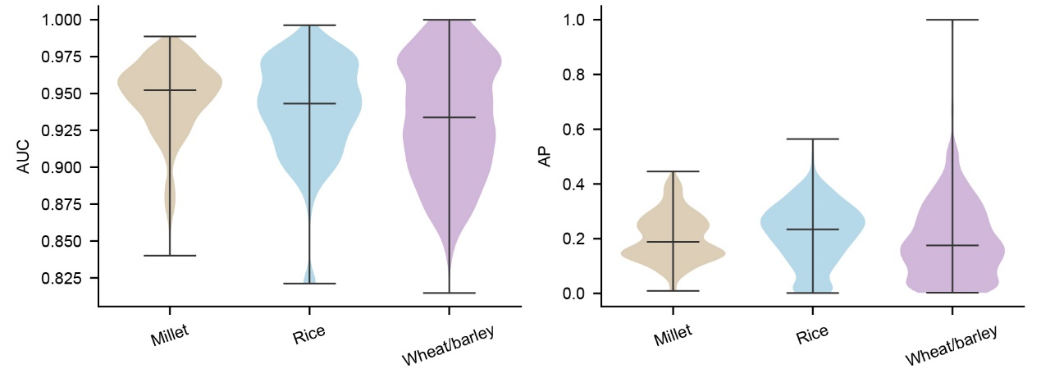
Supplementary Fig. S5 | Chronological Monte Carlo sensitivity of model performance. Chronological-uncertainty sensitivity was evaluated using 100 Monte Carlo iterations. AUC remained consistently high across crop systems, indicating that the spatial-ranking ability of the model was not strongly affected by plausible age perturbations. AP showed greater variability, especially for wheat/barley, reflecting the sensitivity of sparse positive records and low-sample windows to chronological reassignment.
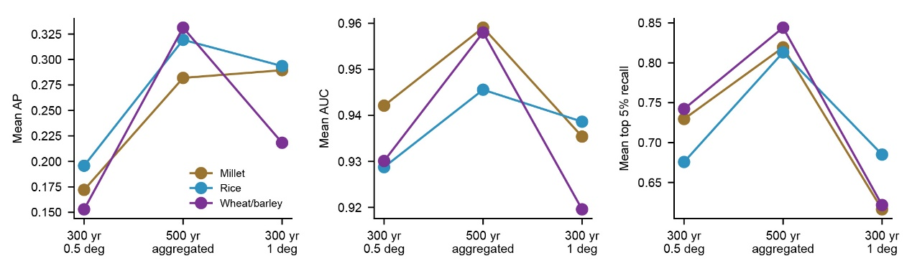
Supplementary Fig. S6 | Spatiotemporal resolution sensitivity. Sensitivity tests compare model performance under the baseline setting of 300-year time windows and 0.5° grid cells with two alternative aggregation schemes: 500-year temporal aggregation and 300-year windows using 1° grid cells.
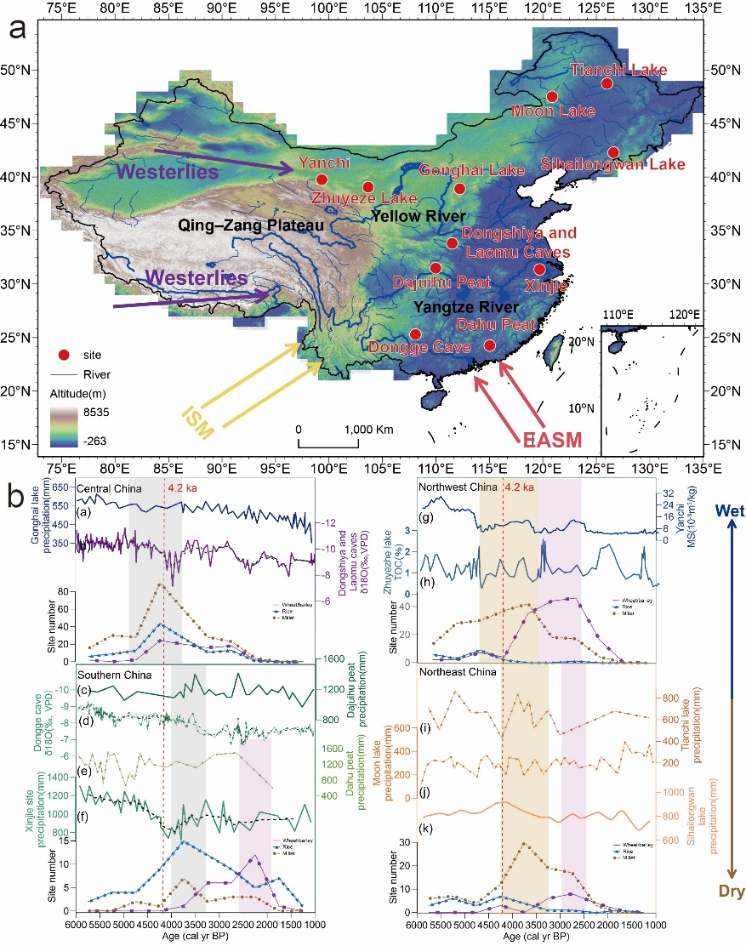
Supplementary Fig. S7 | Comparison of regional paleoclimate indicators with crop record intensity. a, paleoclimate record locations. b, Paleoclimate indicators and crop record based on regional divisions. (a)Gonghai Lake precipitation(Chen et al.,2015); (b)Xinjie site precipitation(Lu et al., 2019); (c)Dongshiya and Laomu caves δ¹⁸O(Li et al., 2026); (d)Dajiuhu peat precipitation(Sun et al., 2019); (e)Dongge cave δ¹⁸O(Wang et al.,2015); (f)Dahu peat precipitation(Xiao et al.,2007); (g)Yanchi MS(Yu et al., 2006); (h)Zhuyeze lake TOC(Li et al., 2012); (i)Tianchi lake precipitation(Liu et al., 2019); (j)Moon lake precipitation(Wu et al., 2012); (k)Sihailongwan lake precipitation(Stebich et al., 2015).

Supplementary Table S1 | Parameter configurations of the dynamic crop-record model used for millet, rice and wheat/barley
Parameter | Millet | Rice | Wheat/barley
Temporal and spatial support
Analysis interval | 6000–2000 BP | 6000–2000 BP | 6000–2000 BP
Time-window width | 300 years | 300 years | 300 years
Candidate grid | 0.5° candidate cells | 0.5° candidate cells | 0.5° candidate cells
Non-local diffusion kernel
σ _{distance-decay scale} | 400 km | 100 km | 100 km
θ_{slope,c} | 0 | 1 | 0
θ_{elev,c} | 0 | 0.8 | 0
θ_{river,c} | 0 | 0 | 0
θ_{align,c} | 0 | 0 | 0
θ_{dir,c} | 0 | 0 | 1.5
Environmental suitability
Climate profile | subhumid_750mm | very_humid_1500mm | subhumid_650mm
Precipitation optimum | 750 mm | 1500 mm | 650 mm
Precipitation width | 350 mm | 550 mm | 330 mm
P–E optimum | -0.1 | 0.45 | -0.2
P–E width | 0.7 | 0.5 | 0.7
Logistic occurrence model
intercept $\left(α_{c}\right)$ | -5.83 | -6.605 | -3.726
β_{persistence} | 3.36 | 3.15 | 2.845
β_{diffusion} | 4.071 | 6.651 | 3.117
β_{environment} | 2.62 | 4.768 | -0.017
β_{diffusion × environment} | -1.603 | -6.266 | -0.252
Temporal-intensity layer
γ_{0,c​} | -1.299 | -1.997 | -1.987
γ_{1,c​} | 0.212 | 0.328 | -0.865
γ_{2,c​} | -0.372 | -0.329 | -0.59
Temporal-intensity peak | 4285 BP | 4499 BP | 3267 BP
Model diagnostics
parameter-search AUC | 0.936 | 0.931 | 0.917
parameter-search AP | 0.16 | 0.13 | 0.126
*Parameter groups are shown as section headings. Temporal and spatial settings were fixed before modelling; diffusion-kernel and environmental-profile parameters were selected from predefined candidate sets; logistic and temporal-intensity coefficients were fitted from the crop-record data; temporal-intensity peaks were derived from the fitted temporal layer. Regional accessibility weights were fixed before model fitting and used as weak predictive accessibility modifiers rather than reconstructed historical transmission routes.

References
Chen F, Xu Q, Chen J, et al. East Asian summer monsoon precipitation variability since the last deglaciation. Scientific Reports 2015;5:11186.
Lu F, Ma C, Zhu C, et al. Variability of East Asian summer monsoon precipitation during the Holocene and possible forcing mechanisms. Climate Dynamics 2019;52:969–989.
Sun J, Ma C, Cao X, Zhao Y, Deng Y, Zhao L, Zhu C. Quantitative precipitation reconstruction in the east-central monsoonal China since the late glacial period. Quaternary International 2019;521:175–184.
Li M, Jia W, Yang Y, et al. Spatial patterns of Asian summer monsoon precipitation in the Chinese monsoon region since the LGM. npj Climate and Atmospheric Science 2026;9:67.
Wang YJ, Cheng H, Edwards RL, et al. The Holocene Asian monsoon: links to solar changes and North Atlantic climate. Science 2005;308:854–857.
Xiao J, Lu H, Zhou W, Zhao Z, Hao R. Evolution of vegetation and climate since the last glacial maximum recorded at Dahu peat site, South China. Science in China Series D: Earth Sciences 2007;50:1209–1217.
Yu YT, Yang TB, Li JJ, et al. Millennial-scale Holocene climate variability in the NW China drylands and links to the tropical Pacific and the North Atlantic. Palaeogeography, Palaeoclimatology, Palaeoecology 2006;233:149–162.
Li Y, Wang NA, Li ZL, et al. Holocene climate cycles in northwest margin of Asian monsoon. Chinese Geographical Science 2012;22:450–461.
Liu X, Zhan T, Zhou X, Wu H, Li Q, Zhao C, et al. Late onset of the Holocene rainfall maximum in northeastern China inferred from a pollen record from the sediments of Tianchi Crater Lake. Quaternary Research 2019;92:133–145.
Wu J, Liu Q. Pollen-recorded vegetation and climate changes from Moon Lake since Late Glacial. Earth Science — Journal of China University of Geosciences 2012;37:947–954.
Stebich M, Rehfeld K, Schlütz F, Tarasov PE, Liu J, Mingram E. Holocene vegetation and climate dynamics of NE China based on the pollen record from Sihailongwan Maar Lake. Quaternary Science Reviews 2015;124:275–289.

